About Khordha
Planning a Trip to Khordha? Here's our list of 6 top Tourist Places to visit in Khordha
Khordha is a small town in the state of Odisha, whose capital Bhubaneswar, belongs to Khordha district and is only 25 km from Khordha town.
Khordha is one of the new districts carved out of the former Puri District on 1st April 1993. The other new district carved out of Puri was Nayagarh. In the year 2000, the district's name was changed from Khurda to Khordha. The district headquarters is located in Khordha Town, formerly known as Jajarsingh or Kurada, (kurada means foul-mouthed). The old milestones of the area had the word KURADA which has now been whitewashed and the word “Khurdha” is written on them. About the origin of the word Khurda(as earlier called) it is also told that the word is derived from two Odia words- ‘Khura’ and ‘Dhara’, meaning razor and edge, probably because the soldiers of Khurda were as sharp and dreadful as the edge of a razor. Neither of the two origins, however can be called authentic.
The history of Khordha depicts that in early days the area was densely populated by the Savaras, a tribal community that is still found in some pockets of the district. Over the period, however, its history is found closely associated with the history of Puri district. About the middle of the 10th century AD, the rule of Bhoumakars was supplanted by that of the Somavamsis.
Top 6 Places to Visit in Khordha
Atri
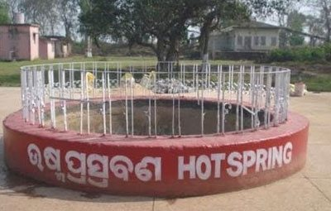
It is situated in the village of Baghamari, at a distance of 42 km from Bhubaneswar and nearly 14 km from Khordha Bus stand. Atri is famous for its perennial Hot Spring. The hot spring is reputed to have medical properties which are used both intensively and extensively for the cure of skin diseases, and a temple dedicated to Lord Hatakeswara(Lord Shiva).
Bhubaneswar
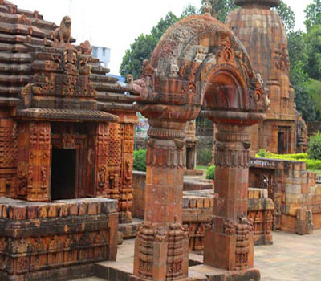
Bhubaneswar the temple city of India and is the capital of Odisha. It is believed that there were about 7000 temples in Ekamra Vana of Bhubaneswar. Reminiscence of the days of yore dating back to the 6th century. Satrughaneswar and Laxamaneswar temple to the gigantic Lingaraj temple of the 11th century are available in the old township. Centuries of temple building activity continued well into the 12th and 13th centuries in the shape of Anant Basudev temple on the southeast of the Bindu Sarovar Tank. Besides the Khandagiri and Udayagiri Caves are rock-cut architectural beauties of the 1st century BC of Jain importance. The zoological paradise of Nandankanan Gardens on the north bank of Kanjia Lake which forms a picturesque Landscape. Modern Bhubaneswar also named as Smart City and has earned a reputation for its IT center and software parks as well as a model venue for conference and convention.
Mangalajodi
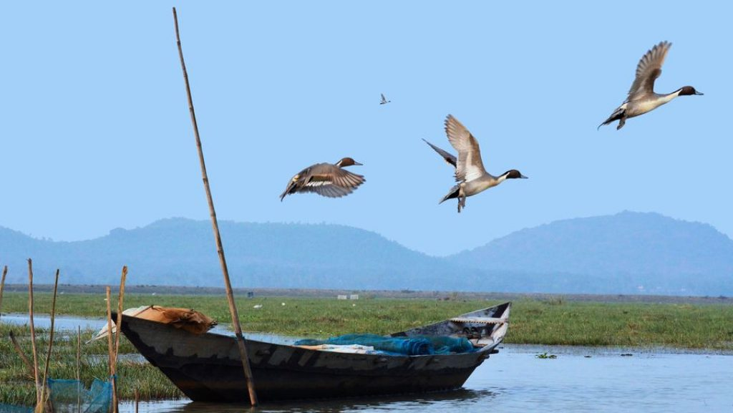
Mangalajodi Ecotourism, located at a distance of 40 km from the district headquarter, a destination to get a peep into Mother Nature. It is an Ecotourism destination on the northern banks of Chilika Lake in Odisha, The Bird's Paradise hosts more than 3,00,000 birds in its marshy waters, especially in winters. It is one of its kind ecosystems, whose protection is epitomized by a sustainable lifestyle. Mangalajodi Ecotourism aims to inspire, inform and enable communities to turn ecosystems into a sustainable source of livelihood through well managed low impact tourism instead of exploiting them for short term profits.
Dhauli
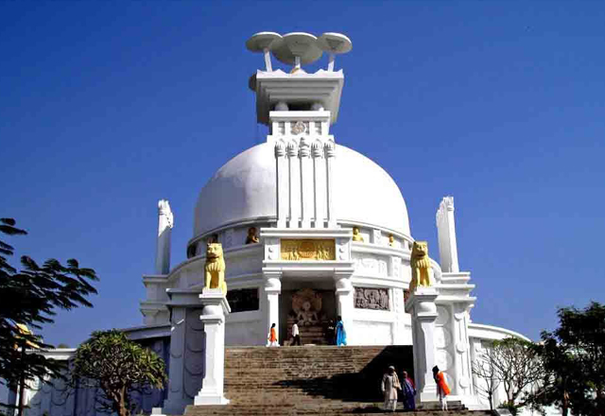
The Peace Pagoda built by the Kalinga Nippon Budha Sangha in 1973 and known as Shanti Stupa commemorates the change of heart of Emperor Ashok and the journey of Buddhism to the nation. There are two temples at Dhauli. One of Vairangeswar Mahadev and Dhabaleswar Mahadev. The proclamations of Emperor Ashok are recorded in the Prakrit language in bhramin script on the rock of Dhauli on the Southeast end.
Khandagir & Udayagiri
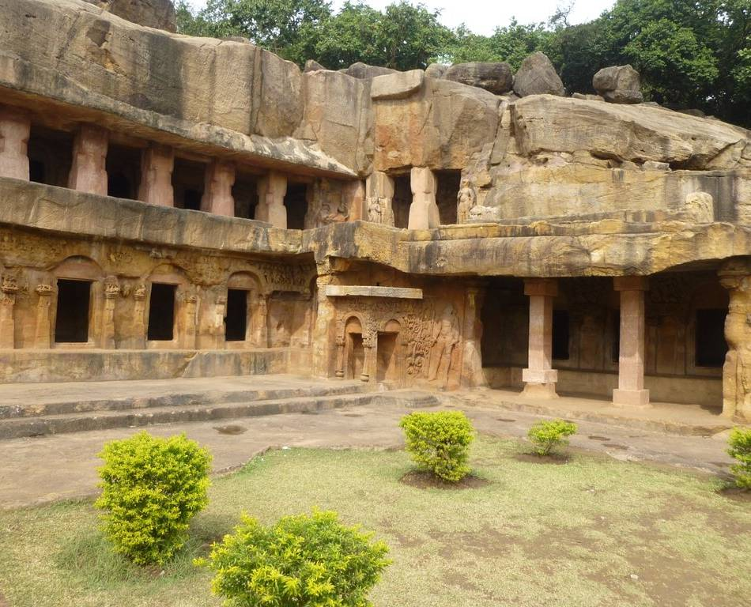
The Khandagiri and Udayagiri Crave relive the memories of the Kalinga Empire under the Jain emperor Kharvela. There is about 40 rock-cut cave adoring the two hills separated by a road.
It is believed that the founder of Jain faith, Mahavir had visited Udayagiri and Khandagiri in the 6th Century BC. Modern scholars are found in Rani and Hati Gumpha in the Udayagiti with a description of the culture of dance in Odisha as far before as the 2nd century BC.
Modern scholars are of the opinion that the Udayagiri cave complex was also a theatre complex. Emperor Kharvela was a staunch and a great patron of culture.
Hirapur
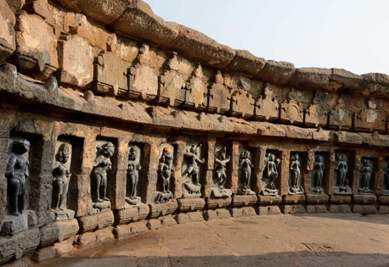
Center of Tantric ordered for the worship of 64 yoginis carved out of black chlorite stone. The temple is believed to be built by the Queen Hiradevi of the Bramha dynasty during the 9th century. It's built-in a circular fashion, completely put together with blocks of sandstone. The inside of the circular wall has cavities, each housing the statue of a Goddess. There are around 56 such idols, made of black granite, inscribed within the wall cavities, centering on the main idol which is the Goddess Kali, who stands on a human head representing the triumph of the heart over the mind. The temple houses a central altar(Chandi Mandapa) which has the remaining 8 Goddess idols on all 4 sides.
How to reach Khordha
By Air
The nearest airport Bhubaneshwar Airport. Khordha town is 35 Kms away from the Airport.
By Rail
Khordha is well connected to other major cities of the country via regular trains. The Railway Station is Khordha Road Junction.
By Road
Instead of Khordha, you can get a bus to Bhubaneswar on a regular basis.
Best Time to Visit Khordha
The best season to visit Khordha is the monsoon season when you can view the scenic beauty of the city. Winter season: Around 12°C(54°F) temperature is seen from December to February. October and February is the best time to visit the city as the temperature is pleasant.
Weather of Khordha
The climate of Khordha District in Summer generally commences in the month of March. The temperature begins to rise rapidly attaining the maximum in the month of May. During the summer, the maximum temperature touches around 41.4°C. and in winter the lowest temperature is 9.5°C. Annual rainfall ins 1443 mm.

