About Koraput
Planning a Trip to Koraput? Here's our list of 20 top Tourist Places to visit in Koraput
Koraput located in the green valley contemplating immaculate freshness was established on 1st April 1936. Decorated by Forests, Waterfalls, terraced Valleys and Darting Springs, the District draws the nature-loving people. The Koraput District lies at 17.4 degrees to 20.7 degrees north latitude and 81.24 degrees to 84.2 degrees east longitude. The Koraput is bounded by Rayagada in the east, Bastar District of Chhattisgarh in the west and Nabarangpur District in the south.
Koraput district was ruled by several dynasties such as Satavahanas, Ikshvakus, Nalas, Ganga kings and kings of Surya vans. In ancient times when the Nalas ruled this tract with Pushkari near modern Umarkote was their capital city. In the medieval period, Nandapur developed as the capital under the Silavamsi kings and after them under the kings of the solar dynasty. Viravikrama Deo of the solar dynasty shifted his capital to Jeypore about the middle of the 17th century and developed into a prospered town.
It was a part of the erstwhile Madras Presidency and became a district of Odisha state on 1st April 1936. In October 1992, erstwhile Koraput district was divided, resulting in the creation of Malkangiri, Rayagada and Nabarangpur district along with present Koraput district.
Top 20 Places to Visit in Koraput
Tribal Museum
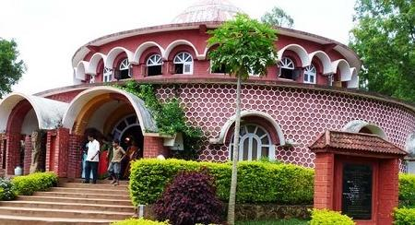
The Tribal Museum, founded in 1992, holds great importance because of its authentic display of the tribal culture of Odisha, providing a glimpse into their largely unexplored lives.
The museum has collections of mines, costumes hand-woven clothes, musical instruments, caters to and educates the tourists about the culture and heritage of the tribals.
Raja Cave & Balmiki Ashram
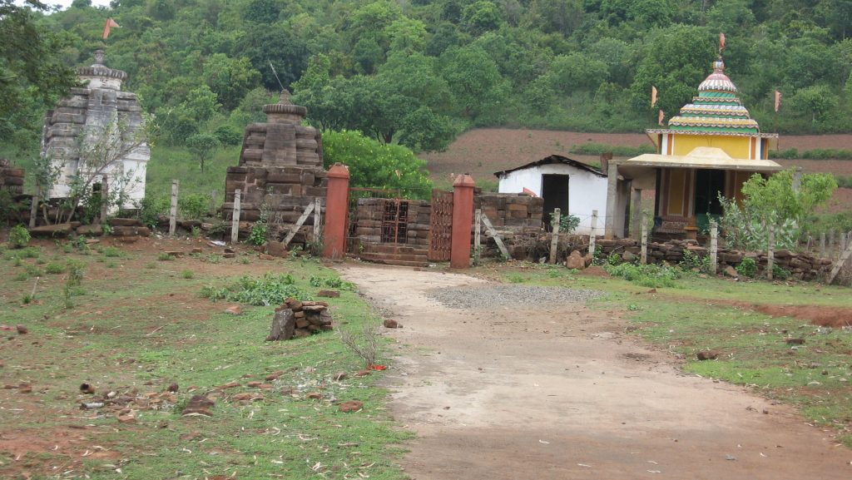
Raja Cave & Balmiki Ashram in other name know as Kapat Parbat. It is believed the ancestor of Balmiki resides in this site situated on the bank of river Machakund and the river dividing border of Odisha & Andra Pradesh. It is a scenic spot & best place for trekking in Nandapur block for Eco & Cave tourism. Akhayaturtiya is the main festival of this site.
Parab
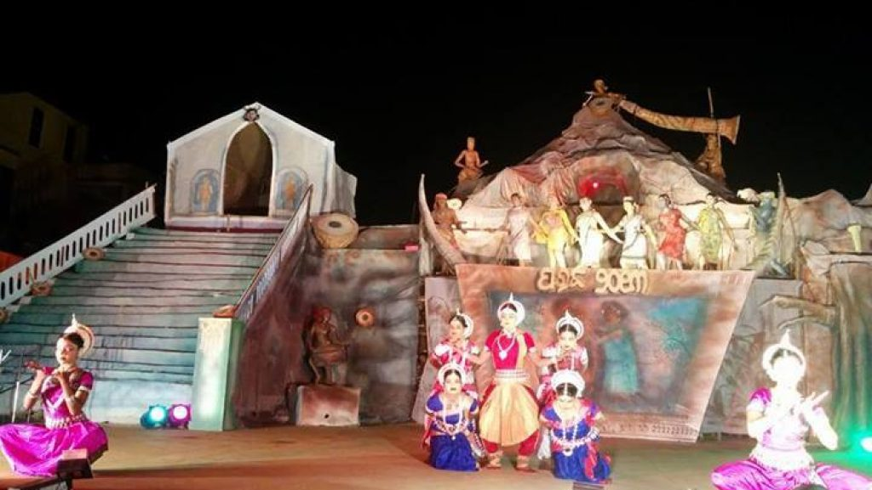
It is the festival named as ‘Parab’ – an annual tribal festival organized by the District Council of Culture, Koraput is a gala event of the state, organized in the month of November every year all over the district. The whole month of Parab witnesses events on sports culture, seminar mountain trekking, boat race and artists camp. On a third day from all over the country are staged on one platform, with crafts mela and exhibitions in the Koraput Parab ground.
Onukadelli
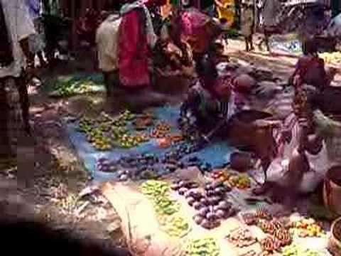
Onukadelli in Koraput drawn the attraction of foreign tourists to its weekly market day on Thursday where the Neolithic tribe Bonda come from the inaccessible forest for better purposes. It is 90 Kms away from Koraput.
Nandapur
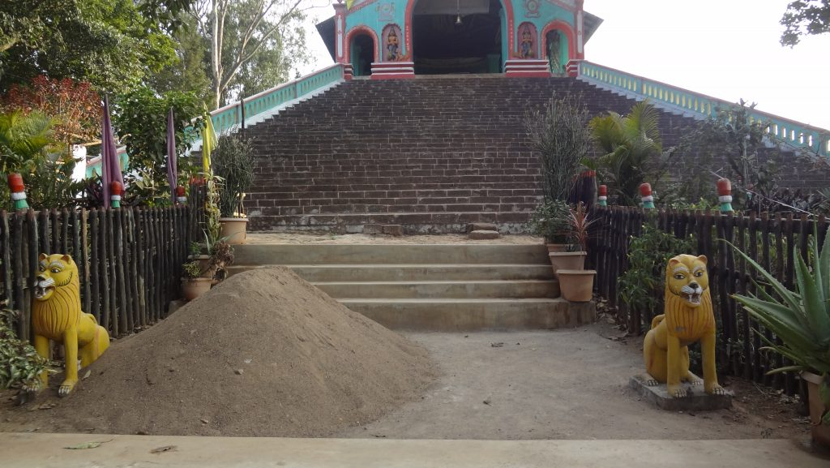
The ancient capital of Jeypore Kingdom Nandapur is famous for the presence of Batrisa Sinhasana. It is a 32 step well-preserved relic linked with the fabled throne of Vikramaditya. The arresting red image as a six-feet Ganesha and the shrine of Bhairavnath and other monuments of great antiquity.
Subai
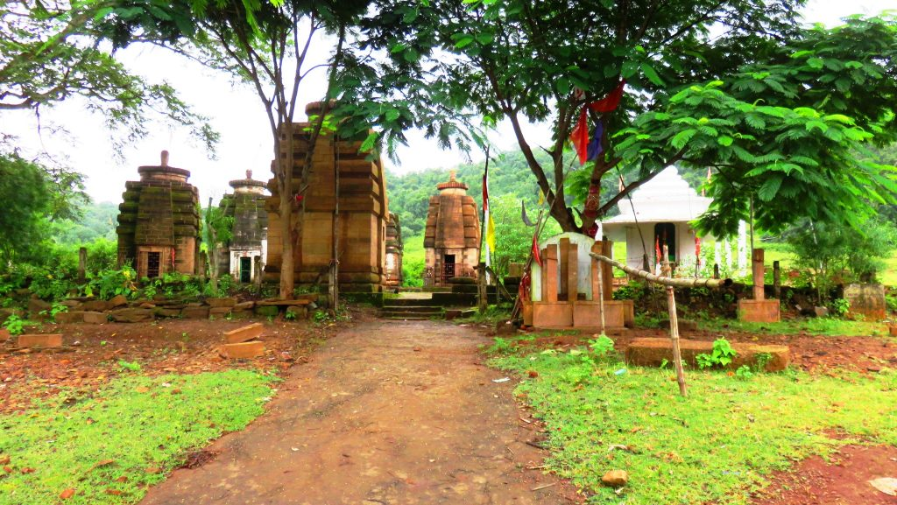
It is a roadside village 16 Kms from Sunabeda and 34 Kms away from Koraput has the relics of a Jain monastery, containing rare images of the Tirthankaras.
Jeypore
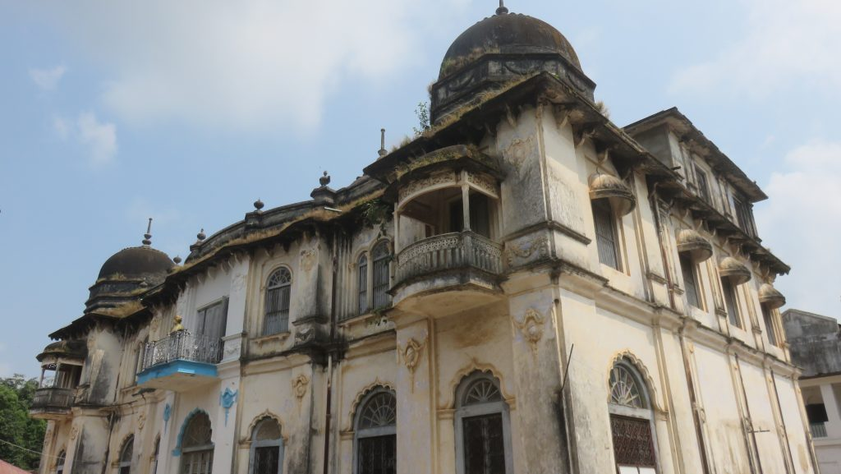
It is the city of victory is the largest town in the district and home to the royal family is steeped in history. The old fort is encircled by a high masonany wall with an imposing gateway. Towards the eastern part of the town is a big tank called Jagannath Sagar attracts water sports.
Kanta Baunsuni Damanjodi
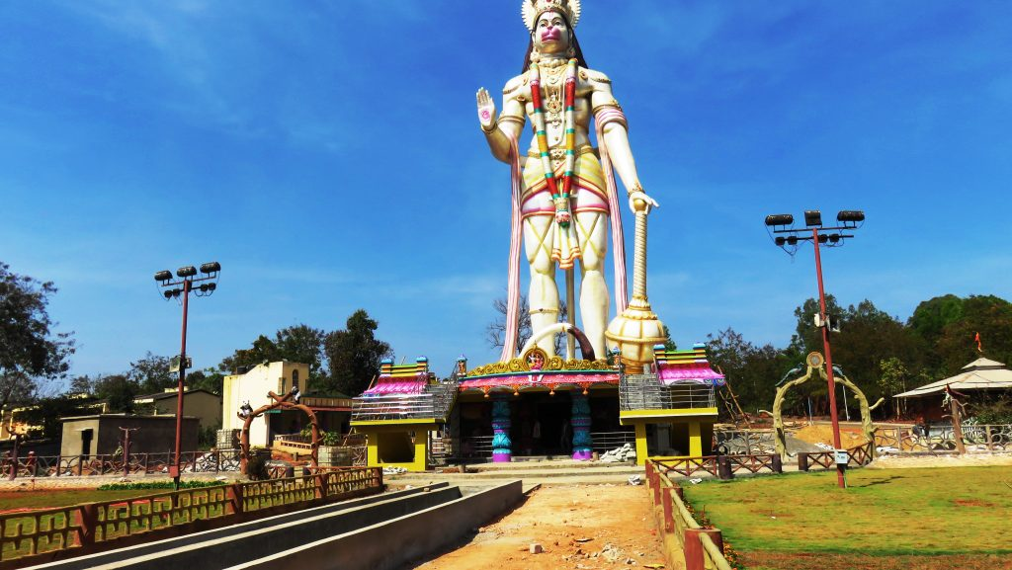
It is the town that became famous with the discovery of bauxite mines in the Panchapatmali hills and setting up NALCO, Asia's biggest Alumina complex. Nearby stands the highest peak of Odisha. And World's Second tallest Hanuman Statue that stands at 108.9 feet(33.1 meters) located at NALCO township, Damanjodi, Koraput.
Dumuriput
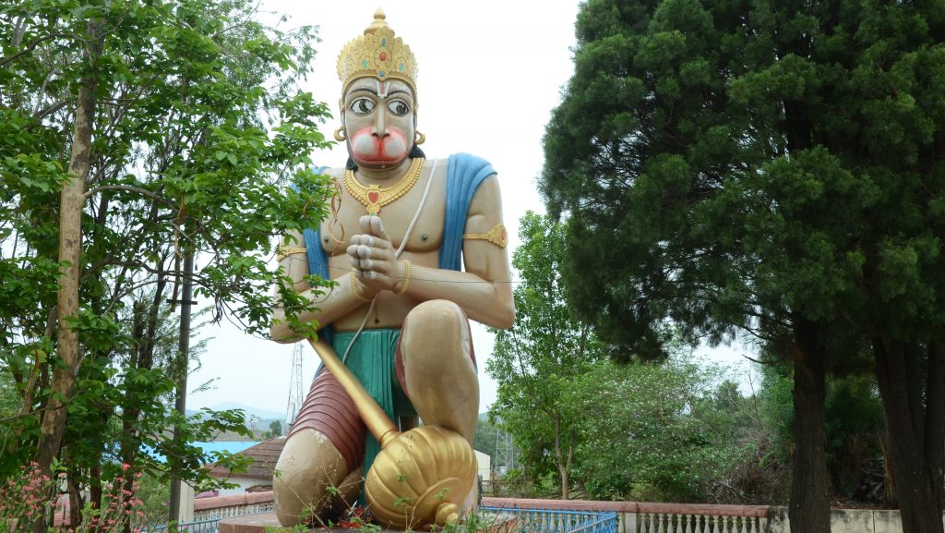
A village stands between Koraput and Sunabeda. The famous Sri Ram Temple situated in the locality is widely known for the highest kneeling Hanuman Statue in Odisha. Ram Navami festival is popularly celebrated every year which attracts a large number of devotees.
kolab Dam
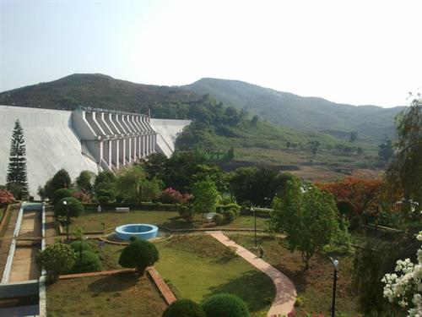
Kolab- At an altitude of about 3000 ft. above sea level on river Kolab, stands the majestic Kolab Reservoir generating Hydro Electric Power. The place is highly admired for its scenic beauty, attracting people for weekend picnic and boating.
Jalaput
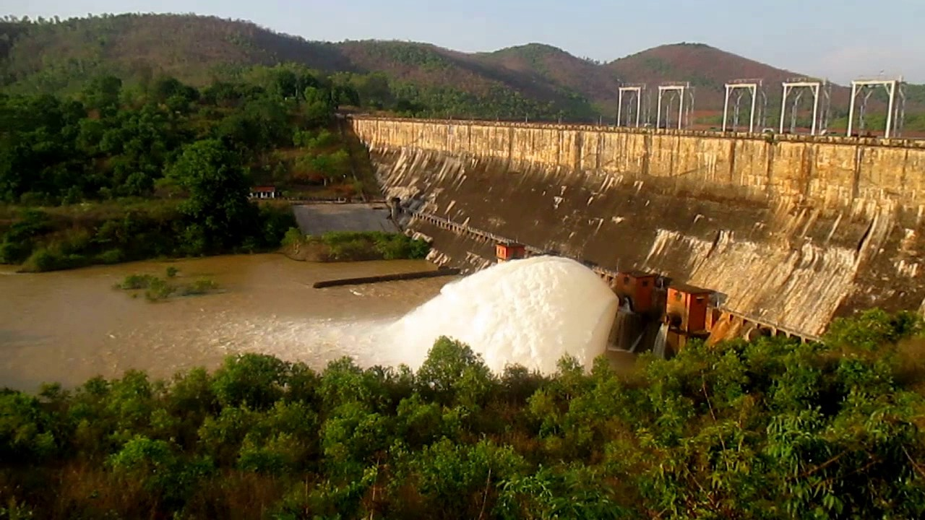
It is a dam reservoir over the Kolab river. It is 68.2 sq. kms in the area and an idyllic place of picnic and pleasure trip. It is 77 Kms away from Koraput.
Sunabeda
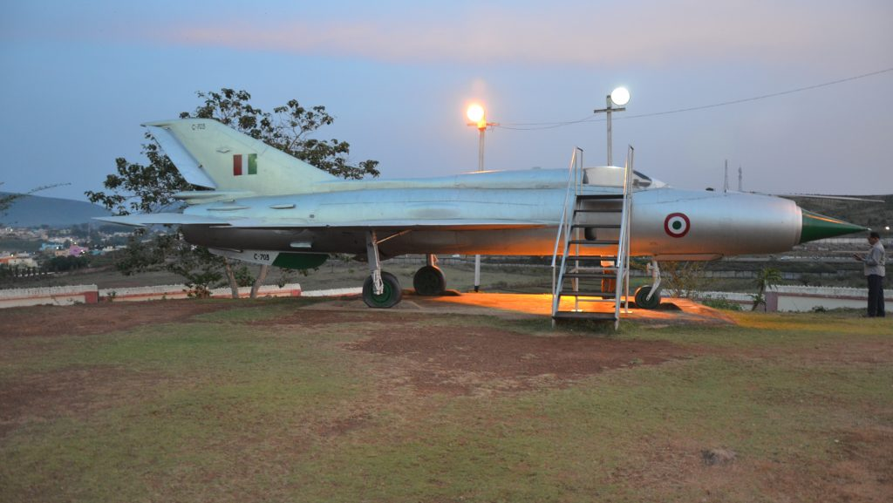
It is a modern township & famous for MIG fighter planes, Sukhoi factory & Museum containing aircraft engines displayed worthy to be seen.
Gulmi
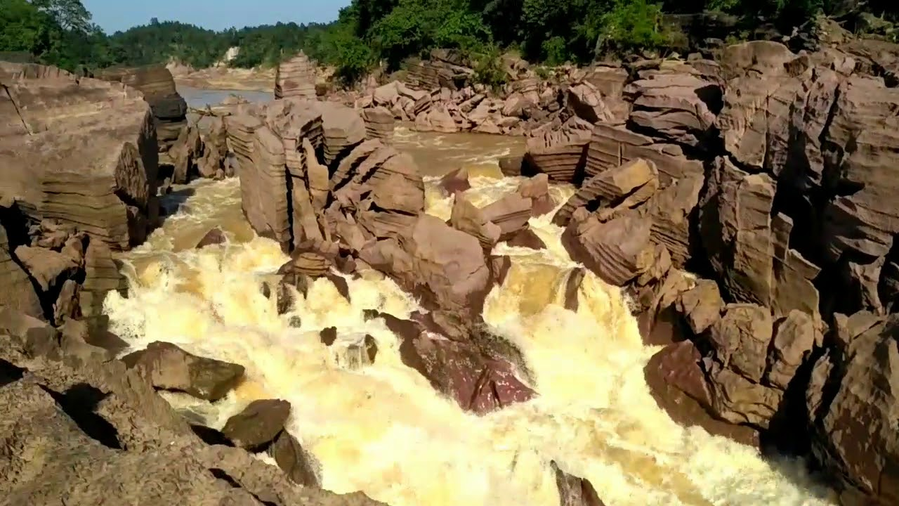
Kolab river forming a whirlpool at Gulmi and attracting large crowed from the district as well as from Chattisgarh state.
Kechela
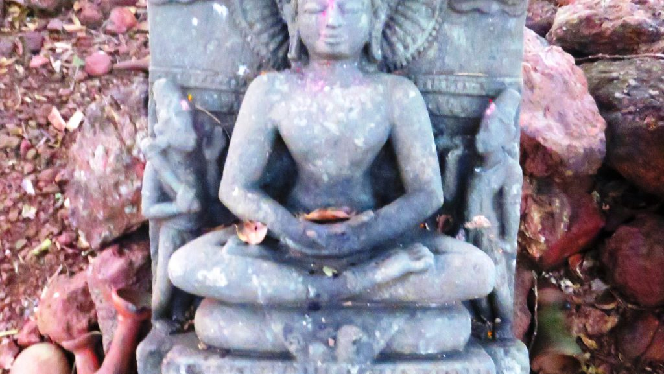
It is a village is known for the copper plate. There is a Jain temple about 30 ft. high contains 05 images of Tirthankaras namely Resavanath, Mahavir Jain, Ambika Devi, Jakhya & Jakhyani. The images are chiseled with great care and achieve a high standard of art which indicates the Kechela was a seat of Jainism in the medieval period.
Machhakund(Duduma)
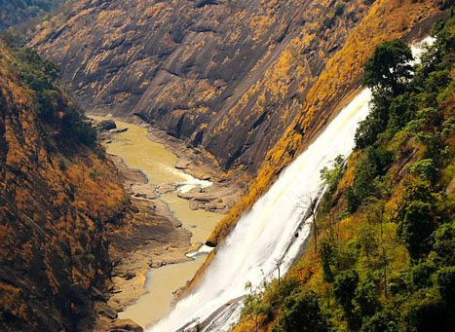
It is the waterfall, popularly known as Matsya Tirtha of epic fame falls from a height of 175 meters. Set in the heart of a picturesque hill, Duduma 70 Kms to the South of Jeypore, and 88 Kms away from Koraput is a rocky outlet for the river Machhkund, which flows through this rough terrain. Rock-climbing enthusiasts can try reaching the base of the fall from the opposite side of the hill, a route tribals claim can be Terribly Strenuous.
Deomali
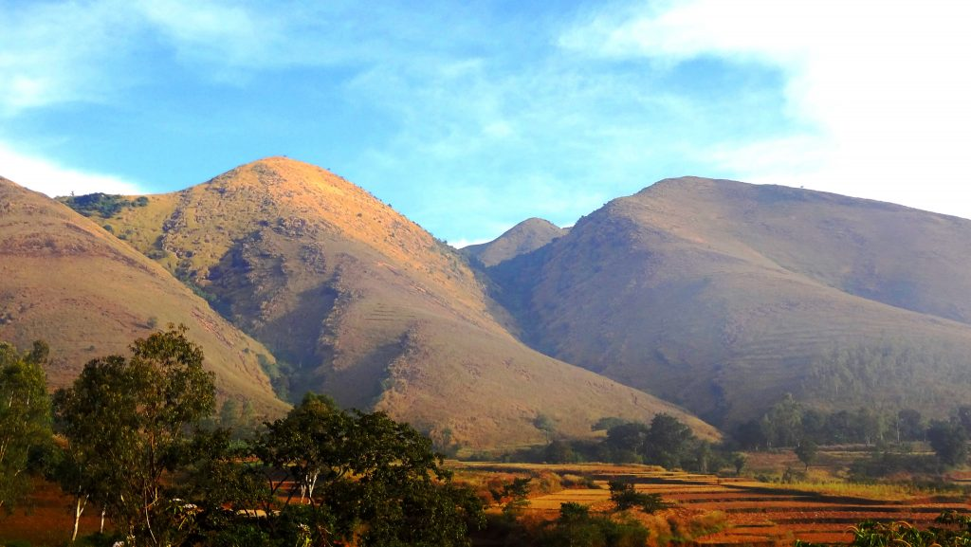
The highest mountain Peak of Odisha Deomali 1762 mt. high nestling in the lap of the Eastern Ghats is an ideal for Aero Gliding and trekking expeditions.
Gupteswar
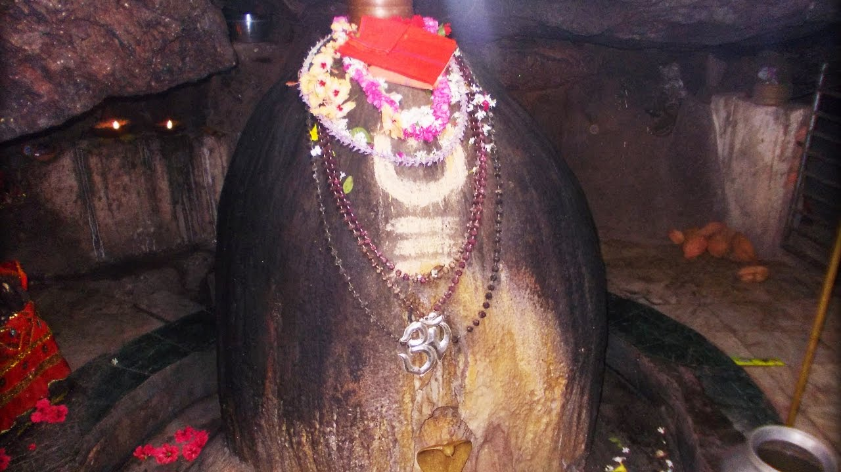
Gupteswar is a cave temple located on the banks of Kolab River, about 80 km from Koraput. Important cave shrine of Lord Shiva situated on a lime stone hill amidst scenic bliss. The temple houses a sacred Swayambhu Shivling called Gupteswar, which literally means the Hidden God.
Sabar Shreekshetra
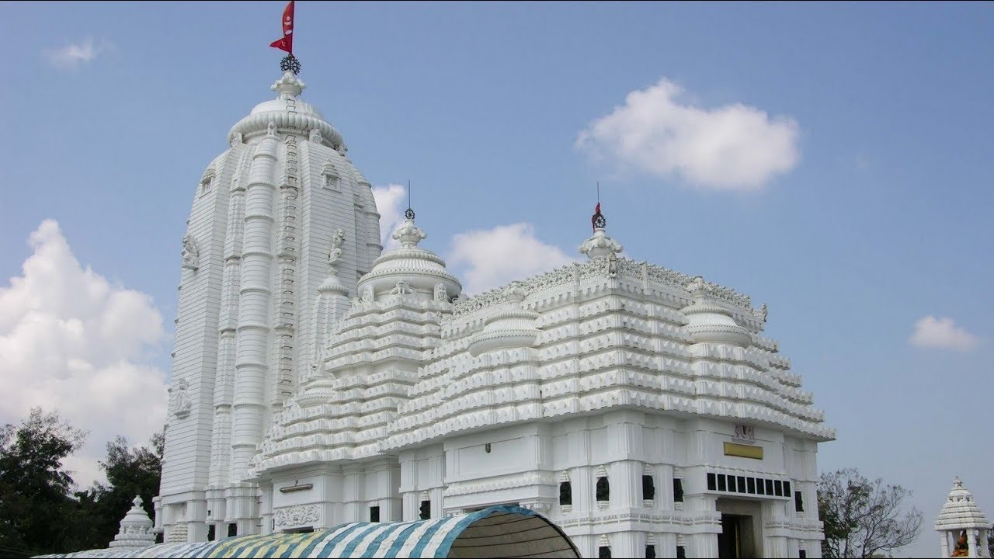
Sabar Shreekshetra means the Sreekshetra of Sabar Peoples in Odisha where a beautiful Jagannath Temple has been built at a height of 940 mts above the sea level located in Koraput town of Odisha, which permits entry to people irrespective of their religion, caste and creed.
Raisil
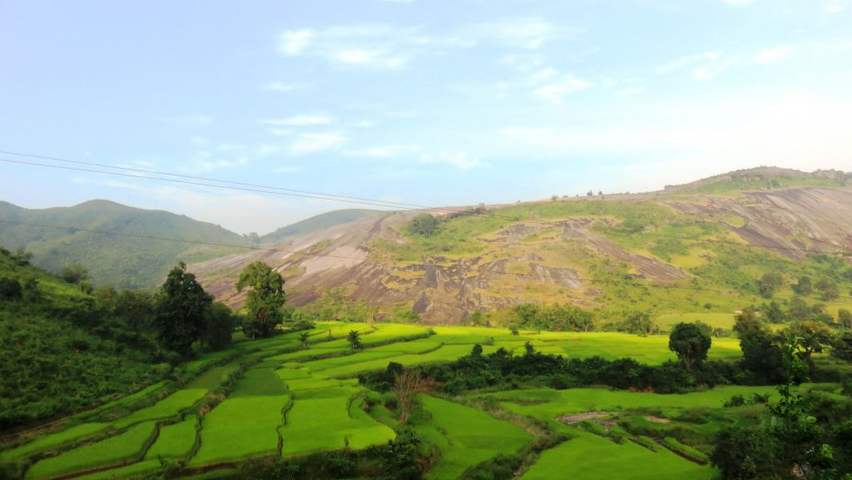
This place in Koraput is ideal for trekking surrounded by natural scenery. “Anla Navami” is celebrated every year with huge colorful gatherings.
Maliguda
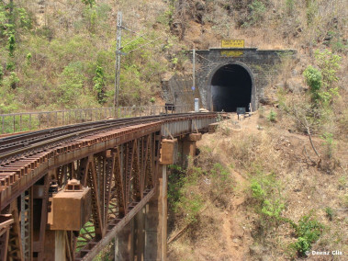
21 Kms eastwards of Jeypore and 43 Kms away from Koraput is a small village where on a hilltop stands India's highest broad gauge railway tunnel. The place is ideal for a weekend picnic.
How to reach Koraput
By Air
Koraput is not well connected to other major cities of the country via regular flights. The nearest Airport is in Visakhapatnam at a distance of 130 kms.
By Rail
There are no regular trains to Koraput from other major cities of the country. The nearest Railway station is at Jagdalpur which is located at a distance of 82 kms.
By Road
You can easily get regular buses to Koraput from other major cities in the country.
Best Time to Visit Koraput
Koraput Weather in June-November: An excellent season to visit Koraput, the average temperature falls around 26°C. The weather is great for outdoors, the air being moderately humid. This is most likely one of the best times to visit Koraput and also a tourist high season.
Weather of Koraput
The Koraput lies on 874m above sea level The climate is tropical in Koraput. This climate is considered to be Aw according to the Köppen-Geiger climate classification. The average annual temperature is 23.1°C in Koraput. The rainfall here averages 1604 mm.

