About Malkangiri
Planning a Trip to Malkangiri? Here's our list of 5 top Tourist Places to visit in Malkangiri
On the 2nd of Oct, 1992, Malkangiri was announced as a separate district. Before that, it was a part of the Koraput district. It's the Malkangiri town which is also the District headquarter. Now this district has become a new home for the refugees coming from Bangladesh. These people were rehabilitated during 1965 when the Dandakaranya Project was commenced. There are some amazing locations located in this district like Balimela Dam, Bonda Ghati or the abode of the Bonda tribe and Satiguda Dam. The Bonda tribe is often considered as the most vulnerable tribe in this country. Malkangiri is also having a power generation station right at Balimela. It's the corridor road for Vijaywada-Ranchi will also pass through this district.
Top 5 Places to Visit in Malkangiri
Balimela
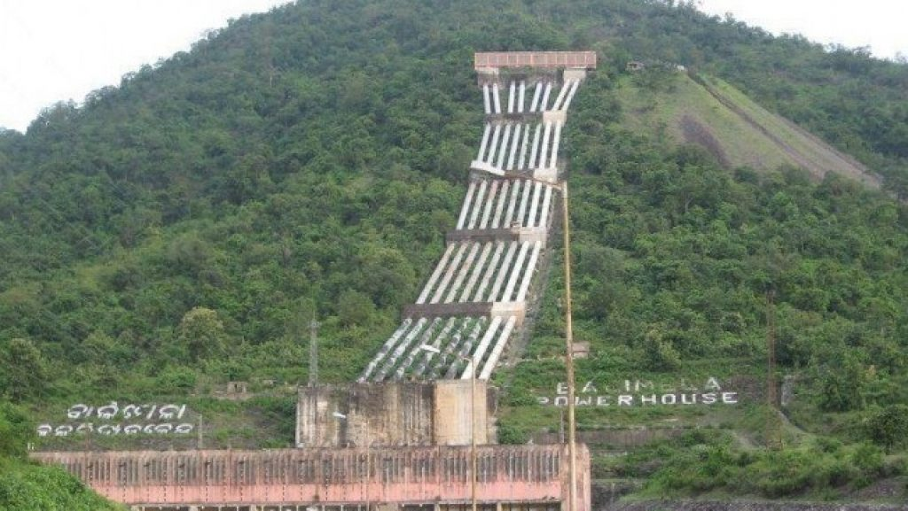
Balimela Dam is in Malkangiri District, which is 35 km, from the east of Malkangiri. A Hydro-electric Project has been established near about the Town jointly by the Government of Odisha and Andhra Pradesh. A dam is being constructed at Chitrakonda, 25 km. from Balimela across the river Sileru. The total inflow into the reservoir is shared equally by the two Governments. The share of the Andhara Pradesh Government has flowed downstream the river while that of Odisha Government is diverted to a high head power some 15 km. south of Balimela.
Ammakunda
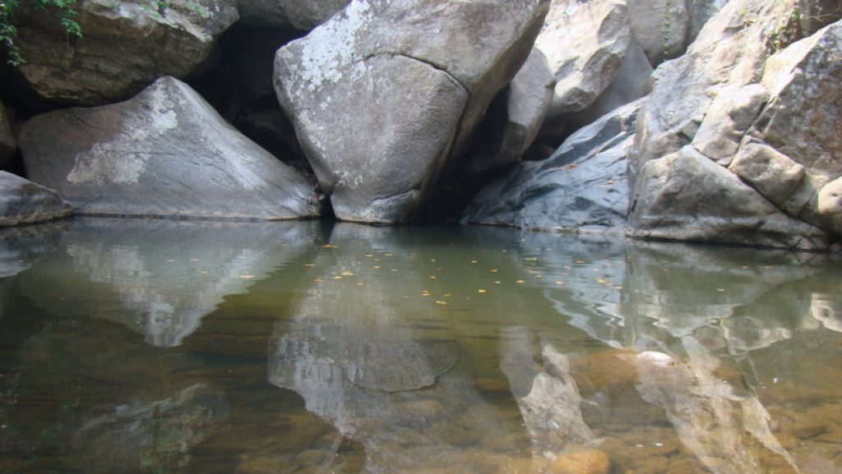
Ammakunda is one of the tourist places in Malkangiri district. It is situated at Khoirput Block near about 70 km from the district headquarter. This cool place embraces a natural waterfall and subsequent flow of water forming a narrow gorge. The fishes found in that gorge are quite friendly to the human being and are believed to be the form of Lord Vishnu in “Matsya Avatar”.
Satiguda Dam
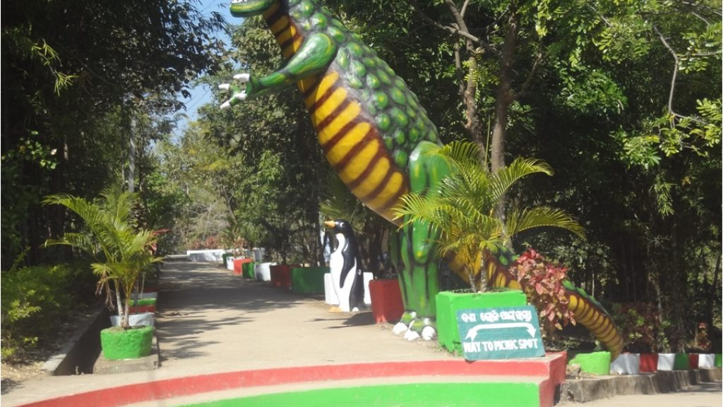
Satiguda Dam is situated at a distance of 8 km. from Malkangiri Town. The Reservoir provides irrigation facilities to the nearby cultivable land throughout the year. The natural beauty of the Dam can be enjoyed in the early morning and evening hours. Boating facility is also available inside the Reservoir, which attracts visitors as well as the local people. Lord Shiva is being worshiped inside a cave near the Dam.
Bhairavi Temple
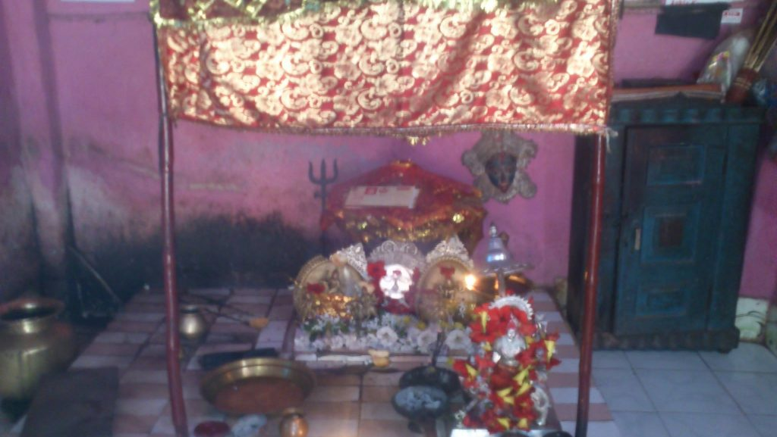
Bhairavi Temple is situated at a distance of 3 km. from Malkangiri Town. The hill deity of Malkangiri is worshiped by the people coming from Jeypore and People leaving Malkangiri for their safe journey. A number of religious visitors are attracted to this temple to worship throughout the day. The deity is believed to be worshiped by the King of Malkangiri whose castles remnants are still found on the Raja Rani Hill just in front of Bhairavi temple.
Manyamkonda
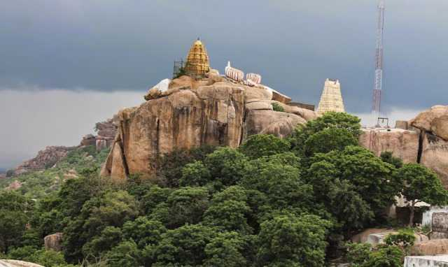
Under the Kalimela block of Malkangiri district, the Manyamkonda is located. From the District headquarter of Malkangiri, this place is located at a distance of 90 km. in this district, the Manyamkonda is considered as a religious place where the Lord Mahaprabhu is worshiped. During March and April months, a huge festival is celebrated at this place.
How to reach Malkangiri
By Air
There are no regular flights from other major cities of the country to Malkangiri. The nearest Airport is Rajahmundry Airport.
By Rail
Malkangiri does not have a Railway Station. The nearest option is Topokal.
By Road
You can easily get regular buses to Malkangiri from other major cities of the country.
Best Time to Visit Malkangiri
Malkangiri Weather in June-November: An excellent season to visit Malkangiri, the average temperature falls around 26°C. The weather is great for outdoors, the air being moderately humid. This is most likely one of the best times to visit Malkangiri and also a tourist high season.
Weather of Malkangiri
The South Eastern Ghat occupies almost the entire Malkangiri district. It is characterized by a warm climate with a maximum temperature of 34°C and a minimum temperature of 13°C.

