About Nabrangpur
Planning a Trip to Nabrangpur? Here's our list of 6 top Tourist Places to visit in Nabrangpur
Nabarangpur, also known as Nabarangapur or Nowrangpur, is a town and a municipality in Nabarangapur district in the Indian state of Odisha. It is the headquarters of the Nabarangpur district. Nabarangpur district is situated at 19.2281° North and 82.5470° East at an average.
Nabarangpur is located at an elevation of 572m from the sea level. It comprises of an area around 5294.5 sq km. at the north side Kalahandi bordering this district and at the west side Jagdalpur of Chhattisgarh. On the east side, Rayagada and at the south Koraput are bordering this district. It's the Indravati River that forms a border between Koraput and Nabarangpur districts.
Top Attractions in Nabrangpur
Podagada
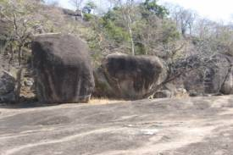
Remains of Ancient Nala Dynasty, situated at 11 KM From Umerkote. Podagada is a place nearer to Umerkote was the capital of the ancient Nala Dynasty. The hill ranges of Podagada infested with deep forest preserves the remains of the ruling dynasties. Their caves, usable, inscriptions and habitable rock structures indicate that before the invasion of Mughals the place was ruled by the Nalas and the Bhakatakas After that Buddhists lived here for a longer period of time.
Chandan Dhara
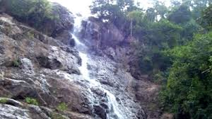
Chandan Dhara is a natural waterfall situated in Jharigam Block 90 KM away from Nabarangpur. The place is also remarkable for a natural Shiva Lingam. Chandan Dhara is an ideal location for outings and picnic.
Papadahandi
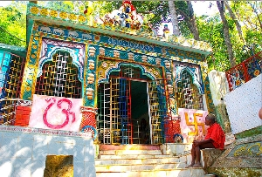
From the district headquarter, the Papadahandi is located at a distance of 12 km. this place is popular for its Shaiva Shrine as well as the Sahid Stamba. During Kartika Purnima, Shiva Ratri as well as Shravana Purnima like occasions, many devotees use to come here.
The Shahid Smruti Stambha
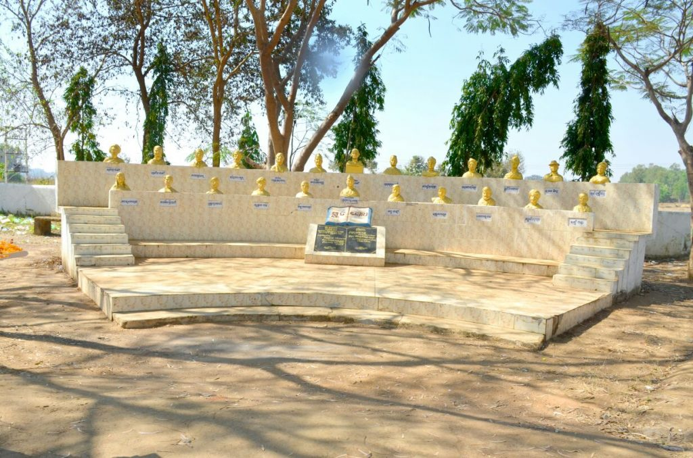
It's the River Tuni's bank where The Shahid Smruti Stambha is located. It is also close to Papadahandi. On 24th Aug 1942, nineteen freedom fighters have died at this place while fighting against the British Soldiers. It was the time when the Quit India Movement was in full flow. Madhab Pradhan was the leader of those nineteen freedom fighters. To memorize those great freedom fighters and their sacrifices for the country, The Shahid Smruti Stambha was built over here. Each year on 24th Aug, the Shahid Divas is observed here.
Maa Bhandargharani
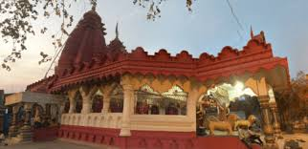
It's the Maa Bhandargharani who is also known as presiding deity at the Nabarangpur district. This goddess is believed as the preserver of wealth and also the protector of human lives. Due to this reason, she is also worshiped at the villages of this district.
Hirli Dangar
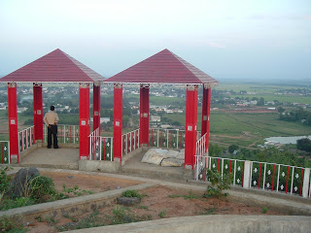
At the Nabarangpur town, the Hirli Dangar is located right at Gandhinagar. This place is where the ancient statue of God Tirupati is located as well as worshiped. Close to this place, the Kusumjhar reserve is located. This part of the district is famous for its amazing natural beauty and has developed as a prominent picnic spot over time.
How to reach Nabrangpur
By Air
No direct connectivity to flight between Bhubaneswar and Nabarangapur is available. The nearest Airport is Visakhapatnam, 280 km. Bhubaneswar is at 580 km distance and Raipur is at 320 km distance.
By Rail
No direct train between Bhubaneswar and Nabarangapur is available. The nearest Railway Station is Jeypore at 40 km, Koraput at 66 km distance and Kesinga at 170 km distance.
By Road
You can visit Nabrangpur through Bhubaneswar, Visakhapatnam or Raipur on road.
Best Time to Visit Nabrangpur
Best time to visit Nabrangpur is winter season, October to March is the perfect time to visit all the places.
Weather of Nabrangpur
The Nabarangapur lies at 582m above sea level The climate is tropical in Nabarangapur. In winter, there is much less rainfall in Nabarangapur than in summer. According to Köppen and Geiger, this climate is classified as Aw. The average annual temperature is 24.8°C in Nabarangapur. The rainfall here averages 1461 mm.

