About Nayagarh
Planning a Trip to Nayagarh? Here's our list of 17 top Tourist Places to visit in Nayagarh
Nayagarh district is one of the 30 districts of Odisha State in eastern India. It was created in 1992 when the erstwhile Puri District was split into three distinct districts, namely Khurdha, Nayagarh and Puri. It is home to the Baisipali Wildlife Sanctuary. It is like a Hill station, so far as natural scenery is concerned. Chhena Poda is the favorite sweet for which Nayagarh is famous in Odisha.
From the history of Nayagarh District, it reveals that the District was founded by Suryamani of Baghela dynasty who had come to Puri on a pilgrimage from ‘Rewa’ of Madhya Pradesh. He had built his fort here and adopted Tiger Head as a state symbol. Ninth king of this dynasty ‘Bagel Singh’(1480–1510) shifted his capital to the District. As per his name, this place was known as ‘Baghua Nayagarh’. He was a Vaishnavite and is known to have made small icons of Shree Vigraha Chaturdha Murty and installed the deities in a mudaltar on the foothill of Balarama for the first time in the history of Nayagarh District.
Top 17 Places to Visit in Nayagarh
Udayapur Library
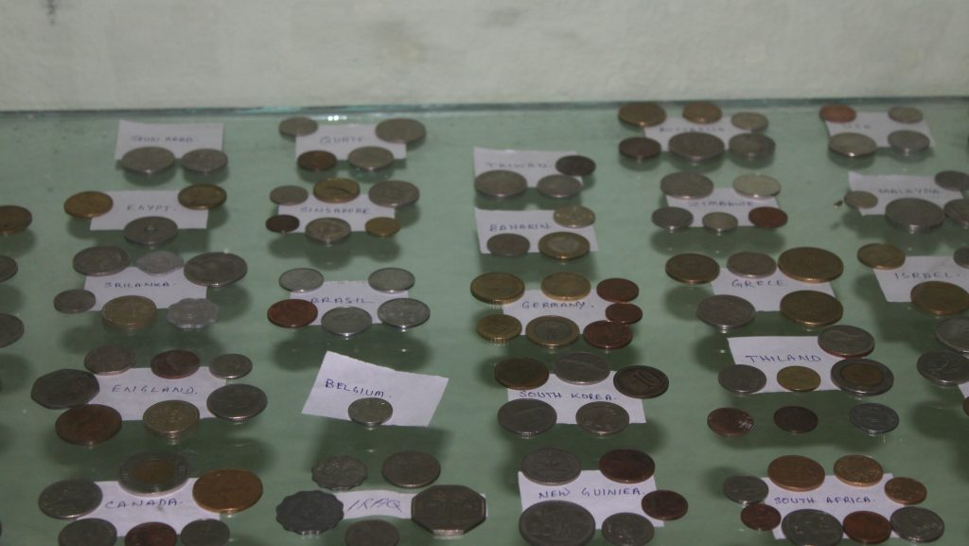
The Banchhanidhi Pathagara, Sri Aurobinda Sangrahalaya and the Jadumani Sahitya Sansada, established by the late Dasarathi Pattnaik(known as Dasia Aja) in a non descript village Udayapur, in culturally rich district of Nayagarh, is a center for pilgrimage for the lovers of literature and culture. Scholars of repute across the world visited this institution. There are 50, 0000 books in different languages and dictionaries in 30 languages. The magazine collection has a rich collection of 65,000 magazines. The museum has 42 sections and has a collection of rare Sculptures, Minerals, Arts, Crafts, Amours, Coins and Postal Stamps etc.
Ranapur
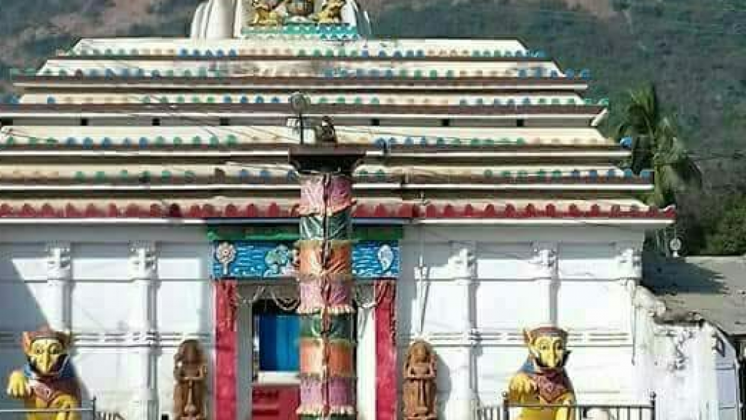
Ranapur situated at a distance of 28 km from Nayagarh, holds special with historical heritage. The place offers numerous pleasant gateways to tourists. The splendid Temple of goddess Maninag atop the Mainak hill is famous as a living Shakti-peeth. Besides, Ranapur also has many other popular shrines like Asurakumari Temple near a scenic waterfall and the Jagannath Temple which is flocked by many devotees during Rathyatra.
Panchupaili Pragana
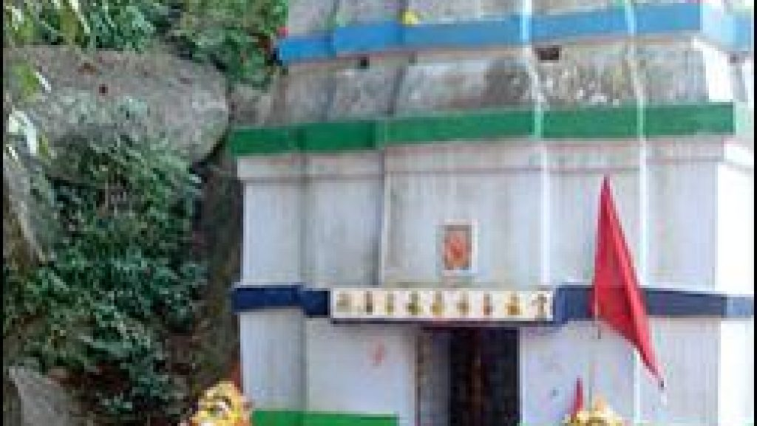
Located about 55kms from Nayagarh, Panchupaili Pargana is an enchanting destination with serenity nestled amidst natures tranquility. The meeting place of River Mahanadi and River Brutang, this piece unfolds the picturesque shrines of Sri Gupteswar Mahadev, Sri Sri Navagunjara Jiu and Goddess Kalapat Thakurani. Different cultural events organized here throughout the year keep the festive charm of this place intact.
Odagaon
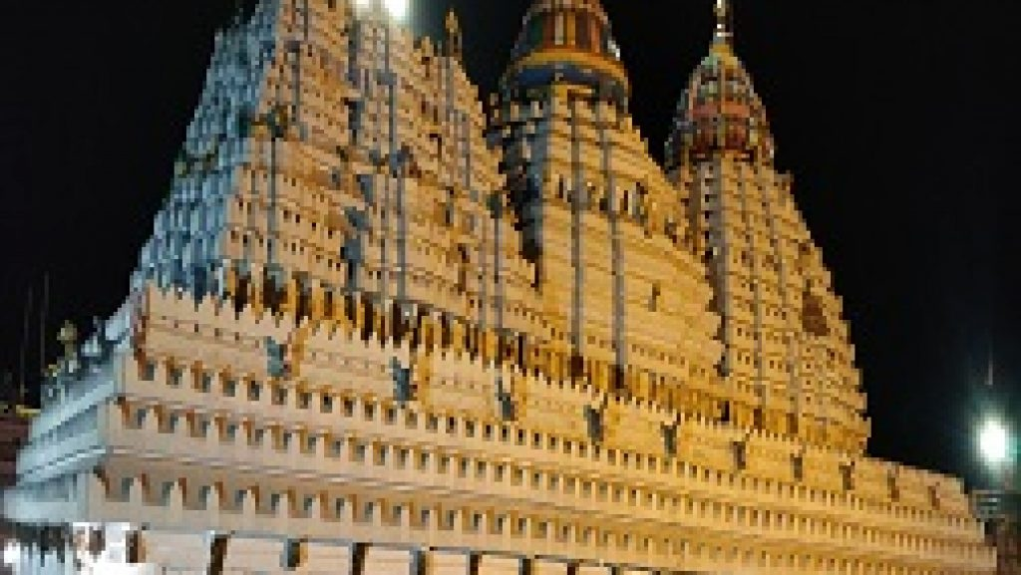
Odagaon is known for the Temple of Lord Raghunathjew. It is one of the famous temples in Odisha dedicated to Lord Ramachandra. This temple has beautiful wooden idols of Sri Raghunath, Sita and Laxman enshrined in it. The Kalash of the temple is made of pure gold. A popular legend associated with the temple states that famous poets of the 17th century, Kavisamrat Upendra Bhanja, had composed his magnum opus- Baidehisha Vilas, here at the feet of Sri Raghunath. Ramanavami is the most important festival celebrated here. Odagaon is 26 km away from Nayagrah(town).
Nayagarh
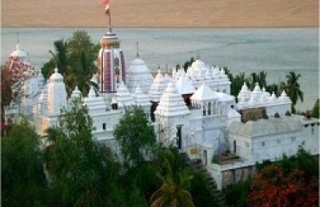
Abounding in natural beauty, Nayagarh town is also famous for many historic places and ancient temples prominent among which are the shrines of Dakshinakali, the living Shakti-peeth and Sri Jagannath Temple. Built between 1788 and 1808 AD, the Jagannath Temple here, reflects Kalingan style of architecture. The presiding deity is worshiped in the form of Dadhibamana. Nayagarh is the base from where one can conveniently travel to numerous scenic, religious and legendary places which the district is endowed with.
Kuanria
Kuanria, a picturesque getaway, about 50 km from Nayagarh, comprises of a huge reservoir flanked by blue hillocks and a 1.5 km long dam over River Kuanria. Among the top attractions is a large deer park spread over 6 acres by the river basin. The park is home to about 160 numbers of Spotted Deer, Barking Deer and Sambar.
A large number of migratory birds also flock to this reservoir during winters. The tranquil beauty of the Hills, River, Forests and the Deer Park make the place a much sought after retreat by the tourists.
Jamupatna
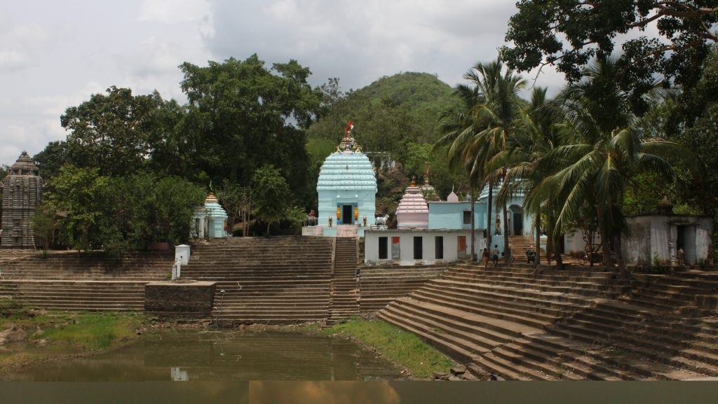
At the foot of Sulia hills, 32 km from Nayagarh stands the shrine of Sri Dutikeswar Mahadev. A centuries old Banyan Tree popularly known as kalpabata stands magnanimously in front of the temple adjoining a pond. Temples dedicated to Goddess Bana Durga, the Sun God and Astabhuja(eight armed Goddess Durga) are found within the temple complex.
Gokulananda Temple
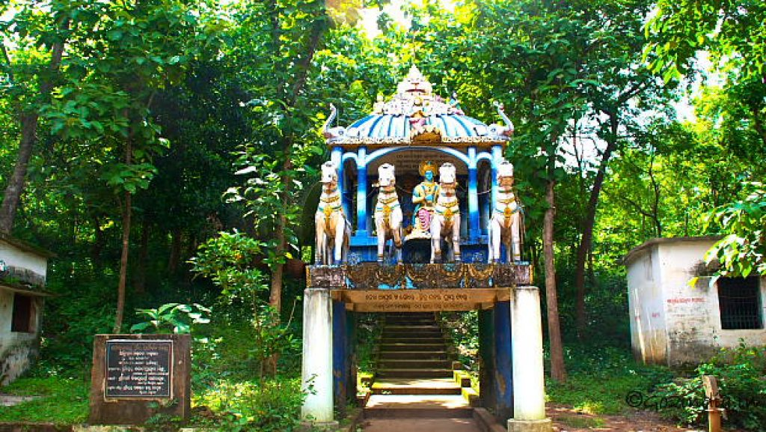
It is situated near Sidhamula village, Sidhamula Grampanchayat in Khandapara Block. The temple of Gokulananda is situated on top of a hill on the bank of river Mahanadi. It is founded by late Sri Baba Swami Ram Laxman Dash Maharaja. It is nice to watch the panoramic view of the hill and flowing water of Mahanadi from the hill as well as from the Sidhamula bridge. The hill is full of tall trees and medicinal plants.
Kuturi
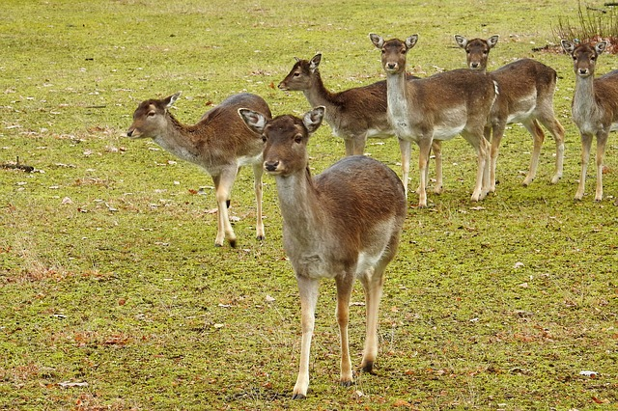
Kuturi is located under Mahanadi Wildlife Sanctuary. This is also the home for Habitat Development Center. This is the center where they facilitate the natural breeding programs for different wild animals. This area comprises of the pond, Napier grass, salt lake as well as an orchard where you can see the medicinal plants and indigenous decorative plants. Here, you can also access the cottages and the watchtowers that are constructed to offer you a great view of the spot.
Baramul
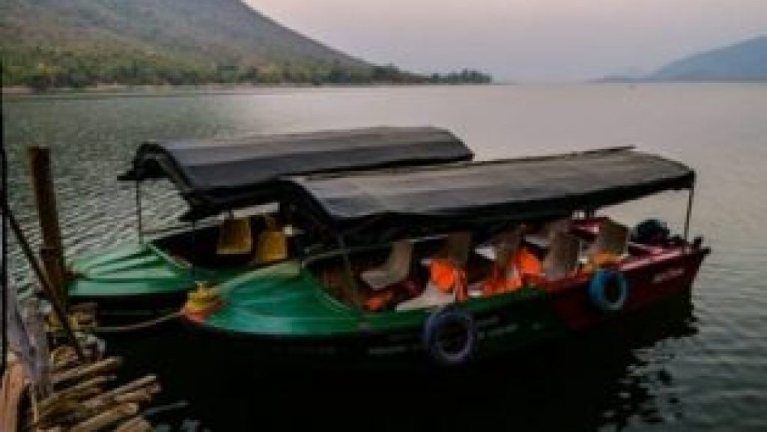
This small village is prominent due to the magnificent Mahanadi gorge on the banks of which it is situated. From Sunakania hills up to Barmul, the course of the river is known as the Satakosia Ganda(Gorge), having a water spread of about 22 km. Barnaul, 110 km from Bhubaneswar, is an ideal place for an outing. Satakosia Gorge is a biological refuge and is considered as an important biographical stepping stone in the link between forest species of Central and South India. Satkosia has significant gangetic and ecological importance as is the wet portion of the Decan Zone. It is famous for its unique gorge ecosystem and for being a beautiful picnic spot. Tourists can avail of medical facilities at Gania CHC which is nearest to the place.
Satokosia Gorge
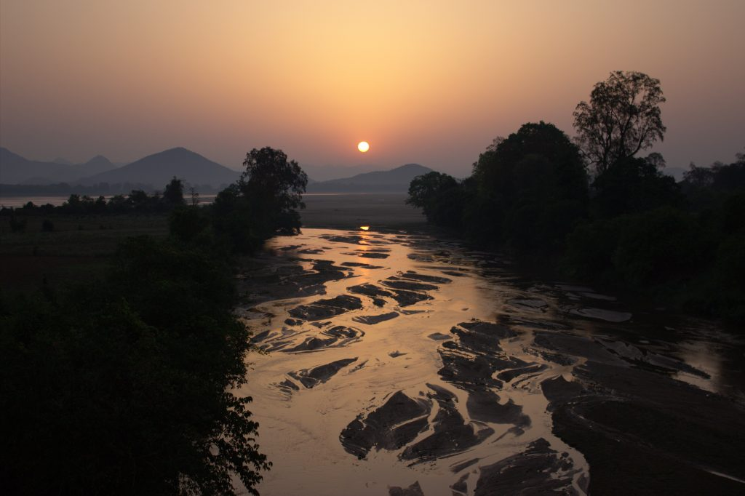
Satakosia Gorge is another most well-known place in Nayagarh and also famous in the state. The natural beauty of the place attracts many tourists from different places. The depth of the water level is very high. There is a wildlife sanctuary in Satakosia. Different types of birds and animals are seen here. The panoramic view of the place is really amazing.
Sarankul
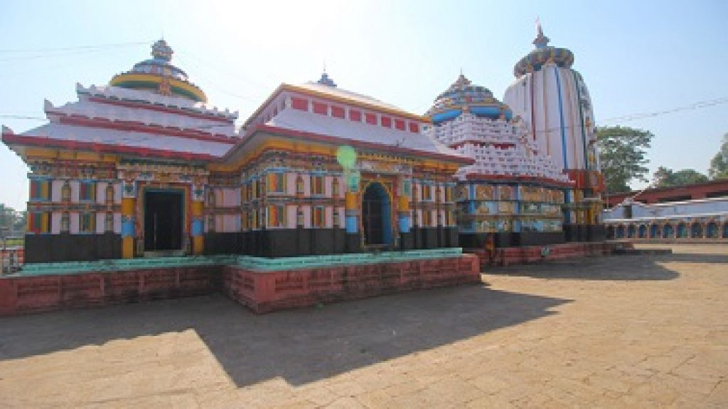
Sarankul stands proud with the 15th century shrine of Sri Ladukeswar, popularly known as Ladu Baba. The presiding deity here is known to be the combined form of Hari(Vishnu) and Hara(Shiva) as is the case with Sri Lingaraj in Bhubaneswar. The festivals and rituals of Sri Ladukeswar are also similar to that of the Lingaraj temple.
Dasapalla
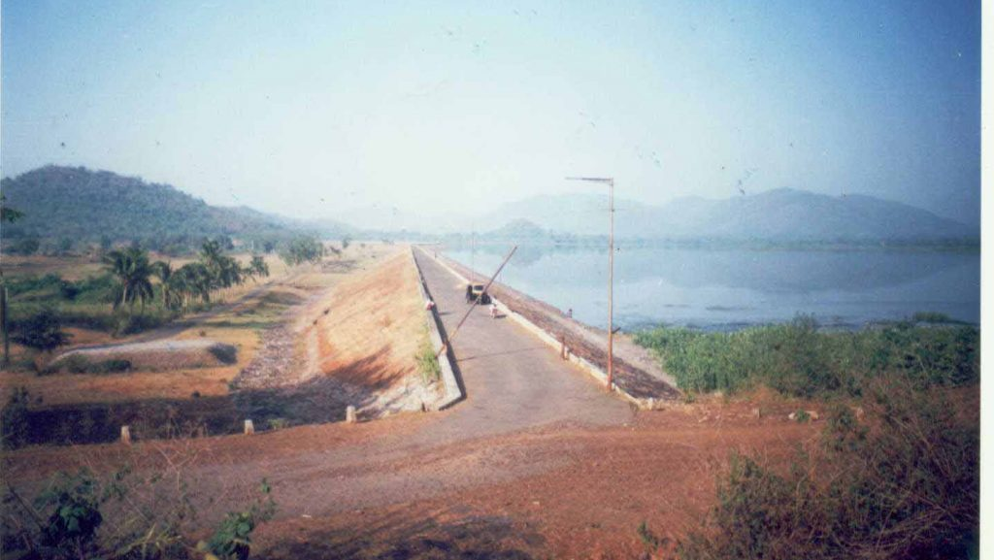
Dasapalla is famous for its Jungles, Animals and Trees. Here the Government has constructed a water project named Kuanria Dam. It is one of the most interesting picnic spots. A deer park close to Kuanria is another attraction. Dasapalla is famous for Mahabir Temple. The Lankapodi festival is observed here.
Kantilo Nilamadhab
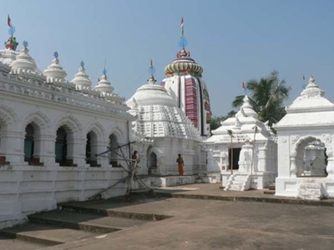
Kantilo Nilamadhab temple is very popular across Odisha. This is where Lord Vishnu is worshiped. Right at the bank of River Mahanadi is Kantilo, this temple is located. Here, there are two hills that are covered with dense forests are located. The prime highlight of this place is the holy water that uses to flow constantly from the feet of Lord Siddheswar and Lord Nilamadhava. However, the central position is always offered to Lord Nilamadahava at this cult that belongs to Lord Jagannath. The shrine of Lord Nilamadhava is still located at the right side of the Laxshmi temple which is located at the Puri Jagannath temple.
It's the Kantilo Nilamadhaba temple which is an ancient temple and it is also famous as a Vaishnav Temple.
Baisipalli Wildlife Sanctuary

On the 6th May 1981, the Baisipalli Wildlife Sanctuary was announced. This wildlife sanctuary is also located close to the Satkosia Gorge Wildlife Sanctuary. This sanctuary is spreading over an area around 168.5 sq km. this wildlife sanctuary is the home for some amazing wild animals like Elephants, Bears, Leopards, Spotted Deer and Sambar Deer.
Dakhinakali
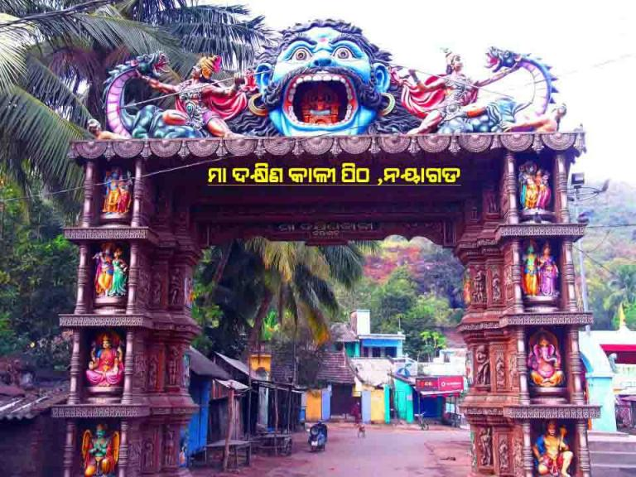
There are two steep hilly ranges where the Dakhinakali is located. This place is known for its natural beauty. In Nayagarh town the Dakhinakali shrine is located and it is considered as the living Shakti-Pitha.
Ladubaba Temple
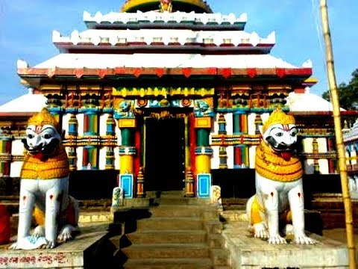
Ladukeswar Temple, popularly known as Ladubaba is a famous temple of Nayagarh and is also popular in other places of Odisha. As this is a temple of Lord Shiva, thousands of people gather here during Shivratri Festival.
How to reach Nayagarh
By Air
The nearest Airport is Biju Pattnaik International Airport, Bhubaneswar.
By Rail
Nearest Railway Station is Nayagarh Town Railway Station-(3 Kms), Khordha Road Railway Station-(69 km) away.
By Road
Tourists can reach Nayagarh by choosing the state highway NH-57.
Best Time to Visit Nayagarh
Best time to visit Nayagarh is winter season. October to March is the perfect time to visit all the places.
Weather of Nayagarh
Nayagarh is characterized by a warm climate with a maximum temperature of 40°C and a minimum temperature of 11°C.

