About Nuapada
Planning a Trip to Nuapada? Here's our list of 8 top Tourist Places to visit in Nuapada
Nuapada is a city in the western region of Odisha state of eastern India. It is the headquarters of Nuapada district. Nuapada district was carved out of the undivided Kalahandi district on 27th March 1993. Situated on the western border of Odisha with Chhattisgarh. The district is part of Odisha both linguistically and culturally.
Nuapada was a part of Kalahandi District until early March 1993, but for administrative convenience, Kalahandi District was divided into two parts — Kalahandi and Nuapada. Nuapada District now comprises one sub-division Nuapada, five Tahsils(Nuapada, Komana, Khariar, Sinapalli and Boden) and five community development blocks(Khariar, Sinapalli, Boden, Nuapada and Komna).
Top 8 Places to Visit in Nuapada
Sunabeda Wildlife Sanctuary
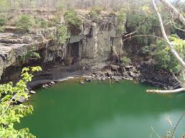
Close to Patora is Sunabeda Wildlife sanctuary. A waterfall called Godhosh about 63 meters amidst dense forest enhances the scenic view of the place. It is only 40 km. from Komna Block headquarter. Sunabeda, a Gram Panchayat is situated at a distance of 40 KM. from Komna Block headquarters. The goddess Sunadei presiding deity of the plateau is sacredly worshiped by the people of the area on the day of Dussehra.
Saliha
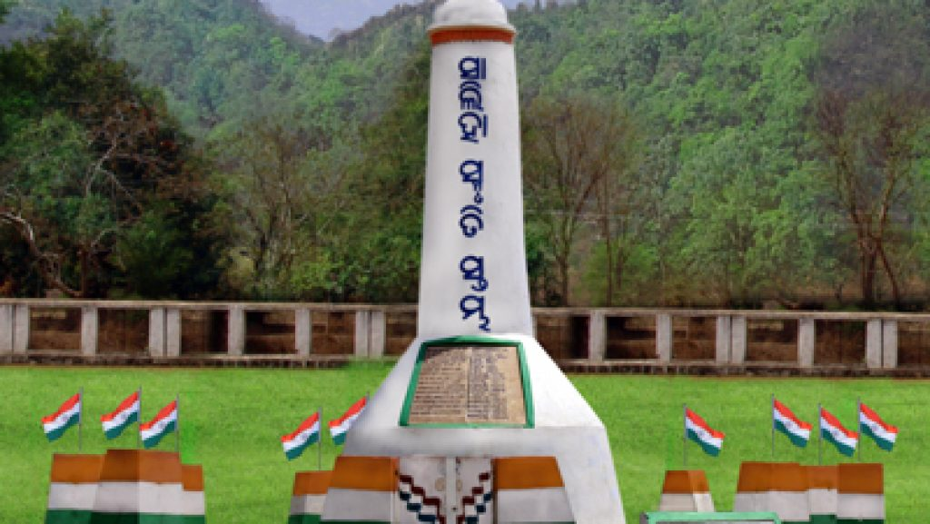
Popularly known as Salihagargh this is a place where the people of Khariar estate united on 30th September 1930 and protested against the taxation on the tenants of the Estate. To commemorate the same a freedom fighters pillar constructed.
Upkaganga
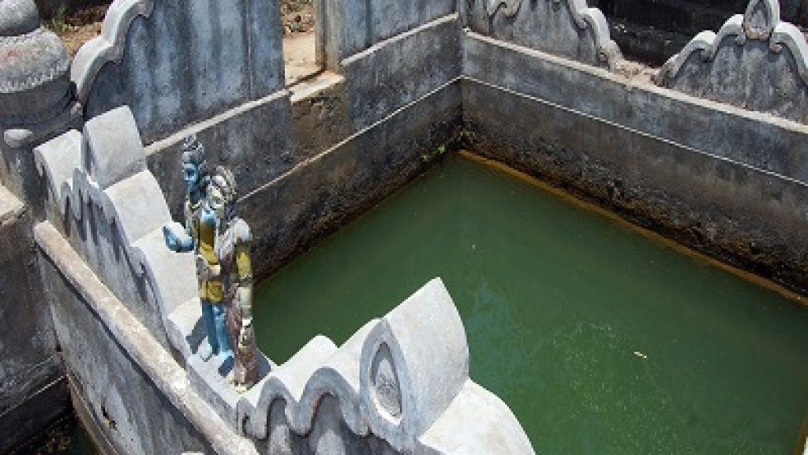
Upkaganga is situated amidst Sunabeda River forest beside two hillocks named Guru Dongor and Pati Dongor Water in 3 separate flows from the earth at a place that seems alike stream in the local language. Water coming from the earth like the stream is called upka accordingly the place is named Upkaganga. The deity Lord Shiva and Jagannath worshiped by the local people.
Patalganga
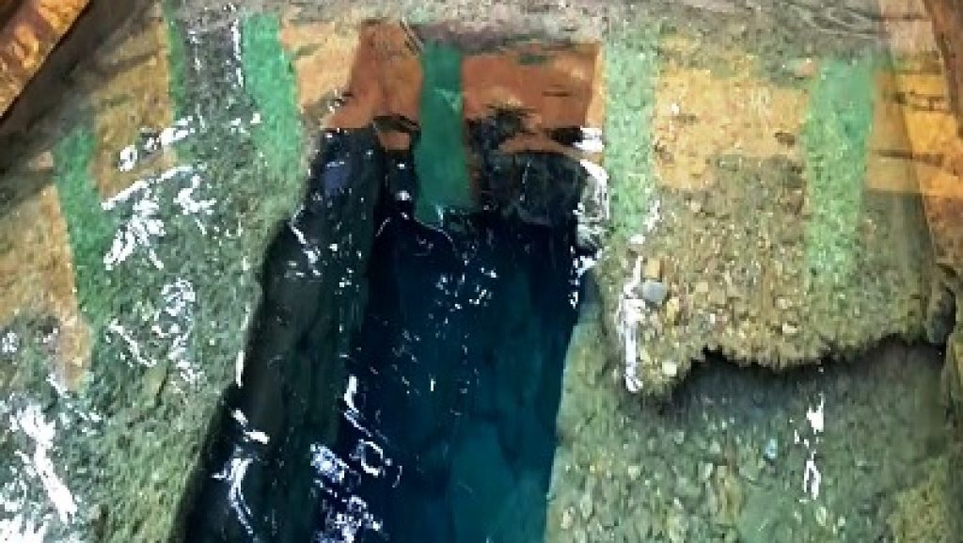
It is a nice spot in the bosom of nature with a perennial spring, the water of which is considered as sacred as that of the holy Ganges. Local people perform their obsequies in the downstream. Legend would have it that Rama, Laxman and Sita visited the spot during their exile where Sita felt thirsty. Laxman pierced the ground with his arrow occasioning the birth of the spring. On the day of the solar eclipse and lunar eclipse. People here gather in large numbers to take their bath in the holy water.
Patora

On the bank of the river, Jonk is a place of uncommon scenic charms. Engirdled on all sides by green-clad hills. It holds in its bosom and irrigation project and culture dating back to the pre-Christian era at Manikgarh. This is the Dam site of the Upper Jonk Irrigation Project situated at a distance of 20Km from the Dist Headquarter. This place is also famous for Yogeswar Temple.
Pataleswar Temple, Budhikomna
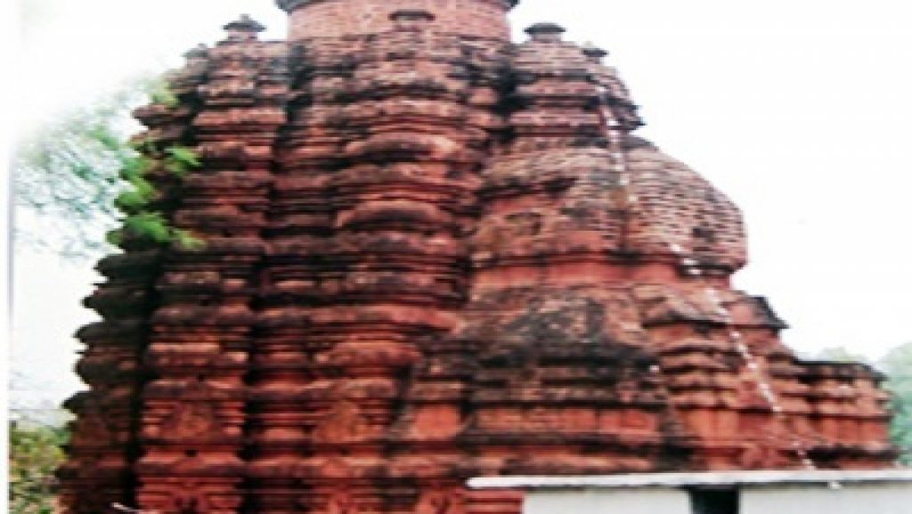
Budhikomna houses the famous temple of Pataleswar made of bricks in Pancha Ratha style unique in the state. A connoisseur of art and architecture finds immense pleasure in observing the different facets of this place. It is also a popular pilgrim center in the locality.
Debagiri
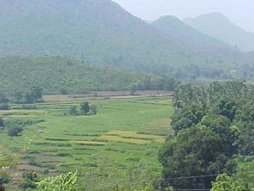
The Devagiri hill rises to a height of 120.2 meters. Unlike other hills, it is not narrower upwards. The top of the hill is a flat platform of a rectangular plan, which can be approached only from the northern side. There are 476 steps which are the unique feature of the Debagiri. At the top of the hill, there are perennial poles of water called Ganga, Yamuna, Saraswati, Bhargavi and Indradyumna.
Rajib Udyan
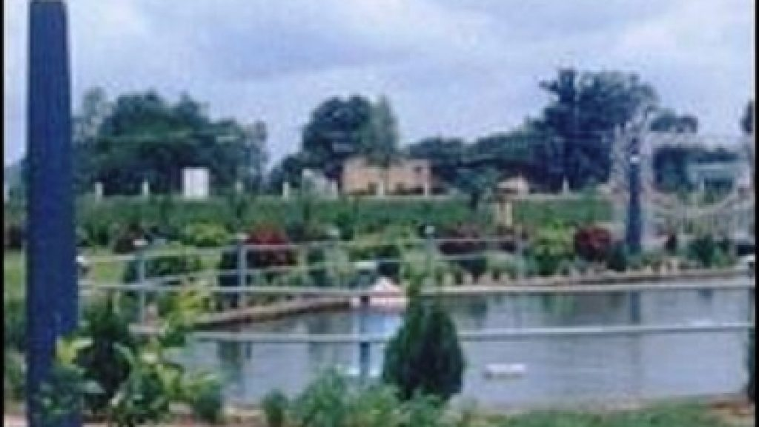
On the left of the dam down the slopes of hill sprawls a replica of the Brundaban Garden. Recline on the velvety grass and enjoy nature in its aesthetic form. Just below the dam, a flora fountain in the making.
How to reach Nuapada
By Air
Raipur(Chhattisgarh) is the nearest Airport which is 182 KMs from tourist place.
By Rail
For all trains Khariar Road is the suitable station to board & only for a passenger train , Nuapada is a suitable station. Its distance from Khariar Road is 72Kms.
By Road
District Headquarters, Nuapada to Krishna Chowk(32 KMs) & then Proceed to Sunabeda(27 KMs).
Best Time to Visit Nuapada
The best time to visit Nuapada are from October to March.
Weather of Nuapada
The Nuapada lies at 7m above sea level The climate here is tropical. The summers are much rainier than the winters in Nuapada. According to Köppen and Geiger, this climate is classified as Aw. The temperature here averages 26.9°C.

