A major port of Odisha , Paradeep is a major seaport town and a designated municipality area in Jagatsinghpur district of Odisha, India. On the confluence of the river Mahanadi and the Bay of Bengal, Paradeep is a beautiful beach. The beach is famous for its clear Blue Water, Green Forest, Stones along side the Beach, a good Marine Drive and the biggest Port.
About Paradeep
Paradeep is one of the most serene and tranquil beaches of Odisha. Boasting of golden shimmering sands, indigo blue waters and lined with huge rock boulders, the beach is not a prominent tourist spot but also a major sea port of the country.
Paradeep Port is a major seaport in Odisha, which is considered to be one of the largest ports on the eastern coast of India. During 2009 - 2010, this port recorded the handling of over 57 million tonnes of cargo, including Thermal Coal and Iron Ore.
It is also the chief sea-borne trade center in the Bay of Bengal, whose foundation stone was laid in 1962 by the then Prime Minister of India, Pandit Jawaharlal Nehru.
Paradeep Port has also been specially mechanised with iron ore berths, cargo berths, container handling facilities and coal handling plants. Close to the port lies the Paradeep Beach at the convergence of the Mahanadi River and the Bay of Bengal.
Top Attractions in Paradeep
Paradeep Port
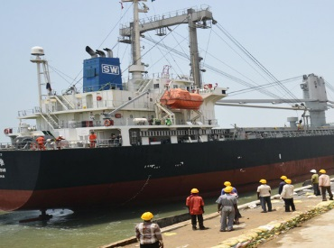
Built in the year 1960, Paradeep Port has become a very important international sea port of the country owing as it receives several direct foreign investments. Initially the area around the sea port was a marshy swampy land originally used by fisher folks for fishing and collecting firewood. Lately, the government of India has planned to make this magnanimous port even bigger to accommodate more trade and commerce.
Light House
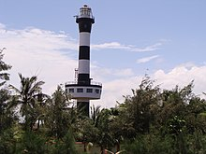
A towering light house is also situated on the beach which has been constructed to keep a watch and for other surveillance purposes. However, the tower allows tourist to come have a look from the inside. The light house opens only from 5:00 PM - 5:30 PM. Make sure you plan your trip accordingly so you don't miss out on the splendid aerial view of the beach and the nearby villages.
Paradeep Marine Aquarium
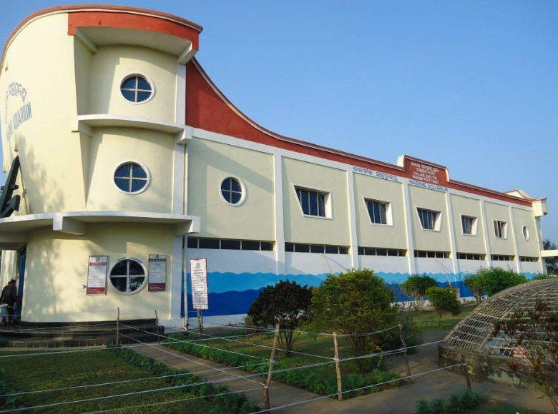
Paradeep Marine Aquarium houses an astonishing collection of vibrantly colourful fish. The in-house museum boasts of 28 splendid tanks with vast varieties of fresh water and marine species of fish and other aquatic animals.
Smruti Udyan
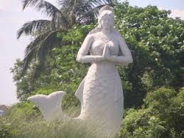
Smruti Udyan is a monumental place of respect in Paradeep which has been dedicated to the lives of thousands of people who died during the massive cyclone of 1999 that hit Odisha. The musical fountain at the Udyan play sentimental music to pay respect to the lost souls. The lush green garden at the front blooms with vibrant flowers ideal to spend an evening.
Jagannath Temple
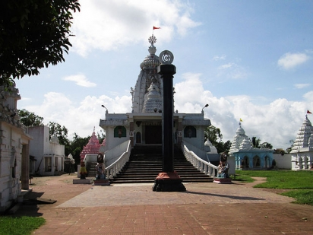
Jagannath Temple is only called a temple otherwise it is the most secular spot one can see anywhere in the world. The 60-feet pillar called the Aruna Stambh is constructed at the entrance of the Mandir.
Nehru Bungalow
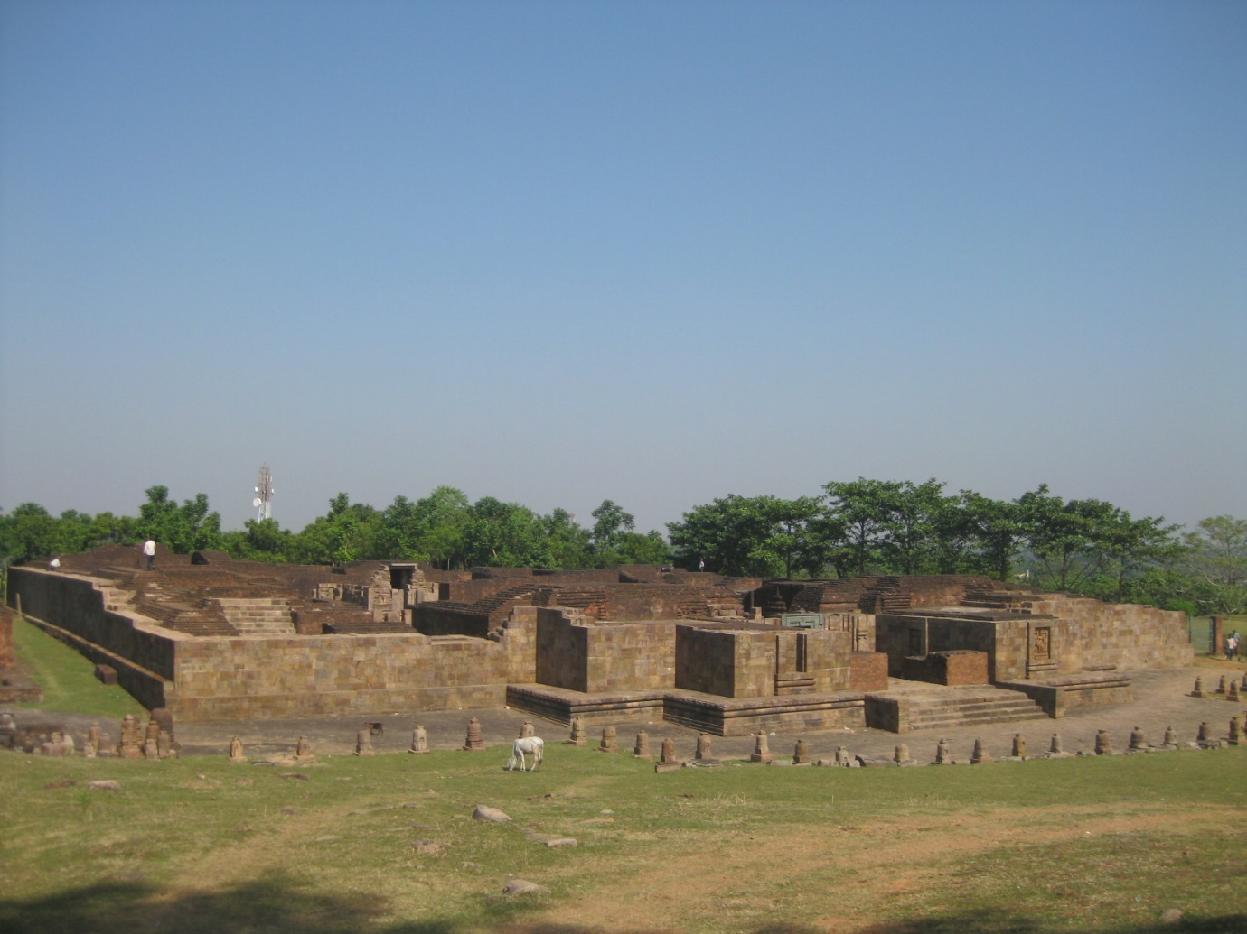
Located at a short distance of 12 kms from the Paradeep Beach, Nehru Bungalow is just the guest house where the first Prime Minister of India Pandit Jawaharlal Nehru stayed at when he came to inaugurate the Paradeep Port. The guest house has now also been converted into a Tourism spot for people who want to go have a look.
Hanuman Temple
Hanuman Temple is yet another prominent attraction in Paradeep. Dedicated to Lord Hanuman, the tiny mandir invites pilgrims from the all over the city to pay homage. Tuesdays are the most crowded days of the week at the temple.
How to Reach Paradeep
By Air
Bhubaneswar is the nearest Airport to reach Paradeep. Bhubaneswar is three hour drive from Paradeep. The Airport has regular Domestic and International Flights to many major cities like Delhi, Kolkata, Bangalore, Chennai, Hyderabad and Mumbai.
By Rail
The nearest Railway Station is Cuttack, which is connected to the major cities of Odisha and is 82 kms from the town. It is linked with the cities like New Delhi, Cuttack, Bhubaneswar, Mysore, Lucknow, Chennai, Kanyakumari, Puri and Ahmedabad.
By Road
Paradeeo is 14 kms from Jadupur, 24 Kms from Silipur, 33 kms from Mahakalparaha, 71kms from Ratanpur, 83 kms from Cuttack, 105 kms from Bhubaneswar, 129 kms from Puri, 129 kms from Dhenkanal, 157 kms from Bijadiha and 193 kms from Anugul. Regular buses are available to reach Paradeep.

