About Puri
Planning a Trip to Puri? Here's our list of 16 top Tourist Places to visit in Puri
One of the four Dhams of Hinduism, Puri is the ancient city that brins with the magic of tourist places that can win hearts in a blink. It's only when one walks along with the many pilgrimages in Puri, chanting the name of Lord Jagannath, that he feels the outpour of peace in his soul.
The District of Puri has been named after its headquarters, Puri. According to Cunningham, the ancient name of this town was Charitra, mentioned by the Chinese pilgrim Hiuen Tsang as Che-li-ta-lo. But the restoration of the word Che-li-ta-lo as Charitra and its identification with the town of Puri are open to doubt. The importance of the town as a seat of Vaisnavism increased when Chodaganga Deva constructed the temple of Purusottama Jagannath and installed the images of the deities. Thereafter, it became famous as the abode of Purusottama and was popularly called Purusottama Kshetra.
In 1912, the new province of Bihar and Odisha was formed and subsequently, Odisha became a separate province in 1936. After integration with Odisha on 1st January 1948, of the feudatory states of Nayagarh, Daspalla, Khandapara and Ranapur with a total area of 3941 sq. km., a separate sub-division comprising these ex-states was added to Puri District with its headquarters at Nayagarh. The fourth sub-division of Bhubaneswar was established on 26th January 1959. The old Puri District consisted of four sub-divisions i.e. Puri Sadar, Khordha, Bhubaneswar and Nayagarh. Puri Sadar sub-division consisted of four Tahasils i.e. 1) Krushna Prasad 2) Sadar 3) Pipili and 4) Nimapara. Again by the year 1995, Puri District was divided into 3 Districts i.e.1. Nayagarh District comprising of Nayagarh sub-division. 2. Khurda District comprising of Khordha and Bhubaneswar sub-divisions. 3. Puri District comprising of Puri Sadar sub-division only.
Top 16 Places to Visit in Puri
Shree Jagannath Temple
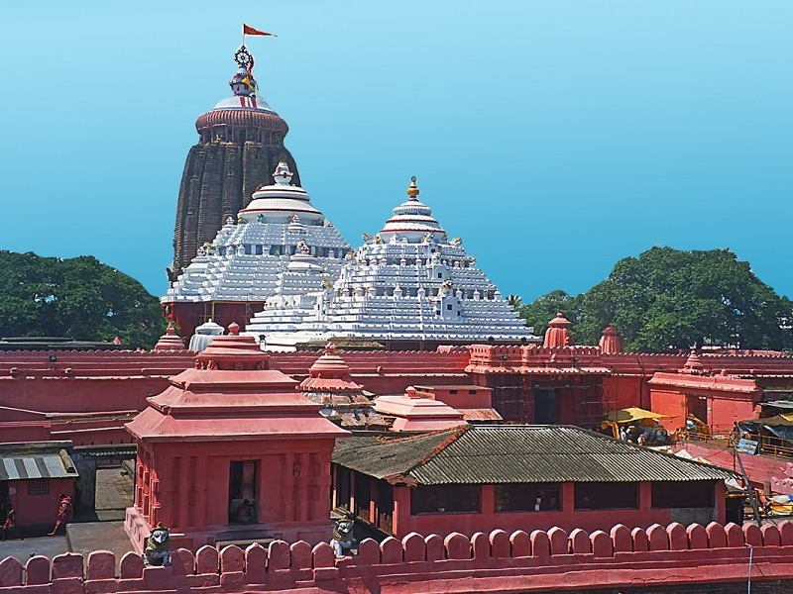
Located in the sacred town of Puri, the Jagannath Temple or the pride of India was built in the 11th century by King Indradyumna. This glorious temple is the abode of Lord Jagannath who is a form of Lord Vishnu. It is the most revered pilgrimage site for Hindus and is included in the pious Char Dham Yatra with Badrinath, Dwarka, and Rameshwaram. Apart from the main shrine that rises high, many minor temples within the complex will make you feel like you have entered God's home itself.
Gundicha Temple
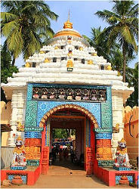
Gundicha Mandir is one of the temples closely related to the festivity of the Rath Yatra of Puri. It is a holy place where God resides for seven days during the festival. This garden is regarded as the place of Lord Jagannath's aunt.
Sakshi Gopal
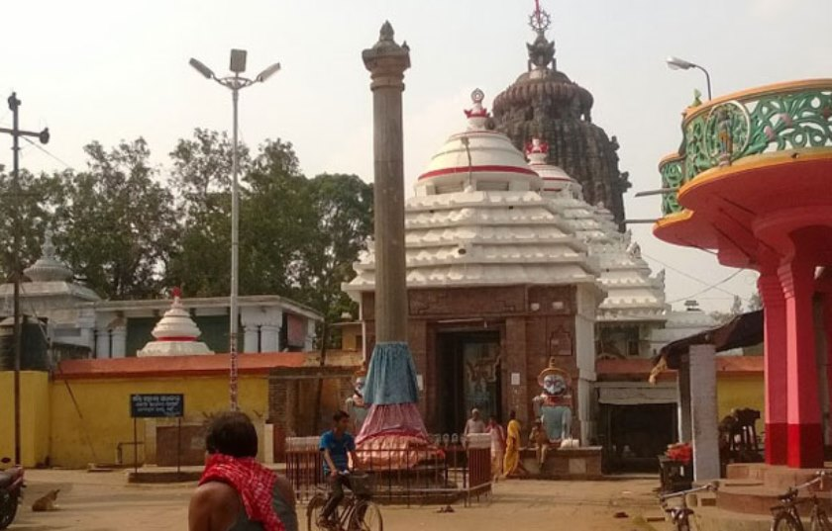
Sakshi Gopal(literal meaning, the witness lord) is a place 20 km away from Puri where a life-size image of the child Krishna is being built. This was to commemorate the incident when Lord Krishna came to this place as a witness to clear out a dispute of two Brahmans. Later it is said that lord liked this place so much that he decided to stay there for a while.
Chilika Lake
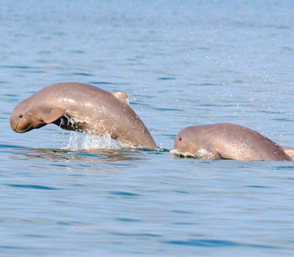
Chilika Lake, the largest brackish water lake in Asia (65 km long, 8-20 km wide, about 2 meter deep), is situated just a few kilometers away from Puri and is a place worth visiting. It has been affectionately called the “Honeymooners' paradise” and “Breakfast Island”. The simmering blue water makes it an excellent site to have a break from the monotonous daily routine.
Kakatpur
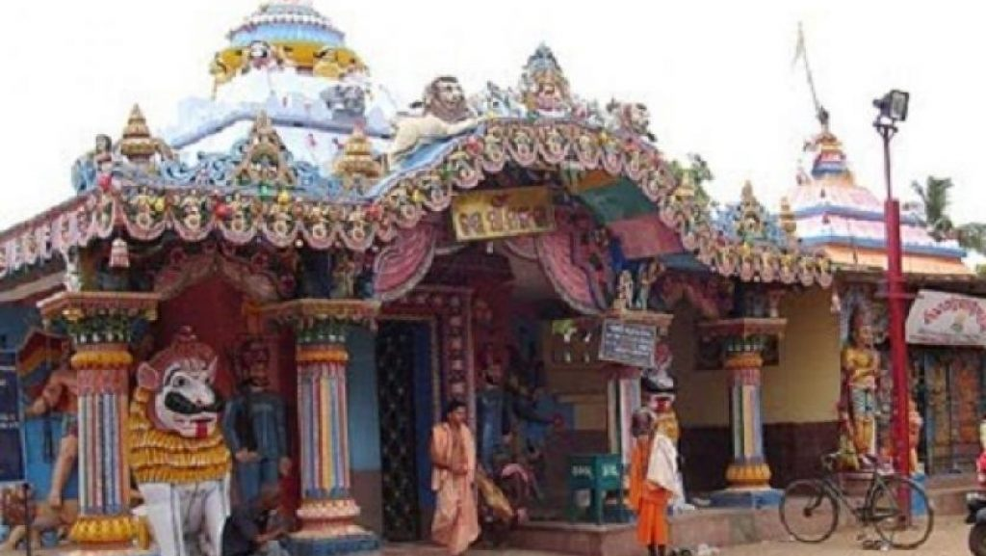
Kakatpur is famous for the Shrine of Goddess Mangala situated on the bank of river Prachi. The present temple dates back to the 15th century AD and the deity belongs to the 9th century AD. Goddess Mangala sits in Lalitasana on a double lotus pedestal. The mother Goddess is Surrounded by a host of Parswa Devatas.
Alarnath Temple
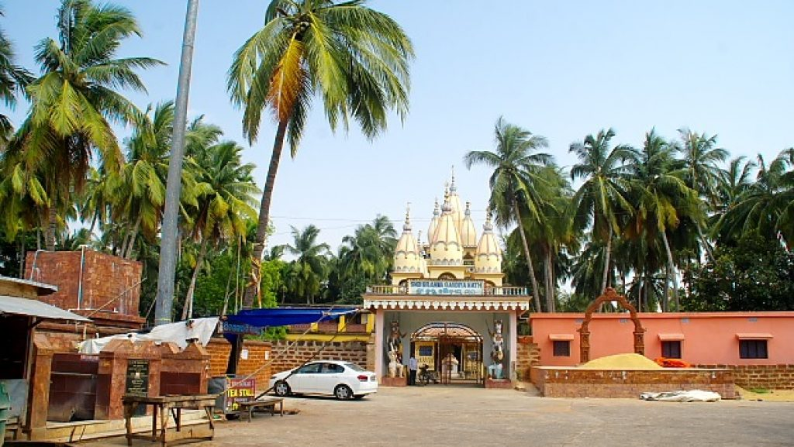
The Vishnu Mandira. Many years ago (in 1610 A.D) Lord Chaitanya Mahaprabhu stayed at Alarnath during anavasara period of Lord Jagannath. Anavasara is the two weeks period when Lord Jagannatha take rests in isolation from the rest of the world after suffering from fever due to the annual bathing festival(Snana Yatra). Lord Chaitanya claimed that he visualized the appearance of Lord Jagannath in Alarnath and spent a long period in worshiping the deity here. It is believed that those who cannot worship Lord Jagannath during his stay in the sick chamber can get the blessings of the deity if they visit the Alarnath temple.
Satyabadi
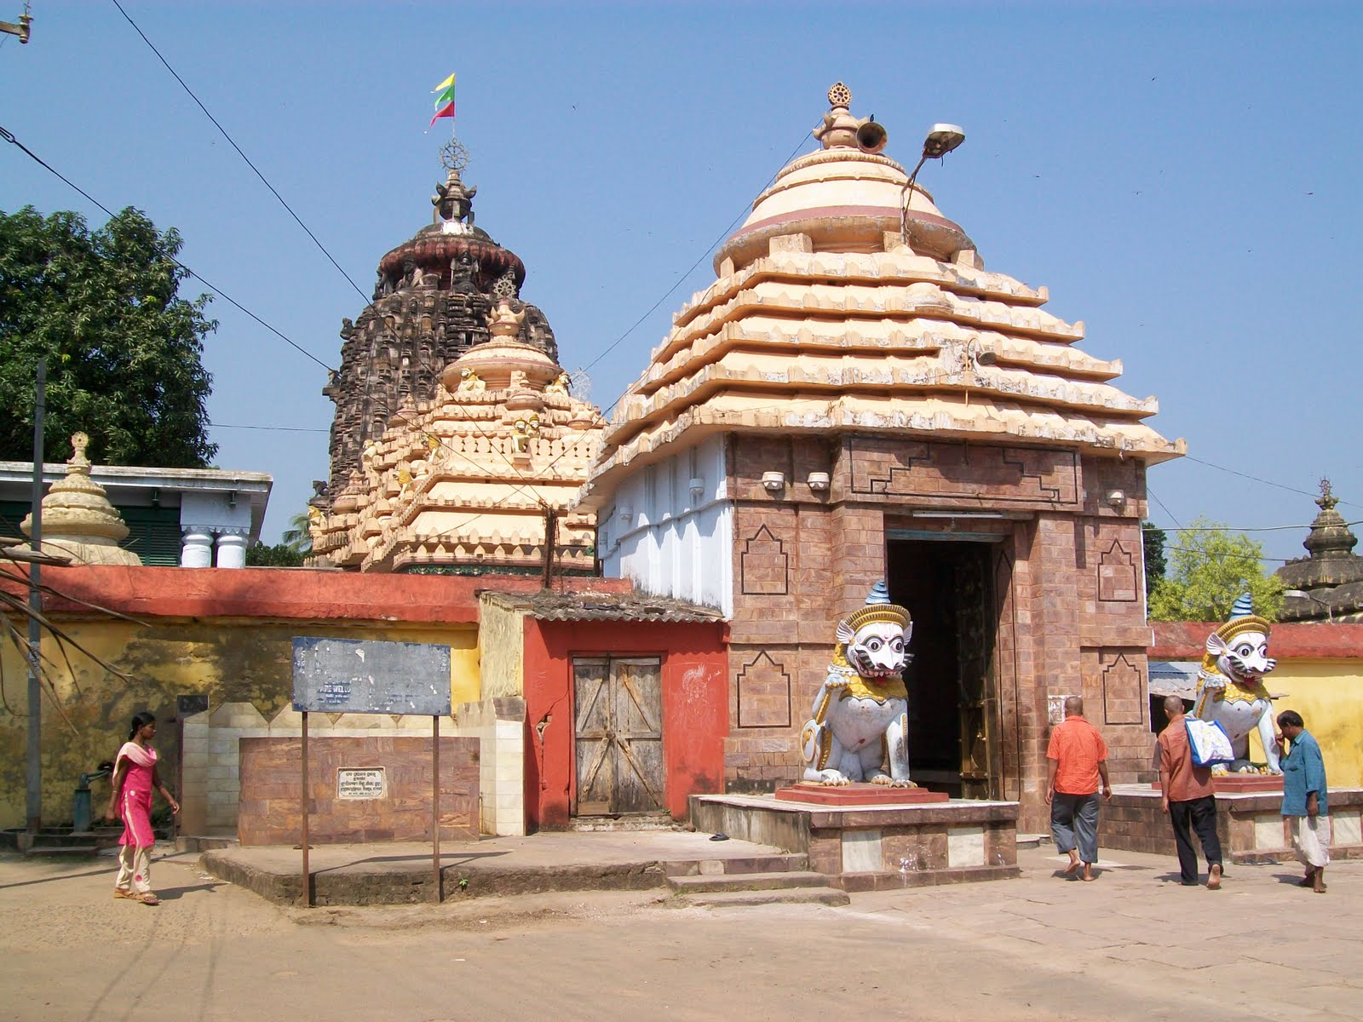
Sakhigopal or Satyabadi is famous for the shrine of Sakhigopal. It is one of the pilgrimage centers in the district and believes that one's pilgrimage to Puri is incomplete without visiting Sakhigopal. The name Sakhi Gopal literally means witness Gopal(Srikrishna). The temple of Sakhigopal is 60 ft height & the image of Shri Krishna and Radha is 5 ft & 4 ft height respectively.
Kuruma
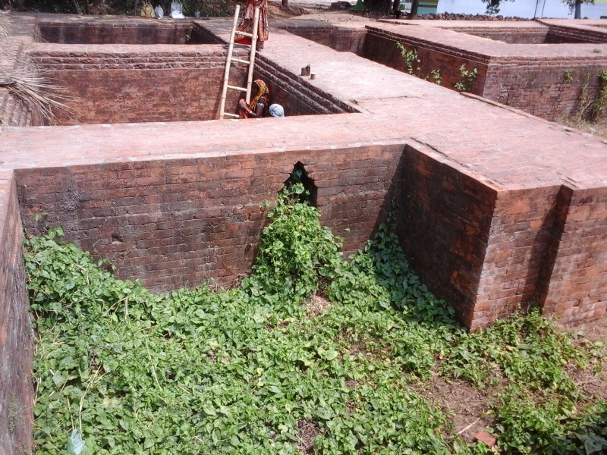
Kuruma is famous for the excavated site of Buddha Vihar. It is a small village known as Jama–Dharma situated at a distance of 8 km from Konark. The village has come to prominence due to the discovery of Archaeological remains like the image of Lord Buddha seated in BhumiSparsa Mudra along with the image of Heruka (a Buddhist deity). There is a brick wall measuring 17 meters.
Chaurasi
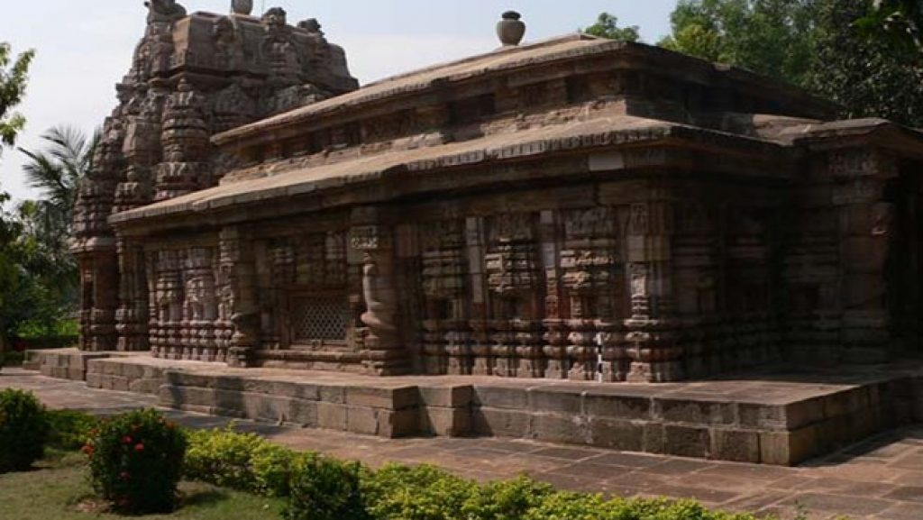
Chaurasi, a small village which is famous for the ancient temple of Varahi. Varahi is the Mother Goddess with the face of a boar. It is believed that She holds a fish in one hand and a cup in the other. The deity belongs to the 9th century AD. She is worshiped accordingly to tantric rites. The existing temple of Laxminarayan and the deity of Nilamadhab are the additional attraction of the place. Close to the village Charasi, Amareswar is also famous for the shrine of Amareswar(Siva).
Biswanath Hill
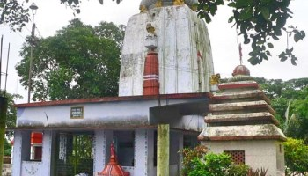
The Temple is located on the upper part of Biswanath Mundia hill near Delang in Puri district, close to Puri and Bhubaneswar. Archeologists opine that there are many Buddhist stupas in this hill. Biswanath Hill is known for its ancient monastery of Dignag, the Buddhist Logician and Philosopher. There is also the archeological remains of a Varaha image.
Biswanath temple, Popularly known as Biswanath Mundia is famous for Lord Siva Biswanath. It is situated at the top of a Mundia(ROCK). It is 1/2 km from Delang Block in Puri district and the Block is situated at just lower to the Biswanath Mundia.
Raghurajpur
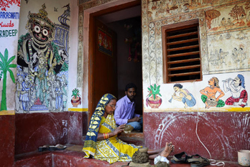
The village is also famous for Gotipua dance. Near to Raghurajpur is another better-known destination is DandaSahi, which has the potential of becoming a heritage village of tomorrow. A small village of about 50 households, Dandasahi is on the side of the historical road, through which Sri Chaitanya had traveled to Puri. The Raghurajpur village, idyllic setting on the Southern bank of the river Bhargavi, surrounded by Coconut, Palm, Mango, Jackfruit, Groves & other tropical trees. The village is famous for the community of artisans who produce different varieties of handicraft items like Patta paintings, palm leaf engravings, stone carvings, paper mache toys & masks, wood carvings, wooden toys, cow dung toys, tusser paintings etc.
Baliharachandi
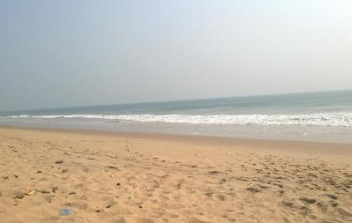
There is a temple dedicated to goddess Harachandi at 27 km southwest of Puri on the NH-203 leading from Puri towards Brahmagiri and Satapada. In Odia language Bali means Sand & Harachandi means an angry form of Goddess Durga. This temple is dedicated to Goddess Durga and is mounted on a sandy hill near the ocean. Beach is very near to the temple which is another major attraction of this place.
Ramachandi
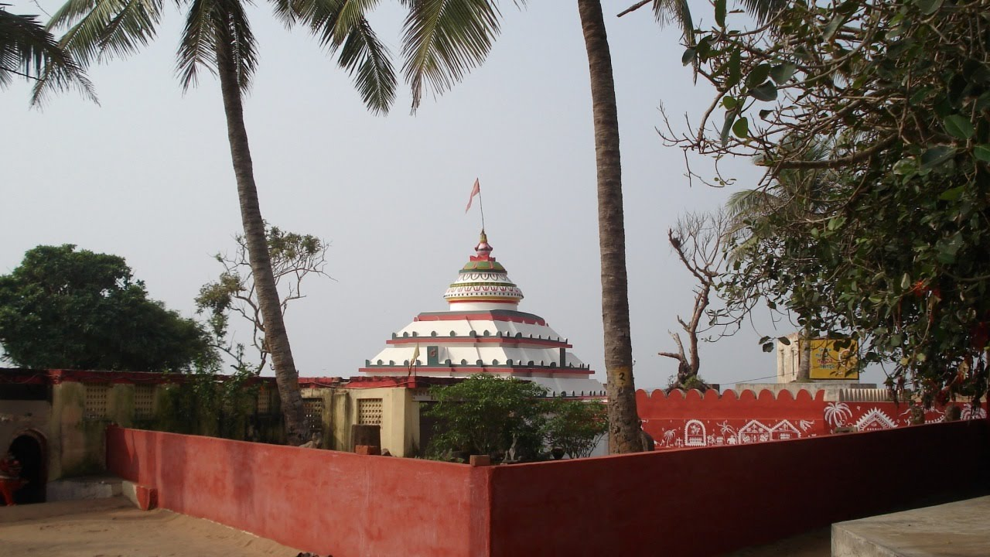
The temple of Goddess ‘Ramachandi’ on the river mouth of Kushabhadra is a splendid scenic picnic spot. It is situated 7 km before Konark on the Marine drive road from Puri to Konark. Ramachandi is popularly believed the presiding deity of Konark and the most benevolent Chandi known. It is certainly more ancient than the Sun temple at Konark.
Pipili
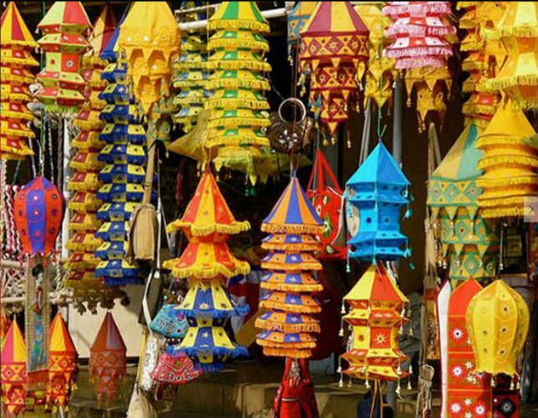
Pipili is famous for Applique works which are a traditional craft of the local People. They prepare Chandua(colorful Arts on clothes), Umbrella, cloth Bags, Purses, Wall Hangings, Carpets, Garments for ladies & other applique works which have a good market in India and abroad. During World famous Ratha Yatra, the chariots(Raths) are being decorated with colorful clothes made by the People of pipili.
Beleswar
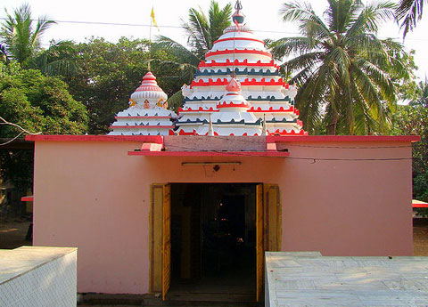
There are many stories about Beleswar Pitha. Some People believed that Lord Rama had established the ‘Siva Lingam’ here and had worshiped by offering Bela before proceeding to Lanka for war with the Demon king Ravana. Since this place was known as ‘Beleswar Pitha’. The temple Beleswar has been constructed on a sand dune. Since the temple as located only at a distance of 4 km from the Sea, it has got more tourist potentiality.
Jahania Pira
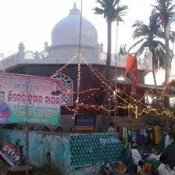
Pir Mukudan Jahania Jahagast Pir is a Muslim saint, located near Astarang on the Beach. According to tradition in the 16th Century, the Muslim saint with his disciples came to India from Baghdad and after staying in Bengal he came to Odisha. He visited many places & finally, he settled down near Astarang. Both Hindus & Muslims offer worship at the shrine. It is also a Beautiful Picnic spot.
How to reach Puri
By Air
The nearest Airport is at Bhubaneshwar (60 km), the state capital.
By Rail
Puri is also linked to other cities in Odisha and the country by train. We would provide you all India tourist permit vehicles for the local transportations and also for the intercity drives too.
By Road
Puri is connected with Bhubaneswar, Konark, Berhampur, Taptapani, Sambalpur and Kolkata by road.
Best Time to Visit Puri
The tropical climate of Odisha with pleasant winters, hot and humid summers and heavy rainfalls makes the period from October to April the best time to visit Puri. White Sands of Puri Beach attract lots of tourists to Puri from October to April.
Weather of Puri
Puri has a moderate and tropical climate. Humidity is fairly high throughout the year. The temperature during summer touches a maximum of 36°C(97°F) and during winter it is 17°C(63°F). The average annual rainfall is 1,337 millimeters (52.6 in) and the average annual temperature is 26.9°C(80.4°F).

