About Subarnapur
Planning a Trip to Subarnapur? Here's our list of 5 top Tourist Places to visit in Subarnapur
Subarnapur District, also called Sonepur District or Sonapur District, is an administrative district of Odisha state in eastern India. The town of Sonepur is the district headquarters. Many loosely call the people of the Sonepur region as Sonepuria.
According to historians the Subarnapur district was known as Paschima Lanka or Western Lanka around the 10th-11th centuries. The evidence comes from a copper plate charter issued in the late 10th century by a Somavamsi prince named Kumara Someswaradeva of Subarnapur district. The Prince had identified himself as the king of Paschima Lanka. It was further found that the Mahada copper plate grant of Kumara Someswaradeva was registered on the bank of river Chitrotpala(Mahanadi) and near to the province of Lanka. The presiding deity of Paschima Lanka was goddess Lankeswari.
This district earned the name “Subarnapur” during the time of Somavamsi ruler. The district was established in 1993.
Top 5 Places to Visit in Subarnapur
Rameswar Temple
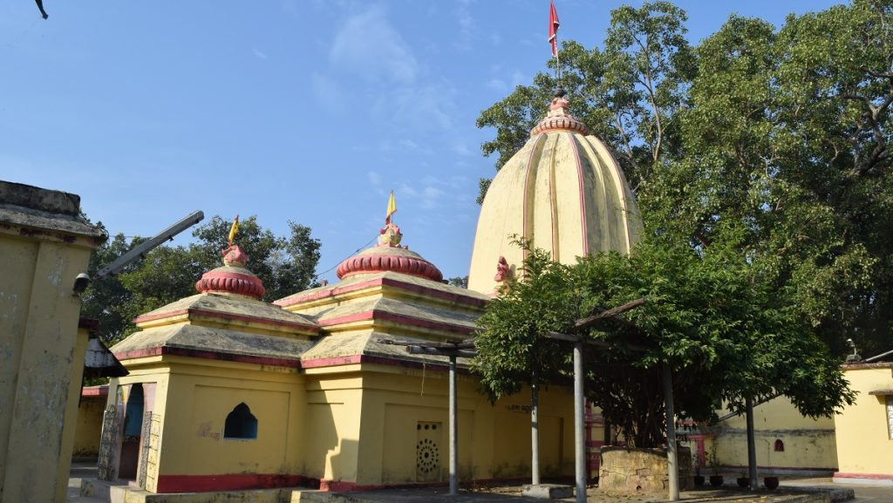
Rameswar Temple is situated on the confluence of the river Mahanadi and Tel. The lingam of the temple is very old. Legend associates Lord Ram with its installation. Lord Kartik and Ganesh along with Goddess Parvati are worshiped here. A Durga temple is also found near the Rameswar temple where the image of a ten-armed Durga is enshrined.
Patali Srikhetra
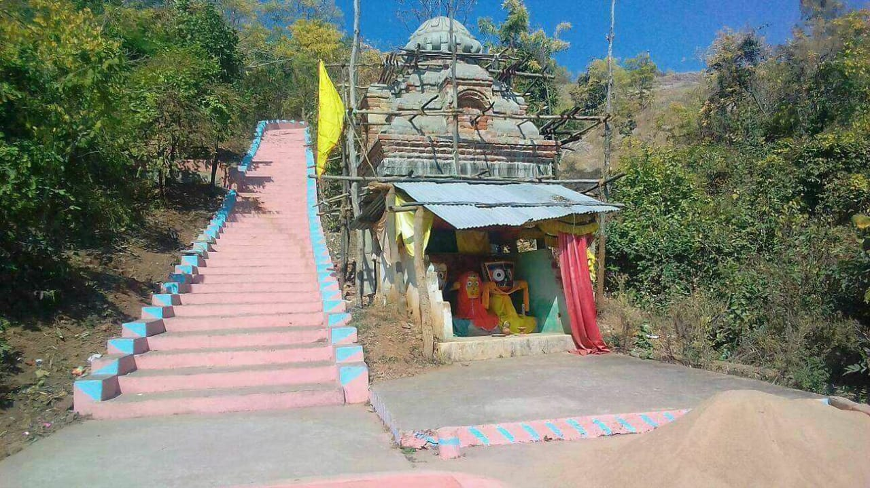
Patali Srikhetra is a famous place with significant historical importance for the Subarnapur district and Odisha. This religious place is associated with Shaktism, Buddhism and Vaishnavism. It is located in the foot of Trikut Hill at Kotsamalai of the Birmaharajpur subdivision of Subarnapur district, Odisha.
Pancharatha Temple
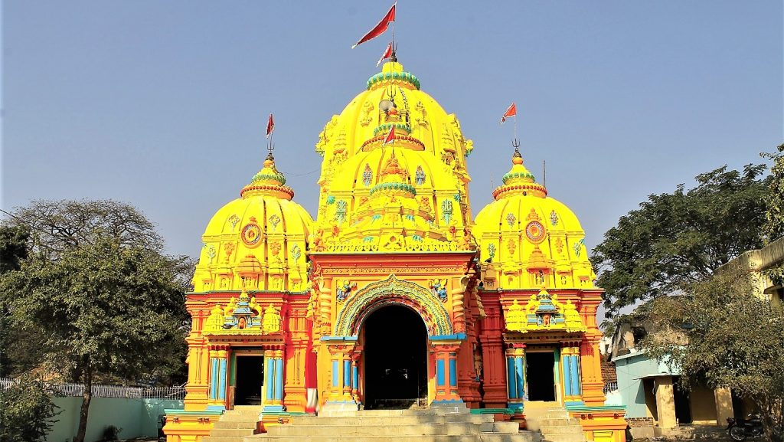
Pancharatha Temple is a highly revered shrine at Sonepur, in Odisha. This beautiful temple, constructed in a chariot size, resembles the Sun Temple at Konark. As many as five temples are built upon a single platform here. Lord Siva, Ganesh, Kartikeya and Rishava along with Goddess Parvati are worshiped here.
Lankeswari Temple

Lankeswari Temple is located inside the river Mahanadi at Sonepur town, Subarnapur district, Odisha. Once upon a time Sonepur region was known as Paschime Lanka. Goddess Lankeswari was the presiding deity of Paschima Lanka. Now Maa Lankeswari is worshiped by the Kaivarta(fisherman) community of Sonepur and people of Subarnapur district.
Bhima Bhoi Samadhi Pitha, Khaliapali
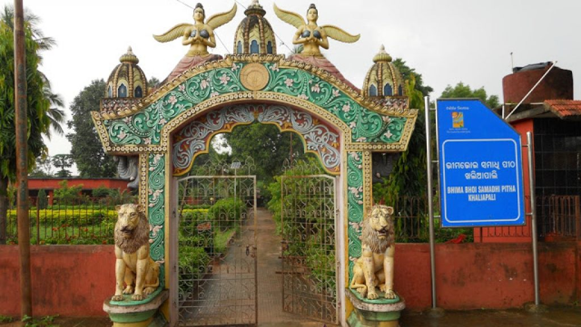
Bhima Bhoi Samadhi Pitha is situated 30 km away from sonepur with Samadhi mandir or Sunya mandir. It was a 110 years old temple.
How to reach Subarnapur
By Air
Nearest Airport is Bhubaneswar Airport-276 Kms.
By Rail
Nearest Railway Stations is Balangir-50 Kms.
By Road
From Bhubaneswar, it is 275 kms on the NH-57 or 276 kms on the NH-55.
Best Time to Visit Subarnapur
The months from September to March are considered the best time to visit Subarnapur as the weather remains changing in the favor of travelers.
Weather of Subarnapur
Subarnapur experiences an extreme type of climate with hot and dry summers followed by humid monsoons and cold winters. The hot season commences from the first week of March and lasts until the second half of June. In May, the temperature rises to 47°C(117°F). In December, the temperature comes down to 5°C(41°F).

