About Sundergarh
Planning a Trip to Sundergarh? Here's our list of 5 top Tourist Places to visit in Sundergarh
Sundergarh is a town in Sundergarh district of the Indian state of Odisha. Sundergarh is recognized as an industrial district in the map of Odisha. Steel plant, Fertilizer plant, Cement factory, Ferrovanadium plant, Machine building factory, Glass and China clay factory and Spinning mills are some of the major industries of this district. Sundergarh occupies a prominent position in the mineral map of Odisha and is rich in iron ore, limestone and manganese.
The name Sundergarh can be translated as beautiful city in Hindi, and it certainly lives up to the name. The rich cultural heritage, embellished by traditional art forms and historical influences, only adds to the beauty. The town is located within the district of the same name in Odisha, which consists of the two former princely states Gangapur and Bonai.
Sundergarh was the capital of the princely State of Gangpur till 1948 and became the district headquarters of the Sundergarh district from 1948. It is understood that, in ancient times, Sundergarh was under the rulers of different dynasties. However, divergent views are available regarding the origin of the ruling family. The present royal family of Gangpur belongs to the Parmar dynasty.
Top 5 Places to Visit in Sundergarh
Vaishno Devi Temple
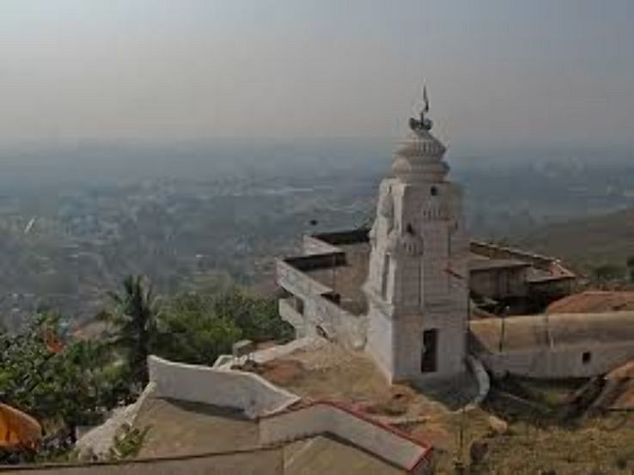
Vaishnodevi Temple at Rourkela is a replica of the original Temple of Vaishnodevi of Jammu(Trikuta Hills) and is situated on the top of the Durgapur Hill facing towards Rourkela Steel Plant. Bhairabanath Temple is situated near Vaishodevi Temple on the hill.
Mandira Dam
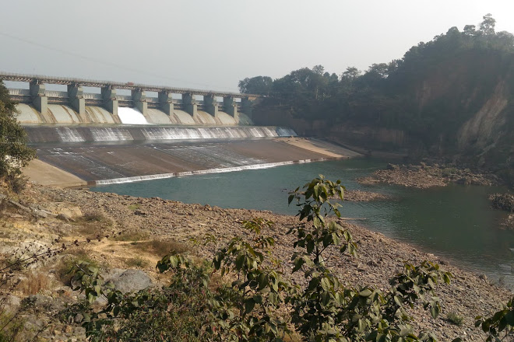
Mandira dam is located near Kansbahal in Sundergarh district, Odisha, India. It is built across the Sankh River, located 16 km upstream from Mandira. The water from the dam is used for Rourkela Steel Plant. Construction of the dam began after 1957.
Hanuman Vatika
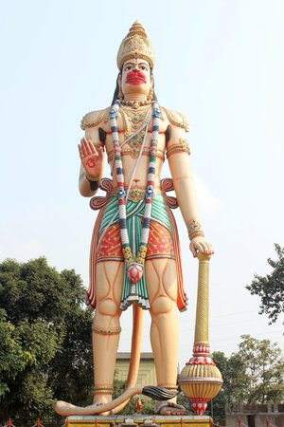
The statue of Hanuman is constructed with a height of 75 feet. There are also a number of temples named Bata Mangala, Binayak, Vaishnodevi, Sarala, Dwadash Linga, Siva, Santoshi Maa, Maa Laxmi etc constructed here for the devotees. Because of the beauty scenario and green area, a number of general visitors came to this place every day here.
Vedvyas Dham
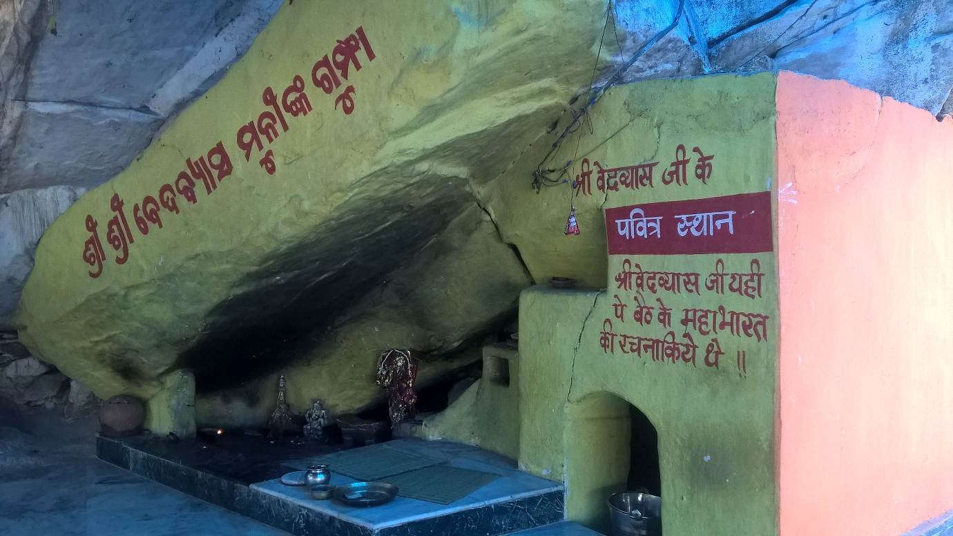
Situated on the confluence of the river Sankha and Koel, which thereafter form the river Brahmani, Vedavyas is not only a place of natural beauty but also is considered a Tritha a place of religious sanctity. A dip in the confluence is belied to wash away all sins. Tradition has it that Vyasadeva, the reputed sage, lived here and composed the great epic Mahabharat. There are three temples here, two dedicated to Lord Siva and one to Rama. A Vedic Ashram and a school on the lines of Gurukula Ashram are the added attractions of the place.
Khandadhar Waterfall
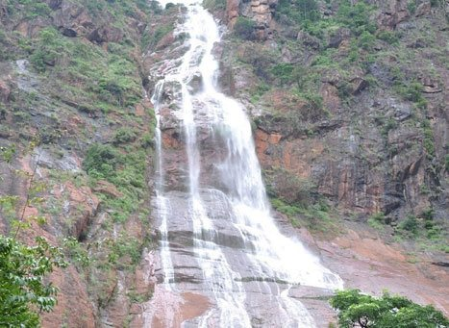
Khandadhar is a glittering waterfall created by a perennial rivulet called Korapani Nala within a few kilometer of its origin. 244 meters in height it is said to be the highest waterfall in Odisha.
How to reach Sundergarh
By Air
There are no regular flights from other major cities of the country to Rourkela. The nearest Airport is Ranchi Airport(140 km away approximately).
By Rail
Nearest Railway Station is Rourkela Junction.
By Road
You can easily get regular buses to Rourkela from other major cities in the country.
Best Time to Visit Sundergarh
The best time to visit Sundergarh is wintertime. September to March is the best time to visit Sundergarh.
Weather of Sundergarh
The climate of this district is characterized by extremely hot summers and cool winters. The climate is hot and moist sub-humid. The normal rainfall of the district is approximately 1230 mm, but there is a deviation in receipt of rainfall pattern which is influencing crop production.

