Group Names: ID

1-Amira Momtaz 231001071
2-Inji Hatem 23100059
3-Habiba Essam Magdy 231001460
4-Sara Ahmed 231001837
5-Menna Khaled 221000165
6-Tasabih Farid 231001581

Supervised by: Sameh El Sayed Ibrahem
Supervised by: TA: Nourine Mamdouh Sabry &Shaimaa Roshdy Abdullah

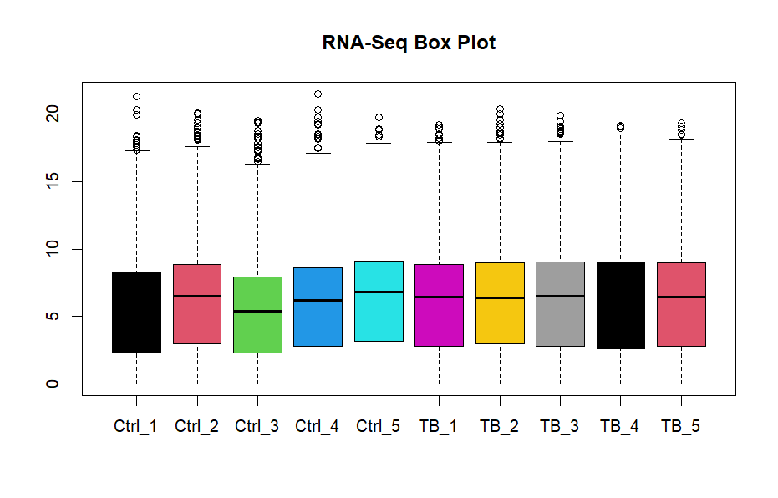
ANS:
A box plot is used to visualize the distribution of gene expression values across samples. It summarizes the data using key statistics such as the mean, quartiles, and potential outliers.
A good-quality box plot is indicated when all samples show similar distributions. Specifically, the boxes should have approximately the same height, and the median lines (center lines inside each box) should be aligned at similar levels across samples. This suggests that the samples are comparable and that no major technical variation exists between them. In this case, the data can be considered well-normalized and suitable for downstream analysis.
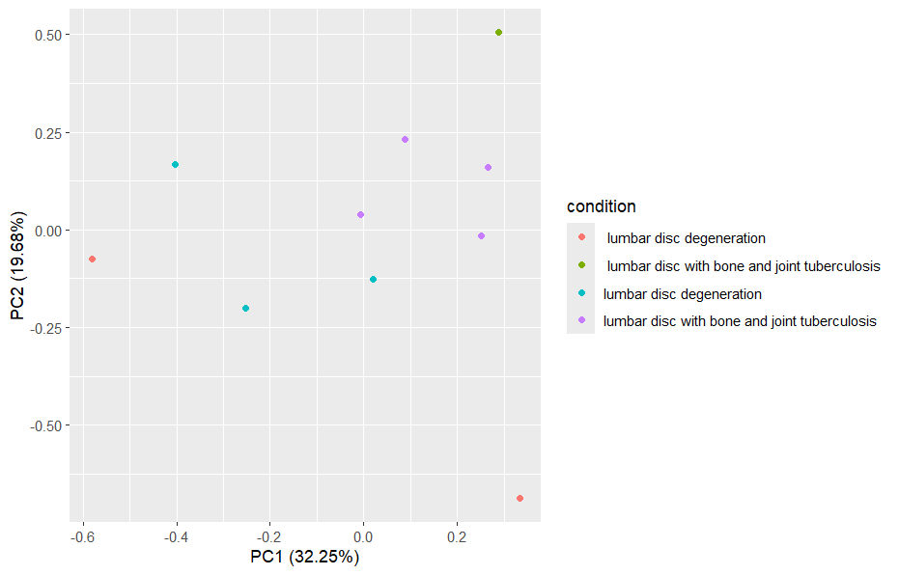
ANS:
PCA is a dimensionality reduction technique used to explore patterns in high-dimensional data such as RNA-seq. It transforms the data into principal components that capture the most variance. samples are scattered randomly or groups are not clearly separated, this suggests weak biological signals or high technical noise. In such cases, further data cleaning or normalization may be necessary.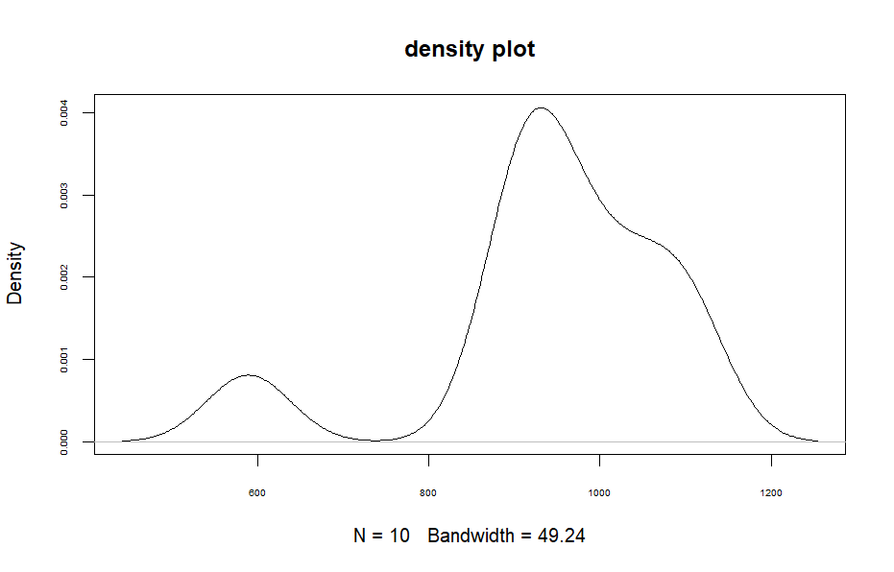
ANS:
A density plot provides a smooth visualization of the distribution of expression values for each sample. Each sample is represented by a curve. curves are widely separated or differ greatly in shape; it suggests variability between samples. This may indicate the presence of outliers, technical noise, or the need for normalization

