**Name: Devmalya Bandyopadhyay**

**Roll no.: R171218039**

**SAP ID: 500069119**

**EXPERIMENT 1**

**Playing with Vagrant**

## Prerequisite

1. Download Ubuntu version less than 6
2. Boot Startup machine should be enabled

## Steps

1. Install [Vagrant](https://www.vagrantup.com/downloads.html).
2. Do the normal setup and restart your pc
3. Open command prompt and check version by typing

vagrant --version



1. Now go to location where you want to store your vagrant file and type

vagrant init

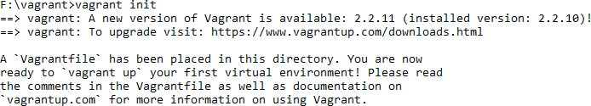

1. Go to that folder Vagrantfile will be created.

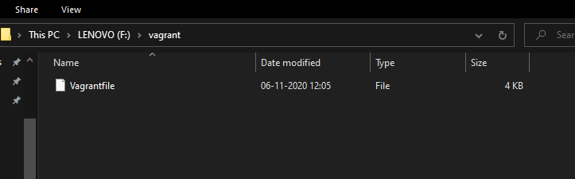

1. Now open that file and change config.vm.box = "base" to config.vm.box = "ubuntu/xenial64"



1. Now in command prompt type

vagrant up

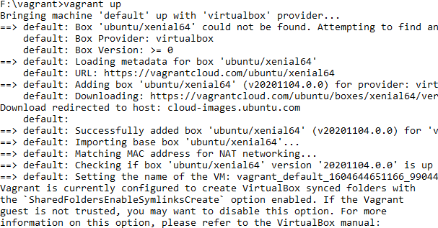

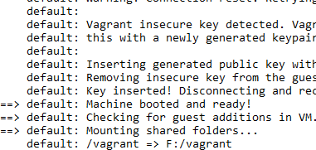

1. Now type

vagrant ssh

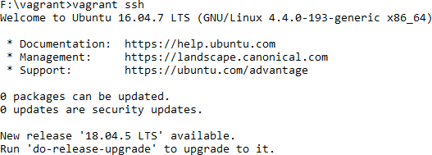

This will change your terminal to ubuntu xenial64.