**EXPERIMENT 2**

Starting VM

$ vagrant up

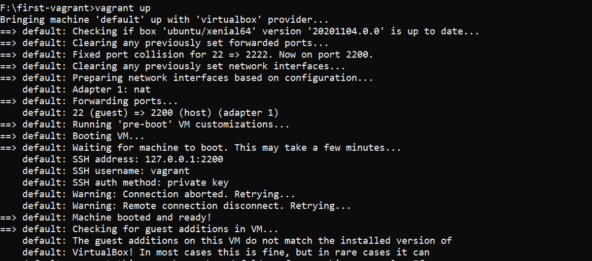

Listing all the volumes in docker and inspecting a volume

$ docker volume ls

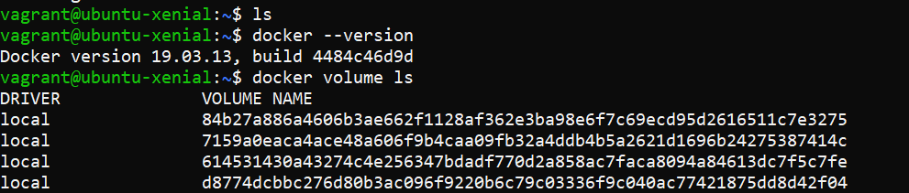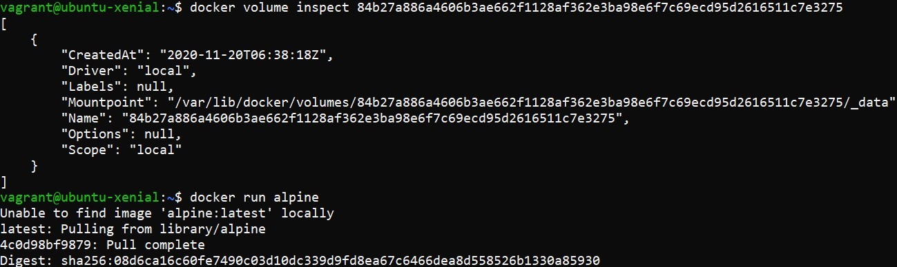

Running an Alpine Image

$ docker run alpine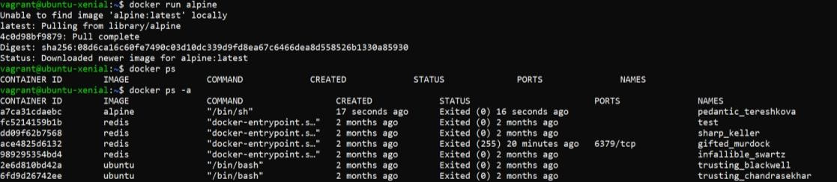

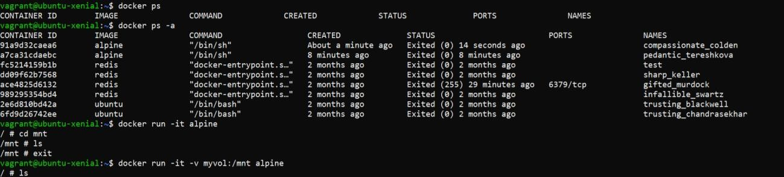

Creating some files in that alpine cont.

$ docker run –it –v myvol:/mnt alpine

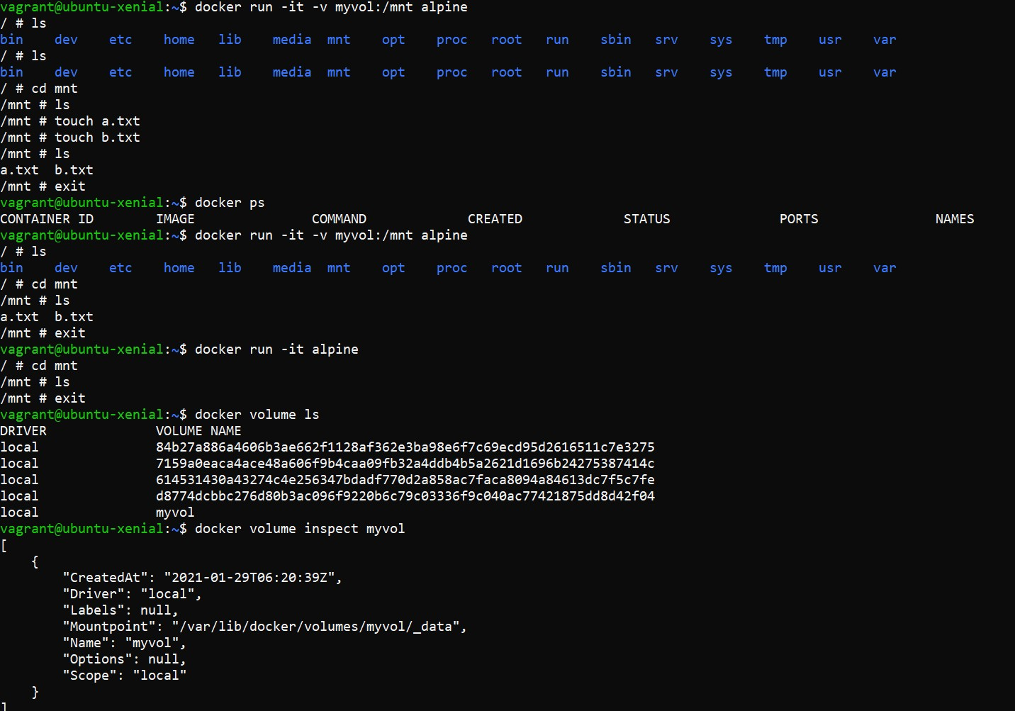

Creating Container with Volume

$ docker run –it –v myvol:/mnt –name c1 alpine

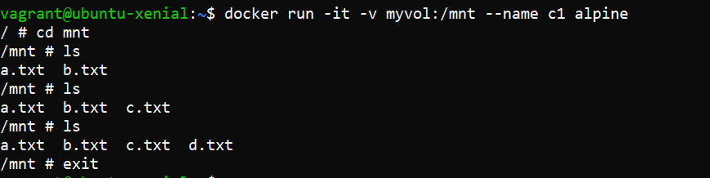

In another instance of terminal, starting a VM and running docker in that

$ docker run –it –v myvol:/mnt –name c2 alpine

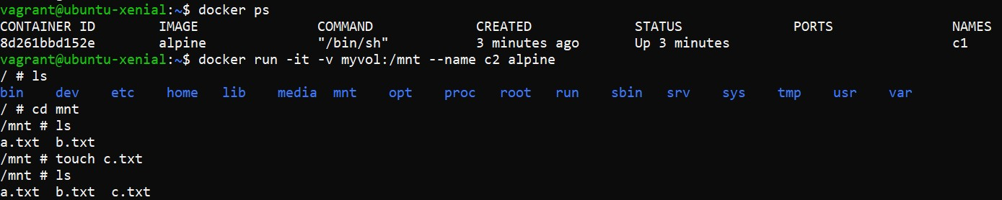

All the files show synced up

$ docker run -it –v myvol:/var ubuntu