Application Containerization Lab

**Name : Harivansh Mathur**

**Roll No : R171218043**

Experiment – 2

(Docker Volumes)

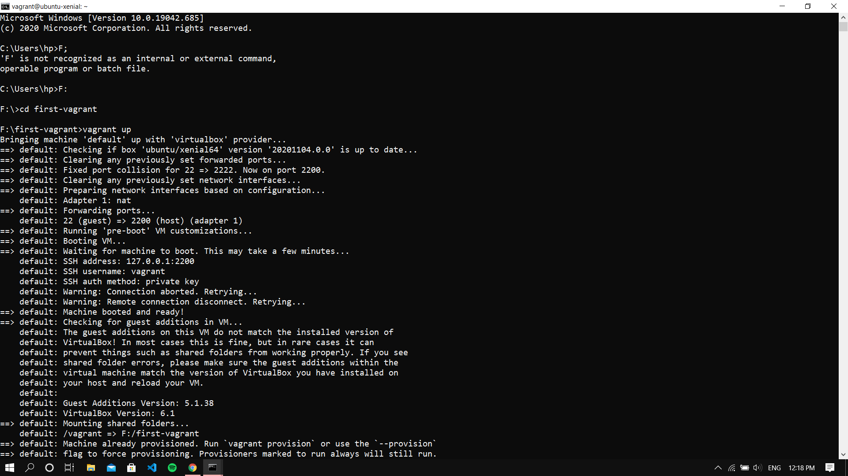

Starting VM

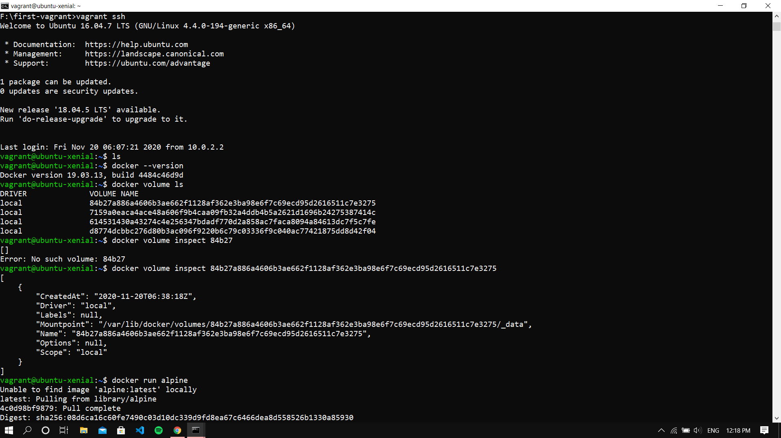

Listing all the volumes in docker and inspecting a volume

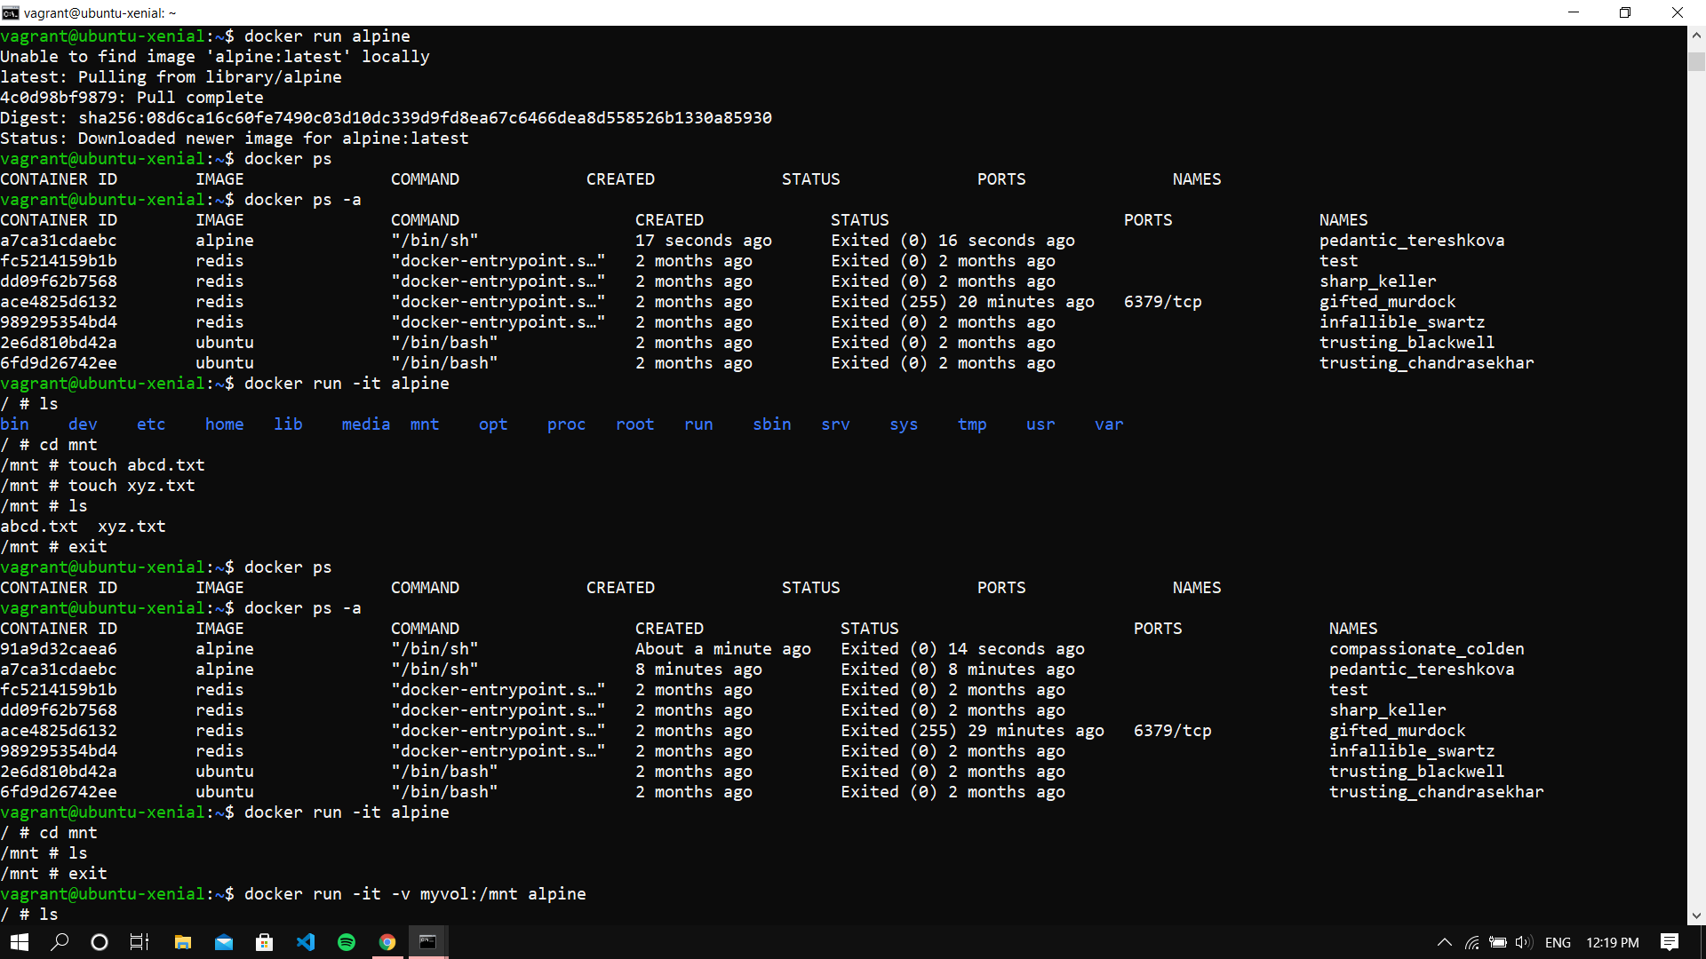

Running an Alpine Image

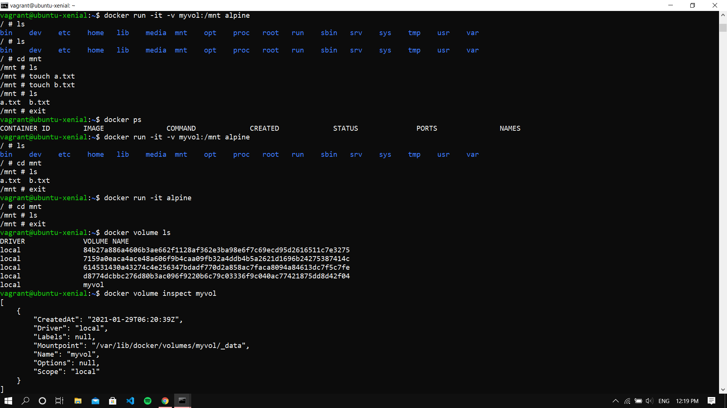

Creating some files in that alpine cont.

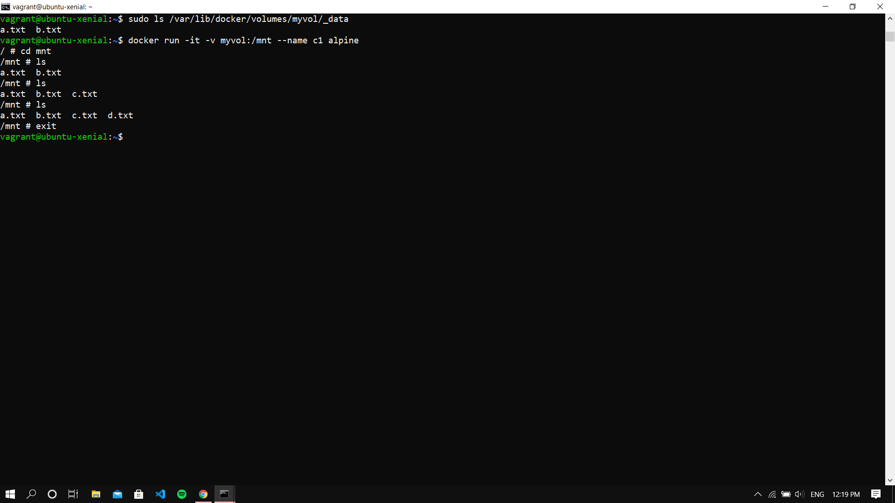

Creating Container with Volume 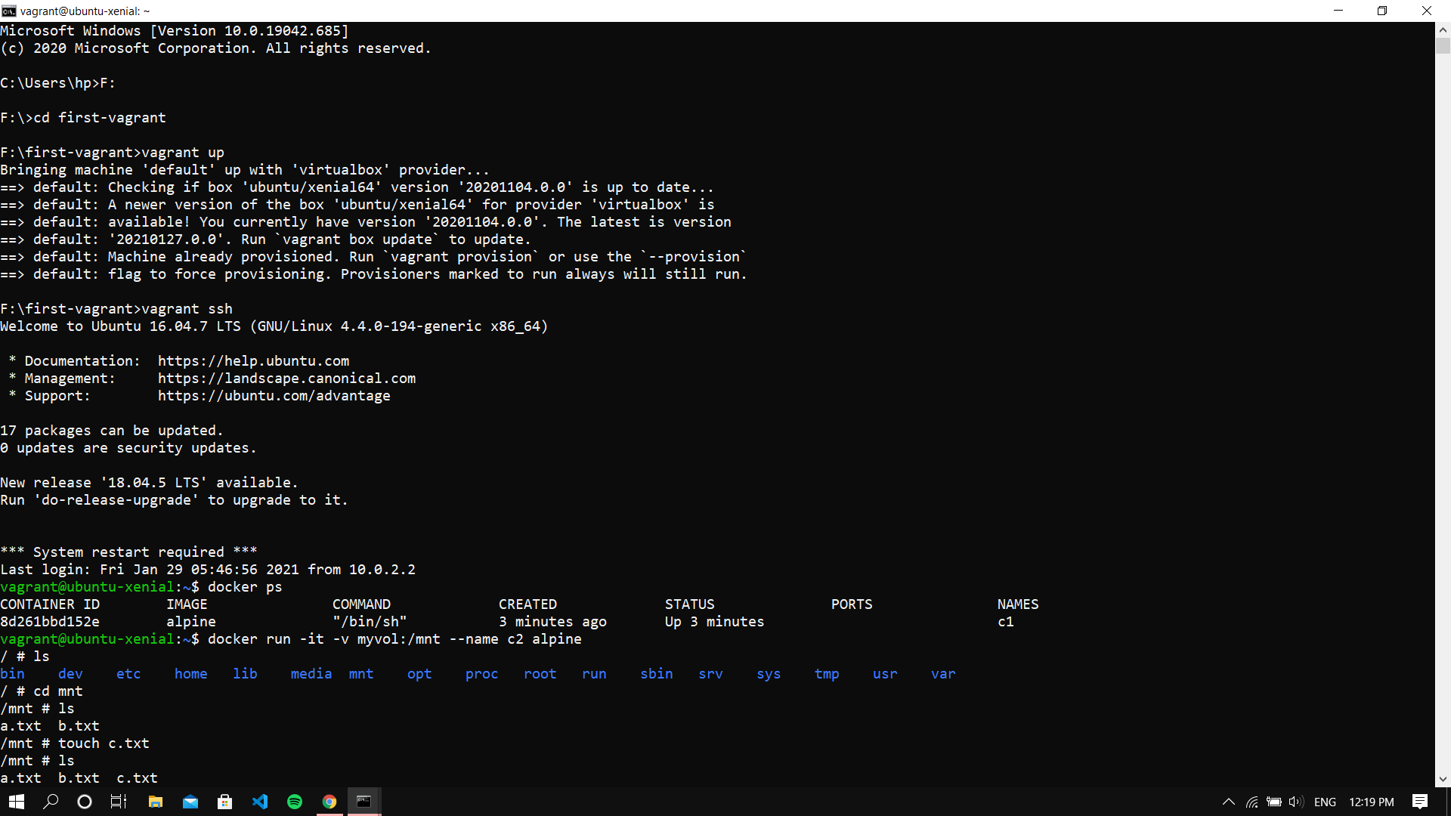

In another instance of terminal, starting a VM and running docker in that

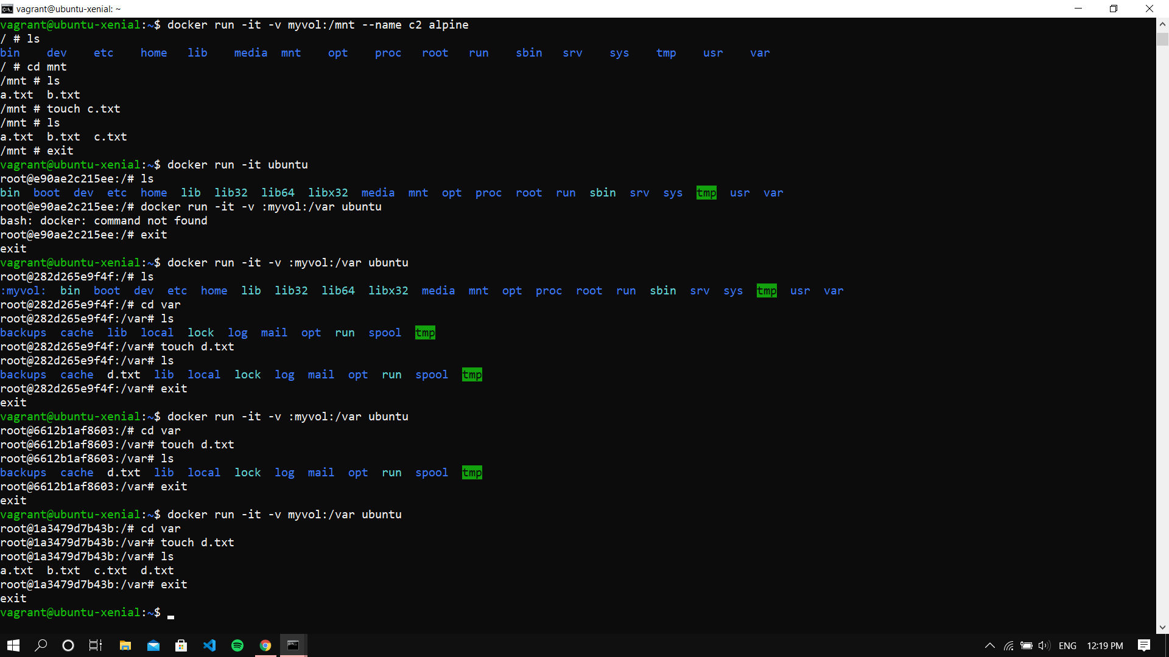

All the files show synced up