- Setting up the environment
The program requires a Python interpreter installed on the computer. To install it, follow these steps:
- Open a browser window and navigate to the Python.org: https://www.python.org/downloads/
- Under the “Python Releases for Windows” heading, click the link for the Latest Python 3 Release - Python 3.x.x.
- Scroll to the bottom and select either Windows x86-64 executable installer for 64-bit or Windows x86 executable installer for 32-bit.
- Install Python.
You can check the path where Python is installed using the following command in Command Promt (see Fig.1.1):
where.exe python
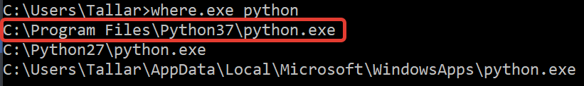
Fig. 1.1 – Path to Python interpreter.
The program uses a set of additional libraries that require manual installation. Pip is the package installer for Python. You can use pip to install required packages (it is installed along with the Python interpreter). List of required libraries:
numpy==1.20.3
matplotlib==3.4.2
scipy==1.7.1
pandas==1.3.3
colour-science==0.3.16
numba==0.53.1
To work with hyperspectral images, you also need to install:
opencv-python==4.5.5.62
seaborn==0.11.2
h5py==2.10.0
Interactive 3D visualization of train (X) and test (Y) datasets, as well as predicted values by LUT available with the installation of the following library:
plotly==5.1.0
Python library versions are constantly updated and it may happen that the code will stop working with the new version of the library. Therefore, the list of libraries contains the version of the package with which this script has been tested and worked successfully on Python 3.8 interpreter.
For example, to install the “numpy” v.1.20.3, enter the following command in Command Promt:
pip3 install numpy ==1.20.3
If you want to install the latest version of the package, enter:
pip3 install numpy
After you have all the required libraries, install the Integrated development environment (IDE) for Python. We recommend using PyCharm. It is a cross-platform IDE that provides consistent experience on the Windows, macOS, and Linux operating systems. To work enough to install the free version «Community»: https://www.jetbrains.com/pycharm/
To load the project in PyCharm, press “File→Open” and select the folder with the project. A list of program files appears in the Project panel on the left (see Fig. 2).
Next, you need to set the required Python interpreter in the program settings:
“File→Settings→Project Interpreter” and choose an interpreter with libraries installed (see Fig. 1.2).

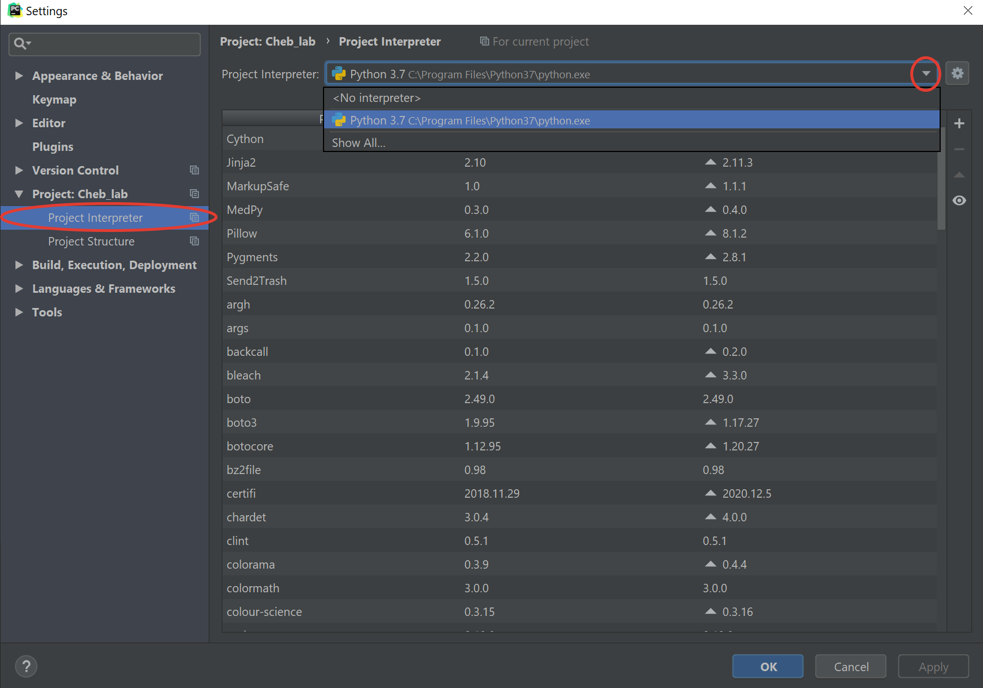
Fig. 1.2 – Choosing a Python interpreter.

- Color difference software
  - Spectral database
The pipelines presented in the previous paragraphs contain a set of initial data. This is spectral data in the range of about 380 ... 780 nanometers and includes reflectance, reference white illuminant, color matching functions of the standard observer and spectral sensitivity of the sensor.
The structures of spectral databases are shown in Fig. 2.1 – 2.3 for white illuminants, reflectances and sensor spectral sensitivity, respectively. Folders are highlighted in light yellow, text files with spectral data are shown in white. For example, the folder “cie” in Fig. 2.1 contains three files with sets of fluorescent, high-pressure and standard (A, D65, E, etc.) white illuminants.

Illuminants

cie

fl

hp

std

mls

mls

sfu

measured with sources
Fig. 2.1 – Structure of the illuminants database

reflectances

babelcolor

sg

chromaxion

std

sfu

books

cardboard

cloth

construction

dupont

krinov

lab_wall

macbeth

munsell

objects

paint-chips

sfu

forest390_850_5

birch

pine

spruce

paper400_700_10

cardboardsce

cardboardsci

mirrorsci

newsprintsce

newsprintsci

papersce

papersci

munsell380_780_1

_glossy

munsell380_800_1

natural400_700_5
Fig. 2.2 – Reflectances database

Fig. 2.3 – Sensor spectral sensitivity database

2.2. Spectral recovery
During the research, we found out that the effectiveness of LUT is ensured, among other things, when the training data points cover the entire input space. Existing datasets do not meet this requirement, so instead of the reflectance database, we used the spectral data recovered using the algorithm LHTSS: Least Hyperbolic Tangent Slope Squared: This method reconstructs a reflectance curve from tristimulus values (or other three-element color specifier, such as RGB) (see Fig. 2.4). It guarantees that the reflectance values will be strictly within the range 0 to 1, making it suitable for applications requiring true 0-1 reflectance curves. The tristimulus values must fall within the object color solid (object colors) for it to work.
Thus, we can ensure a uniform distribution of training points inside the [0…1]³ RGB-cube, which is shown in Fig. 2.5 and can be used in cases RGB2XYZ and RGB2RGB.
CMF (SSS)
Illuminant
Reflectance
XYZ (RGB)
Fig. 2.4 – Spectral recovery principle
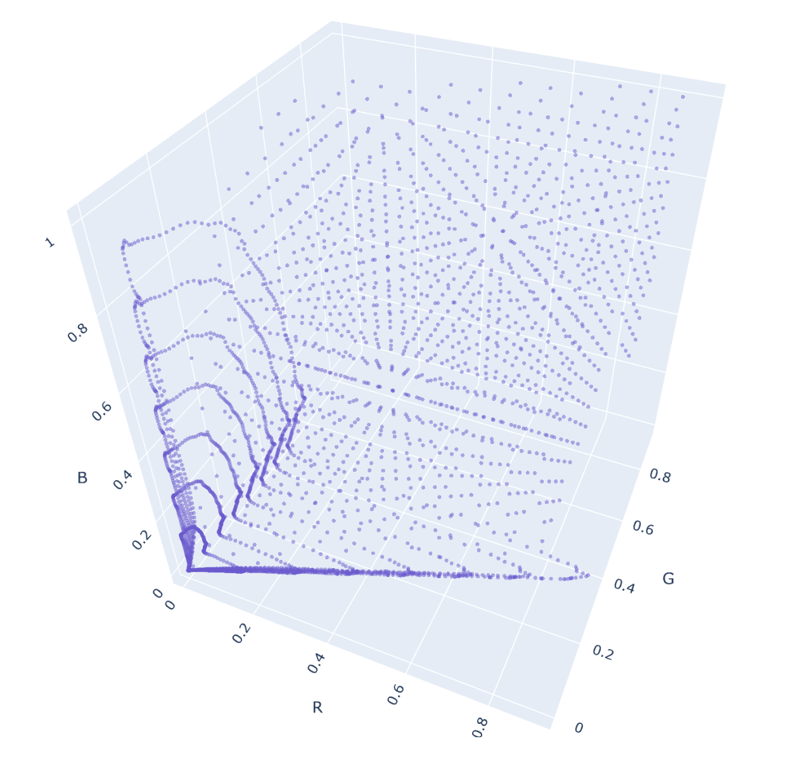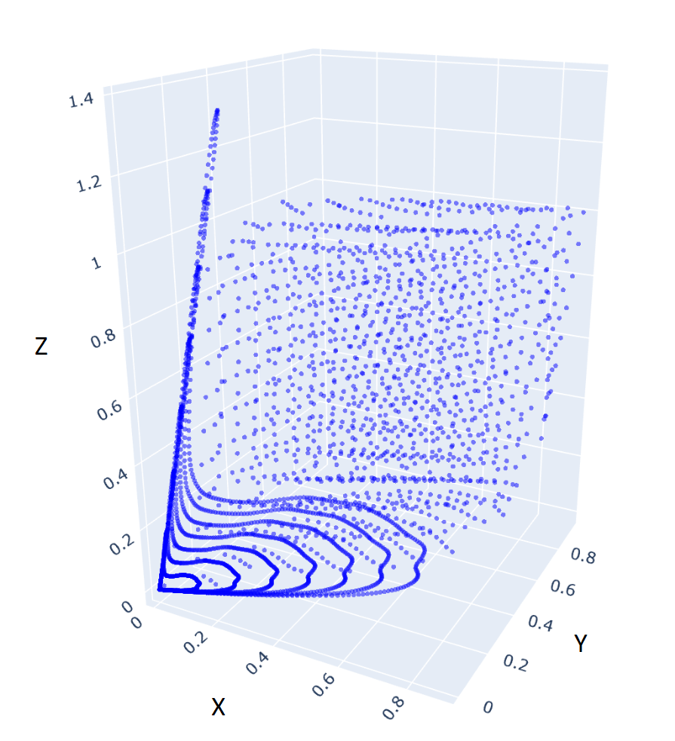
Camera RGB
Observer XYZ
Fig. 2.5 – Train dataset generation using spectral recovery

2.3. Project files and their description
Working directory includes 2 folders and several python files. Their content is given below.

“data” folder - folder containing data required for work - sets of spectral colors, sensor spectral sensitivity, etc.

“results” folder - folder with simulation results.

cmf.py – file with realization of processing procedures for color matching functions of standard observer and sensor spectral sensitivity.

competitors.py – file with implementation of Least Squares competitor and API of Non-optimal LUT competitor.

data_generator.py – The file contains classes for generating train datasets. Train datasets are implemented using spectrum reconstruction.

dataset.py – Class for loading spectral data from a file.

hardcases.py – implementation of special metric, which allows get more detail information about quality of transformation.

hyperspectral_imaging.py – The file contains classes for generating train datasets. The test ones include gradient strips and hyperspectral images.

interface_class.py – The file describes the API of our LUT implementation.

jit_functions.py – Implementation of parallelization of calculations using Python.

main.py – The entry point to the program. Contains launch settings for a case “RGB2XYZ”.

main_gamut_mapping.py – The entry point to the program. Contains launch settings for a case “GamutInProlab”.

main_RGB2RGB.py – The entry point to the program. Contains launch settings for a case “RGB2RGB”.

non_uniform_search.ipynb – A study to evaluate the quality of work of nonuniform LUT.

nonuniform_lut_optiimizer.py – File with the implementation of nonuniform LUT.

not_optimal_lut_construction.py – The file with the implementation of the competitor "non-optimal LUT.

parallelipiped.py – Implementation of the restriction of the RGB-cube by the surface of the parallelepiped.

reflectance_reconstruction.py – Implementation of algorithm LHTSS (Least Hyperbolic Tangent Slope Squared) for spectral recovery.

requirements.txt – the list of libraries versions with which software has been tested and worked successfully on Python 3.8 interpreter

save_results.py – Code for saving the results to the HDD/SSD in the "results" folder in the working directory of the project.

uniform_lut_construction.py – File with the implementation of the optimal LUT.

uniform_search_space.py – File with the implementation of the optimal LUT.

2.4. Working with the software

The interaction with the software is implemented through the execution of main scripts that are responsible for modeling a specific task from the SOW.
- main.py is responsible for RGB-XYZ task;
- main_RGB2RGB for RGB-RGB task;
- main_gamut_mapping.py for gamut mapping tasks respectively.
The basic principles of working with all scripts are the same, or close enough to each other. Therefore, this tutorial will detail the work with the main.py script and then specify the peculiarities of working with other scripts.
RGB-XYZ task
First section, which is worth to be mentioned here is
""" set train and test reflectances """
Here the user can directly set the train and test datasets from different ColorChekers stored in .csv files.
Second section:
""" set parameters for reflectances reconstruction"""
train_grid_frequency = 10
test_grid_frequency = 15
Here the user can set the grid density for spectral reconstructed grid. The number means the value in each dimension, i.e 10 means 10x10x10 grid. It is worth to mention that by our opinion the grid = 40 provides satisfactory results and there are no need to raise this value higher. The user may use another grid as a test data. Note that the dimensions of train and test grids must not coincide, otherwise they will essentially be the same points. For example, they could be 40 and 33 etc.
In this section the user can choose one of available spectral sensitivity functions:
""" set camera sensitivity """
Here the desired illuminant and the corresponded database should be defined
""" set white illuminant """
white_illuminant = dataset.illuminant.cie.std()
white_illuminant_name = 'D65'
The next section defines what kind of test data should be used either color stripes (gradients), or hyperspectral images.
img_mode = 'gradients' # 'gradients', 'hyperspectral'

If the flag:
reconstruct_reflectances_flag = True
the corresponded procedure will start. The best way is to use prerenered grids from .csv files. They can be loaded with the following function call:
reflectances_train = dataset.reflectances.prerendered.grid_40_p50_D65()
note, that the prerendered grid should be with the proper illuminant (suffix D65, or A, or any other).
The hyperspectral imaging section allow to choose one HS picture from the available by setting its number in hs_image_name parameter.
""" hyperspectral imaging """
hs_image_names = ['2021-07-15_003.h5', '2021-07-17_001.h5', '2021-07-18_003.h5', '2021-07-24_002.h5',
'2020-02-25_003.h5', '2020-03-16_015.h5', '2020-03-16_018.h5', '2020-09-15_002.h5',
'2020-09-15_005.h5', '2020-09-15_014.h5']
# hs_image_name = 'none'
# for i in [4, 5, 6, 7, 8, 9]:
hs_image_name = 'data/images/' + hs_image_names[7]

In the section parameters_of_lut the user can choose the desired size of the optimal LUT and set the weights for regularizes. In case when all the sizes are None – the automatic procedure of weights definition will be activated during the process of LUT synthesis.
""" Optimal lut """
parameters_of_lut = {
'number_of_nodes_in_R': 16, # l_r in paper
'number_of_nodes_in_G': 16, # l_g in paper
'number_of_nodes_in_B': 16, # l_b in paper
'lambda_R': 0.00001,
'lambda_S': 0.0001,
'lambda_K': 0.0001,
Another important parameter here is lambda_contrast
'lambda_contrast': None,
When this parameter is set to zero, the calculation is made without taking into account the contrast, when setting a numerical value (usually from 0.0001 to 1) - with preserving the contrast of the reference image.
The parameter “type” defines uniform or nonuniform LUT will be synthesized.
'type': 'uniform', # 'uniform', 'nonuniform'
In section transform_model the desired color transform competitor should be set.
transform_model = "root_polynomial_3x6"
Another competitor – non optimal LUT has the only one parameter – frequency that represents size of the lattice.
""" Not optimal lut processing """
not_opt_lut_obj = NotOptimalLUT(parameters_of_lut['mode'])
not_opt_lut_obj.init_RGB2XYZ(cmf, sss, white_illuminant, white_illuminant_name)
not_opt_lut_obj.fit(frequency=16)

As the script runs, the console will display related information. The execution time depends on the set parameters - LUT size, test data type, calculation variant. Usually, the calculation takes 5 to 10-12 minutes.
At the final stage of the script's execution, graphical results will appear, which must be closed after viewing, in order to continue working. As a result, three graphs with histograms should appear in the project results folder (according to the number of competitors), and in the hs_images folder - the image of color stripes, smoothness map and error map in case of using the 'gradients' parameter or corresponding results of hyperspectral images rendering by each competitor.
When the script finishes running, the special visualization will open in the system browser in a new tab. The training points, built tables, error charts and other related information will be displayed there.

RGB-RGB task
The main difference (and the specificity of the problem) is that here it is necessary to set two illuminants: input and target for mapping. This is represented here:
""" set white illuminant """
white_illuminant_1 = dataset.illuminant.cie.std()
white_illuminant_name_1 = 'D65'
white_illuminant_2 = dataset.illuminant.cie.std()
white_illuminant_name_2 = 'A'
Only the charts with histograms will be provided as graphical results in this task.

Gamut mapping task

The main options should be set in the following section:
parameters_of_data_generator = {
'input_gamut': 'P3-D65', # P3-D65, ITU-R BT.2020
'output_gamut': 'sRGB',
'boundaries': [[0, 1], [0, 1], [0, 1]],
'grid_frequency_train': 40,
'grid_frequency_test': 7
}

The input gamut can be selected from the pre-calculated P3-D65, ITU-R BT.2020.
After executing the script, a set of results will be available, similar to RGB-XYZ case: two graphs with histograms should appear in the project results folder (according to the number of competitors), and in the hs_images folder - the image of color stripes, smoothness map and error map in case of using the 'gradients' parameter or corresponding results of hyperspectral images rendering by each competitor.

