**EASY-FIA USER MANUAL**

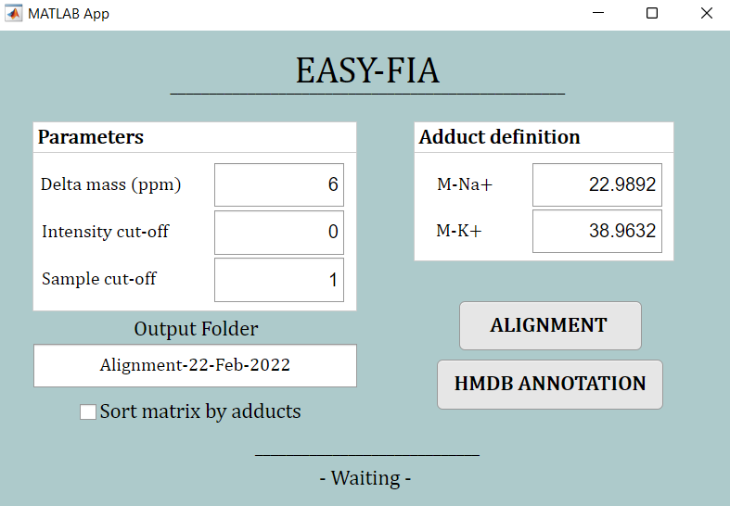

To employ EASY-FIA, the user should follow these instructions:

1. **Install version 9.10 of MATLAB Runtime on the computer.**

To install the Runtime, the user must download from Mathworks website (<https://it.mathworks.com/products/compiler/matlab-runtime.html>) the proper version according to the computer operative system.

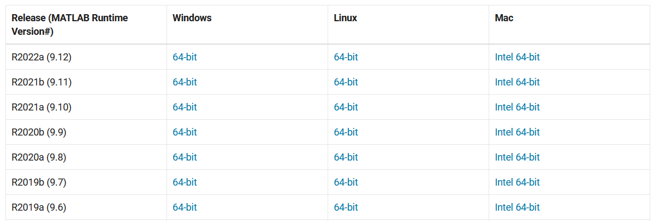

The downloaded folder should be decompressed, and then the user can proceed with the setup through the appropriate file following the instructions.

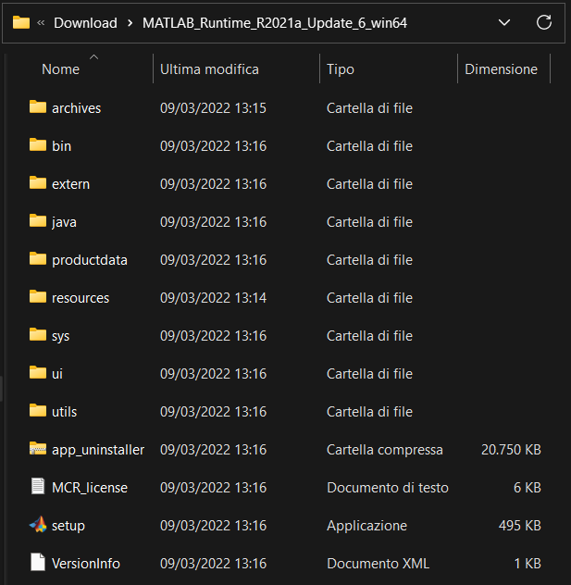

1. **Check if metabolomics data are in the appropriate folder format**.

EASY-FIA requires all the samples and the blank *csv* files to be in the same folder, which must be called *POS* or *NEG* according to the ionization mode of the acquisition. Inside this folder, each blank must have the same name of the corresponding sample, with the prefix “wash”. For instance, if the first sample is named “01”, the blank must be named “Wash_01”. The app is case sensitive and accepts the following prefixes: “wash”, “WASH”, “Wash”. We suggest keeping the names shorter than 5 letters and as simple as possible, avoiding punctuation. We also suggest naming the files in such a way that all the blanks csv are listed after all the sample csv. The accepted csv file must contain the *m/z* list in the first column, and the corresponding intensity in the second one.

1. **Check/modify the elaboration parameters from the *Parameters* box.**

The following parameters can be modified by the user:

* *Delta mass (ppm):* tolerance interval of the instrument used for the acquisition
* *Intensity cut-off:* threshold under which the intensities are discarded
* *Sample cut-off:* minimum number of intensities that each *m/z* must have in order to be considered valid

1. **Check the box *sort matrix by adducts* (optional).**

This option is available for positive ionization mode only*.* If the user checks this box, the intensity matrix will be ordered in such a way that each *m/z* is listed next to its possible adducts.

1. **Click ALIGNMENT and wait for completion.**

When the user presses the alignment button, a dialog window will appear, and he will have to select the folder called POS or NEG which contains the samples and blank *csv* files. Once inside the folder, by clicking on *Open*, the files are uploaded into EASY-FIA.

When the alignment process ends, the notification “Alignment section – THE END” appears on the GUI, and the user can go on with the HMDB annotation.

1. **Click HMDB ANNOTATION and wait for completion.**

The annotation section requires the user to select from a first dialog window the *excel* file produced by the previous alignment section and saved in the appropriate output folder.

Once the user has selected the file, another dialog window will appear, and the user is asked to select the database *mat* file (positive or negative according to the acquisition mode).

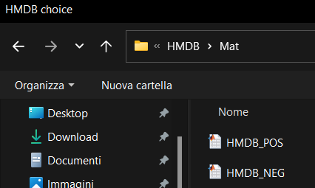

When the annotation section ends, the notification “Annotation section – THE END” appears on the GUI and the result of annotation can be found in the same output folder of the alignment section.