Mutual Fund Analytics Platform
Capstone Project
Bluestock Fintech Pvt. Ltd.

Submitted By:
Anushka Das

Duration:
June 2026

Technologies:
Python, Pandas, NumPy, SQLite,
Power BI, Streamlit,
Machine Learning,
Monte Carlo Simulation,
Markowitz Optimization

DECLARATION

I hereby declare that the project titled “MUTUAL FUND ANALYTICS PLATFORM” submitted as part of the Bluestock Fintech Capstone Project is my original work and has been carried out by me during the internship period.
I further declare that this project has not been submitted, either wholly or partially for any academic or professional evaluation elsewhere. All information, datasets, APIs, and reference materials used in this project have been appropriately acknowledged wherever applicable.
The analyses, visualizations, dashboards, dashboards, machine learning models, portfolio optimization techniques, and reports presented in this document were developed using available mutual fund datasets and tools for educational and professional learning purposes.
I take full responsibility for authenticity and accuracy of the work presents in this reported

Name: Anushka Das
Date: 12th of June, 2026
Signature: Anushka Das

EXECUTIVE SUMMARY

The Mutual Fund Analytics Platform was developed as comprehensive fintech analytics solution for analyzing mutual fund performance, investor behavior, portfolio risk, industry trends using publicly available Indian mutual fund data.
The project integrates data from multiple sources, including AMFI India datasets, mutual fund NAV history, benchmark indices, investor transaction records, portfolio holding, and industry-level statistics. An end-to-end data pipeline was designed and implemented using Python to extract, clean, transform, and process the data into structured datasets suitable for analysis and visualization.
Comprehensive exploratory data analysis (EDA) was performed to identify trends in Assts Under Management (AUM), SIP inflows, investor participation, fund performance, and portfolio composition. Advanced financial metrics such as CAGR, Sharpe Ratio, Alpha, Beta, Maximum Drawdown, Value at Risk (VaR), and Conditional Value at Risk (CvaR) were calculated to evaluate fund performance and risk exposure.
Interactive dashboards were developed using Power BI and Streamlit to provide intuitive access to analytics and business insights. The project was further enhanced through bonus implementations including a machine learning-based mutual fund return prediction model, Monte Carlo simulation for NAV forecasting, Markowitz Efficient Frontier portfolio optimization, automated NAV scheduling, and automated HTML reporting.
The final platform demonstrates the practical application of data engineering, business intelligence, financial analytics, machine learning, and portfolio management concepts within mutual fund domain. The solution provides actionable insights for investors and analysts while showcasing a complete end-to-end analysis workflow.

PROBLEM STATEMENT

The Indian mutual fund industry has witnessed substantial growth in recent years, driven by increasing investor awareness, rising SIP contributions, expanding divgital investment platforms, and growing participation from retail investors. Despite this growth, investors often face difficulties in evaluating mutual fund performance, understanding risk exposure, comparing schemes against benchmark indices, and identifying suitable opportunities based on their financial goals and risk appetite.
Large volumes of mutual fund data are available through AMFI reports, NAV records, benchmark indices, and transaction datasets. However, this information is often fragmented across multiple sources, making comprehensive analysis time-consuming and challenging. Investors and analysts require a centralized platform that can transform raw financial data into meaningful insights through analytics, visualization, and forecasting techniques.
The primary challenge addressed by this project is the development of an end-to-end Mutual Fund Analytics Platform capable of integrating multiple data sources, performing advanced financial analysis, calculating risk and performance metrics, and presenting results through interactive dashboards and reports.
The platform aims to provide a structured approach for analyzing mutual fund performance, investor behavior, portfolio optimization, and business intelligence techniques, the project delivers a comprehensive solution for mutual fund analysis and decision support.

PROJECT OBJECTIVES

The primary objective of this project was to design and develop a comprehensive Mutual Fund Analytics Platform capable of transforming raw mutual fund data into meaningful insights through analytics, visualization, forecasting, and reporting.
The specific objectives of the project are as follows:
O1 – Build a Data Ingestion and ETL Pipeline
Develop an automated Extract, Transform, and Load (ETL) pipeline using Python to collect, clean, transform, and process mutual fund datasets obtained from AMFI India, mfapi.in, and other publicly available sources.
O2 – Design a Structured Data Model
Create a normalized and analytics-ready data architecture capable of efficiently storing and managing mutual fund, benchmark, investor, transaction data for further analysis.
O3 – Perform Exploratory Data Analysis
Analyze mutual fund industry trends, Assets Under Management (AUM), SIP inflows, investor participation, fund distribution, and portfolio composition using statistical and visualization techniques.
O4 – Calculate Risk and Performance Metrics
Evaluate mutual fund performance using key financial indicators including CAGR, Sharpe Ratio, Sortino Ratio, Alpha, Beta, Standard Deviation, Maximum Drawdown, Value at Risk (VaR), and Conditional Value at Risk (CVaR).
O5 – Develop Interactive Dashboards
Create interactive dashboards using Power BI and Streamlit to enable dynamic exploration of mutual fund performance, investor behavior, and market trends.
O6 – Analyze Investor Demographics and Transactions
Study investor transaction patterns, SIP behavior, demographic, and market trends.
O7 – Benchmark Fund Performance
Compare mutual fund performance against benchmark indices such as Nifty 50, Nifty 100, and other market indices to assess relative performance and risk-adjusted returns.

O8 – Generate Reports and Business Insights
Produce professional reports, visualizations, and recommendations that support data-driven decision-making for investors, analysts, and financial stakeholders.
Additional Bonus Objectives
To extend the scope of the project and enhance its practical value, the following advanced features were also implemented:
- Development of a Streamlit-based analytics dashboard.
- Automated NAV update scheduler for a periodic data refresh.
- Machine Learning model for mutual fund return prediction.
- Monte Carlo Simulation for long-term NAV forecasting.
- Markowitz Efficient Frontier portfolio optimization.
- Automated HTML performance reporting system.
The successful completion of these objectives resulted in a comprehensive end-to-end Mutual Fund Analytics Platform integrating data engineering, financial analytics, business intelligence, machine learning, and portfolio management techniques.

DATASET DESCRIPTION AND DATA SOURCES

The Mutual Fund Analytics Platform utilizes multiple datasets representing different aspects of the Indian mutual fund ecosystem. The datasets were provided by the internship company and include financial records, mutual fund performance data, investor transaction details, and benchmark index information. Together, these datasets provide a comprehensive view of fund performance, investor behavior, portfolio composition, and industry growth trends.
Data Sources
The project primarily uses data obtained from the following sources:
- AMFI (Association of Mutual Funds in India)
- mfapi.in REST API
- Publicly available mutual fund industry reports
- NSE and BSE benchmark index data
- Simulated investor transaction datasets generated using realistic market distributions.
Dataset Summary
Dataset | Rows | Description
01_fund_master.csv | 40 | Mutual fund master information including scheme details, fund house, benchmark, expense ratio, and risk category
02_nav_history.csv | 46,000+ | Historical daily NAV records from January 2022 to May 2026
03_aum_by_fund_house.csv | 90 | Quarterly Assets Under Management (AUM) data for leading fund houses
04_monthly_sip_inflows.csv | 48 | Monthly SIP contribution and account statistics
05_category_inflows.csv | 144 | Category-wise mutual fund inflow and outflow data
06_industry_folio_count.csv | 21 | Industry folio growth and investor participation statistics
07_scheme_performance.csv | 40 | Fund performance metrics including CAGR, Sharpe Ratio, Alpha, Beta, and Drawdown
08_investor_transactions.csv | 32,000+ | Investor transaction records including SIPs, lump-sum investments, and redemptions
09_portfolio_holdings.csv | 320 | Equity portfolio holdings and sector allocations
10_benchmark_indices.csv | 8,050 | Historical benchmark index data including Nifty and BSE indices

Data Charecterstics
The datasets collectively capture multiple dimensions of the mutual fund industry, including:
- Fund performance and NAV movement
- Industry growth through AUM and SIP trends
- Investor demographics and transaction behavior
- Benchmark index performance
- Portfolio diversification and sector exposure
- Risk and return characteristics of mutual fund schemes
These datasets formed the foundation for data engineering, exploratory analysis, financial modeling, dashboard development, machine learning applications, and portfolio optimization conducted throughout the project.

SYSTEM ARCHITECTURE AND ETL PIPELINE DESIGN

The Mutual Fund Analytics Platform was designed using a modular data engineering architecture that enables efficient data ingestion, transformation, storage, analysis, and visualization. The architecture follows a structured ETL (Extract, Transform, Load) approach to ensure data quality, consistency, and scalability.
System Architecture
The overall workflow of the platform is illustrated below:
Raw Data Sources (AMFI, mfapi.in, Benchmark Data, Investor Data)
↓
Data Extraction
↓
Data Cleaning & Validation
↓
Data Transformation
↓
Processed Datasets
↓
SQLite Database
↓
Analytics Layer
↓
Power BI Dashboard / Streamlit Dashboard
↓
Reports & Business Insights

Extract Phase
The extraction phase involved collecting data from multiple sources, including mutual fund master records, historical NAV datasets, AUM statistics, SIP inflows, benchmark indices, portfolio holdings, and investor transaction records. The data was provided in CSV format and supplemented through API-based NAV retrieval using mfapi.in.
Transform Phase
The transformation stage focused on improving data quality and preparing the datasets for analysis. Major transformation activities included:
- Handling missing values and inconsistent records.
- Converting columns to appropriate data types.
- Standardizing date formats.
- Removing duplicate entries.
- Creating derived financial metrics.
- Preparing datasets for analytical processing and dashboard integration.
The cleaned datasets were stored separately within the processed data directory to maintain a clear distinction between raw and transformed data.
Load Phase
After cleaning and transformation, the processed datasets were loaded into a structured SQLite database environment. This enabled efficient querying, data aggregation, and integration with analytical workflows. SQLite was selected due to its lightweight nature, ease of deployment, and compatibility with Python-based analytics tools.
Benefits of the ETL Architecture
The ETL architecture provided several advantages:
- Improved data quality and consistency.
- Faster analytical processing.
- Simplified dashboard integration.
- Reproducible data workflows.
- Scalable foundation for future enhancements and automation.
The ETL pipeline served as the backbone of the entire project, supporting exploratory analysis, performance analytics, machine learning models, portfolio optimization, and reporting functionalities.
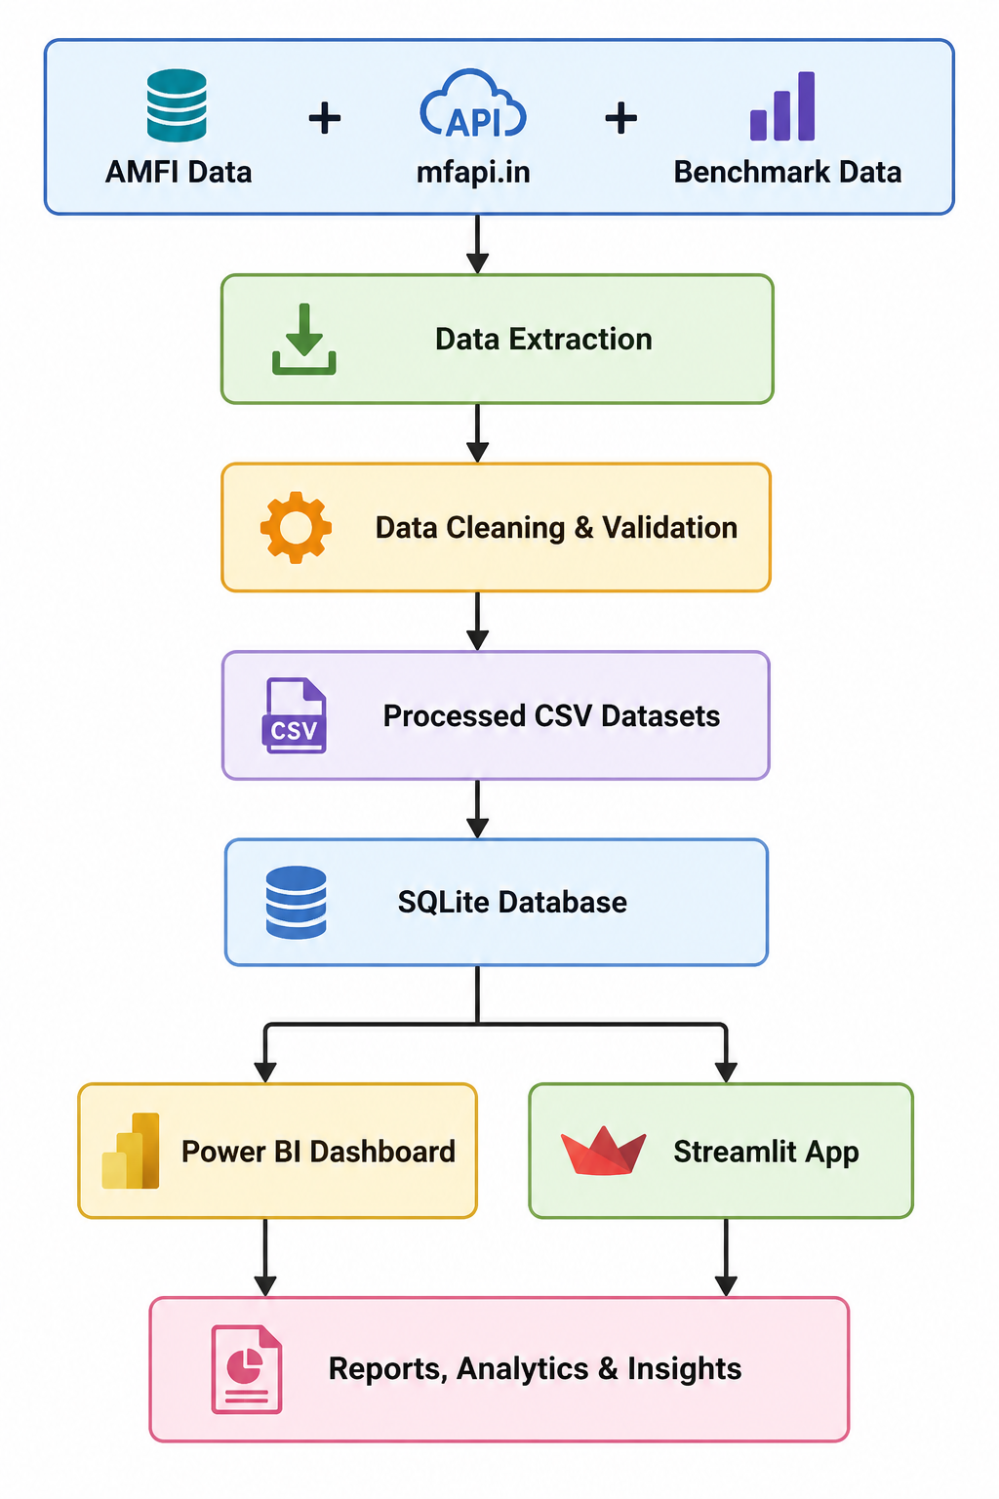
EXPLORATORY DATA ANALYSIS (EDA)

Exploratory Data Analysis (EDA) was performed to understand the overall structure of the mutual fund industry, identify growth trends, analyze investor participation, and evaluate fund category preferences. The objective of this phase was to extract meaningful insights from the processed datasets before performing advanced analytics and predictive modeling.
The analysis focused on key industry indicators such as Assets Under Management (AUM), Systematic Investment Plan (SIP) inflows, folio growth, category-wise fund flows, and fund house distribution. Visualizations were created to identify long-term patterns and market trends.
Key Observations
- Industry AUM demonstrated consistent growth throughout the analysis period, indicating increasing investor confidence in mutual fund investments.
- Monthly SIP inflows showed a strong upward trend, reflecting growing participation from retail investors and the increasing popularity of disciplined investing.
- Industry folio counts continued to rise, suggesting expansion of the mutual fund investor base across different regions and demographics.
- Category-wise inflow analysis revealed that investors favored specific categories such as equity-oriented and diversified funds during periods of market growth.
- Fund house analysis highlighted the concentration of Assets Under Management among a few leading Asset Management Companies (AMCs).
The insights generated during the EDA phase provided the foundation for subsequent risk analysis, performance evaluation, investor analytics, machine learning modeling, and portfolio optimization.
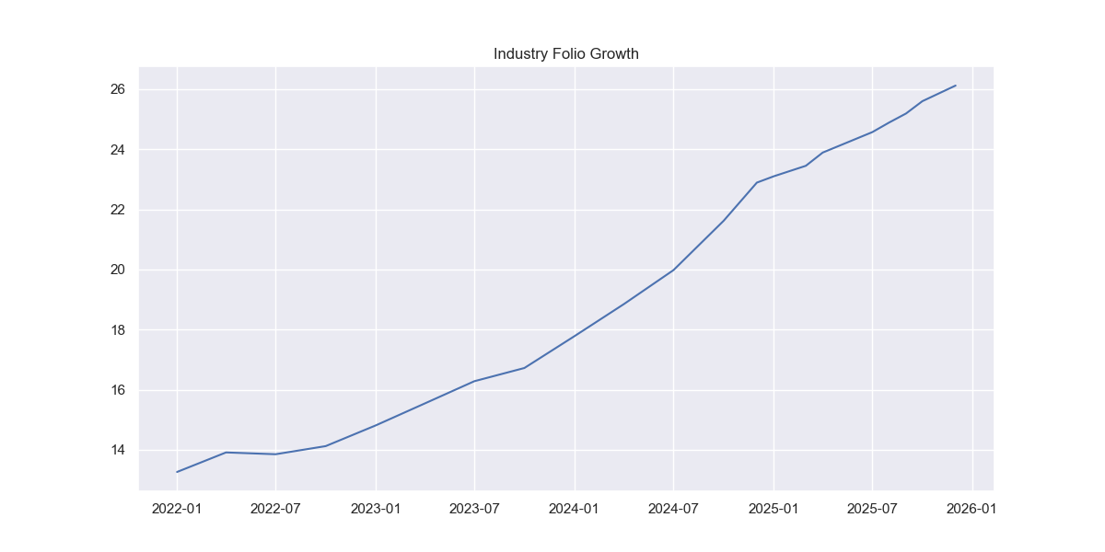
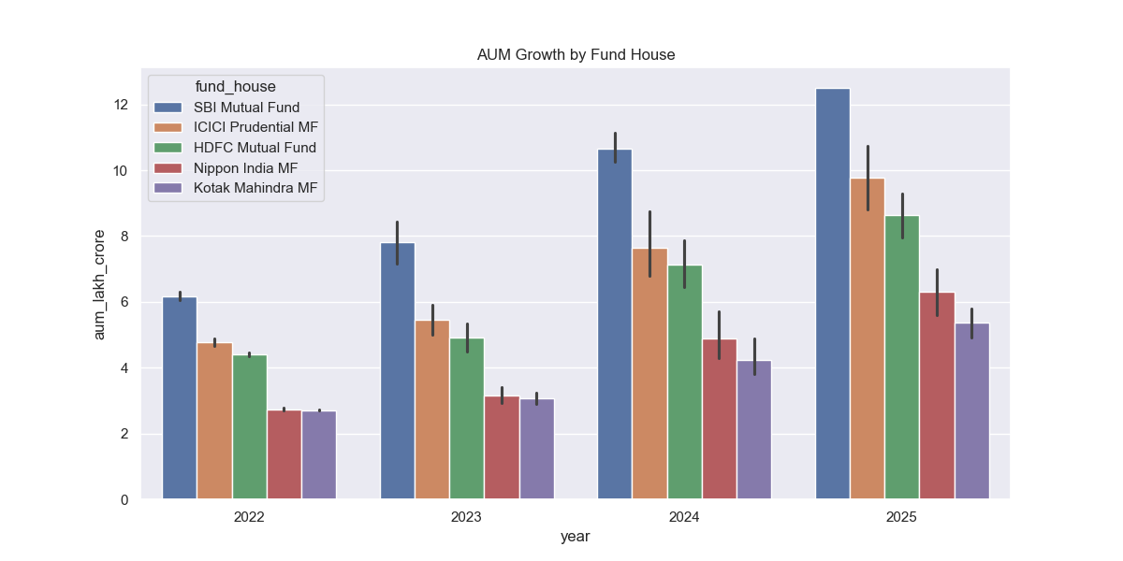
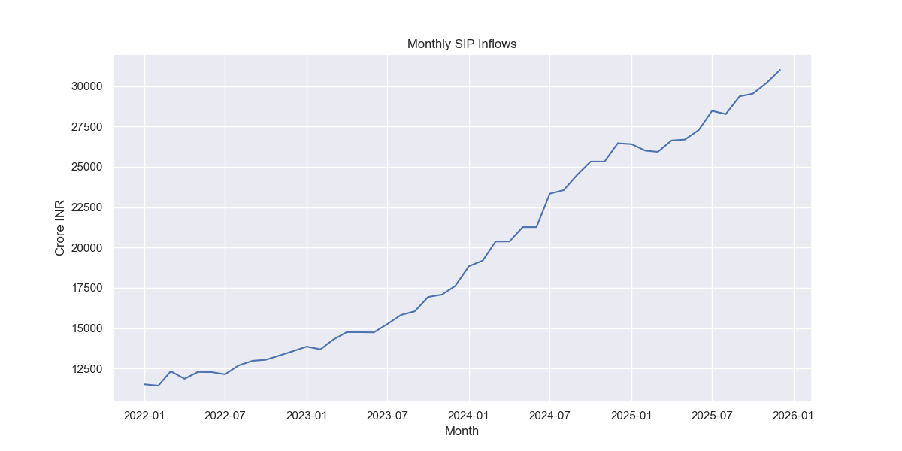
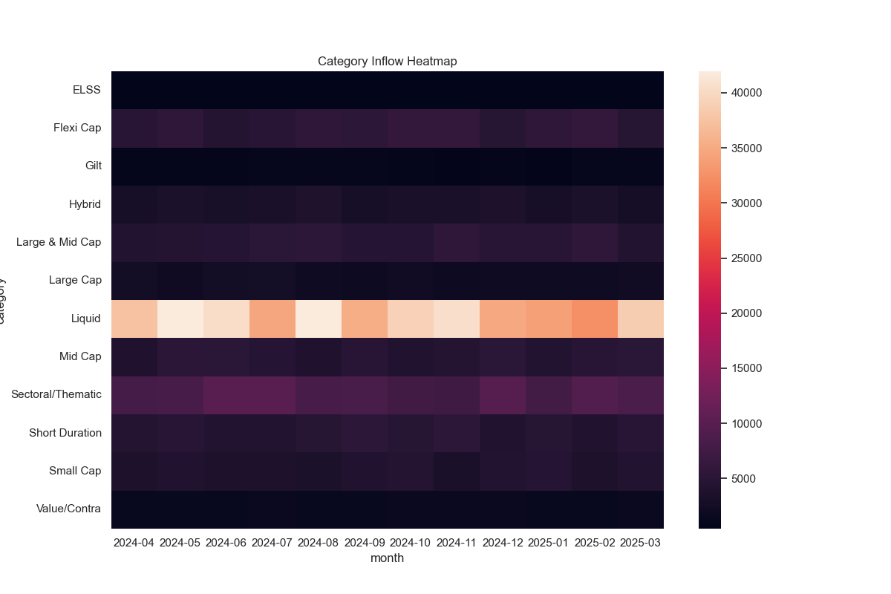

PERFORMANCE AND RISK ANALYTICS

A comprehensive performance and risk analysis was conducted to evaluate the effectiveness of mutual fund schemes across different categories. The analysis focused on measuring returns, risk exposure, downside protection, and risk-adjusted performance using widely accepted financial metrics.
Performance Metrics
Several performance indicators were calculated to compare mutual fund schemes and identify top-performing funds:
Compound Annual Growth Rate (CAGR)
CAGR was used to measure the annualized growth rate of investments over the analysis period. It provides a standardized method of comparing funds with different performance histories.
Sharpe Ratio
The Sharpe Ratio was calculated to evaluate risk-adjusted returns by comparing excess returns against total portfolio volatility. Higher Sharpe values indicate superior risk-adjusted performance.
Sortino Ratio
Unlike the Sharpe Ratio, the Sortino Ratio considers only downside volatility, making it a useful metric for assessing downside risk and capital preservation.
Alpha and Beta
Alpha measures excess return generated relative to the benchmark, while Beta measures sensitivity to market movements. Together, these metrics help assess fund manager performance and market exposure.
Maximum Drawdown
Maximum Drawdown was computed to identify the largest peak-to-trough decline experienced by a fund during the observation period, providing insight into downside risk.
Risk Analytics
Advanced risk measures were also implemented to quantify potential losses and assess portfolio stability.

Value at Risk (VaR)
Historical Value at Risk (95%) was calculated using the daily return distribution of each scheme. VaR estimates the maximum expected loss under normal market conditions at a given confidence level.
Conditional Value at Risk (CVaR)
CVaR was calculated as the average loss beyond the VaR threshold and provides a more conservative estimate of extreme downside risk.
Rolling 90-Day Sharpe Ratio
A rolling Sharpe Ratio analysis was performed to monitor changes in risk-adjusted performance over time and identify periods of stronger or weaker fund performance.
The combination of these metrics enabled a holistic evaluation of fund performance, risk exposure, and investment quality across the mutual fund universe.
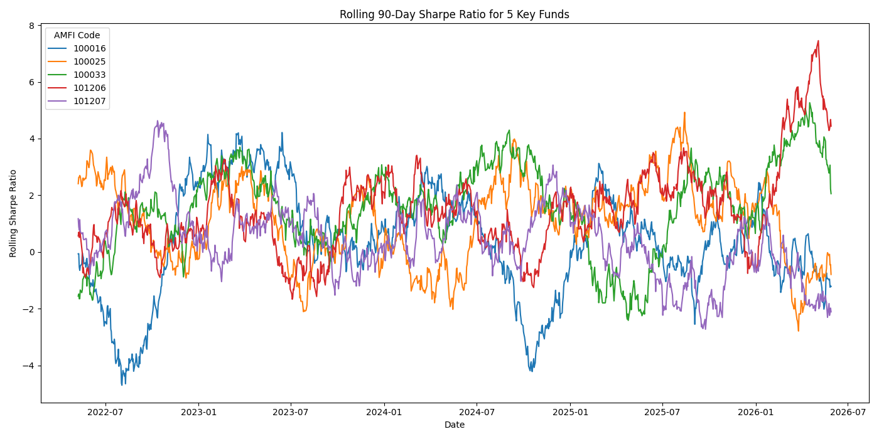


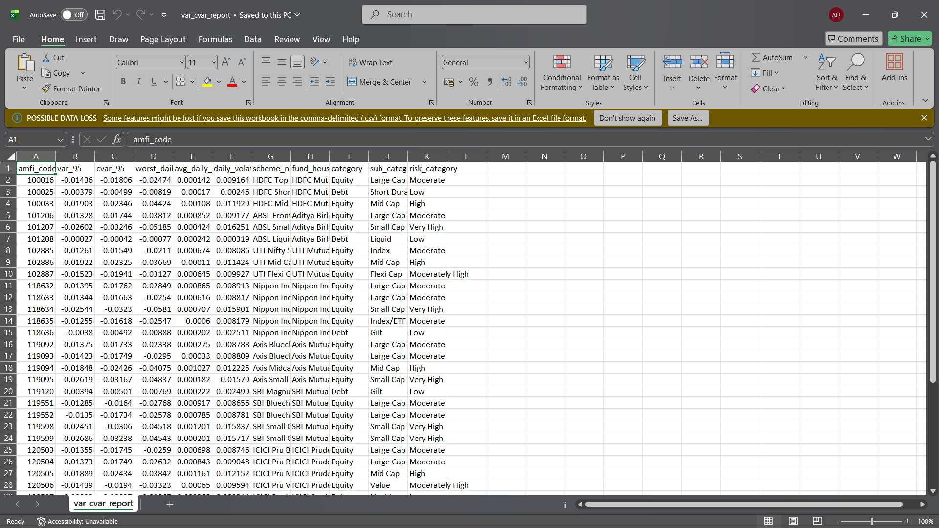

DASHBOARD DEVELOPMENT AND VISUALIZATION

To transform analytical findings into actionable business insights, interactive dashboards were developed using Power BI and Streamlit. These dashboards provide users with a centralized platform for exploring mutual fund performance, investor behavior, market trends, and portfolio analytics.
Power BI Dashboard
A four-page interactive Power BI dashboard was designed to support dynamic analysis of the mutual fund ecosystem.
Industry Overview
The Industry Overview page presents key industry indicators including Assets Under Management (AUM), SIP inflows, total folios, and scheme counts. Trend visualizations highlight the growth of the mutual fund industry over time.
Fund Performance and Risk
This page enables users to compare mutual fund schemes using performance and risk metrics such as returns, volatility, Sharpe Ratio, Alpha, and benchmark performance.
Investor Analytics
Investor transaction behavior was analyzed using demographic attributes including age groups, city tiers, income levels, and transaction types. Interactive filters allow users to explore investment patterns across different investor segments.
SIP and Market Trends
The final dashboard page combines SIP inflow trends with market benchmark movements to identify relationships between investor participation and market performance.
Streamlit Dashboard
In addition to Power BI, a web-based dashboard was developed using Streamlit to provide an alternative interactive analytics platform.
The Streamlit application includes:
- Industry Overview Module
- Fund Performance Analytics
- NAV Trend Explorer
- Investor Analytics
- SIP Market Trends
- Fund Recommendation Engine
The dashboard allows users to dynamically select funds, analyze performance, compare schemes, and receive investment recommendations based on risk appetite.
The combined use of Power BI and Streamlit enhanced accessibility, interactivity, and usability while demonstrating multiple business intelligence approaches for financial analytics.

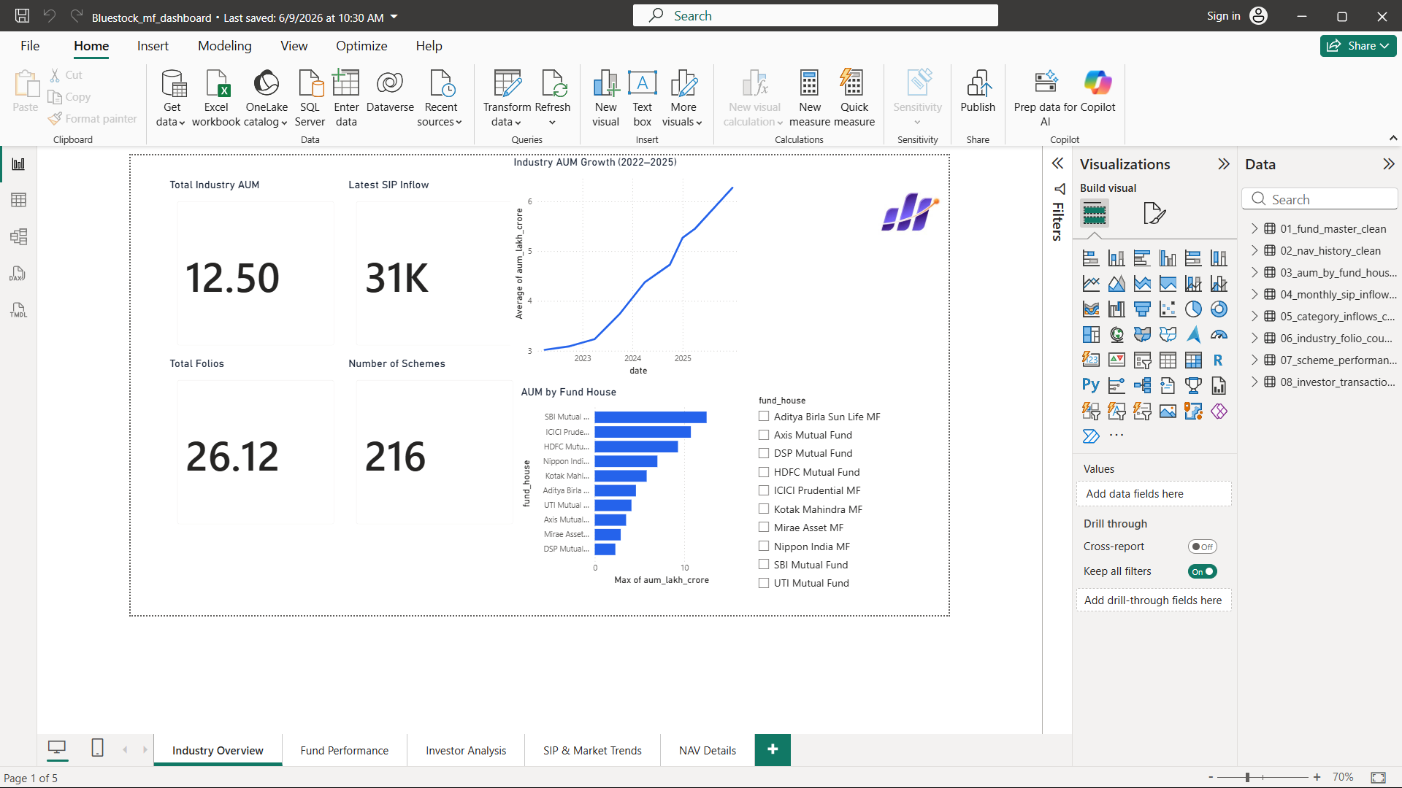
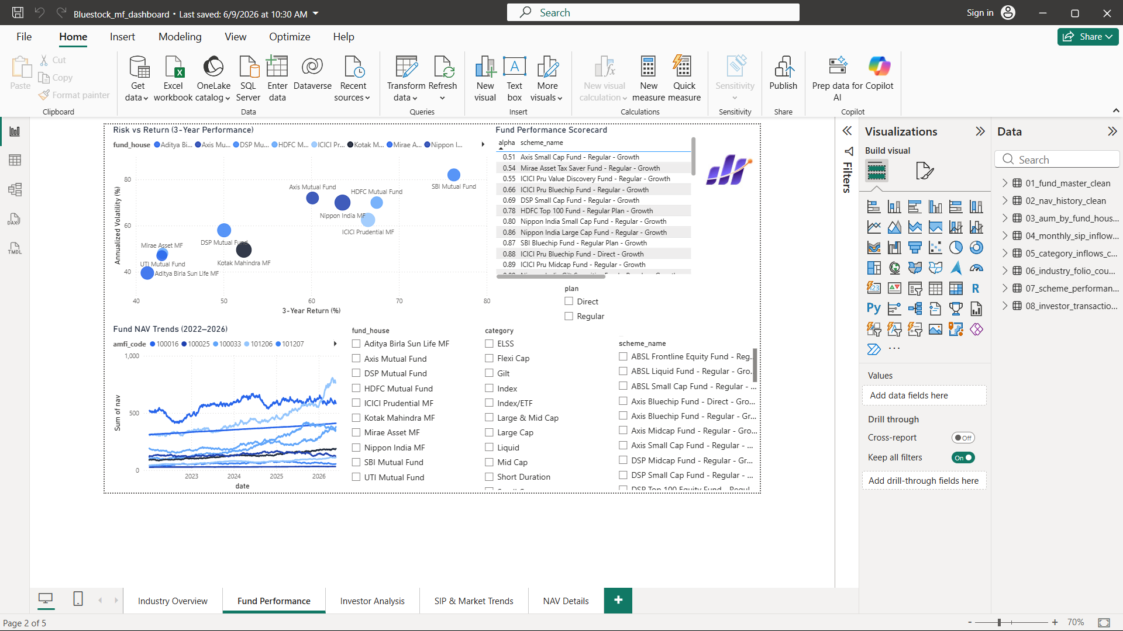
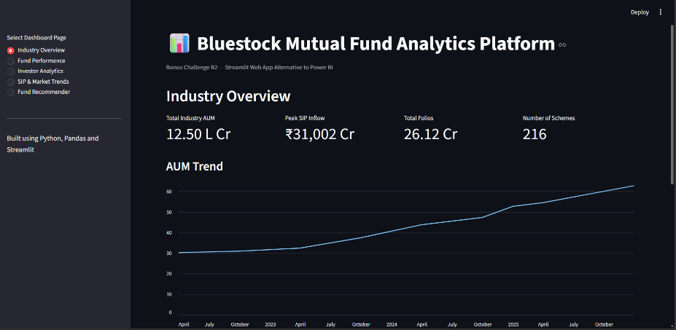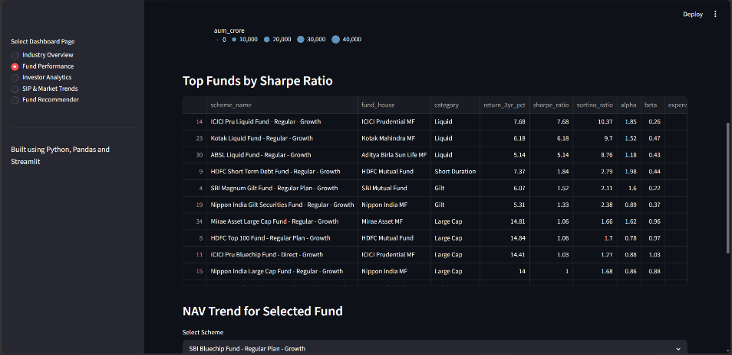

ADVANCED ANALYTICS, KEY FINDINGS AND CONCLUSION
Advanced Analytics
To extend the analytical capabilities of the platform beyond traditional reporting, several advanced analytical techniques were implemented.
Machine Learning-Based Return Prediction
A Random Forest Regression model was developed to predict 3-year mutual fund returns using key performance indicators including Expense Ratio, Sharpe Ratio, Sortino Ratio, Alpha, Beta, Standard Deviation, and Maximum Drawdown.
The model achieved strong predictive performance:
- Mean Absolute Error (MAE): 1.07
- Root Mean Squared Error (RMSE): 1.55
- R² Score: 0.9058
Feature importance analysis revealed that annualized volatility was the most influential factor affecting long-term mutual fund returns.
Monte Carlo Simulation
A Monte Carlo simulation model was implemented to forecast possible future NAV paths using historical return distributions. The simulation generated multiple future scenarios over a five-year investment horizon and provided confidence bands for expected fund performance.
Portfolio Optimization
Markowitz Modern Portfolio Theory was applied to generate an Efficient Frontier and identify the optimal risk-return portfolio. More than 5,000 portfolio combinations were simulated to determine the allocation with the highest Sharpe Ratio.
The optimal portfolio achieved:
- Expected Return: 14.59%
- Portfolio Risk: 6.31%
- Sharpe Ratio: 2.31
Key Findings
The analysis generated several important insights:
- Industry AUM and SIP inflows demonstrated strong long-term growth.
- Retail investor participation continued to increase across multiple demographics.
- Risk-adjusted performance varied significantly across mutual fund categories.
- Volatility emerged as the strongest predictor of future returns in the machine learning model.
- Portfolio diversification substantially improved risk-adjusted returns.
- Automated dashboards improved accessibility and interpretability of mutual fund analytics.
Recommendations
Based on the findings of this project, the following recommendations are proposed:
- Integrate real-time mutual fund APIs for continuous data updates.
- Expand predictive analytics using advanced machine learning and deep learning models.
- Deploy dashboards on cloud platforms for broader accessibility.
- Introduce personalized portfolio recommendation systems.
- Incorporate additional market indicators and macroeconomic variables into future analyses.
Conclusion
The Mutual Fund Analytics Platform successfully demonstrated the integration of data engineering, financial analytics, machine learning, portfolio optimization, and business intelligence techniques within a single end-to-end solution.
The project transformed raw mutual fund datasets into actionable insights through automated data pipelines, advanced risk analysis, interactive dashboards, predictive modeling, and portfolio optimization. The resulting platform provides a scalable foundation for future fintech analytics applications while showcasing practical industry-relevant skills in data science, financial analysis, and business intelligence.

