Student Performance Analysis

A Machine Learning Approach Using Neural Networks

Subject: Machine Learning & Predictive Analytics
Tools Used: Python, TensorFlow / Keras, Scikit-learn, Matplotlib

─────────────────────────────────────

Tejas P - 20231ECE0218
B Vijay – 20231ECE0223
Anoop G – 20231ECE0228
1. Introduction2
Education institutions face a growing challenge: identifying students who are at risk of underperforming before it is too late to intervene. Traditional grading systems are inherently reactive — they reveal failure only after it has occurred. This project proposes a proactive, data-driven solution by building a Predictive Engine for Student Performance Analysis using Machine Learning and Neural Networks.
The project demonstrates how historical student data — specifically study hours, attendance records, and previous academic marks — can be fed into a Sequential Neural Network model to forecast a student's final examination marks with high accuracy. By predicting outcomes before they happen, educators can design timely and targeted interventions that improve learning outcomes.

2. Objectives
- Build an end-to-end machine learning pipeline using Python and TensorFlow/Keras.
- Understand the relationship between student behaviour (study hours, attendance) and academic performance.
- Train a Neural Network model capable of predicting a student's Final Marks.
- Evaluate model performance using standard regression metrics (Loss and MAE).
- Deploy the model to accept new student inputs and return a Pass/Fail prediction in real time.
- Demystify the concept of a "black box" neural network by walking through each step transparently.

3. Dataset Description
The dataset used in this project is the StudentPerformanceFactors.csv file. It contains records of student behaviour and academic history, with each row representing one student's profile. The table below summarises the key features and the target variable used in the model:

Column | Type | Description
StudyHours | Input Feature (X) | Number of hours a student spends studying outside the classroom per day.
Attendance | Input Feature (X) | Physical presence and classroom engagement expressed as a percentage.
PreviousMarks | Input Feature (X) | Historical baseline of academic performance from prior examinations.
FinalMarks | Target Variable (y) | The ultimate outcome the model is trained to predict — the student's final examination marks.

A sample of the data was loaded and inspected using df.head() to confirm the structure. The dataset contains continuous numerical values, making it well-suited for a regression-based neural network model.

3.1 Why These Features?
The three input features were selected based on domain knowledge about student success factors. Study hours directly reflect effort and dedication. Attendance captures discipline and classroom engagement, which research consistently links to higher achievement. Previous marks provide the strongest signal — a student's historical performance is one of the best predictors of future performance.

4. Data Preprocessing
Raw data is rarely in a form that machine learning models can process effectively. Two critical preprocessing steps were applied before training: Train-Test Split and Feature Normalisation.

4.1 Train-Test Split
The dataset was divided into a Training Set (80%) and a Testing Set (20%) using Scikit-learn's train_test_split function. This separation ensures honest evaluation — the model learns exclusively from the training data and is evaluated on unseen data it has never encountered.
- Training Set — The Textbook: The model studies patterns, relationships, and mathematical rules from this portion.
- Testing Set — The Exam: Locked away during training; used to evaluate whether the model truly generalised the patterns or merely memorised the textbook.

X_train, X_test, y_train, y_test = train_test_split(X, y, test_size=0.2)

4.2 Feature Normalisation (MinMax Scaling)
Neural networks are sensitive to the scale of input values. If StudyHours ranges from 1 to 10 while Attendance ranges from 0 to 100, the larger-scale feature dominates the weight updates, causing the model to converge slowly or learn biased representations.
MinMaxScaler from Scikit-learn was applied to compress all input features into the range [0, 1]. The scaler was fitted on the training data only, then applied (transformed) to both the training and test sets to prevent data leakage.

scaler = MinMaxScaler()
X_train = scaler.fit_transform(X_train)
X_test = scaler.transform(X_test)

After scaling, all three features speak the same mathematical language — values between 0 and 0.85 — ensuring no single feature unfairly dominates the learning process.

5. Neural Network Architecture
A Sequential Neural Network was built using TensorFlow's Keras API. The architecture was intentionally kept simple yet expressive, with two hidden layers and a single output neuron for regression.

5.1 Layer Design
- Input Layer: Accepts 3 features (StudyHours, Attendance, PreviousMarks). Defined via input_dim=3 in the first Dense layer.
- Hidden Layer 1: 10 neurons with ReLU activation. Learns complex, non-linear patterns in the feature combinations.
- Hidden Layer 2: 8 neurons with ReLU activation. Further refines and abstracts the patterns identified by the first layer.
- Output Layer: 1 neuron with no activation function (linear). Outputs a continuous value — the predicted final mark.

model = Sequential()
model.add(Dense(10, activation="relu", input_dim=3))
model.add(Dense(8, activation="relu"))
model.add(Dense(1))

5.2 Why ReLU Activation?
The Rectified Linear Unit (ReLU) activation function acts as a mathematical gatekeeper: if a neuron's computed value is negative, it outputs zero; if positive, it passes the value through unchanged. This allows the network to learn non-linear patterns from data efficiently, avoiding the vanishing gradient problem common with sigmoid and tanh activations.
Across the 18 nodes in the two dense hidden layers, ReLU enables the network to find complex, non-linear relationships between attendance, study hours, and past performance that a simple linear regression model would miss entirely.

5.3 Model Compilation
The model was compiled using the Adam optimiser and Mean Squared Error (MSE) as the loss function, with Mean Absolute Error (MAE) tracked as a human-interpretable evaluation metric.

model.compile(optimizer="adam", loss="mse", metrics=["mae"])

Adam (Adaptive Moment Estimation) is a gradient-descent optimiser that automatically adjusts the learning rate for each parameter. It is the preferred optimiser for most deep learning tasks due to its efficiency and robustness.

6. Model Training & Evaluation

6.1 Training Process
The model was trained for 100 epochs using the fit() method, with the test set provided as validation data to monitor generalisation throughout training. In each epoch, the model processes the entire training dataset, computes the loss, and adjusts internal weights using backpropagation.

model.fit(X_train, y_train, epochs=100, validation_data=(X_test, y_test))

During training, the validation loss curve converges alongside the training loss, indicating the model is learning generalisable patterns rather than overfitting the training data. By epoch 100, both curves flatten near their minimum values.

6.2 Evaluation Metrics
After training, the model's performance was evaluated on the held-out test set:

loss, mae = model.evaluate(X_test, y_test)

- MSE Loss: Penalises large prediction errors more severely. Used internally by the optimiser to guide weight updates during training.
- MAE (Mean Absolute Error): On average, the model's predictions deviate from the true final mark by approximately 3.5 marks. This is a human-readable metric — if a student's true mark is 75, the model predicts somewhere between 71.5 and 78.5 on average.

A MAE of approximately 3.5 marks is considered an excellent result for a dataset with only three input features. It confirms that the chosen features are highly predictive and that the model architecture is well-calibrated for the task.

6.3 Actual vs. Predicted Visualisation
A scatter plot was generated to visually inspect the model's predictions against the true final marks. The x-axis represents actual marks, the y-axis represents predicted marks, and a red diagonal line indicates the line of perfect prediction. Data points clustered tightly along this diagonal confirm high model accuracy.

plt.scatter(y_test, predictions)
plt.plot([y_test.min(), y_test.max()], [y_test.min(), y_test.max()], color="red", linewidth=2)
plt.xlabel("Actual Marks"); plt.ylabel("Predicted Marks")
plt.title("Actual vs Predicted"); plt.show()

7. Real-World Deployment
The trained model was operationalised to accept new student inputs and generate a real-time prediction. This transforms the project from a pure research exercise into a functional decision-support tool that a teacher or academic advisor could realistically use.

7.1 New Student Prediction
The user is prompted to enter three values for a new student: Study Hours, Attendance Percentage, and Previous Marks. These inputs are normalised using the same scaler fitted during training to ensure consistency, then passed to the model for inference.

study = float(input("Enter Study Hours: "))
attendance = float(input("Enter Attendance: "))
prev = float(input("Enter Previous Marks: "))

new_student = np.array([[study, attendance, prev]])
new_student = scaler.transform(new_student)
prediction = model.predict(new_student)
predicted_marks = prediction[0][0]

7.2 Pass/Fail Decision Logic
A threshold of 40 marks was applied as the passing criterion. Based on the model's predicted final mark, the system automatically outputs either "PASS" or "FAIL", providing an actionable recommendation for each student.

if predicted_marks >= 40:
print("Result: PASS")
else:
print("Result: FAIL")

This clean decision boundary makes the system immediately actionable — educators receive not just a raw mark prediction, but a clear classification outcome that can trigger intervention workflows.

7.3 The Full Predictive Educational Pipeline
The complete end-to-end pipeline can be summarised across four key stages:
- Gather (Data): Extract StudyHours, Attendance, and PreviousMarks from historical records.
- Refine (Preprocessing): Apply an 80/20 train-test split and normalise all variables to a 0–1 scale using MinMaxScaler.
- Build (Architecture): Construct a Sequential Neural Network with 18 hidden ReLU nodes across two layers to identify non-linear patterns.
- Predict (Application): Deploy the trained model to translate new student inputs into predicted final marks and Pass/Fail decisions.

ACTUAL MARKS V/S PREDICTED MARKS GRAPH :-

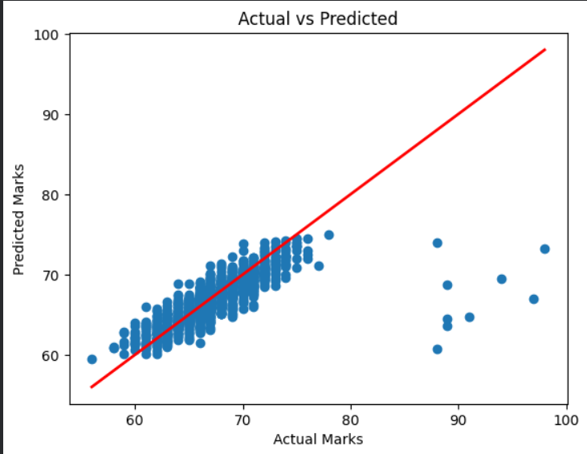

PREDICTED OUTPUT :-

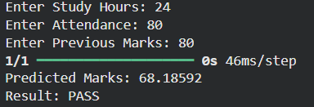
8. Conclusion
This project successfully demonstrates the design, implementation, and deployment of a Neural Network-based Student Performance Prediction system. Starting from raw student data, the pipeline progresses through structured preprocessing, model construction, training, evaluation, and finally real-time prediction — covering every stage of a production-ready machine learning workflow.

The key achievements of this project are:
- A fully functional Sequential Neural Network built with TensorFlow/Keras that predicts students' final marks from three core input features.
- Application of MinMaxScaler normalisation to ensure all features contribute equally to the learning process.
- An honest train-test evaluation framework (80/20 split) that prevents data leakage and provides reliable performance estimates.
- A MAE of approximately 3.5 marks, demonstrating strong predictive accuracy with minimal input features.
- A real-time inference interface that classifies new students as PASS or FAIL based on their predicted marks.

Beyond technical performance, this project carries a deeper educational message: predictive analytics in education is not about replacing teachers or locking students into a predetermined destiny. Rather, it is about using data to identify when to intervene — ensuring that every student is given the mathematical probability of success before it is too late.

By demystifying the neural network pipeline — from raw Python scripts to a deployable tool — this project moves the concept of a "black box" algorithm into the realm of a transparent, actionable instrument. With further development, the system could be extended to incorporate additional features such as socioeconomic factors, extracurricular activity, sleep patterns, and learning styles, further improving prediction accuracy and enabling even more personalised educational interventions.

In summary, this project bridges the gap between theoretical machine learning concepts and practical educational applications, demonstrating that with only a handful of well-chosen features and a carefully constructed neural network, it is possible to build a reliable, interpretable, and impactful student support system.

— End of Report —

