Term paper

On

**Analysis of virtual reality and Augmented reality**

Submitted to **Amity University Uttar Pradesh**

In partial fulfilment of the requirements for the award of the degree of Bachelor of Technology in Computer Science and Engineering by **Atia Naim**

**A2305222498**

Under the guidance of

**Dr Neha Tyagi**

DEPARTMENT OF COMPUTER SCIENCE AND ENGINEERING

AMITY SCHOOL OF ENGINEERING AND TECHNOLOGY

**DECLARATION**

I, **Atia Naim,** hereby state and affirm that the project titled **“Analysis of virtual reality and Augmented reality**”which is submitted by me to **Department of Computer Science and Engineering, Amity School of Engineering Technology, Amity University Uttar Pradesh, Noida** is my original work.

I confirm that the content, findings, and conclusions presented in this project are based on my own research, analysis, and understanding.

I further declare that this project has not been previously submitted for the purpose of obtaining any degree, diploma, or similar recognition. It is a unique contribution that has not formed the basis for any other academic qualification or professional achievement.

Date: 07/07/2023

Atia Naim   
A2305222498

3CSE8 (2022-2026)

**CERTIFICATE**

On the basis of the report submitted by **Atia Naim (A2305222498),** student **of** Bachelor’s of technology in Computer Science and Engineering. I hereby certify that the project titled titled **“Analysis of virtual reality and Augmented reality**” which is submitted to the Department of Computer Science and Engineering. Amity University, Noida Uttar Pradesh in partial fulfilment of the requirements for the award of the Degree of Bachelor of Technology in Computer Science and Engineering is an original contribution with the existing knowledge and faithful record of work carried out by him under my guidance and supervision. To the best of my knowledge this work has not been submitted in part of or full for any degree or diploma to this university or anywhere else.

**Date:** 07/07/2023

**Place:** Noida

**Dr. Neha Tyagi**

(Associate Professor)

Department Of Computer Science and Engineering

Amity School of Engineering and Technology,

Amity University,

Uttar Pradesh, Noida

**Acknowledgment**

I would like to express my deepest gratitude and appreciation to all those who have contributed to the successful completion of this report on the analysis of Augmented Reality (AR) and Virtual Reality (VR). Their support, guidance, and assistance have been invaluable throughout the research process.

First and foremost, I am immensely grateful to my faculty guide, Dr. Neha Tyagi, whose expertise, encouragement, and insightful feedback played a vital role in shaping this report. Your guidance helped me navigate through the vast landscape of AR and VR technologies, and your constant support motivated me to push my boundaries and deliver a comprehensive analysis.

I am also thankful to the numerous experts, professionals, and researchers in the field of AR and VR who generously shared their knowledge and experiences. Their insights and perspectives were invaluable in gaining a proper understanding of the industry and its potential applications.

I am also grateful to my parents, friends and colleagues for their support and encouragement throughout this research endeavour. I also appreciate their effort in filling the survey form for the comparisons and compilation of my research result.

ATIA NAIM

**Abstract**

This report presents an analysis of virtual reality (VR) and augmented reality (AR) technologies, examining their characteristics, applications, and potential impact across various domains. Virtual Reality is a computer-programmed environment that allows users to engage and explore a 3D virtual domain. It is a stimulating experience that can be either entirely different or similar to the real world. Augmented Reality refers to a technology that superimposes virtual content onto the real world by creating an enhanced perception of reality. It combines computer generated elements with the user’s real-world in real time with the use of a camera or other sensors. By understanding the similarities, differences, and properties of VR and AR, this analysis aims to provide insights into their unique capabilities. The report examines the underlying technologies, hardware, and software components for both VR and AR. It highlights their applications in gaming, entertainment, education, healthcare, manufacturing, and architecture. It also addresses ethical considerations. It concludes by emphasizing the importance of understanding the capabilities and implications of VR and AR for informed decision-making and innovation in various sectors.

CONTRIBUTORS

This research paper was completed with the collaborative efforts of Kriti Arora, Tanvi Singh, Atia Naim and Ridhima Saraswat. We all have jumped in together to provide closest to accurate information regarding the topic. We hope this paper assists the readers to get a better and clear understanding of the topic and enlighten them with the intricacies at hand.

**Tanvi Singh** discussed with us the similarities between the two technologies in consideration. She showed the significant advantages of VR and how it impacts us both socially and ethically. Through a collaborative effort with Ridhima Saraswat, they examined the key contributors in the field of AR and VR, contributing to a well-rounded analysis. Additionally, she dedicated her time and effort to finalize the editing of the rough draft.

**Atia Naim** provided us with a comprehensive introduction to the technology of AR, explaining its essence, origins, and historical development. In addition to it, she also discussed the hardware and software used in this technology. Moreover, she presented a thorough analysis of how AR impacts us socially and ethically, highlighting its implications and potential benefits. lastly, she dedicated herself to the final formatting of the report, ensuring a professional and accurate layout.

**Kriti Arora** provided us with contrast between the two technologies highlighting their contrasting features. She discussed the notable advantages and applications of AR, while also providing insights into the hardware and software components of VR. Furthermore, she took the initiative to design and administer a survey, leading to valuable findings that contributed to the conclusive remarks, Thus compiling to final conclusion.

**Ridhima Saraswat** presented a comprehensive introduction to the technology of VR, its historical background and development. She also offered valuable insights into the practical applications of VR technology in different domains, showcasing its versatility and real-world relevance. Additionally, she contributed to the final compilation of the report, rechecking the order of contents to ensure a coherent presentation.

***Analysis of virtual reality***

***and***

***Augmented reality***

Tanvi Singh

Dept. of Computer Science and Engineering,

ASET

Amity University, Noida

[tanvi.singh1@s.amity.edu](mailto:tanvi.singh1@s.amity.edu)

Atia Naim

Dept. of Computer Science and Engineering,

ASET

Amity University Noida

[atia.naim@s.amity.edu](mailto:atia.naim@s.amity.edu)

Kriti Arora

Dept. of Computer Science and Engineering,

ASET

Amity University Noida

[kriti.arora2@s.amity.edu](mailto:kriti.arora2@s.amity.edu)

Ridhima Saraswat

Dept. of Computer Science and Engineering,

ASET

Amity University Noida

[ridhimasaraswat012@gmail.com](mailto:ridhimasaraswat012@gmail.com)

Dr. Neha Tyagi

Associate Professor

Department of Computer Science and Engineering

ASET

Amity University Uttar Pradesh

[ntyagi2@amity.edu](mailto:ntyagi2@amity.edu)

**Context**

|  |
| --- |
| TOPIC |
| Introduction | | 8 |
| Similarities between Augmented reality (AR) and virtual reality (VR) | | 9 |
| Contrast between Augmented reality and Virtual Reality | | 10 |
| History of VR | | 11 |
| History of AR | | 12 |
| User experience and design challenges for AR | | 13 |
| User experience and design challenges for VR | | 15 |
| Significant advancements in VR | | 16 |
| Significant advancements in AR | | 16 |
| Key Contributors In The Field Of Virtual Reality | | 17 |
| Key Contributors In The Field Of Augmented Reality | | 18 |
| Hardware and Software for VR | | 19 |
| Hardware and Software for AR | | 21 |
| Application of AR | | 22 |
| Application of VR | | 24 |
| Social and Ethical Impacts of Augmented Reality | | 26 |
| Social and Ethical Impacts of Virtual Reality | | 27 |
| Conclusion | | 28 |
| Bibliography | | 30 |

1. **Introduction**

**Virtual Reality** is a computer-programmed environment that allows users to engage and explore a 3D virtual domain. It is a stimulating experience that can be either entirely different or similar to the real world. Users are immersed in a digital world that can be perceived through their senses, including sight, hearing, and sometimes touch. All this by just wearing a VR headset or some other specialized equipment.

The key components included in Virtual Reality are: -

* VR Reality: It is the primary set of equipment that is to be worn on the head to experience virtual reality. It consists of a high-resolution display, lenses to display the images, and motion sensors to track the user's head movements. It completely covers the user's field of view and blocks out the real-world surrounding and replaces it with the virtual environment.
* Input Devices**:** The systems use various devices like handheld controllers, data gloves, or motion tracking sensors, that enable user interaction within the virtual environment. These input devices allow users to manipulate objects, navigate through the virtual space, and perform actions within the virtual world.
* Computer Hardware**:** Powerful hardware is required to generate and render a realistic virtual environment. High-performance processors, graphics, cards, and sufficient memory to handle the demanding computational requirements of VR applications.
* Tracking System**:** To create an engrossing encounter, virtual reality often uses tracking systems to monitor the user's movements and adjust the virtual environment accordingly. This allows users to move within the virtual space and have their actions mirrored in the virtual world.
* Audio Structure**:** Sound is one of the fundamental part of virtual reality. it enhances the immersion and practicality of the experience. The setup includes high-quality headphones or inbuilt audio systems to provide spot on spatial audio, allowing users to hear sounds coming from separate directions.

Virtual Reality finds applications in various fields, like in gaming and entertainment. it offers an unmatched degree of immersion, enabling players associate with virtual worlds and characters. VR is also used for training purposes, allowing individuals to practice complex tasks and scenarios in a safe and controlled environment. Architecture and design industries also utilize VR to create virtual walkthroughs, aiding in decision-making processes. VR also plays a crucial role in healthcare sector, it assists in pain management, rehabilitation, and exposure therapy.

VR technology's ongoing development has immense potential to transform industries, modernize human-computer interaction, and create new opportunities in entertainment, learning, and communication. It offers immersive experiences, enhances training and education, and redefines how we connect and collaborate. The future of VR is promising, with boundless possibilities for immersive, engaging, and impactful experiences across various aspects of our lives.

**Augmented Reality** refers to a technology that superimposes virtual content onto the real world by creating an enhanced perception of reality. It combines computer generated elements with the user’s real-world in real time with the use of a camera or other sensors. It captures the surrounding environment and display the augmented content on a device like table, smartphone etc.

The key components included are: -

* Input devices and Sensors**:** Devices like cameras, microphones, GPS, etc. are used. They capture real world data and provide information about the user’s location, movement, and orientation.
* Processing and Recognition: The input data is analysed and processed to recognize user’s environment. This includes computer vision techniques, object recognition algorithms and spatial mapping to detect and track real world objects.
* Content Creation and Rendering: The system creates virtual content like 2D images, 3D models, animations etc. This virtual content is rendered and precisely aligned with the real-world view to create seamless integration.
* Display and Output: The rendered virtual content is displayed to the user through various devise like smartphones, tablets or smart glasses. Audio output can also be used to enhance the AR experience.
* User Interface and its interaction: The AR system provides ways for users to interact with the virtual content and manipulate the augmented environment. It involves touch gestures, voice commands, hand tracking, or specialized input devices.

Augmented reality has numerous applications across various fields, including gaming, education, healthcare, marketing, and entertainment. It can enhance training and simulation, improve spatial understanding, enable interactive storytelling, facilitate remote collaboration, and provide contextual information in real-time.

As technology advances, AR is becoming more immersive, precise, and integrated into our daily lives, opening new possibilities for innovation, and transforming the way we perceive and interact with the world around us.

1. **Similarities between Augmented Reality and Virtual Reality**

Even though virtual and augmented reality are two different technologies, they do overlap on certain grounds.

* Gadget utilisation**:** Both AR and VR involve usage of similar gadgets such as headsets or glasses which provide the user with immersive experience. They all involve incorporation of display, sensors, and tracking systems to capture user’s movement.
* Virtual object: Both at the end deal with virtual objects thus have to be created by the developer. They both deal with 3D content (though 2D content can also be used in AR).
* Interaction: Involves user interaction where the objects, spaces and content can be manipulated by the user.
* Training and Simulations: AR and VR are used in various industries, including military, healthcare, and aviation, to provide realistic training simulations and improve learning outcomes.
* Spatial Mapping: Both technologies can spatial map the user's surroundings to understand the environment and incorporate virtual elements accordingly.
* Education: The scope of these technologies is immense in the field of education where they can provide the students with realistic visuals to understand the concepts more thoroughly.
* Design and Architecture: AR and VR when incorporated in design and architecture industries can create virtual prototypes, visualize designs, and showcase projects to clients in a more efficient manner.
* Healthcare and Medical Applications: extremely helpful in surgical training and education.

1. **Contrast between Augmented reality and Virtual Reality**

* **Basic Idea**
* Augmented reality is a technological technique which integrates the real world with the computer programmed content creating a collaborative environment for the user.
* Virtual reality is a technological technique that replaces the actual surroundings of the user creating a virtual interactive space (like a digital realm) for them.
* **User Engagement**
* Augmented reality enhances the user’s actual world by incorporating digital entities, such as 3D objects, graphics and information in users view point. User can interact with both physical and virtual elements simultaneously.
* Virtual reality engages the user in a fictional digital realm. User can only interact with virtual elements or digital entities that too using specific virtual reality hard ware.
* **Hardware Requirement**
* Augmented reality could easily be accessed using standard devices like smartphones, tablets and smart glasses.

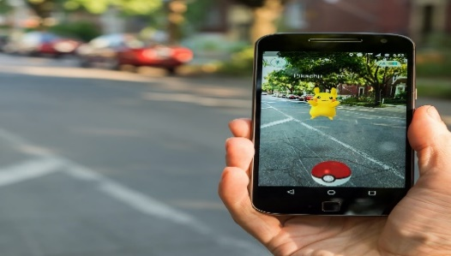

* Virtual reality requires dedicated device like VR headsets for its utilization. VR headsets usually comprises of different motion sensors and screen trackers for its functioning. some common VR headsets are Oculus Rift, Samsung Gear VR, HTC Vive and Google Daydream View.

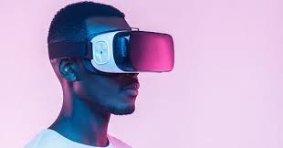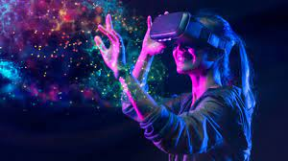

Mayank Banoula (March 9, 2023) Corrinna Peters (March 7, 2023)

* **Application**
* Augmented reality applications include gaming, education, training simulations, navigation, industrial design, retail, healthcare etc. some common examples of AR are Pokemon Go, Snapchat filters, and AR-assisted surgeries.
* Virtual reality application includes gaming, training simulations like car simulators to learn driving, architecture, virtual tours etc .
* **Content Generation**
* Augmented reality content generation is usually done is real time, continuously adapting to user’s environment.
* Virtual reality content generation is usually pre-programmed to provide a specific experience.
* **Health and Safety**
* Augmented reality comparatively provide lower safety hazards as the user is still aware of their surroundings.
* On contrary virtual reality can potentially cause motion sickness and dizziness after a prolonged use. it also increases the chances of safety risks if the user is not careful enough.

1. **History Of AR and VR**

Over the course of several decades, Augmented Reality (AR) and Virtual Reality (VR) have developed a rich history. These technologies have experienced significant growth and have found their way into diverse fields like gaming entertainment, training, healthcare, and architecture. this proves as a promising future for these technologies.

**Virtual Reality (VR)**

# 1960s:

* Ivan Sutherland, a computer scientist, develops the "Sword of Damocles," considered one of the earliest VR head-mounted display (HMD) systems. It used a head-mounted display and a suspended arm mechanism to track head movements.

# 1970s:

* Myron Krueger develops "Videoplace," an interactive environment that allowed users to interact with projected computer graphics using their bodies.

# 1980s:

* Jaron Lanier, a computer scientist and artist, coins the term "Virtual Reality" and founds VPL Research, a company dedicated to developing and selling VR-related products.
* VPL Research introduces devices like the DataGlove, which tracks hand movements, and the EyePhone, a head-mounted display with integrated stereo speakers.
* NASA starts using VR in their training programs, including the VIEW system for training astronauts in simulated environments.

# 1990s:

* Sega releases the Sega VR headset for arcade gaming, which provides a stereoscopic 3D experience.
* The Virtuality Group introduces a series of VR arcade machines, such as the "Virtuality 1000CS," enabling multiplayer VR gaming experiences.
* Nintendo releases the Virtual Boy console, a VR headset that displays red monochrome graphics. Despite its limited success, it paves the way for future developments in the gaming industry.
* VR research and development continue in various academic and industrial settings, but interest and funding decline towards the late 1990s.

# 2000s:

* The gaming industry continues to explore VR concepts, but technological limitations, high costs, and limited market demand prevent widespread adoption.
* Various universities and research institutions work on advancing VR technology, focusing on areas such as immersive displays, tracking systems, and haptic feedback.

# 2010s:

* The Oculus Rift, a high-quality VR headset, is introduced via a Kickstarter campaign, capturing significant attention and reinvigorating interest in VR.
* The Oculus Rift's success leads to a resurgence of VR development, with other companies, such as HTC (Vive) and Sony (PlayStation VR), entering the market with their own headsets.
* VR gains traction beyond gaming, finding applications in healthcare, education, architecture, and training simulations.
* Mobile VR becomes accessible with the introduction of smartphone-based VR headsets like Google Cardboard and Samsung Gear VR.
* Mixed Reality (MR) headsets, such as Microsoft's HoloLens, blend virtual elements with the real world, further expanding the possibilities of immersive experiences.

# 2020s:

* VR technology continues to evolve with advancements in display resolutions, field of view, and tracking systems.
* Companies and developers create a wide range of VR experiences, including games, virtual tours, social interactions, and training programs.
* VR finds applications in therapeutic treatments, architectural visualization, remote collaboration, and more.
* Standalone VR headsets gain popularity, eliminating the need for external devices or a powerful PC, making VR more accessible to a broader audience.

The history of VR has seen significant advancements and periods of both enthusiasm and stagnation. However, with the ongoing development of technology and the increasing interest in immersive experiences, VR is poised to continue evolving and finding new applications in various industries.

**Augmented Reality (AR)**

# 1960s:

* Ivan Sutherland, a computer scientist, develops the "Sword of Damocles," an early head-mounted display (HMD) system that had both VR and AR elements. It superimposed simple wireframe graphics onto the user's view.

# 1970s:

* Myron Krueger creates "Videoplace," an interactive system that allows users to interact with computer-generated graphics projected onto physical space. Although not strictly AR, it laid the groundwork for interactive digital overlays on the real world.

# 1980s:

* Steve Mann develops the "WearComp," a wearable computing system that used a camera to capture the user's view and overlay digital information on top of it, essentially creating an early form of AR.

# The term "Augmented Reality" was first introduced by Thomas Caudell, a researcher employed at Boeing. Caudell coined this phrase to describe a digital display system designed to aid in the process of aircraft assembly. This system seamlessly combines virtual information with the real-world environment, providing valuable assistance and enhancing the efficiency of assembling aircraft components.

# 1990s:

* Louis Rosenberg founds the Virtual Fixtures company, which explores AR concepts for industrial and military applications. They develop AR systems that enhance human performance in various tasks.
* Hirokazu Kato develops the ARToolKit, an open-source software library that enables the tracking of markers and the overlay of digital information onto live camera feeds.

# 2000s:

* AR applications begin to emerge in the entertainment industry. ARQuake, a project by Bruce Thomas, Mark Billinghurst, and others, allows users to play a real-world version of the popular game Quake, overlaying virtual enemies onto the user's surroundings.
* In 2009, Layar releases the first AR mobile app, which allows users to view digital information overlaid on their smartphone's camera view. This marks the beginning of AR on mobile devices.

# 2010s:

* Google introduces Google Glass, a wearable AR device that resembles a pair of glasses. It displays digital information in the user's field of view, allowing for hands- free interaction with the digital world.
* Microsoft develops the HoloLens, a mixed reality headset that combines AR and VR elements. It enables users to interact with holographic digital content in the real world.
* Pokémon Go, a mobile AR game, becomes a global phenomenon, introducing AR to a wide audience and showcasing its potential for gaming and interactive experiences.
* AR finds applications in various industries, including architecture, healthcare, education, and marketing. Companies like IKEA use AR to allow customers to visualize furniture in their homes, while surgeons use AR to enhance surgical procedures.

# 2020s:

* AR technology continues to advance, with improvements in hardware, software, and computer vision algorithms. Smartphones and tablets become common platforms for AR experiences.
* Apple introduces ARKit, a framework for developing AR apps on iOS devices, which drives further adoption and innovation in the AR space.
* AR glasses and headsets, like the Microsoft HoloLens 2 and the Magic Leap One, offer more immersive and hands-free AR experiences.
* AR becomes increasingly integrated into everyday life, with applications ranging from navigation and shopping to social media filters and remote collaboration.

The history of AR showcases its evolution from early experimental systems to mainstream applications. As technology continues to progress, AR is expected to become even more prevalent, offering new ways to interact with digital information and enhancing our perception of the real world.

# User Experience and Design Challenges for AR

Augmented Reality has emerged as a transformative technology with the potential to revolutionize various industries and enhance user experiences. However, implementing effective AR experiences presents several challenges that need to be addressed to ensure seamless user interactions and optimal design.

# User Experience Challenges:

* Spatial Understanding: AR requires users to perceive and interact with virtual entities overlaid in the real world. One of the primary challenges is achieving accurate spatial understanding, it includes depth perception, object placement, and occlusion. Incomplete or inaccurate spatial mapping can result in confounded experiences and difficulty interacting with virtual objects.
* User Interface Design: Designing intuitive and user-friendly interfaces for AR applications is indispensable. Striking a balance between displaying relevant information and avoiding visual clutter poses a challenge. Determining optimal placement, size, and format of AR elements while considering user context and preferences is essential to provide smooth and consistent experiences.
* Interaction and Input: AR offers unique interaction possibilities, such as gestures, voice commands, and haptic feedback. However, designing intuitive and efficient input methods without overwhelming users can be challenging. Balancing simplicity and complexity while providing clear instructions for interaction is vital for an optimal user experience.
* Performance and Latency: AR experiences heavily rely on real-time tracking, rendering, and processing of virtual content. Poor performance and delay issues can negatively impact the user experience by causing lag, jitter, or inaccurate object placement. Maintaining smooth and responsive interactions is essential for a compelling AR experience.

# Design Challenges:

* Contextual Relevance: Designing AR applications that seamlessly integrate with the user's environment and context is vital. Ensuring that virtual objects are contextually relevant, meaningful, and aligned and anchored with the user's goals is a challenge. Designers must consider factors such as the user's location, task, and preferences to provide valuable AR experiences.
* Visual Realism and Aesthetics: Achieving realistic and visually appealing virtual objects in AR can be challenging. Maintaining consistency in lighting, shading, and object integration with the real world requires advanced rendering techniques. Striking a balance between realism and visual aesthetics while considering performance limitations is crucial.
* Privacy and Ethical Considerations: AR applications often collect user data, including

location and visual information. Protecting user privacy, ensuring data security, and addressing ethical concerns related to data usage and potential misuse present significant design challenges. Maintaining the right balance between personalized experiences and user privacy is essential.

* Social Acceptance and Norms: AR can introduce new social dynamics and challenges. Balancing individual user experiences with social acceptance and norms can be complex. Avoiding obtrusive or disruptive AR experiences in public spaces and considering cultural, social, and ethical implications are crucial for widespread adoption.

Augmented Reality holds immense potential to transform user experiences across various domains. However, addressing the user experience and design challenges associated with AR technology is paramount for its successful implementation. By focusing on spatial understanding, user interface design, interaction, performance, contextual relevance, visual realism, privacy, ethics, and social acceptance, designers can create immersive, intuitive, and meaningful AR experiences that delight users and drive widespread adoption.

# User Experience and Design Challenges for VR

Virtual Reality (VR) has gained significant attention as an immersive technology that transports users into virtual worlds. While VR offers exciting possibilities, it also presents unique user experience (UX) and design challenges. This report aims to explore the key UX and design challenges associated with VR technology.

# User Experience Challenges:

* Motion Sickness: VR experiences can induce motion sickness or discomfort due to a mismatch between the user's visual perception and the physical sensations they experience. Minimizing motion sickness through optimized movement, field of view, and frame rates is crucial for a comfortable and enjoyable user experience.
* Presence and Immersion: Achieving a sense of presence and immersion in VR is essential for creating compelling experiences. Challenges include creating realistic virtual environments, accurate tracking of head and body movements, and providing convincing haptic feedback to enhance the feeling of being present in the virtual world.
* User Interface Design: Designing intuitive and effective user interfaces in VR presents unique challenges. Navigating menus and interacting with virtual objects require careful consideration of spatial and gestural interactions. Striking a balance between providing necessary information and avoiding visual clutter is crucial for an immersive and user-friendly interface.
* Interaction and Input: VR offers various input methods, including handheld controllers, motion tracking, voice commands, and even eye tracking. Designing intuitive and natural interaction methods that align with user expectations is essential for an optimal UX. Ensuring that interactions are responsive and accurate is crucial for maintaining user engagement.

# Design Challenges:

* Comfort and Ergonomics: VR hardware design must prioritize user comfort and ergonomics to ensure extended periods of use without physical discomfort or fatigue. Designing lightweight and adjustable headsets, ergonomic controllers, and optimizing weight distribution are critical factors in creating a comfortable VR experience.
* Visual Realism and Performance: VR demands high-quality graphics and smooth performance to maintain a sense of realism and prevent distractions. Striking a balance between visual fidelity, rendering performance, and minimizing latency is crucial. Optimizing graphical assets and leveraging advanced rendering techniques are key considerations for creating immersive and visually appealing VR experiences.
* Content Creation and Adaptation: Creating compelling and engaging VR content presents unique challenges. Adapting traditional forms of media, such as films and games, to the VR medium requires reimagining storytelling techniques, camera perspectives, and user interactions. Designers need to explore new creative approaches and understand the affordances and limitations of VR as a medium.
* Accessibility: Ensuring that VR experiences are accessible and inclusive to a wide range of users is vital. Challenges include addressing physical limitations, providing customization options for different abilities, and considering the needs of users with visual, auditory, or cognitive impairments. Designing for a diverse user base help create inclusive VR experiences.

Virtual Reality presents exciting opportunities for immersive and engaging experiences, but it also brings several UX and design challenges. By addressing challenges related to motion sickness, presence and immersion, UI design, interaction and input, comfort and ergonomics, visual realism and performance, content creation and adaptation, and accessibility and inclusivity, designers can create compelling and user-friendly VR experiences. Overcoming these challenges will contribute to the widespread adoption and advancement of VR technology.

# Significant advancements in VR

As we all are already aware, technology around us is far different than the one present a decade or even half a decade ago. The need for more innovation pushes us into developing fresh things on a frequent basis.

The technology of virtual reality has been around since the 1960s and has undergone numerous developments.

# Hardware:

From basic headsets made according simple mechanics we have now shifted to more complicated ones such as the HTC Vivo Pro which offer the consumer an immersive experience with their wider and better displays and better tracking making the whole setup more realistic.

The gear available today allows the user to feel the true essence of the virtual world and creating a sense of oneness with it.

# Size:

The equipment size has halved and many are now standalone (require no connection to the PC)

# Improved Graphics:

Brands like AMD have improved graphics card creating a more realistic experience.

# Availability:

Due to drastic change in technology, the once available on big theatre styled cabinets like the Sensorama is now available one click away on our smartphones

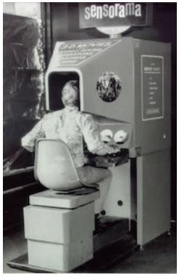

Sensorama

# 

# Significant advancements of Augmented reality

Augmented reality has experienced significant advancements in recent years, redefining the way in which we engage with digital realm and thus enhancing our experiences in various fields.

Some of the major advancements in AR are

* Enhanced hardware: Over the years, AR devices have evolved to be more lightweight, compact and powerful. AR devices have also encountered developments in display technology, enabling superior resolution and wider visual scope, resulting in more authentic and captivating AR interactions.

Smart glasses, such as Microsoft HoloLens and Magic Leap One, offer immersive AR experiences.

* Interactive mapping and tracking: AR have witnessed advancements in form of improved computer vision algorithms and advanced sensors, enabling real-time tracking and mapping of the physical surroundings This allows AR systems to accurately connect digital content with precise positions and objects in real-time, producing a seamless and captivating encounter.
* Objectdetectionand engagement: AR has developed to demonstrate superior skill in identifying and understanding objects in real world. Machine learning algorithms and computer vision techniques empower AR systems to recognize objects, including buildings, products, or landmarks, and provide relevant information for an interactive experience.
* Audio:Spatial audio techniques produce an illusion of 3D sound, enabling users to perceive sound sources originating from specific direction adding to the realism of AR environments.
* Training and Education**:** AR has evolved into a valuable tool in training and education. By superimposing digital content onto real-world scenarios, AR enables interactive and captivating learning experiences. This includes medical simulations, virtual laboratories, historical recreations, and language learning.
* Gesture tracking and voice sensing: AR systems have grown more adept at recognizing and comprehending gestures and voice commands. This empowers users to interact with digital content and control AR applications using natural and intuitive gestures or voice instructions. Hand tracking technology, combined with machine learning algorithms, facilitates precise gesture recognition, enriching the user experience.
* Multi user and multi device experience**:** AR has developed to support multi-user and multi-device experiences, encouraging collaboration and interaction among multiple users within the same augmented environment
* Advanced visual quality**:** Developments in rendering techniques, graphics processing, and display technologies have brought about enhanced visual realism in AR.

1. **Key Contributors In The Field Of Augmented Reality**

The field of augmented reality (AR) has seen numerous key contributors who have made significant contributions to its development and advancement. While it is challenging to provide an exhaustive list, here are some prominent individuals and companies that have played influential roles in the field of AR:

* Ivan Sutherland was regarded as the "father of computer graphics". He is known for his groundbreaking work on the Sketchpad system in the year 1960, which laid the formation of AR technologies.
* Steve Mann: A pioneer in wearable computing and AR, Steve Mann has been researching and developing AR systems since the 1980s. He is known for his work on wearable AR displays and the concept of "mediated reality."
* Thad Starner: Thad Starner is a computer scientist and one of the early pioneers of wearable computing and AR. He co-founded the MIT Wearable Computing Project and later became a technical lead for Google Glass.
* Mark Bolas: As a researcher and professor at the University of Southern California, Mark Bolas has contributed significantly to AR and virtual reality (VR). He co-founded the Mixed Reality Lab at USC and has worked on various AR projects.
* Magic Leap: Magic Leap is a prominent company in the AR industry. They have developed an AR headset that blends virtual objects with the real world, providing highly immersive experiences. Rony Abovitz, the co-founder of Magic Leap, has been instrumental in advancing AR technology.
* Microsoft: Microsoft has made significant contributions to AR with its HoloLens headset. Alex Kipman, the inventor of Kinect and a technical fellow at Microsoft, has been instrumental in the development of HoloLens and the company's AR efforts.
* Meta Company: Meta Company, now known as Meta View, was a company that focused on creating AR headsets. Its founder, Meron Gribetz, aimed to create a more natural and intuitive AR interface using hand gestures.
* Apple: Apple has made significant investments in AR technology, introducing ARKit, a development platform for creating AR applications for iOS devices. Apple's CEO, Tim Cook, has expressed a strong interest in AR and considers it a transformative technology.
* Facebook: Facebook: Facebook has been actively engaging in the development of AR through its AR platform, Spark AR. They have offered creators with the necessary tools and frameworks to develop AR experiences on popular platforms such as Messenger and Instagram. Mark Zuckerberg, the CEO of Facebook, has emphasized the potential of AR in social interactions.
* Google: Google has been involved in AR through projects like Google Glass and ARCore, an AR development platform for Android devices. They have also explored AR applications in areas such as navigation and education.

Please note that this list is not exhaustive, and there are numerous other individuals, research groups, and companies that have contributed to the field of AR. The field is rapidly evolving, and new contributors and innovations continue to emerge.

1. **Key Contributors In The Field Of Augmented Reality**

The field of virtual reality (VR) has been shaped by numerous key contributors who have made significant contributions to its development and advancement. While it is difficult to provide an exhaustive list, here are some prominent individuals and companies that have played influential roles in the field of VR:

* Jaron Lanier: Jaron Lanier is often referred to as the "father of virtual reality." He coined the term "virtual reality" and founded VPL Research, a company that developed some of the earliest commercial VR devices.
* Ivan Sutherland: Ivan Sutherland, mentioned earlier as a key contributor to AR, also made significant contributions to VR. His pioneering work on the Sword of Damocles, an early VR head-mounted display, laid the groundwork for immersive virtual reality experiences.
* Palmer Luckey: Palmer Luckey is the founder of Oculus VR, a company that played a crucial role in popularizing modern VR. Oculus Rift, the company's flagship headset, gained significant attention and was later acquired by Facebook.
* Oculus VR (Facebook Reality Labs): Following the acquisition by Facebook, Oculus VR has continued to contribute to the field of VR under Facebook Reality Labs. They have released subsequent iterations of their VR headsets and invested in VR content development.
* Valve Corporation: Valve Corporation, a prominent video game developer and publisher, collaborated with HTC to create the HTC Vive, a popular VR headset. Valve also developed the SteamVR platform, providing a robust ecosystem for VR games and experiences.
* HTC: HTC, a Taiwanese consumer electronics company, partnered with Valve to develop the HTC Vive. Their collaboration resulted in one of the first high-quality room-scale VR systems available to consumers.
* Sony Interactive Entertainment: Sony's PlayStation VR has played a significant role in bringing VR to the gaming market. The company's expertise in console gaming and their dedicated VR headset for PlayStation have contributed to the growth of VR in the gaming industry.
* Google: Google has made contributions to VR with its Google Cardboard, a low-cost VR viewer that utilizes smartphones as the display. They have also developed the Daydream VR platform and invested in VR content and experiences.
* Michael Abrash: Michael Abrash is a renowned software engineer and researcher who has contributed to the advancement of VR technology. He worked at Valve Corporation and later joined Oculus VR/Facebook Reality Labs, where he continues to be involved in VR research.
* Unity Technologies and Epic Games: These game engine developers, with Unity and Unreal Engine respectively, have provided developers with powerful tools and frameworks for creating VR experiences. Their engines have been widely adopted and have played a significant role in VR content creation.

Please note that this list represents a selection of key contributors and companies in the field of VR, but there are many other individuals, research groups, and companies that have made significant contributions to the advancement of virtual reality technology. The field continues to evolve, and new innovators are constantly emerging.

1. **Hardware and Software for VR**

To overlay the virtual content and enhancing our perception and interaction with the environment both hardware and software components are required.

**Hardware**

VR hardware generally comprises a collection of interconnected components that collaborate to deliver a captivating virtual reality encounter. some of the core components of VR are:

* Head-Mounted Display (HMD): The primary constituent of a VR setup is the head-mounted display (HMD), it is a wearable device that you wear on your head like a pair of goggles or a helmet. It usually comprises of dual screens, one for each eye, and lenses that project the virtual content to your eyes. Additionally, it may feature integrated sensors to track head movements, facilitating real-time adjustments to the displayed visuals.
* Computing framework: In order to meet the requirements of VR systems, a dedicated VR-ready computer with a high-performance graphics card, sufficient RAM, and a fast processor is often recommended However, an alternative option is to use standalone VR headsets, which have their own built-in computing capabilities, eliminating the need for an external computer altogether.
* Tracking system: A tracking system is essential for accurately detecting your movements within the virtual environment. VR incorporates diverse tracking technologies, such as:
* Inside-Out Tracking: This approach utilizes built-in cameras or sensors on the HMD to accurately track the position and movement of the headset and controllers. By eliminating the requirement for external sensors or cameras, it provides increased flexibility and simplifies the setup process.
* Outside-In Tracking: This method depends on external sensors or cameras strategically positioned in the room to track the HMD and controllers. By capturing precise position and movement data, these sensors enable the VR system to recreate your actions within the virtual world.
* Controllers: VR controllers are portable gadgets that allow users to engage and interact within the virtual environment. These controllers typically feature buttons, triggers, and touch-sensitive surfaces, enabling users to engage with and manipulate virtual objects. Additionally, they have the ability to track hand movements, allowing users to effortlessly grasp, pick up, and manipulate objects within the virtual environment.
* Audio Devices: Immersive audio plays a crucial role in crafting an authentic VR encounter. Numerous VR systems incorporate integrated headphones or speakers within the HMD to deliver spatial audio, heightening the feeling of presence by offering precise audio positioning that corresponds to your head movements.
* Additional Accessories: The availability of supplementary accessories may vary depending on the VR system and its intended purpose. These accessories can encompass haptic feedback devices that offer tactile sensations to amplify immersion or dedicated peripherals such as VR treadmills or motion platforms that enable more intuitive movement within the virtual realm.

**Software**

Virtual reality (VR) software is essential for the development, distribution, and administration of an immersive virtual reality experience. Some key components of VR software are:

* VR content creation: VR Content Creation involves utilizing VR software tools for the creation of virtual content, including 3D modelling, animation, and audio editing. Some common examples are Unity or Unreal Engine.
* Audio and Spatial Sound: VR software incorporates audio rendering capabilities to craft an enveloping soundscape. It utilizes spatial sound techniques to emulate 3D audio, where sounds radiating from precise locations within the virtual environment.
* VR Simulation and Interactions: VR software offers a broad spectrum of interactive experiences and simulations. Users have the freedom to venture through virtual realms, engage with virtual objects, shape the environment, unravel puzzles, partake in gaming, or immerse themselves in virtual training scenarios. The software facilitates real-time physics simulations, object interactions, and dynamic responses to user input.
* User Interface (UI) and Interaction: VR software provides user interfaces specifically designed for VR environments. These interfaces enable users to traverse, choose preferences, and engage with the virtual realm. Example of UI elements include manual gestures, digital overlays, vocal commands, and controllers.
* Social and Multiplayer Capabilities: VR software offers networking and multiplayer capabilities, enabling users to connect with one another in virtual environments. They can engage in activities, communicate through voice chat, and share virtual spaces for social interactions and participate in multiplayer events.

1. **Hardware and Software for AR**

To overlay the virtual content and enhancing our perception and interaction with the environment both hardware and software components are required.

**Hardware**

* Smartphones and Tablets: Many AR apps are available on smartphones they use built in cameras, sensors, and processing power. They can also display AR content and track the user’s position and orientation.
* AR Glasses: Augmented reality glasses or smart glasses are wearable devices designed especially for AR experience. They include a display that overlays virtual content onto the user's field of view, as well as sensors and cameras for tracking and interaction. Examples of AR glasses include Microsoft HoloLens, Magic Leap One, and Google Glass Enterprise Edition.
* Head-Mounted Displays: Head-Mounted Displays or HMDs are wearable devices that cover the user's entire field of view, immersing them in a virtual environment. Some HMDs, such as the Microsoft HoloLens, also support AR functionality by blending virtual content with the real world.
* AR Headsets: AR headsets are similar to HMDs but are specifically designed for AR experiences. They provide a see-through display that overlays virtual content onto the user's view of the real world. Some examples of AR Headsets include “The Nreal Light” and “The Vuzix Blade”.
* Motion Tracking Systems: These systems use various sensors, such as cameras, accelerometers, gyroscopes, and depth sensors, to track the user's movements and position accurately. They enable accurate alignment of virtual content with the real world, enhancing the AR experience. Some examples of Motion Tracking System include “The Microsoft Kinect” and “The Leap Motion Controller”.

**Software**

* AR Development Platforms: These platforms provide the necessary tools, libraries, and APIs to create AR applications. Some popular AR development platforms include Unity 3D (with AR Foundation), Apple ARKit (for iOS), Google ARCore (for Android), and Microsoft Mixed Reality Toolkit.
* Computer Vision and Tracking: Computer vision algorithms and tracking techniques play a crucial role in AR software by facilitating the recognition and tracking of objects and surfaces in the real world. Several popular libraries commonly employed for computer vision and tracking in AR are OpenCV, Vuforia, and ARToolKit. These software libraries leverage advanced computer vision techniques to accurately position and align virtual content within the user's environment.
* Content Creation Tools: Software tools like 3D modelling and animation software like Autodesk Maya, Blender etc., are used to create 3D models, animations, and other digital assets for AR experiences.
* AR Applications: These are the actual applications or experiences that run on AR-enabled devices. They can range from AR games and entertainment to industrial training and visualization tools.

1. **Application of AR**

The potential of augmented reality applications is immense, as they can transform the way we learn, explore, and communicate, breathing life into knowledge and imagination in extraordinary ways. Here are some important applications of augmented reality:

* Gaming: By providing captivating and engrossing encounters, augmented reality has brought a revolutionary shift to the gaming industry. A prime illustration of this is seen in Pokémon Go, a widely popular game where players utilize their smartphones to capture virtual Pokémon creatures that seamlessly blend into real-world surroundings through an overlay of digital elements.
* Entertainment**:** AR is used in theme parks, museums, and sports events to create interactive and engaging experiences. For instance
* Disney's Magic Kingdom incorporates AR technology into various experiences, such as interactive games and character interactions like "Sorcerers of the Magic Kingdom," where visitors use their devices to interact with virtual characters in the park.
* Museums like the Smith-sonian National Museum of Natural History use AR to provide additional facts and details.
* At historical sites like the Acropolis Museum, AR is employed to reconstruct ancient structures, transporting visitors back in time.
* Zoos and aquariums like the San-Diego Zoo, uses AR to deliver interactive and educational experiences by superimposing virtual creatures onto real animals.
* Education and Training: AR has the potential to transform education by making learning more engaging and interactive. For instance, anatomy classes can utilize AR to project 3D models of the human body, allowing students to explore and interact with various organs and systems. This hands-on experience enhances understanding and retention.
* Retail and E-commerce**:** Retailers are utilizing augmented reality (AR) to elevate the shopping experience, empowering customers with innovative visualization tools.
* A prime example is IKEA's Place app, which grants users the ability to virtually position furniture within their rooms, offering a glimpse of how it fits and complements their existing decor hence enabling the users to preview furniture and home decor items in their own spaces before committing to the purchase.
* Lenskart, a popular eyewear retailer, has used augmented reality (AR) technology to enhance the shopping experience for their customers. Through their AR-powered virtual try-on feature, users can virtually try on different glasses and sunglasses from the Lenskart collection using their smartphones or devices. This technology allows customers to see how various frames look on their face in real-time, providing an accurate representation of how the glasses would appear when worn.
* Medical Applications**:** AR has proven valuable in medical fields, such as surgery and medical training. Surgeons can use AR to utilize patient data, such as CT scans, onto the surgical field, providing real-time guidance during procedures. Medical students can also benefit from AR by practicing virtual surgeries or studying detailed anatomical models.
* Industrial Design and Manufacturing**:** AR is utilized in design and manufacturing to streamline workflows and minimize errors. Designers can visualize and manipulate 3D models in real-world environments, enabling informed decisions about product design. AR-guided assembly instructions assist workers in complex manufacturing processes, reducing training time and enhancing accuracy.
* Navigation: AR in navigation uses augmented reality technology to overlay digital information onto the real world, enhancing the navigation experience. It provides real-time guidance through visual markers and arrows superimposed on the user's field of view, directing them along the route. Contextual information, such as ratings, reviews, and menus of nearby places, can also be displayed. AR navigation apps can leverage real-time data, such as traffic conditions or public transportation schedules, to provide up-to-date information. The most common example of ar navigation is google maps.
* Fashion**:** An example of AR in the fashion industry is the use of virtual fitting rooms. With AR-powered apps, customers can virtually try on clothing items without physically being present in a store. By overlaying virtual garments onto the customer's image in real-time, AR allows them to see how different styles, sizes, and colors would look on their body. Through this alternative implementation of AR, organizations can streamline their operations, improve efficiency, and ensure higher quality outputs in design and manufacturing**.**
* Architecture: AR in architecture allows architects and designers to visualize and present designs in an immersive and interactive manner. Through AR applications, virtual 3D models can be overlaid onto real-world environments, providing clients and stakeholders with a realistic view of proposed structures.

An example of augmented reality (AR) in architecture is the use of AR visualization tools like the Microsoft HoloLens. Architects can utilize the HoloLens headset to superimpose virtual 3D models of buildings onto physical spaces in real-time

* Social Media**:** AR in social media allows users to apply filters, effects, and interactive digital elements to their photos, videos, and stories. It adds creativity, fun, and self-expression to social media content. Users can choose from a variety of filters that modify their appearance or apply virtual objects, characters, or animations to their posts.

some examples of social media apps that use AR are snapchat, Instagram and tik-tok.

1. **APPLICATIONS OF VR**

The versatility of Virtual Reality (VR) extends Across diverse industries. From healthcare to education and beyond, VR proves invaluable in how we approach various sectors, unlocking new possibilities and enhancing experiences. some applications of VR are:

* Gaming and Entertainment: VR provides immersive gaming experiences by placing the player in a virtual world. Users can interact with the virtual environment, explore new worlds, and have a more engaging gaming experience.
* Training and Simulation: VR is extensively used for training purposes in industries such as aviation, military, healthcare, and manufacturing. It allows trainees to practice in realistic virtual environments, reducing costs and risks associated with real-world training scenarios. For example, pilots can practice flight simulations, surgeons can perform virtual surgeries, and soldiers can undergo combat training in a safe environment.
* Education and E-Learning: VR is increasingly being used in education to enhance learning experiences. Students can explore historical sites, visit museums, or even travel through space, providing a more immersive and interactive learning environment.
* Architecture and Design: Virtual Reality (VR) presents a transformative solution by enabling architects and designers to construct virtual prototypes of buildings, interiors, and landscapes. Clients can then explore and experience these designs before they are built, allowing for better visualization and decision-making.
* Healthcare and Therapy: VR has applications in healthcare for pain management, physical therapy, and mental health treatment. It can help distract patients from pain during medical procedures or provide simulated environments for therapeutic interventions.
* Real Estate and Tourism: VR allows potential buyers to take virtual tours of properties, saving time and resources. Similarly, in the tourism industry, VR enables people to explore travel destinations and attractions virtually before making travel plans.
* Engineering and Prototyping: VR aids engineers in designing and testing prototypes virtually, reducing the time and cost associated with physical prototypes. It allows for better visualization, collaboration, and identifying design flaws early in the product development process.
* Sports and Fitness: VR can be used to enhance sports training by creating realistic simulations and scenarios for athletes. It can also be used for virtual fitness classes, gamifying workouts, and providing motivation for users.
* Social and Communication: VR provides a platform for social interactions and communication in virtual environments. Users can meet, interact, and collaborate with others from different locations, fostering virtual communities and enhancing remote collaboration.
* Art and Design: VR opens new possibilities for artists and designers to create immersive and interactive artworks. It allows users to engage with art in unique ways and explore virtual exhibitions and galleries.

Some real-life applications of Virtual Reality are:

* Manufacturing and Product Design:
* Ford: The automotive giant uses VR to create virtual prototypes, allowing designers and engineers to visualize and test different vehicle designs before building physical prototypes.
* Boeing: The aircraft manufacturer employs VR to simulate assembly processes, enabling workers to train and optimize production workflows in a virtual environment.
* Construction and Architecture:
* Mortenson Construction: This construction company utilizes VR to create immersive walkthroughs of building designs, enabling clients to experience and provide feedback on the planned structures before construction begins.
* AECOM: The architecture and engineering firm employs VR for virtual collaboration, allowing teams spread across different locations to meet virtually and review design plans in a shared 3D environment.
* Healthcare and Medical Training:
* Cedars-Sinai Medical Centre: The hospital uses VR simulations to train medical professionals in complex procedures, such as minimally invasive surgeries, improving their skills and reducing risks during actual surgeries.
* AccuVein: This medical technology company offers a VR-based device that helps healthcare professionals locate veins for blood draws and IV insertions, enhancing accuracy and minimizing patient discomfort.
* Oil and Gas:
* Chevron: The energy company utilizes VR for safety training, creating realistic simulations of hazardous environments and emergency scenarios to train employees on proper protocols and response procedures.
* BP: The oil and gas company employs VR for immersive visualization of complex drilling operations, enabling engineers and geologists to plan and optimize exploration processes.
* Retail and E-commerce:
* IKEA: The furniture retailer offers a VR app that allows customers to visualize and place furniture in their homes, helping them make informed purchasing decisions and reducing the need for physical store visits.
* Alibaba: The e-commerce giant uses VR to create virtual shopping experiences, enabling customers to browse and interact with products in a virtual store environment.
* Training and Education:
* Walmart: The retail corporation employs VR for employee training, providing simulations of various scenarios like customer interactions and emergency situations to enhance skills and knowledge.
* SimSpray: This VR training system is used in vocational schools and trade programs to teach painting techniques, reducing material cost and providing a safe environment for learners.

1. **Social and Ethical Impacts of Augmented Reality**

Augmented Reality has the potential to significantly impact society and raise a considerable amount of social and ethical considerations. While AR offers exciting possibilities for enhancing human experiences and improving various sectors, it also presents challenges and risks that need careful consideration.

Some key aspects of the social and ethical impacts of AR:

* Privacy: AR technology often requires access to personal data for location tracking, user preferences, and behaviour analysis. This data can be valuable for targeted advertising or personalized experiences, but it raises concerns about privacy violations. Users may not have full control over the collection, storage, and use of their data. To discourse this, developers and AR platforms should prioritize user consent, transparency in data practices, and robust data protection measures.
* Security and Safety: As AR blurs the restrictions between the physical and digital worlds, there are potential security risks. Malicious actors could exploit vulnerabilities in AR systems to manipulate information, create misleading experiences, or launch cyberattacks. It is vital to implement robust security measures, such as encryption, authentication protocols, and vulnerability testing, to protect users and prevent unauthorized access or manipulation of AR experiences.
* Psychological and Emotional Impact: AR experiences can be immersive and appealing, but excessive use or reliance on AR can impact users' mental and emotional well-being. Addiction, detachment from reality, and increased anxiety are some of the potential risks. Balancing AR usage with real-world experiences, promoting digital wellness, and providing user education on responsible consumption is significant to mitigate these impacts.
* Digital Divide and Accessibility: AR technology relies on devices such as smartphones, smart glasses, or headsets. The cost and availability of these devices may create a digital divide, where certain individuals or communities have limited access to AR experiences. Bridging this gap and ensuring equitable access to AR technology is important to prevent exacerbating social inequalities. Additionally, considering accessibility needs, such as designing AR experiences for individuals with disabilities, is crucial for inclusivity.
* Ethical Content and User Interaction: AR content can raise ethical concerns, such as promoting violence, explicit content, or spreading misinformation. Developers and platforms must establish clear guidelines and policies to ensure responsible content creation and user interaction within AR environments. Implementing moderation mechanisms, empowering users to report inappropriate content, and enforcing content standards are necessary to mitigate ethical challenges.
* Impact on Real-world Interactions: The immersive nature of AR experiences can impact real-world interactions. Users engrossed in AR may become less aware of their physical surroundings, leading to accidents or social disconnection. It is important to educate users about responsible AR usage, such as using AR in appropriate contexts and maintaining situational awareness, to ensure safety and social cohesion.
* Workplace and Economic Disruptions: AR has the potential to revolutionize industries and workflows, bringing increased efficiency and new opportunities. However, there may be concerns about job displacement and economic inequalities resulting from the adoption of AR technologies. Preparing the workforce through upskilling and reskilling initiatives, ensuring fair employment practices, and fostering a supportive transition to AR-enabled workplaces are important to minimize disruptions and promote inclusive economic growth.

Addressing these social and ethical impacts requires collaboration among various stakeholders. Developers should prioritize responsible design, incorporating privacy and security measures, and consider potential psychological and social effects. Policymakers can establish regulations and guidelines to protect user rights, promote accessibility, and address ethical concerns. User education and digital literacy initiatives are crucial to empower individuals to make informed decisions and engage responsibly with AR technology. Finally, fostering open dialogue and ongoing ethical considerations within the AR community can drive positive change and mitigate potential risks.

1. **Social and ethical impact of Virtual Reality**

The technology of virtual reality has impacted our surroundings and has changed the way we see and experience things. Not only has it brought to us a new immersive experience but has also impacted us socially and ethically.

**Benefits of VR**

* Try before you buy**:** VR technology aids the customer by giving them a virtual experience of the product and enabling them to fully get a hands-on experience.
* Prototyping:Earlier the development of certain products was difficult and expensive. Now due to the presence of technology, prototypes are produced faster and at a cheaper rate.
* Health Sector**:** It can help patients with stress and anxiety by making them experience those situations virtually and thus helping overcome them.
* Tourism**:** VR technology can enable people to visit different locations of the world from the comfort of their homes. Its usage can be seen in Google Street View; where we are able to have a 360° view of a place.

Despite having numerous benefits, this technology has certain drawbacks as well.

**Drawbacks of VR**

* Sensory vulnerability**:** Since they use headsets that often cover our sensory organs such as eyes and ears; they can make is prone to accidents.
* Social isolation**:** Technologies like these can make us oversee the need to be physically present at a place and thus can make us more habitual to isolation which would lead to loneliness. Meta is a prime example where with the help of virtual spaces it provides its users to interact with other people over the virtual space without actually having to be together.

1. **Conclusion**

Upon analysing both the survey results and our research findings, it becomes evident that augmented reality and virtual reality hold tremendous potential. While our peer group has some level of awareness about these technologies, there is a notable demand for a deeper understanding and knowledge on this subject.

By drawing a comparison between the survey outcomes and our own investigation, it becomes apparent that augmented reality and virtual reality offer vast opportunities for various industries and sectors.

Considering this, there is a pressing need to enhance awareness and knowledge on augmented reality and virtual reality among our peer group. This can be achieved through targeted educational initiatives, informative sessions, workshops, or presentations. By fostering a deeper understanding, we can unlock the full potential of augmented reality and virtual reality and ensure that our peers are well-equipped to embrace these technologies effectively.

**Some insights of our survey Forms response chart. Question title: Have you ever used augmented reality (AR) or virtual reality (VR) technology?
. Number of responses: 16 responses.**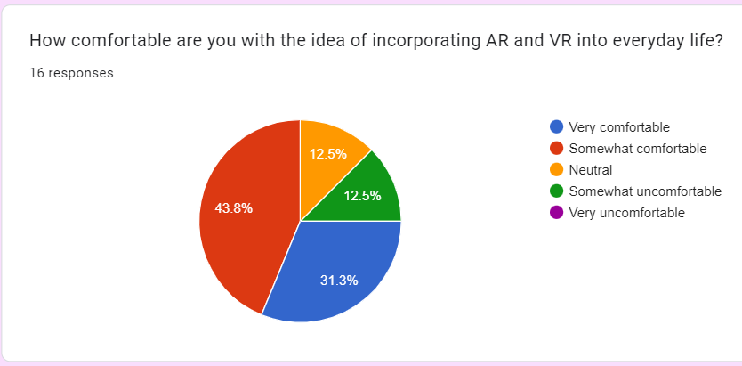

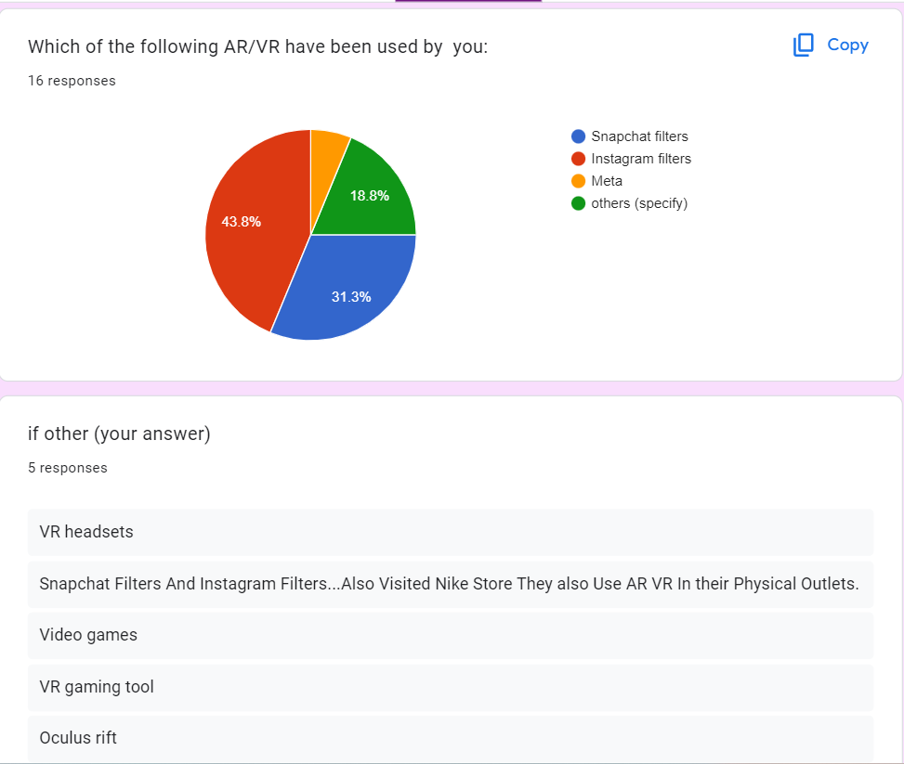

**Forms response chart. Question title: In which areas do you think AR and VR technologies have the most potential for innovation and growth? (Select all that apply)
. Number of responses: 16 responses.**

**Forms response chart. Question title: Which of the following factors would most likely influence your decision to purchase an AR or VR device? (Select all that apply)
. Number of responses: 16 responses.**

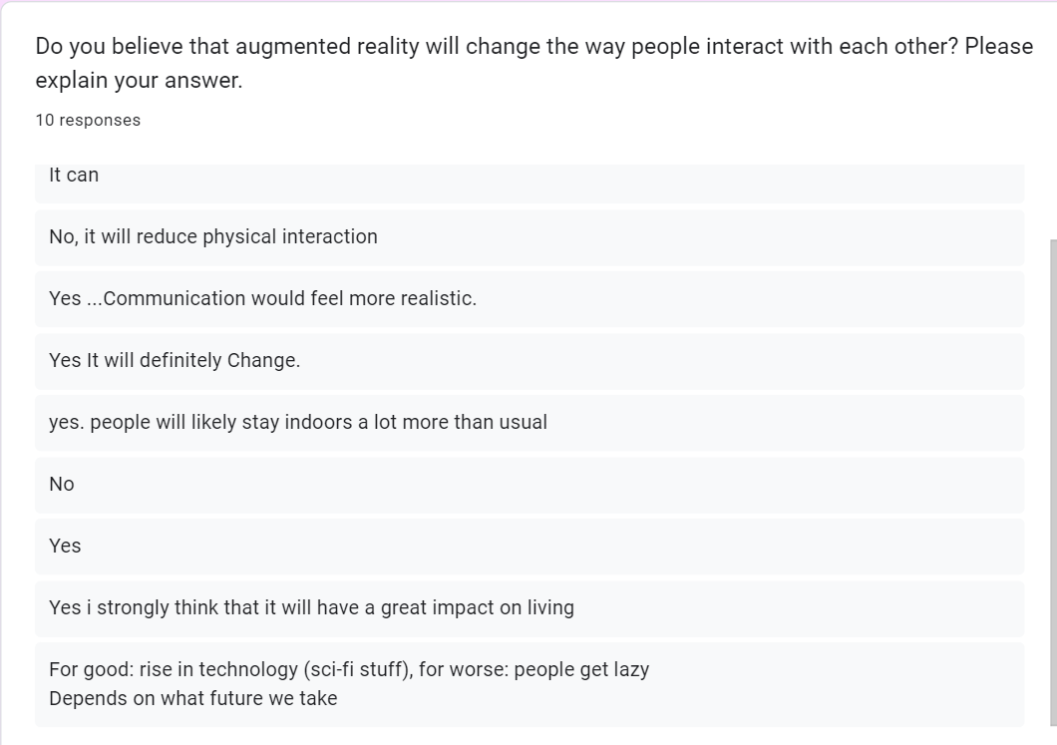

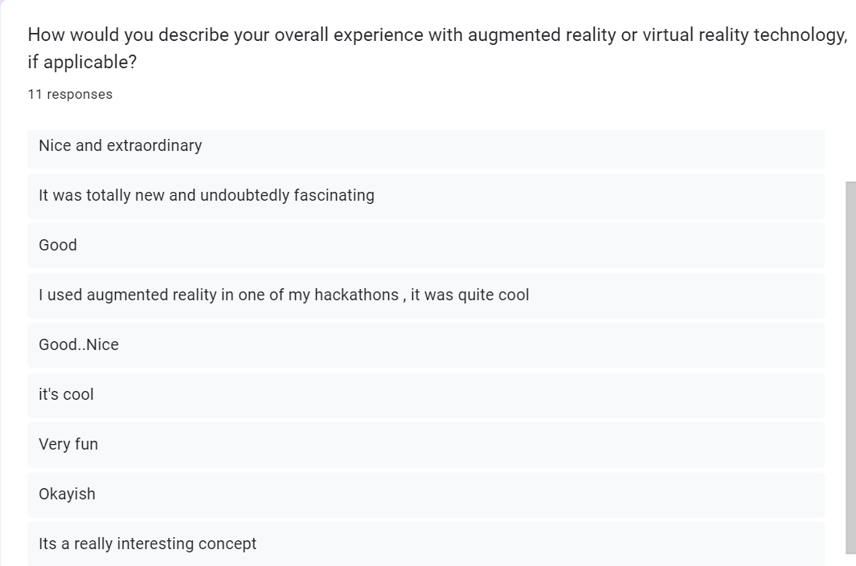

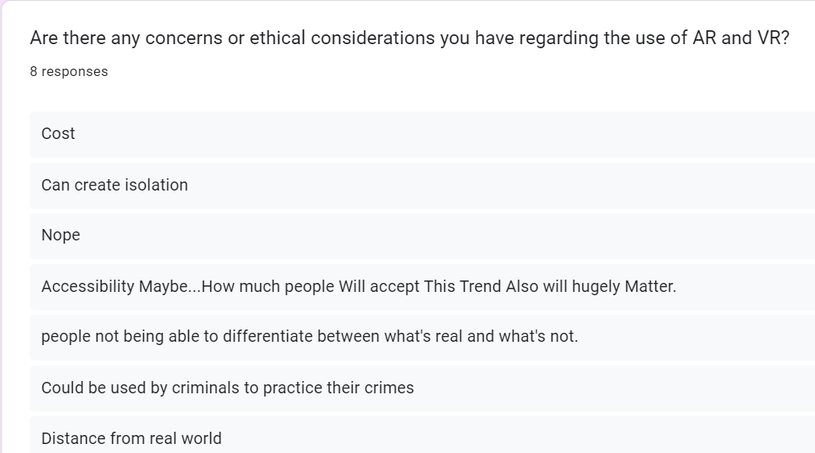

**Link for the survey form**

https://forms.gle/CynzgaMrtKX9vm6X8

**Bibliography**

Asamonye, David. “Virtual Reality and Augmented Reality — Different or Similar?”

*DEV Community,* Oct 22,2019.

<https://dev.to/david405/virtual-reality-and-augmented-reality-different-or-similar-45kl>

Banoula, Mayank. “What is Virtual Reality? Everything you neeed to know.”

*Simplilearn*, March 9, 2023.

<https://www.simplilearn.com/tutorials/artificial-intelligence-tutorial/what-is-virtual-reality>

Pathak, Amrita. “Augmented Reality (AR) vs. Virtual Reality (VR): The Differences”

*GEEKFLARE,* May 19, 2023.

<https://geekflare.com/augmented-reality-vs-virtual-reality/#geekflare-toc-ar-vs-vr-similarities>

Peters, Corrinna. “The future of virtual reality and augmented reality in data.”

*adatis*, March 7, 2023.

<https://adatis.co.uk/the-future-of-virtual-reality-and-augmented-reality-in-data/>

Speicher, Maximilian. “What is augmented reality, anyway?”

*THE CONVERSATION*, November 16, 2018

<https://theconversation.com/what-is-augmented-reality-anyway-99827>

“History of Virtual Reality.” *Virtual Reality Society*,

<https://www.vrs.org.uk/virtual-reality/history.html>

“The evolution of modern virtual reality headsets”

*Linde Virtual Academy,* December 27, 2021.

<https://vr.linde.com/2021/12/27/the-evolution-of-modern-virtual-realit>y/