NostrVault

Milestone 02 Shared Engine

STATUS  In implementation |  | OWNER  NostrVault maintainers |  | LAST UPDATED  October 05, 2026

Authors | Codex implementation handoff
Reviewers | Maintainer review pending
Related docs | MEMORY/NostrVault-15-Commit-Plan.md; docs/architecture.md
Scope | Portable engine, encrypted fixture storage and native platform boundaries.

1 Abstract
Milestone 02 replaces a numeric platform probe with shared Rust validation, cryptography and persistence foundations. The same public fixture is validated, encrypted, saved and reopened through a browser Worker, Linux IPC and Android JNI. This design establishes the boundaries that later vault and recovery features will use.
The implementation is a bounded fixture proof. It does not connect signers or relays, create a production vault, read conversations or import user archives. Final milestone acceptance requires the complete build, lint and runtime gates; platform evidence and remaining blockers are recorded in repository memory.

2 Goals and Non Goals
Goals | Non-goals
Validate one signed fixture through Rust on every host. | No signer or relay networking.
Authenticate encrypted records after storage reopen. | No production vault format or password policy.
Prove age interoperability and Android headless JNI. | No background scheduler or physical-device claim.
Reject malformed inputs and preserve failing outcomes. | No general archive importer or recovery guarantee.

3 Background and Problem Statement
Milestone 01 established packaging, narrow native IPC, CSP and a real WASM Worker probe. Those checks did not establish whether the selected Nostr, crypto and storage libraries work across the intended hosts. Milestone 02 resolves that dependency risk before identity and collection work begins.
Rust owns validation and cryptographic policy. React renders results; the Worker supplies browser I/O and IndexedDB. Native adapters own SQLite and JNI. Host code supplies secure randomness, selects isolated storage paths and enforces a single active proof. No host substitutes a JavaScript success result.

4 Implemented Architecture

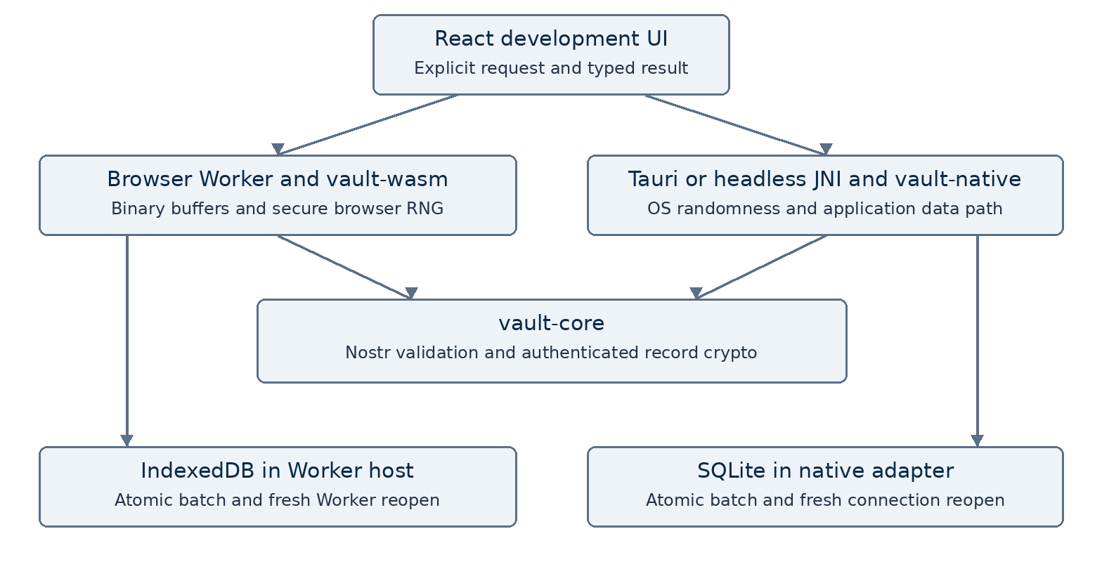
Figure 1. Shared Rust engine and platform adapters.

Core components

Component | Responsibility | Primary storage | Failure behavior
vault-core | Event checks; bounded contracts; record crypto. | No platform store | Typed rejection
vault-native | SQLite proof and headless JNI entry point. | Isolated SQLite | Rollback; reject
vault-wasm | Rust exports; shared age adapter. | WASM memory | Reject; no fallback
Worker host | Binary transport; IndexedDB; cancellation. | Fixture IndexedDB | Abort; close; reopen
React and Tauri | Display results; narrow native commands. | No user database | Show failure state

5 Request Lifecycle
- An explicit button starts foundation_proof with a version, request identifier and declared fixture lengths.
- TypeScript and Rust validate shape and bounds. Rust checks canonical event ID, signature and the fixed fixture author/kind scope.
- The host selects a disposable proof store and secure random salt, data key and independent nonces. No identity secret is requested.
- Argon2id derives a wrapping key. XChaCha20-Poly1305 wraps the data key and encrypts the payload with bound context identifiers.
- The adapter atomically writes ciphertext. An injected failure in the second batch write must preserve old data and expose no partial batch.
- The native connection is destroyed and reopened; the browser terminates Worker A and reads through Worker B. Cancellation stops host waiting.
- Authenticated bytes must match the fixture before success. Results carry event ID, byte count and crypto/storage evidence; no plaintext is logged.

6 API and Data Contracts

Primary data contract

Field | Type | Required | Description
version | u32 | Yes | Protocol version 1; other versions rejected.
requestId | string | Yes | 1–64 ASCII letters, digits, hyphen or underscore.
operation | string | Yes | foundation_proof only.
eventLength | integer | Yes | Exact event bytes; maximum 64 KiB.
payloadLength | integer | Yes | Exact payload bytes; maximum 1 MiB.
result | object/null | Yes | Event ID, byte count and verified proof flags.
error | object/null | Yes | Structured redacted code; exclusive with result.

Contract guarantees

- Reject invalid metadata and lengths before avoidable copying, parsing or cryptographic work.
- Keep one active host request; reject concurrent work and mismatched or stale replies.
- Keep proof version, account, record and operation context in authenticated associated data.
- Fixture evidence proves the exercised operation, not production archive trust or recoverability.
Contract definitions are maintained with their runtime validators in
crates/vault-core/src/lib.rs and src/foundation-contract.ts.

7 Consistency Idempotency and Replay

This milestone has no durable jobs or relay side effects. Repeated proof runs use isolated fixture storage. Atomic batches and close/reopen evidence establish the adapter contract. Cancellation never claims to undo completed native work or committed storage.
Scenario | Expected behavior | Reasoning
Concurrent request | Reject as busy. | One active host proof limits work.
Second write fails | Abort the whole batch. | Earlier data remains readable.
Cancelled Worker | Terminate and ignore late replies. | A fresh request uses a new Worker.
Unknown version | Reject before processing. | No silent compatibility fallback.

8 Security and Privacy Considerations

- Use public test identities only. No signer permissions, relay publication or routing updates are requested. Native capabilities allow only the explicit foundation commands.
- Bound all inputs and batches. Return redacted error codes; do not log passwords, keys, event bodies or recovered payloads. Treat the ZIP as opaque bytes.
- Record proof uses Argon2id v19, 8 MiB, one iteration and one lane, then XChaCha20-Poly1305. These are non-production parameters. Host RNG failure fails closed.
- Archive proof uses age v1 recipient and passphrase modes, log2(N)=16 and imported maximum18. Complete authenticated reading before releasing recovered bytes.
- Imported readable conversations remain archive-derived until signer validation in later milestones. Archive integrity never establishes original authorship. Private restoration follows recipient-inbox policy and required authentication.

9 Operational Readiness
Signal | Required evidence | Responsibility | Launch gate
Core and contracts | Adversarial vectors; strict lint | Maintainers | Required
Browser execution | Real Worker; restart; interoperability | Maintainers | Required
Linux runtime | Packaged proof; IPC ACL; CSP | Maintainers | Required
Android foundation | ARM64 build; x86_64 instrumentation | Maintainers | Required
Final candidate | Complete verify:commit passes | Maintainers | Required
Delivery constraint: local signed-off milestone commit only after all required gates pass. No public release, deployment or production credentials. CI timing is measured; a five-minute Android target is a separate follow-up, not a completion claim.

10 Alternatives Considered

Alternative | Why it was considered | Why it was not selected
Throwaway proof only | Small initial change. | Would require rebuilding the shared boundaries.
Full engine now | Earlier product surface. | Expands later milestone scope before platform proof.
JavaScript crypto fallback | Avoids WASM dependency work. | Creates a second authority and hides target failures.
One storage framework | Uniform host API. | Adds an async abstraction without current need.

11 Deferred Decisions
- Milestone 03 selects production password costs, key lifecycle and vault migrations.
- Milestone 04 establishes actual signer compatibility and permissions.
- Milestone 06 proves real message capture, restart and signer-free offline reading.
- Physical Android and background scheduling evidence remain assigned to later milestones.

12 Decision and Next Steps
Keep the three-crate boundary and the approved fifteen-milestone scope. Adopt dependencies only with actual target evidence. Record exact final checks and limits before the local milestone commit. This document describes the foundation implementation; it does not declare the complete application or milestone gate finished.
Milestone | Deliverable | Exit criteria
02 core | Portable validation and crypto | Native and WASM vectors pass
02 hosts | SQLite, IndexedDB and JNI | Reopen, rollback and headless proof
02 gate | All automated checks | Final candidate passes; limits recorded
03 next | Production encrypted vault | Start only after milestone 02 acceptance

Source of truth: repository code, Cargo.lock and MEMORY/memory.md. Foundation evidence is distinct from product capability.

