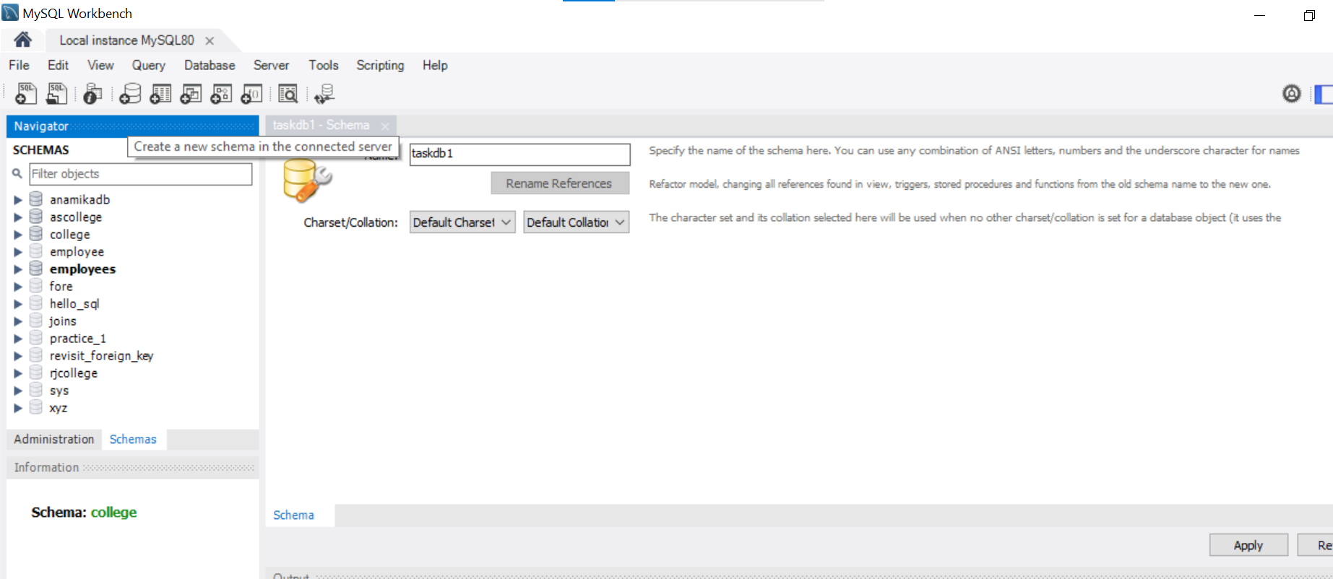

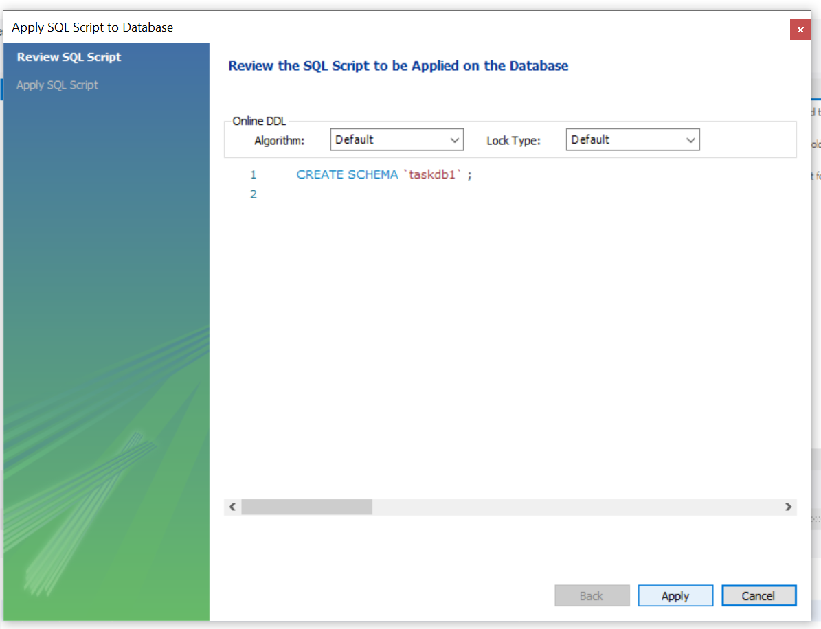

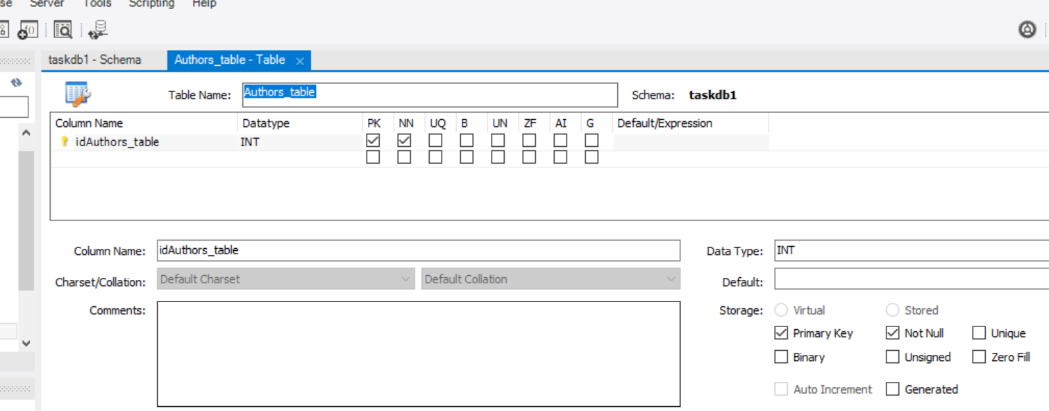

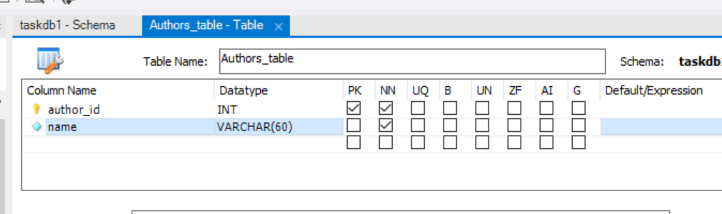

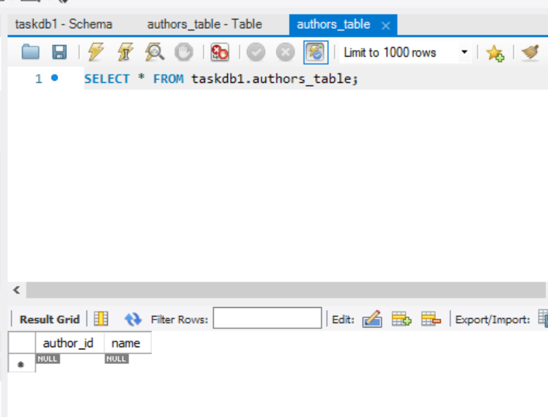

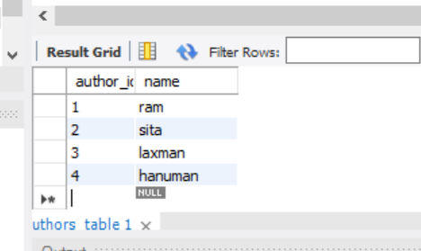

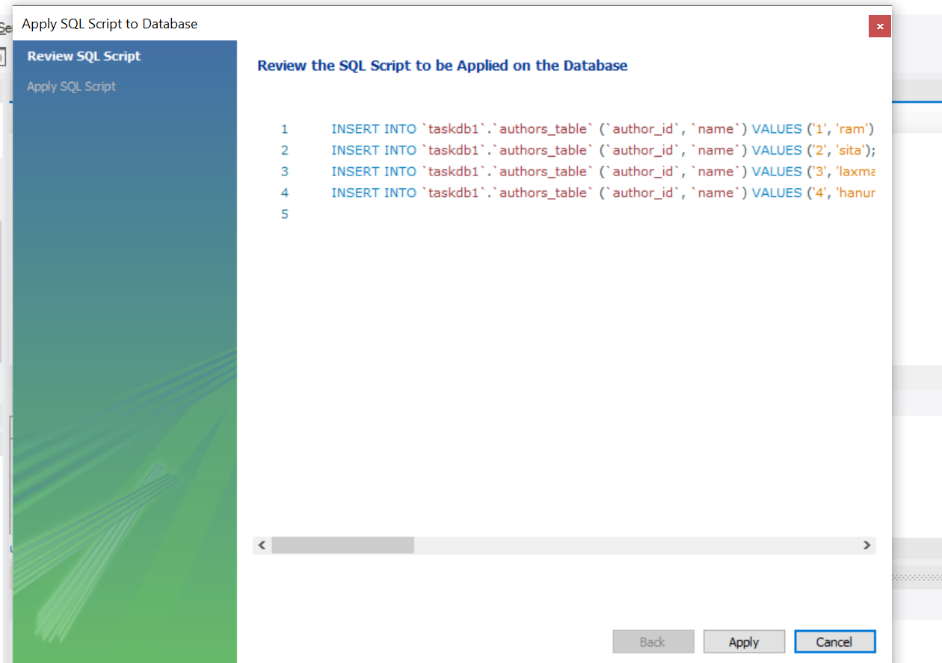

BOOKS TABLE

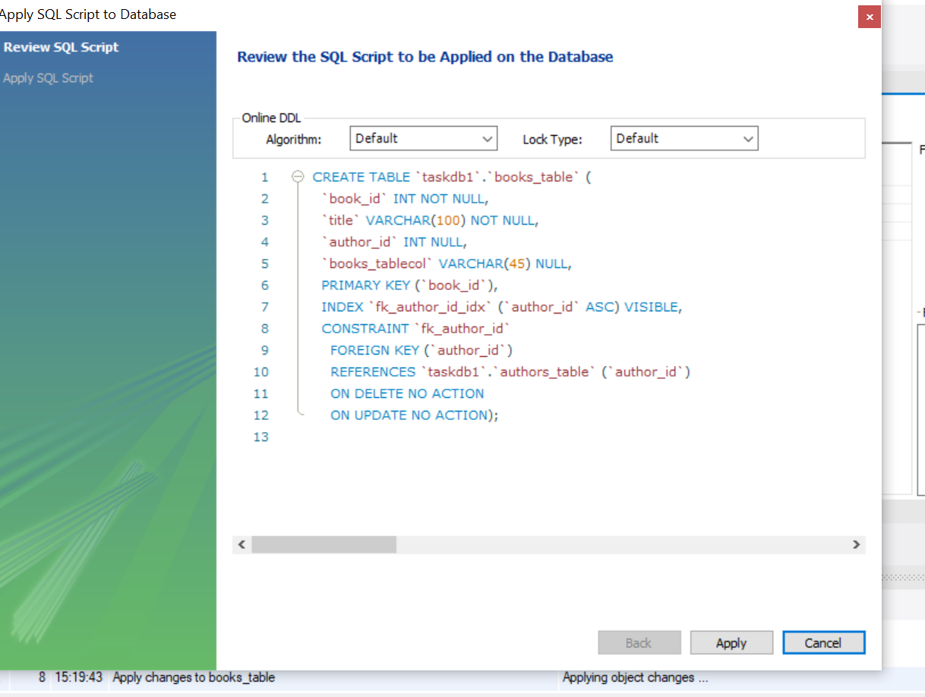

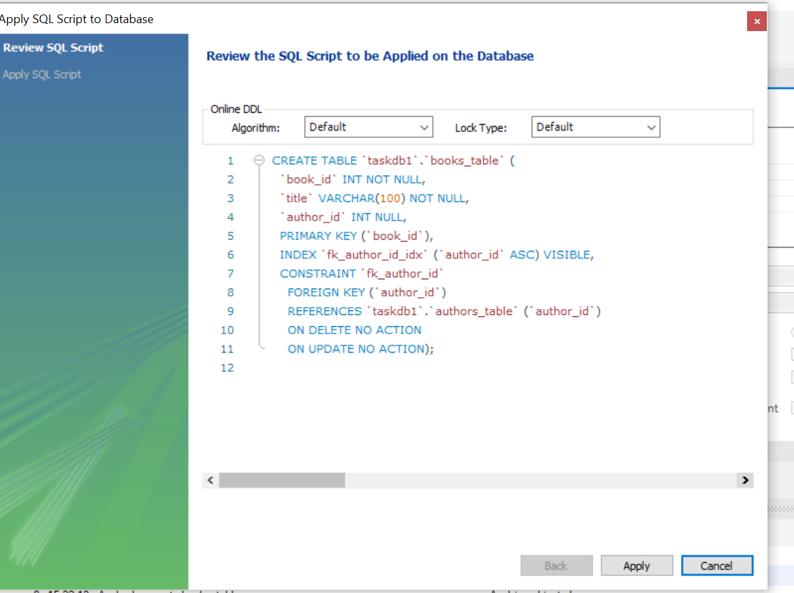

CREATE TABLE `taskdb1`.`books_table` (

`book_id` INT NOT NULL,

`title` VARCHAR(100) NOT NULL,

`author_id` INT NULL,

PRIMARY KEY (`book_id`),

INDEX `fk_author_id_idx` (`author_id` ASC) VISIBLE,

CONSTRAINT `fk_author_id`

FOREIGN KEY (`author_id`)

REFERENCES `taskdb1`.`authors_table` (`author_id`)

ON DELETE NO ACTION

ON UPDATE NO ACTION);

STUDENT TABLE

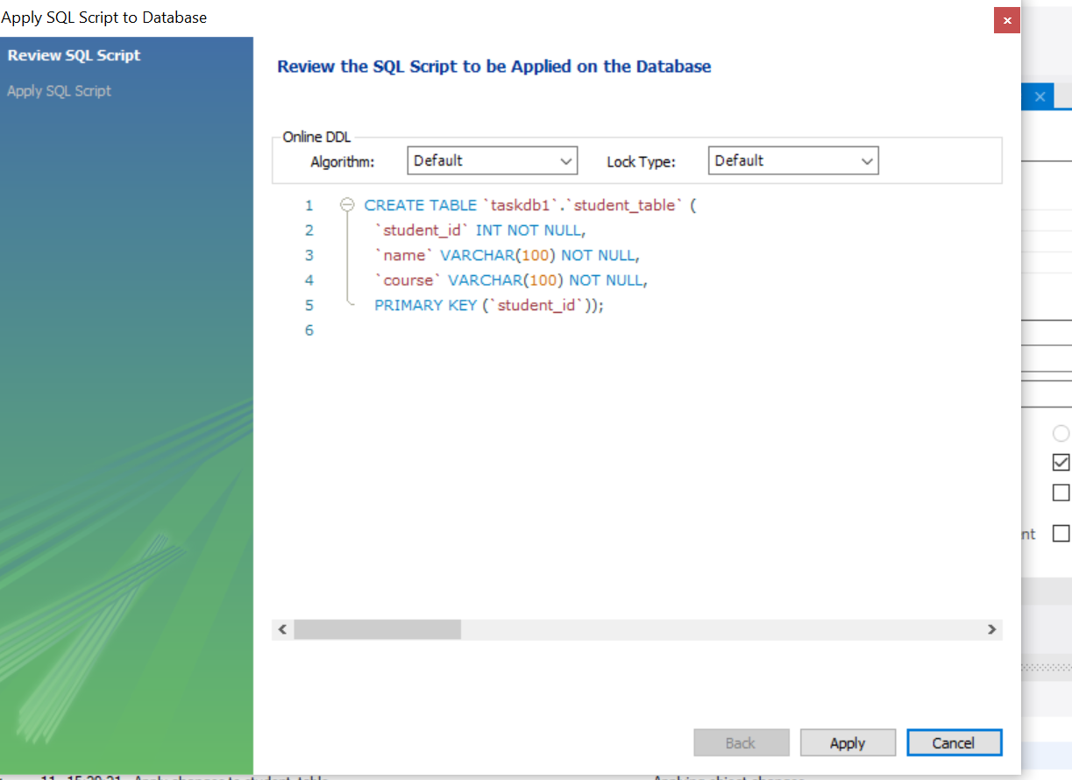

CREATE TABLE `taskdb1`.`student_table` (

`student_id` INT NOT NULL,

`name` VARCHAR(100) NOT NULL,

`course` VARCHAR(100) NOT NULL,

PRIMARY KEY (`student_id`));

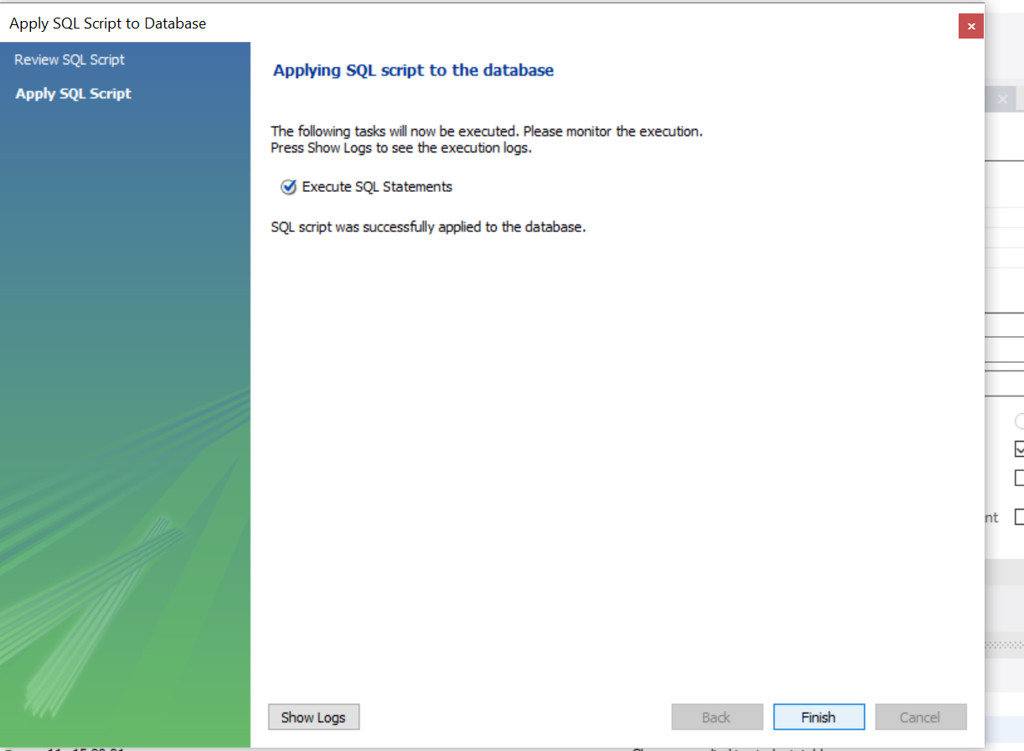

ISSUE TABLE

CREATE TABLE `taskdb1`.`issue_table` (

`issue_id` INT NOT NULL,

`book_id` INT NULL,

`student_id` INT NULL,

`issue_date` DATE NULL,

`return_date` DATE NULL,

PRIMARY KEY (`issue_id`),

INDEX `book_id_idx` (`book_id` ASC) VISIBLE,

INDEX `fk_student_id_idx` (`student_id` ASC) VISIBLE,

CONSTRAINT `fk_book_id`

FOREIGN KEY (`book_id`)

REFERENCES `taskdb1`.`books_table` (`book_id`)

ON DELETE NO ACTION

ON UPDATE NO ACTION,

CONSTRAINT `fk_student_id`

FOREIGN KEY (`student_id`)

REFERENCES `taskdb1`.`student_table` (`student_id`)

ON DELETE NO ACTION

ON UPDATE NO ACTION);

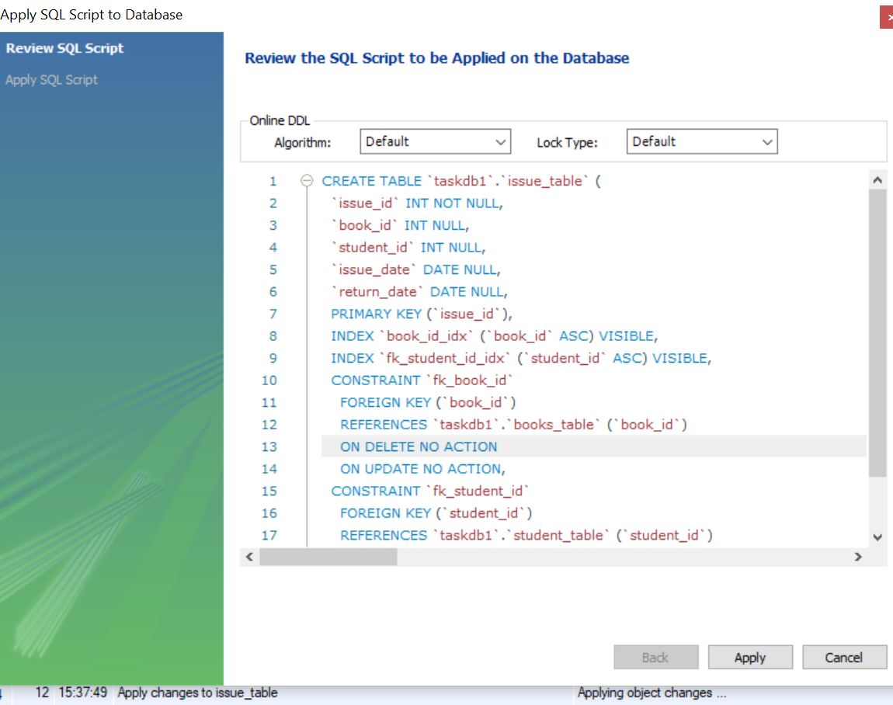

CREATE ER DIAGRAM

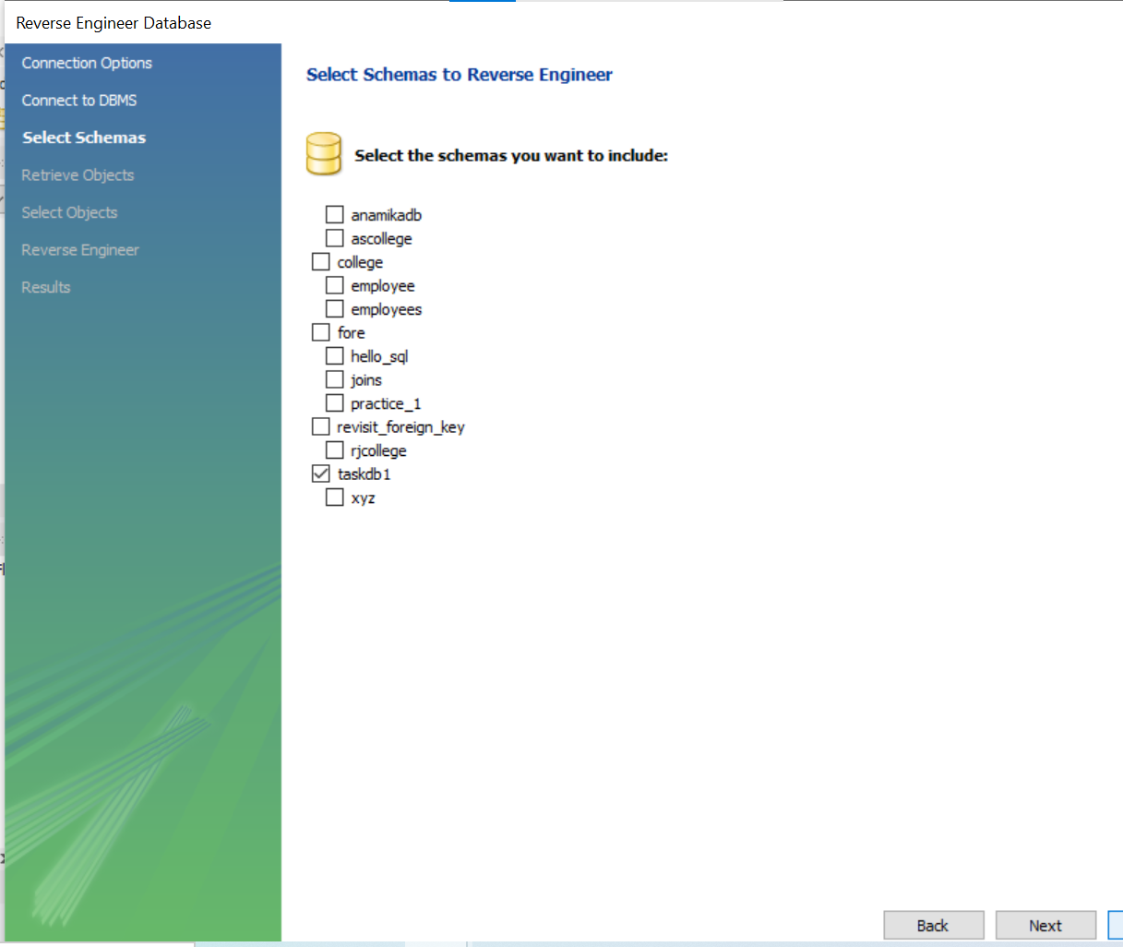

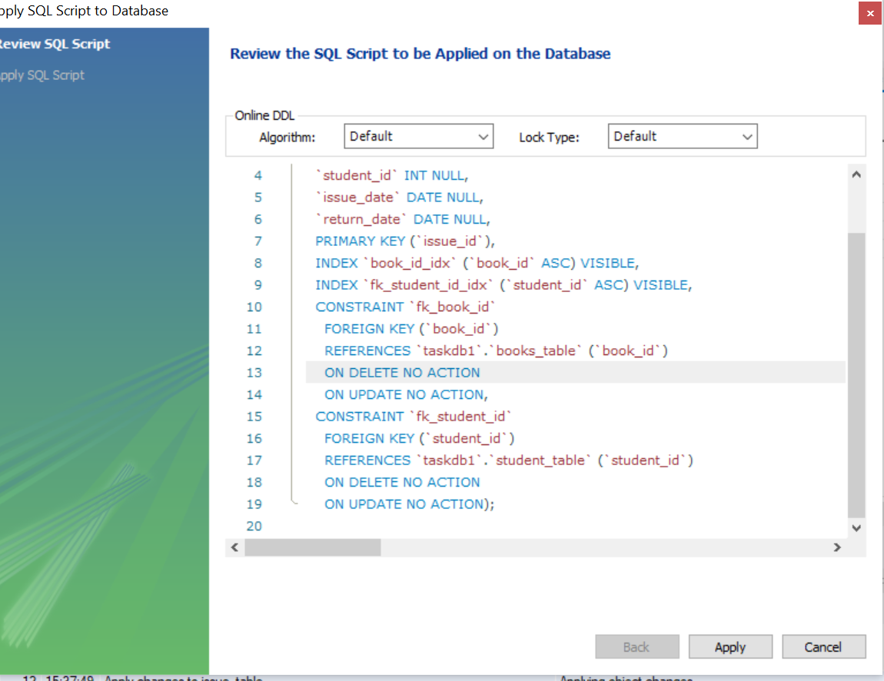

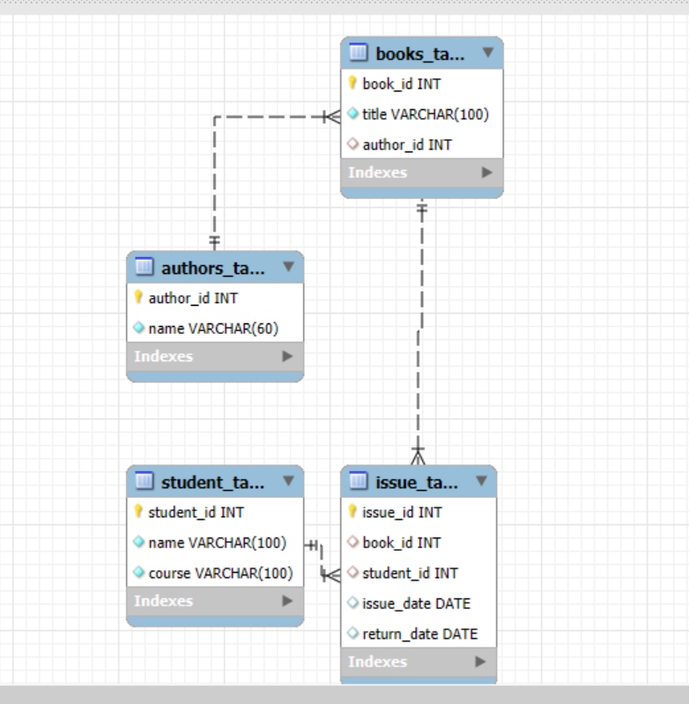

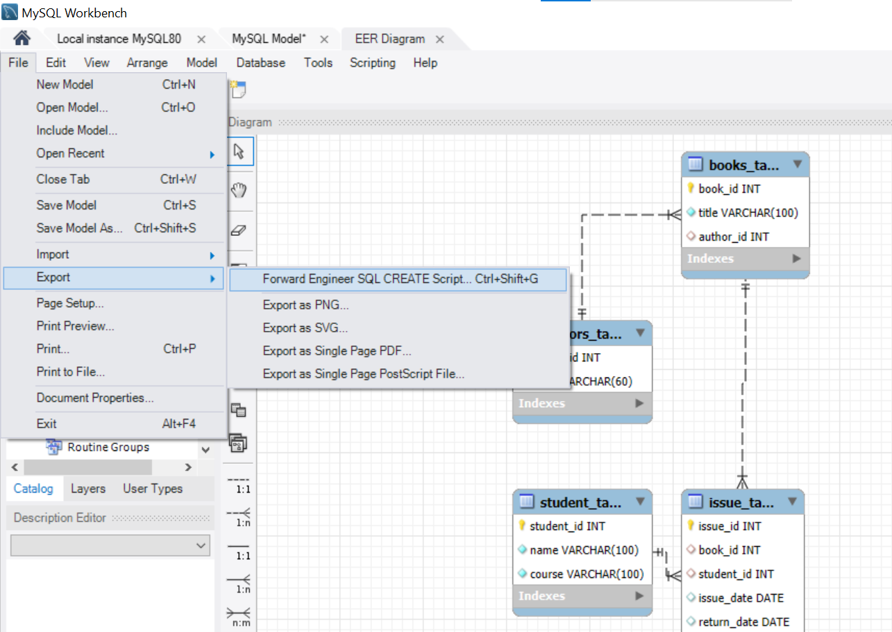

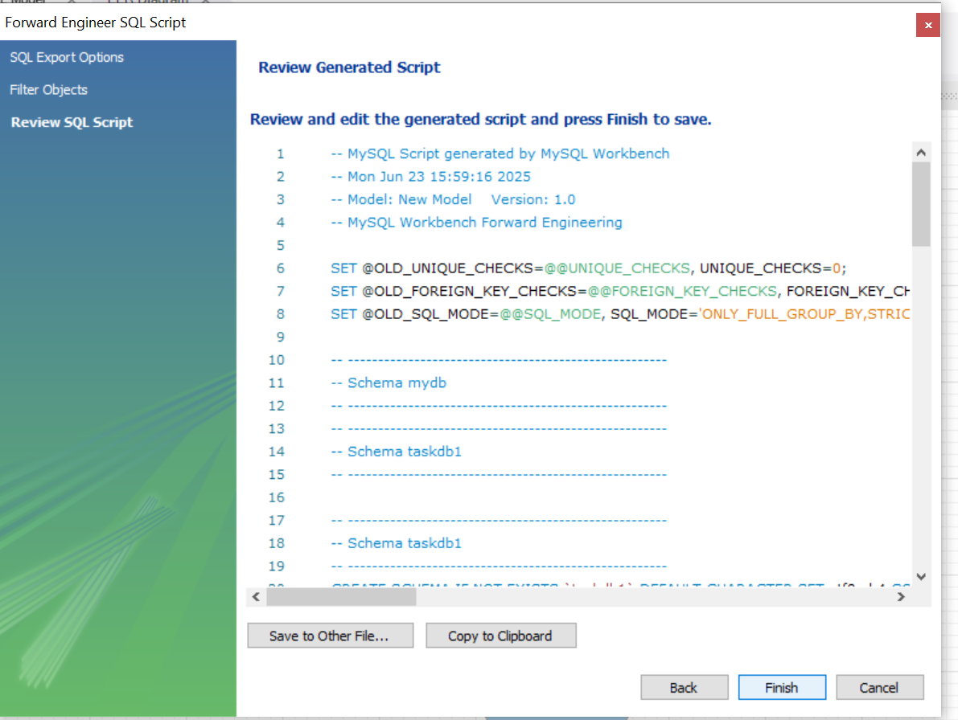

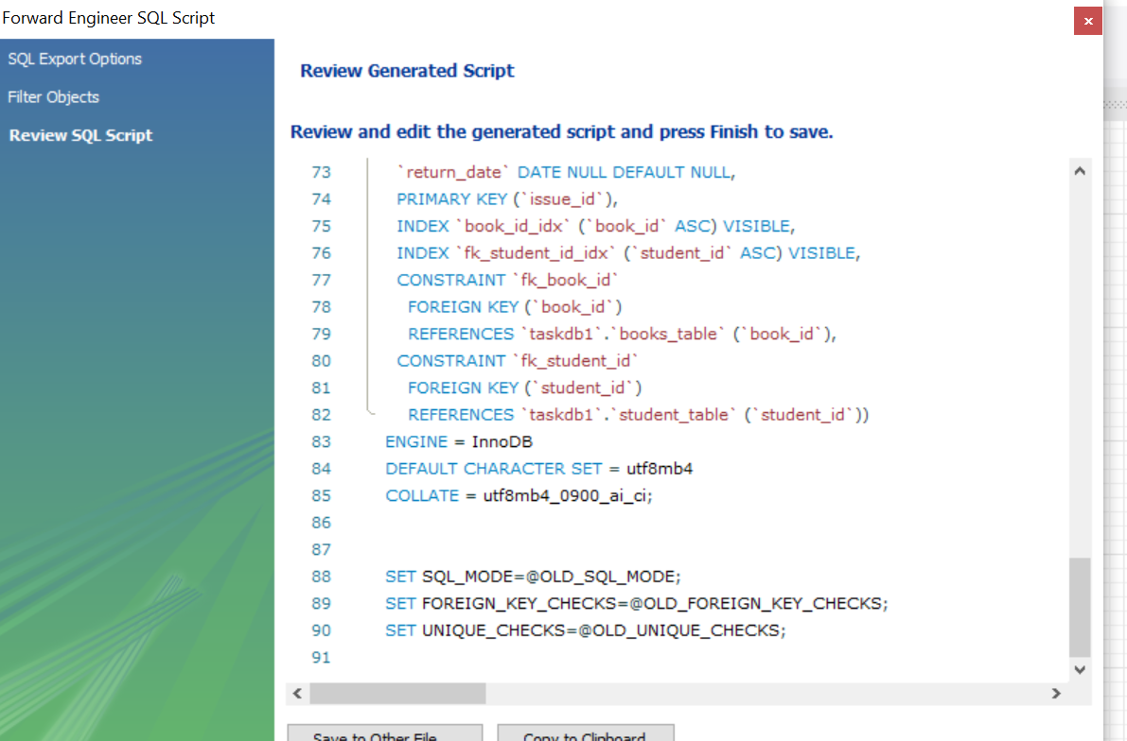

-- MySQL Script generated by MySQL Workbench

-- Mon Jun 23 15:59:16 2025

-- Model: New Model Version: 1.0

-- MySQL Workbench Forward Engineering

SET @OLD_UNIQUE_CHECKS=@@UNIQUE_CHECKS, UNIQUE_CHECKS=0;

SET @OLD_FOREIGN_KEY_CHECKS=@@FOREIGN_KEY_CHECKS, FOREIGN_KEY_CHECKS=0;

SET @OLD_SQL_MODE=@@SQL_MODE, SQL_MODE='ONLY_FULL_GROUP_BY,STRICT_TRANS_TABLES,NO_ZERO_IN_DATE,NO_ZERO_DATE,ERROR_FOR_DIVISION_BY_ZERO,NO_ENGINE_SUBSTITUTION';

-- -----------------------------------------------------

-- Schema mydb

-- -----------------------------------------------------

-- -----------------------------------------------------

-- Schema taskdb1

-- -----------------------------------------------------

-- -----------------------------------------------------

-- Schema taskdb1

-- -----------------------------------------------------

CREATE SCHEMA IF NOT EXISTS `taskdb1` DEFAULT CHARACTER SET utf8mb4 COLLATE utf8mb4_0900_ai_ci ;

USE `taskdb1` ;

-- -----------------------------------------------------

-- Table `taskdb1`.`authors_table`

-- -----------------------------------------------------

CREATE TABLE IF NOT EXISTS `taskdb1`.`authors_table` (

`author_id` INT NOT NULL,

`name` VARCHAR(60) NOT NULL,

PRIMARY KEY (`author_id`))

ENGINE = InnoDB

DEFAULT CHARACTER SET = utf8mb4

COLLATE = utf8mb4_0900_ai_ci;

-- -----------------------------------------------------

-- Table `taskdb1`.`books_table`

-- -----------------------------------------------------

CREATE TABLE IF NOT EXISTS `taskdb1`.`books_table` (

`book_id` INT NOT NULL,

`title` VARCHAR(100) NOT NULL,

`author_id` INT NULL DEFAULT NULL,

PRIMARY KEY (`book_id`),

INDEX `fk_author_id_idx` (`author_id` ASC) VISIBLE,

CONSTRAINT `fk_author_id`

FOREIGN KEY (`author_id`)

REFERENCES `taskdb1`.`authors_table` (`author_id`))

ENGINE = InnoDB

DEFAULT CHARACTER SET = utf8mb4

COLLATE = utf8mb4_0900_ai_ci;

-- -----------------------------------------------------

-- Table `taskdb1`.`student_table`

-- -----------------------------------------------------

CREATE TABLE IF NOT EXISTS `taskdb1`.`student_table` (

`student_id` INT NOT NULL,

`name` VARCHAR(100) NOT NULL,

`course` VARCHAR(100) NOT NULL,

PRIMARY KEY (`student_id`))

ENGINE = InnoDB

DEFAULT CHARACTER SET = utf8mb4

COLLATE = utf8mb4_0900_ai_ci;

-- -----------------------------------------------------

-- Table `taskdb1`.`issue_table`

-- -----------------------------------------------------

CREATE TABLE IF NOT EXISTS `taskdb1`.`issue_table` (

`issue_id` INT NOT NULL,

`book_id` INT NULL DEFAULT NULL,

`student_id` INT NULL DEFAULT NULL,

`issue_date` DATE NULL DEFAULT NULL,

`return_date` DATE NULL DEFAULT NULL,

PRIMARY KEY (`issue_id`),

INDEX `book_id_idx` (`book_id` ASC) VISIBLE,

INDEX `fk_student_id_idx` (`student_id` ASC) VISIBLE,

CONSTRAINT `fk_book_id`

FOREIGN KEY (`book_id`)

REFERENCES `taskdb1`.`books_table` (`book_id`),

CONSTRAINT `fk_student_id`

FOREIGN KEY (`student_id`)

REFERENCES `taskdb1`.`student_table` (`student_id`))

ENGINE = InnoDB

DEFAULT CHARACTER SET = utf8mb4

COLLATE = utf8mb4_0900_ai_ci;

SET SQL_MODE=@OLD_SQL_MODE;

SET FOREIGN_KEY_CHECKS=@OLD_FOREIGN_KEY_CHECKS;

SET UNIQUE_CHECKS=@OLD_UNIQUE_CHECKS;