**Identifying the potential causes for inefficient sewage management and treatment in India**

GROUP-02 - Akanksha, Alok Kumar, Aman Singh, Anand Prakash, Anshul Bajaj

ABSTRACT:

The study paper titled "Potential causes for inefficient sewage management and treatment in India" will examine the difficulties and possible reasons for inefficiency while delving into the complexities of sewage management and treatment in India. The Water (Prevention and Control of Pollution) Act, 1974, which primarily governs policy and legal regulation framework, as well as the functions of Central and State Pollution Control Boards, will be the main focus of this paper's analysis of the current state of urban wastewater management (UWM) in India [1][2]. The limitations of the current wastewater treatment regulations and the reliance on On-Site Sanitation (OSS) systems—which are frequently non-compliant and susceptible to revision—will also be examined by the study [4]. The study will look more closely at Delhi's sewage generation and treatment capacity discrepancy, highlighting the need for better technology and infrastructure for sewage disposal and treatment [3]. Along with the health problems connected to using untreated water for irrigation, the study will also cover how untreated sewage affects groundwater and surface water pollution [2]. The article will suggest ways to overcome these obstacles, including encouraging prefabrication of systems to allocate compliance responsibilities in the best possible way and revising technical standards to support a paradigm shift toward on-site sanitation that is safer and more effective [4]. The study will also emphasize how crucial it is to manage greywater and how future systems, policies, and standards must incorporate this idea [4].

In conclusion, the research paper will provide a comprehensive understanding of the potential causes of inefficient sewage management and treatment in India, offering actionable insights and recommendations for improving the current scenario.

**INTRODUCTION:**

Plants are essential to protecting the environment and human health (Metcalf & Eddy, 2013). Water quality is negatively impacted by human activity, necessitating wastewater treatment in order to separate clean and polluted water according to impurity concentration (Tchobanoglous et al., 2014). This study explores the historical context of sewage treatment, highlighting the development from antiquated drainage systems to the cutting-edge treatment facilities of the present day. It also describes the first and second phases of treating By cleaning wastewater before releasing it into natural bodies of water, water sewage treatment wastewater, including how to remove organic matter, settle sediments, and use bacteria for biological purification. All of these steps are necessary to guarantee that the water is safe to discharge.

Background Information in History

The idea of treating wastewater is not new; it was first introduced by ancient cultures in Mesopotamia, Greece, and the Indus Valley (Metcalf & Eddy, 2013). To handle wastewater, these prehistoric societies created crude drainage systems that were mainly concerned with getting the waste out of populous regions. However, the notion of treating wastewater to eliminate contaminants and pathogens did not originate until the 19th century (Tchobanoglous et al., 2014).

The discovery of the activated sludge method in England by Edward Ardern and William Lockett in the late 1800s marked the beginning of the modern sewage treatment facility (Metcalf & Eddy, 2013). By using aerobic bacteria to break down organic materials in wastewater, this novel technique greatly raised the treated effluent's quality. The preliminary treatment, primary treatment, secondary treatment, and tertiary treatment phases of the activated sludge process were developed throughout time to eliminate distinct contaminants and pathogens (Techobanoglous et al., 2014).

Types of treatments in sewage treatment plants:

Primary Treatment -

The first step in treating wastewater is called primary treatment, and it focuses on employing sedimentation to remove solid particles (Metcalf & Eddy, 2013). During this procedure, wastewater enters enormous sedimentation tanks, where suspended solids sink to the bottom due to gravity. The volume and pathogen concentration of these solids, often referred to as primary sludge, are subsequently reduced by removal and additional treatment in anaerobic digesters. After being cleared of the majority of solid particles, the wastewater moves on to the secondary treatment phase.

Secondary Treatment -

A crucial stage in the treatment of wastewater is secondary treatment, which uses biological processes to get rid of nutrients and organic materials (Tchobanoglous et al., 2014). The most popular technique is activated sludge, in which aerobic bacteria break down organic materials in wastewater. transforming it into cellular biomass, water, and carbon dioxide. After being separated by sedimentation from the treated effluent, this biomass, also known as secondary sludge, is treated in anaerobic digesters. In the third stage, the cleared effluent—which has now undergone extensive purification—gets additional treatment.

Disinfection and Tertiary Treatment -

The last stage of wastewater treatment, known as tertiary treatment, aims to eliminate any remaining contaminants and pathogens (Metcalf & Eddy, 2013). Processes including filtration, chemical treatment, and disinfection may be used at this step. Any leftover suspended solids are removed by filtration, and certain contaminants, such nitrogen and phosphorus, are removed chemically by adding flocculants and coagulants. Disinfection guarantees the removal of any remaining organisms, making the treated effluent safe for release into natural bodies of water. Disinfection is frequently accomplished through the use of chlorine, UV radiation, or ozone (Tchobanoglous et al., 2014).

Water sewage treatment plants are a crucial part of contemporary infrastructure because they filter wastewater before it is released into natural water bodies, protecting the environment and public health. By use of a sequence of primary, secondary, and tertiary treatment phases, these establishments efficiently eliminate contaminants and pathogens, converting wastewater into a resource suitable for safe reuse or release. The demand for continuous improvements in the design and operation of water sewage treatment plants will only grow as the world's population and urbanization continue to rise.

**THEORY:**

Water sewage treatment plants are crucial for preserving the environment's health and the quality of the water supply. These facilities are made to bring contaminated water back to a desirable standard so that it can be used for irrigation, drinking water, and aquatic life. In order to remove impurities and pollutants from the water, the treatment procedure usually combines chemical, biological, and physical processes.

An essential part of wastewater treatment are the basic and secondary stages. Organic and inorganic debris are eliminated from the wastewater during the primary stage by allowing solids to settle. The removal of large floating objects, the settling of stones, sand, and cinders, and the creation of raw primary biosolids are usually the tasks involved in this step. The initial stage of the wastewater treatment process is intended to eliminate around 60% of the suspended solids and 35% of the biochemical oxygen demand (BOD).

Through biological processes, over 85% of the organic content is removed in the secondary stage, which aims to further purify wastewater. To help microorganisms break down organic debris, secondary treatment methods like the trickling filter and activated sludge process are frequently employed. In order to allow bacteria to proliferate and break down the organic debris, wastewater is passed over a bed of rocks or plastic media in the trickling filter process. Through the use of bacteria-containing sludge, the organic matter in wastewater is broken down in the process of activated sludge.

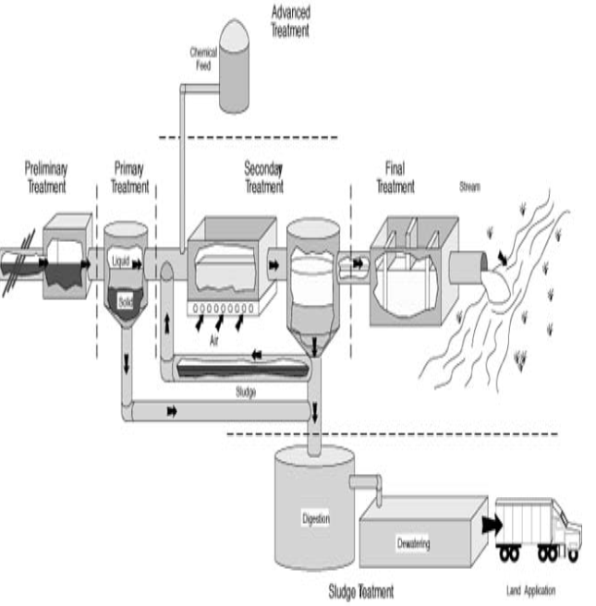

Figure 1- A schematic diagram of Sewage Treatment Process

Designed to eliminate any residual pollutants and impurities, the third stage of wastewater treatment is the last one. Processes include filtration, disinfection, and sedimentation are common chemical and physical procedures used at this stage. To make the water safe to be released back into the environment, the tertiary step is meant to get rid of any leftover nutrients, pathogens, and suspended particulates.

The choice of the best treatment technology is influenced by a number of variables, including the resources at hand, the climate, the availability of land, and financial concerns. When constructing a water sewage treatment plant, considerations including the intended quality of the treated water, the quantity and quality of the wastewater, and the local laws and ordinances must all be made.

To increase the sustainability and efficiency of water sewage treatment plants, new methods and technologies have been developed recently. As an illustration, membrane bioreactors (MBRs) are a novel form of treatment technology that blend membrane filtration and the activated sludge process. Reusing the treated water is made possible by this technology's ability to eliminate viruses and smaller particles.

Adding green infrastructure, including built wetlands and biofilters, is another way to make water sewage treatment plants more sustainable. By treating wastewater naturally, these systems eliminate the need for energy-intensive mechanical operations.

To sum up, water sewage treatment plants are necessary to preserve water quality as well as the environment and public health. The primary and secondary stages of wastewater treatment are essential steps in this process, and a number of factors determine which treatment technique is best. Green infrastructure and membrane bioreactors are two examples of new technologies and methods being developed to increase the sustainability and efficiency of water sewage treatment plants.

**Sewage treatment in Industrialized Nation:**

**Spain Water Sewage Treatment Plant:**

Spain's water resources are being stressed by rising water demands and frequent instances of water stress, especially in the Mediterranean region [8][9]. Treated wastewater has emerged as a vital resource for this region's future, and its inclusion in the range of feasible water options begs questions about the various qualities achieved through each type of treatment, the scope of current water reuse initiatives, and the management structure of wastewater treatment plants (WWTPs) [9]. In order to assess the current condition of WWTPs in Mediterranean Spain, this article will concentrate on plant sizes, treatment methods, water use, and governance structures.

Techniques

Spain has an extensive sewage treatment system that comprises sludge treatment as well as preliminary, primary, secondary, and tertiary treatment stages [8][9].

Preliminary Treatment:

Using various thickness screens and sieves, big and medium-sized solid waste is removed during the preliminary treatment process. Grease and sand particles are removed using desanders and degreasers. The next step is primary treatment, which includes keeping the water in decanter centrifuges for one to two hours in order to remove some of the suspended solids. Gravity aids in the separation of these particles [8].

Secondary Treatment:

By employing biological processes that use bacteria and other microorganisms to break down and remove the various nutrients and organic matter, secondary treatment aims to remove both from the water organic matter and nutrients like nitrogen and phosphorus [8].

Tertiary Treatment:

The goal of tertiary treatment is to raise the water's ultimate quality so that it can be utilized for human consumption or returned to the environment. A number of procedures are used in this phase to get rid of harmful organisms, like fecal bacteria [8].

Sludge Treatment:

In Spain, sludge treatment plays a significant role in the sewage treatment process. Sludge is the primary by-product of wastewater treatment and needs to be appropriately managed. This covers procedures including stabilization, thickening, dewatering, and disposing of or reusing the sludge [8].

Spain employs cutting-edge bioaugmentation technology in addition to these conventional methods of treating sewage to enhance the process. For instance, a new treatment method has been put in place in Villalba de los Barros, Spain, which makes the wastewater collecting system function more like a wastewater treatment plant. This results in cost savings as well as an improvement in the quality of the treated wastewater [10].

Additionally, 13.5 hm3/day of treated wastewater were reused in Spain in 2018, mostly for agriculture, demonstrating the country's high rate of wastewater reuse. Enhancements in crop yield and fertilizer usage have resulted from this, together with the provision of substitutes for treated wastewater release in regions where disposal is challenging [9].

Outcomes

Plant Dimensions and Methods of Treatment

According to the report, there are 136 WWTPs in Mediterranean Spain in total, with a variety of plant sizes and treatment methods [8][10]. The autonomous communities of Andalusia, Catalonia, Madrid, Valencia, and Murcia are home to the largest plants and are also the primary producers of treated wastewater in the nation [8][9]. Public-private facilities have the most advanced treatment systems and are also the biggest in terms of size [9].

Governance Regimes and Water Use

The analysis shows that although there are few public plants, there are a significant number of private WWTPs and a smaller number of public-private WWTPs [9]. The integration of treated wastewater into the range of feasible water options is contingent upon the governance framework of WWTPs [9]. The analysis demonstrates that public-private plants, which are also the largest in size [9], have the most advanced treatment systems.

Practices for Reusing Water

The research emphasizes how treated wastewater has a great deal of potential for irrigation of golf courses and farms in Valencia, Murcia, and Andalusia [9]. Reusing water for various purposes, such industrial or recreational purposes, is still in its infancy [9]. In locations where dumping is problematic, the use of recovered water in agriculture reduces the need for fertilizer and offers an alternative to treated wastewater disposal [8]. In regions where wastewater was previously being utilized for irrigation with less treatment, the sanitary guarantee is increased by the wastewater recovery treatments [8].

Discussion

The study, which focuses on plant sizes, treatment methods, water usage, and governance regimes, offers insightful information about the condition of WWTPs in Mediterranean Spain. The findings indicate that public-private plants, which are also the largest in size [9], have the most advanced treatment systems. The research also emphasizes how treated wastewater has a great deal of potential for irrigation of golf courses and farms in Valencia, Murcia, and Andalusia [9]. Reusing water for various purposes, such industrial or recreational purposes, is still in its infancy, though.

In summary

According to the study's conclusion, treated wastewater has emerged as a vital resource for Mediterranean Spain. However, when this resource is included in the range of feasible water options, it raises concerns about the various qualities that result from each type of treatment, the scope of current water reuse activities, and the governance structure of WWTPs [9]. The study, which focuses on plant sizes, treatment methods, water usage, and governance regimes, offers insightful information about the condition of WWTPs in Mediterranean Spain. The findings indicate that public-private plants, which are also the largest in size [9], have the most advanced treatment systems. Additionally, the study emphasizes how treated wastewater has a lot of potential for irrigation of golf courses and agriculture in particular regions, such Valencia, Murcia, and Andalusia [9].

**Sewage Treatment in Developing Countries:**

**Pagla Sewage treatment plant, Dhaka, Bangladesh:**

With more than 21 million people living there, Dhaka, the capital of Bangladesh, is among the world's most densely inhabited cities. Sewage generation has increased as a result of the city's fast industrialization and urbanization, placing a heavy burden on the sewage treatment system. The Pagla Sewage Treatment Plant (PST), which has a 120 MLD design capacity, is the only sewage treatment facility in Dhaka [11]. But barely 40 MLD of sewage are being treated at the plant right now, significantly less than its design capacity [11]. The purpose of this study is to present a thorough analysis of the PST's current state, including its capacity, performance, design, and the difficulties it faces in meeting the rising demand for sewage treatment in Dhaka.

Design and Capacity:

The PST was created to treat wastewater produced primarily by residential sources, with a small amount also coming from commercial sources such as restaurants, laundry facilities, marketplaces, schools, colleges, workplaces, and retail centers [11]. Domestic wastewater treatment is mostly based on how well bacteria and microorganisms grow in a particular tank or reactor and how well they are able to establish themselves; each tank needs a media [11]. While larger plants operate in controlled environments and rely on a constant supply of oxygen to meet their treatment needs, the basic, open treatment system is powered by the sun and air. The PST features a design capacity of 120 MLD, 49,000 domestic sewage connections, 778 km of varying diameter sewer line, 20 lift stations for sewage, and one central pump station [11].

Performance:

Only 40 MLD of sewage are being treated by the PST, which is only half of its intended capacity of 120 MLD. This indicates that its performance is subpar. This is mostly the result of poor and insufficient maintenance performed on both the treatment plant and the sewer network. The effects of an inadequate sewage treatment system have a significant influence on the city's entire health system. The Pagla wastewater plant's final effluent quality above the permissible limits of Bangladesh Environmental Quality Standard. The study, which focused on optimizing the treatment process at Pagla WWTP, revealed that the maximum values of BOD5 and COD were 455 mg/L and 810 mg/L, respectively [11].

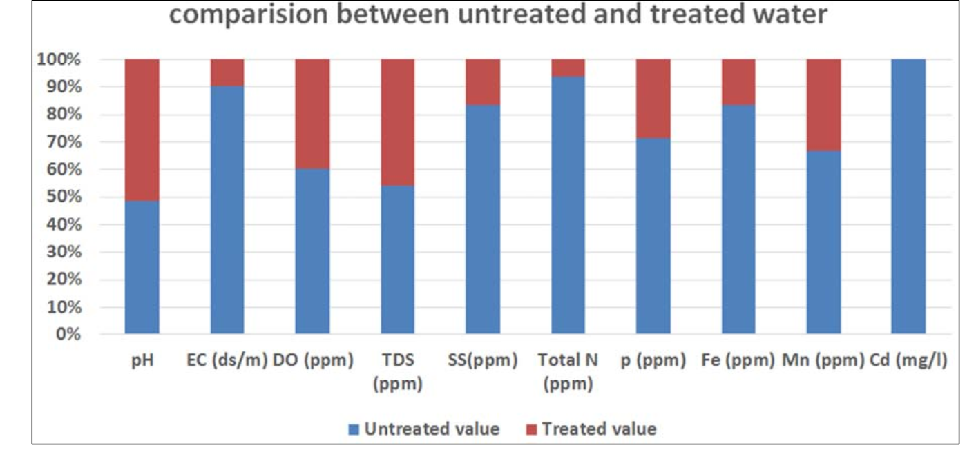

***Figure 2.*** *Compare between treated value (after treatment) and untreated value (before treatment) of Pagla sewage waste water treatment plant.*

Challenges:

Dhaka's expanding need for sewage treatment presents the PST with a number of obstacles. Among them are:   
Limited Capacity: The PST's 120 MLD design capacity is significantly less than Dhaka's present sewage treatment demand [11].

Inadequate Maintenance: Both the sewer network and the treatment plant require inadequate maintenance, which has an impact on the PST's performance [11].

Lack of Awareness: The public is not aware of the significance of proper sewage treatment or the harm that improper sewage treatment causes to the environment and public health [11].

Financial Constraints: Maintaining the sewer network and increasing the PST's capacity are financially challenging due to the high expense of sewage treatment [11].

**Indian water sewage treatment plant:**

**Jajmau water sewage treatment plant, Kanpur** –

This city is home to the first-ever full-scale UASB demonstration facility for municipal wastewater in the world. It was constructed and put into service in 1989. The facility was built to handle 5 million liters of household wastewater per day, and according to Khan (1995), the biogas yield was 0.1-0.15 m3/kg COD eliminated with a 75%–80% methane gas concentration. Table 1 displays the plant's performance statistics.

The process used for treating the wastewater is as following-

Wastewater influent -> pumping -> screening -> UASB reactor -> secondary settling tank -> discharged to river

In Kanpur, a 36 MLD unit has been in service since March 1995 (Tare et al. 1997).

Table 1 gives an overview of the plant's performance.

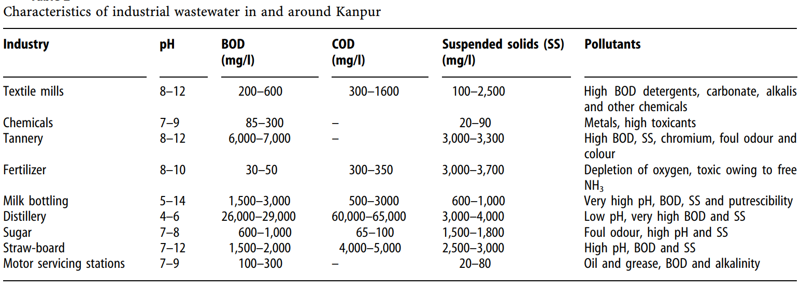

Table 1

**Indore water sewage treatment plant:**

The city of Indore is home to four sewage treatment facilities. The daily capacity of each sewage treatment plant to treat wastewater is 70 mld. The efficiency of these plants is between 65 and 75 percent. Like other cities, Indore lacks a suitable system for gathering wastewater from sewage and an independent system for gathering wastewater from industry. Sewage treatment plants are less able to properly treat the wastewater and have a lower treatment efficiency as a result of the absence of this efficient collecting and separation mechanism. The wastewater is treated using the following procedure:

Wastewater Influent -> pumping -> screening -> greet chamber -> primary settling tank -> aeration tank -> secondary settling tank ->effluent discharge

The treated water's quality is below acceptable bounds. An assessment of the effects of sewage sludge and water on soil, water, and environmental health in Indore was carried out through a survey. Water and sewage sludge samples were taken from every treatment facility. Using established protocols, the pHs, ECe, total nutrients (NPK), available nutrients (NPK), and heavy metal concentrations (Pb, Ni, Cr, Cd, Hg, and As) of the sludge samples were examined. The standard media and procedures were utilized to analyze the effluent samples for EC, pH, DO, BOD, COD, TDS, cations (Ca2 +, Mg2 +, Na+, K+), anions (Cl-, HCO3-, NH4-N and P), micronutrients (Zn, Fe, and Cu), heavy metals (Cd, Cr, Ni, and Pb), pathogens (Escherichia coli, Fecal coli, Straptococcus), bacteria, and fungi. The principal nutrients were found in very high concentrations and ranges in the sewage sludge study results, such as accessible N (0.46-0.63%), P (0.0044-0.0060%), K (0.029 0.041%), and total N (1.54-1.92%), P (0.61 0.92%), and K (0.35-0.43%). In the same way, there were also the heavy metals Pb (26-154 ppm), Ni (12-596 ppm), Cr (66-1098 ppm), Cd (2-9 ppm), Hg (7-32 ppm), and As (8-23 ppm). In peri-urban regions, the 485 million liters of sewage water that are disposed of every day have the potential to provide additional irrigation to almost 16000 hectares of land annually. In terms of NPK, it produces a nutritional potential of 8,100, 1200, and 11,000 tones.

There are issues because the high concentration of heavy metals in sewage sludge and effluents may prevent their long-term use agriculture due to environmental degradation and phytotoxicity.

**DELHI Water sewage treatment plant:**

Delhi, the capital of India, has a population of over 21 million1, making it one of the world's fastest-growing metropolitan areas. The demand for adequate sewage treatment and disposal facilities arose from the city's increased sewage generation as a result of its rapid population expansion and urbanization. However, the majority of the wastewater is released into the environment untreated due to inadequate sewage treatment and disposal infrastructure in the city, which pollutes downstream areas [12]. The goal of this study paper is to present an overview of Delhi's sewage treatment plants (STPs), with a particular emphasis on the Okhla wastewater plants, as well as the difficulties in addressing the city's expanding sewage treatment needs.

With 16.75 million people residing there overall, 97.5% of them are urban dwellers [12]. Sewage creation has increased as a result of the growing urban population; in Delhi1, 3909 million liters of sewage are produced daily (MLD). The entire amount of sewage created and the amount of sewage that is actually treated is 1706.44 MLD, despite the fact that the available sewage treatment capacity is only 2940.66 MLD, and only 74.9% of this capacity is treated [12].

The Delhi Jal Board is in charge of treating and transferring wastewater throughout Delhi via a network of sewage lines totaling around 7000 km. With a total installed capacity of 2799.82 MLD and an actual treatment capacity of 2202.56 MLD1, Delhi has 35 STPs, of which 31 are active. The STPs provide treated wastewater that is safer for the environment by using a variety of technologies, such as physical, chemical, and biological approaches, to remove toxins from wastewater [12].

Numerous investigations have been carried out to evaluate and track the physicochemical characteristics of wastewater at Delhi and sewage treatment facility inlets and outlets [13][14]. These investigations have demonstrated the efficacy of STPs in eliminating pollutants from wastewater, such as metals and microbes. Nonetheless, certain organic pollutants are still present in the treated wastewater; these contaminants are transferred to agricultural soils and are found in higher concentrations [13].

After more than ten years of work and Rs. 872crore in expenses since 1994, the Yamuna river's water quality remains far below normal despite efforts to develop sewage treatment infrastructure [12]. Aerobic bioreactors can also effectively handle the modest levels of polycyclic aromatic hydrocarbons found in sewage sludge [14]. Clustering techniques and the use of hierarchical categorization methodologies could reduce the amount of money and labor needed for the monitoring of various sites [14].

Challenges faced in water treatment plants of India:

* Technical and Management Challenges:

The efficacy and efficiency of these facilities are impacted by a number of crucial technical issues that water and sewage treatment plants in India face. Among the principal difficulties are:   
Financial issues: High maintenance costs, downtime, and inefficient equipment affecting treatment efficiency and operational expenses.

Aging infrastructure: The deterioration of pipelines, tunnels, dams, pumps, and other equipment owing to time and usage [15].

Aging Workforce: The operation and maintenance of treatment facilities are impacted by a shortage of skilled workers resulting from an aging workforce [15].

Energy Consumption: Considerable energy is used, particularly during biological treatment procedures, which makes sustainable operations difficult [15].

Sludge Management: Handling and disposing of sludge generated during the treatment process appropriately to prevent harm to the environment [15].

Land Availability: Because of urbanization and population increase, it is difficult to get enough land for the construction of treatment plants [15].

Environmental Footprint: High treatment plant expenses, large land requirements, energy usage, and sludge production [15].

Continuous Operation: Treatment plants must be operated and maintained around-the-clock, necessitating skilled and knowledgeable personnel. 1. Real-Time Monitoring: Insufficient real-time data monitoring resulting in non-compliance with discharge restrictions and system faults   
[15].   
The aforementioned issues underscore the intricacy and significance of tackling diverse technical aspects to guarantee the effective and enduring functioning of water and sewage treatment facilities in India.

* Economical Challenges:

The problems associated with sewage treatment in India are complex, arising from political as well as economic factors.

Sewage treatment capacity is lacking in comparison to the rapidly urbanizing scenario due to the high expense of constructing and maintaining sewage treatment plants (STPs) and the government's difficulty meeting construction targets. Effective treatment is hampered by clogged and silted sewage drains, and the current infrastructure is frequently unable to handle the growing amounts of sewage.

Adding to the problem is industrial waste, which raises the expense of water treatment and makes it unfeasible for democratic governments to provide their constituents with modern sewage systems [15].

* Political Challenges:

The profitable nature of the water industry, which has drawn a lot of interest from Indian companies, has restricted the private sector's political engagement in municipal water systems.

A fair share of the water industry is being sought after by the Confederation of Indian Industry (CII) and other associations; nevertheless, in order to enhance water management and these fundamental services, industry, government, and community must collaborate. Water crises worldwide cannot be resolved by the private sector, and it is challenging to implement differential pricing so that the wealthy are able to afford expensive sewage treatment and the impoverished can afford their less expensive disposal system, which is almost never linked to the sewerage system [15].

* How these problems affect people's lives:

India faces a serious problem with its inadequate sewage treatment infrastructure. Approximately 93% of sewage flows untreated into ponds, lakes, and rivers, severely polluting water sources and resulting in diseases like diarrhea, which kills 350,000 Indian children every year.

The urban impoverished are more at risk since they live close to polluted drains and canals where bacteria and mosquitoes thrive. The biggest cities in India have centralized sewage systems, which include subterranean pipelines, pumping stations, and treatment facilities. However, these systems are costly to construct and run, requiring constant power, knowledgeable operators, and intensive maintenance. Because of this, less than half of them are effective[16].

* Government measures to address this problem:

Smaller, more affordable systems to treat wastewater closer to the point of generation are being encouraged by groups like the Consortium for Decentralized Wastewater Treatment System Dissemination Society (CDD), which has been working to develop more cost-effective and efficient sewage systems in response to these challenges.

The Decentralized Wastewater Treatment System (DEWATS) of CDD has adapted many technologies to situations in which professional labor is few, energy is not always accessible, and mechanical parts that break might never be fixed 2. The system's purpose is to make it possible to reuse water for gardening and toilet flushing more efficiently. With the use of gravity, plants, and natural bacteria in place of power and chemicals, DEWATS can function at up to 80% less cost than traditional technologies [15].

**Conclusion:**

India's sewage treatment system and management are confronted with a multitude of issues that necessitate a comprehensive strategy to effectively tackle. India's sewage treatment system and management could be enhanced by the following measures:

1. **Decentralized Wastewater Treatment Systems (DEWATS):** By treating wastewater closer to the source, DEWATS allow for more efficient reuse of water for things like gardening and toilet flushing. These systems can function up to 80% cheaper than conventional technologies since they rely on gravity, plants, and naturally occurring microbes rather than power and chemicals [18].
2. **Appropriate Technology:** For sustainable sewage treatment in India, it is imperative to employ appropriate technology, such as affordable, straightforward, and reuse-and-recycle-focused solutions. Decentralized approaches that make use of plants and some bacteria that are connected with them are efficient and reasonably priced, making them appropriate for reuse and gradual improvement.   
   [17].
3. **Technology Selection:** The selection of technology is contingent upon various project-specific factors, such as the criteria regarding effluent quality, the availability of land, energy requirements, and costs. For instance, the highest rate of filtration wastewater treatment technology is the membrane bioreactor, or MBR, which is perfect for locations where land is scarce [20].
4. **Public opinion:** The success of programs aimed at managing wastewater is greatly dependent on public opinion. Campaigns for public awareness and education can influence perceptions of wastewater treatment and encourage the use of sustainable practices [19].

**REFERANCES:**

[1] <https://www.niti.gov.in/sites/default/files/2022-09/Waste-Water-A4_20092022.pdf>

[2] <https://www.indiawaterportal.org/articles/wastewater-management-framework-india-policy-challenges-and-solutions-sustainable-future>

[3] <https://ijari.org/assets/papers/6/2/IJARI-CV-18-06-104.pdf>

[4] <https://www.ncbi.nlm.nih.gov/pmc/articles/PMC7816121/>

[5]<https://www.researchgate.net/publication/284715711_Sewage_Treatment_and_Management_in_Goa_India_A_Case_Study>

[6] Metcalf & Eddy. (2013). Wastewater Engineering: Treatment and Reuse (5th ed.). McGraw-Hill

[7] Education. Tchobanoglous, G., Burton, F. L., & Stensel, H. D. (2014). Wastewater Engineering: Treatment and Reuse (5th ed.). McGraw-Hill Education.

* OAPEN Library: Basic Principles of Wastewater Treatment
* PMC - NCBI: Wastewater Treatment & Water Reclamation
* Environmental Protection Agency: How Wastewater Treatment Works...The Basics
* MDPI: Study on the Choice of Wastewater Treatment Process Based on the Energy Theory
* Biology Libre Texts: Wastewater and Sewage Treatment
* Water Research Foundation: Membrane Bioreactors for Wastewater Treatment
* US Environmental Protection Agency: Green Infrastructure for Wastewater Management
* Water Environment Federation: Constructed Wetlands for Wastewater Treatment
* US Geological Survey: Biofilters for Wastewater Treatment

[8] <https://www.passavant-geiger.com/en/case-studies/detail/cambrils-spain>

[9] <https://www.waterworld.com/home/article/16216132/small-spain-municipality-innovating-wastewater-treatment-with-new-bioaugmentation-technology>

[10]<https://documents1.worldbank.org/curated/en/507721559627554397/pdf/Environmental-and-Social-Impact-Assessment-of-Pagla-STP-and-Trunk-Mains.pdf>

[11] Haq, K. (2006). Environmental-and-Social-Impact-Assessment-of-Pagla-STP-and-Trunk-Mains.pdf. World Bank Documents.

[12] Shreya Gupta, SK Singh, and Vishal Gandhi. A study on Sewage Treatment and Disposal in Delhi. International Journal of Advance Research and Innovation, 2021.

[13] D., Tripathi, J.K. et al. A study of the effectiveness of sewage treatment plants in Delhi region. Appl Water Sci 3, 57–65 (2013).

[14] Singh et al. 2004; Frank Laturnus et al. 2007; Foresti et al. 2006; Orhon et al. 1997; Tare et al. 1997; Govt. report 2005; Trably and Patureau 2006; Sato et al. 2005.

[15] Top 9 Challenges of Water and Wastewater Treatment Plants - Euroteck India

[16] Prof. Shyam R. Asolekar, "Challenges of Sewage Treatment in India" - Indian Institute of Technology Bombay [PDF]

[17] Challenges of Sewage Treatment in India, Prof. Shyam R. Asolekar, Centre for Environmental Science and Engineering, Indian Institute of Technology Bombay, gy y Powai, Mumbai 400 076 Phones: 022- 2576 7851 E-mail: [asolekar@iitb.ac.in](mailto:asolekar@iitb.ac.in)

[18] Fixing India's Sewage Problem, Stanford Social Innovation Review, <https://ssir.org/articles/entry/fixing_indias_sewage_problem>

[19] Rethinking wastewater management in India, The Third Pole, <https://www.thethirdpole.net/en/pollution/waterwaste-management-in-india/>

[20] <https://www.downtoearth.org.in/news/waste/india-is-adopting-advanced-sewage-wastewater-treatment-tech-but-must-choose-those-that-best-meet-local-needs-92863>