**DBMS**

**Report on SQL Queries**

Name - Neeraj

Roll no - 23bcs085

CSE - B

Create the following tables (Don’t specify any constraints):

A. Category_details (category_id numeric (2), category_name varchar (30) ) B.

Sub_category_details (sub_category_id numeric(2), category_id

numeric(2),sub_category_name varchar(30)

C. Product_details (Product_id numeric (6), category_id 3

numeric(2),sub_category_id numeric(2), product_name

varchar(30))

**SOLUTION :-**

CREATE TABLE Category_details (

category_id NUMERIC(2),

category_name VARCHAR(30)

);

CREATE TABLE Sub_category_details (

sub_category_id NUMERIC(2),

category_id NUMERIC(2),

sub_category_name VARCHAR(30)

);

CREATE TABLE Product_details (

Product_id NUMERIC(6),

category_id NUMERIC(2),

sub_category_id NUMERIC(2),

product_name VARCHAR(30)

);

Output -

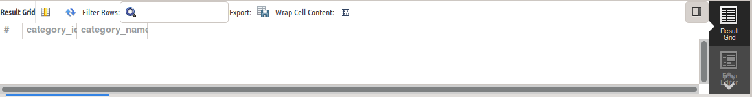

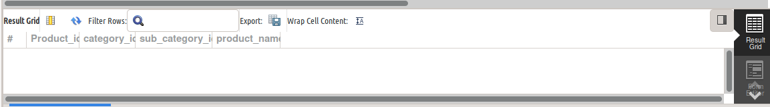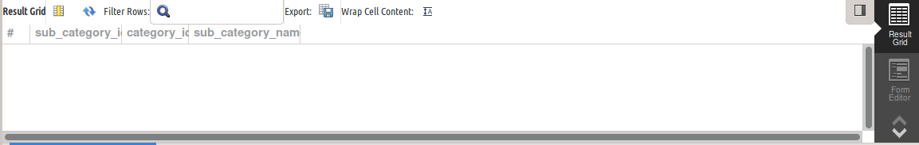

**Now perform the following operations:**

1. Add a primary key constraint (without any constraint name) on column

category_id of category_details table.

ALTER TABLE Category_details

ADD PRIMARY KEY (category_id)

Output -

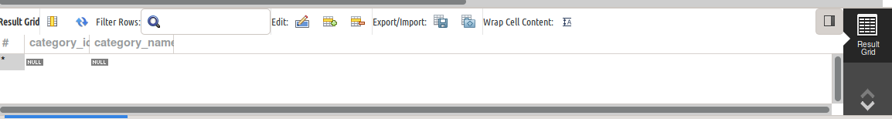

2. Add a primary key constraint with a constraint name on column sub_category_id

of sub_category_details table.

Output -

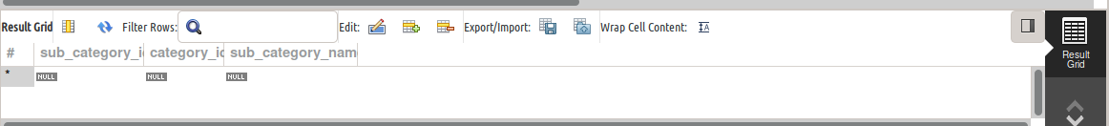

3. Add a foreign key constraint with constraint name on column category_id of sub_category_details table referencing category_id of category_details table.

ALTER TABLE Sub_category_details

ADD CONSTRAINT fk_category_id FOREIGN KEY (category_id)

REFERENCES Category_details(category_id);

Output -

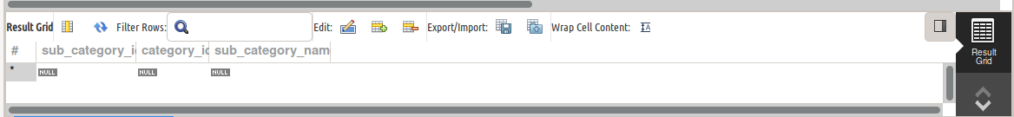

4. For the product_details table add the primary key constraint on product_id. Also add foreign key constraint on category_id and sub_category_id columns referencing category_details(category_id) and sub_category_details (sub_category_id).

ALTER TABLE Product_details

ADD CONSTRAINT pk_product PRIMARY KEY (Product_id);

ALTER TABLE Product_details

ADD CONSTRAINT fk_product_category FOREIGN KEY (category_id)

REFERENCES Category_details(category_id);

ALTER TABLE Product_details

ADD CONSTRAINT fk_product_subcategory FOREIGN KEY (sub_category_id)

REFERENCES Sub_category_details(sub_category_id);

Output -

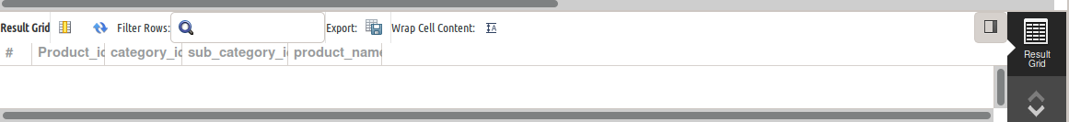

5. Add a new column (price numeric(2)) to product_details table

ALTER TABLE Product_details

ADD COLUMN price NUMERIC(2);

Output -

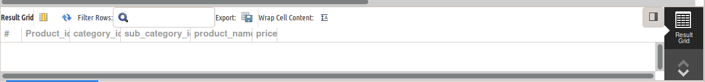

6. Modify the data type of price to numeric(6,2)

ALTER TABLE Product_details

MODIFY COLUMN price NUMERIC(6,2);

Output -

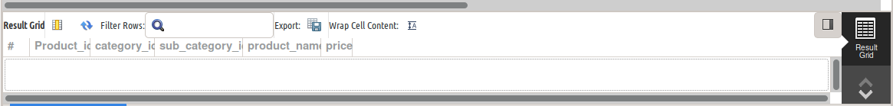

7. Insert four tuples in the table. (With valid data)

INSERT INTO Category_details (category_id, category_name) VALUES

(1, 'Electronics'),

(2, 'Clothing');

INSERT INTO Sub_category_details (sub_category_id, category_id, sub_category_name) VALUES

(1, 1, 'Smartphones'),

(2, 1, 'Laptops'),

(3, 2, 'T-shirts'),

(4, 2, 'Jeans');

INSERT INTO Product_details (Product_id, category_id, sub_category_id, product_name, price) VALUES

(100001, 1, 1, 'iPhone 15', 999.99),

(100002, 1, 2, 'MacBook Air', 1299.99),

(100003, 2, 3, 'Cotton Tee', 24.99),

(100004, 2, 4, 'Slim Fit Jeans', 59.99);

Output -



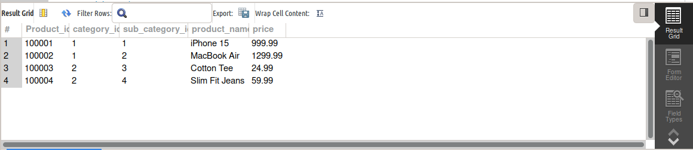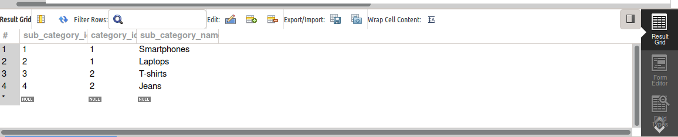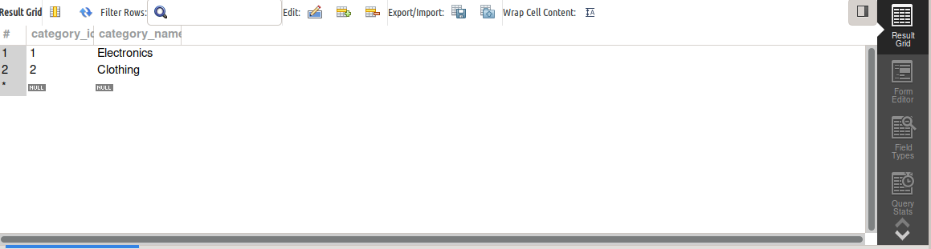

8. Drop the price column

ALTER TABLE Product_details

DROP COLUMN price;

Output -

