1. Folder nestle final code has the arduino code required for the project.you need to configure some settings before uploading the code.

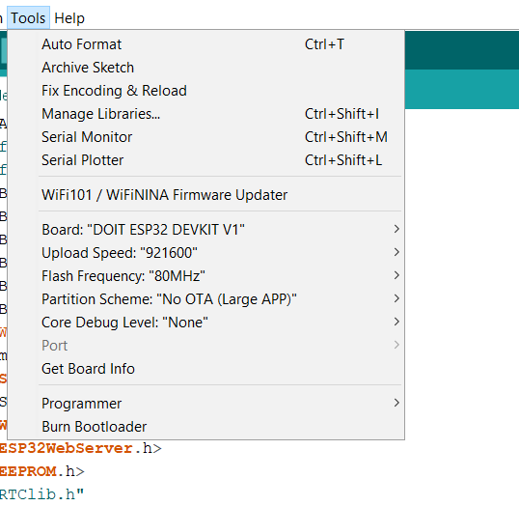

Set the partition scheme to No OTA.

1. Secondly there is a folder named New_Project which is the pcb design for the project you can open the board by click on “untitled.brd”

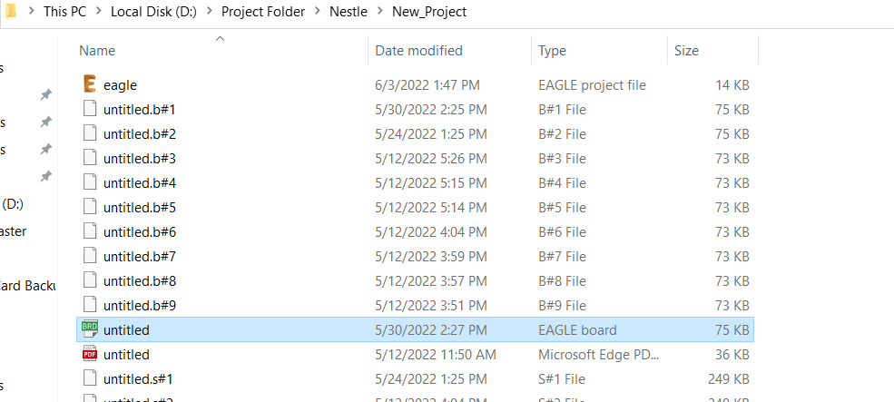

1. A word file named nestlepcb in this folder has the pcb designs sized for printing usable pcb circuits. Page 10 and 11 are correctly resized in accordance with HR desk printer. Print it on a A4 size paper first and check that the esp32 fits perfectly on that paper than print it with the best quality(photo quality) on a glossy paper for pcb printing.
2. SD card can be formatted using sd card formatter software and then you can just copy all the text files in Nestle sd card backup folder to the formatted sd card.