**TRAFFIC MANAGEMENT SYSTEM**

**ABSTRACT**

* Intelligence Traffic Management System (ITMS) provides effective and efficient solutions toward the road traffic management and decision making problems, and thus helps to reduce fuel consumption and emission of greenhouse gases, and increases the standard of sustainable living.
* Software based real time bi-directional traffic management system (TMS) with Artificial Neural Network (ANN) was proposed and implemented. The proposed TMS solves a decision problem, dynamic road weights calculation, using different environmental, road and vehicle related decision attributes.
* In addition, the development of the real time operational models as well as their solving challenges has increased in a rapid manner. Therefore, in this chapter, we integrate the design and development of a neural based complete real time operational ITMS, with the combination of software based modules including traffic monitoring, road weight updating, forecasting, and optimum route planning decision.
* This chapter will also co-ordinate with large scale complex data. Collecting, extracting the insights and inherit meaning, and modeling the tremendous amount of continuous data is a challenging task. A discussion on the future advancements on this ITMS model is also included. Keywords: Intelligence Traffic Management System (ITMS), Artificial Neural Network, Long Short Term Memory Networks (LSTM), Road Weight Forecast, Route Planning. INTRODUCTION Intelligence Traffic Management System (ITMS) incorporates modern
* (Verma, 2012;

**INTERENT BASED TRAFFIC MANAGEMENT SYSTEM**

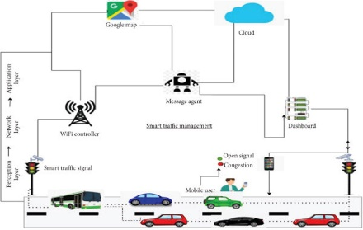

**BLOCK DIAGRAM OF TRAFFIC MANAGEMENT SYSTEM**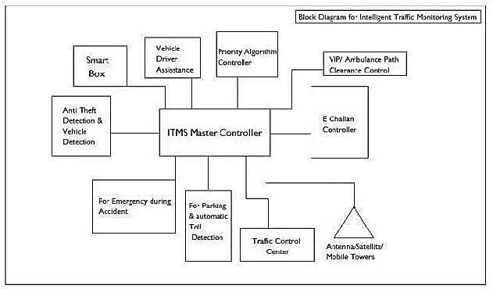

The ITMS is not also a basis for smart switching of traffic lights but it’s a whole new evolution of traffic monitoring system. The above diagram represents the I st generation of ITMS. It houses the basic functional systems like:

* Anti-Theft/ Vehicle detection.
* Emergency signaling during accidents
* Car Parking / Automatic Toll Deduction.
* E Challan Systems.
* VIP/Ambulance path Clearance.
* Priority Algorithm controller (Smart Switching)
* Smart Box (for smart switching).
* Vehicle Driver Assistance (VDA) System.
* Traffic Control Center.
* Antenna/Satellites/Towers for Communication.

**This intelligent system comprises several components,**

* including wireless sensors,
* RFID tags,
* and BLE beacon