Seminar HCI and BCI in practice

Session0: Python Tutorial (installation)

Step 1: Download Anaconda
First Way: Go to the website and download
https://www.anaconda.com/download/success (06/04/2025)
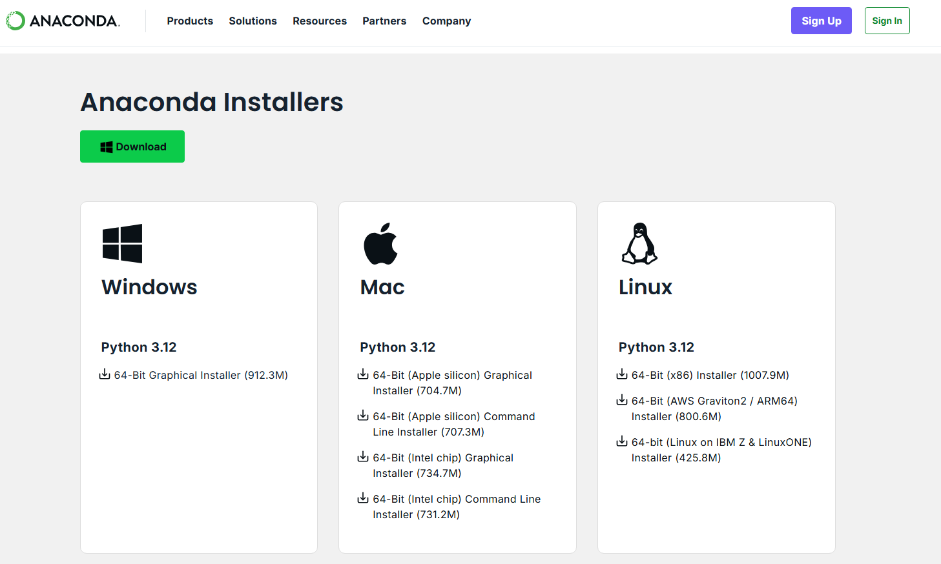

Second Way: Use command window or powershell
Win-Users:
Win+R cmd
curl https://repo.anaconda.com/archive/Anaconda3-2024.10-1-Windows-x86_64.exe --output .\Downloads\Anaconda3-2024.10-1-Windows-x86_64.exe

Mac-Users:
Win+R powershell
wget "https://repo.anaconda.com/archive/Anaconda3-2024.10-1-Windows-x86_64.exe" -outfile "./Downloads/Anaconda3-2024.10-1-Windows-x86_64.exe"

Linux-Users:
Depends on CPU architectures.
https://www.anaconda.com/docs/getting-started/anaconda/install#macos-linux-installation

Step 2: Build Environment
Open Anaconda PowerShell Prompt

# Step0: change your working directory (use:'cd','pushd',etc.)
cd H:\BCI_py\Session_00

# Step1: Check current python version
python –version

# Step2: Check current conda working environment
conda info --envs

# Step3: Create a new conda working environment for BCI-Seminar
conda create -n BCI_Seminar python=3.12.7
# -n: short form for --name
# if the cur. py version is already your target version, 'python=3.12.7' can be ignored

# Step4: Activate the working environment for Seminar
conda activate BCI_Seminar
# Step4-1: Check conda environment again
conda info –envs

# Setp5: Install relevant packages (Specify your own path)
pip install -r "H:\BCI_py\Session_00\requirement.txt"
# if you did Step0, then "requirement.txt"

# Step6: Install Jupyter notebook in current new working environment
conda install jupyter
pip install notebook

# Step7: Open notebook file in today’s session
jupyter notebook "Session_00_student.ipynb"

Step 3 (Optional): Build a Shortcut to start notebook script
We can create a shortcut; thus, we can directly go into the environment we want, also the target folder where we will always work. Now our goal is to write a command line like following below:

%WINDIR%\System32\cmd.exe /k "call D:\Programming\Anaconda\Scripts\activate.bat BCI_seminar && cd /d C:\Users\yevge\Desktop\BCI_py\Student && jupyter notebook"

# Step0: preparate your shortcut command
right click on Anaconda Prompt Open file Location Target Copy the command here:

Example:
%WINDIR%\System32\cmd.exe "/K" D:\Programming\Anaconda\Scripts\activate.bat D:\Programming\Anaconda

# Step1: Get your shortcut command

Extract the parts you need and write the grammar like the example command line. Add environment name, and your working directory, at the end type jupyter notebook. Don’t forget the connecting parts and quote and back quote sign. Then you get:

# Step2: Create shortcut
Open your working folder right click New Shortcutcopy the command line aboveName your short cut (like “Seminar_laucher”)

