### Demographics survey

**1. Your age** _____________

**2. Your email address** _____________

**3. What is your current gender identity?**

Woman

Man

Trans Male/Trans Man

Trans Female/Trans Woman

Genderqueer/Gender non-conforming

Different Identity

Prefer not to say

**4. What sex were you assigned at birth, meaning on your original birth certificate?**

Male

Female

**5. How would you describe your main racial/ethnic background?**

Australian – neither Aboriginal nor Torres Strait Islander

Australian Aboriginal or Torres Strait Islander

Pacific Islander, or other Oceania

British or European

Asian

Middle Eastern

African

North American

Central or Southern American

**6. Please indicate the highest level of education you have completed.**

(1) Still at secondary school (2) Did not finish secondary school (3) Year 12 or equivalent (4) Certificate level, diploma, or advanced diploma (5) Bachelor's degree

(6) Postgraduate Degree (e.g. Honours, Masters, Doctorate, PhD)

# Measures of anxiety: State-Trait Anxiety Inventory (STAI) – Beckler 2010

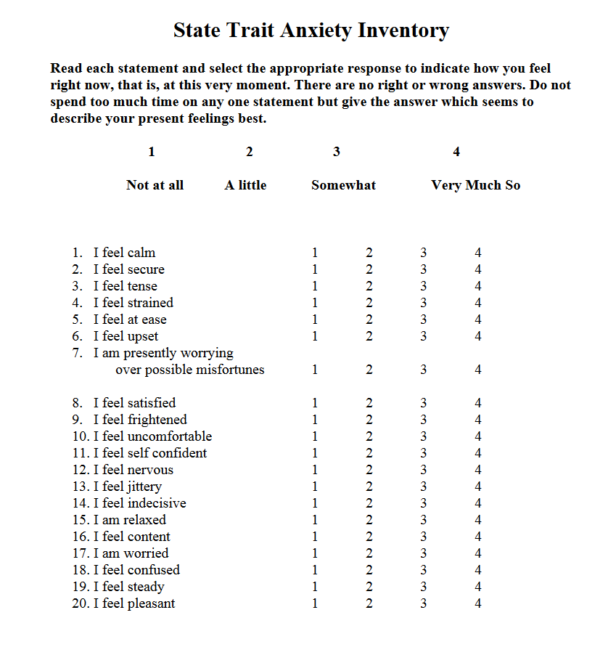

**The Difficulties in Emotion Regulation Scale Short Form (DERS-SF) – Kaufman et al., 2015**

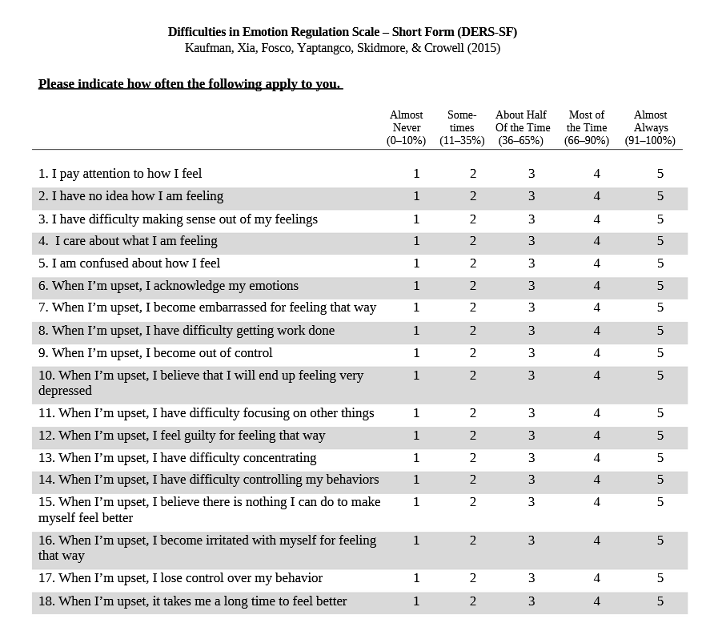

**Pittsburg Sleep Quality Index (PSQI) – Buysse 1989**

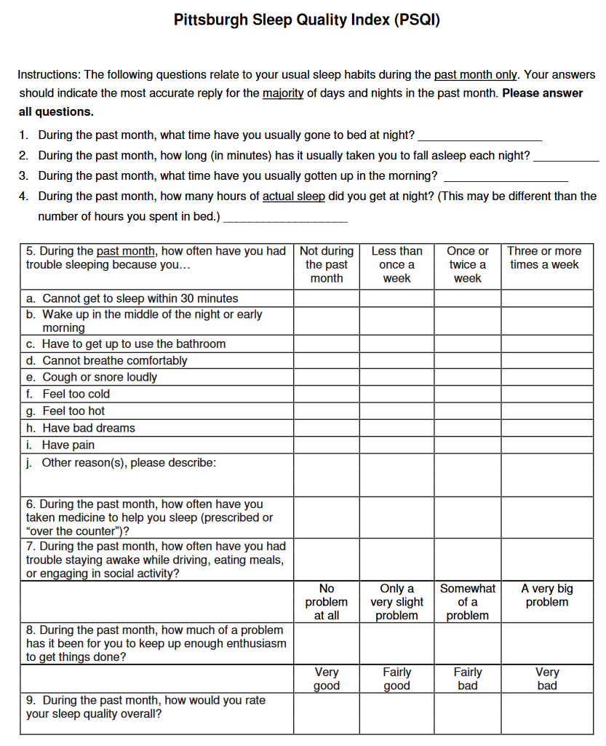

**Depression Anxiety Stress Scale short form – Lovibond & Lovibond 1995**

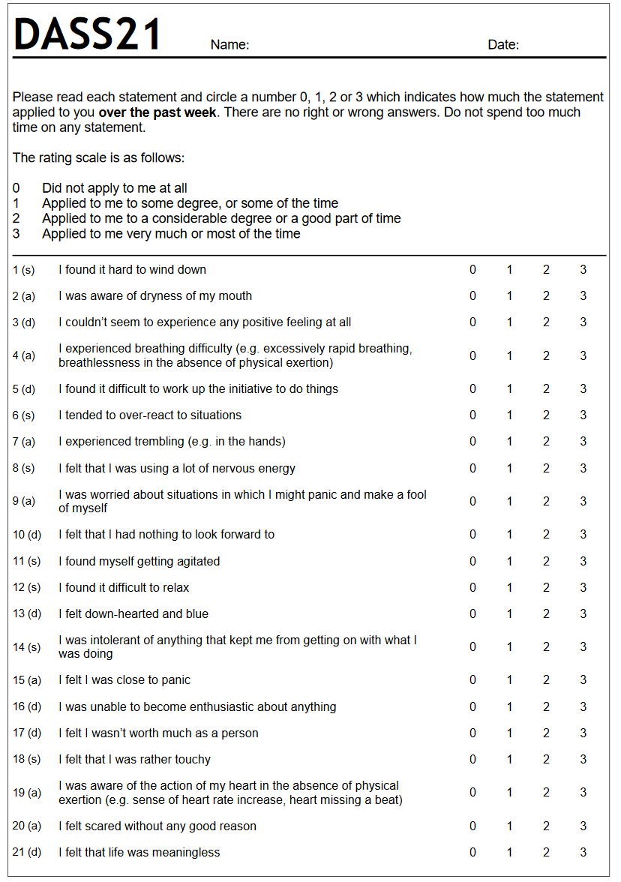

**Intolerance of Uncertainty Scale: Freeston 1994**

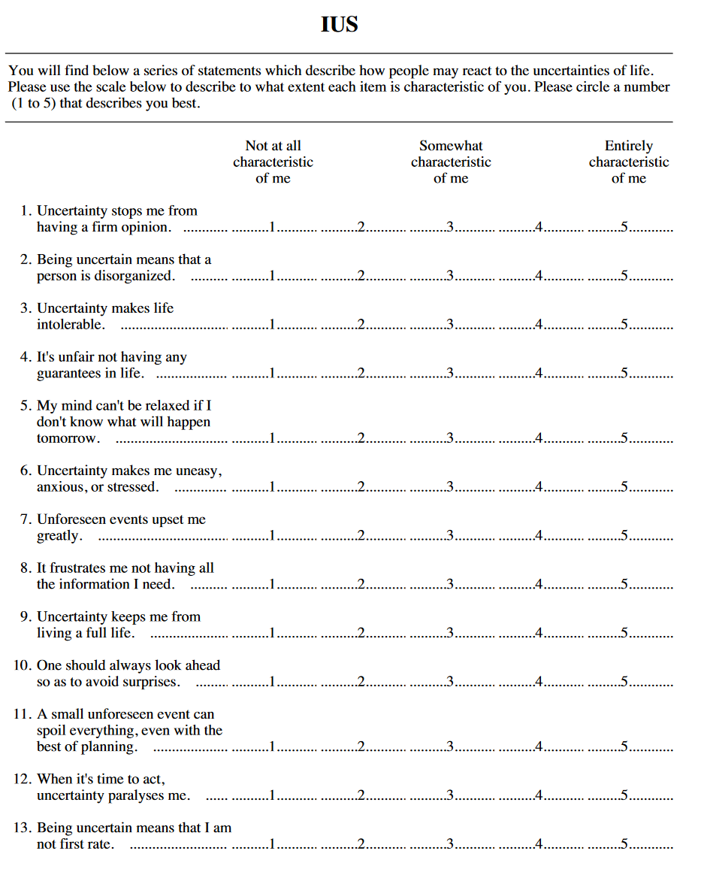

Behavioral Inhibition and Behavioral Activation Scale (BIS/BAS) Carver & White 1994

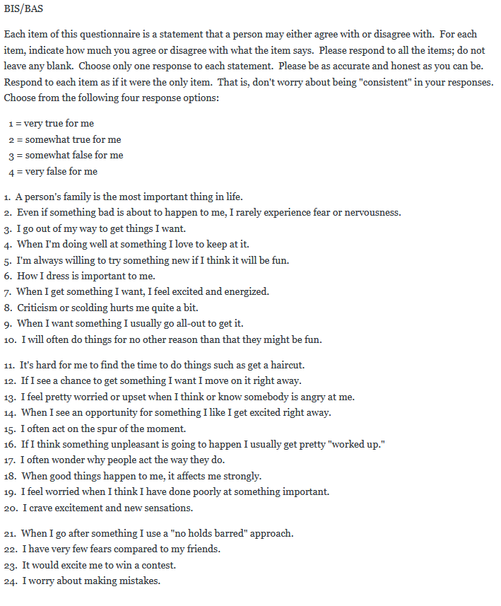

**MIDI Sense of Control - Lachman and Weaver (1998)**

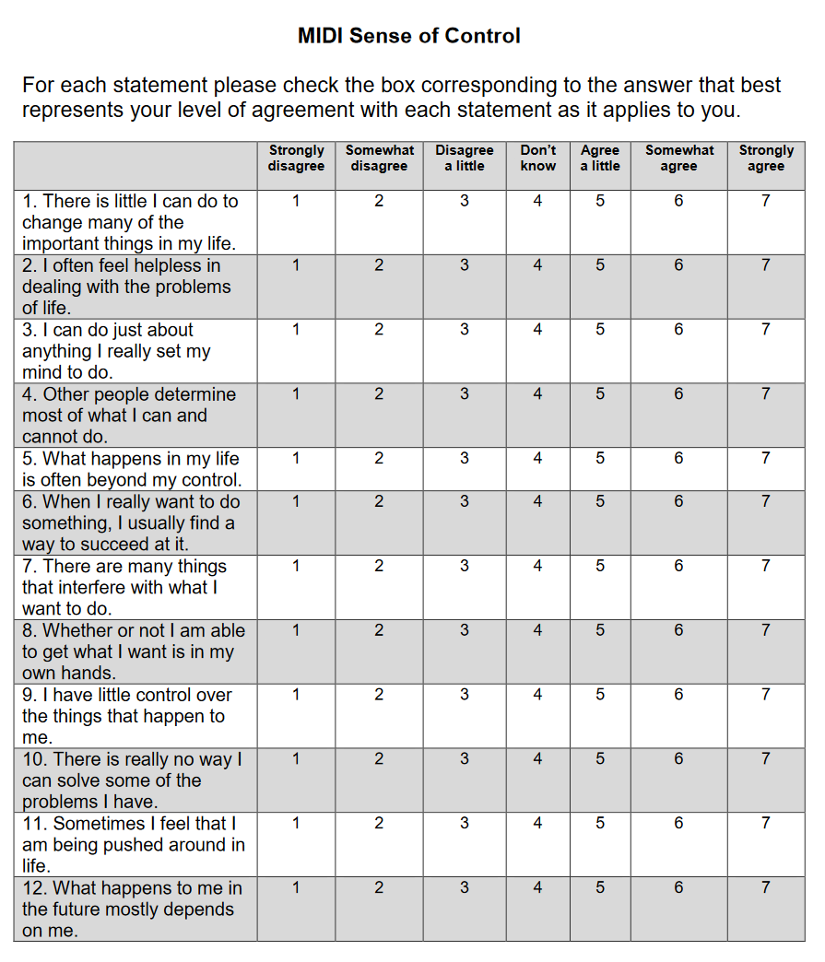

Emotion Regulation Questionnaire (ERQ) – Gross and John, 2003

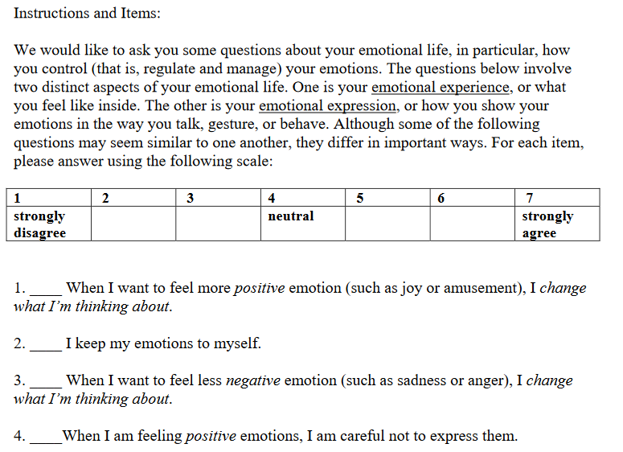

**Perceived Stress Scale - Cohen, Kamarch, & Mermelstein,1983**

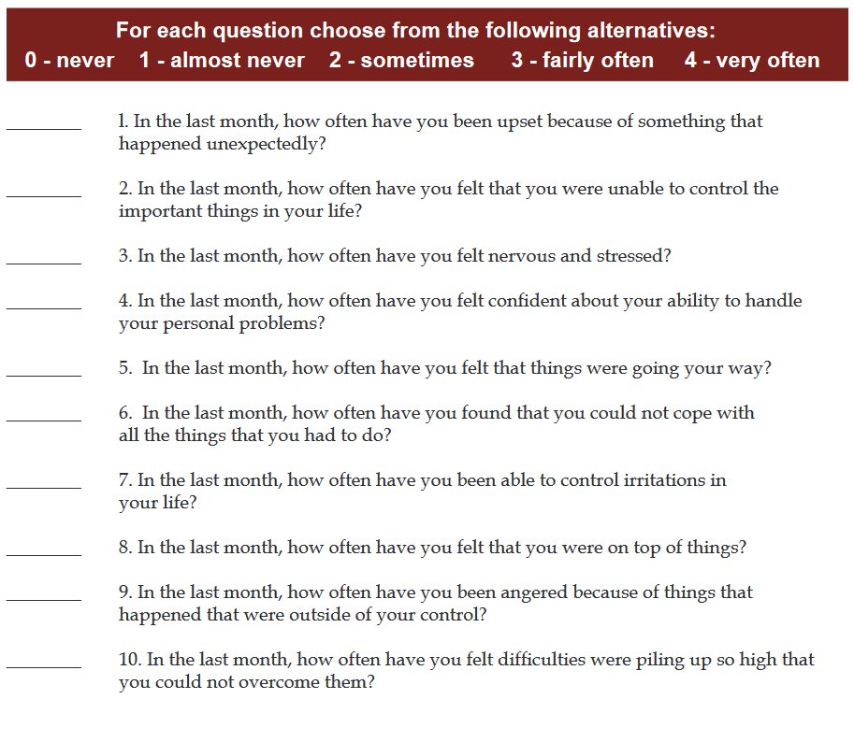

**Relationship Assessment Scale –** Chonody et al., 2018

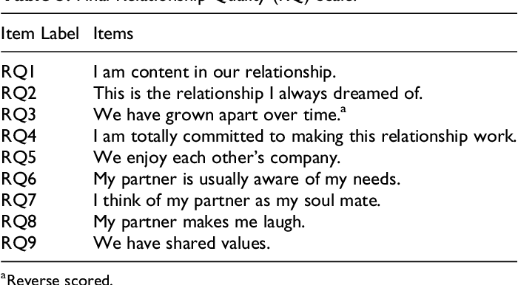

**Multidimensional Scale of Perceived Social Support (MSPSS) – Zimet et al., 1988**

