**CONTACTS:**

**Dr. Sarah Tashjian: +61 475 145 654**

**Prof. Kim Felmingam:**

***Contact Dr. Tashjian first if there are any issues. She will direct you to Prof. Felmingham if any subjects are in distress.***

**PRIOR TO SCAN**

**To bring to the scan**

* USB with tasks and for data backup
* Laptop with tasks and instructions
* Participant reimbursement – brown cash envelopes
* Hardcopies of
  + PLS,
  + consent, assent, parent consent
  + withdrawal of consent,
  + payment form
* Printed payment receipt
* Check participant ID/name/contact number in Google drive subject info spreadsheet
* Notebook for scanning notes

**Setting up**

* Walk participant through consent form and have them sign it.
* Confirm participant completed the pre-scan questionnaires on Pavlovia.
* Check shared mailbox to make sure participant has not emailed to cancel or notify they will be late.

**Participant arrival**

* Meet participant at entrance to Kenneth Myer building at agreed time.
* Ask if they need to use the restroom outside of MBICU before their scan time starts.

**Participant briefing (AVOID REPETITION)**

* Discuss overview of scan – ‘MRI_ParticipantBriefing_AdolescentSafety’ presentation.
* Task training instructions for Safety Task and Generalization Task.
  + Note. While it is encouraged that briefing is conducted in a responsive and friendly manner, it is paramount that task instructions are provided as closely as possible to what is written on the slides to ensure consistency across participants.
* Confirm if the participant feels they can correctly complete the task.
* Double check understanding of the button responses.
* Ask participant if they have any questions.

**Prepare for MRI safety screening**

* Ask participant to get changed into scrubs (explain sizing; all clothing should be off; except underwear, socks, and shoes. Women can wear sports bra without athletic fabric.).
  + Note. If wearing anything on the chest, it will have to be taken off if there is metal – when in doubt, ask on-duty radiographer
* Once participant is changed, notify on-duty radiographer for safety screening.
* Remind participant to use the toilet and get water before entering scanning room.

**Participant debrief**

* Get general feedback of experience in scanner.
* Debrief on task-related distress (e.g., remind participants that task performance was not monitored and doesn’t reflect anything of the participant).
* Acknowledge distress that screening/questionnaire questions may bring up.
  + Note. It is encouraged that debriefing is done in a responsive, validating, and supportive manner. The sequence of debriefing can be altered to best address participant’s concerns, and to allow space for participant reflection.
  + Participants may ask about details of the study, and it is sufficient to revisit key points in the Plain Language Statement without further elaboration or to acknowledge that we don’t know. It is important that we do not provide incorrect information.
* Remind that a debrief document with support service contact will be emailed to participant alongside images of their brain, and second email with invitation to the eHealth trial.
  + Note. More information on the eHealth trial can be found [here](https://unimelbcloud.sharepoint.com/:f:/r/teams/NeuroWIRED/Shared%20Documents/Recruitment/SEED?csf=1&web=1&e=EPlBTl).

**Reimbursement**

* Provide reimbursement to participants (cash in envelope)
* Participants and researcher to sign receipt

**Concluding scanning session**

* Ask participant to change back into their clothes, remind to leave used scrubs in the basket outside the changing room.
* Walk participant out.

**Email to Sarah & Yubing**

* Please send a debriefing email after scanning to Sarah & Yubing. Include any issues that arose, and questions about processes, participants etc.

**Prior to participant being in scanner (outside the scanner room)**

1. Log into fMRI-guest profile on the experimental computer – password is on the base of the monitor computer.
2. Adjust the display to a resolution of 1024 x 768.
3. Change computer volume to 30 and make sure the computer is not on mute.
4. Make sure button box amp next to computer is switched on.
5. Ensure task bar is set to automatically hide.
6. Turn on speaker.

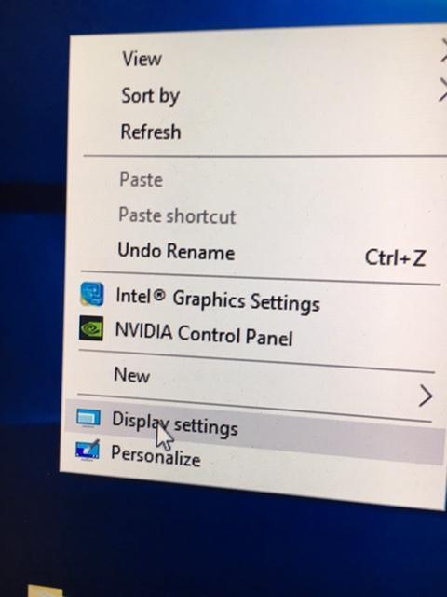

1. Open Google Chrome→YouTube Nature Scenes that is bookmarked, for the sMRI.
2. Open “AND Lab” folder. Open “Safety Tasks” for 4 x experimental files.
3. Ensure the YouTube video is on the screen with the black “Subscribe”button visible at the bottom of the screen and the video is on mute.
4. Check trigger box settings – keyboard/ASCII
5. Open “Documents→AND LAB” folder.
   1. 1. Structural
   2. 2. Localiser Pre
   3. 3. Safety Runs1-4
   4. 4. Localiser Post
   5. 5. Generalisation Runs1-3
6. Set up the scanning book. Sections on the page include:
   1. Date.
   2. Participant first name and initial of surname.
   3. Participant ID.
   4. “Localiser Pre”
   5. “Safety”
   6. “Localiser Post”
   7. “Generalisation”
   8. Notes (input any relevant notes)
7. Open PsychoPy—there is a shortcut on the Desktop—and load all tasks into the PsychoPy Runner window by selecting the blue plus symbol (see image below). Once these experiments have been loaded, minimise Psychopy.

**Participant being set up in scanner (inside the scanner room)**

1. Radiographer will give the button box to participant and explain how it works, make sure you tell the radiographer to explain 1,2,3,6,7,8 for the generalisation task and 1,6 for the safety task.
2. Once the Participant has moved into scanner the radiographer checks that the participant can see the subscribe button.

* Respiratory belt - Radiographer
* Emergency buzzer - Radiographer
* Blanket - Radiographer
* Headphones - Radiographer
* Heart rate monitor - radiographer
* Button Box - radiographer

**During Scanning (outside the scanner room)**

***PLANNING SCANS script”***

***Hi X, how are you doing? Is the volume of my voice ok?*** *(Adjust if needed)* ***We're going to do some planning scans which will take a couple of minutes. We just need you to lie there and stay still. We will talk to you shortly.***

***STRUCTURAL T1 SCAN script***

***EXPERIMENTER:***

***“Hi _____, how are you doing? OK, so this is the first scan, it’s the structural brain scan and it will go for 7 minutes. We just need you to lie there and stay still. Are you ready? Ok great, starting the scan now.”***

1. Open the YouTube nature scenes video to fullscreen. Press play

**LOCALISER PRE TASK**

***EXPERIMENTER: Hi __, you still doing okay? Ok, the next task is a task you haven’t seen before. For this task, you just need to look at the screen and carefully view the images. After the task we’ll explain what you will do next. There will be no loud noise for this task. Make sure you keep your head as still as possible during the entire task. Does that all make sense? Can you press the buttons for me to test they are working: Button 1? Button 2? Button 3? Button 6? Button 7? Button 8? Okay great. We’ll be starting soon, so remember to keep still.***

Drag the localiser task into the psychopy runner. Enter the participant ID and “PRE”.

**AFTER LOCALISER PRE SCRIPT**

***The scan is over now. I’m going to set up for the next task and I will speak to you shorty.***

Once the “Safety” experiment tab and go to the instructions folder

**INSTRUCTIONS TASK**

**EXPERIMENTER: “*Hi _____, how are you feeling? You’re doing great. Next, you are going to go through the instructions for the first decision making game you’ll play. During the instructions please press ‘1’ to advance the screen. Once you’re finished with the instructions you’ll do a few practice trials. We won’t be scanning your brain during the instructions. We can answer any questions you have before you start the game. Are you ready to see the instructions?*”**

**“*Ok, great, we’ll start shortly.*”**

Open the index.html file and enter the participant ID. This will open a browser and the instructions will start.

**AFTER INSTRUCTIONS TASK**

***The instructions are over now. Do you have any questions?***

***I’m going to set up for the game and I will speak to you shorty.***

Open up Run 1 of the “Safety” experiment by pressing play in the psychopy runner.

**SAFETY TASK script– adjust the amp volume AFTER reading script**

**“*Hi _____, is everything going OK? You have been doing very well. The next task is the safety task with the animals and weapons you just saw. For this task you’ll be playing a series of battles. You will hear a loud tone if you lose the battle. Your job is to make a choice about whether you think you will win or lose the battle by pressing ‘1’ with your left pointer finger if you think you’ll lose and ‘6’ with your right pointer finger if you think you’ll win. The outcome of the battle is based on the strength of the animal and the power of the weapon. Your guess about winning or losing has no effect on the battle outcome. We just want to know what you think will happen so we can see how accurate you are. You’ll make a decision about whether you think you’ll win or lose when you see every picture. So if you see a weapon first but you don’t know what animal you’ll encounter we want you to guess whether you’ll win or lose just based on the weapon. If you see an animal first we want to know whether you think you’ll win or lose based just on the animal before you learn what weapon you have. Then when you see the second picture you’ll have all the information about the battle and you can update your choice. So make a rating at every picture based on whether you think you’ll win or lose based on the information you have. Does that make sense?”***

**“*Great, we will start in a minute. Please remember to keep very still*.”**

1. Check the sound settings again – volume 30 and computer not on mute.
2. *TURN UP AMP NOW*
3. Turn up the headphone volume (left Line1 AND middle Line 2) to maximum (reference image on next page).

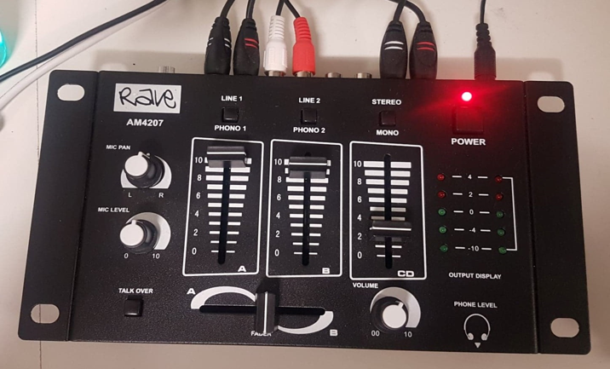

1. Open the psychopy file in the runner and press play.
2. Enter participant ID and run number. Press continue
3. The ‘Waiting for scanner” screen should now be showing

**SAFETY POST SCRIPT**

***The scan is over now. I’m going to set up for the next task and I will speak to you shorty.***

**SAFETY TASK RUN 2**

**EXPERIMENTER: “*Hi _____, how are you feeling? You’re doing great. You’re going to play the second round of the safety game now. Are you ready?***

Open Run 2 in the psychopy runner, enter participant ID and run number

**SAFETY TASK RUN 3**

**EXPERIMENTER: “*Hi _____, how are you feeling? You’re doing great. You’re going to play the next round of the safety game now. Are you ready?***

Open Run 3 in the psychopy runner, enter participant ID and run number

**SAFETY TASK RUN 4**

**EXPERIMENTER: “*Hi _____, how are you feeling? You’re doing great. You’re going to play the last round of the safety game now. Are you ready?***

Open Run 4 in the psychopy runner, enter participant ID and run number

**LOCALISER POST TASK script**

1. ***EXPERIMENTER: Hi __, you still doing okay? Ok, the next task is a task you haven’t seen before. For this task, you just need to look at the screen and carefully view the images. There will be no loud noise for this task. Make sure you keep your head as still as possible during the entire task. Does that all make sense? Okay great. We’ll be starting soon.***
2. Drag the localiser task into the psychopy runner. Enter the participant ID and “POST”.

**GENERALISATION TASK SCRIPT**

**“*Hi _____, is everything going OK? You have been doing very well. The next task is the task you learned about before you started the scan. In this task you’ll pretend that you’re either a lion, hyena, or antelope. Remember the lion is the strongest, followed by the hyena, and the antelope is the weakest. Each animal will vary in it’s health based on how dark the color of the animal is. You’ll also be battling each of these animals. You will hear a loud tone if you lose the battle. Your job is to tell us how confident you are about whether you will survive the battle by pressing ‘1, 2, 3’ with your left hand and ‘6, 7, 8’ with your right hand. ‘1’ means you think you’re going to lose and you have a very low confidence of survival. ‘8’ means you think you’re going to win and have a very high confidence of survival. The outcome of the battle is based on the strength and health of the animal you’re playing as combined with the strength and health of the animal you’re battling. The confidence rating does not affect the outcome of the battle. We just want to know what you think will happen so we can see how accurate you are. Make a rating at every picture based on whether you think you’ll survive based on the information you have. Does that make sense?”***

**“*Great, we will start in a minute. Please remember to keep very still*.”**

1. Check the sound settings again – volume 30 and computer not on mute.
2. *TURN UP AMP NOW*
3. Turn up the headphone volume (left Line1 AND middle Line 2) to maximum (reference image on next page).

1. Open the psychopy file in the runner and press play.
2. Enter participant ID and run number. Press continue
3. The ‘Waiting for scanner” screen should now be showing

**GENERLISATION POST SCRIPT**

***The scan is over now. I’m going to set up for the next task and I will speak to you shorty.***

Open Run 2 in the psychopy runner, enter participant ID and run number

**GENERALISATION TASK RUN 2**

**EXPERIMENTER: “*Hi _____, how are you feeling? You’re doing great. You’re going to play the second round of this game now. Are you ready?***

Open Run 2 in the psychopy runner, enter participant ID and run number

**GENERALISATION TASK RUN 3**

**EXPERIMENTER: “*Hi _____, how are you feeling? You’re doing great. You’re going to play the second round of this game now. Are you ready?***

Open Run 3 in the psychopy runner, enter participant ID and run number

**After Scanning (outside the scanner room)**

1. Insert USB.
2. Copy DATA FILES from AND LAB folder to USB [PATH AND NUMBER OF FILES]
3. Eject USB and insert into laptop.
4. Upload data files to google drive [LINK]
5. Eject USB and shut down laptop.
6. Set the resolution on the experimental computer back to what it was (recommended). No need to shut down or log out of the computer.

**Take back to AND Lab from the scanner:**

* USB for data backup, containing task data
* Notebook for scanning notes; and,
* Hardcopies of PLS, consent, withdrawal of consent, and (signed) payment forms.