Demographics survey

1. Your age _____________

2. What is your current gender identity?

Woman
Man
Trans Male/Trans Man
Trans Female/Trans Woman
Genderqueer/Gender non-conforming
Different Identity
Prefer not to say

3. What sex were you assigned at birth, meaning on your original birth certificate?

Male
Female

4. What is your current weight and height? Please estimate to the best of your abilities.

Weight: __________________ kg
Height: __________________ cm

6. Main language spoken at home:

English
Other (please specify): .................................................................

7. How would you describe your main racial/ethnic background?

Australian – neither Aboriginal nor Torres Strait Islander
Australian Aboriginal or Torres Strait Islander
Pacific Islander, or other Oceania
British or European
Asian
Middle Eastern
African
North American
Central or Southern American

8. Please indicate the highest level of education you have completed.

(1) Still at secondary school (2) Did not finish secondary school
(3) Year 12 or equivalent (4) Certificate level, diploma, or advanced diploma (5) Bachelor's degree
(6) Postgraduate Degree (e.g. Honours, Masters, Doctorate, PhD)

9. Are you currently in paid employment?

(1) Yes (2) No
If yes, how many hours do you work per week? __________________

11. How many hours do you exercise per week (taking your free time to exercise?).

12. What is your dominant hand

13. Do you take any medications

(1) Yes (2) No

14. If yes, please list the medications you take _________________________________________

______________________________________________________________________________

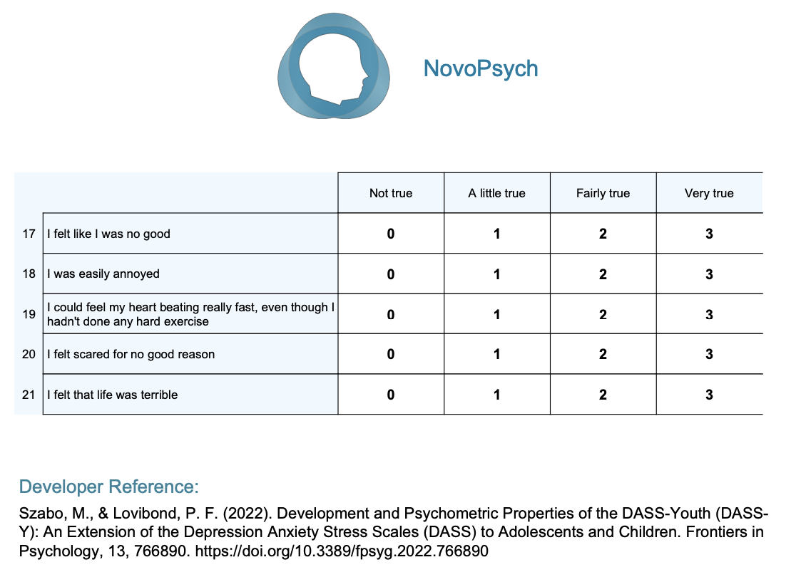

STAI
INSTRUCTIONS: A number of statements which people have used to describe themselves are given below. Read each statement and then circle an answer sheet to indicate how you generally feel. There are no right or wrong answers. Do not spend too much time on any one statement, but give the answer which seems to describe how you generally feel.
1 | 2 | 3 | 4
Almost Never | Sometimes | Often | Almost Always

_____1. | I feel pleasant
_____2. | I feel nervous and restless
_____3. | I feel satisfied with myself
_____4. | I wish I could be as happy as others seem to be
_____5. | I feel like a failure
_____6. | I feel rested
_____7. | I am "calm, cool, and collected"
_____8. | I feel that difficulties are piling up so that I cannot overcome them
_____9. | I worry too much over something that really doesn't matter
_____10. | I am happy
_____11. | I have disturbing thoughts
_____12. | I lack self-confidence
_____13. | I feel secure
_____14. | I make decisions easily
_____15. | I feel inadequate
_____16. | I am content
_____17. | Some unimportant thought runs through my mind and bothers me
_____18. | I take disappointments so keenly that I can't put them out of my mind
_____19. | I am a steady person
_____20. | I get in a state of tension or turmoil as I think about my recent concerns and interests

Intolerance of Uncertainty Scale - Short Form

(Carleton, Norton, & Asmundson, 2007)

Please circle the number that best corresponds to how much you agree with eachh item.
 | Not at all characteristic of me | A little characteristic of me | Somewhat characteristic of me | Very characteristic of me | Entirely characteristic of me
1. Unforeseen events upset me greatly. | 1 | 2 | 3 | 4 | 5
2. It frustrates me not having all the information I need. | 1 | 2 | 3 | 4 | 5
3. Uncertainty keeps me from living a full life. | 1 | 2 | 3 | 4 | 5
4. One should always look ahead so as to avoid surprises. | 1 | 2 | 3 | 4 | 5
5. A small unforeseen event can spoil everything, even with the best of planning. | 1 | 2 | 3 | 4 | 5
6. When it’s time to act, uncertainty paralyses me. | 1 | 2 | 3 | 4 | 5
7. When I am uncertain I can’t function very well. | 1 | 2 | 3 | 4 | 5
8. I always want to know what the future has in store for me. | 1 | 2 | 3 | 4 | 5
9. I can’t stand being taken by surprise. | 1 | 2 | 3 | 4 | 5
10. The smallest doubt can stop me from acting. | 1 | 2 | 3 | 4 | 5
11. I should be able to organize everything in advance. | 1 | 2 | 3 | 4 | 5
12. I must get away from all uncertain situations. | 1 | 2 | 3 | 4 | 5
Score:______

BIS/BAS
Each item of this questionnaire is a statement that a person may either agree with or disagree with. For each item, indicate how much you agree or disagree with what the item says. Please respond to all the items; do not leave any blank. Choose only one response to each statement. Please be as accurate and honest as you can be. Respond to each item as if it were the only item. That is, don't worry about being "consistent" in your responses. Choose from the following four response options:
1 | 2 | 3 | 4
Very false for me | Somewhat false for me | Somewhat true for me | Very true for me

- A person’s family is the most important thing in life.
- Even if something bad is about to happen to me, I rarely experience fear or nervousness.
- I go out of my way to get things I want.
- When I’m doing well at something, I love to keep at it.
- I’m always willing to try something new if I think it will be fun.
- How I dress is important to me.
- When I get something I want, I feel excited and energized.
- Criticism or scolding hurts me quite a bit.
- When I want something, I usually go all-out to get it.
- I will often do things for no other reason than that they might be fun.
- It’s hard for me to find the time to do things such as get a haircut.
- If I see a chance to get something I want, I move on it right away.
- I feel pretty worried or upset when I think or know somebody is angry with me.
- When I see an opportunity for something I like, I get excited right away.
- I often act on the spur of the moment.
- If I think something unpleasant is going to happen, I usually get pretty “worked up.”
- I often wonder why people act the way they do.
- When good things happen to me, it affects me strongly.
- I feel worried when I think I have done poorly at something important.
- I crave excitement and new sensations.
- When I go after something, I use a “no holds barred” approach.
- I have very few fears compared to my friends.
- It would excite me to win a contest.
- I worry about making mistakes.

Adaptive Function of Music Listening Scale
Rate each item on a 5-point Likert-scale ranging from 1 (Strongly Disagree) to 5 (Strongly Agree)
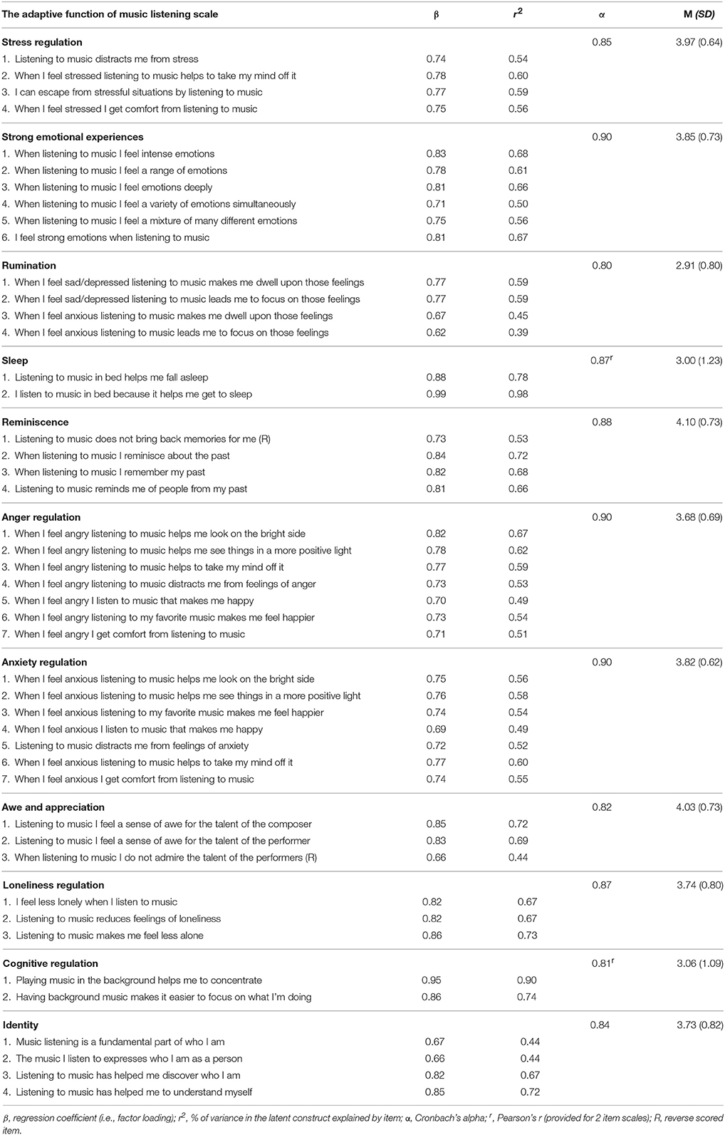

EMOTION REGULATION QUESTIONNAIRE (ERQ)
Reference: Gross, J.J., & John, O.P. (2003). Individual differences in two emotion regulation processes: Implications for affect, relationships, and well-being. Journal of Personality and Social Psychology, 85, 348-362.
Scale 1-7, 1=strongly disagree, 4=neutral, 7=strongly agree
1. ____ When I want to feel more positive emotion (such as joy or amusement), I change what I’m thinking about.
2. ____ I keep my emotions to myself.
3. ____ When I want to feel less negative emotion (such as sadness or anger), I change what I’m thinking about.
4. ____When I am feeling positive emotions, I am careful not to express them.
5. ____When I’m faced with a stressful situation, I make myself think about it in a way that helps me stay calm.
6. ____ I control my emotions by not expressing them.
7. ____When I want to feel more positive emotion, I change the way I’m thinking about the situation.
8. ____ I control my emotions by changing the way I think about the situation I’m in.
9. ____When I am feeling negative emotions, I make sure not to express them.
10. ____When I want to feel less negative emotion, I change the way I’m thinking about the situation.

Scoring: Items 1, 3, 5, 7, 8, 10 make up the Cognitive Reappraisal facet. Items 2, 4, 6, 9 make up the Expressive Suppression facet.

