The theoretical volume is very close to exact, because its calculated using definite integration. In using definite integration the number of slices used to calculate the volume are infinitesimal allowing for very precise results. Using the summation of cross sectional shapes with a set thickness would not produce results as precise. The thickness of the cross sectional shapes would effect the calculated volume’s resolution as to how well and how many slices could fit within the bounds of the shape of the model.

For my model I chose to use the Commodore Computer logo and I used semicircles as the cross sectional shape. One of the early problems I faced using semicircles was that the volume of a semicircle was calculated by and the difference between the top and bottom functions would give a diameter. Therefore, I divided the difference between the top and the bottom function by two to acquire a radius. Another issue I faced is that there are multiple gaps in the logo. Therefore, I segmented the logo into sectors where there is clear discontinuation. The sectors of the logo are labeled from A to G. I then wrote a program in C to perform the summation calculations using the cross sectional shapes. The program and its output are attached. Below is a listing of the equations used along with the logo divided into its respected sectors.

Equations Used in Figure to Model
Function | Bounds | Purpose
 |  | Upper outer section of “C”. Domain is given. Composes sectors C, D, and E.
 |  | Lower outer section of “C”. Domain is given. Composes sectors C, D, and E.
 |  | Upper inner section of “C”. Domain is given. Composes sectors D, and E.
 |  | Lower inner section of “C”. Domain is given. Composes sectors D, and E.
 |  | Upper trapezoid slant. Domain is given. Composes sector B.
 |  | Lower trapezoid slant. Domain is given. Composes sector G.
 |  | Upper trapezoid top. Domain is given. Composes sectors A and B.
 |  | Lower trapezoid bottom. Domain is given. Composes sectors F and G.
 |  | Upper trapezoid bottom. Domain is given. Composes sector B.
 |  | Lower trapezoid top. Domain is given. Composes sector F.
 |  | Vertical bounds for trapezoids and “C”. Range is given. Composes sector A, D, E, and F.

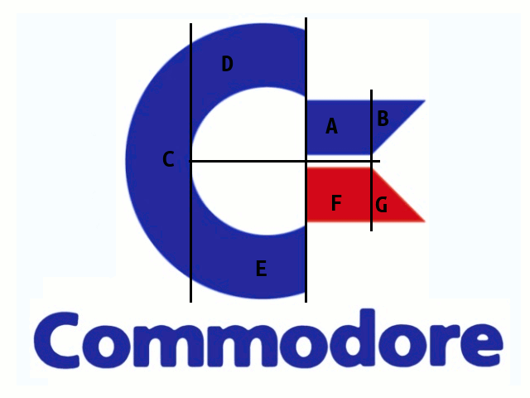
I then performed integration using the semicircle cross sections using the TI-36x Pro and computed a volume very close to the volume computed by summation. Below are the integrals used for calculating the volume of the logo. Note: The integrals are simplified from the original equations listed above.

Volume Approximations
Sector | Integral | Approximate Volume Integration | Approximate Volume Summation
A |  | 0.5137417998 | 0.517117
B |  | 0.0575130705 | 0.053948
C |  | 8.835729338 | 8.837455
D |  | 2.40694629 | 2.401476
E |  | 2.40694629 | 2.401476
F |  | 0.5137417998 | 0.053948
G |  | 0.0575130705 | 0.517117
Totals |  | 14.7921316586 | 14.782537
Difference | Integral - Summation |  | 0.0095946586

However, in both instances using integration and summation with semicircular cross sections do not accurately represent the volume of the logo if it was integrated by rotation around the x-axis. This is due to the semicircular cross sections not being able to represent the rotation of the model around the x-axis in areas where there are gaps (every sector except sector C). Sectors D and E should have formed a dome like structure with a hollow center, but instead in using semicircular cross sections two independent arms are formed. When rotating around the x-axis sectors C, D, and E should form a cup like structure instead of a “C” like figure. The trapezoids would also form a hollow figure as well when rotated around the x-axis. The only sector that is represented accurately using semicircular cross sections is sector C since it does not have a gap. Sector C when rotated around the x-axis would have formed such a shape and when halved would have been very close to the semicircular model created. When halving the total volume of the three dimensional model, if the half model was done correctly, would have resulted in a value very close to the half model. Instead due to the gaps and isolating sectors the errors in the half model’s calculations are evident especially in the much larger volume computed by rotation around the x-axis, compared to the semicircular cross sections used to create the model. The true volume of model by integration is the most accurate representation of the volume that a three dimensional model of the logo would have had. Below is a listing of what integrals are used when calculating the actual three dimensional model. Note: Some sectors overlap therefore only one sector has to be calculated. Example: Sector D and E overlap so when performing the washer method only Sector D or E have to be calculated when rotating around the x-axis. Sector C is composed of two equations mirrored across the x-axis, therefore in this instance only the top equation is used when performing integration. Also, some integrals are simplified.

True Volume of Model by Integration
Sector | Integral | Method | Volume Computed
A |  | Washer Method | 6.681735648
B |  | Washer Method | 1.35207642
C  (Only upper equation) |  | Disk Method | 17.67145868
D |  | Washer Method | 47.71293843
Totals |  |  | 73.41820918

Note how half of the rotation of the top of sector C is very close to the summation and integration using semicircular cross sections volume. This is due to not having to rotate around a gap, creating a shape that can be created with semicircles. Semicircles cannot create an accurate shape when gaps are present, because they cannot rotate over a gap.

If the model was correct then true integration halved should have yielded a result close to the semicircular cross section summation and integration. However, due to errors caused by human error, and gaps: half of the true volume by integration 36.70910459 and the volume calculated by semicircular integration 14.7921316586 are very distant values. The difference between the two volumes are 21.91697293 units cubed.

All in all, the most accurate and precise theoretical volume of the Commodore Computer logo would have been calculated using the True Volume of Model by Integration, using rotation around the x-axis. Using semicircles as the cross sectional shape the volume in between the gaps could not be computed and the area’s in where there were gaps were sectored off and computed independently from the other sectors. It was not until the end when they were summed together. The summation and integration that used semicircular slices were close in value, however where very far away from the true theoretical volume computed by integration and rotation around the x-axis.

Attached is the program and output used to compute the summation by using semicircles as the cross sectional shape along with other scratch work used to create the model.

