Docker – Proyecto Bank

Imágenes creadas en Docker:

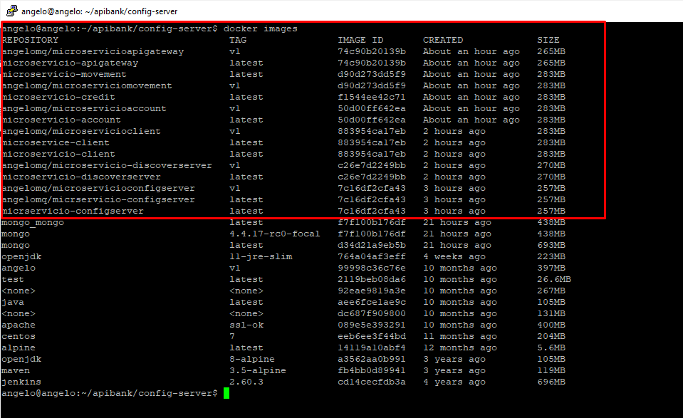

Contenedores levantados y funcionando en su respectivo puerto:

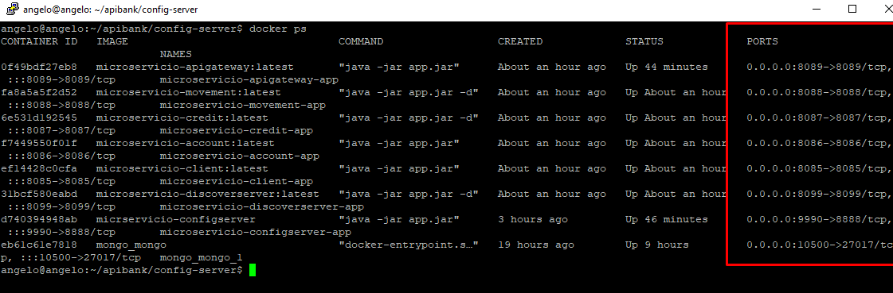

IP DEL SERVIDOR: 192.168.232.130

Repositorio DOCKER HUB: <https://hub.docker.com/u/angelomq>

Api Gateway: <http://192.168.232.130:8089>

Discovery Server: <http://192.168.232.130:8089>

Config Server: http://192.168.232.130:9990

Microservice Client: <http://192.168.232.130:8085>

Microservice Credit: <http://192.168.232.130:8087>

Microservice Account: <http://192.168.232.130:8086>

Microservice Movement: <http://192.168.232.130:8088>

BD MONGO: 192.168.232.130:10500

Pruebas:

