**Department of Computer Science and Engineering**

**Graphic Era** **Deemed to** **be University**

**Dehradun-248002**

MINI PROJECT REPORT

ON

FACE RECOGNITION

Project report submitted in partial fulfilment of the

Requirements for the

Award of the Degree of B.Tech in

Computer Science and Engineering.

**BY**

Animesh Kumar

University Roll no:

2016636

**DECLARATION**

**I, Animesh kumar** student of **B-tech, Semester IV**, Department of Computer Science and Engineering, Graphic Era Deemed University, Dehradun, declare that the technical project work entitled “**FACE RECOGNITION”** has been carried out by me and submitted in partial fulfillment of the course requirements for the award of degree in B- tech of **Graphic Era Deemed University** during the academic year **2022-2023**. The matter embodied in this synopsis has not been submitted to any other university or institution for the award of any other degree or diploma.

Date: 16/07/22

**ACKNOWLEDGEMENT**

Here by I am submitting the project report on **“Face recognition”** as per the scheme of Graphic Era Deemed University, Dehradun.

I would like to express our sincere gratitude to **Dr. Devesh Pratap Singh,** Head of Dept. of Computer Science, for providing a congenial environment to work in and carry out our project.

I consider it mine cardinal duty to express the deepest sense of gratitude to Mr. **Akshay Rajput** Asst. Professor, Department of Computer Science and Application for the invaluable guidance extended at every stage and in every possible way.

Finally, I am very much thankful to all the faculty members of the Department of Computer Science and Technology, friends and our parents for their constant encouragement, support and help throughout the period of project conduction.

**Problem Statement: Face Recognition System**

An application is required which can take input of an image from the user and process it to recognize the face of the person using the loaded dataset of images.

A complete face recognition system must include face detection, face preprocessing and face recognition processes. A typical system should therefore be able to extract the face region from the results of the face detection step and then separate the face region from its background model, providing a basis for subsequent extraction of features that differentiate between different people. Recent work on deep learning-based methods has delivered significant improvements in accuracy over previous methods.

**Motivation**

In the real world, we are always surrounded by images. For various sectors and fields, we need to identify and classify images. Whether it's a school attendance system that recognizes your face or missiles that recognize enemy bases. We need to identify them all. And so we build a system that can recognize faces among all those arriving datasets.

We explore, understand, and apply the latest advances in face detection and recognition technology.

**TOOLS / SOFTWARE**

* Visual code studio
* Open CV
* Python
* Haar cascade classifier

**Libraries needed for data collection & preprocessing**

* import cv2 (pip install opencv-python)
* import numpy (pip install numpy)
* from os import listdir
* CascadeClassifier (**Used to detect object in the frame)**

**METHODOLOGY**

1. Data set collection
2. Training data set
3. Detection or test

**Face Detection with Haar Cascade**

**So what is Haar Cascade?** It is an Object Detection Algorithm used to identify faces in an image or a real time video. The algorithm uses edge or line detection.

Haar cascade Features:

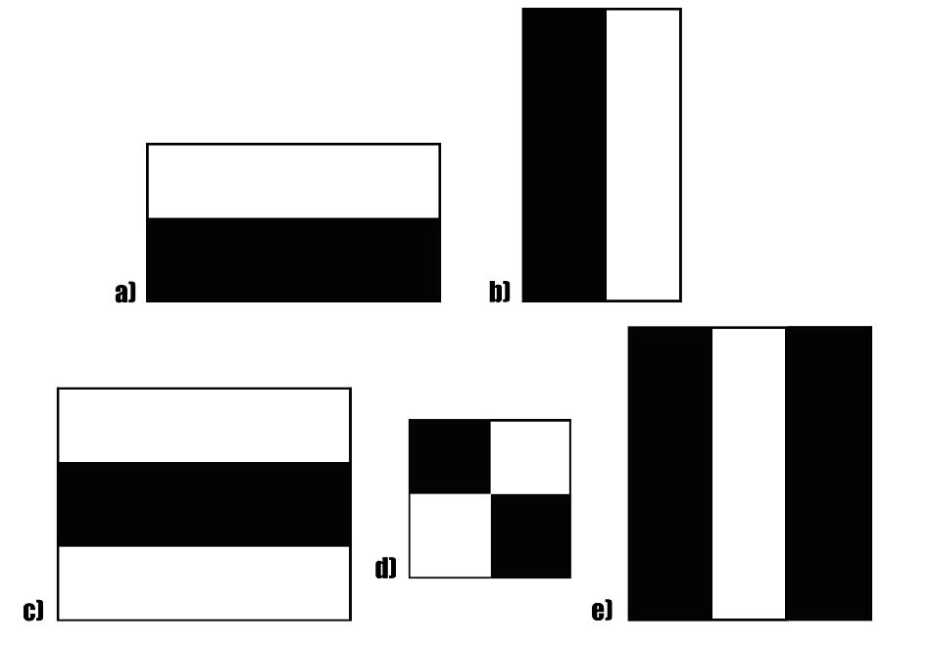

Fig. A sample of Haar features used in the Original Research Paper published by Viola and Jones.

(a,b):-Edge feature

(c,e):-line feature

(d):-four rectangle feature

## **Stepwise Implementation:**

OpenCV comes with lots of pre-trained classifiers.

Here we are going to use haarcascade_frontalface_default.xml for detecting faces.

**Step 1:** Loading the image.

**Step 2:** Converting the image to grayscale (Initially, the image is a three-layer image (i.e., RGB), So It is converted to a one-layer image (i.e., grayscale).)

**Step 3:** Loading the required haar-cascade XML classifier file

(Here, we need “haarcascade_frontalface_default.xml” for face detection.).

**Step 4:** Applying the face detection method on the grayscale image (This is done using cv2::CascadeClassifier::detectMultiScale method. which returns boundary rectangles for the detected faces (i.e., x, y, w, h) ).

**Step 5:** Iterating through rectangles of detected faces

Rectangles are drawn around the detected faces by the rectangle method of the cv2 module by iterating over all detected faces.

**Dataset:** The model for recognition of images is trained on a database of 200+ images. For a person, cropped image with different angles have been included in the dataset. Extracting faces using OpenCV Face Detection.

**Step 1:** Create images with rectangle around faces using Part 1 dataset.py and store them in the folder.

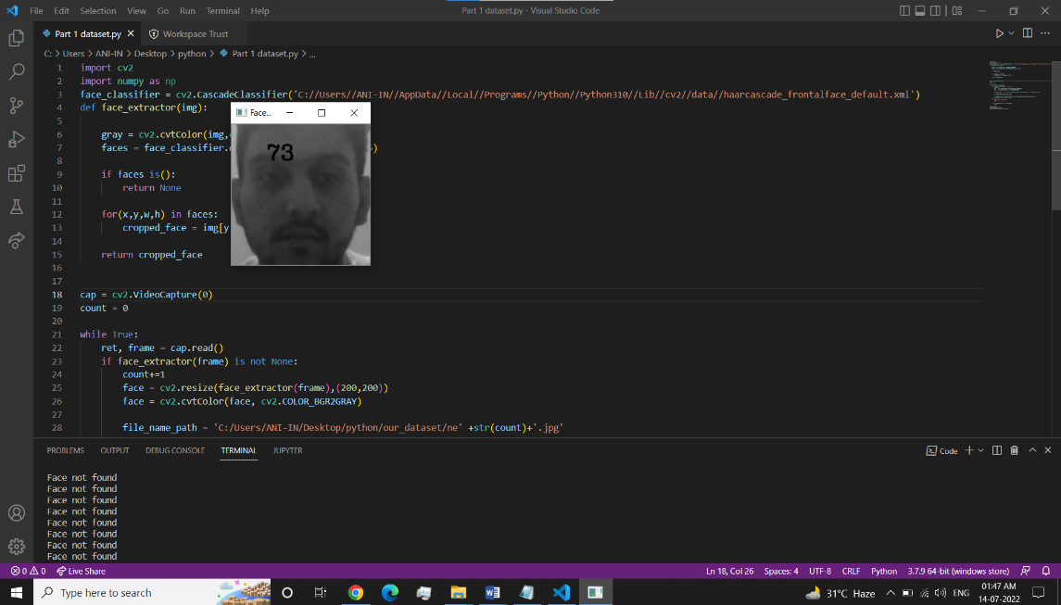

**Step 2:** Extract faces from a set of images using def face_extractor(img) and store them in the folder our_dataset. This would make labelling/extracting faces very easy and could be used for further analysis.

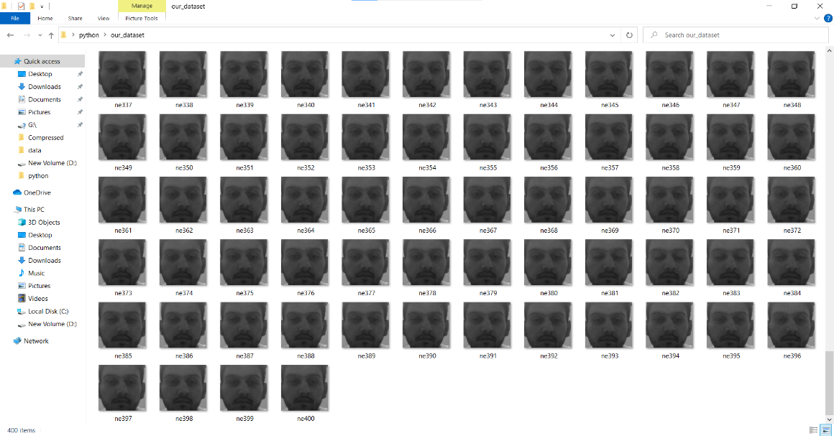

**Use training model**

model = cv2.face.LBPHFaceRecognizer_create()

model.train(np.asarray(Training_Data), np.asarray(Labels))

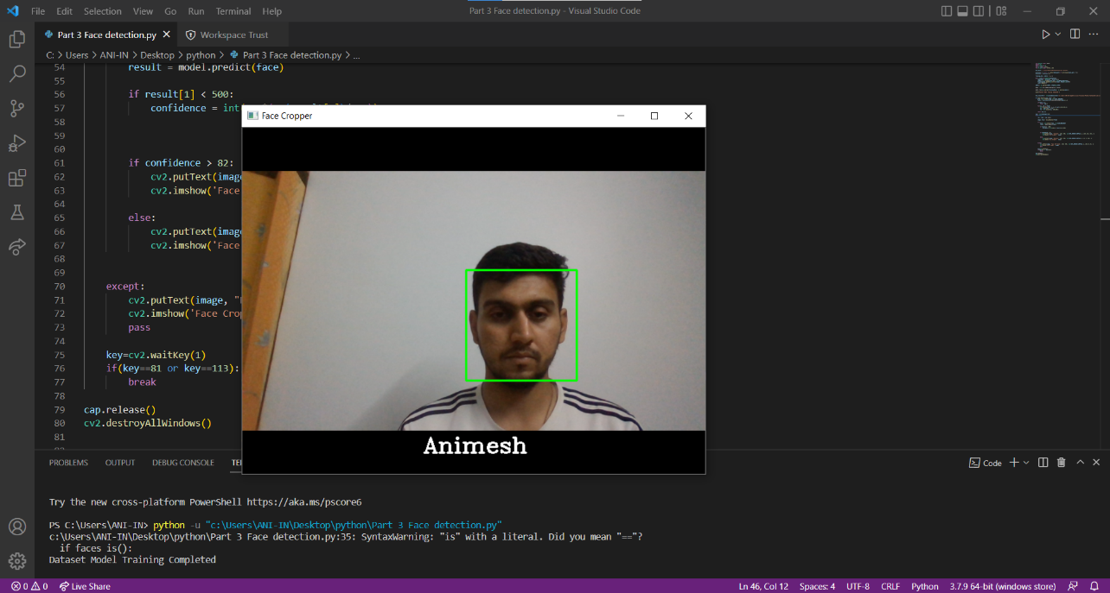

**Conclusion**

Face recognition is a technology that can recognize, analyze, and match faces. It has many benefits, especially simplifying tasks within organizations that experience a high volume of people entering in and out of their facilities.

The future of face recognition may surprise you. As technology improves, some experts believe that our faces will eventually replace IDs, passports and credit cards as a means of identification. If this prediction becomes a reality, any company that implements face recognition today might gain a competitive advantage tomorrow.