Skills
Skills
Reusable instruction files that teach Claude Code how to handle a task - write the skill once, and Claude applies it automatically whenever the task comes up. No more repeating yourself.
SKILL.md · On-demand matching · Config, sharing & troubleshooting
IN THIS GUIDE
Everything you need to write, organize, share, and debug skills:
- What skills are, where they live, and when to reach for one
- Creating your first skill and how matching & priority work
- Advanced configuration - metadata, allowed-tools, and progressive disclosure
- Choosing between skills, CLAUDE.md, subagents, hooks, and MCP
- Sharing skills across a team, and using them inside subagents
- Troubleshooting - a practical checklist for when a skill misbehaves

ON THIS PAGE
› 1. What Skills Are
› 2. Where Skills Live
› 3. Creating a Skill
› 4. How Matching & Priority Work
› 5. Advanced Configuration
› 6. Choosing the Right Tool
› 7. Sharing Skills
› 8. Skills & Subagents
› 9. Troubleshooting

01 What Skills Are
Every time you explain your team’s coding standards to Claude, you’re repeating yourself - re-describing how you want PR feedback structured, reminding it of your commit-message format. Skills fix this. A skill is a Markdown file that teaches Claude how to do something once; Claude then applies that knowledge automatically whenever it’s relevant.
Each skill is a folder containing a SKILL.md file, with a name and description in its frontmatter. The description is how Claude decides whether to use the skill: it compares your request against all available skill descriptions and activates the ones that match. Here’s what the frontmatter looks like:
SKILL.MD
---
name: pr-review
description: Reviews pull requests for code quality. Use
when reviewing PRs or checking code changes.
---
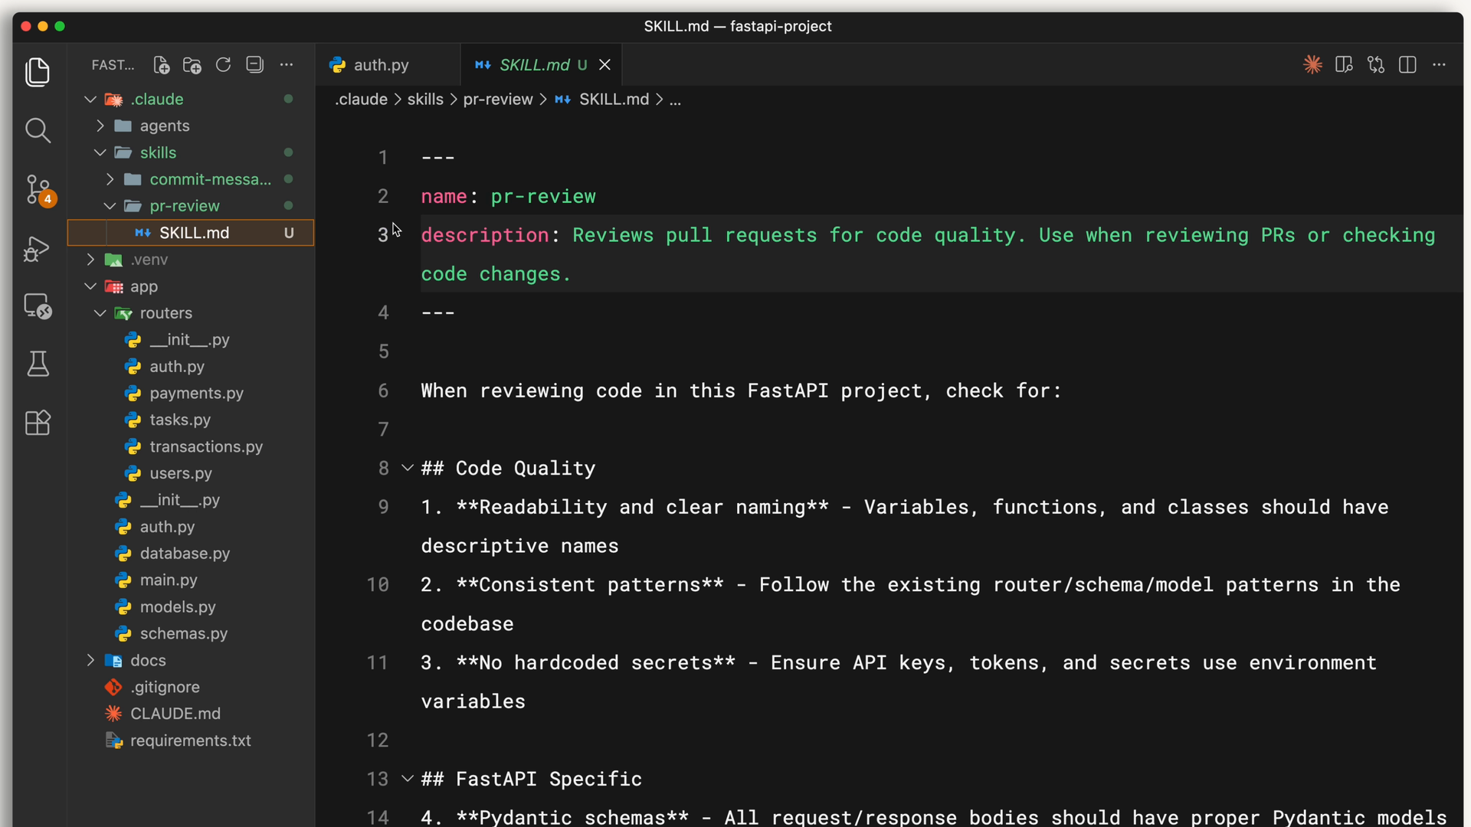
A skill is a SKILL.md file with a name and description in its frontmatter.
Below the frontmatter, you write the actual instructions - your review checklist, formatting preferences, or whatever Claude needs to know for that task.

When to reach for a skill
Skills work best for specialized knowledge that applies to specific tasks:
- Code-review standards your team follows
- Commit-message formats you prefer
- Brand guidelines for your organization
- Documentation templates for specific kinds of docs
- Debugging checklists for particular frameworks
- Evaluation checklists for machine-learning code
RULE OF THUMB
If you find yourself explaining the same thing to Claude repeatedly, that’s a skill waiting to be written.

How skills differ from other customization
Skills are unique because they’re automatic and task-specific. CLAUDE.md loads into every conversation; slash commands require you to type them explicitly. A skill loads on demand - Claude keeps only the name and description in context until your request matches, so your PR-review checklist isn’t taking up space while you’re debugging. When a skill matches, you’ll see it load in the terminal:
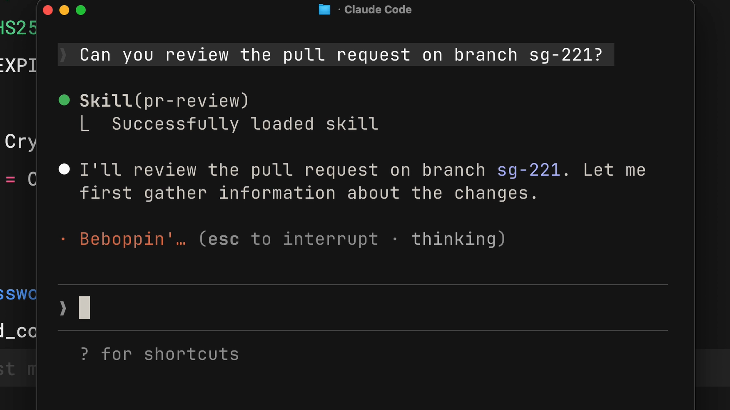
When a skill matches your request, you’ll see it load in the terminal.

02 Where Skills Live
You can store skills in different places depending on who needs them:
Scope | Location | Shared with
Personal | ~/.claude/skills | Just you - follows you across all your projects.
Project | .claude/skills in the repo root | Everyone who clones the repo - commit it.
Personal skills hold things like your commit-message style or how you like code explained. Project skills hold team standards - brand guidelines, preferred fonts and colors - and are version-controlled alongside your code. On Windows, personal skills live in C:/Users/<your-user>/.claude/skills.

03 Creating a Skill
Let’s build a personal skill that teaches Claude to write PR descriptions in a consistent format. First, create a directory inside the skills folder - the directory name should match the skill name:
TERMINAL
mkdir -p ~/.claude/skills/pr-description
Then create a SKILL.md inside it, with frontmatter on top and instructions below:
~/.CLAUDE/SKILLS/PR-DESCRIPTION/SKILL.MD
---
name: pr-description
description: Writes pull request descriptions. Use when
creating a PR, writing a PR, or when the user asks to
summarize changes for a pull request.
---
When writing a PR description:
1. Run `git diff main...HEAD` to see all changes on the branch
2. Write a description following this format:

## What
One sentence explaining what this PR does.
## Why
Brief context on why this change is needed.
## Changes
- Bullet points of specific changes made
- Group related changes together
- Mention any files deleted or renamed

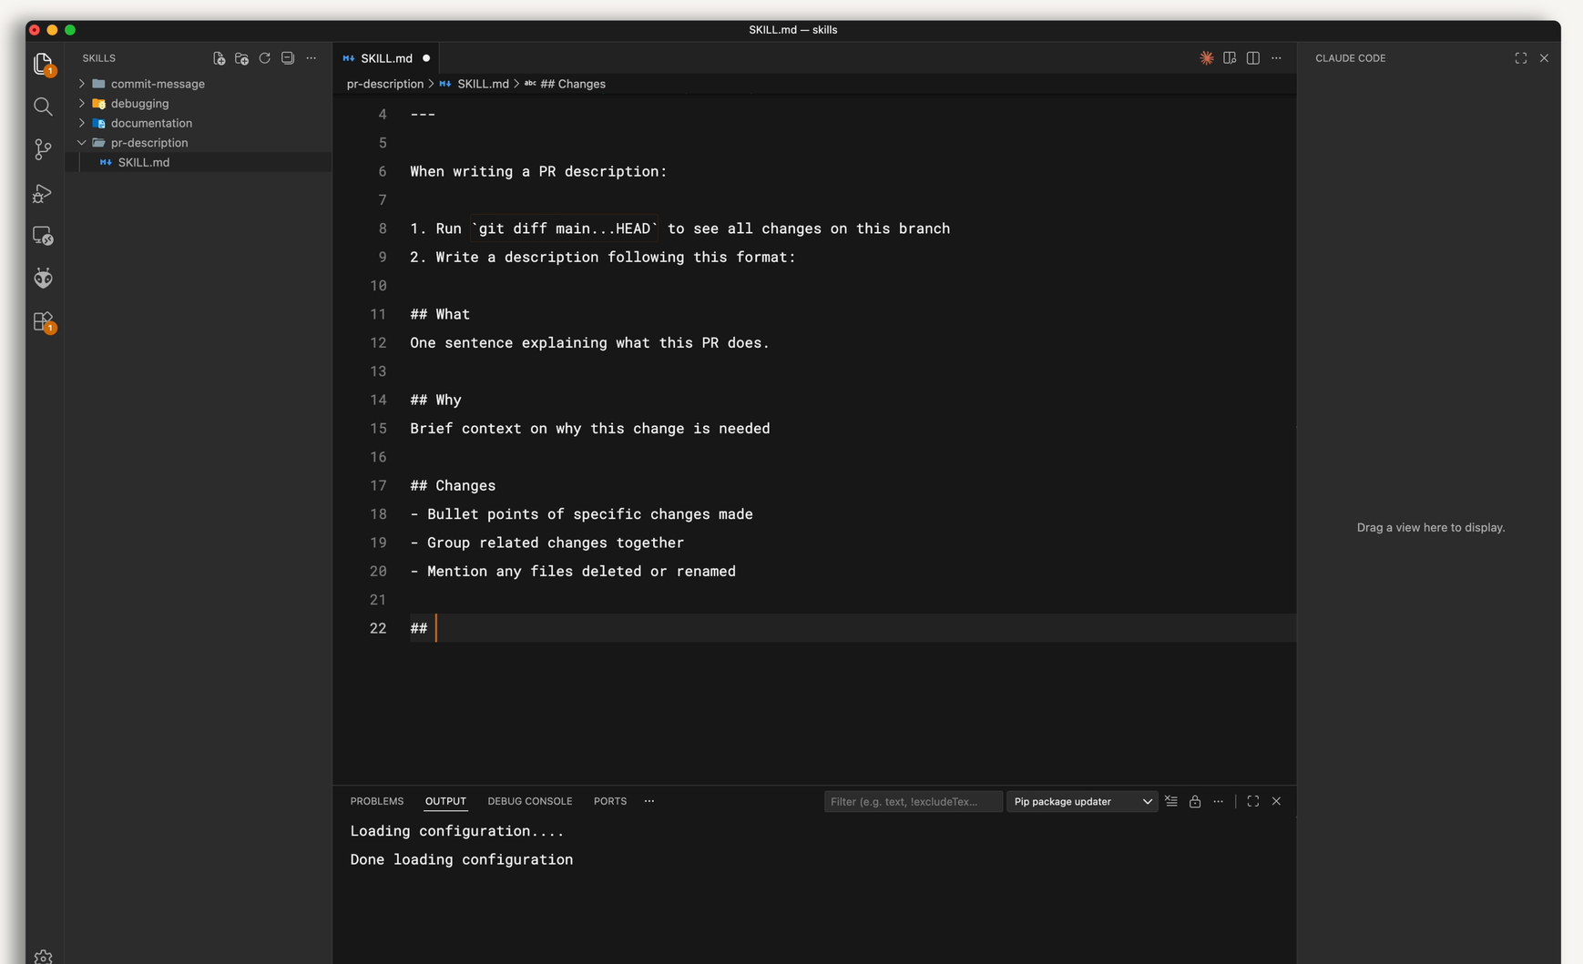
The pr-description SKILL.md: frontmatter on top, the instructions Claude follows below.
The name identifies the skill; the description is the matching criteria; everything after the second set of dashes is what Claude follows once the skill activates.

Testing your skill
Claude Code watches your skills folders, so a new or edited skill is picked up without a restart. If the skills folder itself did not exist when your session started, run /reload-skills (or restart). Then verify the skill by checking the available-skills list.
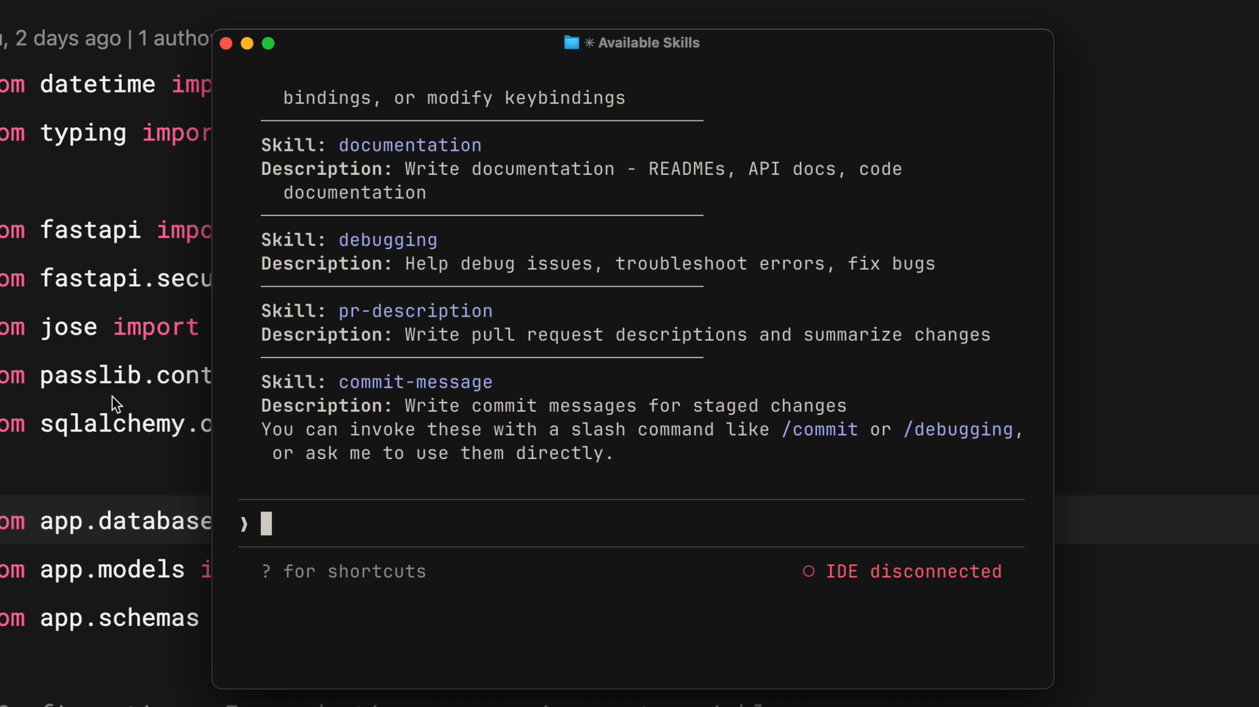
Confirm your new skill appears in the available-skills list.
To test it, make some changes on a branch and say “write a PR description for my changes.” Claude will indicate it’s using the skill, check your diff, and produce a description in your template - the same format every time.

Updating and removing
To update a skill, edit its SKILL.md. To remove one, delete its directory. Changes are picked up during the session; if one is not, run /reload-skills or restart Claude Code.

04 How Matching & Priority Work
When Claude Code starts, it scans your skill locations but loads only the name and description - not the full content. When you send a request, Claude compares your message against those descriptions using semantic matching. “Explain what this function does” would match a skill described as “explain code with visual diagrams,” because the intent overlaps.
Once a match is found, Claude loads the skill. Depending on your permission settings, Claude Code may ask you to approve it first - keeping you aware of what context it’s pulling in. It then reads the complete SKILL.md and follows its instructions.
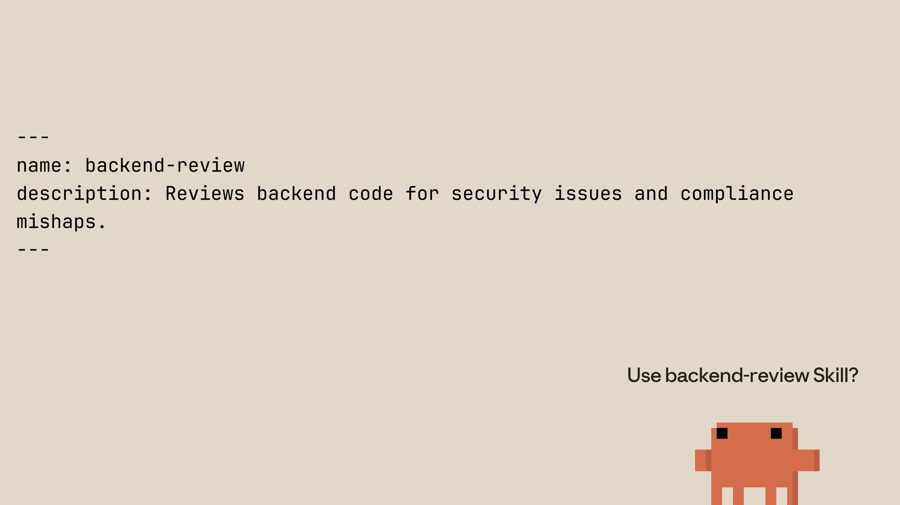
Claude Code can ask before loading a matched skill, then reads the full SKILL.md and follows it.

Priority when names conflict
If a cloned repo has a skill with the same name as one of yours, a clear priority order decides which wins:
Priority | Source
1 · Highest | Enterprise (managed settings) | Org-wide standards
2 | Personal (~/.claude/skills) | Your own
3 | Project (.claude/skills) | Per-repo
4 · Lowest | Plugins (installed) | Community
So an enterprise code-review skill overrides a personal one of the same name - letting organizations enforce standards while individuals still customize. Plugin skills are namespaced as plugin-name:skill-name, so they sit alongside yours rather than replacing them. To avoid conflicts, use descriptive names like model-eval-review rather than just review.
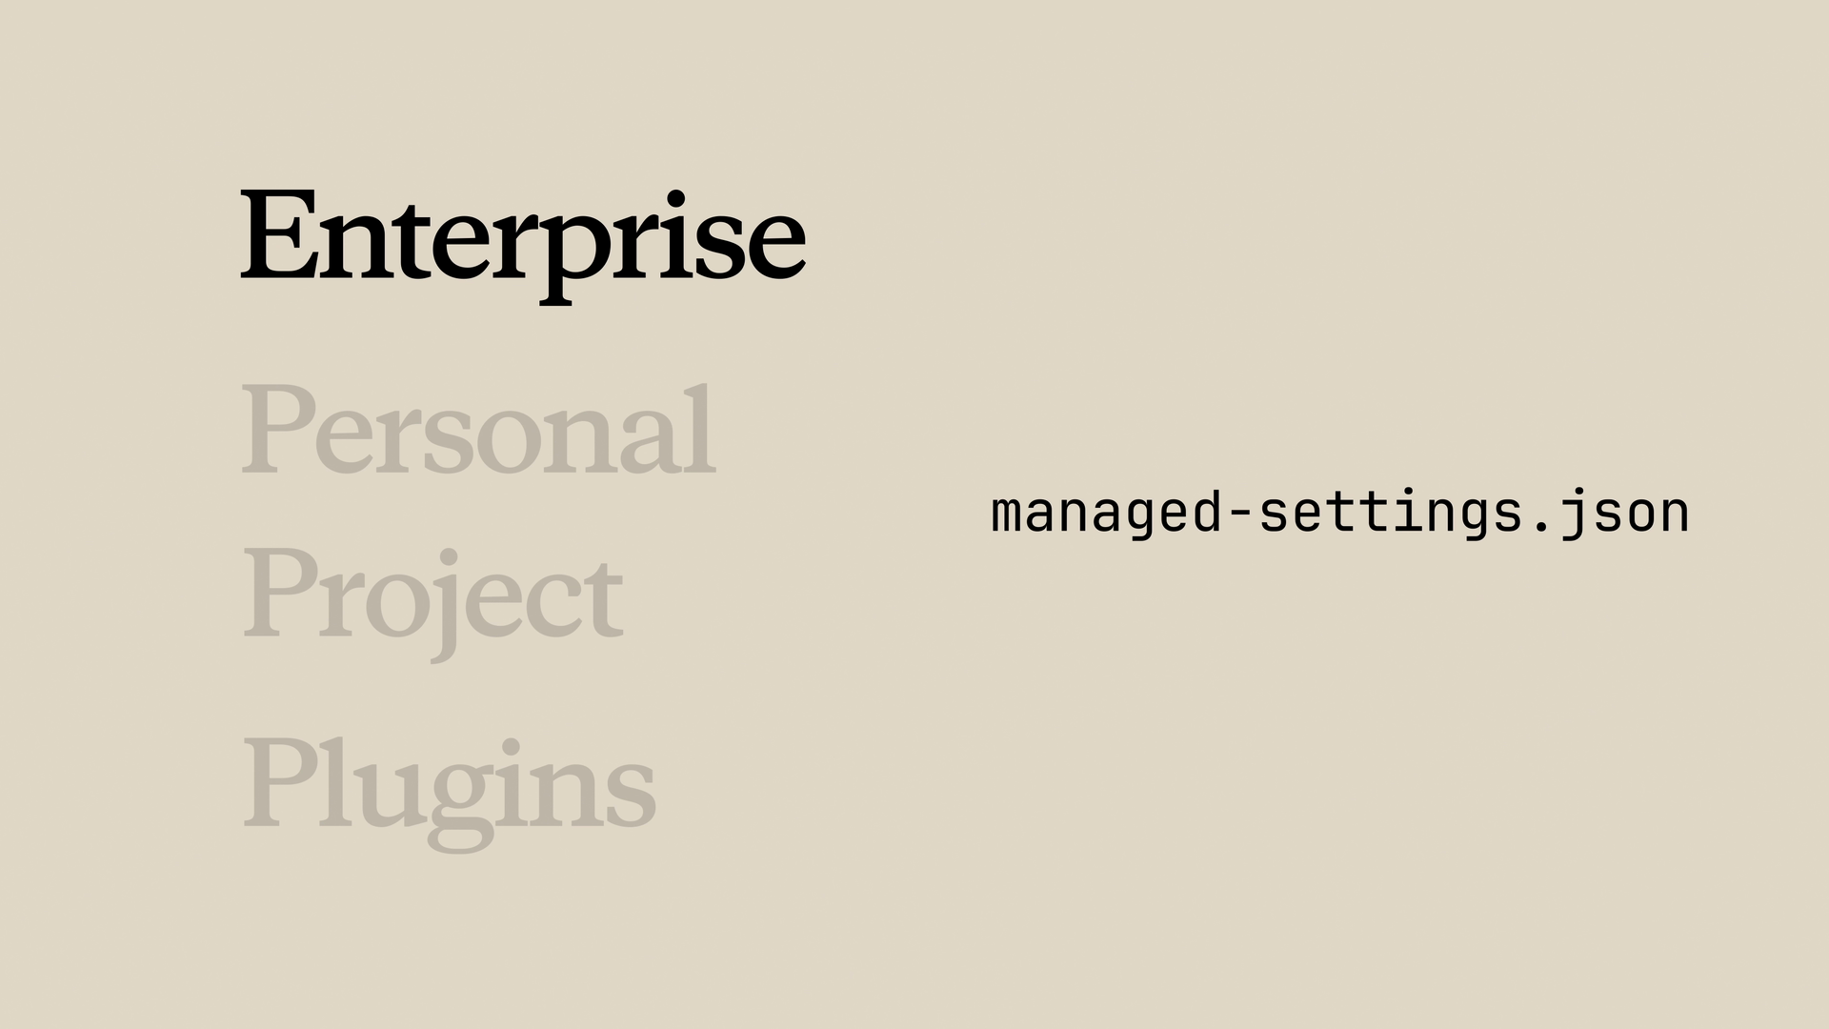
When a higher-priority skill shares a name, yours is shadowed - make names distinct.

05 Advanced Configuration

Metadata fields
The Agent Skills standard defines these frontmatter fields - two required, the rest optional. Claude Code is more forgiving (it falls back to the folder name when name is missing), but following the standard keeps skills portable:
Field | Required? | What it does
name | Required | Identifier - lowercase, numbers, hyphens; ≤ 64 chars; matches the directory name.
description | Required | Tells Claude when to use the skill; ≤ 1,024 chars. The most important field - it drives matching.
allowed-tools | Optional | Pre-approves tools Claude may use without asking while the skill is active. It does not block other tools.
model | Optional | Specifies which Claude model to use while the skill is active.

Writing effective descriptions
Be explicit. If someone told you “your job is to help with docs,” you wouldn’t know what to do - and Claude thinks the same way. A good description answers two questions: What does the skill do? and When should Claude use it? If a skill isn’t triggering when you expect, add more keywords that match how you actually phrase requests - the language is what Claude matches against.

Pre-approving tools with allowed-tools
Some skills always need the same few tools - an onboarding guide reads files, searches, and runs a command or two. Set allowed-tools and, while the skill is active, Claude can use those tools without asking you each time:
SKILL.MD
---
name: codebase-onboarding
description: Helps new developers understand how the system works.
allowed-tools: Read, Grep, Glob, Bash
model: sonnet
---

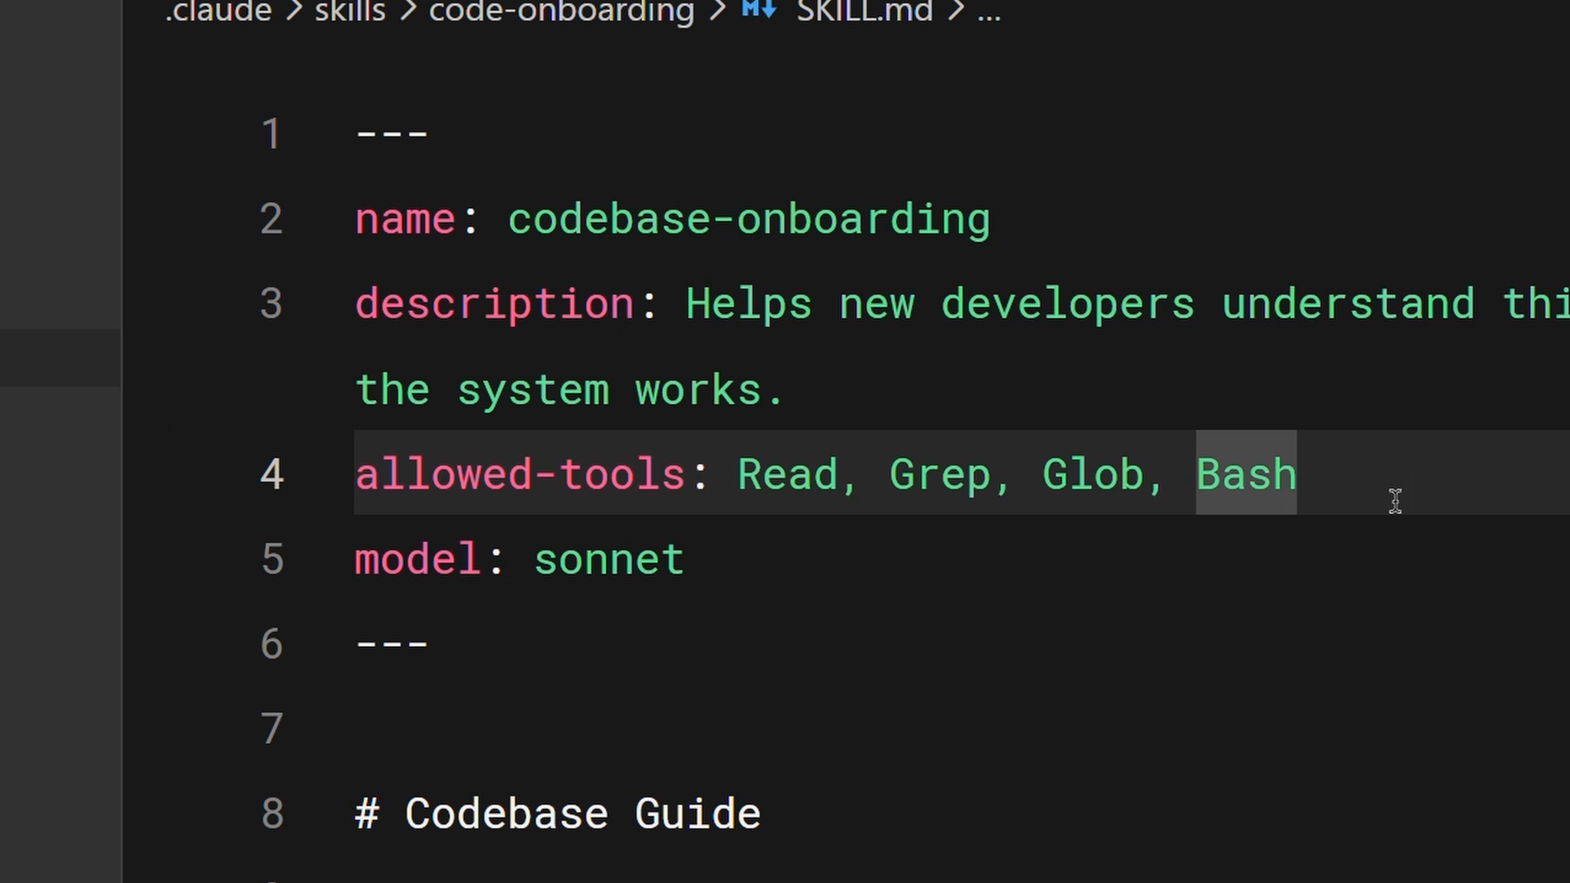
With allowed-tools set, the listed tools are pre-approved while the skill is active.
Omit allowed-tools entirely and the skill pre-approves nothing - Claude uses its normal permission model. Note that allowed-tools grants; it does not restrict. Every other tool stays available under your usual permission settings. When you need a hard limit, such as a reviewer that must never edit files, run the work in a subagent whose tools field lists only read-only tools (see section 8).

Progressive disclosure
When a skill activates, its SKILL.md loads into context. Cramming everything into one 2,000-line file wastes context and is no fun to maintain. Instead, keep essential instructions in SKILL.md and put detailed material in separate files Claude reads only when needed. The standard suggests organizing the directory like this:
SKILL DIRECTORY
my-skill/
├── SKILL.md # essential instructions
├── scripts/ # executable code (run, not read)
├── references/ # additional documentation
└── assets/ # images, templates, data files
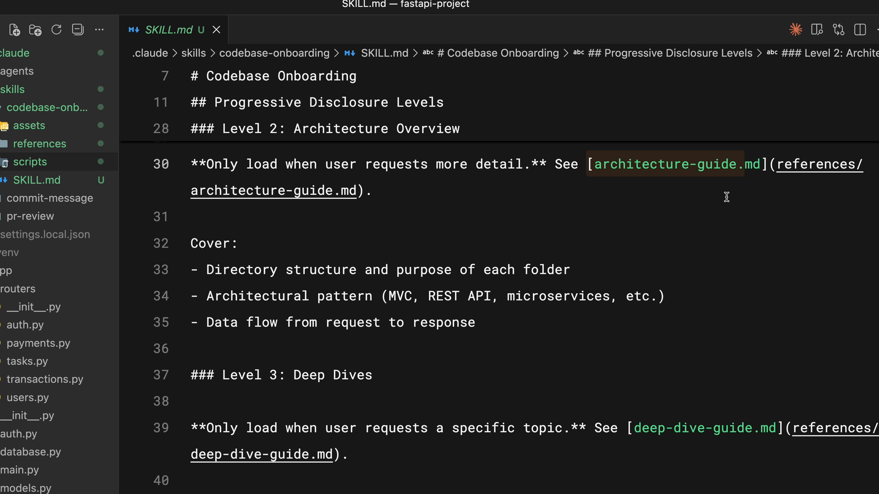
Link to reference files from SKILL.md so Claude loads them only when needed.
Link to the supporting files with clear notes about when to load them - Claude reads architecture-guide.md only when someone asks about system design, not when they ask where to add a component. It’s like a table of contents in context rather than the whole document. A good rule of thumb: keep SKILL.md under 500 lines; beyond that, split it.

Using scripts efficiently
Scripts in your skill directory can run without loading their contents into context - the script executes and only the output consumes tokens. The key instruction to include in SKILL.md is to tell Claude to run the script, not read it. This is ideal for environment validation, consistent data transformations, and operations that are more reliable as tested code than generated code.

06 Choosing the Right Tool
Claude Code offers several customization options. They solve different problems - knowing when to use each prevents you from building the wrong thing.
Feature | Loads | Best for
Skills | On demand, when matched | Task-specific expertise
CLAUDE.md | Every conversation | Always-on project standards
Slash commands | When you type them | Explicit, on-demand actions
Subagents | In an isolated context | Delegated work
Hooks | On events (saves, tool calls) | Automated side effects
MCP servers | External connection | External tools & integrations
CLAUDE.md loads in every conversation; a skill loads only when it matches your request.
Use CLAUDE.md for project-wide standards that always apply (“never modify the database schema,” framework preferences). Use subagents to delegate work to a separate context with its own tool access. Use hooks for operations that should run on every file save or before specific tool calls. And use skills for task-specific expertise that should load only when the topic is relevant.
A typical setup combines them: CLAUDE.md for always-on standards, skills for on-demand expertise, hooks for event-driven automation, subagents for isolated delegation, and MCP servers for external tools. Each handles its own specialty - don’t force everything into one approach.

07 Sharing Skills
A PR-review skill only you use is helpful; shared across your team, it standardizes review for everyone. There are three main ways to distribute skills.

Commit them to your repository
The simplest method: place skills in .claude/skills and anyone who clones the repo gets them automatically - no extra installation. Push updates and everyone gets them on the next pull. The .claude directory holds your agents, hooks, skills, and settings, all version-controlled. Best for team coding standards and project-specific workflows.

Distribute through plugins
Plugins extend Claude Code with custom functionality designed to be shared. In your plugin project, create a skills directory where each skill gets its own folder with a SKILL.md. After you publish the plugin to a marketplace, others can discover and install it. Best when your skills aren’t too project-specific and could help the wider community.
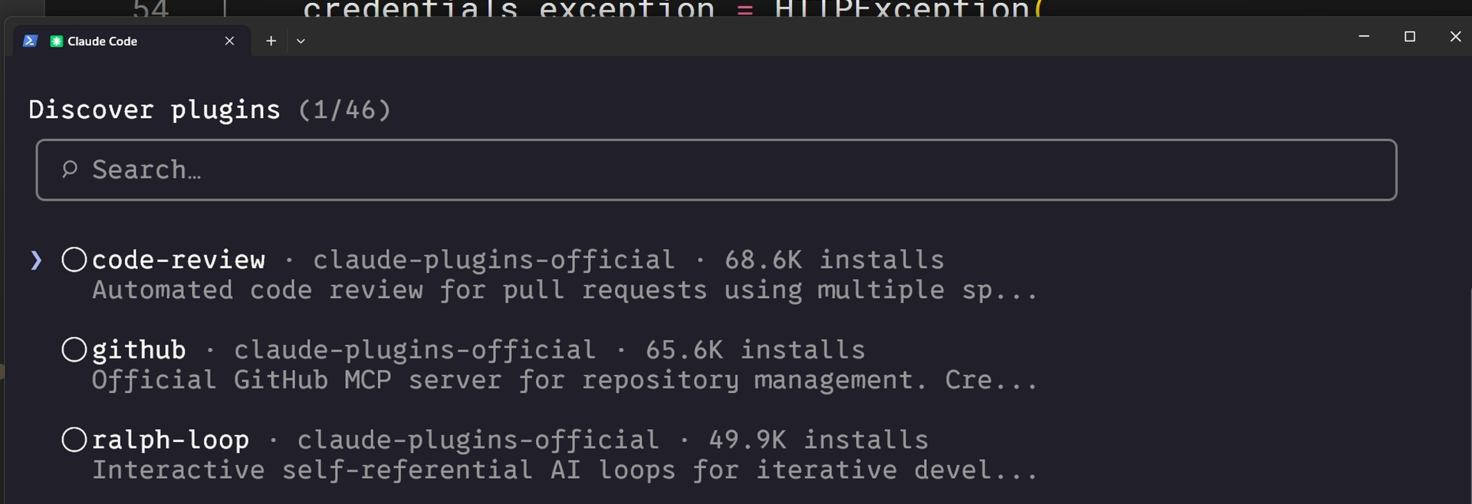
Distribute skills as a plugin so others can install them from a marketplace.

Enterprise deployment
Administrators can deploy skills organization-wide through managed settings. Enterprise skills take the highest priority - they override personal, project, and plugin skills of the same name. The managed-settings file also supports strictKnownMarketplaces to control where plugins may be installed from:
MANAGED SETTINGS
"strictKnownMarketplaces": [
{
"source": "github",
"repo": "acme-corp/approved-plugins"
},
{
"source": "git",
"url": "https://git.acme-corp.example/compliance-plugins.git"
}
]
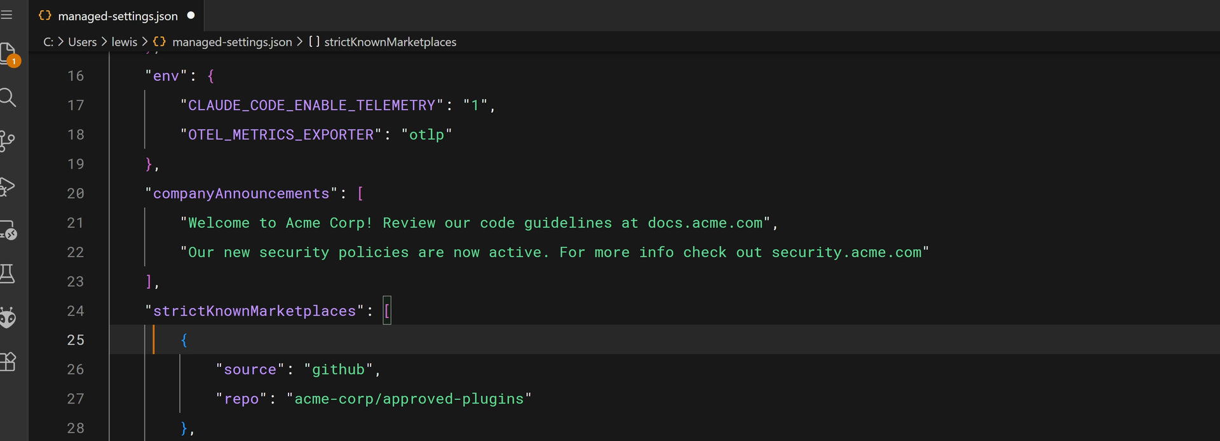
Enterprise managed settings deploy skills organization-wide at the highest priority.
This is the right choice for mandatory standards, compliance requirements, and practices that must be consistent across the organization.

08 Skills & Subagents
SUBAGENTS START CLEAN
When you delegate a task, the subagent starts with a fresh, isolated context. It doesn’t see your conversation history or the skills you’ve already loaded in the main conversation.
A few important distinctions:
- Built-in subagents (Explore, Plan, general-purpose) don’t preload skills.
- Custom subagents you define can preload skills: list them in the skills field, and the full content of each is injected into the subagent’s context when it starts.
- The skills field controls what is preloaded, not what is allowed. Without it, a subagent that has the Skill tool can still find and load skills while it works. To keep a subagent away from skills entirely, leave Skill out of its tools.
To create a custom subagent, add a Markdown file to .claude/agents (project) or ~/.claude/agents (personal), or ask Claude to write one for you. Claude Code picks up new and edited agent files within a few seconds. Here is a read-only reviewer for machine-learning evaluation code that preloads the model-eval-review skill from the demo:
~/.CLAUDE/AGENTS/MODEL-EVAL-REVIEWER.MD
---
name: model-eval-reviewer
description: Reviews Python model-evaluation code in its own context and
reports findings without changing files. Use when asked to delegate an
ML evaluation review, or to have a subagent check how a model's
metrics, thresholds, or splits were computed.
tools: Read, Grep, Glob
model: sonnet
skills: model-eval-review
---
You are a reviewer for machine-learning evaluation code. Read the files
you are given and apply the preloaded model-eval-review checklist to
them. Report your findings in that skill's output format, with the file
and line for each one. You are read-only: describe fixes, never apply
them.
Two fields do the work. skills preloads model-eval-review, so every delegated review applies the same checklist without relying on how the request is worded. tools is a strict allowlist: with only Read, Grep, and Glob, the subagent cannot edit files, write files, or run commands - the guarantee allowed-tools in a skill cannot give.
Delegate with a plain request - “Use the model-eval-reviewer subagent to review src/failure_model/evaluate.py” - or type @ and pick it from the list. The subagent reads the code in its own context and only its findings come back, so your main conversation stays clean.

Skill or subagent?
Run a skill inline when you want its standard applied to the task in front of you, with the work visible in your conversation. Hand it to a subagent when the task is self-contained, reads many files, or needs hard tool limits - and list the skill in the subagent’s skills field so the standard travels with it.

09 Troubleshooting
When skills don’t work, the problem usually falls into a few predictable categories - and most fixes are straightforward. Start with a validator to catch structural problems before you debug anything else: the Agent Skills reference validator (skills-ref validate ./my-skill), or the small offline checker that ships with the demo project (skillcheck ./my-skill, which also checks subagent files). For loading errors, claude --debug surfaces messages mentioning your skill name.

Skill doesn’t trigger
Almost always the description. Claude uses semantic matching, so your request must overlap with the description’s meaning. Check it against how you actually phrase requests, add trigger phrases users would say, and test variations like “help me profile this,” “why is this slow?”, “make this faster.” If any variation fails, add those keywords.

Skill doesn’t load
Check the structure: the SKILL.md must be inside a named directory (not at the skills root), and the file name must be exactly SKILL.md - all caps on “SKILL,” lowercase “md.”

Wrong skill gets used
Your descriptions are too similar - make them distinct. Being specific doesn’t just help Claude decide when to use a skill; it also prevents conflicts with similar-sounding ones.

Skill is being shadowed
A higher-priority skill (often enterprise) has the same name - see the priority order in section 4. Rename yours to something more distinct (usually the easier path), or talk to your admin about the enterprise skill.

Plugin skills not appearing
Run /reload-plugins or restart Claude Code; if that fails, clear the cache and reinstall. If they still don’t appear, the plugin structure may be wrong - this is where a validator earns its keep.

Runtime errors
The skill loads but fails during execution. Common causes: missing dependencies (install them, and note them in the description so Claude knows what’s needed); permissions (run chmod +x on referenced scripts); and path separators (use forward slashes everywhere, even on Windows).

QUICK TROUBLESHOOTING CHECKLIST
- Not triggering? Improve the description and add trigger phrases.
- Not loading? Check the path, file name, and YAML syntax.
- Wrong skill used? Make descriptions more distinct from each other.
- Being shadowed? Check the priority hierarchy and rename if needed.
- Plugin skills missing? Clear the cache and reinstall.
- Runtime failure? Check dependencies, permissions, and paths.

Write it once, and Claude brings the right expertise to every matching task.

Demo
Build Your First Claude Code Skill
A Hands-On, End-to-End Walkthrough
In roughly 20 minutes you’ll build a review Skill for machine-learning evaluation code that activates automatically whenever you ask Claude to review how a model is evaluated - and watch it catch the mistakes behind models that look great in testing and disappoint in production. Then you’ll hand the same review to a read-only subagent.
The examples use Python and scikit-learn.
SKILL.md · description matching · allowed-tools · subagents

ON THIS PAGE
› 1. Prerequisites
› 2. Create the Skill
› 3. Load and Verify
› 4. Read the Sample
› 5. Run the Review
› 6. Pre-approve Read-only Tools
› 7. Delegate to a Subagent
› 8. Summary
› 9. Troubleshooting
› 10. Next Steps
01 Prerequisites
- Claude Code installed and running (claude is available in your terminal).
- Python 3.10 or newer, and Git.
- The project files, installed in a virtual environment:
git clone https://github.com/ANI-IN/claude-code-skills-python.git
cd claude-code-skills-python
python3 -m venv .venv && source .venv/bin/activate
pip install -e ".[dev]"
PERSONAL SKILL
This exercise builds a personal Skill. It lives in your home directory and is available across all of your projects. The project folder is only where you run the review.
Project Files - Link
02 Create the Skill
A Skill is a folder containing a SKILL.md file. The folder name must match the Skill name.
mkdir -p ~/.claude/skills/model-eval-review
Create ~/.claude/skills/model-eval-review/SKILL.md with the following content:
---
name: model-eval-review
description: Reviews Python machine-learning evaluation code for results
that look better than they are. Use when reviewing how a model is
evaluated, checking metrics, thresholds, or train/test splits, or when
the user asks to review ML, scikit-learn, or model-evaluation code.
---
When reviewing model-evaluation code, check for the issues below.
Report each finding with file and line, severity (High / Medium / Low),
and a recommended fix.

## Evaluation checklist
1. Test set used for decisions: hyperparameters, the decision threshold,
or the model choice picked by scoring on the same test set that is
then reported.
2. Misleading metrics: accuracy alone on imbalanced classes. Expect
precision, recall, and F1 for the rare class, or PR-AUC.
3. No baseline: results not compared with a trivial model, such as one
that always predicts the majority class.
4. Unreproducible numbers: no fixed random_state or seed for the split,
the model, or NumPy.
5. Evaluating on training data: metrics computed on rows the model was
trained on.

## Output format
Group findings by severity, highest first. Close with a one-line verdict:
"Results can be trusted" or "Blockers found: N High-severity issues".
The description is what Claude matches your request against when deciding whether to activate a Skill, so the wording deliberately includes the terms an engineer would actually use - evaluation, metrics, threshold, scikit-learn. Everything below the second --- is the instruction set Claude follows once the Skill is active.
Check the file for structural mistakes with the project’s checker:
skillcheck ~/.claude/skills/model-eval-review
03 Load and Verify
Start Claude Code from the project folder:
claude
If Claude Code was already running when you created ~/.claude/skills, run /reload-skills first. Then confirm the Skill is registered:
What skills do you have available?
model-eval-review should appear in the list. If it does not, see Troubleshooting.
04 Read the Sample
The project is a predictive-maintenance model. Each row of a sensor log is one machine, and the label says whether it failed within seven days. Failures are rare - about 4% of machines. src/failure_model/evaluate.py trains a random forest and reports a test accuracy of about 0.97. It contains deliberate evaluation mistakes for the Skill to detect:
def evaluate(X, y):
X_train, X_test, y_train, y_test = train_test_split(
X, y, test_size=TEST_FRACTION
)

model = RandomForestClassifier(n_estimators=100)
model.fit(X_train, y_train)
scores = model.predict_proba(X_test)[:, 1]

best_threshold, best_accuracy = THRESHOLDS[0], 0.0
for threshold in THRESHOLDS:
predictions = (scores >= threshold).astype(np.int64)
accuracy = float(np.mean(predictions == y_test))
if accuracy > best_accuracy:
best_threshold, best_accuracy = threshold, accuracy

return EvaluationResult(threshold=best_threshold, accuracy=best_accuracy)
The planted issues are a decision threshold chosen on the test set, accuracy as the only metric on imbalanced data, no baseline (always predicting “no failure” scores about 0.96), and an unseeded split and model. Leave them in place - they give the Skill something real to find.
05 Run the Review
Request a review using natural phrasing:
Review the model evaluation in src/failure_model/evaluate.py
Claude matches the request to the Skill’s description, loads model-eval-review, and applies the checklist. The output groups findings by severity - the threshold tuned on the test set, the accuracy-only reporting, the missing baseline, and the unseeded randomness - each with a file, line, and recommended fix, and a closing verdict.
WHY THIS MATTERS
The standard is now defined once. Every engineer with this Skill receives the same review, in the same format, on every request - without anyone needing to recall the checklist.
06 Pre-approve Read-only Tools (Optional)
A review only needs to read and search. The allowed-tools field pre-approves tools so Claude can use them without asking while the Skill is active. Update the frontmatter:
---
name: model-eval-review
description: Reviews Python machine-learning evaluation code for results
that look better than they are. Use when reviewing how a model is
evaluated, checking metrics, thresholds, or train/test splits, or when
the user asks to review ML, scikit-learn, or model-evaluation code.
allowed-tools: Read, Grep, Glob
---
allowed-tools grants permission; it does not take any away. Every other tool remains available under your normal permission settings. To guarantee that a review never edits code, delegate it to a subagent with restricted tools - the next step.
07 Delegate to a Subagent
A subagent runs in its own context window and returns only its result. It starts clean - it doesn’t see the skills you used in the main conversation - so list the Skill in its skills field to preload it. Its tools field is a strict allowlist. Create ~/.claude/agents/model-eval-reviewer.md:
---
name: model-eval-reviewer
description: Reviews Python model-evaluation code in its own context and
reports findings without changing files. Use when asked to delegate an
ML evaluation review, or to have a subagent check how a model's
metrics, thresholds, or splits were computed.
tools: Read, Grep, Glob
model: sonnet
skills: model-eval-review
---
You are a reviewer for machine-learning evaluation code. Read the files
you are given and apply the preloaded model-eval-review checklist to
them. Report your findings in that skill's output format, with the file
and line for each one. You are read-only: describe fixes, never apply
them.
Claude Code picks up the new file within a few seconds (restart if ~/.claude/agents did not exist when the session started). Then delegate:
Use the model-eval-reviewer subagent to review src/failure_model/evaluate.py
The subagent reviews the file with the preloaded checklist and returns the same structured findings. It cannot apply fixes: its only tools are Read, Grep, and Glob.
08 Summary
- A Skill is a folder plus a SKILL.md file with name and description frontmatter.
- The description drives matching; phrase it in the language people actually use.
- Skills load on demand only when a request matches, unlike CLAUDE.md, which loads in every conversation.
- allowed-tools pre-approves tools while a Skill is active; it does not block others.
- Custom subagents preload Skills through their skills field, and their tools field is a strict allowlist.
- Define a standard once, and it applies automatically and consistently for everyone who has the Skill.
09 Troubleshooting
Symptom | Resolution
Skill not listed | Run skillcheck on the folder. The file must be named exactly SKILL.md (uppercase “SKILL”, lowercase “md”) and sit inside a named folder, not loose in skills/.
Skill does not activate | The description does not overlap with how the request was phrased. Add the terms you would actually use.
Wrong Skill activates | Two descriptions are too similar. Make them more distinct.
Changes not taking effect | Run /reload-skills, or restart Claude Code. A skills folder created after the session started is not watched until you do.
Subagent not found | Run skillcheck on the agent file. If ~/.claude/agents did not exist when the session started, restart Claude Code.
10 Next Steps
- Move the Skill into the repository’s .claude/skills/ and commit it, so the whole team receives it on clone.
- Add a references/ file with your full guide to evaluation metrics and link to it from SKILL.md, so the larger document loads only when needed (progressive disclosure).
- Create a second Skill for another recurring task - an experiment report, a model card, or a data-quality checklist.

Define the standard once - and every engineer with the Skill gets the same review, automatically, every time.

