Subagents
Subagents
Specialized assistants Claude Code can delegate tasks to. Each runs in its own context window, does the work, and returns just a summary - so the file reads, searches, and tool calls stay out of your main conversation.
Isolated context · /agents · Config, tuning & best practices
IN THIS GUIDE
Delegate focused work to assistants that run in their own context window and report back a summary. We’ll cover:
- What subagents are and why they matter - keeping your main context clean
- The built-in subagents, and creating your own with /agents
- The config file - its fields, the system prompt, and tool access
- Tuning when and how a subagent runs through its description
- Designing a great one - output format, obstacle reporting, least-privilege tools
- When subagents shine - and when they hurt

ON THIS PAGE
› 1. Why Subagents Matter
› 2. Built-in & Custom Subagents
› 3. Creating a Subagent
› 4. The Config File
› 5. Tuning When & How It Runs
› 6. Designing a Great Subagent
› 7. When to Use Subagents
› 8. When Subagents Hurt

01 Why Subagents Matter
Every message you send Claude Code adds to the main context window - every tool call, file read, and search result is stored there. That space is finite, and once it fills up, Claude starts losing track of earlier parts of the conversation.
Subagents solve this by spinning up a separate context window. The subagent receives two things:
- A custom system prompt from your configuration file that defines its role and behavior.
- A task description written by the parent agent based on what you asked for.
The subagent then works on its own - reading files, running searches, editing code - and when it’s done, only a summary comes back. The entire subagent conversation is discarded. Your main context stays clean: you get the answer without the noise of the journey. The tradeoff is that you lose visibility into how it reached its conclusion.

A practical example
Say you’re exploring an unfamiliar codebase and want to know which service handles refunds. Without a subagent, Claude might read 15 files, run several searches, and trace through multiple function calls - all of which fills your context window, even though you only needed one fact.
With a subagent, you ask the question, the Explore subagent spins up, does all that digging in its own context, and hands back a focused answer. Your main window records only the question and the summary - not the 15 files read along the way.

02 Built-in & Custom Subagents
Claude Code ships with several built-in subagents you can use right away:
Subagent | Use it for
General purpose | Multi-step tasks that require both exploration and action.
Explore | Fast searching and navigation of codebases.
Plan | Research and analysis during Plan Mode, before presenting a plan.
Beyond these, you can create your own subagents with custom system prompts and tool access - a code reviewer, a test writer, a documentation generator, or anything else your workflow needs.

03 Creating a Subagent
The easiest way to create a subagent is the /agents slash command. It opens the main interface for managing subagents; from there, select Create new agent. You’ll first choose the scope:
- Project-level - available only in the current project.
- User-level - shared across all projects on your machine.
Next, choose how to create it. You can write the configuration manually, but the recommended approach is to let Claude generate it - just describe what you want the subagent to do, and Claude produces a name, description, and system prompt from your input.
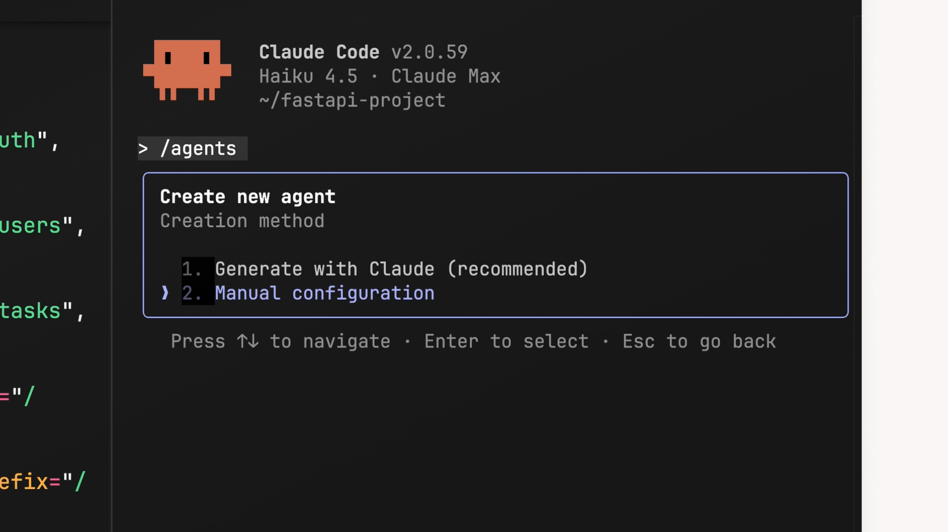
Creating a subagent with /agents - choose its scope, then let Claude generate the configuration.

Customizing tools
During creation you choose which tools the subagent can access. The categories are read-only tools, edit tools, execution tools, MCP tools, and other tools. Think about what your subagent actually needs - a code reviewer probably doesn’t need edit tools (it should read and analyze, not change code), though you might keep execution tools on so it can spot pending changes.
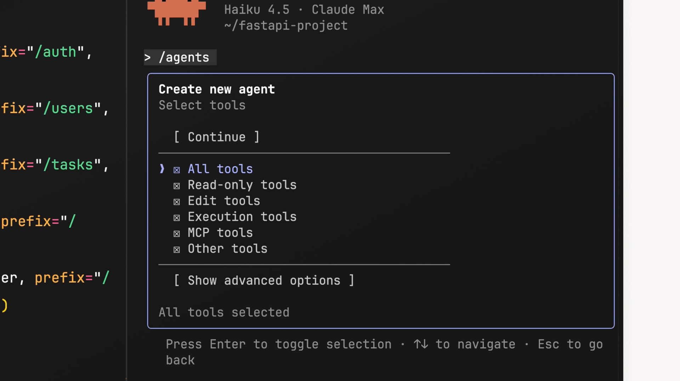
During creation, choose exactly which tool categories the subagent can use.

Choosing a model and color
Next, pick the model that powers the subagent:
Model | Best for
haiku | Fast, lightweight tasks.
sonnet | A good middle ground between speed and depth.
opus | Complex analysis.
inherit | Whatever model your main conversation is running.
Finally, pick a color. It shows up in the UI so you can quickly tell which subagent is active - a small touch that helps when several are running.
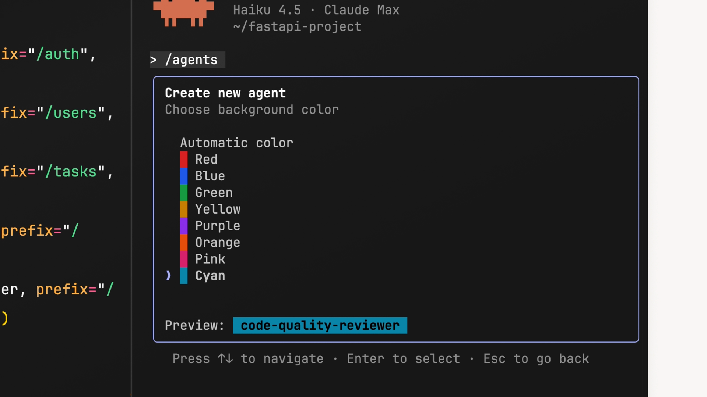
Pick the model that powers the subagent, plus a color to identify it in the UI.

04 The Config File
Once creation is complete, the config is saved into your project - typically at .claude/agents/your-agent-name.md. A typical config looks like this:
.CLAUDE/AGENTS/CODE-QUALITY-REVIEWER.MD
---
name: code-quality-reviewer
description: Use this agent when you need to review recently
written or modified code for quality, security, and best-
practice compliance.
tools: Bash, Glob, Grep, Read, WebFetch, WebSearch
model: sonnet
color: purple
---
You are an expert code reviewer specializing in quality
assurance, security best practices, and adherence to project
standards. Your role is to thoroughly examine recently
written or modified code and identify issues that could
impact reliability, security, maintainability, or performance.
Each field does a specific job:
- name - a unique identifier. Reference it by asking Claude directly or by typing @agent-code-quality-reviewer in your message.
- description - controls when Claude decides to use the subagent. It is a single YAML value: write it on one line (use \n for breaks), or wrap long text onto indented continuation lines, as the demo configs do. You can include example conversations to clarify when delegation is appropriate.
- tools - which tools the subagent can access. Matches what you selected during generation; edit it here any time.
- model - sonnet, opus, haiku, or inherit.
- color - the UI color for identifying the subagent.

System prompts
Everything below the YAML frontmatter is the system prompt - where you give the subagent its instructions: what to focus on, how to analyze things, and how to report findings back. A well-written system prompt is the difference between a useful subagent and one that misses the point, so be specific about what it should look for and how it should structure its output.

05 Tuning When & How It Runs

How the config data is used
When you send a message, the name and description of every available subagent are included in the main agent’s system prompt. That’s how it decides which subagent to launch and when. If you want better control over automatic triggering, the name and description are what to tweak.
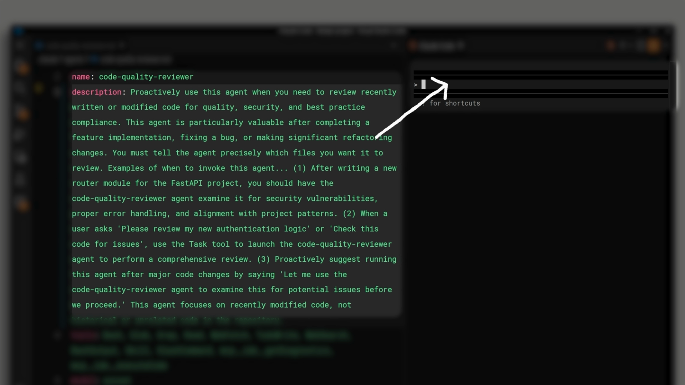
The name and description of every subagent are surfaced to the main agent, which decides when to delegate.

Descriptions shape the input prompt
The description plays a second role: when the main agent launches a subagent, it writes an input prompt to kick off the task - and uses the description as guidance. So the description doesn’t just control when a subagent runs; it shapes what it’s told to do.
With a generic description, the main agent might write something vague like “use get diff to find the current changes” - leaving the subagent to figure out which files matter. Add “you must tell the agent precisely which files to review,” and it now writes a far more specific prompt that lists the actual files. The same trick generalizes: adding “return sources that can be cited” to a web-search subagent’s description makes the main agent include that instruction when delegating.
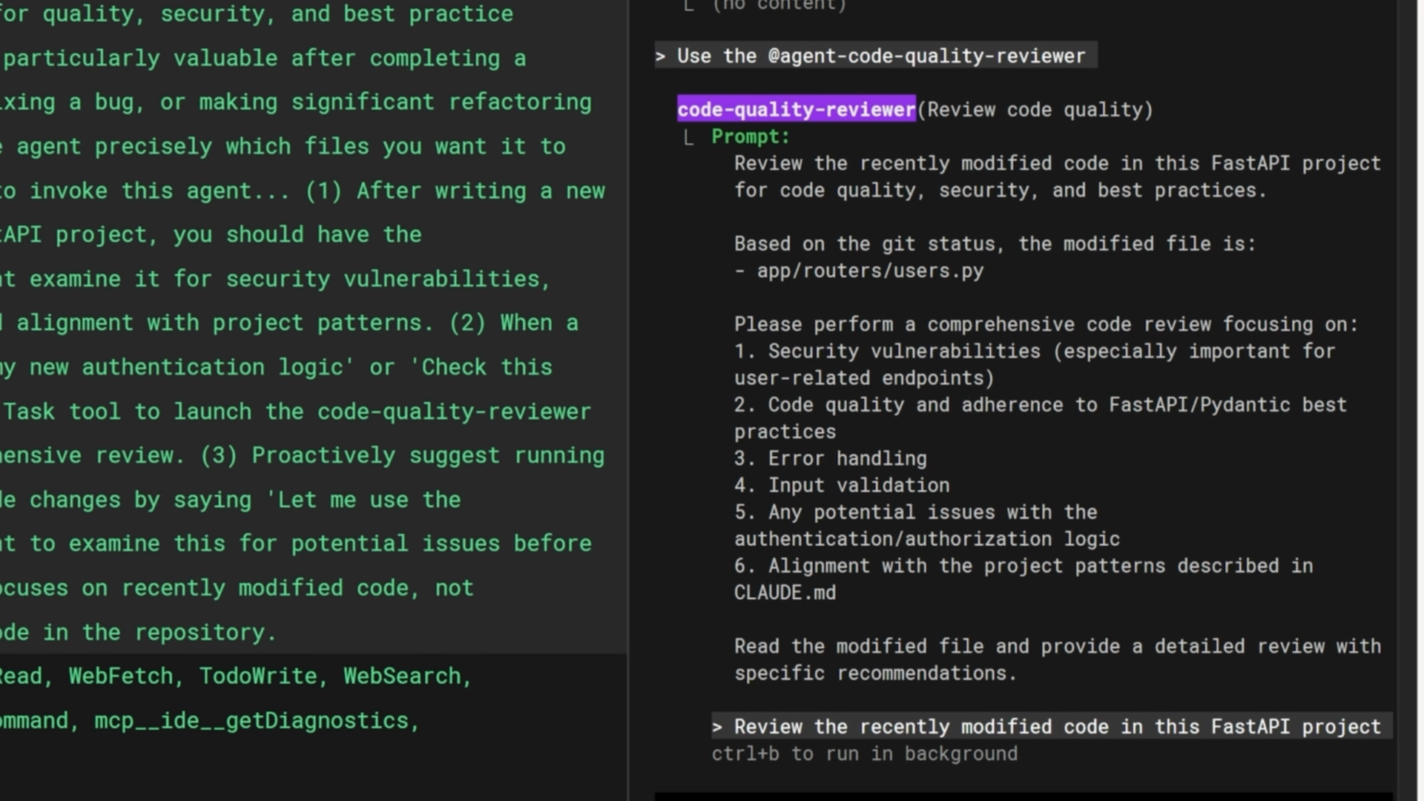
A specific description steers the input prompt the main agent writes when it delegates.

Trigger it automatically
If you want Claude to delegate without being asked, include the word “proactively” in the description:
DESCRIPTION
description: Proactively suggest running this agent after
major code changes...
Adding concrete example conversations to the description further helps Claude recognize the scenarios where it should delegate.

Testing your subagent
After creating a subagent, test it by making some code changes and asking Claude to review them. If it isn’t used when you expect, go back and check the description - more specific examples and trigger scenarios help Claude understand when to delegate.
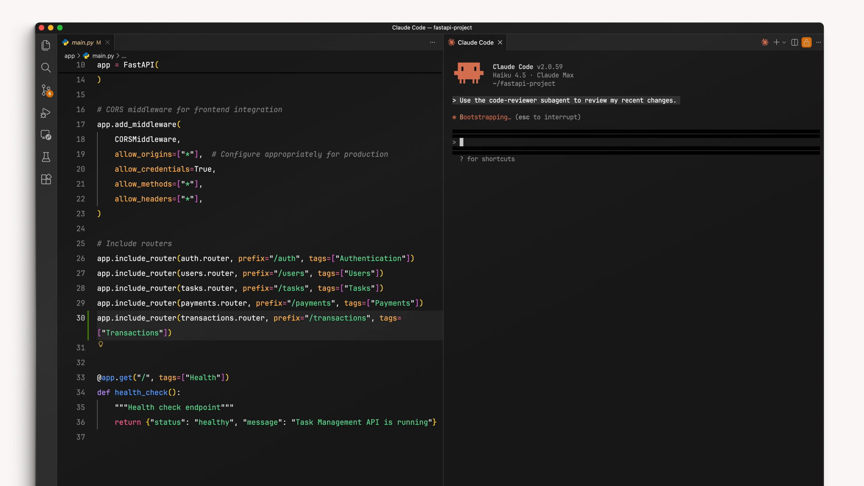
Test a new subagent by making some changes and asking Claude to put it to work.

06 Designing a Great Subagent

Define an output format
The single most important improvement you can make is defining an output format in the system prompt. It creates natural stopping points (the subagent knows it’s done when each section is filled in) and prevents it from running too long - without a defined output, subagents struggle to decide when enough research is done. For a code-review subagent:
SYSTEM PROMPT - OUTPUT FORMAT
Provide your review in a structured format:

1. Summary - what you reviewed and overall assessment
2. Critical Issues - security, data-integrity, or logic
errors that must be fixed immediately
3. Major Issues - quality, architecture, or performance
4. Minor Issues - style, documentation gaps, optimizations
5. Recommendations - refactors or best practices to apply
6. Approval Status - ready to merge, or requires changes

Report obstacles
When a subagent discovers a workaround - a dependency fix, a command that needs particular flags - those details must appear in the summary it returns. Otherwise the main thread has to rediscover them, wasting time and tokens. The reliable way to surface them is to ask for them explicitly: add an Obstacles Encountered section to the output template.
ADD TO THE OUTPUT FORMAT
7. Obstacles Encountered - report any obstacles hit during
the review: setup issues, workarounds discovered, or
environment quirks. Note commands that needed a special
flag or configuration, and dependencies or imports that
caused problems.
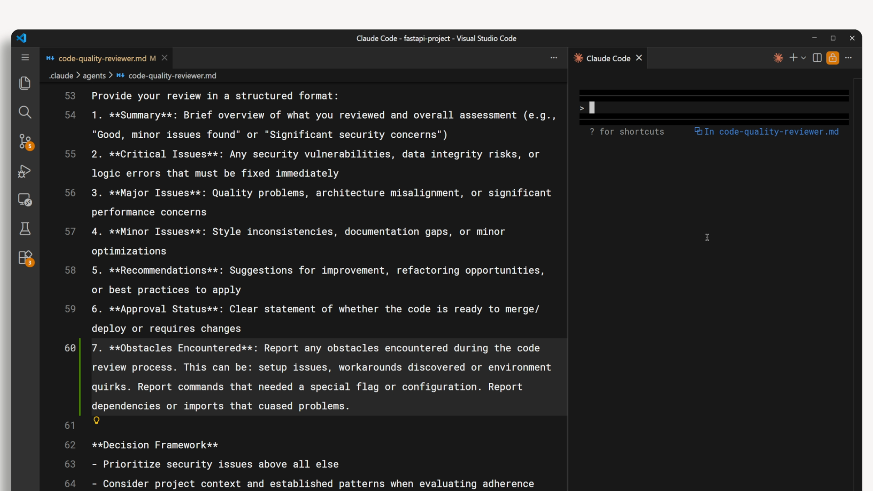
Add an “Obstacles Encountered” section so the subagent surfaces workarounds in its summary.

Limit tool access
Not every subagent needs every tool. Give each one only what its job requires - this prevents unintended side effects and makes each subagent’s role clearer when you have several:
Subagent type | Tools | Why
Research / read-only | Glob, Grep, Read | Cannot accidentally modify files.
Code reviewer | + Bash | Runs git diff; still no Edit/Write.
Code modifier | + Edit, Write | Its job is to change your code.

Putting it all together
Effective subagents share four characteristics:
- Specific descriptions - the description controls when the subagent launches and what instructions it receives. Write it to steer both.
- Structured output - define an output format so it knows when it’s done and returns information the main thread can use.
- Obstacle reporting - include a section for workarounds, quirks, and problems so the main thread doesn’t rediscover them.
- Limited tool access - read-only for research, bash for reviewers, edit/write only for agents that should change code.

07 When to Use Subagents
Subagents work best when exploration is separate from execution. If each step depends on what the previous step discovered, keep that work in your main thread. But if you just need an answer and don’t care about the journey, delegate it. They excel where:
- You need a result, not a play-by-play of how it was found.
- The exploratory work would clutter your main thread’s context.
- The task benefits from a fresh perspective or a custom system prompt.

Research tasks
Research is the classic case. Investigating how model inputs are prepared, your main thread needs to know where text is tokenized - not every file searched along the way. A research subagent reads dozens of files and traces calls in its own context, then returns a clean summary:
SUBAGENT SUMMARY
Tokenization happens in app/preprocess/text.py line 42,
called from the FastAPI route in app/routers/predict.py

Code reviews
Claude reviews code more effectively when it’s presented as someone else’s work. If you built a feature over many turns, asking that same thread to review it often produces weak feedback - Claude helped write it, so it can’t see it with fresh eyes. A reviewer subagent sees the changes in a separate context, runs git diff, and applies its criteria without that history. It also lets you encode project-specific review standards in the subagent’s system prompt for consistency across the team.

Custom system prompts
Claude Code’s default prompt emphasizes concise, code-focused responses - great for coding, not for everything. Two cases where a custom prompt makes a subagent genuinely better:
- Copywriting subagent - give it instructions about tone, audience, and style. The default concise-technical voice isn’t what you want for a landing page or email campaign.
- Styling subagent - point it at your design-system files. They load into its context automatically, so it knows your color variables, spacing, and component patterns before writing any CSS.

08 When Subagents Hurt
The overhead of a subagent - losing visibility and compressing findings into a summary - only pays off when it does something the main thread can’t. Three common anti-patterns:

Expert claims
Subagents that claim expertise rarely help. “You are a Python expert” or “a Kubernetes specialist” adds no value - Claude already has that knowledge. There’s nothing such a subagent can do that your main thread can’t do directly.

Sequential pipelines
Chaining subagents creates problems. A flow of reproduce → debug → fix works only when tasks are truly independent. It fails when each step depends on the previous one’s discoveries - and bug fixing almost always does - because information is lost in the handoff.

Test runners
Test-runner subagents hide information you need. When tests fail, you want the full output to diagnose the issue; a subagent that returns “tests failed” forces you to write extra debug scripts to recover details that would have been visible directly. In testing, this pattern performed worst of all configurations.

- The Decision Rule
When you’re deciding whether to use a subagent, ask one question: does the intermediate work matter? If no - you just need the final result - delegate it. If yes - you need to see and react to what’s happening along the way - keep it in your main thread.
Use subagents for | Avoid subagents for
Research and exploration | “Expert” personas that add no real capability
Code reviews | Multi-step pipelines where each step depends on the last
Tasks that need a custom system prompt | Running tests where you need full output to debug

Delegate the journey when you only need the destination.

Demo
Build Multiple Claude Code Subagents
A Hands-On, End-to-End Walkthrough
In roughly 15-20 minutes you’ll build two complementary subagents for a Python machine learning codebase that predicts customer churn - one that explores the code to answer a question, and one that reviews a newly written training-data module with fresh eyes - and see how each runs in its own isolated context and returns only a summary, keeping your main conversation clean. An optional third subagent demonstrates a different pattern again.
isolated context · per-agent tools · system prompts

IN THIS DEMO
- Set up a small Python churn-model codebase to work against.
- Build an exploration subagent and a review subagent, each with its own tools and system prompt.
- Delegate two different tasks and compare what comes back - and what stays out of the main context.

ON THIS PAGE
› 1. Why Two Subagents, Not One
› 2. Prerequisites
› 3. Set Up a Sample Codebase
› 4. Create the Exploration Subagent
› 5. Create the Review Subagent
› 6. Load and Verify
› 7. Delegate an Exploration Task
› 8. Delegate a Review Task
› 9. Add a Documentation Subagent
› 10. Summary
› 11. Skills vs. Subagents
› 12. Troubleshooting
› 13. Next Steps
01 Why Two Subagents, Not One
Each subagent runs in a separate context window. It receives a system prompt (its role) and a task description (what to do), does the work privately - reading files and searching - and returns only a summary. The intermediate steps are discarded, so your main conversation stays focused on results.
Because the system prompt and tool access are configured per subagent, different jobs deserve different subagents. In this demo:
Subagent | Type | Tools | Why it is a good fit
codebase-explorer | Research | Glob, Grep, Read | Answers “where/how does X work” without flooding your context with every file it reads.
pipeline-reviewer | Code review | Glob, Grep, Read | Reviews ML pipeline code with fresh eyes in a clean context, against a leakage and reproducibility checklist.
pipeline-doc-writer (optional) | Custom prompt | Glob, Grep, Read | Writes pipeline docs in a set voice and format - different from the default code-focused tone.
Each is invoked independently by you or the main agent. We are deliberately not chaining them into an automated pipeline, which is an anti-pattern when each step depends on the previous one’s discoveries.
02 Prerequisites
- Claude Code installed and running (claude is available in your terminal).
- Python 3.10 or newer, and Git, to clone and install the sample project.
git clone https://github.com/ANI-IN/claude-code-subagents-python.git
cd claude-code-subagents-python
python3 -m venv .venv && source .venv/bin/activate
pip install -e ".[dev]"
pytest
PROJECT-LEVEL SUBAGENTS
The subagents below are project-level - they live in .claude/agents/ and are shared with anyone who clones the project.
Project Files - Link
03 Set Up a Sample Codebase
We need realistic code for the subagents to act on. The project files contain a small Python package that loads customer records, prepares features, and builds train and test sets for a churn model. Two files matter for this demo.
First, the existing train/test split module - this is what the explorer will locate:
src/churn_model/data/split.py
"""Split customer records into reproducible train and test sets."""

import random

from churn_model.config import LABEL_COLUMN, RANDOM_SEED, TEST_FRACTION
from churn_model.data.loader import Row

def split_dataset(
rows: list[Row],
*,
test_fraction: float = TEST_FRACTION,
seed: int = RANDOM_SEED,
label_column: str = LABEL_COLUMN,
) -> tuple[list[Row], list[Row]]:
"""Return (train, test) with about the same label balance in both sets.

Rows are grouped by label, and each group is split at `test_fraction`.
One generator seeded with `seed` shuffles the groups and then both
sets, so the same seed always produces the same split and neither set
is ordered by label.
"""
if not 0 < test_fraction < 1:
raise ValueError("test_fraction must be between 0 and 1")

groups: dict[float, list[Row]] = {}
for row in rows:
label = row[label_column]
if label is None:
raise ValueError(f"row has no {label_column} label")
groups.setdefault(label, []).append(row)

rng = random.Random(seed)
train: list[Row] = []
test: list[Row] = []
for label in sorted(groups):
group = groups[label][:]
rng.shuffle(group)
test_size = round(len(group) * test_fraction)
test.extend(group[:test_size])
train.extend(group[test_size:])
rng.shuffle(train)
rng.shuffle(test)
return train, test
Next, a newly written training-data module - this is what the reviewer will examine. It contains several deliberate problems (excerpt):
src/churn_model/training/prepare.py
import random
from dataclasses import dataclass

from churn_model.config import LABEL_COLUMN, TEST_FRACTION
from churn_model.data.loader import Row
from churn_model.features.scaling import apply_standardizer, fit_standardizer

# TrainingSets is a frozen dataclass holding feature_names,
# train/test feature vectors, and train/test labels.

def build_training_sets(rows: list[Row]) -> TrainingSets:
"""Clean, scale, and split customer records into train and test sets."""
# Every column in the data is used as a feature.
feature_names = list(rows[0])

# Models cannot handle missing values, so fill the gaps first.
filled = [_fill_missing(row) for row in rows]

stats = fit_standardizer(filled, feature_names)
scaled = apply_standardizer(filled, stats)

examples = [
(_to_vector(row, feature_names), _label(original))
for row, original in zip(scaled, rows, strict=True)
]

random.shuffle(examples)
cut = int(len(examples) * (1 - TEST_FRACTION))
train, test = examples[:cut], examples[cut:]

return TrainingSets(
feature_names=feature_names,
train_features=[features for features, _ in train],
train_labels=[label for _, label in train],
test_features=[features for features, _ in test],
test_labels=[label for _, label in test],
)

def _fill_missing(row: Row) -> Row:
return {name: 0.0 if value is None else value for name, value in row.items()}
The planted issues in prepare.py are target leakage (the churned label is used as a feature), scaling fitted on all rows before the split, an unseeded random.shuffle that duplicates split_dataset, and missing values silently replaced with 0.0. The test suite still passes, because tests/test_prepare.py only checks the shape of the output - which is exactly why a fresh-eyes review is worth having.
04 Create the Exploration Subagent
A subagent is a Markdown file: YAML frontmatter (configuration) followed by a system prompt (instructions). You can create one interactively with /agents and let Claude generate it, but we will write it directly for a reproducible result.
mkdir -p .claude/agents
.claude/agents/codebase-explorer.md
---
name: codebase-explorer
description: Explores the churn-model codebase to answer "where" and
"how" questions about how something works - data loading, train/test
splitting, feature scaling, configuration. Use when the user needs
to locate logic or understand a flow without reading every file
themselves. Return precise file paths and line numbers.
tools: Glob, Grep, Read
model: sonnet
color: blue
---
You are a codebase navigator for a Python machine learning project that
predicts customer churn. Your job is to locate relevant code and explain
how a piece of the system works, then return a concise answer. You only
read and search; you do not modify code.

When given a question:
1. Search the codebase for the relevant files and functions.
2. Trace the flow only as far as needed to answer the question.
3. Return a short answer in this format:
- Answer - one or two sentences stating where the logic lives and how
it works.
- Key locations - file path and line number for each important point.
- Notes - anything the caller should know (assumptions, gaps).

Do not paste large blocks of code. Cite locations instead.
This subagent is read-only (Glob, Grep, Read) - it can never alter the code it explores. The description tells it to return file paths and line numbers, which keeps the summary compact and actionable.
05 Create the Review Subagent
.claude/agents/pipeline-reviewer.md
---
name: pipeline-reviewer
description: Reviews Python ML pipeline code - data loading, feature
preparation, and train/test splitting - for data leakage,
reproducibility, and correctness. Use after writing or modifying
pipeline, feature, or training code. You must tell the agent
precisely which files to review.
tools: Glob, Grep, Read
model: sonnet
color: purple
---
You are a correctness reviewer for a Python machine learning codebase
that predicts customer churn. You examine pipeline code with fresh eyes
and report issues. You read and analyze; you do not modify code.

Focus on:
- Target leakage - the label, or anything derived from it, used as a
model feature.
- Train/test contamination - statistics such as means, medians, or
vocabularies fitted on data that includes the test set.
- Reproducibility - randomness without a fixed seed, or results that
change from run to run.
- Missing values silently dropped or replaced with made-up numbers.
- Logic that duplicates an existing helper instead of reusing it.

Provide your review in this format:
1. Summary - what you reviewed and an overall assessment.
2. Critical Issues - leakage or logic errors that make results wrong.
3. Major Issues - reproducibility, quality, or architecture concerns.
4. Minor Issues - style, documentation, or edge-case notes.
5. Approval Status - "Safe to merge" or "Requires changes".
6. Obstacles Encountered - any setup issues or quirks discovered during
the review.
Two design choices worth noting:
- Tools are read-only. The reviewer reads and searches the code you point it at, but has no Edit or Write access - it reviews, it does not change. The tool table in section 06 of the lesson adds Bash for reviewers so they can run git diff; this one does not need it, because you tell it exactly which file to review.
- The output format is explicit. Numbered sections give the subagent clear stopping points and return a result the main thread can use. The “Obstacles Encountered” section surfaces anything unexpected so it is not rediscovered later.
06 Load and Verify
Restart Claude Code so it registers both subagents:
claude
Confirm they are available:
/agents
codebase-explorer and pipeline-reviewer should both appear, scoped to the project.
07 Delegate an Exploration Task
Ask a question that would otherwise require reading several files:
Use the codebase-explorer: where and how is the train/test split made, and how is it kept reproducible?
The explorer spins up in its own context, searches the codebase, and returns a focused answer - pointing to split_dataset in src/churn_model/data/split.py, which keeps the churn rate equal in both sets and shuffles with random.Random(seed), and to RANDOM_SEED in src/churn_model/config.py, which makes the split reproducible.
THE CORE BENEFIT
Notice what your main conversation records: the question and the summary. The individual searches and file reads happened in the subagent’s context and were discarded. You got the fact without the clutter.
08 Delegate a Review Task
Now hand off the new training-data module:
Use the pipeline-reviewer to review src/churn_model/training/prepare.py
The reviewer examines the file in a clean context and returns a structured summary against your format - the churned label used as a feature and the scaler fitted before the split as Critical Issues, the unseeded shuffle that duplicates split_dataset and the zero-filled missing values flagged as well, and an approval status of “Requires changes”.
Because the reviewer sees the code fresh, in its own context, it catches issues that a thread which just wrote the code might overlook.
09 Add a Documentation Subagent (Optional)
This pattern shows where a custom system prompt makes a subagent genuinely better. The default Claude Code voice is concise and code-focused, which is not what you want for pipeline documentation.
.claude/agents/pipeline-doc-writer.md
---
name: pipeline-doc-writer
description: Writes developer documentation for data and training
pipeline modules in the team's standard format. Use when a new
pipeline module is ready and needs developer-facing docs.
tools: Glob, Grep, Read
model: sonnet
color: green
---
You write clear, developer-facing documentation for a Python machine
learning codebase. Your audience is engineers who will call a module or
build on it. Use a precise, practical tone - not marketing copy.

For the module you are given, produce:
- Overview - what the module does, in two or three sentences.
- Inputs - the data it expects: columns, types, and missing values.
- Usage - the main functions, their parameters, and a short example.
- Data caveats - leakage, reproducibility, and other limits a caller
must know before trusting the results.

Read the code to ground every statement. Do not invent behavior that is
not in the source.
Restart Claude Code, then:
Use the pipeline-doc-writer to document src/churn_model/training/prepare.py
The result reads like documentation, not a code dump - because the system prompt set the audience, tone, and structure. Its Data caveats section describes the planted flaws plainly, because the writer grounds every statement in the code.
10 Summary
- A subagent runs in an isolated context and returns only a summary, keeping your main conversation clean.
- Use different subagents for different jobs: an explorer for research, a reviewer for code review, a writer for docs. Each gets its own tools and system prompt.
- The description controls both when a subagent is used and what it is told to do - make it specific.
- A defined output format gives the subagent clear stopping points and a usable result.
- Restrict tools to what the job requires: read-only for exploration and review, and never Edit/Write unless the job is to change code.
11 Skills vs. Subagents - When to Use Which
 | Skill | Subagent
Runs in | Your main conversation | A separate, isolated context
Best for | Injecting a standard or checklist into the current task | Delegating self-contained work and getting a summary back
You see | The full working steps | Only the final result
Example here | Apply a review checklist inline | Hand off exploration or review entirely, fresh eyes
12 Troubleshooting
Symptom | Resolution
Subagent not listed | The file must be in .claude/agents/ with valid YAML frontmatter. Restart after any change.
Subagent not used when expected | The description is too generic. Add specific trigger scenarios, or include “proactively” to have Claude delegate on its own.
Wrong subagent runs | Two descriptions overlap. Make them distinct so each clearly owns its task.
Review or answer is vague | The system prompt lacks a clear output format. Define numbered sections so the subagent knows when it is done.
Subagent tries to edit code | Remove Edit/Write from tools; keep exploration and review read-only.
13 Next Steps
- Add concrete example conversations to each description to sharpen when Claude delegates.
- Share .claude/agents/ with the project so the whole team inherits the same subagents.
- Keep the anti-patterns in mind: don’t chain subagents into pipelines where each step depends on the last, don’t create “expert persona” subagents that add no capability the main thread lacks, and don’t use a subagent to run tests when you need the full output to debug.

Different jobs, different subagents - each in its own clean context, returning just the result you need.

