**PROJECT-NAME: FLIPKART**

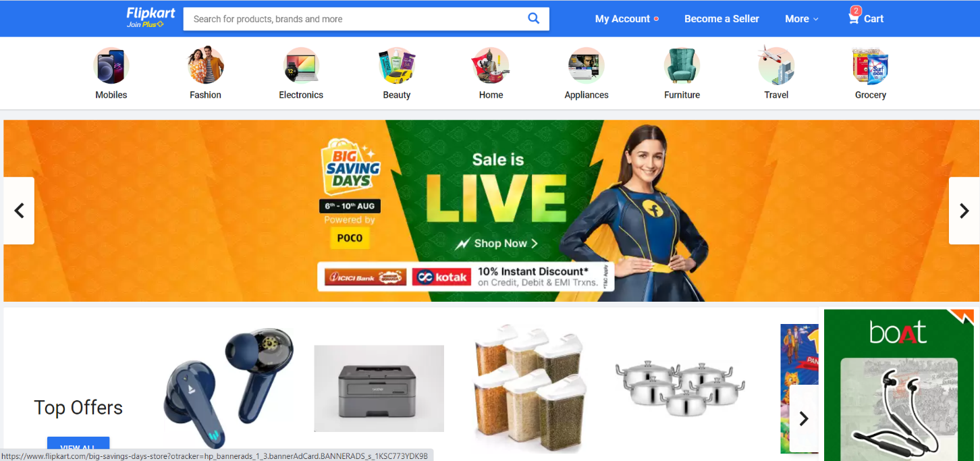

**OVERVIEW:** It’s an e-commerce website for consumer electronics, fashion, home essentials, groceries, and lifestyle products.

1. **HOME PAGE:**

* LOGO
* ICONS - (WISHLIST, ADD TO CART)
* SEARCH BAR
* SLIDERS WITH ARROWS - (IMAGES)
* DEALS - (IMAGES)
* FEATURED - (IMAGES TRENDING - (IMAGES)
* FOOTER – ( CONTACT US , HELPLINES , BRIEF DESCRIPTION ,ABOUT THE COMPANY , SOCIAL-MEDIA ICONS , LINK TO MOBILE APP )

1. **REGISTRATION FORM:**

* NAME AND ADDRESS DETAILS
* E-MAIL ADDRESS
* D.O.B
* SHOPPING PREFERENCE

1. **MAIN PAGE:**

* FILTERS - ( BRANDS , COLOR , DISCOUNT RANGE , PRICE COUNTRY OF ORIGIN , MATERIAL , FEATURES , FIT , OCCASION , PATTERN , RATING , SIZE , TYPE , SORT BY: )
* MAGES OF THE CHOSEN PRODUCT WITH DETAILS LIKE -

( BRAND , PRODUCT NAME , PRICE , DISCOUNT% ( IF ANY ) )

* ON CLICKING THE IMAGE - (MULTIPLE IMAGES OF THE

PRODUCT WILL APPEAR FROM DIFFERENT ANGLES , ZOOM IN , ZOOM OUT)

* PRODUCT DESCRIPTION - BRAND , PRODUCT NAME ,

PRICE , DISCOUNT% (IF ANY) , SIZE CHART ,

DELIVERY OPTIONS , PRODUCT

DETAILS , SIZE & FIT , MATERIAL & CARE ,

SPECIFICATIONS , RATINGS , CUSTOMER REVIEWS

* LOWER HALF OF THE PAGE - RELATED PRODUCTS

1. **PAYMENT PAGE:**

* ADDRESS SELECTION
* PAYMENT METHOD - (PHONEPE , GOOGLE PAY , BHIM UPI ,

COD , CREDIT/DEBIT CARD , NET

* + BANKING , EMI , PAYTM)