**Summarize v/s Summarize Columns**

* **Both will give table as a result.**

**Using SUMMARIZE :-**

**Dax :-**

**SUMMARIZE (<table>, <groupBy_columnName>,<name>,<expression>])**

**Summarize = SUMMARIZE(Bikedata, Bikedata[Country],"Sales by Country",[Sales] )**

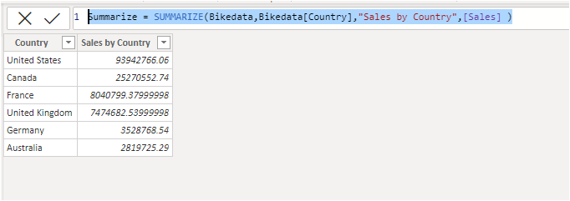

**Using SUMMARIZECOLUMNS :-**

**Dax :-**

**SUMMARIZECOLUMNS(<groupBy_columnName>,<name>,<expression>)**

**Summarize Columns = SUMMARIZECOLUMNS(Bikedata[Country],"Country wise Sales",[Sales])**

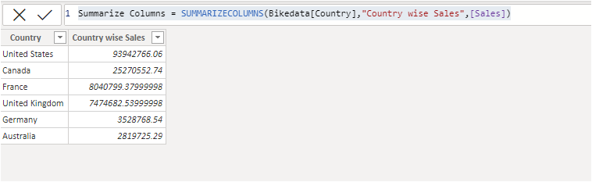

**Difference between Summarize and Summarizecolumns :-**

1. **In Summarize function we need to pass table name as a parameter where as in SummarizeColumns function no need to pass the table name as a parameter.**
2. **In Summarizecolumns we have an option to add a filter.**

**In the below Example i want only the total sales of france country.**

**Dax :-**

**SUMMARIZECOLUMNS(<groupBy_columnName>,(filterTable),<name>,<expression>)**

**Summarize Columns filter = SUMMARIZECOLUMNS(Bikedata[Country],FILTER(Bikedata,Bikedata[Country] = "France"),"Country wise Sales",[Sales])**

