MAHARASHTRA
Satbara Utara (7/12 Extract)
सातबारा उतारा — Complete Reference Guide
Land Records | Forms | Legal Significance | Term Glossary

Revenue Department, Government of Maharashtra
e-MahaBhumi | Bhulekh Maharashtra

1. What is Satbara (7/12 Utara)?
The 7/12 extract (Satbara Utara — सातबारा उतारा) is the most critical land record document in Maharashtra, maintained by the Revenue Department of Maharashtra. It serves as the official proof of land ownership, containing historical land data and playing a vital role in property transactions, legal disputes, loans, and government schemes.
Why is it called 7/12?
The document is named after the two government forms it combines:
Form | Name (Marathi)
Form 7 (सात) | Malakachya Hakkache Tapashil — मालकाच्या हक्काचे तपशील — Records landowner details and legal rights.
Form 12 (बारा) | Pik Pahani — पीक पाहणी — Contains information on agricultural activities, crops, and soil type.
For any landowner in Maharashtra, the 7/12 extract is a legally binding document that must be presented for property transactions, inheritance claims, loans, and government schemes.

2. Sample 7/12 Document (Form 7 & Form 12)
Official e-MahaBhumi sample showing Form 7 (left) and Form 12 (right)
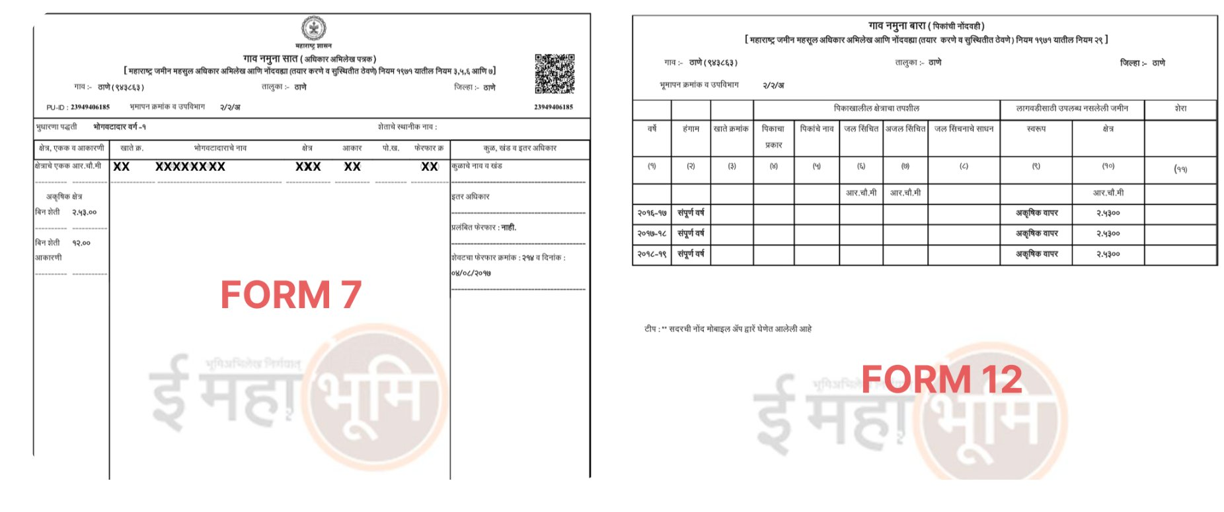
Source: e-MahaBhumi Portal — ई महाभूमि | Bhulekh Maharashtra

3. Form 7 — Ownership Register (अधिकार अभिलेख)
Form 7 is the Rights Register — it establishes who owns the land, how they acquired it, and any legal encumbrances. Every term and column in this form is explained below.
Section A — Header Details
Term (Marathi) | English Meaning | What it Contains
गाव (Gaon) | Village | Name of the village where the land is situated
तालुका (Taluka) | Sub-District / Block | Administrative block that the village falls under
जिल्हा (Jilha) | District | The district of the land
भूमापन क्रमांक व उपविभाग | Survey Number & Sub-Division | Unique plot number assigned by the Survey Department
PU-ID | Permanent Unique ID | A unique digital identifier for each 7/12 record on the portal
Section B — Ownership Details (भोगवटादाराचे तपशील)
Term (Marathi) | English Meaning | What it Contains
भोगवटदार वर्ग-१ | Occupant Class 1 | Full ownership rights — can sell, mortgage, or transfer freely
भोगवटदार वर्ग-२ | Occupant Class 2 | Conditional ownership — requires government permission to transfer
शेताचे स्वामिनाव | Owner's Name | Name(s) of the registered landowner(s)
खाते क्र. (Khate Kr.) | Account Number | Land revenue account number for this owner
भोगवटादाराचे भाग (Hissa) | Owner's Share | The fractional share of the land (e.g. 1/2, 1/3) in joint ownership
खरेद (Khared) | By Purchase / Sale | Land acquired through a registered sale deed
वारसान (Varasan) | By Inheritance | Land passed to heirs on death of the previous owner
बक्षीस (Bakshis) | By Gift Deed | Land acquired as a gift through a registered gift deed
Section C — Land Area & Assessment (क्षेत्र व आकार)
Term (Marathi) | English Meaning | What it Contains
क्षेत्र (Kshetra) | Area | Total land area of the survey number in hectares and ares
हेक्टर (Hektar) | Hectare | Primary unit of area (1 hectare = 10,000 sq. metres)
आर (Are) | Are | Sub-unit (1 Are = 1/100th of a hectare)
आकार (Akar) | Land Revenue Assessment | Annual government tax payable on the land
पो.ख. (Pohech Kharch) | Collection Charges | Administrative fee charged on top of land revenue
अकृषिक क्षेत्र (NA) | Non-Agricultural Land | Portion of land converted from farming to other use (residential/commercial)
बिन शेती (Bin Sheti) | Non-Cultivated Land | Land that is not currently cultivated but remains agricultural in classification
Section D — Other Rights & Encumbrances (इतर अधिकार / बोजा)
Term (Marathi) | English Meaning | What it Contains
कुळाचे नाव व खंड | Tenant Name & Rent | Name of the tenant (kul) cultivating the land and the rent payable
इतर अधिकार | Other Rights | Rights of third parties — right of way, water rights, easements, etc.
बोजा / तारण (Borg / Taran) | Encumbrance / Mortgage | Loans or mortgages taken against the land — bank name, loan amount
फेरफार क्र. (Ferfar Kr.) | Mutation Number | Reference number of the last mutation (ownership change) entry
Section E — Mutation / Pending Changes (फेरफार)
Term (Marathi) | English Meaning | What it Contains
प्रलंबित फेरफार: नाही | Pending Mutation: None | Confirms there are no ownership changes awaiting approval
शेवटचा फेरफार क्रमांक | Last Mutation Number & Date | Tracks the most recent ownership change with date
दाखल (Dakhal) | Entered / Recorded | New name/right has been officially recorded
खारीज (Kharij) | Deleted / Removed | Previous name/right removed from the record

4. Form 12 — Crop Inspection Register (पीक पाहणी)
Form 12 records what is being cultivated on the land each season. It is updated annually by the village Talathi (revenue officer) after physical inspection of the fields.
Column-by-Column Breakdown
Col. | Marathi Label | English Meaning | Details
(१) | वर्ष (Varsha) | Year | Agricultural year (e.g., 2016-17, 2017-18)
(२) | हंगाम (Hangam) | Season | Kharif (खरीप — Monsoon), Rabi (रब्बी — Winter), Unikala (उन्हाळी — Summer)
(३) | खाते क्रमांक | Account Number | Landowner's revenue account number
(४) | पिकाचा प्रकार | Crop Type | Whether the land is Jirayat (जिरायत — rain-fed) or Bagayat (बागायत — irrigated)
(५) | पिकांचे नाव | Crop Name | Specific crop grown (e.g., Soybean, Wheat, Rice, Cotton, Sugarcane)
(६) | जल सिंचित (Jal Sincit) | Irrigated Area | Area (in R.Chi.Mi.) irrigated by a water source
(७) | अजल सिंचित | Un-irrigated Area | Area that depends entirely on rainfall — no artificial irrigation
(८) | जल सिंचनाचे साधन | Source of Irrigation | Well (विहीर), Canal (नाळी), Borewell, Dam, River, Lift Irrigation
(९) | स्वरूप (Swarup) | Nature of Land Use | e.g., अकृषिक वापर = Non-Agricultural Use; खाली = Fallow; पेरता = Sown
(१०) | क्षेत्र (Kshetra) | Area | The area in this status (in R.Chi.Mi. / Hectare-Are)
(११) | शेरा (Shera) | Remarks | Any special observations by the Talathi — disputes, errors, pending mutations
Crop Season Terms Explained
Season | Marathi | Period & Crops
Kharif | खरीप हंगाम | June – October (Monsoon). Crops: Rice, Soybean, Jowar, Cotton, Tur
Rabi | रब्बी हंगाम | October – March (Winter). Crops: Wheat, Gram, Onion, Sunflower
Unikala | उन्हाळी हंगाम | March – June (Summer). Crops: Sugarcane, Vegetables, Groundnut
Sampurna Varsha | संपूर्ण वर्ष | Full Year — applies to perennial land use (orchards, NA land, fallow)

5. Complete Glossary — Every Key Term
Ownership & Rights Terms
Marathi Term | Transliteration | Meaning
मालक | Malak | Owner — the registered legal owner of the land
खातेदार | Khatedar | Account holder — the person in whose name land revenue is recorded
हिस्सा | Hissa | Share — fractional ownership in jointly owned land
एकत्रिक मालकी | Ekatrik Malki | Joint ownership — multiple owners on the same record
वाटप | Watap | Partition — division of land among multiple heirs
इनाम | Inam | Grant land — historically granted by rulers, now under state regulation
सरकार | Sarkar | Government — land belonging to or acquired by the state
कायम | Kayam | Permanent — indicates permanent rights or entries
Land Classification Terms
Marathi Term | Transliteration | Meaning
जिरायत | Jirayat | Rain-fed / dry land — dependent only on rainfall, lower value
बागायत | Bagayat | Irrigated land — has access to water source, higher value
पडकर | Padkar | Barren land — uncultivable, rocky or highly degraded
गायरान | Gairan | Village common / grazing land — cannot be privately owned
अकृषिक (NA) | Akrushik | Non-Agricultural — converted land for residential or commercial use
पानंद | Panand | Access path — narrow strip between fields for movement
सरकारी जागा | Sarkari Jaaga | Government land — reserved for public use
देवस्थान | Devsthan | Temple / religious trust land
Mutation & Transaction Terms
Marathi Term | Transliteration | Meaning
फेरफार | Ferfar | Mutation — official change of ownership in land records
नोंदणी | Nondani | Registration — official recording of a deed or transaction
वारसात | Varasat | Succession entry — recorded after owner dies and heirs take over
दाखल खारीज | Dakhal Kharij | Mutation process — adding new owner and removing old owner
सत्यप्रतिलिपी | Satya Pratilit | Certified copy — official copy with government seal, legally valid
मोजणी | Mojani | Survey / measurement — physical measurement of land boundaries
तपासणी | Tapasni | Verification / inspection by revenue officer
Financial & Encumbrance Terms
Marathi Term | Transliteration | Meaning
बोजा | Borg | Encumbrance — any liability, loan, or claim against the land
तारण | Taran | Mortgage — land pledged as security for a loan
कर्ज | Karja | Loan — debt recorded against the land
महसूल | Mahasul | Land Revenue — annual government tax payable by the landowner
थकबाकी | Thakbaki | Arrears — outstanding unpaid dues on the land
भूमी संपादन | Bhumi Sampadan | Land Acquisition — government taking over land for public projects

6. Legal Importance & Use Cases
The 7/12 Satbara is not merely a record — it is the primary legal instrument for land-related matters in Maharashtra. Below are its key applications:
Use Case | Details
Proof of Ownership | Acts as the primary legal proof of land ownership. Required for all property inheritance and succession claims.
Loan & Mortgage | Banks and financial institutions require the 7/12 for agricultural loans, home loans, and when accepting land as collateral.
Government Subsidies | Mandatory for PM Kisan Samman Nidhi, crop insurance, agricultural subsidies, and disaster compensation.
Land Transactions | Buyers and builders verify 7/12 records before purchase. Mandatory for sale deeds, lease agreements, and development plans.
Legal Disputes | Primary evidence in property fraud cases, boundary disputes, and ownership conflicts in courts and revenue tribunals.
Government Acquisition | Required to claim compensation when the government acquires land for infrastructure or public projects.
NA Conversion | Must be verified before applying to convert agricultural land to non-agricultural (NA) status for development.

Document prepared for reference purposes. Always obtain a certified copy from the e-MahaBhumi portal (mahabhumi.gov.in) for official use.

