PRISM
Project is regarding movies the processing of it editing and other stud called post production is manages from this software
1. Login Screen
Username
Security pin
Company selection (All the three companies can login)(Three roles)(Admin has all access)
GST who handle billing
Non GST billing
Today’s date(Calendar to select)
In the application we have Six modules
Operations-Booking, Leaves Entry(Editor), Chalan Entry, Chalan Revise(not explained by him)
Masters-Customer, Project , Room, Editor, User(not explained)
Reports-Conflict Report, Booking Report, Editor Report, Chalan Report, Leave Report(not exp), Booking Message(not exp), Chalan Not Prepared(not exp)
Utility-User Rights
Windows-All the tabs that are open
Exit
2) Operations
A) Booking Details(Every field will be editable)
Adding the info for booking a room(calendar selection for booking for days of a month)
we can hide cancelled booking from the hide check box below calendar
We can also cancel a booking and enter reason for it and save a vertical line will come on that booking. Once cancelled cannot be edited u need to book again.
we have ignore conflict for Editors and Rooms when marked then that rooms or that editor can be assigned again in other booking as they are marked as ignore conflict the repeat booking will be saved for them.
while saving we get a warning saying number of conflict we can ignore it and save further it is an alert
If the Editor or Room is not marked as ignore conflict then we cannot save duplicates.
This are the fields to enter the actual from and to time will be entered when work has started
final billing we be done by total booking time minus total actual time spend they charge hourly
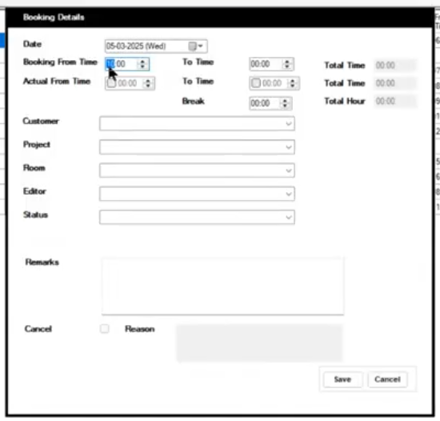
Customer, Project, Room, Editor will be shown by their Active status
This are the fields shown after filling booking form
fields---(cancel Flag, Rooms(Music, Sound Recording, Visual Effects), Customer, Project, Contact Person, Editor, From Time, To Time, Actual From Time, Actual To Time, Break Hours, Total Hour, Status-Planning-if room is not vacant for work, Tentative, Confirmed)
Room types will have number from 1 to 5
The Room field has some extra entries Clients office(production house room)
The Editor field has some extra entries (Clients editor and Clients technician)
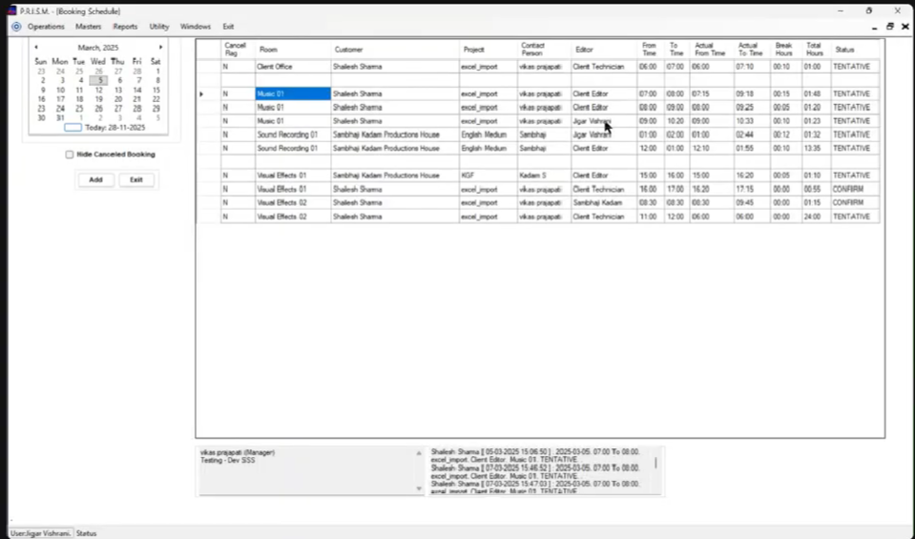
Here when we click on a project name we will get a repeat dialog box to enter the days to be repeated for that project with the same details and when saved the conflict alert or not and then save in the booking list for another day we can view by calendar.
When chalan or Invoice is created for a project then there will be a mark of chalan and invoice( yes or no) on the project
Below on this page from the rooms booked whenever we hover on click on a booking a log entry is there in the footer
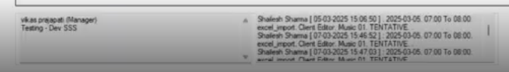
a. The contact person info name and number and the remark for that booking in left log box
b. The customer with booking details and the edits done for that booking with time stamp in right log box as the clients can arrive early and late also. So that we can confront the client by this info.
Editor name [data and time when edited], Date of booking, Time of booking, Project name, Customer name, Room name and status
B) Leave Entry (Editor)
Fields(Editor, Leave From, Leave To, Notes)
C) Chalan Entry
chalan creation for a project
D) Chalan Revise
Editing the created chalan
3) Masters
A) Customer Master
Fields(Customer name, Short Name, PAN Number, GST Number, Address, Email, Contact Person, Mobile No, Telephone Number, Notes)----mostly the customer name and short name are important other are for display purpose
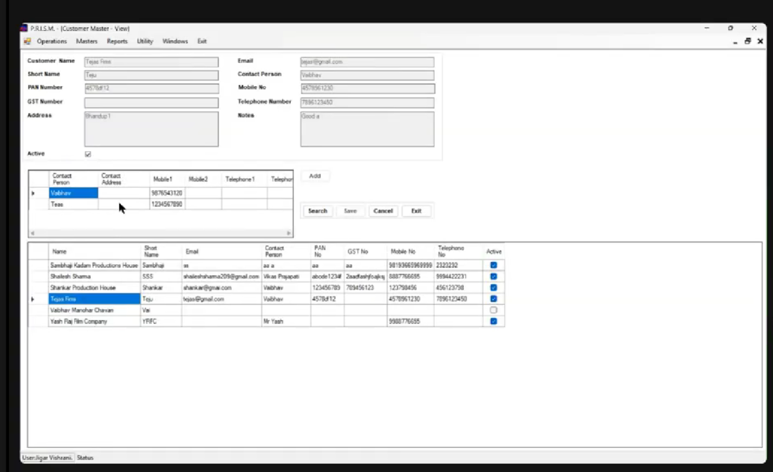
For a customer we need to have multiple contact person u can see in the second table we are adding multiple contact person for that person (contact person for that customer)
we cannot delete that customer we will simply mark them active and inactive in the Customers table u can see
Double on that customer to edit info
B) Project masters (For customers)
Fields(Project Name, Short Name, Customer(Dropdown), Contact person(For project-Dropdown), Active or Active Checkbox for the project, Project Type(Dropdown), Notes)
The customer and the contact person names for the dropdown will be coming from customer masters but the project type can be Movie, Teaser, Advertise, Serial, Web Series, Trilogy. Suppose for a project we enter a project type so it will be saved next time it will come as a dropdown
When we select the column in the projects table we see the sorted names in each column to find the unique ones easily
Double click on that project to edit info
C) Room Master
Fields(Type, Name, Short Name, Ignore Conflict check box, Active Inactive Checkbox, Notes)
Music and Sound Recording are clubbed as Type=Sound
Type will be Saved as entered and will come as dropdown option
D) Editor Master
Fields(Type, Name, Short Name, Ignore Conflict check box, Active Inactive Checkbox, Join Date, Leaving Date(A checkbox in it if ticked he is inactive not then he is active , Notes)
4) Reports –(To Export)
A) Conflict Report(where we will be able to see the conflict report-It will be calculated by the Editors, Time, Rooms)
Here we will see the rooms and editor conflicts booking details
Fields(Customer, Project Type, Project, Room, Editor, Status, From Date, To Date)
B) Booking Report
Fields(Customer Dropdown-filter, Project Type Dropdown-filter, Project Dropdown-filter, Room Dropdown-filter, Editor Dropdown-filter, Status Dropdown-filter, From Date, To Date, Actual time not entered check box-filtering(To enter time by Taking follow up), Cancel check box-filtering-cancelled customer details )
windows filtering when clicked on each column of the reports and filtering by entering names of project(BAH ENTERED LIST DOWN BAHUBALI- IF EXIST)
EXPORT EXCEL AND CSV AND COPY PASTING DETAILS
C) Editor Report(Here we will get the editors details)
Fields(Editor, From Date, To Date)
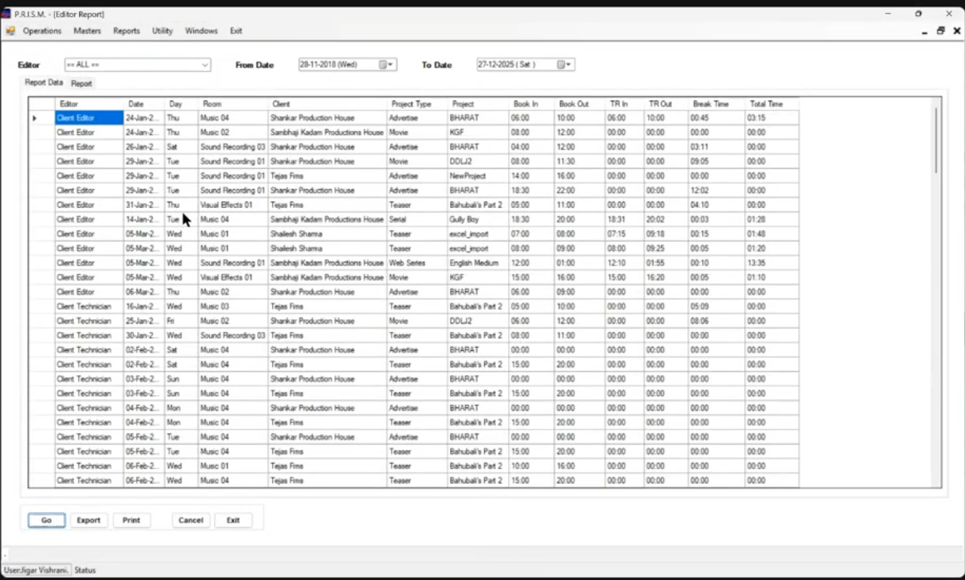
There is a print format here in the Editor Report when clicked a format shows
A print format with Booking Date, Project Name , Client Name, Booking From and To, Actual From and To Break Time, Total Time
The Format
14 dates in one page then rest on other page and then from each total time that editors Total time will be calculated
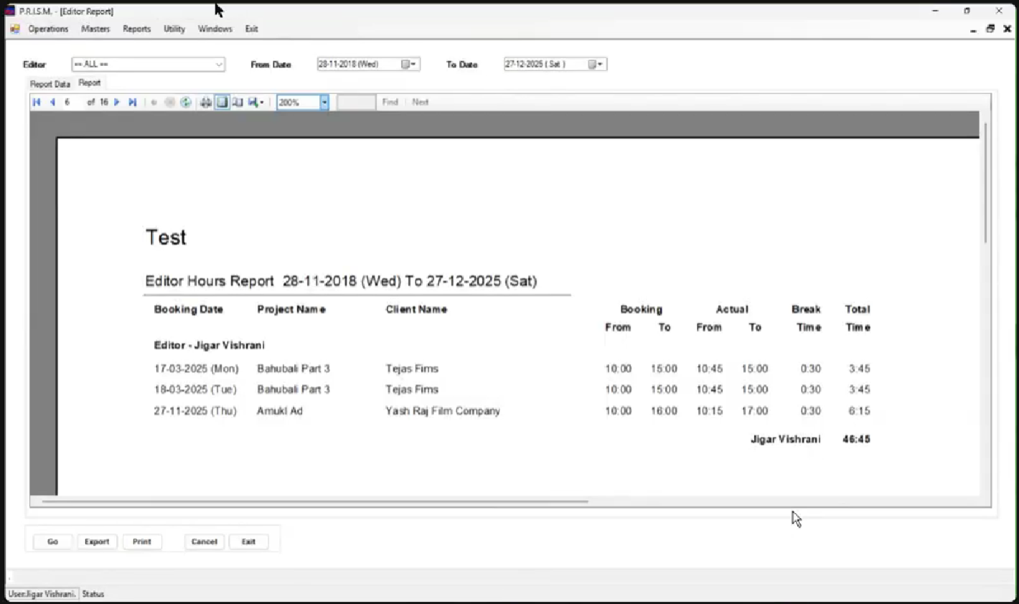
D) Chalan Report
Fields(Customer Name, From Date, To Date, Cancel Chalan)
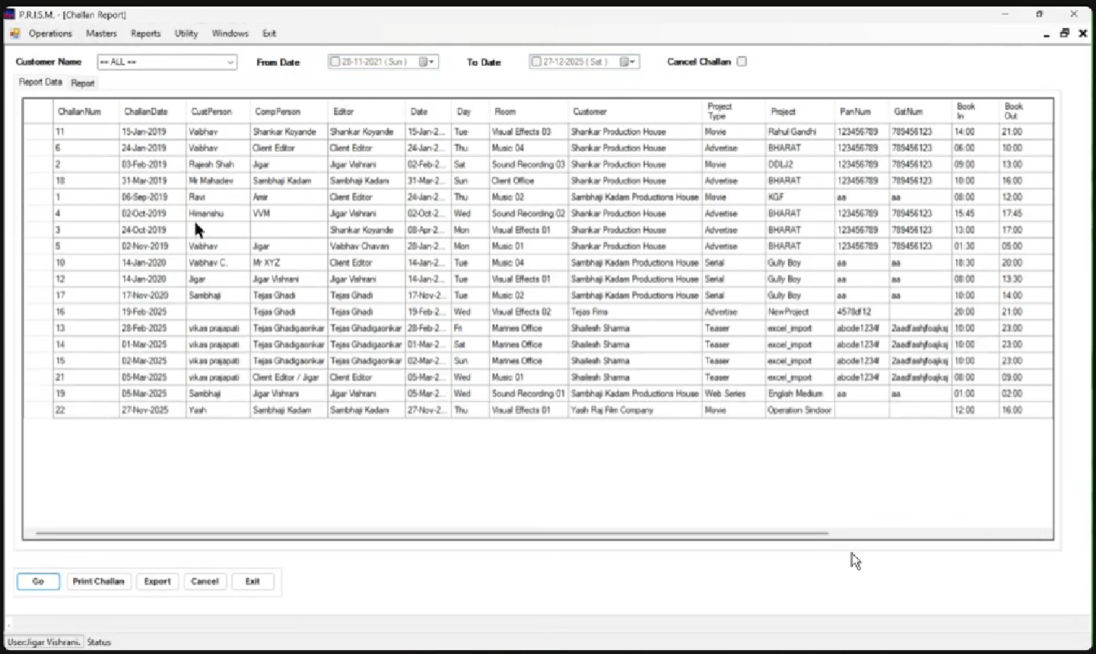
The chalan also has a format a table with project details and below five sign some additional info
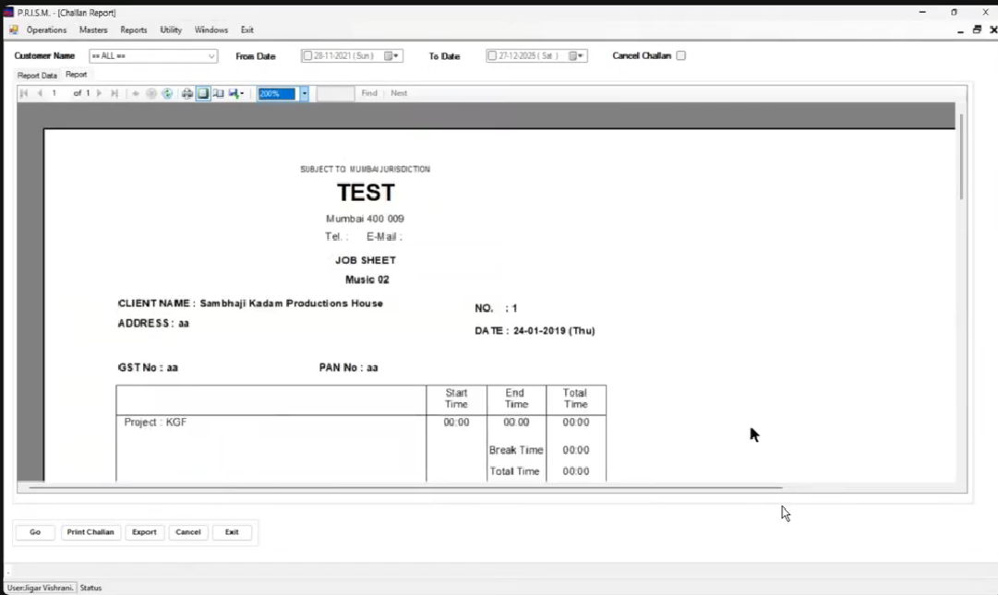
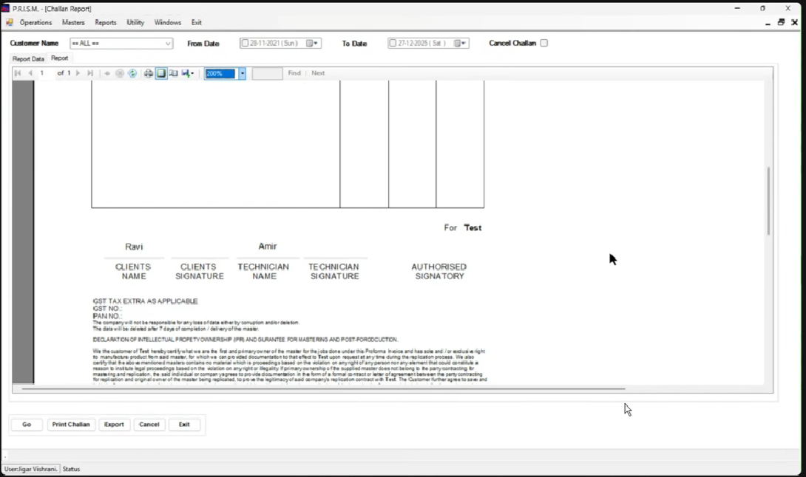
We can also print the cancelled chalan if we tick the cancel chalan checkbox and we can view the slip of it
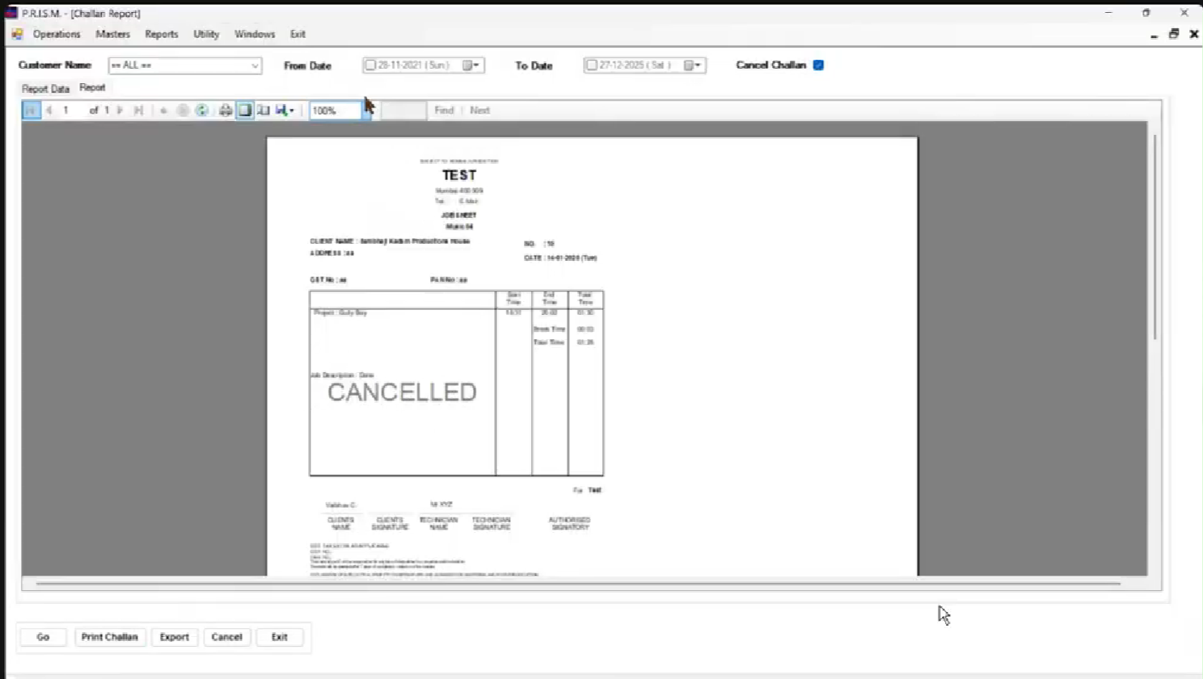
5) Utility(users access are managed for each module and access for each sections in each modules)
