Signature Recognition using Neural Networks

In propose work we are evaluating performance of various neural networks algorithms such as CNN, LSTM, RBF, Siamese and Capsule Net to recognize Forge and real signatures. To train all algorithms we have utilized below dataset from KAGGLE repository

<https://www.kaggle.com/datasets/pranjitlahon/real-and-forged-signatures>

Each algorithm performance is measured using various metrics such as accuracy, precision, recall, confusion matrix and FSCORE. Among all algorithms CNN and Siamese working best with an accuracy of over 95%.

To implement this project we have designed following modules

1. Upload Signature Dataset: using this module will upload dataset to application and then read and resize all images and then create training array
2. Preprocess Dataset: using this module will shuffle, normalize and process all images features
3. Train & Test Dataset Split: process images will be split into train and test where application using 80% dataset for training and 20% for testing
4. Run CNN Algorithm: 80% training features will be input to CNN algorithm to train a model and this model will be applied on 20% test data to calculate accuracy and other metrics
5. Run CapsuleNet Algorithm: 80% training features will be input to CapsuleNet algorithm to train a model and this model will be applied on 20% test data to calculate accuracy and other metrics
6. Run LSTM Algorithm: 80% training features will be input to LSTM algorithm to train a model and this model will be applied on 20% test data to calculate accuracy and other metrics
7. Run Radial Basis Algorithm: 80% training features will be input to RBF algorithm to train a model and this model will be applied on 20% test data to calculate accuracy and other metrics
8. Run Siamese Algorithm: 80% training features will be input to Siamese algorithm to train a model and this model will be applied on 20% test data to calculate accuracy and other metrics
9. Comparison Graph: will plot comparison graph between all algorithms
10. Signature Recognition from Test Image: using this module will upload test image and then CNN algorithm will recognized image as forge or real.

SCREEN SHOTS

To run project double click on run.bat file to get below screen

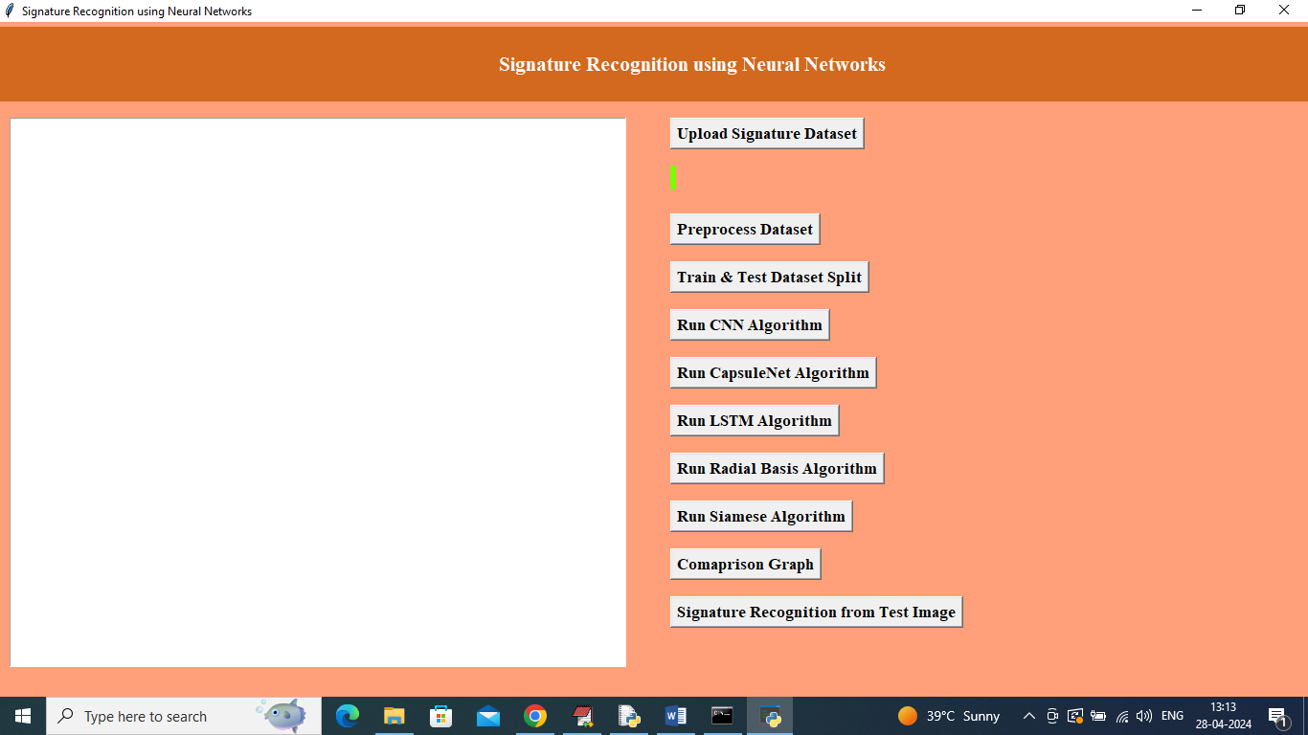

In above screen click on ‘Upload Signature Dataset’ button to upload dataset and get below page

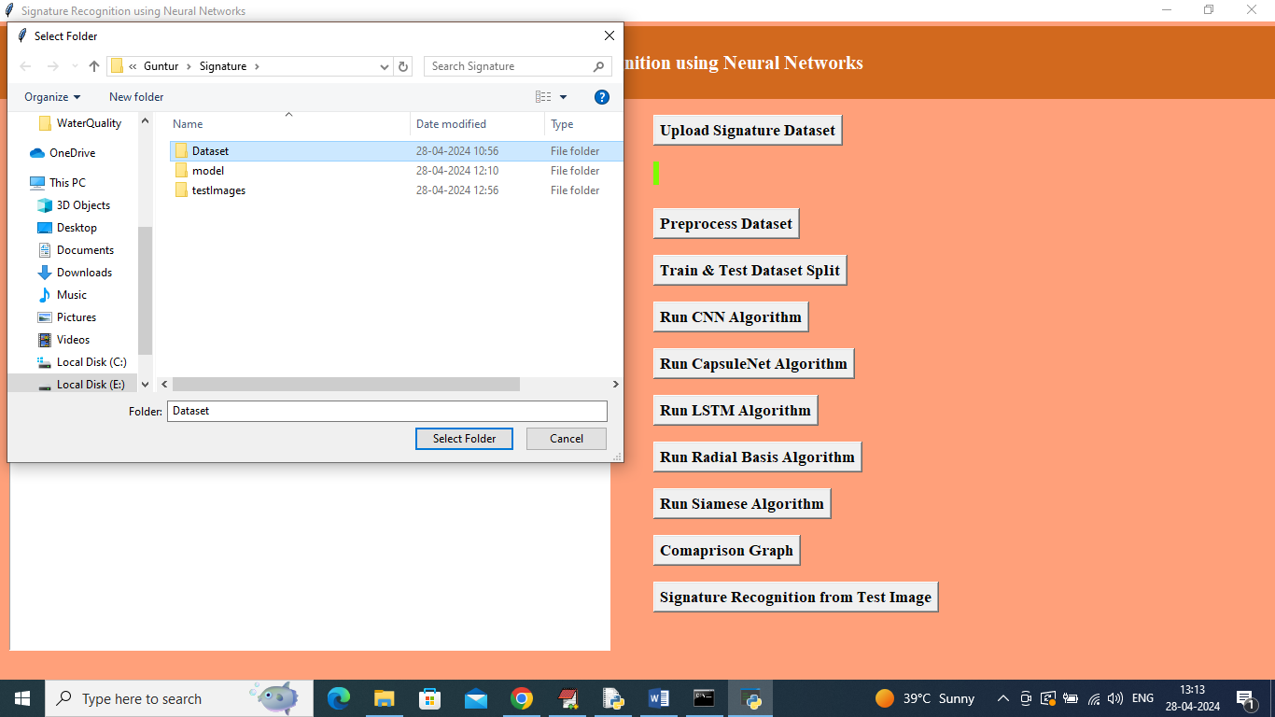

In above screen selecting and uploading entire dataset folder and then click on “select folder’ button to load dataset and get below page

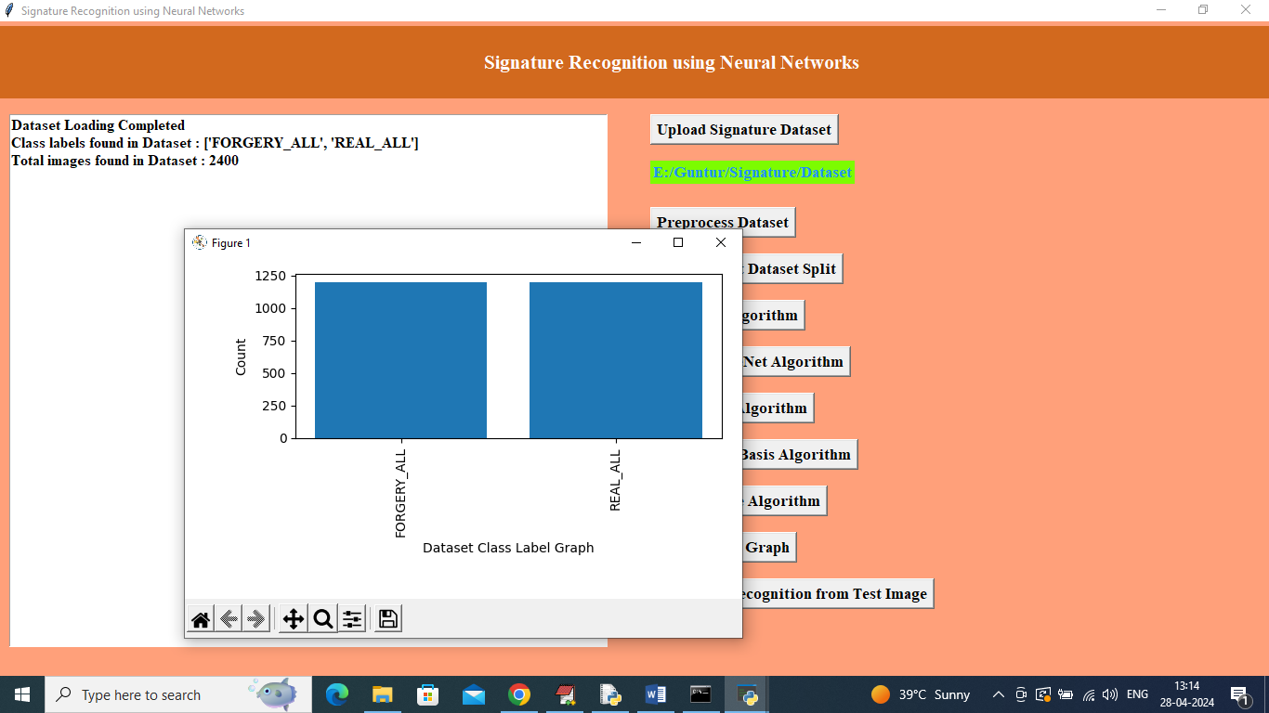

In above screen dataset loaded and can see different classes found in dataset and then can see total number of images loaded and in graph x-axis represents class label and y-axis represents number of images found in that category and now click on ‘Preprocess Dataset’ button to process images

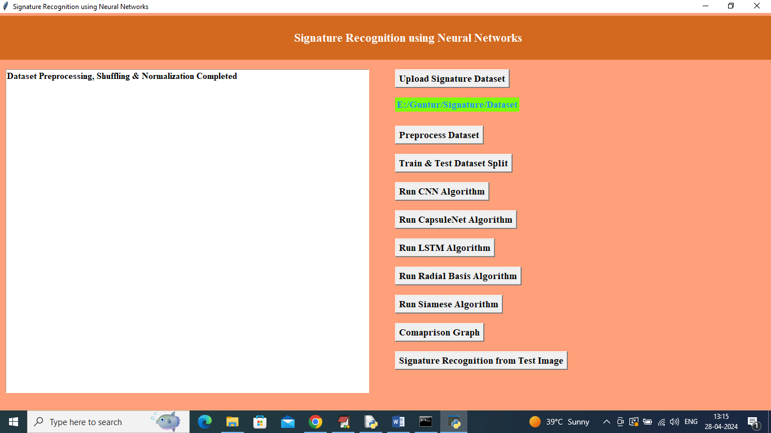

In above screen dataset shuffling and normalization completed and now click on ‘Train & Test Dataset Split’ button to split dataset into train and test and then will get below page

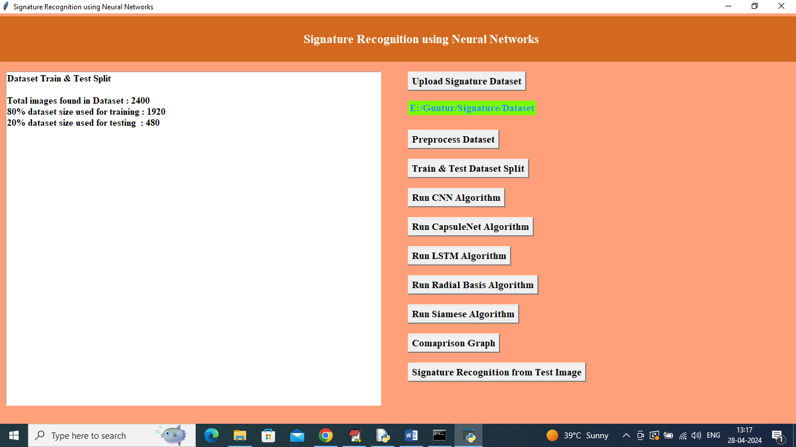

In above screen can see total images and then can see train and test size and now click on ‘Run CNN Algorithm’ button to train CNN and get below page

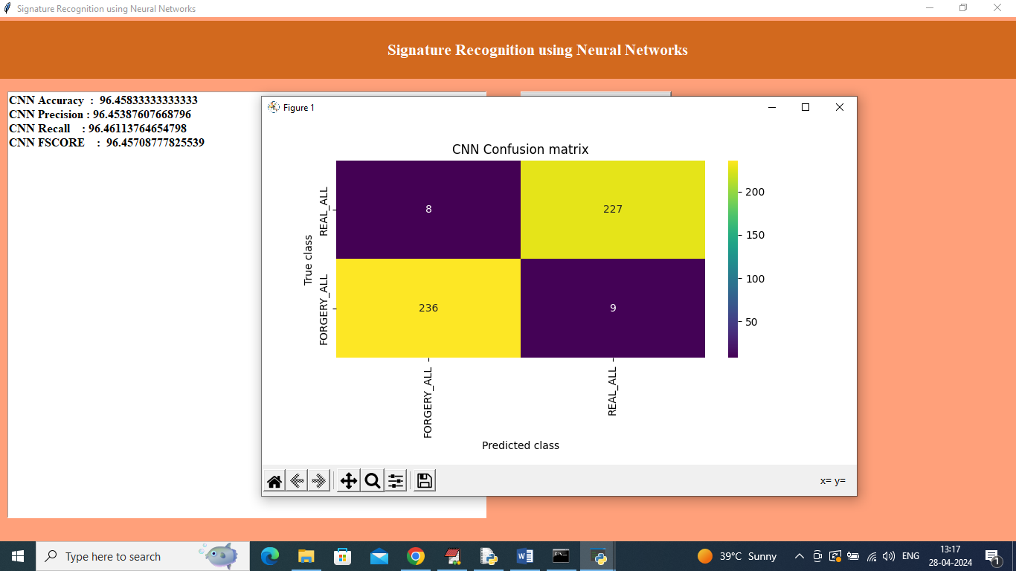

In above screen CNN got 96% accuracy and can see other metrics results as precision, recall and FSCORE. In confusion matrix graph x-axis represents Predicted Labels and y-axis represents True Labels and then Yellow boxes represents correct prediction count and blue boxes represents incorrect prediction count which are very few and now close above graph and then click on ‘Run Capsule Net Algorithm’ button to get below page

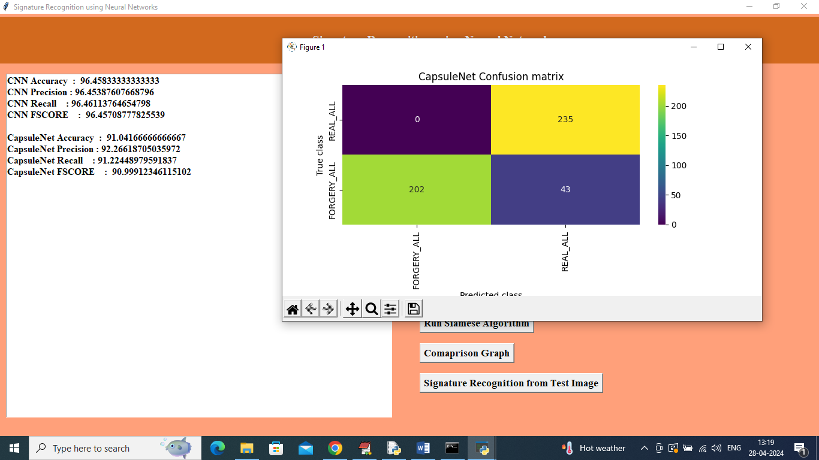

In above screen Capsule Net got 91% accuracy and can see other metrics also and now click on ‘Run LSTM Algorithm’ button to get below page

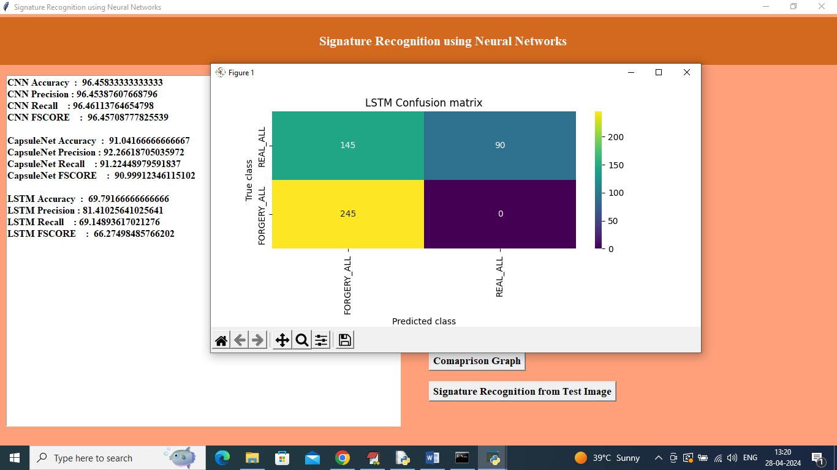

In above screen LSTM got 69% accuracy and now click on ‘Run Radial Basis Algorithm’ button to get below page

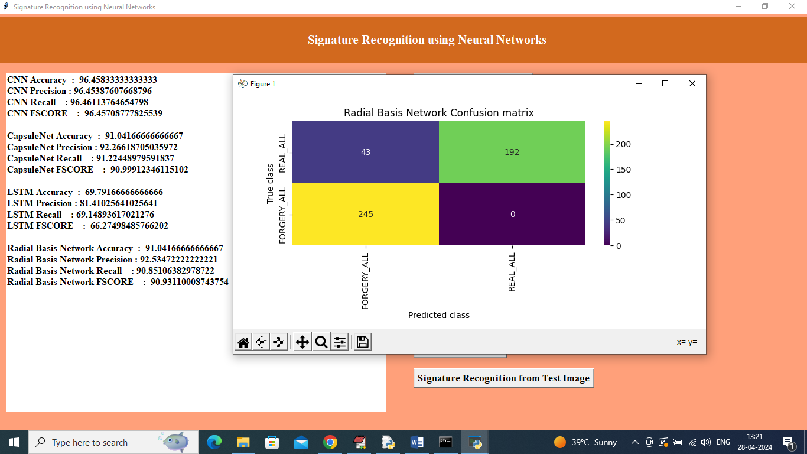

In above screen Radial Basis got 91% accuracy and now click on ‘Run Siamese Algorithm’ button get below output

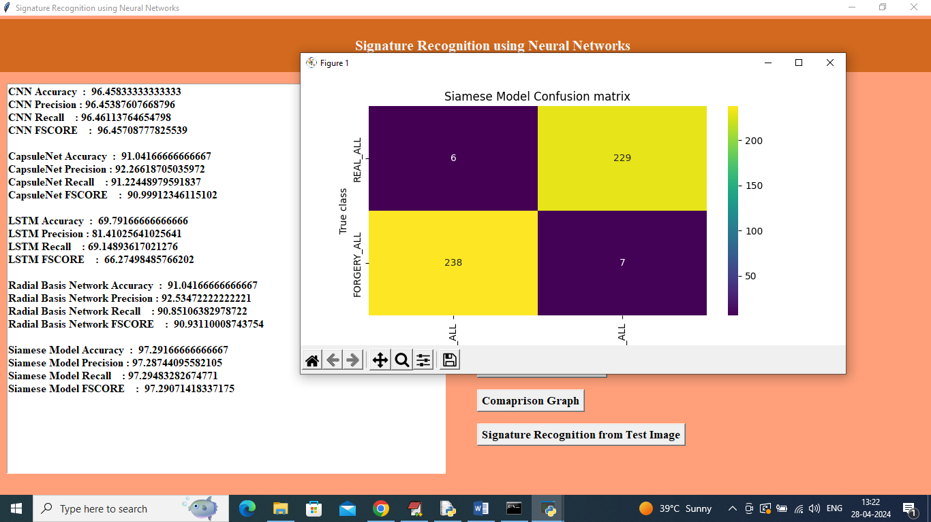

In above screen ‘Siamese Algorithm’ got 97% accuracy and now click on ‘Comparison Graph’ button to get below page

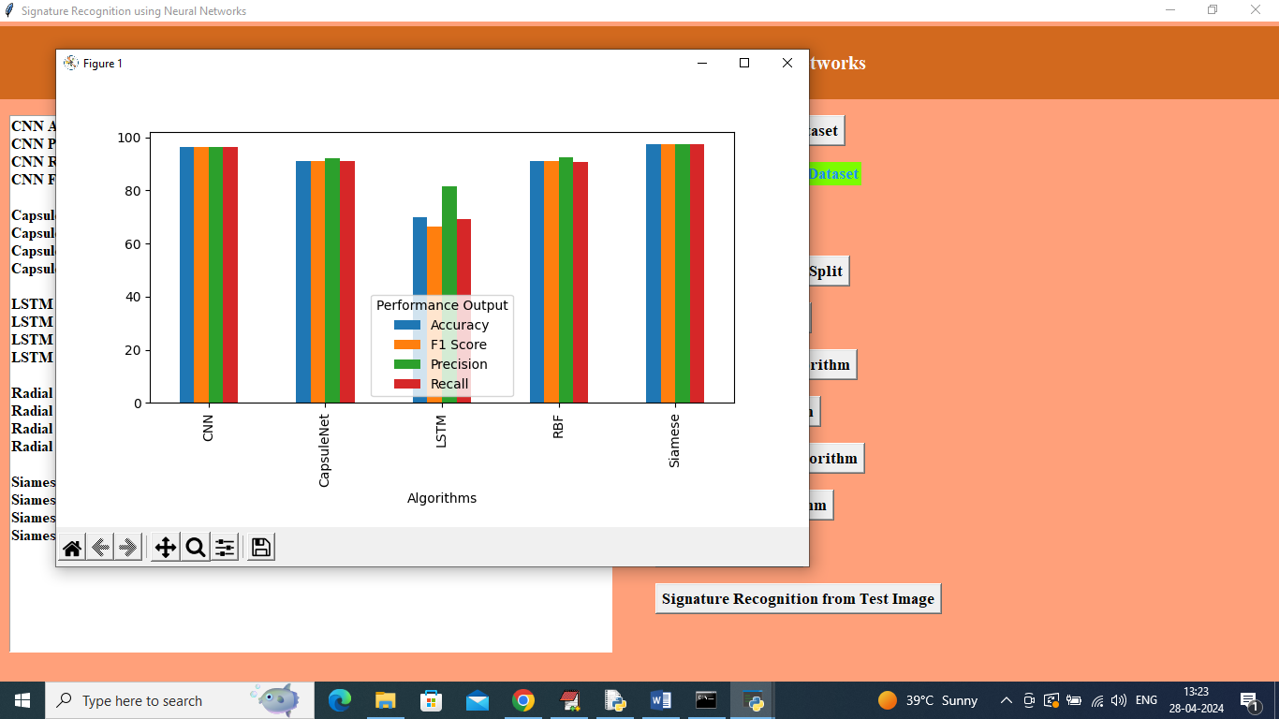

In above graph x-axis represents algorithm names and y-axis represents accuracy and other metrics in different color bars and can see in all algorithms CNN and Siamese got high performance and now click on ‘Signature Recognition from Test Image’ button to upload test image and recognize signature

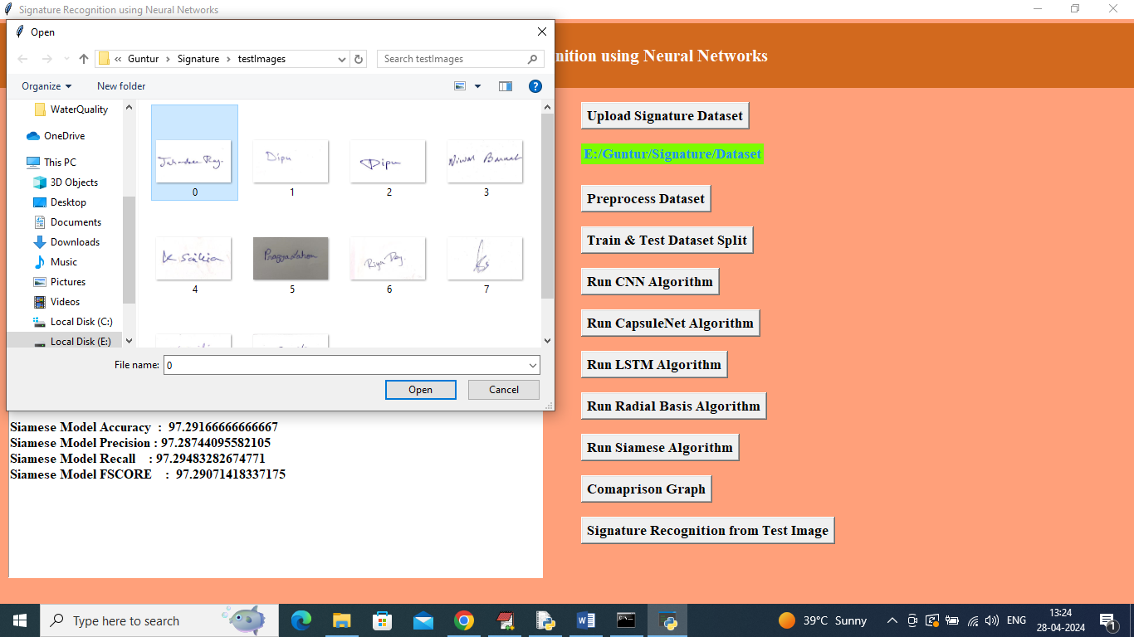

In above screen selecting and uploading 0.jpg image and then click on ‘Open’ button to get below page

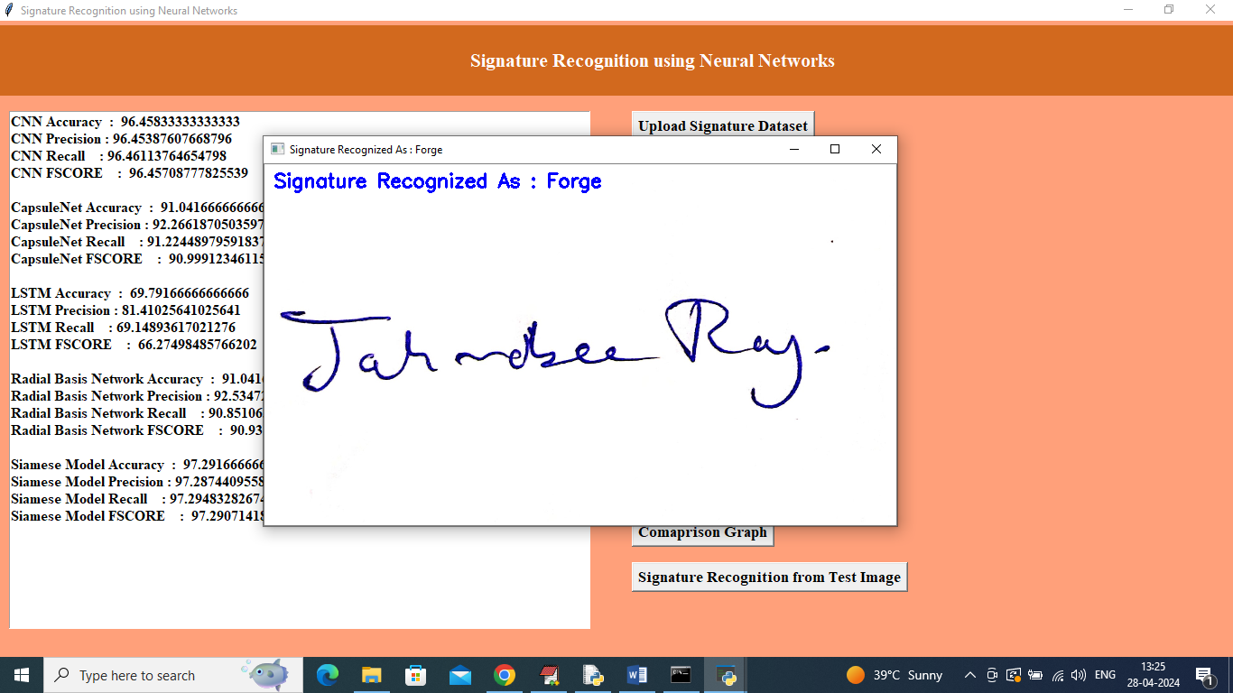

In above screen signature recognized as ‘Forge’ and similarly you can upload and test other images

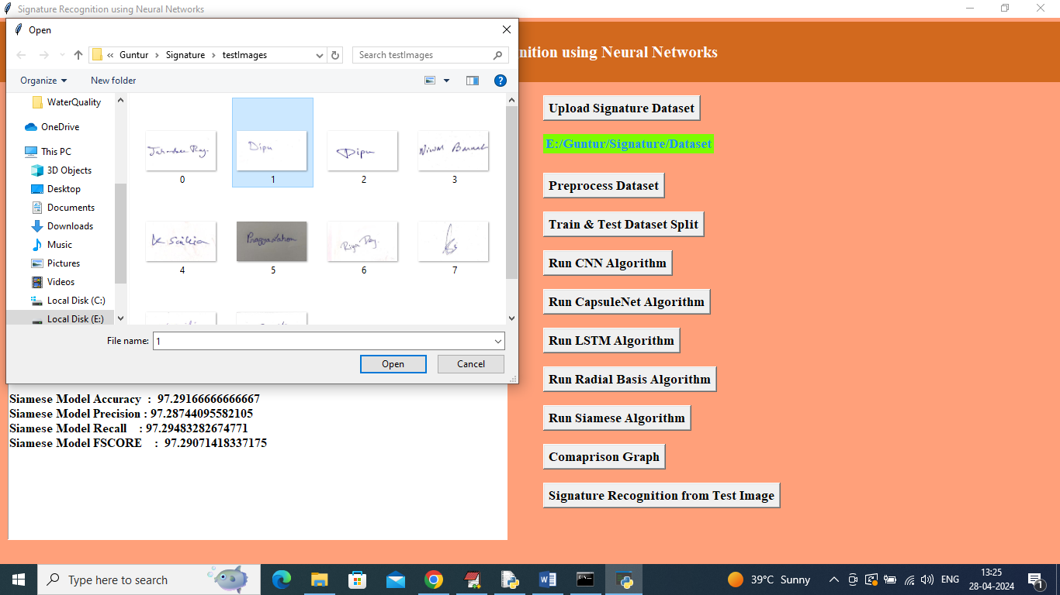

In above screen uploading another image and below is the output

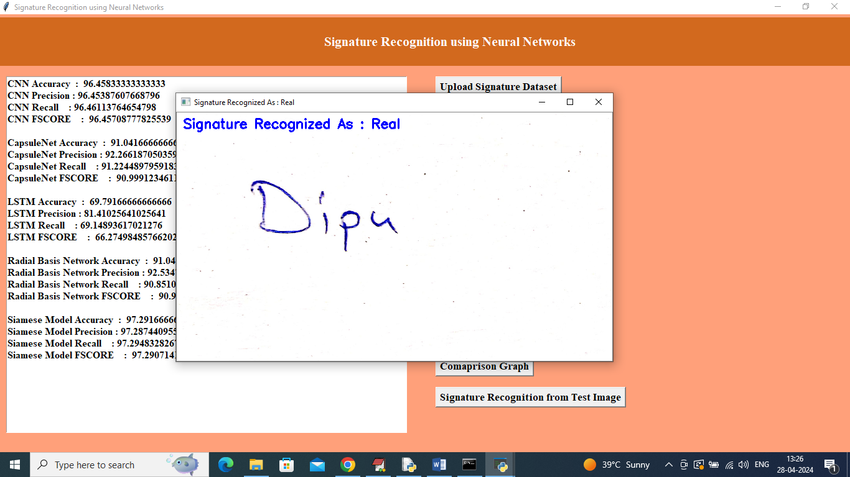

Signature recognized as Real’.