**CHAPTER 1**

**INTRODUCTION**

* 1. **Computer Graphics**

To draw a picture say, fish moving inside the water. Suddenly will get an idea to use paint, but the degree of accuracy, quality of image is not satisfied and become very sad. There is no need to worry, for every problem there will be a solution, so this problem of creating fish moving inside the water can be solved using COMPUTER GRAPHICS without any difficulties.

Computer Graphics become a powerful tool for the rapid and economical production of pictures. There is virtually no area in which Graphical displays cannot be used to some advantage so it is not surprising to find the use of CG so widespread.

Although early application in engineering & science had to rely on expensive & cumbersome equipments, advances in computer technology have made interactive computer graphics a practical tool.

Computer Graphics in a diverse area such as science, engineering, medicine, business, industry, government, art, entertainment, education and training.

Now it can be answered about computer graphics as generalized tool for drawing and creating pictures and simulates the real world situations within a small computer window.

**1.2 Applications of computer Graphics**

Nowadays Computer Graphics used in almost all the areas ranges from science, engineering, medicine, business, industry, government, art, entertainment, education and training.

**1.2.1 CG in the field of CAD**

Computer Aided Design methods are routinely used in the design of buildings, automobiles, aircraft, watercraft, spacecraft computers, textiles and many other applications.

**1.2.2 CG in presentation Graphics**

Another major application area presentation graphics used to produce illustrations for reports or generate slides. Presentation graphics is commonly used to summarize financial, statistical, mathematical, scientific data for research reports and other types of reports.2D and 3D bar chart to illustrate some mathematical or statistical report.

**1.2.3 CG in computer Art**

CG methods are widely used in both fine art and commercial art applications. Artists use a variety of computer methods including special purpose hardware, artist’s paintbrush program (lumena), other pain packages, desktop packages, maths packages, animation packages that provide facility for designing object motion. Ex: cartoons design is an example of computer art which uses CG.

**1.2.4 Entertainment**

Computer graphics methods are now commonly used in making motion pictures, music, videos, games and sounds. Sometimes graphics objects are combined with the actors and live scenes.

**1.2.5 Education and Training**

Computer generated models of physical financial, economic system is often as education aids. For some training application special systems are designed. Ex: specialized system is simulator for practice sessions or training of ship captain, aircraft pilots and traffic control.

**1.2.6 Image Processing**

Although the methods used in CG image processing overlap, the 2 areas are concerned with fundamentally different operations. In CG a computer is used to create picture. Image processing on the other hand applies techniques to modify existing pictures such as photo scans, TV scans.

**1.2.7 User Interface**

It is common for software packages to provide a graphical interface. A major component of a graphical interface is a window manager that allows a user to display multiple window area. Interface also displays menus, icons for fast selection and processing.

**1.3 Open GL**

OpenGL (Open Graphics Library) is a standard specification defining a cross-language, cross-platform API for writing applications that produce 2D and 3D computer graphics. The interface consists of over 250 different function calls which can be used to draw complex three-dimensional scenes from simple primitives. OpenGL was developed by Silicon Graphics Inc. (SGI) in 1992 and is widely used in CAD, virtual reality, scientific visualization, information visualization, and flight simulation. It is also used in video games, where it competes with Direct3D on Microsoft Windows platforms (see OpenGL vs. Direct3D). OpenGL is managed by a non-profit technology consortium, the Khronos Group.

Most of the application will be designed to access OpenGL directly through functions in three libraries. Functions in the main GL (or OpenGL in windows) library have names that begin with the letters gl and are stored in a library usually referred to as GL (or OpenGL in windows). The second is the **OpenGL Utility Library** (GLU). This library uses only GL functions but contains code for creating common objects and simplifying viewing. Allfunctions in GLU can be created from the core GL library but application programmers prefer not to write the code repeatedly. The GLU library is available in all OpenGL implementations; functions in the GLU library begin with letters glu.

To interface with the window system and to get input from external devices into the programs, need at least one more system-specific library that provides the “glue” between the window system and OpenGL. For the X window system, this library is functionality that should be expected in any modern windowing system.

**OpenGL serves two main purposes:**

1. Hide complexities of interfacing with different 3D accelerators by presenting a single, uniform interface.

2. Hide differing capabilities of hardware platforms by requiring support of full OpenGL feature set for all implementations (using software emulation if necessary).

OpenGL's basic operation is to accept primitives such as points, lines and polygons, and convert them into pixels. This is done by a graphics pipeline known as the OpenGL state machine.

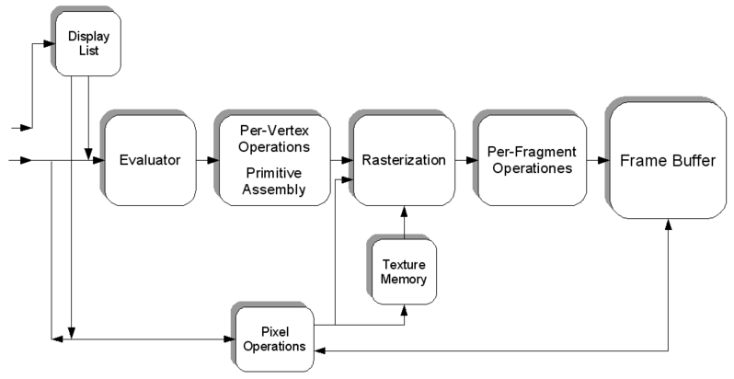

Figure 1.1 OpenGL Graphics Pipeline

A brief description of the process in the graphics pipeline could be:

1. Evaluation, if necessary, of the polynomial functions which define certain inputs, like NURBS surfaces, approximating curves and the surface geometry.

2. Vertex operations, transforming and lighting them depending on their material. Also clipping non visible parts of the scene in order to produce the viewing volume.

3. Rasterization or conversion of the previous information into pixels. The polygons are represented by the appropriate color by means of interpolation algorithms.

4.Per-fragment operations, like updating values depending on incoming and previously stored depth values, or color combinations, among others.

5. Lastly, fragments are inserted into the Frame buffer.

Most OpenGL commands either issue primitives to the graphics pipeline, or configure how the pipeline processes these primitives. OpenGL is a low-level, procedural API, requiring the programmer to dictate the exact steps required to render a scene. This contrasts with descriptive (aka scene graph or retained mode) APIs, where a programmer only needs to describe a scene and can let the library manage the details of rendering it. OpenGL's low-level design requires programmers to have a good knowledge of the graphics pipeline, but also gives a certain amount of freedom to implement novel rendering algorithms.

Fig 2.1 shows the organization of the libraries for an X Window System environment. For this window system, GLUT will use GLX and the X libraries. The application program, however, can use only GLUT functions and thus can be recompiled with the GLUT library for other window systems.

OpenGL application Program

GLU

GL

GLUT

GLX

Xlib, Xtk

Frame Buffer

**Fig 2.1 Library organization of OpenGL**

**1.4.1 Advantages of OpenGL**

**1. Industry standard**

An independent consortium, the OpenGL Architecture Review Board, guides the OpenGL specification. With broad industry support, OpenGL is the only truly open, vendor-neutral, multiplatform graphics standard.

**2. Stable**

OpenGL implementations have been available for more than seven years on a wide variety of platforms. Additions to the specification are well controlled, and proposed updates are announced in time for developers to adopt changes. Backward compatibility requirements ensure that existing applications do not become obsolete.

**3 .Reliable and portable**

All OpenGL applications produce consistent visual display results on any OpenGL API-compliant hardware, regardless of operating system or windowing system.

**4. Evolving**

Because of its thorough and forward-looking design, OpenGL allows new hardware innovations to be accessible through the API via the OpenGL extension mechanism. In this way, innovations appear in the API in a timely fashion, letting application developers and hardware vendors incorporate new features into their normal product release cycles.

**5. Scalable**

OpenGL API-based applications can run on systems ranging from consumer electronics to PCs, workstations, and supercomputers. As a result, applications can scale to any class of machine that the developer chooses to target.

**6. Easy to use**

OpenGL is well structured with an intuitive design and logical commands. Efficient OpenGL routines typically result in applications with fewer lines of code than those that make up programs generated using other graphics libraries or packages. In addition, OpenGL drivers encapsulate information about the underlying hardware, freeing the application developer from having to design for specific hardware features.

**7. Well-documented**

Numerous books have been published about OpenGL, and a great deal of sample code is readily available, making information about OpenGL inexpensive and easy to obtain.

* 1. **Problem Statement**

The problem statement is to digitalize India by the introduction of BULLET TRAIN for economy and growth in our country in comparison to other countries like China, Japan, France etc. So here we demonstrate the working model simulation of a Bullet train.

**1.5 Objective of the project**

* The interactive demo of Bullet Train.
* Graphical approach towards understanding the Bullet Train design.

**1.6 Organization of the Report**

Firstly we introduce computer graphics and its applications. Then we introduce various graphics concepts and the basic idea of the Project which includes the code and various functions used in OpenGL, and also deals with design and implementation inbuilt graphics functions and hardware and software requirement with results obtained and concludes the project and also mentions the future scope, at the end the references used for the project are listed.

**CHAPTER 2**

**SYSTEM SPECIFICATION**

System requirements are intended to communicate in precise way, the functions that the system must provide. To reduce ambiguity, they may be written in a structured form of natural language supplemented by tables and system models.

1. **Hardware and Software requirements:**

**2.1 Hardware Requirements:**

* Processor of 2.2G Hz or higher speed
* 20MB Hard Disk Space
* 1GB RAM
* Keyboard
* Mouse

**2.2 Software Requirements:**

* Microsoft Visual Studio 6.0
* Windows-98/XP/Vista/win7 Operating System
* MS-Office
* Graphics package available in Microsoft Visual Studio 6.0

**CHAPTER 3**

**ANALYSIS**

**3.1 Analysis**

The flow diagram represents the working of the project. The starts symbol indicates the beginning of execution. The display screen consists of an option to start the project, to know the details of control and quit the project which is done by keyboard. Once the project is started the animation will be displayed automatically and the keyboard event will provide the next slide as well as previous slides.The user manual which specifies all the options available is also displayed at the beginning.

**cHAPTER 4**

**DESIGN**

**4.1 Flow diagram**

**Flow diagram** is a collective term for a representing a or set of dynamic in a. The term flow diagram is also used as synonym of the flowchart and sometimes as counterpart of the flowchart.

**Introduction**

**4 – FRONT PART**

**2 –BULLET TRAIN**

**1 – SCENERY**

**5 – TUNNEL**

**Q - Exit**

Fig 4.1 Flow Diagram for Bullet Train Simulation

**4.2 Description of Flow Diagram**

* The flow of the program starts from the main function. The buffer memory is cleared, output screen size is fixed and the window is created.
* Then the display function calls the display function (display) is called. Based on the user input from the keyboard the next slide to be outputted is decided.
* Function display() is used to call all the slides based on the ‘1’,’2’,’3’or’4’.
* Functions scenery, bullet train, front and tunnel are used to draw the respective SLIDES.
* In order to provide motion for the object, idle function was used.

**cHAPTER 5**

**implementation**

**5.1 Graphic functions**

**5.1.1 void glBegin(glEnum mode);**

Initiates a new primitive of type mode and starts the collection of vertices. Values of mode include GL_POINTS, GL_LINES and GL_POLYGON.

**5.1.2 void glEnd( );**

Terminates a list of vertices.

**5.1.3 void glColor3f[ i f d ] (TYPE r, TYPE g, TYPE b);**

Sets the present RGB colors. Valid types are int ( i ), float ( f ) and double ( d ). The maximum and minimum values of the floating-point types are 1.0 and 0.0, respectively.

**5.1.4 void glClearColor(GLclampf r,GLclampf g,GLclampf b,GLclampf a);**

Sets the present RGBA clear color used when clearing the color buffer. Variables of GLclampf are floating-point numbers between 0.0 and 1.0.

**5.1.5 int glutCreateWindow(char *title);**

Creates a window on the display. The string title can be used to label the window. The return value provides a reference to the window that can be used where there are multiple windows.

**5.1.6 void glutInitWindowSize(int width, int height);**

Specifies the initial height and width of the window in pixels.

**5.1.7 void glutInitWindowPosition(int x, int y);**

Specifies the initial position of the top-left corner of the window in pixels.

**5.1.8 void glutInitDisplayMode(unsigned int mode);**

Request a display with the properties in mode. The value of mode is determined by the logical OR of operation including the color model (GLUT_RGB, GLUT_INDEX) and buffering (GLUT_SINGLE, GLUT_DOUBLE);

**5.1.9 void glFlush( );**

Forces any buffered any OpenGL commands to execute.

**5.1.10 void glutInit (int argc, char **argv);**

Initializes GLUT. The arguments from main are passed in and can be used by the application.

**5.1.11 void glutMainLoop( );**

Cause the program to enter an event processing loop. It should be the last statement in main.

**5.1.12 void glutDisplayFunc(void (*func) (void));**

Registers the display function func that is executed when the window needs to be redrawn.

**5.1.13 gluOrtho2D(GLdouble left, GLdouble right, GLdouble bottom, GLdouble top);**

Defines a two-dimensional viewing rectangle in the plane Z=0;

**5.1.14 void glClear(GL_COLOR_BUFFER_BIT);**

To make the screen solid and white.

**5.1.15 void MouseFunc(myMouse);**

It is used for the implementation of mouse interface.

Passing the control to

void myMouse(int button,int state,int x,int y);

**5.1.16 void KeyboardFunc(key);**

It is used for the implementation of keyboard interface.

Passing control to

void key(unsigned char key,int x,int y);

**5.1.17 void translate[fd](TYPE x,TYPE y,TYPE z);**

Alters the current matrix by displacement of (x,y,z).Type is either GLfloat or GLdouble.

**5.1.18 void glPushMatrix(); void glPopMatrix();**

Pushes to and pops from the matrix stack corresponding to current matrix mode.

**5.1.19 void glLoadMatrix[fd](TYPE *m);**

Loads the 16 element array of TYPE GLfloat or GLdouble as a current matrix.

**5.2 USER DEFINED FUNCTIONS**

**5.2.1 Keyboard Function**

void mykey(unsigned char key, int x, int y)

{

switch (key)

{

case'l':

case'L':reinit();

sceneid--;

break;

case'k':

case'K':reinit();

sceneid++;

break;

}

}

void menu(int id)

{

int n = 0;

while (n<1)

{

switch (id)

{

case 1:

st = (st + 1) % 2;//stop train

break;

case 2://nightmode

nig = (nig + 1) % 2;

break;

case 3:break;

case 4: exit(0);

break;

}

n++;

}

}

**5.2.2 Mouse Function**

void mouse(int btn, GLint state, GLint x, int y)

{

if (btn == GLUT_LEFT_BUTTON&&state == GLUT_DOWN)

printf("x=%d y = %d", x, y);

}

**5.2.3 Display Function**

void display()

{

glClear(GL_COLOR_BUFFER_BIT);

switch (sceneid)

{

case 0: scene0();

break;

case 1: scene1();

break;

case 2: scene2();

break;

case 3: scene3();

break;

case 4: scene4();

break;

}

glutSwapBuffers();

}

**5.2.4 Init Function**

void myinit()

{

glClearColor(1.0, 1.0, 1.0, 1.0);

glClear(GL_COLOR_BUFFER_BIT);

glColor3f(1.0, 0.0, 0.0);

glMatrixMode(GL_PROJECTION);

glLoadIdentity();

gluOrtho2D(0, 499, 0, 499);

}

**5.2.5 Train and Other Functions**

void train(int x)

{

int y;

if(sceneid==3||sceneid==4)

y=50;

else

y=150;

glColor3ub(240, 240, 241);

circle(0, 360, x, y + 15, 15);

glBegin(GL_POLYGON); //MOVING TRAIN // ENGINE //

glColor3ub(240, 240, 241);

glVertex2f(x, y);

glVertex2f(x + 165, y);

glVertex2f(x + 165, y + 100);

glVertex2f(x + 25, y + 100);

glVertex2f(x, y + 50);

glEnd();

glBegin(GL_LINES);

glVertex2f(x + 5, y + 30);

glVertex2f(x - 5, y + 40);

glEnd();

glBegin(GL_POLYGON); //COACH 1//

glColor3ub(240, 240, 241);

glVertex2f(x + 175, y);

glVertex2f(x + 282, y);

glVertex2f(x + 282, y + 100);

glVertex2f(x + 175, y + 100);

glEnd();

glColor3f(0.0, 0.0, 1.0);

glBegin(GL_POLYGON); //COACH 1 WINDOW //

glColor3f(0, 1, 1);

glVertex2f(x + 245, y + 60);

glVertex2f(x + 270, y + 60);

glVertex2f(x + 270, y + 85);

glVertex2f(x + 245, y + 85);

glEnd();

glBegin(GL_POLYGON); //ENGINE WINDOW //

glColor3f(0, 1, 1);

glVertex2f(x + 25, y + 50);

glVertex2f(x + 50, y + 50);

glVertex2f(x + 50, y + 85);

glVertex2f(x + 25, y + 85);

glEnd();

glColor3ub(0, 0, 0); //bogey

glBegin(GL_POLYGON);

glVertex2f(x + 165, y + 5);

glVertex2f(x + 175, y + 5);

glVertex2f(x + 175, y + 95);

glVertex2f(x + 165, y + 95);

glEnd();

glBegin(GL_POLYGON); //COACH 2

glColor3ub(240, 240, 241);

glVertex2f(x + 293, y);

glVertex2f(x + 400, y);

glVertex2f(x + 400, y + 100);

glVertex2f(x + 293, y + 100);

glEnd();

glBegin(GL_POLYGON); //COACH2 WINDOW

glColor3f(0, 1, 1);

glVertex2f(x + 340, y + 60);

glVertex2f(x + 365, y + 60);

glVertex2f(x + 365, y + 85);

glVertex2f(x + 340, y + 85);

glEnd();

glBegin(GL_POLYGON); //DOOR 1//

glColor3f(0.8, 0.78, 0.78);

glVertex2f(x + 180, y + 20);

glVertex2f(x + 200, y + 20);

glVertex2f(x + 200, y + 70);

glVertex2f(x + 180, y + 70);

glEnd();

glBegin(GL_POLYGON); //DOOR 2//

glColor3f(0.8, 0.78, 0.78);

glVertex2f(x + 300, y + 20);

glVertex2f(x + 320, y + 20);

glVertex2f(x + 320, y + 70);

glVertex2f(x + 300, y + 70);

glEnd();

}

void electricwire()

{

int y;

if(sceneid==2||sceneid==3)

y=200;

else

y=300;

glLineWidth(2);

glBegin(GL_LINES);

glColor3f(0, 0, 0);

glVertex2f(-1000, y);

glVertex2f(5000, y);

glEnd();

glBegin(GL_LINES);

glColor3f(0, 0, 0);

glVertex2f(-1000, y+30);

glVertex2f(5000, y+30);

glEnd();

}

void track()

{

int y;

if(sceneid==2||sceneid==3)

y=35;

else

y=135;

glLineWidth(2);

glBegin(GL_LINES);

glColor3f(0, 0, 0);

glVertex2f(-1000, y);

glVertex2f(5000, y);

glEnd();

glBegin(GL_LINES);

glColor3f(0, 0, 0);

glVertex2f(-1000, y+10);

glVertex2f(5000, y+10);

glEnd();

glPointSize(8);

glBegin(GL_LINES);

glColor3f(0, 0, 0);

for (i = -3000; i <= 5000; i = i + 10)

{

glVertex2f(i, y);

glVertex2f(i, y+10);

}

glEnd();

}

void sky()

{

if (nig == 0)

{

glBegin(GL_POLYGON);

glColor3f(0.4, 0.6, 1);

glVertex2f(0, 230);

glVertex2f(0, 700);

glVertex2f(700, 700);

glVertex2f(700, 230);

glEnd();

int l;

glColor3f(1.0, 1.0, 0.0); //SUN

for (l = 0; l <= 35; l++)

{

circle_draw(100 + sun, 450, l);

}

}

void road()

{

glColor3f(0.2, 0.7, 0.3); //road

glBegin(GL_POLYGON);

glVertex2f(0, 200);

glVertex2f(0, 12);

glVertex2f(10000, 12);

glVertex2f(10000, 200);

glEnd();

glColor3f(0.3, 0.5, 0.2); //lower road

glBegin(GL_POLYGON);

glVertex2f(550, 180);

glVertex2f(600, 180);

glVertex2f(600, 280);

glVertex2f(550, 280);

glEnd();

for (i = -3000; i <= 5000; i = i + 20)

{

glVertex2f(i + 5, 200);

glVertex2f(i + 10, 230);

}

glEnd();

glColor3f(0.0, 0.0, 0.0);

glRasterPos3f(320,190,0);

cityname("Bangalore");

glRasterPos3f(320,170,0);

cityname("City Jn.");

glColor3ub(200, 233, 240); //poles

glBegin(GL_POLYGON);

glVertex2f(25, 25);

glVertex2f(25, 280);

glVertex2f(35, 280);

glVertex2f(35, 25);

glEnd();

glLineWidth(0.5);

glColor3f(0.0, 0.0, 0.0);

glLineWidth(5);

glBegin(GL_LINES);

glVertex2f(35, 275);

glVertex2f(65, 230);

glEnd();

glBegin(GL_LINES);

glVertex2f(35, 230);

glVertex2f(65, 230);

glEnd();

glBegin(GL_LINES);

glVertex2f(35, 230);

glVertex2f(65, 200);

glEnd();

}

void overhead()

{

int y;

if(sceneid==2||sceneid==3)

y=200;

else

y=300;

glLineWidth(1);

glColor3f(0, 0, 0);

glVertex2f(0, y);

glVertex2f(1000, y);

glEnd();

glBegin(GL_LINES);

glColor3f(0, 0, 0);

glVertex2f(0, y+30);

glVertex2f(10000, y+30);

glEnd();

}

void hill()

{

glColor3f(0.5f, 0.3f, 0.0f);

glBegin(GL_TRIANGLE_STRIP);

glVertex2f(100, 400);

glVertex2f(280, 230);

glVertex2f(0, 230);

glEnd();

}

void scene1()

{

glClearColor(0.0, 0.0, 0.0, 0.0);

glClear(GL_COLOR_BUFFER_BIT);

glFlush();

}

void scene2()

{

glClearColor(1.0, 1.0, 1.0, 1.0);

glClear(GL_COLOR_BUFFER_BIT);

sky();

hill();

electricwire();

road();

track();

overhead();

glFlush();

}

void scene3()

{

glPushMatrix();

sky();

hill();

electricwire();

road();

track();

overhead();

glColor3f(1.0, 0.0, 0.0);

glPointSize(3.0);

if (!st)

glTranslated(-xx, 0, 0);

train(50);

train(750);

train(1450);

train(2150);

train(2850);

glColor3f(0.0, 0.0, 0.0);

glPopMatrix();

}

void scene4()

{

int l;

glClearColor(0.4, 0.6, 1,1.0);

glClear(GL_COLOR_BUFFER_BIT);

glColor3f(0.0,0.0,0.0); //cable

glLineWidth(4);

glBegin(GL_LINE_LOOP);

glVertex2f(250,200);

glVertex2f(200,200);

glVertex2f(400,700);

glVertex2f(450,700);

glEnd();

glLineWidth(2);

glBegin(GL_LINES);

glVertex2f(257,343);

glVertex2f(307,341);

glEnd();

glColor3f(0.2, 0.7, 0.3); //land

glBegin(GL_POLYGON);

glVertex2f(0,0);

glVertex2f(700,0);

glVertex2f(700,100);

glVertex2f(0,100);

glEnd();

glColor3f(0.5,0.3,0.0); //side track

glBegin(GL_POLYGON);

glVertex2f(180,100);

glVertex2f(140,0);

glVertex2f(370,0);

glVertex2f(310,100);

glEnd();

glColor3f(1,1,1);

glColor3f(0.0,0.0,0.0);

glLineWidth(4);

glBegin(GL_LINE_LOOP);//track

glVertex2f(240,100);

glVertex2f(200,0);

glVertex2f(300,0);

glVertex2f(260,100);

glEnd();

glColor3f(0.0,0.0,0.0); //top part

glBegin(GL_POLYGON);

glVertex2f(240,260);

glVertex2f(240,280);

glVertex2f(260,280);

glVertex2f(260,260);

glEnd();

glLineWidth(2);

glBegin(GL_LINE_LOOP);

glVertex2f(252,280);

glVertex2f(257,343);

glVertex2f(307,341);

glEnd();

glColor3ub(240, 240, 241); //body

glBegin(GL_POLYGON);

glVertex2f(230,100);

glVertex2f(180,170);

glVertex2f(180,220);

glVertex2f(180,250);

glVertex2f(250,265);

glVertex2f(315,250);

glVertex2f(315,220);

glVertex2f(315,170);

glVertex2f(270,100);

glEnd();

glColor3ub(225, 230, 225); //nose

for(l=0;l<25;l++)

circle_draw(250,110,l);

glColor3ub(50,50,50); //lights

glBegin(GL_POLYGON);

glVertex2f(215,100);

glVertex2f(205,100);

glVertex2f(195,120);

glVertex2f(205,120);

glEnd();

glBegin(GL_POLYGON);

glVertex2f(295,100);

glVertex2f(285,100);

glVertex2f(295,120);

glVertex2f(305,120);

glEnd();

glColor3f(1.0,1.0,0.0);

for(l=0;l<4;l++)

{

circle_draw(208,105,l);

circle_draw(292,105,l);

}

glColor3f(0, 1, 1);

glBegin(GL_POLYGON); //windows

glVertex2f(185,190);

glVertex2f(185,240);

glVertex2f(310,240);

glVertex2f(310,190);

glEnd();

glLineWidth(3);

glColor3ub(240, 240, 241);

glBegin(GL_LINES);

glVertex2f(247,190);

glVertex2f(247,240);

glEnd();

glColor3f(0.0,0.0,1.0);

glBegin(GL_LINES);

glVertex2f(200,140);

glVertex2f(297,140);

glEnd();

glBegin(GL_LINES);

glVertex2f(197,145);

glVertex2f(300,145);

glEnd();

glColor3ub(200, 233, 240); //polef

glBegin(GL_POLYGON);

glVertex2f(120,50);

glVertex2f(140,50);

glVertex2f(140,380);

glEnd();

glColor3f(0.0,0.0,0.0);

glBegin(GL_LINES);

glVertex2f(140,320);

glVertex2f(295,310);

glEnd();

}

**CHAPTER 6**

**TESTING**

* **Unit Testing**
* Individual components are tested to ensure that they operate correctly. Each component is tested independently, without other system components.
* **Module Testing**
* A module is a collection of dependent components such as a object class, an abstract datatype or some looser collection of procedures and functions. A module related components, so can be tested without other system modules.
* **System Testing**
* This is concerned with finding errors that result from unanticipated interaction between sub-system interface problems.
* **Acceptance Testing**
* The system is tested with data supplied by the system customer rather than simulated test data.

**CHAPTER 7**

**SNAPSHOTS**

Illustrates the scenes of **BULLET TRAIN**

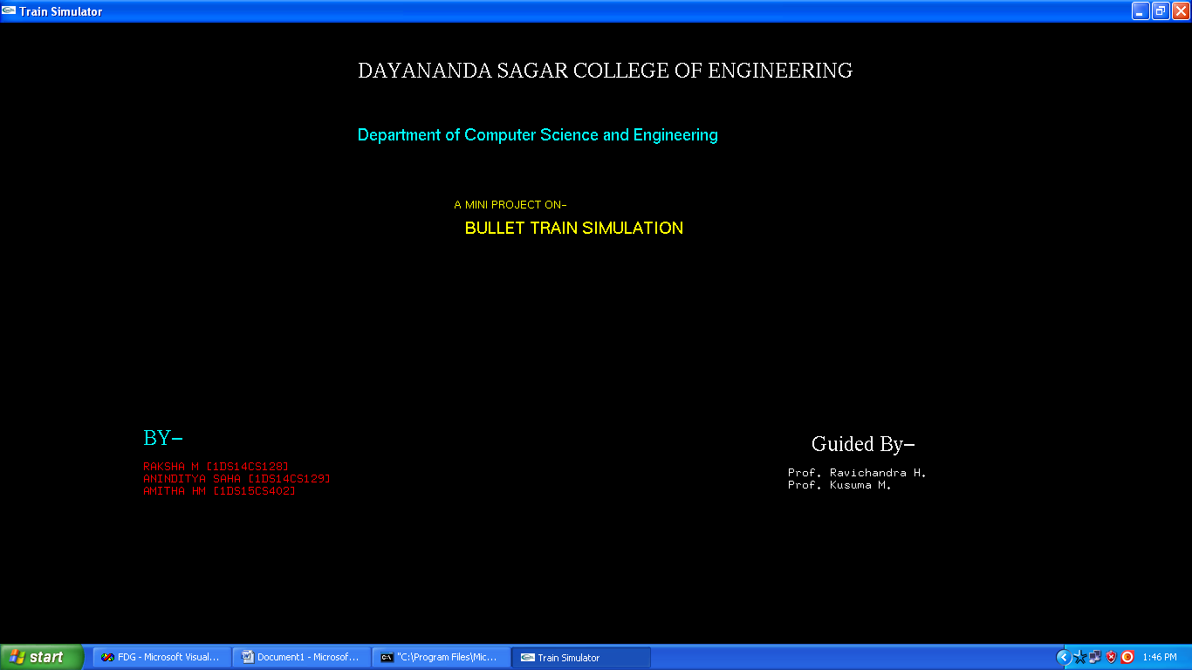

Fig 7.1 Introductory part of the project

It is the introduction scene to the project. When the user loads the Bullet rain project the above scene will be displayed and then we need to press k to start the project.

* Press ‘k’ to go to next scene
* Press ‘l’ to go to previous scene
* Press ‘q’ to Exit

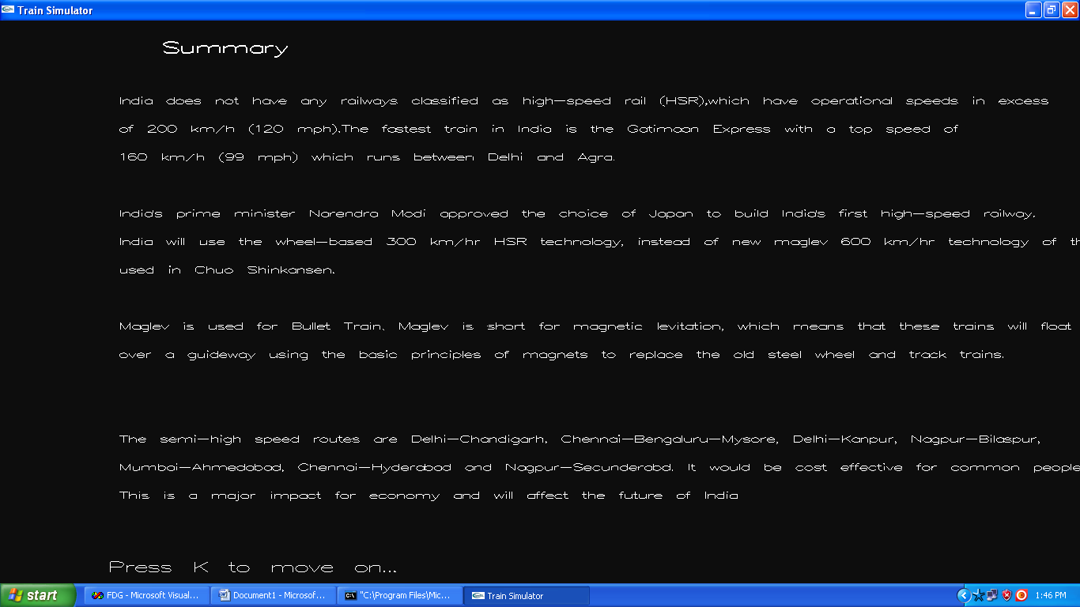

Fig 7.2 Brief description about Bullet Train

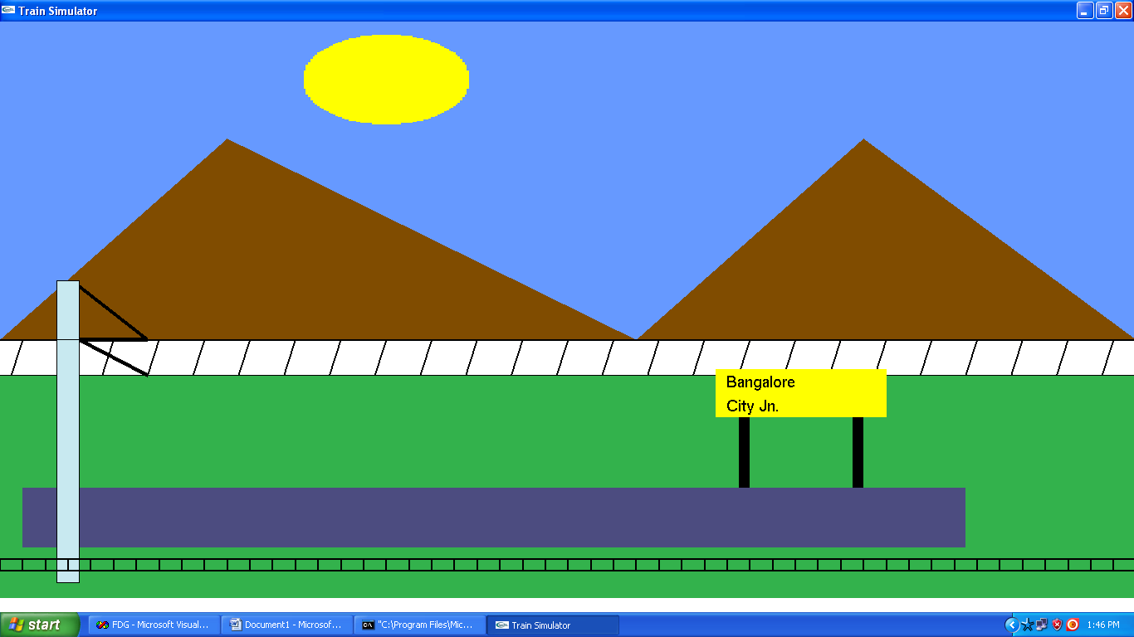

Fig 7.3 Train Station

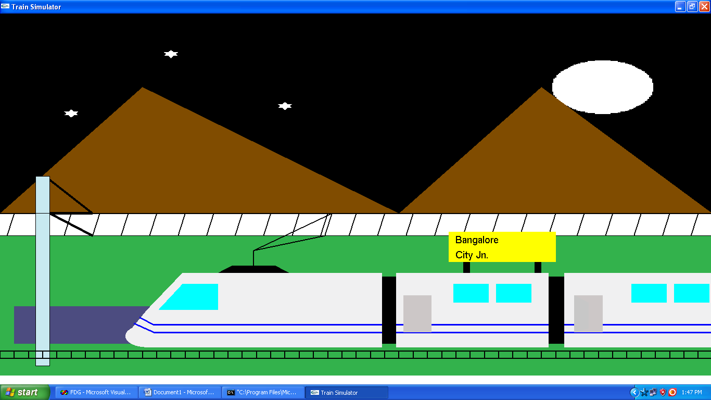

Fig 7.4 Simulation of Bullet Train

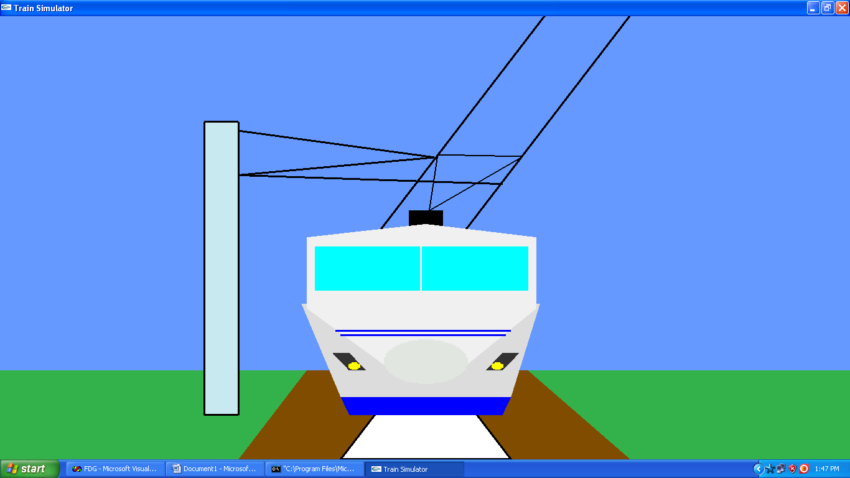

Fig 7.5 Front part of the Bullet Train

. 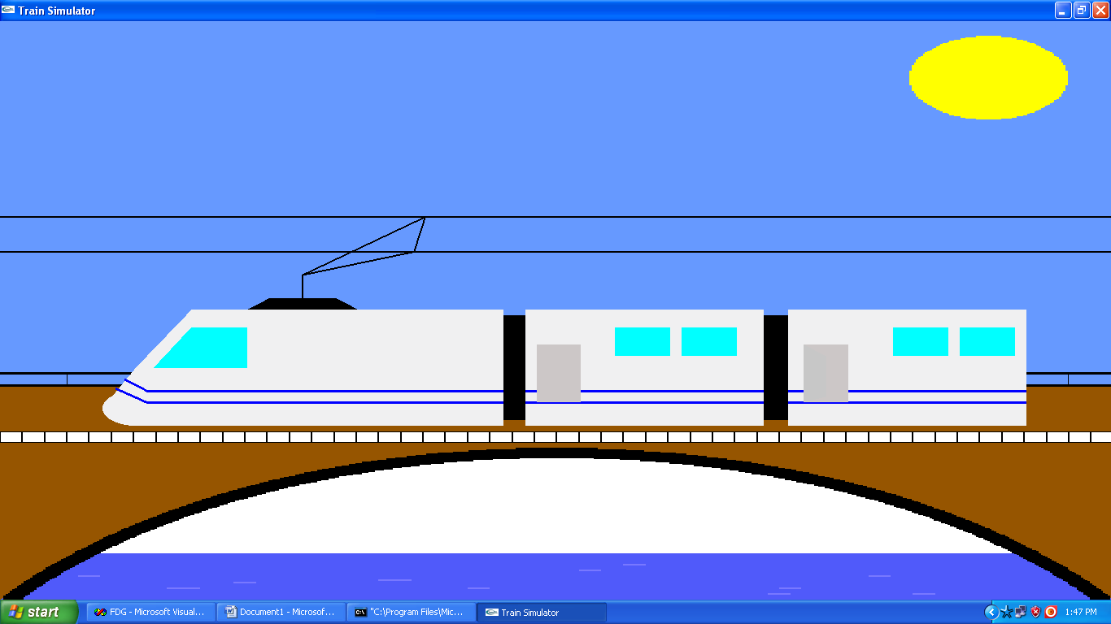

Fig 7.6 Train moving over a Suspension bridge

**CHAPTER 8**

**CONCLUSION**

As specified by the problem statement we have designed a working model for the simulation of the Bullet Train as expected, without the concept of wheels, and with the use of magnetic energy the train is able to reach at high speeds without any hindrance.

**FUTURE ENHANCEMENTS**

In addition to OpenGL code that we have used in the project for the simulation of bullet train, we can add the following features

1. We can include a signal for moving and stopping of the train.
2. Since a bullet train operates more than 300 miles per hour, we can increase the speed of the train in order to make it more better than other trains.

**APPENDIX – 1**

* Initially user needs to install the Microsoft visual C++ 6.0 version.
* Then he has to create the a new project which is of win 32 console application format so the creation must be done as shown below :

File🡪New 🡪 In projects menu select win32 console application 🡪 Give appropriate name to the project 🡪 Finish. This creates the new project.

* Then insert a new class as follows

Insert 🡪 New class 🡪Give appropriate name 🡪0k

* Select the file view and the click on the source name file 🡪Source files 🡪 source filename.cpp then paste the file into the workspace.
* Compile the code by Build🡪Compile
* Link the object file by selecting Build🡪 Build filename.exe
* Execute the filename,exe file by Build🡪 execute filename.exe

**APPENDIX - 2**

**9.1 Manual**

* Press ‘k’ to go to next scene
* Press ‘l’ to go to previous scene
* Press ‘q’ to Exit

**BIBLIOGRAPHY**

**Books referred**

1. Edward Angel -Interactive Computer Graphics A Top-Down Approach with OpenGL, 5th Edition, Addison-Wesley, 2008.
2. F. S. Hill - Computer Graphics Using OpenGL – 2nd Edition, Pearson Education, 2001.