

**DIGITAL ASSIGNMENT 2 [backtracking AND DYNAMIC PROGRAMMING]**

**CSE2012–DESIGN AND ANALYSIS OF ALGORITHMS (L25-26)[MRS GAYATHRI P]**



**FEBURARY 10, 2023**

**ANIRUDH VADERA**

**20BCE2940**

**QUESTION 1:**

**Design an algorithm and implement matrix chain multiplication problem using dynamic programming approach.**

**PSEUDOCODE:**

**Algorithm:**

The basic idea behind dynamic programming for matrix chain multiplication is to build a table or array that stores the optimal cost of multiplying each subchain of matrices. The table is filled in a bottom-up manner, starting with subchains of length 2 and gradually building up to the full chain of matrices.

At each step, we consider all possible ways to split the subchain into two smaller subchains, compute the cost of multiplying each smaller subchain, and then add the cost of multiplying the resulting two matrices. We then choose the split that yields the minimum cost and store that cost in the table.

By storing the optimal costs of each subchain, we can avoid computing the same subproblem multiple times and thus achieve a more efficient solution.

We can start filling up the array dp with base cases, where dp[i][i] equals zero since there is no multiplication involved for a single matrix.

* Iterate from **l = 2 to N-1** which denotes the length of the range:
* Iterate from **i = 0 to N-1**:
* Find the right end of the range (**j**) having **l** matrices.
* Iterate from **k = i+1 to j** which denotes the point of partition.
  + Multiply the matrices in range (**i, k**) and (**k, j**).
  + This will create two matrices with dimensions **arr[i-1]*arr[k]** and **arr[k]*arr[j]**.
  + The number of multiplications to be performed to multiply these two matrices (say **X**) are **arr[i-1]*arr[k]*arr[j]**.
  + The total number of multiplications is **dp[i][k]+ dp[k+1][j] + X**.
* The value stored at **dp[1][N-1]** is the required answer.

**Time Complexity:** O(N3 )  
**Auxiliary Space:**O(N2)

**SOURCE CODE:**

#include <bits/stdc++.h>

#include <algorithm>

using namespace std;

// Driver Code

int main()

{

    cout << "Enter the Number of Elements of the dimension array : ";

    int n;

    cin >> n;

    int *arr = (int *)malloc(n * sizeof(int));

    cout << "Enter the elements of the dimension array : "

         << "\n";

    for (int i = 0; i < n; i++)

    {

        cout << "Element "

             << i << " : ";

        cin >> arr[i];

    }

    // Main Logic

    /* One extra row and one extra column are

    allocated in dp[][]. 0th row and 0th

    column of dp[][] are not used */

    // The DP matrix -> Used for memoization

    int dp[n][n];

    int i, j, k, L;

    /* dp[i, j] = Minimum number of scalar

    multiplications needed to compute the

    matrix A[i]A[i+1]...A[j] = A[i..j] where

    dimension of A[i] is arr[i-1] x arr[i] */

    // arr is the given dimension array

    // cost is zero when multiplying

    // one matrix.

    for (i = 1; i < n; i++)

    {

        dp[i][i] = 0;

    }

    // L is chain length.

    for (L = 2; L < n; L++)

    {

        for (i = 1; i < n - L + 1; i++)

        {

            j = i + L - 1;

            // Initialize with a very high value so that we can find minimum

            dp[i][j] = INT_MAX;

            for (k = i; k <= j - 1; k++)

            {

                dp[i][j] = std::min(dp[i][j], dp[i][k] + dp[k + 1][j] + arr[i - 1] * arr[k] * arr[j]);

            }

        }

    }

    cout << "Minimum number of multiplications is : " << dp[1][n - 1];

    getchar();

    return 0;

}

**OUTPUT SCREENSHOT:**

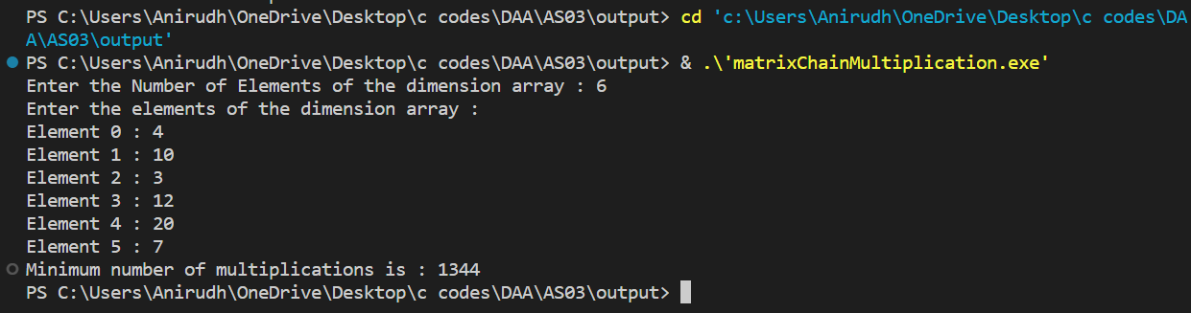

**QUESTION 2:**

**Implement N-Queens problem using backtracking technique.**

**PSEUDOCODE:**

The idea is to place queens one by one in different columns, starting from the leftmost column. When we place a queen in a column, we check for clashes with already placed queens. In the current column, if we find a row for which there is no clash, we mark this row and column as part of the solution. If we do not find such a row due to clashes, then we backtrack and return false.

* Place the queens col­umn wise, start from the left most column
* If all queens are placed:  
   return true and print the solu­tion matrix.  
   Else  
   Try all the rows in the cur­rent column.
* Check if queen can be placed here safely if yes mark the cur­rent cell in solu­tion matrix as 1 and try to solve the rest of the prob­lem recursively.
* If plac­ing the queen in above step leads to the solu­tion return true.
* If plac­ing the queen in above step does not lead to the solu­tion , BACKTRACK, mark the cur­rent cell in solu­tion matrix as 0 and return false.
* If all the rows are tried and noth­ing worked, return false and print NO SOLUTION.

**Time Complexity:** O(N!)  
**Auxiliary Space:** O(N2)

**SOURCE CODE:**

#include <stdio.h>

#include <math.h>

// Stores the number of Solutions

int count = 0;

// Printing the solution

void print(int n, int **board)

{

    printf("\n\nSolution %d:\n\n", ++count);

    for (int i = 1; i <= n; i++)

    {

        printf("\t%d", i);

    }

    for (int i = 1; i <= n; i++)

    {

        printf("\n\n%d", i);

        for (int j = 1; j <= n; ++j)

        {

            if (board[i] == j)

            {

                printf("\tQ");

            }

            else

            {

                printf("\t-");

            }

        }

    }

}

// function to check for proper positioning of queen

void queen(int *board, int row, int n)

{

    int column;

    for (column = 1; column <= n; ++column)

    {

        if (place(board, row, column))

        {

            board[row] = column; // no conflicts so place queen

            if (row == n)

            {

                print(n, board); // printing the board configuration

            }

            else

            {

                queen(board, row + 1, n); // try queen with next position

            }

        }

    }

}

int main()

{

    int n;

    printf("\n\nEnter number of Queens:");

    scanf("%d", &n);

    // Creating the baord

    int *board = (int *)malloc(n * sizeof(int));

    queen(board, 1, n);

    return 0;

}

/*funtion to check conflicts

If no conflict for desired postion returns 1 otherwise returns 0*/

int place(int *board, int row, int column)

{

    for (int i = 1; i <= row - 1; ++i)

    {

        // checking column and digonal conflicts

        if (board[i] == column)

        {

            return 0;

        }

        else if (abs(board[i] - column) == abs(i - row))

        {

            return 0;

        }

    }

    return 1; // no conflicts

}

**OUTPUT SCREENSHOT:**

**For 3 queens No Solutions Possible:**

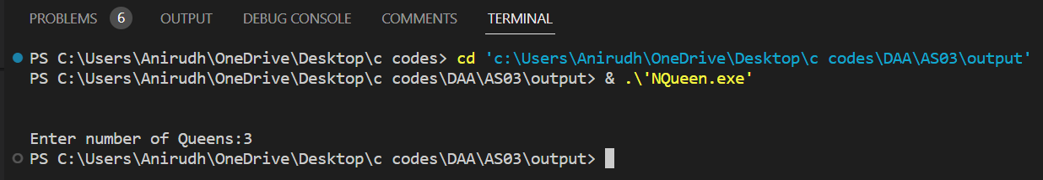

**For 1 queens (1 Solution Possible):**

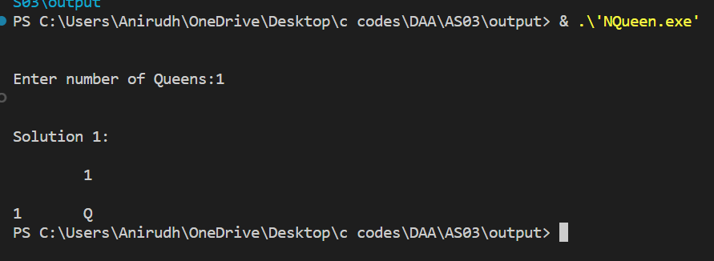

**For 6 queens (4 Solution Possible):**

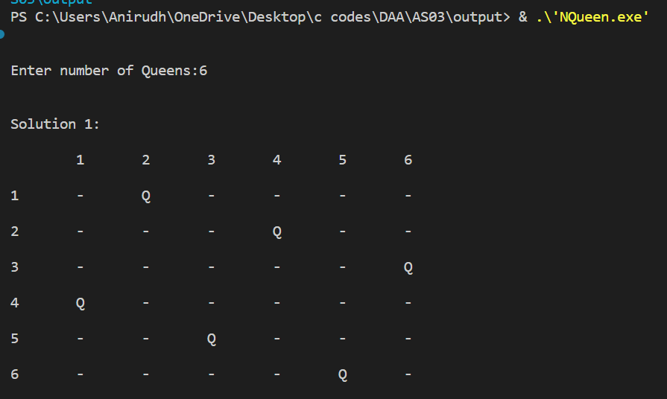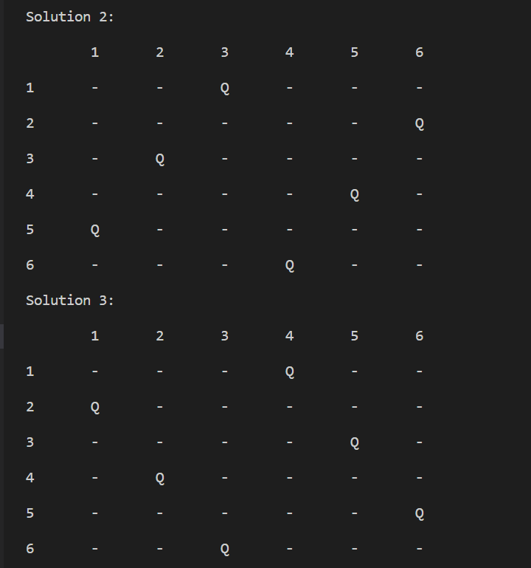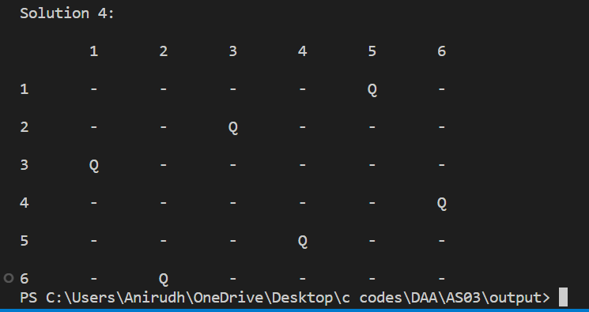

**QUESTION 3:**

**Design an algorithm using Naïve approach to check whether given pattern P is plagiarized in given Text T.**

**PSEUDOCODE:**

**Inputs:**

Text (string)

Pattern (string)

**Output:**

List of starting positions of the pattern in the text

Initialize an empty list to store the starting positions of the pattern in the text.

Calculate the length of the text and the pattern.

Loop through the text from 0 to n - m, where n is the length of the text and m is the length of the pattern.

For each index i in the loop, compare the pattern with the substring of the text starting at index i and having length m.

If the substring and the pattern are identical, add the index i to the list of starting positions.

Continue the loop until all possible substrings of the text have been compared with the pattern.

Return the list of starting positions.

**Algorithm-NAVE_STRING_MATCHING (T, P)**

**for i←0 to n-m do**

**if P[1......m] == T[i+1.....i+m] then**

**print "Match Found"**

**end if**

**end**

Time Complexity = **O(m* (n-m))**

**SOURCE CODE:**

#include <bits/stdc++.h>

using namespace std;

// Driver's Code

int main()

{

    int l1, l2;

    cout << "Enter the length of the Text : ";

    cin >> l1;

    char *text = (char *)malloc(l1 * sizeof(char));

    cout << "Enter the Text : ";

    cin >> text;

    cout << "Enter the length of the Pattern : ";

    cin >> l2;

    char *pattern = (char *)malloc(l2 * sizeof(char));

    cout << "Enter the Pattern : ";

    cin >> pattern;

    /* A loop to slide pat[] one by one */

    int f = 0;

    for (int i = 0; i <= l1 - l2; i++)

    {

        int j;

        /* Check for pattern starting from index i */

        for (j = 0; j < l2; j++)

        {

            if (text[i + j] != pattern[j])

            {

                break;

            }

        }

        if (j == l2) // if we found a match

        {

            f = 1;

            cout << "Pattern found at index : " << i << endl;

        }

    }

    if (f == 0)

    {

        cout << "The pattern is not in given Text";

    }

    return 0;

}

**OUTPUT SCREENSHOT:**

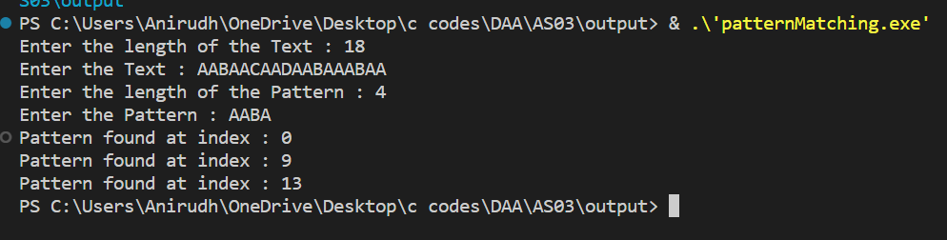

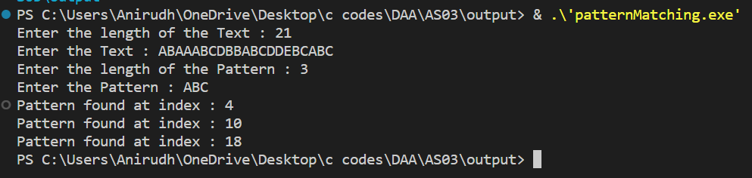

**Pattern Not in Text:**

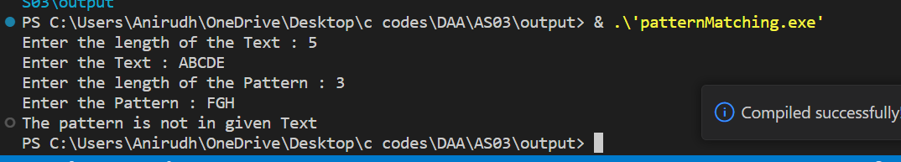

**QUESTION 4:**

**Implement Rabin Karp algorithm to check whether given pattern P is plagiarized in given Text T.**

**PSEUDOCODE:**

The Rabin-Karp algorithm uses the hash values of the pattern and the text to quickly compare substrings. If the hash values match, the algorithm compares the actual substrings to ensure a match. If the hash values do not match, the algorithm uses a rolling hash function to compute the hash value for the next substring. This approach can be more efficient than traditional pattern matching algorithms for large texts and patterns, where computing the hash values is faster than comparing all substrings.

Input: A text string T and a pattern string P.

1. Compute the hash value H(P) for the pattern string P.
2. Compute the hash value H(T[0..m-1]) for the first m characters of the text string T, where m is the length of the pattern string P.
3. For i = 0 to n-m do the following:

a. If H(P) = H(T[i..i+m-1]), then compare each character of P with the corresponding character of T[i..i+m-1]. If all characters match, then the pattern P is found at position i in the text string T.

b. If H(P) != H(T[i..i+m-1]), then compute the hash value H(T[i+1..i+m]) for the next m characters of the text string T using the rolling hash function.

c. Repeat step 3a and 3b until a match is found or all possible positions in the text string T have been checked.

1. If the pattern P is not found in the text string T, return "Pattern not found". Otherwise, return the position(s) in T where the pattern occurs.

**Time Complexity:**

Best/Average Case: O(n+m)

Worst Case: O(nm)

**Auxiliary Space:**O(1)

**SOURCE CODE:**

#include <bits/stdc++.h>

using namespace std;

#define d 10 // any arbitary value

void rabinKarp(char *pattern, char *text, int q, int l1, int l2)

{

    int p = 0;

    int t = 0;

    int h = 1; // hash value

    int j;     // Looping varaible

    int f = 0; // Flag variable

    for (int i = 0; i < l2 - 1; i++)

    {

        h = (h * d) % q;

    }

    // Calculate hash value for pattern and text

    for (int i = 0; i < l2; i++)

    {

        p = (d * p + pattern[i]) % q;

        t = (d * t + text[i]) % q;

    }

    for (int i = 0; i <= l1 - l2; i++)

    {

        if (p == t)

        {

            for (j = 0; j < l2; j++)

            {

                if (text[i + j] != pattern[j])

                    break;

            }

            if (j == l2) // The match is found

            {

                f = 1;

                printf("Pattern is found at index:  %d \n", i);

            }

        }

        if (i < l1 - l2)

        {

            t = (d * (t - text[i] * h) + text[i + l2]) % q;

            if (t < 0)

            {

                t = (t + q);

            }

        }

    }

    if (f == 0)

    {

        printf("The pattern is not in given Text");

    }

}

int main()

{

    int l1, l2;

    cout << "Enter the length of the Text : ";

    cin >> l1;

    char *text = (char *)malloc(l1 * sizeof(char));

    cout << "Enter the Text : ";

    cin >> text;

    cout << "Enter the length of the Pattern : ";

    cin >> l2;

    char *pattern = (char *)malloc(l2 * sizeof(char));

    cout << "Enter the Pattern : ";

    cin >> pattern;

    int q = 13;

    rabinKarp(pattern, text, q, l1, l2);

}

**OUTPUT SCREENSHOT:**

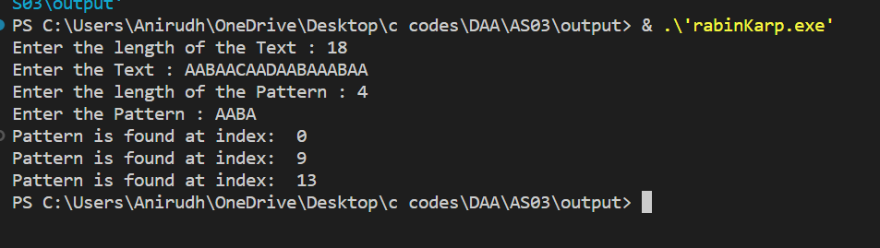

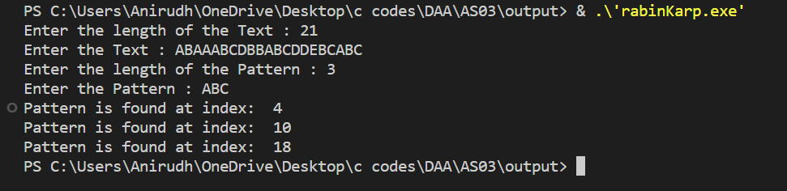

**Pattern Not in Text:**

