

**(DIGITAL ASSIGNMENT - 2) CLASSES AND OBJECTS**

**CSE1007(JAVA PROGRAMMING)LAB:L31-L32**



**FEBURARY 20, 2022**

**ANIRUDH VADERA**

**20BCE2940**

**ACTIVITY – 4:**

**QUESTION 1:**

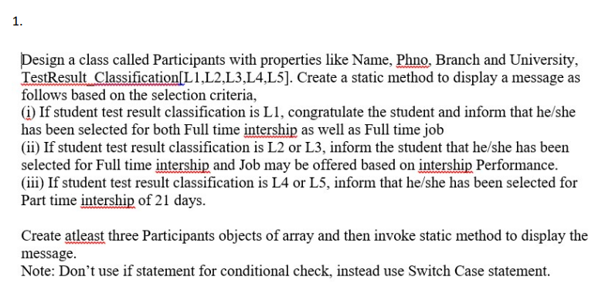

**CODE:**

import java.util.Scanner;

public class Participants {

    String Name;

    int Phno;

    String Branch;

    String University;

    static String[] TestResultClassification;

    Participants(String Name, int Phno, String Branch, String University) {

        this.Name = Name;

        this.Phno = Phno;

        this.Branch = Branch;

        this.University = University;

    }

    static void display(Participants[] Participant_array) {

        for (int i = 0; i < TestResultClassification.length; i++) {

            System.out.println("The result of student " + Participant_array[i].Name + " is : ");

            switch (TestResultClassification[i]) {

                case "L1":

                    System.out.println("Congratulations You have been selected for both Internship and Full Time Job");

                    break;

                case "L2":

                    System.out.println(

                            "You have been selected for Internship and based on the performance in Internship program you will be offered Full Time Job");

                    break;

                case "L3":

                    System.out.println(

                            "You have been selected for Internship and based on the performance in Internship program you will be offered Full Time Job");

                    break;

                case "L4":

                    System.out.println("You have been selected for Part Time Internship for 21 days");

                    break;

                case "L5":

                    System.out.println("You have been selected for Part Time Internship for 21 days");

                    break;

            }

        }

    }

    public static void main(String[] args) {

        Scanner in = new Scanner(System.in);

        int n;

        System.out.println("Enter the number of Participants : ");

        n = in.nextInt();

        Participants[] array_object = new Participants[n];

        System.out.println("Enter the Participants Details: ");

        in.nextLine();

        String[] TestResultClassification = new String[n];

        for (int i = 0; i < n; i++) {

            System.out.println("Participant : " + (i + 1));

            System.out.print("Name : ");

            String Name = in.nextLine();

            System.out.print("Phno : ");

            int Phno = in.nextInt();

            in.nextLine();

            System.out.print("Branch : ");

            String Branch = in.nextLine();

            System.out.print("University : ");

            String University = in.nextLine();

            System.out.print("TestResultClassification : ");

            TestResultClassification[i] = in.nextLine();

            array_object[i] = new Participants(Name, Phno, Branch, University);

        }

        Participants.TestResultClassification = TestResultClassification;

        System.out.println();

        System.out.println("ANIRUDH VADERA (20BCE2940)");

        Participants.display(array_object);

        in.close();

    }

}

**CODE SNAPSHOT:**

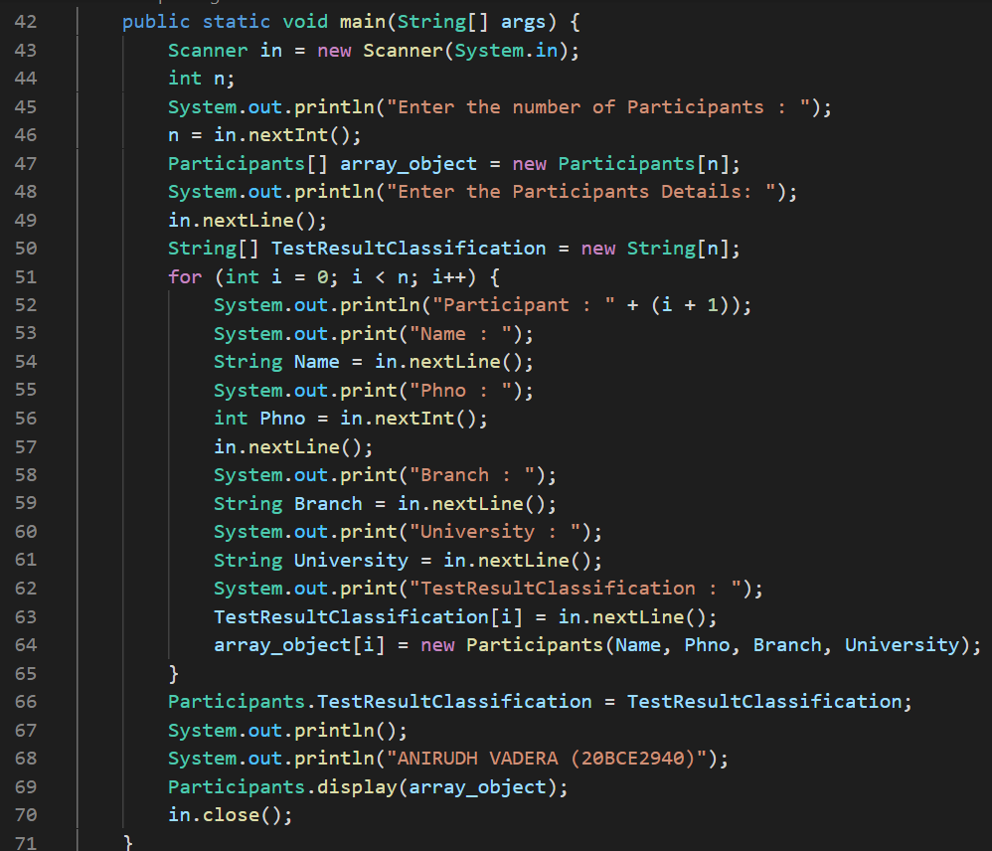

**OUTPUT:**

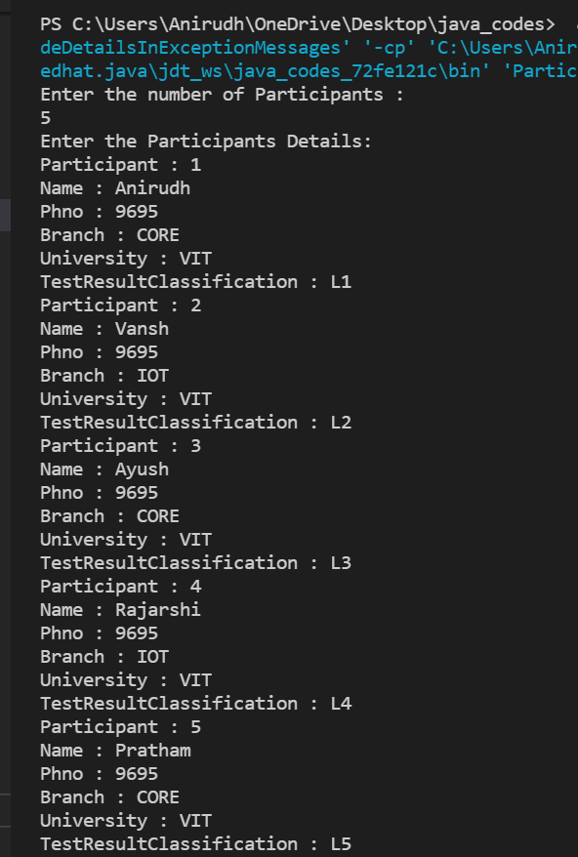

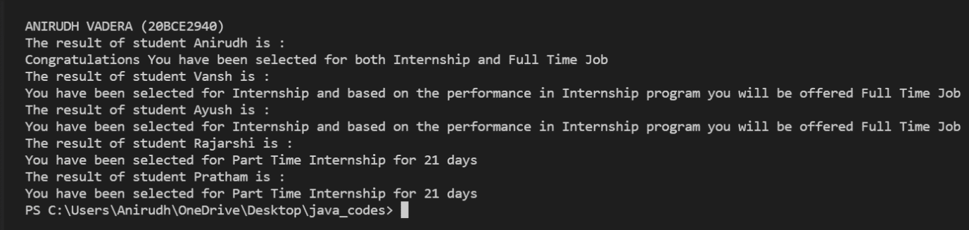

**QUESTION 2:**

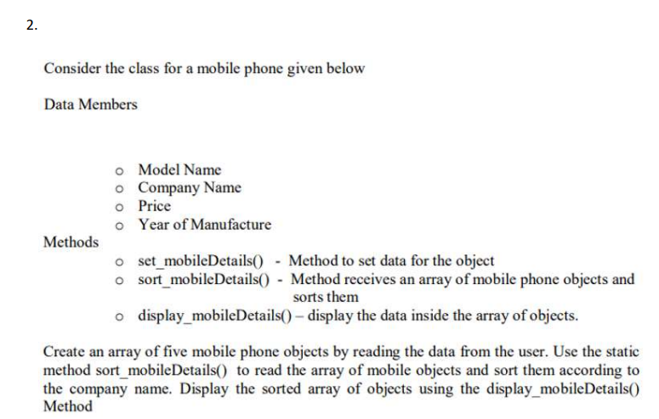

**CODE:**

import java.util.Scanner;

public class MobilePhone {

    String ModelName;

    String CompanyName;

    int Price;

    int YearOfManufacture;

    void set_mobileDetails(String ModelName, String CompanyName, int Price, int YearOfManufacture) {

        this.ModelName = ModelName;

        this.CompanyName = CompanyName;

        this.Price = Price;

        this.YearOfManufacture = YearOfManufacture;

    }

    static void sort_mobileDetails(MobilePhone[] mobilePhoneArray) {

        int min_idx = 0;

        MobilePhone temp;

        for (int i = 0; i < mobilePhoneArray.length - 1; i++) {

            min_idx = i;

            for (int j = i + 1; j < mobilePhoneArray.length; j++) {

                if (mobilePhoneArray[min_idx].CompanyName.compareTo(mobilePhoneArray[j].CompanyName) > 0) {

                    min_idx = j;

                }

            }

            if (min_idx != i) {

                temp = mobilePhoneArray[min_idx];

                mobilePhoneArray[min_idx] = mobilePhoneArray[i];

                mobilePhoneArray[i] = temp;

            }

        }

    }

    static void display_mobileDetails(MobilePhone[] mobilePhoneArray) {

        for (int i = 0; i < mobilePhoneArray.length; i++) {

            System.out.println("Details For Mobile : " + (i + 1));

            System.out.println("ModelName : " + mobilePhoneArray[i].ModelName);

            System.out.println("CompanyName : " + mobilePhoneArray[i].CompanyName);

            System.out.println("Price : " + mobilePhoneArray[i].Price);

            System.out.println("yearOfManufacture : " + mobilePhoneArray[i].YearOfManufacture);

        }

    }

    public static void main(String[] args) {

        Scanner in = new Scanner(System.in);

        int n;

        System.out.println("Enter the number of Mobiles : ");

        n = in.nextInt();

        MobilePhone[] array_object = new MobilePhone[n];

        System.out.println("Enter the MobilePhone Details: ");

        for (int i = 0; i < n; i++) {

            in.nextLine();

            System.out.println("Mobile Phone : " + (i + 1));

            System.out.print("ModelName : ");

            String ModelName = in.nextLine();

            System.out.print("Company Name : ");

            String CompanyName = in.nextLine();

            System.out.print("Price : ");

            int Price = in.nextInt();

            System.out.print("Year of Manufacture : ");

            int YearOfManufacture = in.nextInt();

            array_object[i] = new MobilePhone();

            array_object[i].set_mobileDetails(ModelName, CompanyName, Price, YearOfManufacture);

        }

        System.out.println("ANIRUDH VADERA (20BCE2940)");

        System.out.println("Before Sorting the Mobile Details are : ");

        MobilePhone.display_mobileDetails(array_object);

        MobilePhone.sort_mobileDetails(array_object);

        System.out.println("After Sorting the Mobile Details are : ");

        MobilePhone.display_mobileDetails(array_object);

        in.close();

    }

}

**CODE SNAPSHOT:**

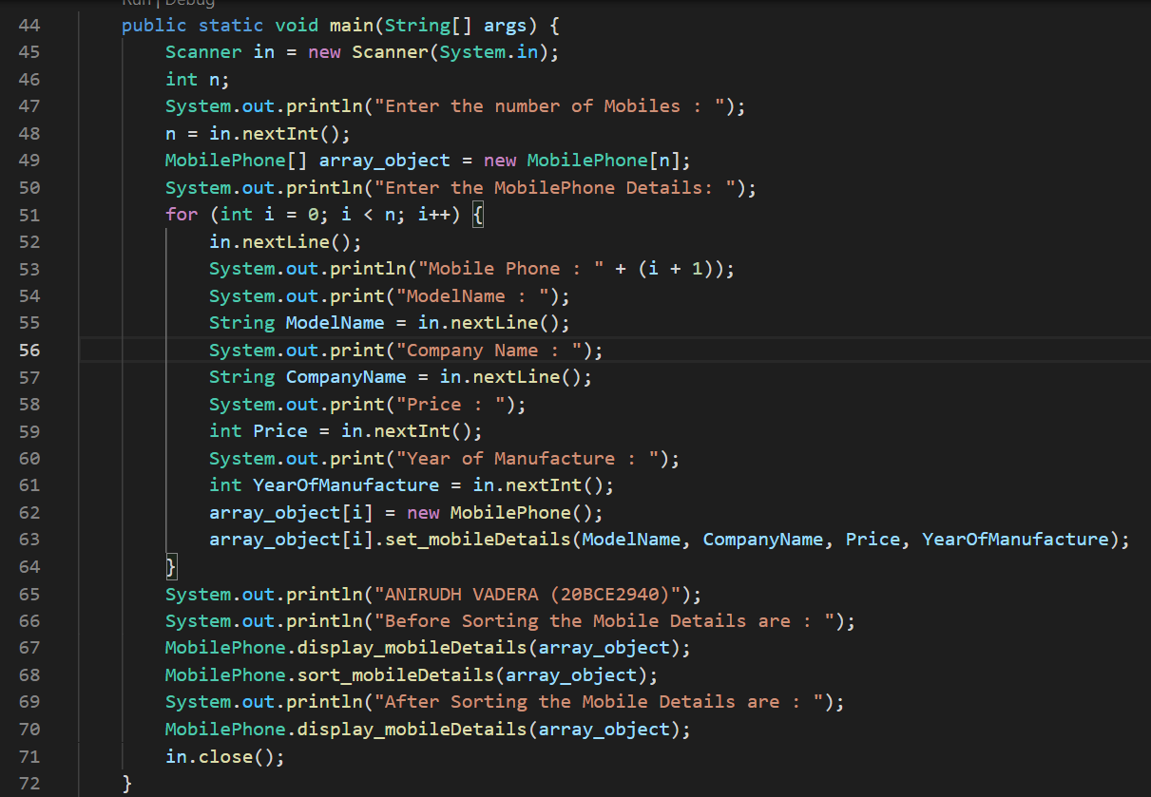

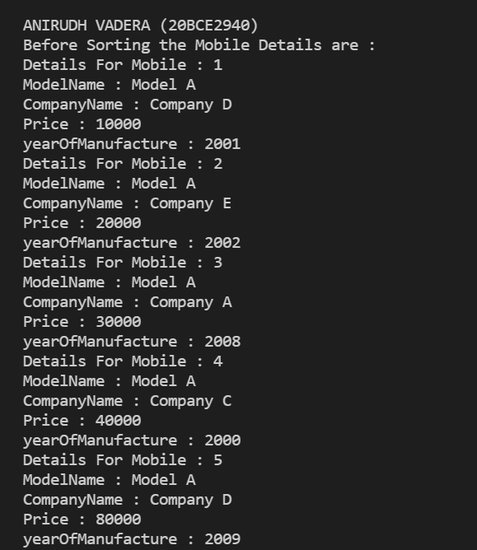**OUTPUT:**

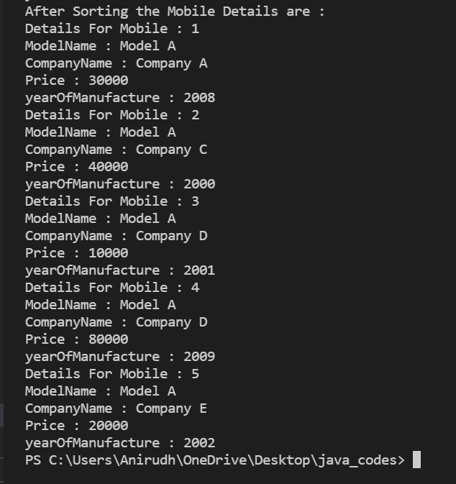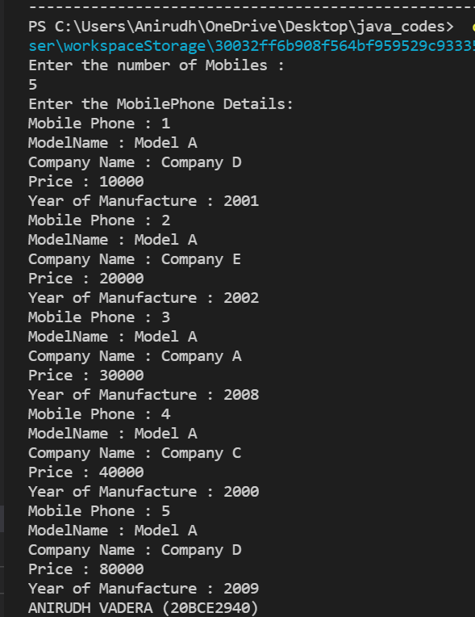

**QUESTION 3:**

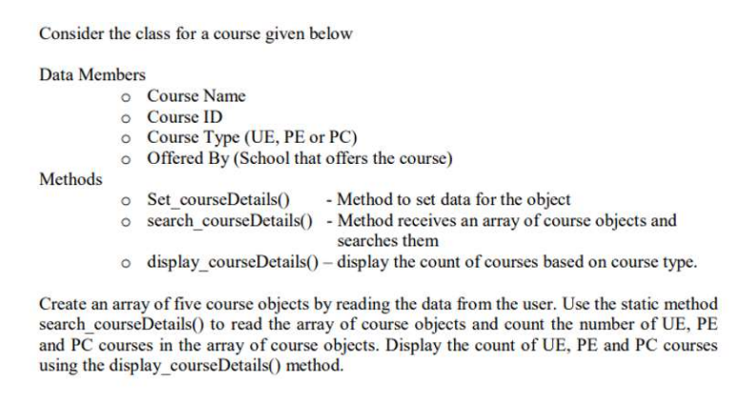

**CODE:**

import java.util.Scanner;

public class Course {

    String CourseName;

    int CourseId;

    String Coursetype;

    String School;

    static int count_UE;

    static int count_PE;

    static int count_PC;

    void set_courseDetails(String CourseName, int CourseId, String Coursetype, String School) {

        this.CourseName = CourseName;

        this.CourseId = CourseId;

        this.Coursetype = Coursetype;

        this.School = School;

    }

    static void search_courseDetails(Course[] courseArray) {

        for (int i = 0; i < courseArray.length; i++) {

            switch (courseArray[i].Coursetype) {

                case "UE":

                    Course.count_UE++;

                    break;

                case "PE":

                    Course.count_PE++;

                    break;

                case "PC":

                    Course.count_PC++;

                    break;

            }

        }

    }

    static void display_courseDetails(Course[] courseArray) {

        System.out.println("The Counts are as Follows : ");

        System.out.println("Number of UE Courses : " + Course.count_UE);

        System.out.println("Number of PE Courses : " + Course.count_PE);

        System.out.println("Number of PC Courses : " + Course.count_PC);

    }

    public static void main(String[] args) {

        Scanner in = new Scanner(System.in);

        int n;

        System.out.println("Enter the number of Courses : ");

        n = in.nextInt();

        Course[] array_object = new Course[n];

        System.out.println("Enter the Course Details: ");

        in.nextLine();

        for (int i = 0; i < n; i++) {

            System.out.println("Course : " + (i + 1));

            System.out.print("Course Name : ");

            String CourseName = in.nextLine();

            System.out.print("Course ID : ");

            int CourseId = in.nextInt();

            in.nextLine();

            System.out.print("Course Type : ");

            String Coursetype = in.nextLine();

            System.out.print("School : ");

            String School = in.nextLine();

            array_object[i] = new Course();

            array_object[i].set_courseDetails(CourseName, CourseId, Coursetype, School);

        }

        Course.search_courseDetails(array_object);

        System.out.println("After Searching for the UE,PE,PC courses the results are : ");

        Course.display_courseDetails(array_object);

        in.close();

    }

}

**CODE SNAPSHOT:** 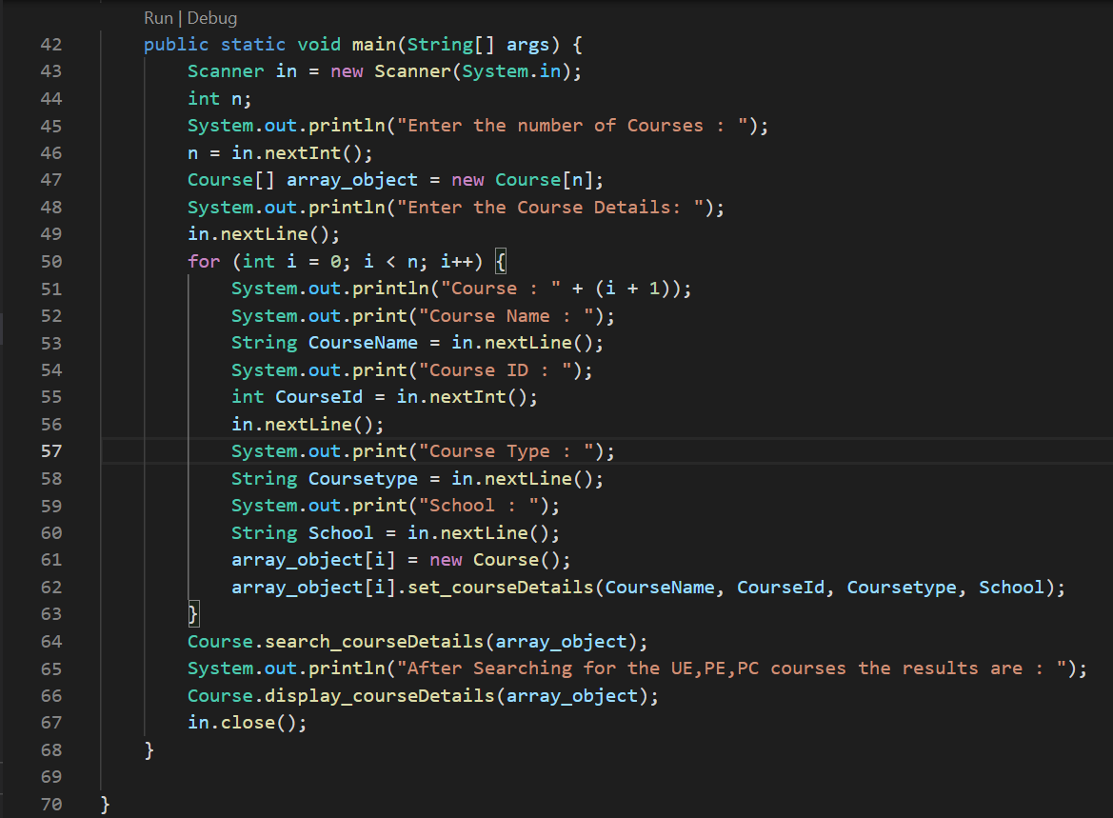

**OUTPUT:**

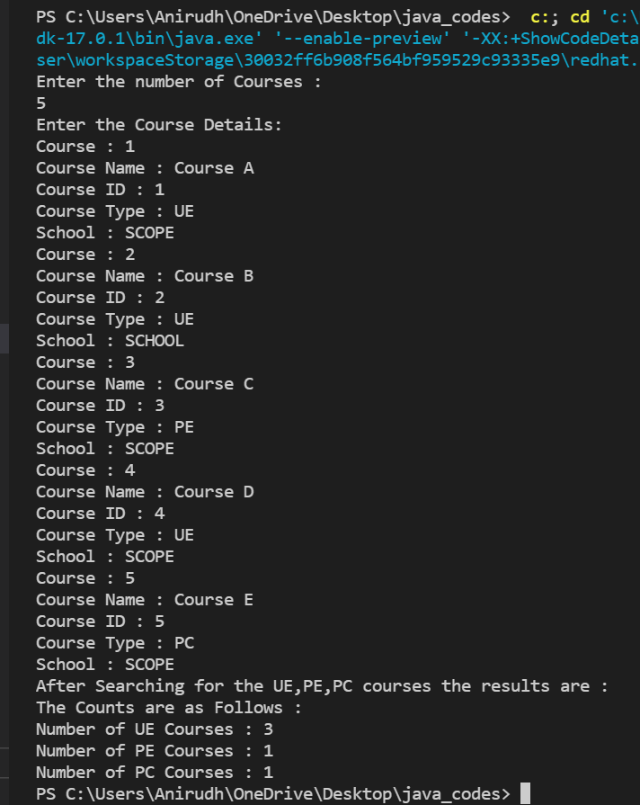

**ACTIVITY – 5:**

**QUESTION 1:**

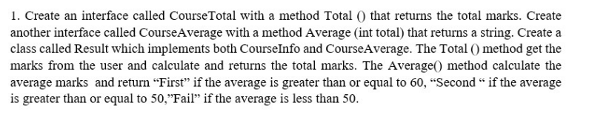

**CODE:**

import java.util.Scanner;

interface CourseTotal {

    int Total();

}

interface CourseAverage {

    String Average(int total);

}

public class Result implements CourseTotal, CourseAverage {

    int marks1;

    int marks2;

    int marks3;

    Scanner in = new Scanner(System.in);

    public int Total() {

        System.out.println("Enter the marks : ");

        System.out.print("Marks1 : ");

        marks1 = in.nextInt();

        System.out.print("Marks2 : ");

        marks2 = in.nextInt();

        System.out.print("Marks3 : ");

        marks3 = in.nextInt();

        return (marks1 + marks2 + marks3);

    }

    public String Average(int total) {

        float average = total / 3;

        if (average >= 60) {

            return ("First");

        } else if (average >= 50) {

            return ("Second");

        } else {

            return ("Fail");

        }

    }

    public static void main(String[] args) {

        Result obj = new Result();

        System.out.println();

        System.out.println("ANIRUDH VADERA (20BCE2940)");

        System.out.println();

        int total = obj.Total();

        System.out.println(obj.Average(total));

    }

}

**CODE SNAPSHOT:**

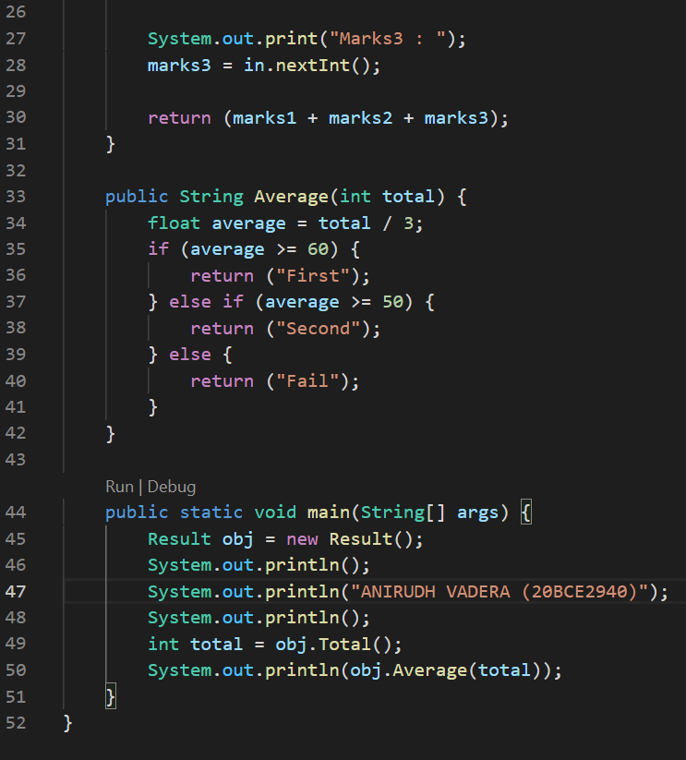

**OUTPUT:**

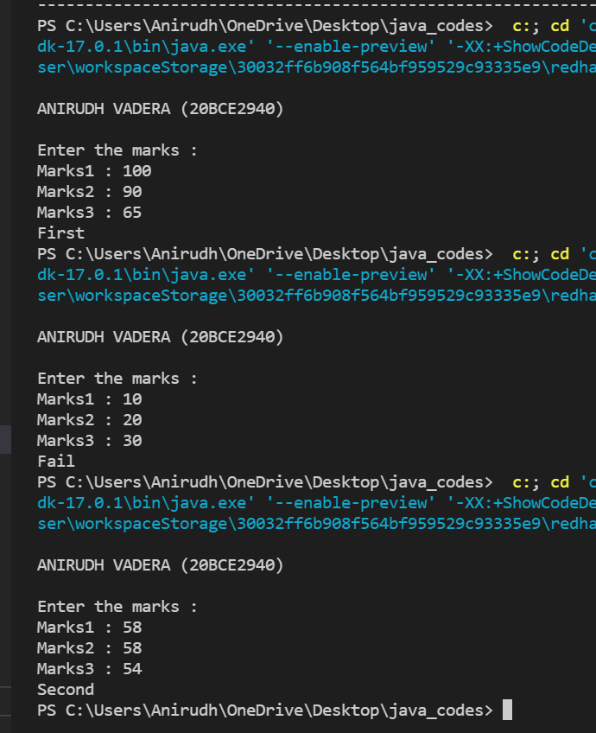

**QUESTION 2:**

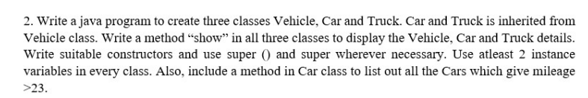

**CODE:**

class Vehicle {

    int vehicleCount;

    int vehicleTypes = 2;

    Vehicle() {

        System.out.println("Vehicle Constructor getting called from child");

    }

    void show() {

        System.out.println("I am vehicle");

        System.out.println("Vehicle Counts : " + vehicleCount);

        System.out.println("Vehicle Types : " + vehicleTypes);

    }

}

class Car extends Vehicle {

    String carModel;

    int mileage;

    Car(String carModel, int mileage) {

        this.carModel = carModel;

        super.vehicleCount = super.vehicleCount + 1;

        this.mileage = mileage;

    }

    static public void list(Car[] car_array) {

        System.out.println("Cars Model with mileage greater than 23 : ");

        for (int i = 0; i < car_array.length; i++) {

            if (car_array[i].mileage > 23) {

                System.out.println(car_array[i].carModel);

            }

        }

    }

    void show() {

        System.out.println("I am Car");

        System.out.println("Car Model : " + carModel);

        System.out.println("Car Mileage : " + mileage);

    }

}

class Truck extends Vehicle {

    String truckModel;

    int mileage;

    Truck(String truckModel, int mileage) {

        super();

        this.truckModel = truckModel;

        super.vehicleCount = super.vehicleCount + 1;

        this.mileage = mileage;

    }

    void show() {

        System.out.println("I am Truck");

        System.out.println("Truck Model : " + truckModel);

        System.out.println("Truck Mileage : " + mileage);

    }

}

public class activity5q2 {

    public static void main(String[] args) {

        Car[] obj1 = new Car[3];

        for (int i = 0; i < 3; i++) {

            String x = "Model" + (i + 1);

            obj1[i] = new Car(x, ((i * 10) + 20));

        }

        Truck obj2 = new Truck("Model1", 50);

        System.out.println("ANIRUDH VADERA (20BCE2940)");

        obj1[0].show();

        obj1[1].show();

        obj1[2].show();

        Car.list(obj1);

        obj2.show();

    }

}

**CODE SNAPSHOT:**

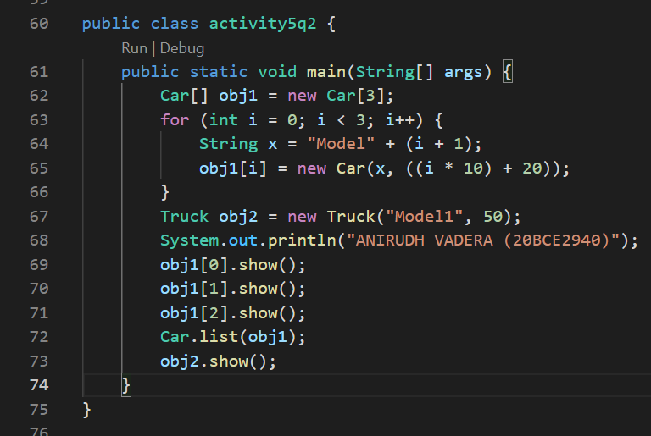

**OUTPUT:**

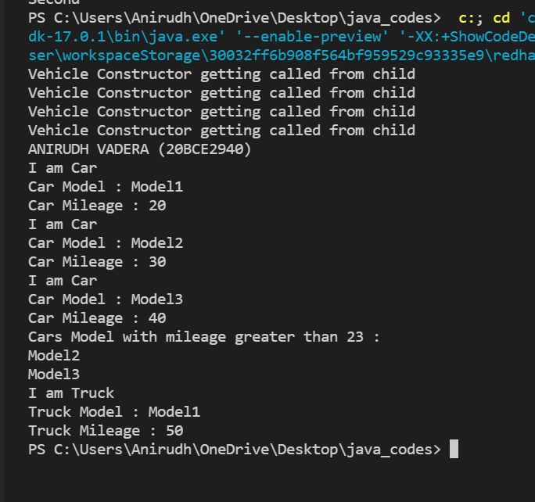

**QUESTION 3:**

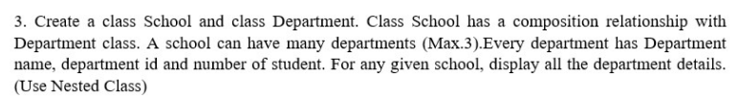

**CODE:**

import java.util.Scanner;

public class activity5q3 {

    class School {

        Department[] department_array;

        School(Department[] department_array) {

            this.department_array = department_array;

        }

        class Department {

            String name;

            int id;

            int no_of_children;

            Department(String name, int id, int no_of_children) {

                this.name = name;

                this.id = id;

                this.no_of_children = no_of_children;

            }

        }

        void display() {

            for (int i = 0; i < department_array.length; i++) {

                System.out.println("Department : " + (i + 1));

                System.out.println("Department Name : " + department_array[i].name);

                System.out.println("Department ID : " + department_array[i].id);

                System.out.println("Department Students : " + department_array[i].no_of_children);

            }

        }

    }

    public static void main(String[] args) {

        activity5q3 main = new activity5q3();

        Scanner in = new Scanner(System.in);

        System.out.println("Enter the number of the department : ");

        int n = in.nextInt();

        if (n > 3) {

            System.out.println("The number of the departments should be less than 4 : ");

        } else {

            School.Department[] dep = new School.Department[n];

            School obj = main.new School(dep);

            for (int i = 0; i < dep.length; i++) {

                dep[i] = obj.new Department(("Name" + i), (i), (i + 10));

            }

            System.out.println("ANIRUDH VADERA (20BCE2940)");

            obj.display();

        }

        in.close();

    }

}

**CODE SNAPSHOT:**

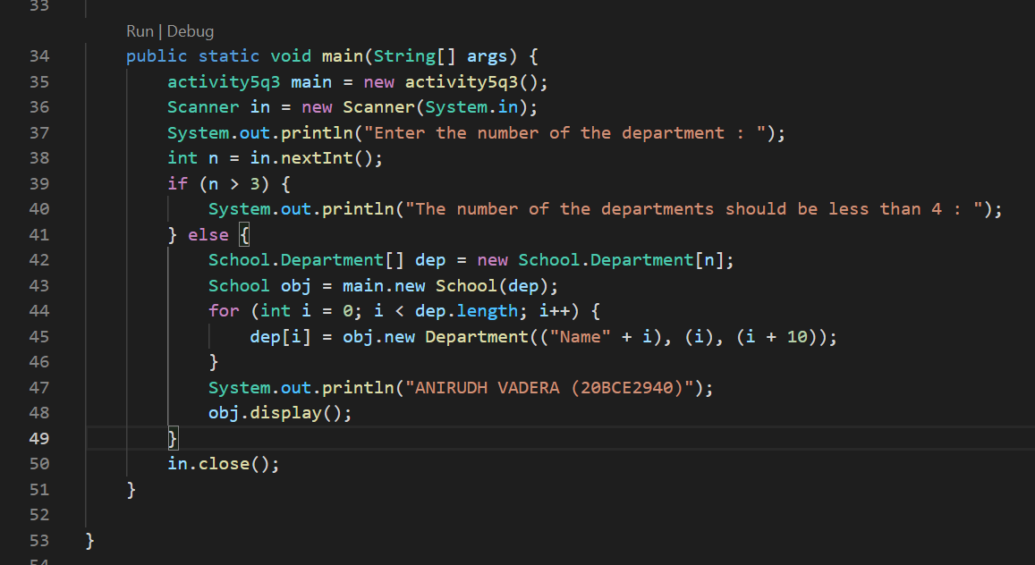

**OUTPUT:**

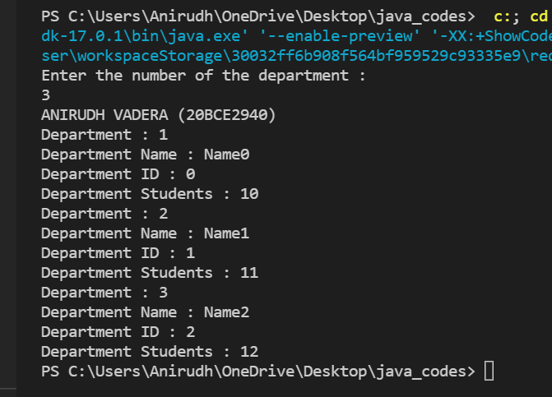

**QUESTION 5:**

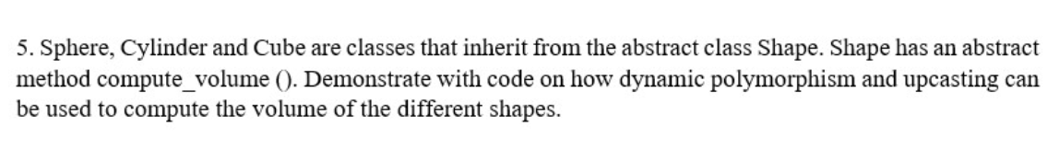

**CODE:**

import java.util.Scanner;

abstract class Shape {

    abstract void compute_volume();

}

class Sphere extends Shape {

    int r;

    double volume;

    Sphere(int r) {

        this.r = r;

        volume = (4 / 3) * Math.PI * r * r * r;

    }

    void compute_volume() {

        System.out.println("The Volume of Sphere is : ");

        System.out.println(volume);

    }

}

class Cylinder extends Shape {

    int r;

    int h;

    double volume;

    Cylinder(int r, int h) {

        this.r = r;

        this.h = h;

        volume = Math.PI * r * r * h;

    }

    void compute_volume() {

        System.out.println("The Volume of Cylinder is : ");

        System.out.println(volume);

    }

}

class Cube extends Shape {

    int a;

    double volume;

    Cube(int a) {

        this.a = a;

        volume = a * a * a;

    }

    void compute_volume() {

        System.out.println("The Volume of Cube is : ");

        System.out.println(volume);

    }

}

public class activity5q5 {

    public static void display(Shape x) {

        System.out.println("The Result is : ");

        x.compute_volume();

    }

    public static void main(String[] args) {

        int n;

        System.out.println("Enter the number of Shapes : ");

        Scanner in = new Scanner(System.in);

        n = in.nextInt();

        Shape[] shapes = new Shape[n];

        for (int i = 0; i < shapes.length; i++) {

            System.out.println("Enter the Shape type : ");

            System.out.println("1 : Sphere");

            System.out.println("2 : Cylinder");

            System.out.println("3 : Cube");

            int x = in.nextInt();

            if (x == 1) {

                System.out.print("Enter the radius of Sphere : ");

                int r = in.nextInt();

                System.out.println();

                shapes[i] = new Sphere(r);

            } else if (x == 2) {

                System.out.print("Enter the radius of Cylinder : ");

                int r = in.nextInt();

                System.out.print("Enter the height of Cylinder : ");

                int h = in.nextInt();

                System.out.println();

                shapes[i] = new Cylinder(r, h);

            } else {

                System.out.print("Enter the side of Cube : ");

                int a = in.nextInt();

                System.out.println();

                shapes[i] = new Cube(a);

            }

        }

        System.out.println("ANIRUDH VADERA (20BCE2940)");

        for (int i = 0; i < shapes.length; i++) {

            display(shapes[i]);

        }

        in.close();

    }

}

**CODE SNAPSHOT:**

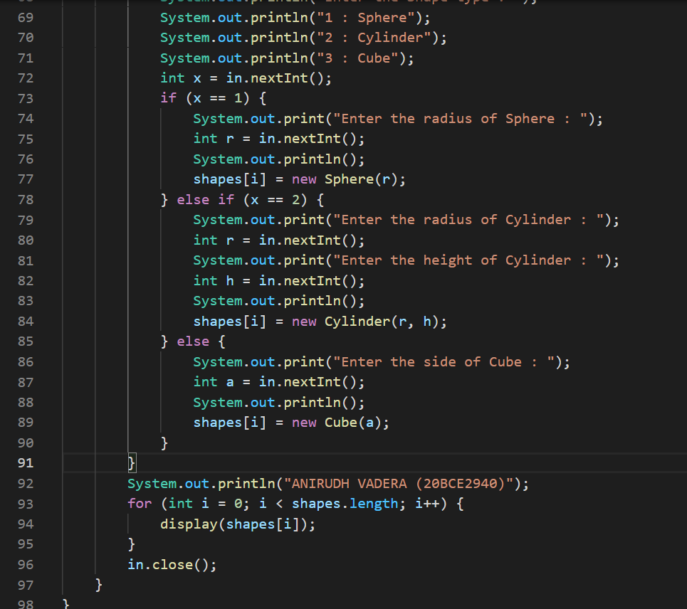

**OUTPUT:**

