

**(DIGITAL ASSIGNMENT) HACKERANK QUESTIONS**

**CSE1007(JAVA PROGRAMMING)THEORY:B1+TB1**



**April 6, 2022**

**ANIRUDH VADERA**

**20BCE2940**

**INITIALLY:**

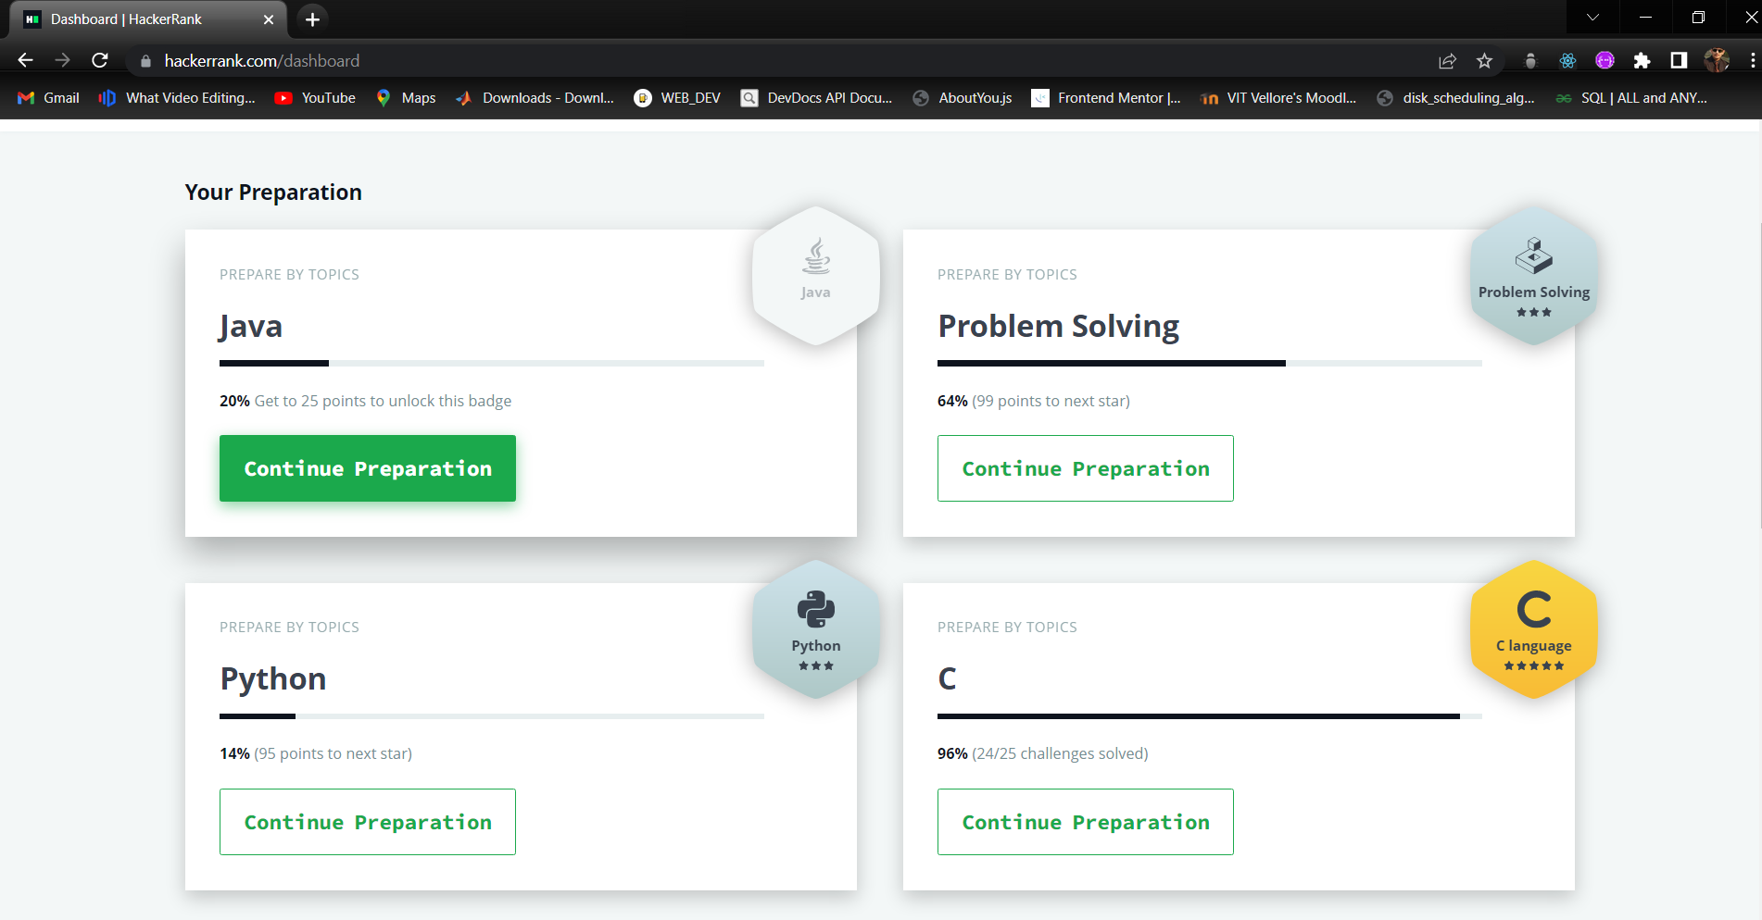

**LINK FOR MY HACKERANK PROFILE:**

<https://www.hackerrank.com/anirudh_vadera21>

**ACCOUNT SCREENSHOT:**

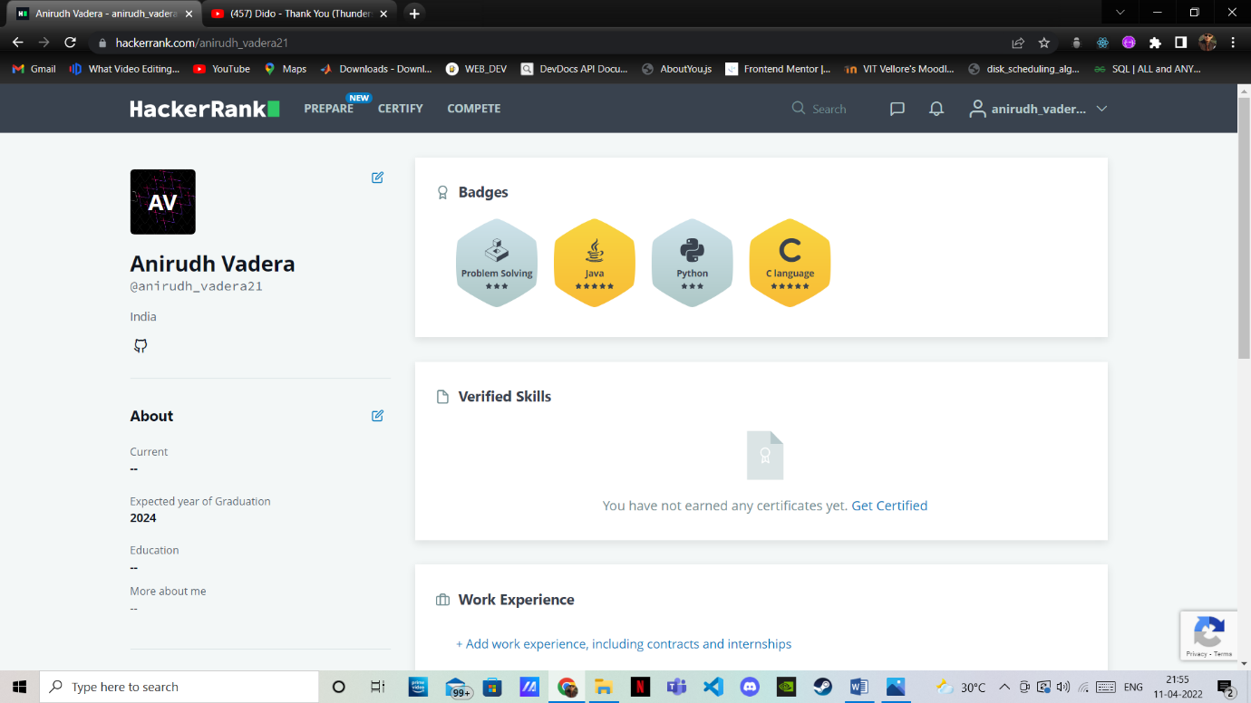

**FINALLY:**

