

**DIGITAL ASSIGNMENT : palindrome and bios input/output**

**CSE2006 - MICROPROCESSOR AND INTERFACING(L39-40)[MRS SHOBHA REKH]**



**October 29, 2022**

**ANIRUDH VADERA**

**20BCE2940**

**QUESTION 1:**

**Use the BIOS interrupts and read a character from the keyboard and display the same on the computer screen.**

**Explanation:**

**BIOS Interrupts used:**

**To Read a Character that is entered from Keyboard:**

**INT 21h** / **AH=1** - read character from standard input, with echo, result is stored in **AL**.  
if there is no character in the keyboard buffer, the function waits until any key is pressed.  
  
Example:

mov ah, 1

int 21h

**To Display a character that was entered:**

**INT 21h** / **AH=2** - write character to standard output.  
entry: **DL** = character to write, after execution **AL = DL**.  
  
Example:

mov ah, 2

mov dl, 'a'

int 21h

**Code Screenshot:**

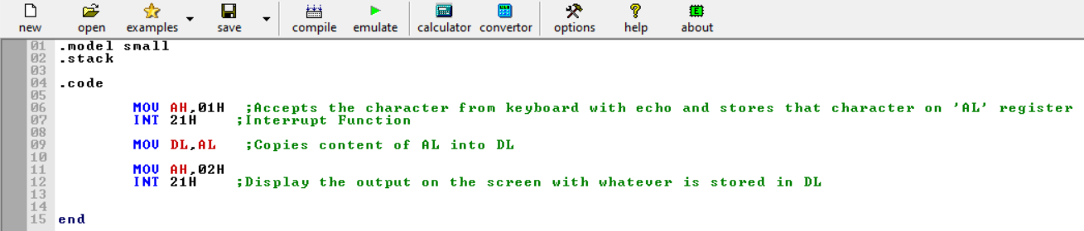

**Assembly Language Code:**

.model small

.stack

.code

MOV AH,01H ;Accepts the character from keyboard with echo and stores that character on 'AL' register

INT 21H ;Interrupt Function

MOV DL,AL ;Copies content of AL into DL

MOV AH,02H

INT 21H ;Display the output on the screen with whatever is stored in DL

end

**Execution Proof:**

**Command: masm in_out.asm**

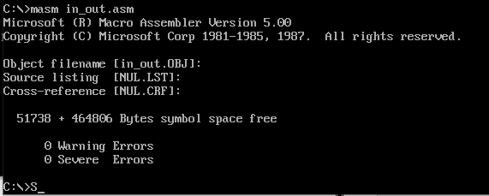

**Command: link in_out.obj**

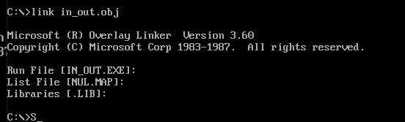

**Command: debug in_out.exe**



**Giving Inputs:**

Input Given as: **h(A string literal)**

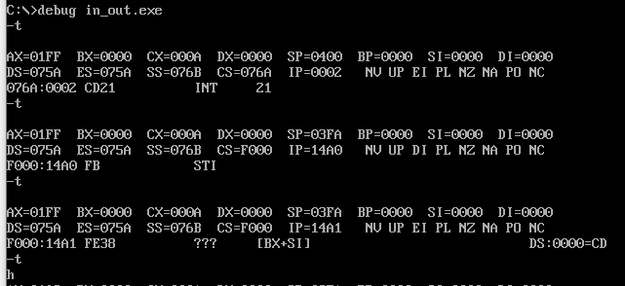

**The Output is:**

We get the output as: **h** (Hence Code is working fine)

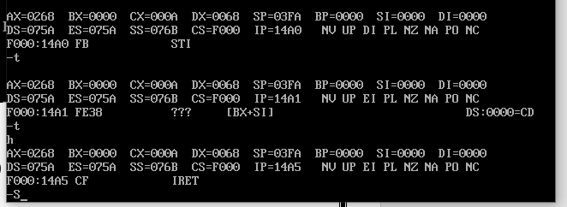

**Giving Inputs:**

Input Given as: **v**

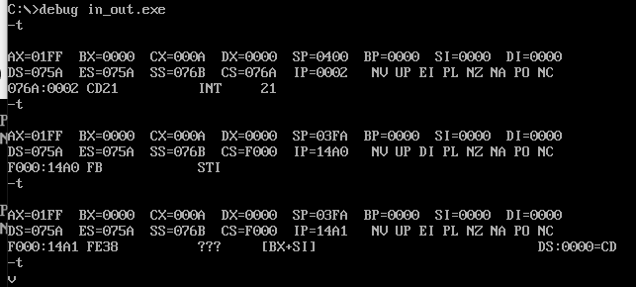

**The Output is:**

We get the output as: **v** (Hence Code is working fine)

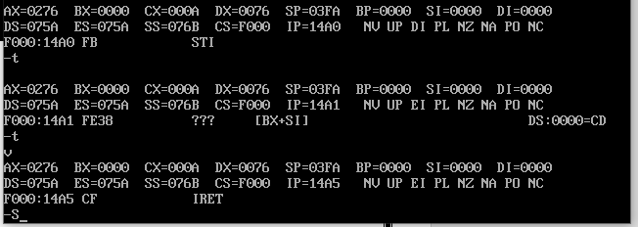

**Giving Inputs:**

Input Given as: **1(A Number)**

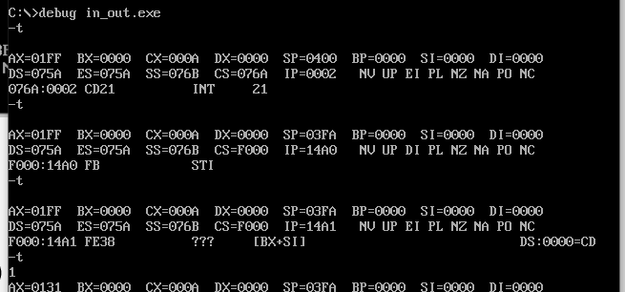

**The Output is:**

We get the output as: **1** (Hence Code is working fine)

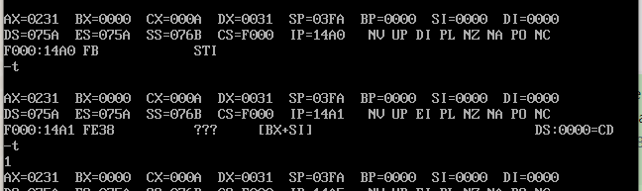

**Giving Inputs:**

Input Given as: **#(A special Character)**

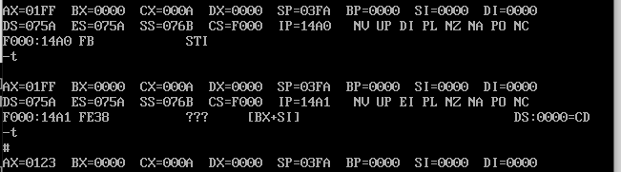

**The Output is:**

We get the output as: **#** (Hence Code is working fine)

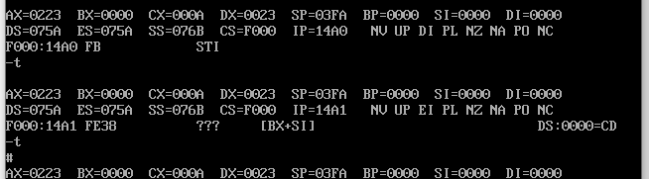

**QUESTION 2:**

**Store a string in the program. Find if the stored string is a Palindrome or not.**

**Display “It is a Palindrome “or display “It is not a Palindrome”. Use BIOS interrupts to display string on the monitor.**

**Explanation:**

**To Enter a string by user:**

**INT 21h** / **AH=0Ah** - input of a string to **DS:DX**, fist byte is buffer size, second byte is number of chars actually read. this function does **not** add '$' in the end of string.

Example:

org 100h

mov dx, offset buffer

mov ah, 0ah

int 21h

jmp next

buffer db 10,?, 10 dup(' ')

**To Display a string that was entered:**

**INT 21h** / **AH=9** - output of a string at **DS:DX**. String must be terminated by '**$**'.  
  
Example:

org 100h

mov dx, offset msg

mov ah, 9

int 21h

ret

msg db "hello world $"

**In Assembly Language:**

1. Create a string
2. Traverse to the end of the string
3. Get the address of the end of the string, SI
4. Load the starting address of the string, DI
5. Compare the value stored at the address
6. Increment the pointer, DI
7. Decrements the pointer, SI
8. Compare again the value stored at SI and DI
9. Repeat the steps until SI>=DI
10. If all the Characters match print string is palindrome else print not palindrome

**FlowChart:**

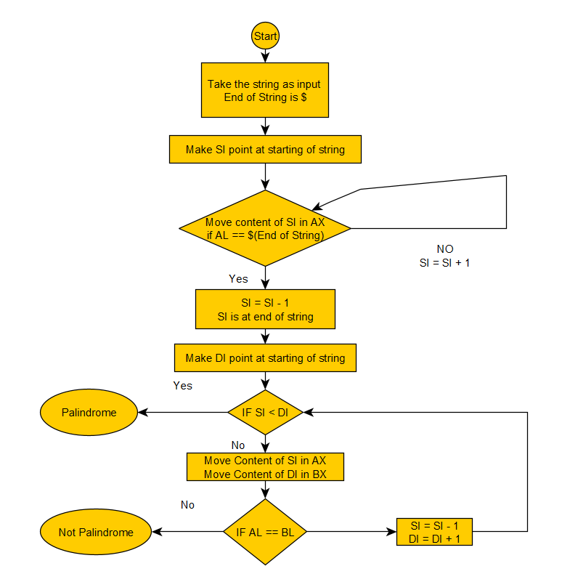

**Code Screenshot:**

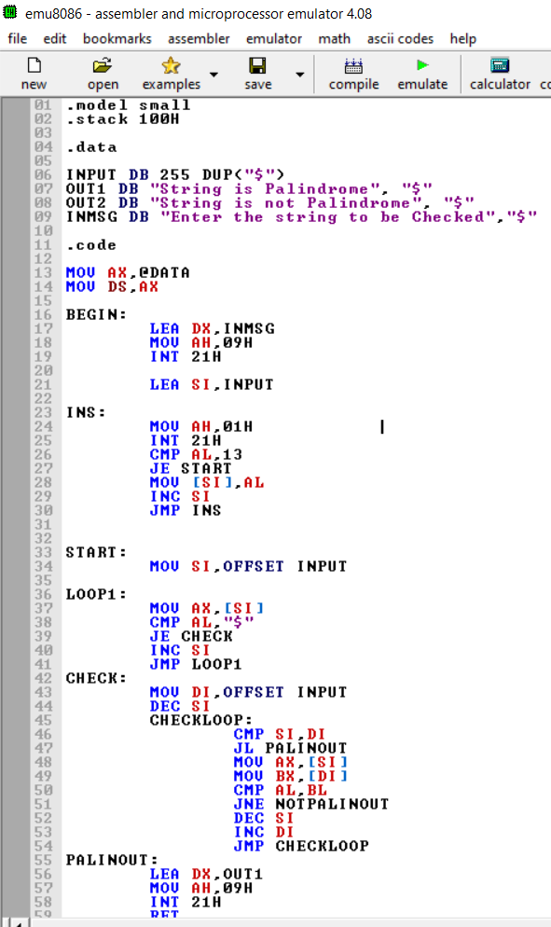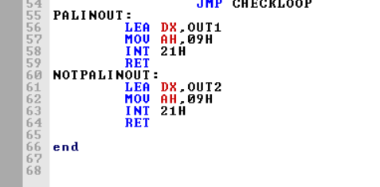

**Assembly Language Code:**

.model small

.stack 100H

.data

INPUT DB 255 DUP("$")

OUT1 DB "String is Palindrome", "$"

OUT2 DB "String is not Palindrome", "$"

INMSG DB "Enter the string to be Checked","$"

.code

MOV AX,@DATA

MOV DS,AX

BEGIN:

LEA DX,INMSG

MOV AH,09H

INT 21H

LEA SI,INPUT

INS:

MOV AH,01H

INT 21H

CMP AL,13

JE START

MOV [SI],AL

INC SI

JMP INS

START:

MOV SI,OFFSET INPUT

LOOP1:

MOV AX,[SI]

CMP AL,"$"

JE CHECK

INC SI

JMP LOOP1

CHECK:

MOV DI,OFFSET INPUT

DEC SI

CHECKLOOP:

CMP SI,DI

JL PALINOUT

MOV AX,[SI]

MOV BX,[DI]

CMP AL,BL

JNE NOTPALINOUT

DEC SI

INC DI

JMP CHECKLOOP

PALINOUT:

LEA DX,OUT1

MOV AH,09H

INT 21H

RET

NOTPALINOUT:

LEA DX,OUT2

MOV AH,09H

INT 21H

RET

end

**Execution Proof:**

**Command: masm palindrome.asm**

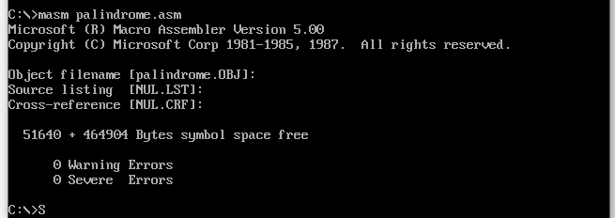

**Command: link palindrome.obj**

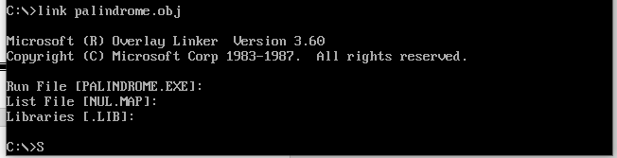

**Command: debug palindrome.exe**



**We give Input character by character as we are running in debugging mode.**

**So to give a input of length 5 we need to give 5 characters line by line.**

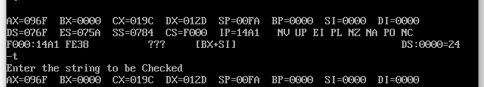

**Giving Inputs:**

Given Input : **madam**

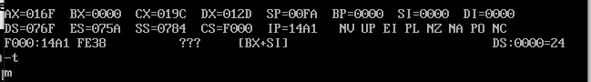

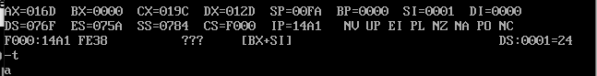

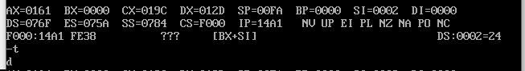

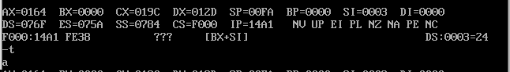

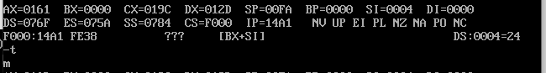

Press Enter to End Entering the String

**The Output is:**

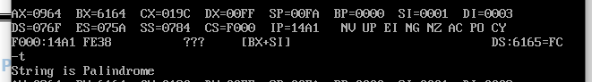

Hence the String is **Palindrome**

**Giving Inputs:**

Given Input : **Pal**

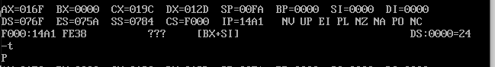

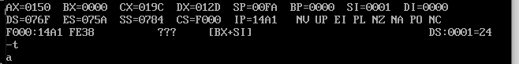

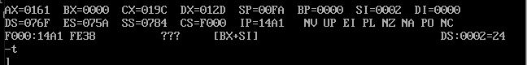

Press Enter to End Entering the String

**The Output is:**

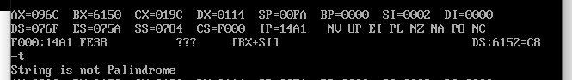

Hence the String is **Not Palindrome**

**Giving Inputs:**

Given Input : **abba**

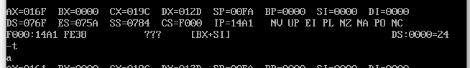

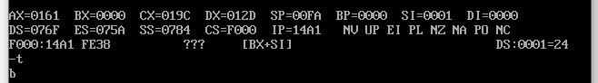

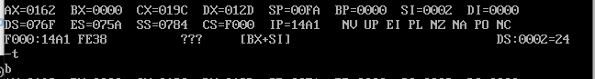

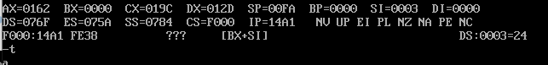

Press Enter to End Entering the String

**The Output is:**

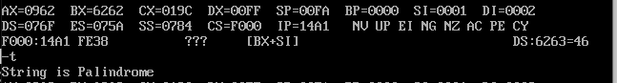

Hence the String is **Palindrome**