

**REVIEW1 – MINECO SMART HELMET**

**MICROPROCESSOR AND INTERFACING(D1)**



**MR SIVA SHANMUGAM G**

**team**

1. **ANIRUDH VADERA(20BCE2940)**
2. **AADITRY CHOUDHURY(20BCE2618)**
3. **VAIBHAV GARG(20BCE0742)**

**SEPTEMBER 08,2022**

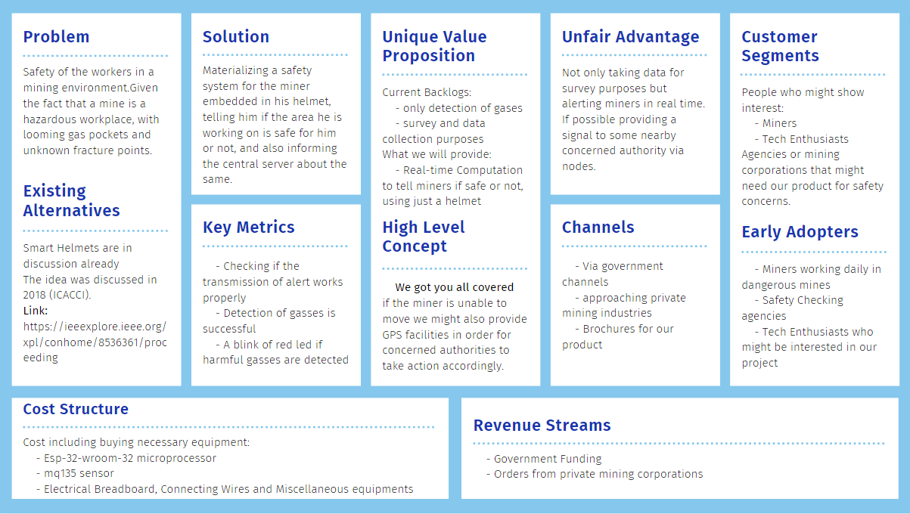**LEAN CANVAS:**

**OBJECTIVE:**

This project mainly focuses on the safety of the workers in a mining environment.

Given the fact that a mine is a hazardous workplace, with looming gas pockets and unknown fracture points. This helmet that we wish to design will be a perfect safety companion to a miner in case of adversities.

**MINECO** stands for **Miner-Companion** which clearly justifies its role and objective of development.

The sole objective of this project is to give safe and connected work environment to a miner and his life.



**SUMMARY OF PROJECT:**

**Background of work:**

The main purpose of the work is to design a smart helmet system for mining industry.

It will constantly monitor the different concentration of the gases in the environment of the miner and will alert him as well as the control centre of any hazardous event such as gas leaks or mine collapses in which case the miner is left completely alone and unaware, a small example being

Carbon monoxide which is a completely tasteless gas and also has no smell but one of the most poisonous and harmful gases that exists in a mining environment, which means that a miner cannot detect the gas on his own using his natural senses of smell or taste. In these situations, it becomes absolutely necessary that there must be some mechanism to save his life, this is where our device comes in, The **MINECO** smart helmet.

**METHODOLOGY:**

Constantly monitor the concentration of some specific gases that are known to be harmful to the miner’s health such as carbon monoxide, Alcohol, Benzene, etc. and keep processing their concentrations to check if it's below a safe threshold or not, in case it is harmful for the miner, a proper response/alert must be given to him as well as in the control centre about the condition of the area and also give a mechanism to alert all the nearby workers.

**PROPOSED OUTCOME:**

The proposed project will be made using mq135 sensor to get the concentration of the gases present in the air and will be processed on an esp-32-wroom-32 microprocessor.

Basically materialising a safety system for the miner embedded in his helmet, telling him if the area he is working on is safe for him or not, and also inform the central server about the same.

**NOVELTY OF THE PROPOSED PROJECT:**

The response and the alert in case of some hazardous event highly depends on the general layout of the mine, and hence the solution or the design for it is unique depending to the targeted location or structure of the mine which may use different hardware depending on the physical constraints presented in the working environment.

There have been projects which can detect gases in a mine but they are used only for data collection and survey purposes but in this given project we will be using real time computation to tell the miner if he is safe or not, all of this via his helmet and no additional load.

**RELEVANCE IMPORTANCE OF PROPOSED PROJECT:**

To the public and to the mining industry. There haven’t been much innovations to improve the conditions of the miners despite the fact that it is one of the most hazardous workplaces to be in.

The life of a miner is at risk all the time, we are set to diffuse this issue with the help of this project to some extent.

Even one life saved would justify all the time and effort invested in this project

Rather than going for a project that maximises profits in other domains

The project will be a great help in ensuring the safety of all the miners working in the mining field, and hence will be highly relevant to the miners and their family.

**APPLICABILITY OF THE PROJECT:**

The applicability of a project depends on how economical it is to materialise and also on the ease of use it offers to the industry it is introduced to.

The proposed project will be made using mq135 sensor to get the concentration of the gases present in the air and will be processed on an esp-32-wroom-32 microprocessor.

Which is quite economical considering all the other options available in the market, also all of the mechanisms and workings of the entire project will be embedded in the helmet of the miner which means that he does not need to carry any additional load or any technical expertise to be safe.

**Short Term Applicability:**

Can help in saving lives of many miners in case of some emergencies.

**Long Term Applicability:**

Based on the frequency of the hazardous gases leaked, a proper evacuation route could be made for some particular locations based on the past records of alert in the mine.

**GAP IDENTIFIED:**

The embedded software for the wearable device will vary depending on the structure of the mine and the kind of alert we plan to issue and hence the model could vary vastly depending on the general layout of the mine and hence will affect the availability and economical factor of the final product.

**SIGNIFICANCE AND FUTURE ENHANCEMENTS:**

Main significance of this project is in mining sector and the lack of a wearable device / assistant to the miner, where we can monitor the real time status of the mining environment around the miner and can raise appropriate alert to others depending on if some hazardous situation has occurred thus adding the necessary safety lacking in the current industry for the miners.

The given project is in its genesis or origin state which means that there will be a vast scope of improvement in it with time given that a community collaborates on this and highlights shortcomings and suggests improvements on the same making the product feasible Since the product greatly depends on the layout or structure of the mine, we can work towards making it more flexible or general in nature in future.