

**REVIEW3 – MINECO SMART HELMET**

**CSE2006 - MICROPROCESSOR AND INTERFACING(D1)(L)**





**MRS SHOBHA REKH**

**team**

1. **ANIRUDH VADERA(20BCE2940)**
2. **AADITRY CHOUDHURY(20BCE2618)**
3. **VAIBHAV GARG(20BCE0742)**

**NOVEMBER 10,2022**

**TABLE OF CONTENTS:**

|  |  |  |
| --- | --- | --- |
|  |  |  |
|  |  |  |
|  |  |  |
|  |  |  |
|  |  |  |
|  |  |  |

**ABSTRACT:**

IOT have been recently expanded its application across all domains mainly in form of wearables. The main objective of this research is to see how well it performs in the mining industries. Miners in the mining area are prone to dangers that can't be detected by normal human senses. A Smart Mining Helmet will be able to alert the miner whenever the area around him becomes unsafe. The primary danger in the mines is mainly due to air quality around the miner, many toxic gases in the mine and some nontoxic gases present in unsafe concentration can greatly harm the miner health over the long term of his life. Our project focuses on a mine supervising system monitor using IOT with sensors attached on top of the helmet to give real-time surveillance with early-warning system on various harmful gases using a small buzzer. In addition to that, once a area becomes unsafe the helmet acts as a broadcasting device which gives necessary warning to other helmets as well about the potential danger. Index Terms- Smart Helmet, IOT, Broadcast, ESP Now

**INTRODUCTION:**

The primary focus of any industry today is the safety of the workers working in that industry. But more often times, these standards don't really apply with much sincerity for miners working in the mining industries. Mining is an occupation where miners are required to go into mines to extract various resources, where their lives are constantly at risk. The risk they face can be immediate live threatening like the collapse of the mines or some misplaced landmine, or it can be a like a slow poison to them like constant exposure to CO in unsafe concentration. The problems faced by miners due to air quality in the mine comes out to be more dangerous than any immediate danger they face during mining. It kills miners slowly over the course of his/her life, without the miner even knowing the reason for his bad health. The area around the miners in the mine is not something a human being can accurately access relying solely on his senses, there is a strong need for proper safety measures for miners working in the mines, and one of the solutions for the above-mentioned problem is to make an equipment wore by the miners that is intelligent enough to help the miner detect the danger around him. If Miners senses aren't enough to access the environment around him then he needs to be given extra sensors which can sense what is required and can alert the miner accordingly. But Mining is a hard job where the miners often change or drop their equipment depending on their weight and use and comfort for them while working, so instead of providing an extra equipment to them, it is far better to integrate the safety system into their helmet using IOT technology and make it wearable.

**OBJECTIVE:**

This project mainly focuses on the safety of the workers in a mining environment.

Given the fact that a mine is a hazardous workplace, with looming gas pockets and unknown fracture points. This helmet that we wish to design will be a perfect safety companion to a miner in case of adversities.

**MINECO** stands for **Miner-Companion** which clearly justifies its role and objective of development.

The sole objective of this project is to give safe and connected work environment to a miner and his life

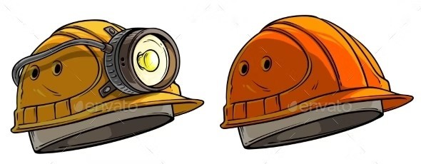

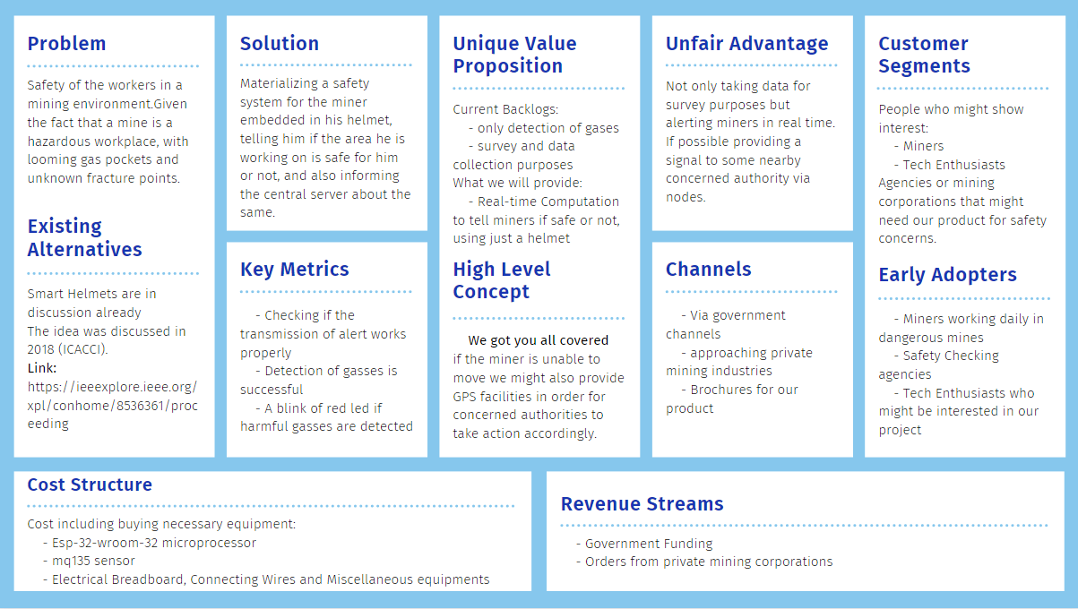**LEAN CANVAS:**

**HARDWARE REQUIREMENT SPECIFICATION:**

**1)ESP8266:** The ESP8266 is a low-cost Wi-Fi microchip, with built-in TCP/IP networking software, and microcontroller capability, produced by Espressif Systems in Shanghai, China. The chip was popularized in the English-speaking maker community in August 2014 via the ESP-01 module, made by a third-party.

The ESP8266 module **enables microcontrollers to connect to 2.4 GHz Wi-Fi**, using IEEE 802.11 bgn. It can be used with ESP-AT firmware to provide Wi-Fi connectivity to external host MCUs, or it can be used as a self-sufficient MCU by running an RTOS-based SDK.

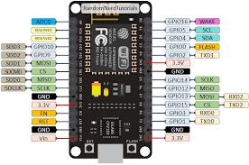

**2)DHT11:** The DHT11 is **a basic, ultra low-cost digital temperature and humidity sensor**. It uses a capacitive humidity sensor and a thermistor to measure the surrounding air and spits out a digital signal on the data pin (no analog input pins needed). It's fairly simple to use but requires careful timing to grab data.

This sensor is used in various applications such as **measuring humidity and temperature values in heating, ventilation and air conditioning systems**. Weather stations also use these sensors to predict weather conditions. The humidity sensor is used as a preventive measure in homes where people are affected by humidity.

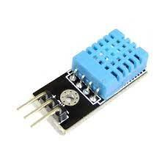

**3)MQ135:** The MQ-135 Gas sensor can **detect gases like Ammonia (NH3), sulfur (S), Benzene (C6H6), CO2, and other harmful gases and smoke**. Similar to other MQ series gas sensor, this sensor also has a digital and analog output pin.

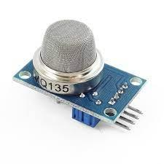

**4)Buzzer:** A buzzer or beeper is **an audio signaling device**, which may be mechanical, electromechanical, or piezoelectric (piezo for short). Typical uses of buzzers and beepers include alarm devices, timers, train and confirmation of user input such as a mouse click or keystroke.

 When power is applied, current runs through the coil of wire inside the buzzer, which produces a magnetic field. The flexible ferromagnetic disk is attracted to the coil when the magnetic field is activated, then returns to rest when the magnetic field is off.

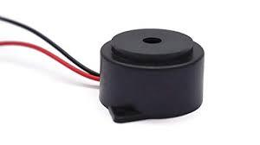

**5)LED:** The major uses of LED (Light Emitting Diodes) are **to illuminate objects and even places**. Its application is everywhere due to its compact size, low consumption of energy, extended lifetime, and flexibility in terms of use in various applications. Applications and uses of LEDs can be seen in: TV Backlighting.

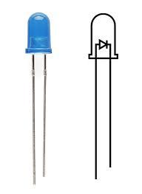

**6)Breadboard:** A breadboard (sometimes called a plugblock) is used for **building temporary circuits**. It is useful to designers because it allows components to be removed and replaced easily. It is useful to the person who wants to build a circuit to demonstrate its action, then to reuse the components in another circuit.

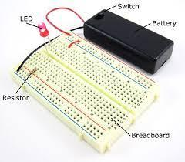

**SOFTWARE REQUIREMENT SPECIFICATION:**

**The flow:**

* In the scenario of a mine collapse or a gas leak of carbon monoxide , The gas sensors of the helmet will read the abnormal quantities of the gases based on which the Individual warning system of the helmet would go off warning the miner to equip his gas mask in the form of a Red Led and a loud buzzer .
* The miner will know that the mining environment is not safe and thus will try to evacuate in a concise amount of time thanks to the warning he will receive by the helmet.
* At the same time the Helmet which has the MCU embedded to it will broadcast an SOS message to all other nearby nodes or helmets (using ESP Now ) telling them to evacuate the area and get help based on the seriousness of the situation.
* The helmets that receive the warning will now act as a broadcast point for other helmets to warn them, In layman terms setting up a chain reaction of warnings letting all the miners in the area be aware of the warning and telling them to evacuate, Thus saving a lot of lives in the process. All of this will be materialised in using the ESP Now Broadcast mode

**FLOWCHART/ALGORITHMS:**

**ACTIVITIES:**

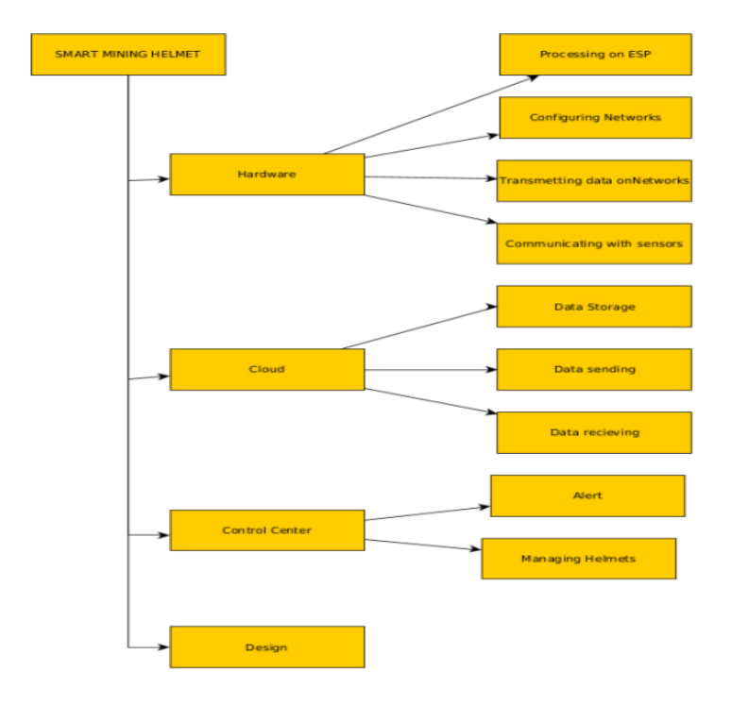

**CONTROL STRUCTURE:**

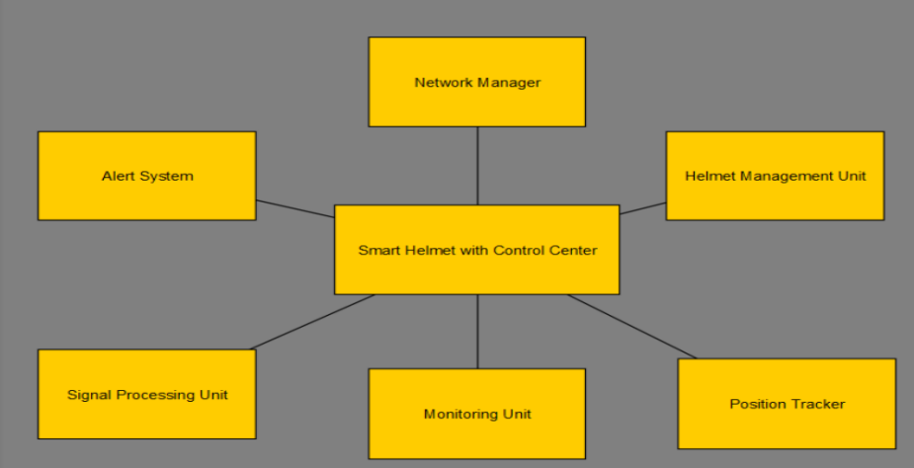

**SCHEMATIC VIEW:**

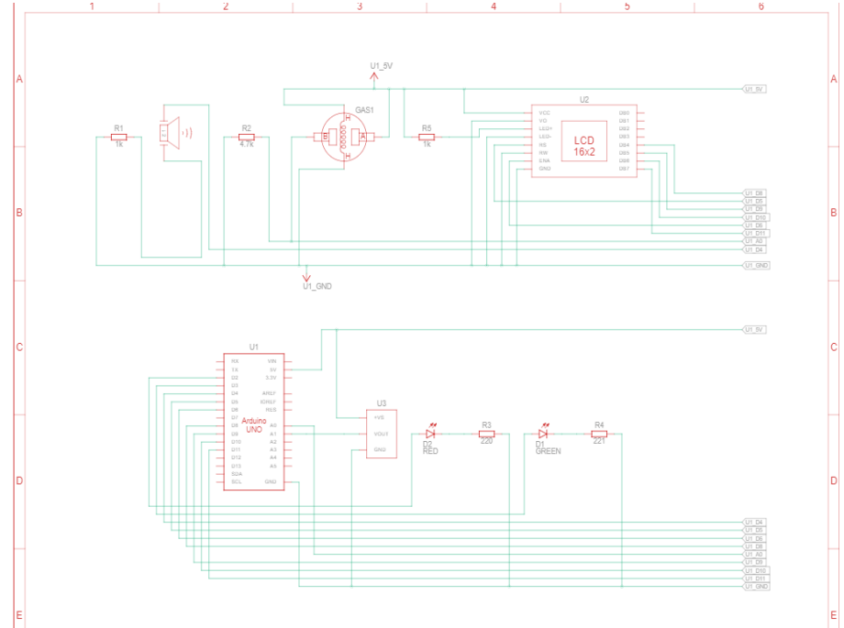

**CONCERNED WORK:**

In this section we illustrate the solution to the above specified domain of work. That is a smart helmet based on various functionalities with broadcasting abilities. The entire workflow can be divided into 3 Sections:

1. **The Node/ Individual Helmet:**

The central Node of the entire project or perhaps the most important one of all the three. The Node will be an improvement of the already available industry-based safety helmet for mining, notably the Rachet type build with a flashlight. HDPE, Polypropylene Plastic will be the Material with which the helmet will be made, it has been approved by ISI For Indian mining standards and is already in use in many parts of the world. The On-Board-flashlight will be having its own power source, possibly a Secondary Cell/Battery of 9volts or more.

In addition to being highly durable and easy to wear, The Helmet will be supporting the following entities on its body:

• An ESP 8266 Microcontroller with ESP Now

• An MQ135 Gas sensor

• A DHT11 Temperature and Humidity

• A Multicolor LED Supporting at least two colors(RGB 5mm Preferable)

• A Section of EPE Foam Sheet for Protecting the MC And other sensors

• Active Buzzer Module (3.3 to 5 Volts)

• An LED Display (Optional)

• A Suitable Flashlight

• An Inbuilt Silicone Purifier/Respirator

1. **The Server Side:**

The server side or the administration will be constantly able to monitor the situation of any miner who wears the smart helmet. These include the current Gas concentration near the helmet/miner, The temperature of that particular area and the humidity

The Server side will have a GUI Interface and wireframe to provide a convenient Dashboard with maximum functionalities and Database integrations with the cloud. The databases will store the current and as well as the past behaviors of the mine based on the parameters the helmet can collect data of(Notably The temperature, Humidity, Gas concentrations) which can also be used for later analysis or simply data collection. The dashboard will preferably be built using Flex Dashboard which runs on R (A very well-known Statistically Specialized Programming Language) , The dashboard will be aimed to provide a very concise yet informative view of the mine and its behavior based on which the administrator will take decisions. As a whole the server side will be designed for data collection, monitoring and special provisions for Emergency Services in case of any adversity in the mine or on the miner.

1. **The Network:**

All of these above nodes/Helmet will be equipped with a microcontroller( ESP8266 as mentioned above), these boards have inbuilt WIFI and BLE modules to support wireless communication. The aim will be to materialise a Wireless Ad-Hoc Network of Sensors (WASN) Using an inbuilt protocol on the ESP82 Board which is known as ESP Now.

**ESP Now:**

ESP-NOW is yet another protocol developed by Espressif, which enables multiple devices to communicate with one another without using Wi-Fi. The protocol is similar to the low-power 2.4GHz wireless connectivity that is often deployed in wireless mouses. So, the pairing between devices is needed prior to their communication. After the pairing is done, the connection is secure and peer-to-peer, with no handshake being required. Different from traditional Wi-Fi protocols, the first five upper layers in OSI are simplified to one layer in ESPNOW, so the data does not need to go through the physical layer, data link layer, network layer, transport layer in turn, which reduces the delay caused by packet loss under congested network, and leads to a quick response time.

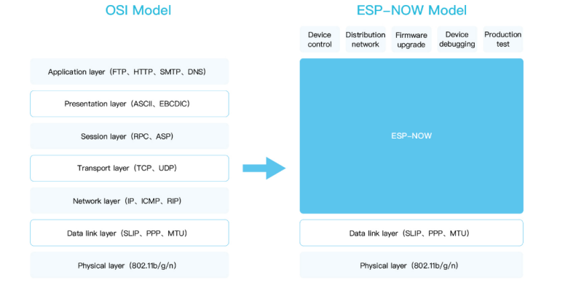

The data transmission mode of ESP-NOW is flexible including unicast and broadcast, and supports one-to-many and many-to-many device connection and control. ESPNOW can be also used as an independent auxiliary module to help network configuration, debugging and firmware upgrades.

There are two roles defined in ESP-NOW according to the data flow, initiator and responder. The same device can have two roles at the same time. Generally, switches, sensors, LCD screens, etc. play the role of initiator in an IoT system, when lights, sockets and other smart applications play the role of responder.

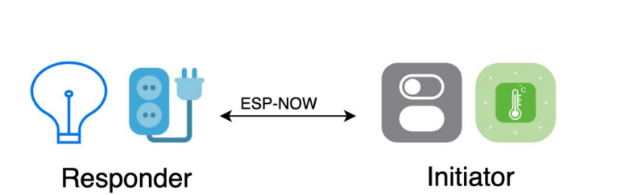

**Broadcast Mode:**

Specifically with the ESP Now we will be using the ESP Now Broadcast mode to configure the helmets, The Broadcast mode allows the nodes to act as both a Sender and a receiver of the packet that is concerned.

LMK of the paired device is used to encrypt the vendorspecific action frame with the CCMP method. The maximum number of different LMKs is six. If the LMK of the paired device is not set, the vendor-specific action frame will not be encrypted.

**METHODOLOGY:**

Constantly monitor the concentration of some specific gases that are known to be harmful to the miner’s health such as carbon monoxide, Alcohol, Benzene, etc. and keep processing their concentrations to check if it's below a safe threshold or not, in case it is harmful for the miner, a proper response/alert must be given to him as well as in the control centre about the condition of the area and also give a mechanism to alert all the nearby workers.

**PROPOSED OUTCOME:**

The proposed project will be made using mq135 sensor to get the concentration of the gases present in the air and will be processed on an esp-32-wroom-32 microprocessor.

Basically materialising a safety system for the miner embedded in his helmet, telling him if the area he is working on is safe for him or not, and also inform the central server about the same.

**NOVELTY OF THE PROPOSED PROJECT:**

The response and the alert in case of some hazardous event highly depends on the general layout of the mine, and hence the solution or the design for it is unique depending to the targeted location or structure of the mine which may use different hardware depending on the physical constraints presented in the working environment.

There have been projects which can detect gases in a mine but they are used only for data collection and survey purposes but in this given project we will be using real time computation to tell the miner if he is safe or not, all of this via his helmet and no additional load.

**RELEVANCE IMPORTANCE OF PROPOSED PROJECT:**

To the public and to the mining industry. There haven’t been much innovations to improve the conditions of the miners despite the fact that it is one of the most hazardous workplaces to be in.

The life of a miner is at risk all the time, we are set to diffuse this issue with the help of this project to some extent.

Even one life saved would justify all the time and effort invested in this project

Rather than going for a project that maximises profits in other domains

The project will be a great help in ensuring the safety of all the miners working in the mining field, and hence will be highly relevant to the miners and their family.

**APPLICABILITY OF THE PROJECT:**

The applicability of a project depends on how economical it is to materialise and also on the ease of use it offers to the industry it is introduced to.

The proposed project will be made using mq135 sensor to get the concentration of the gases present in the air and will be processed on an esp-32-wroom-32 microprocessor.

Which is quite economical considering all the other options available in the market, also all of the mechanisms and workings of the entire project will be embedded in the helmet of the miner which means that he does not need to carry any additional load or any technical expertise to be safe.

**Short Term Applicability:**

Can help in saving lives of many miners in case of some emergencies.

**Long Term Applicability:**

Based on the frequency of the hazardous gases leaked, a proper evacuation route could be made for some particular locations based on the past records of alert in the mine.

**GAP IDENTIFIED:**

The embedded software for the wearable device will vary depending on the structure of the mine and the kind of alert we plan to issue and hence the model could vary vastly depending on the general layout of the mine and hence will affect the availability and economical factor of the final product.

**SCREENSHOT OF STIMULATED OUTPUTS:**

**TINKERCAD SIMULATION:**

**SAFE:**

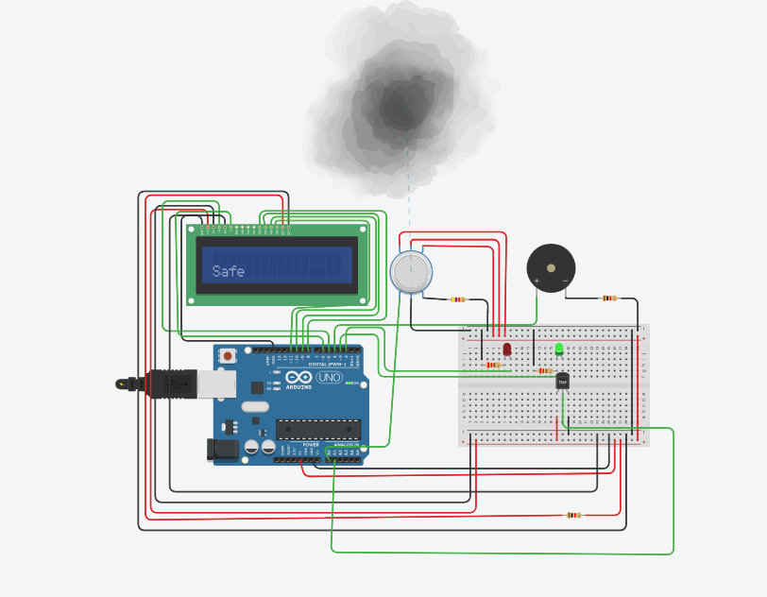

**IN HIGH GAS CONCENTRATION(UNSAFE):**

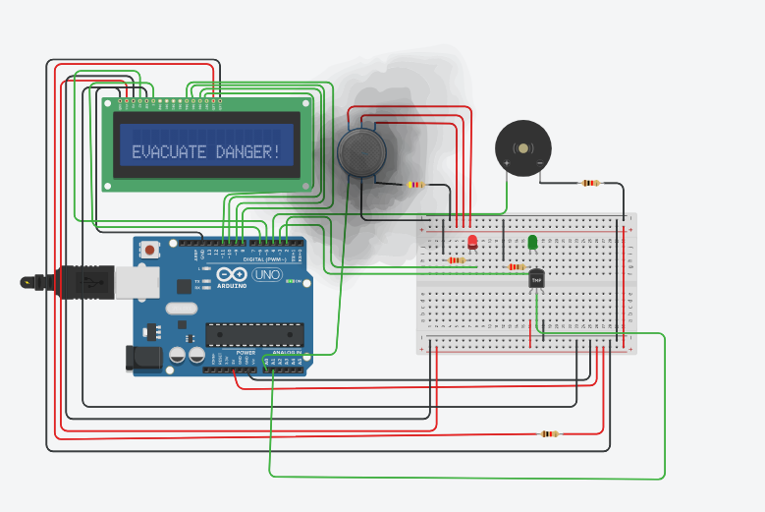

**IN HIGH TEMPRATURE(UNSAFE):**

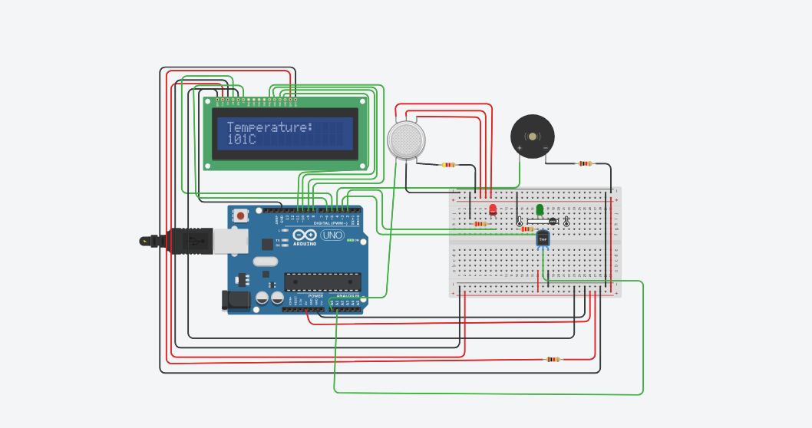

**SPACE TAKEN ON BOARD:**



**ARDUINO IDE SCREENSHOTS OF REAL TIME DATA (DATA IS RECEIVED AFTER EVERY 18 SEC):**

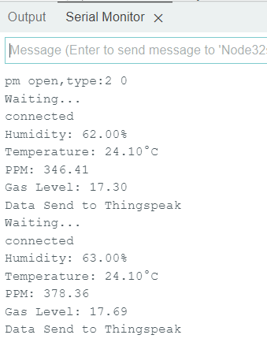

**AFTER SOME TIME:**

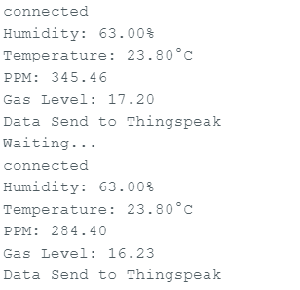

**UPDATION OF DATA IN DATABASE:**

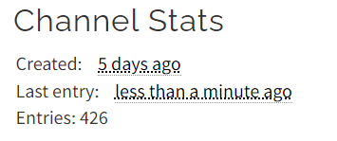

**TOTAL ENTERIES: 426**

**CHANGE IN TEMPRATURE:**

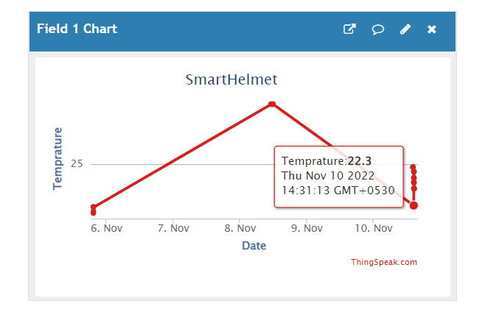

**CHANGE IN HUMIDITY:**

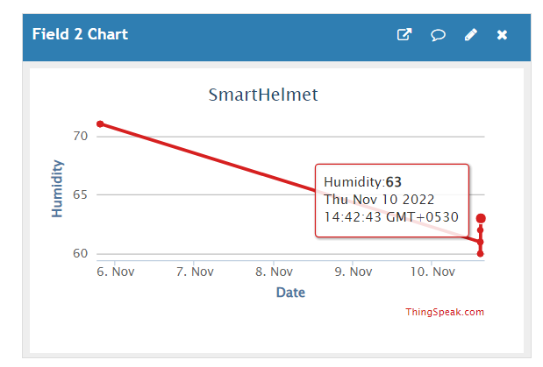

**CHANGE IN PPM:**

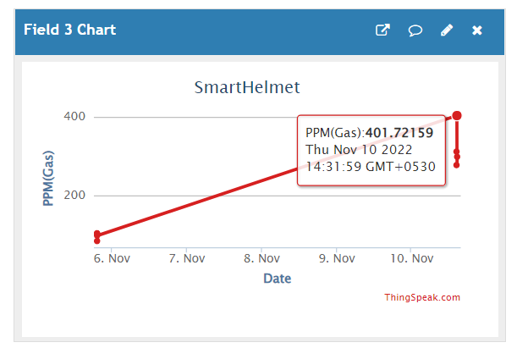

**CHANGE IN GAS LEVEL:**

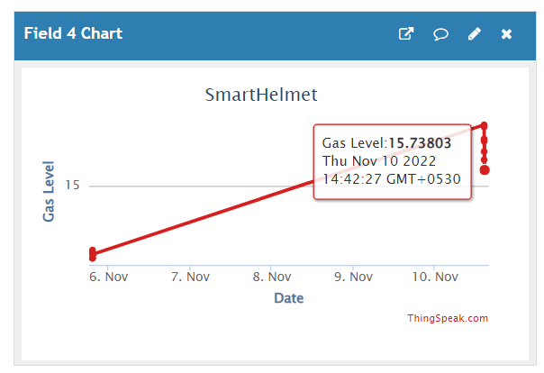

**UPDATION OF DATA EVERY 10 SEC ON TO THE SERVER SIDE:**

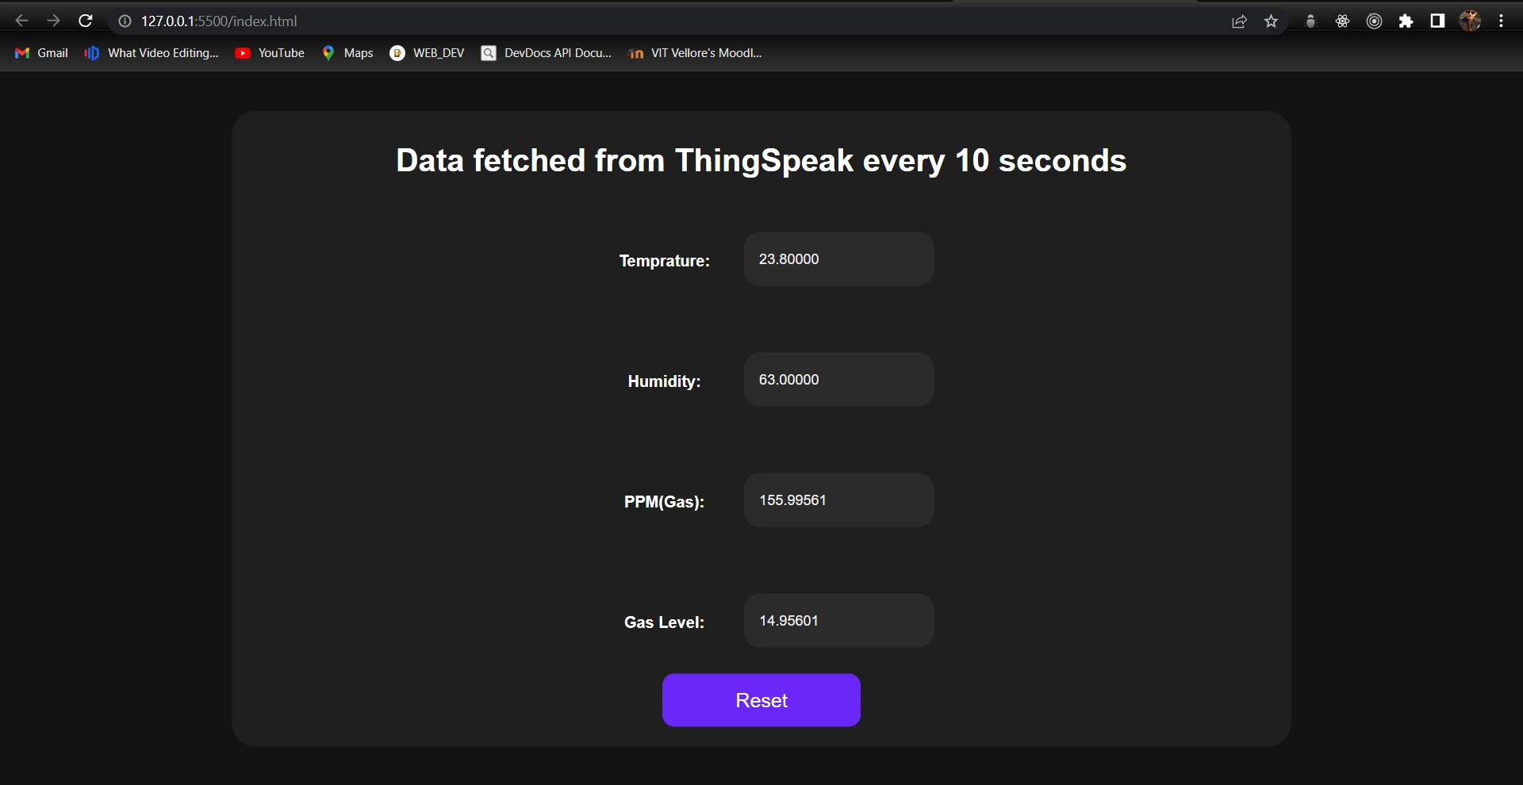

**AFTER SOME TIME:**

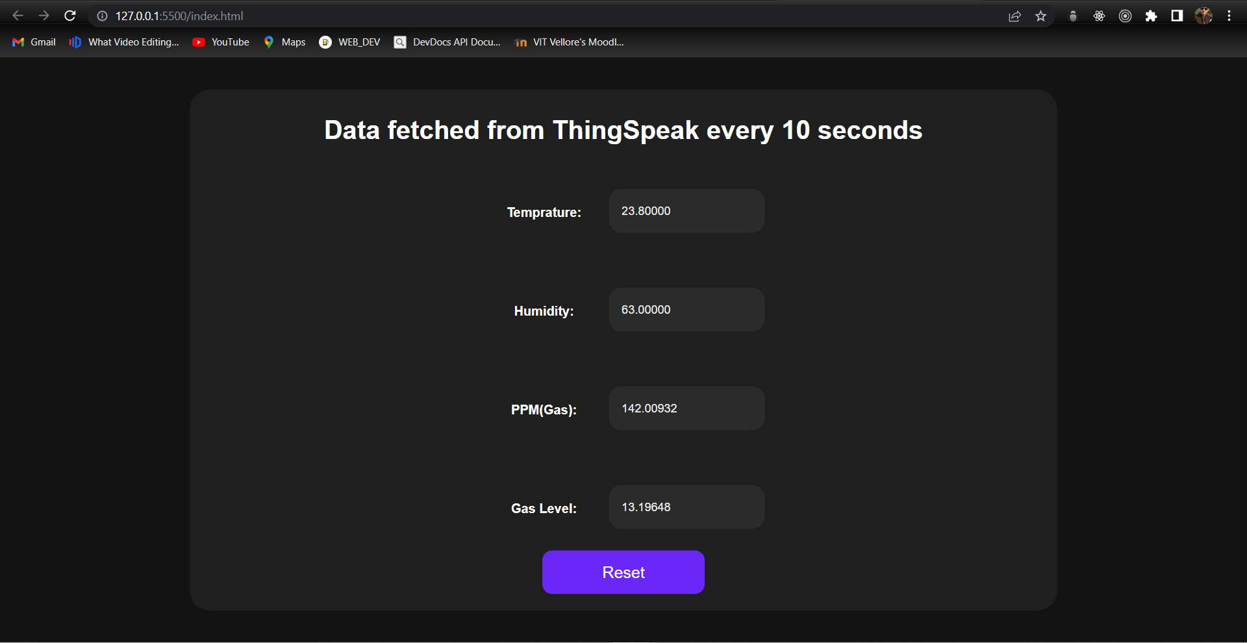

**PHOTOGRAPHS OF HARDWARE PROJECT:**

**CIRCUIT:**

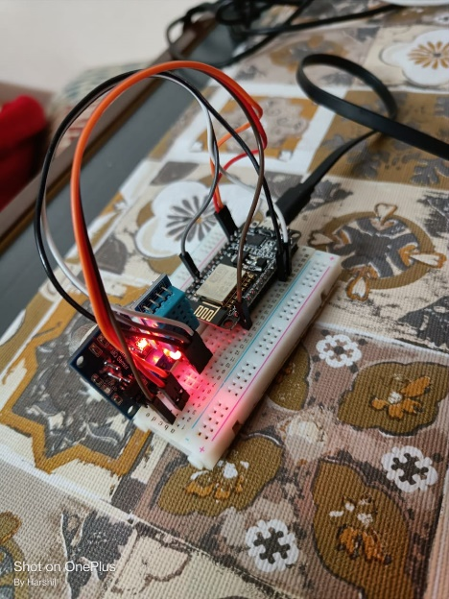

**HELMET:**

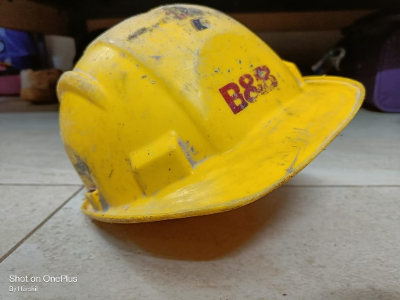

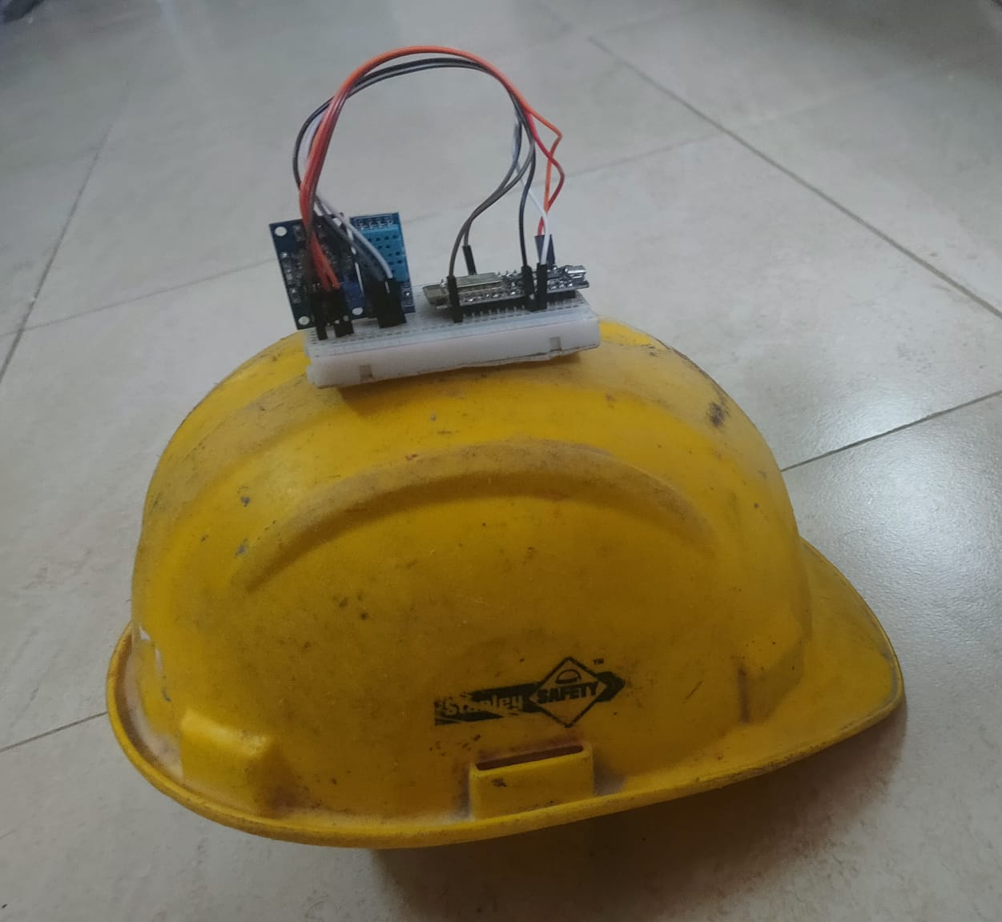**FINAL PROJECT(ASSUMPTION):**

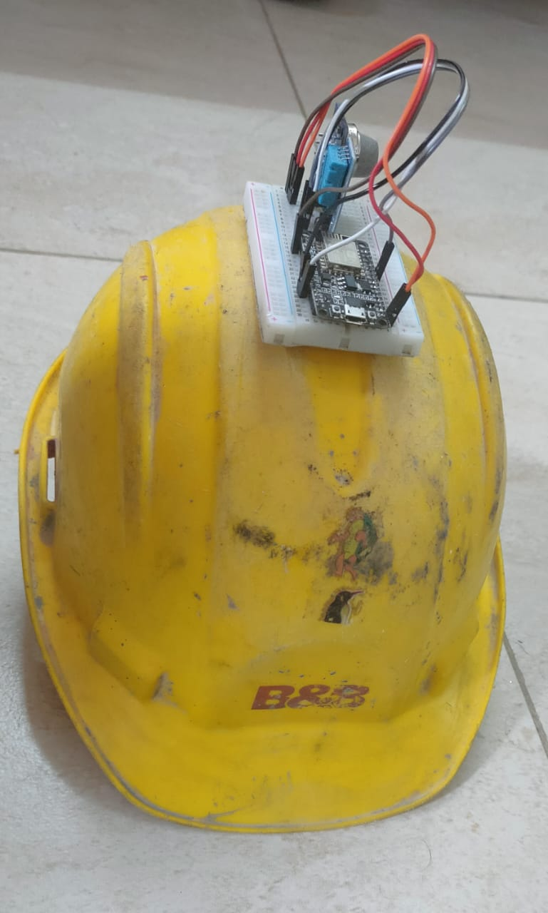

**SUMMARY OF PROJECT:**

**Background of work:**

The main purpose of the work is to design a smart helmet system for mining industry.

It will constantly monitor the different concentration of the gases in the environment of the miner and will alert him as well as the control centre of any hazardous event such as gas leaks or mine collapses in which case the miner is left completely alone and unaware, a small example being

Carbon monoxide which is a completely tasteless gas and also has no smell but one of the most poisonous and harmful gases that exists in a mining environment, which means that a miner cannot detect the gas on his own using his natural senses of smell or taste. In these situations, it becomes absolutely necessary that there must be some mechanism to save his life, this is where our device comes in, The **MINECO** smart helmet.

**CONCLUSION AND FUTURE WORK:**

Main significance of this project is in mining sector and the lack of a wearable device / assistant to the miner, where we can monitor the real time status of the mining environment around the miner and can raise appropriate alert to others depending on if some hazardous situation has occurred thus adding the necessary safety lacking in the current industry for the miners.

The given project is in its genesis or origin state which means that there will be a vast scope of improvement in it with time given that a community collaborates on this and highlights shortcomings and suggests improvements on the same making the product feasible Since the product greatly depends on the layout or structure of the mine, we can work towards making it more flexible or general in nature in future.

**ACKNOWLEDGEMENT:**

We would like to express my deep and sincere gratitude to my research supervisor Prof. Dr. SHOBHA REKH - SCOPE, Vellore Institute of Technology. For us, who were completely new to the research community, He has provided us invaluable guidance. She taught us the methodology to carry out the research and to present the work as clearly as possible. We are grateful for what she has offered us. Her sincerity and motivation have deeply inspired us.