

**DIGITAL ASSIGNMENT : BCD COUNTER USING ARDUINO**

**CSE2006 - MICROPROCESSOR AND INTERFACING(L39-40)[MRS SHOBHA REKH]**



**October 29, 2022**

**ANIRUDH VADERA**

**20BCE2940**

**Explanation:**

High – 5V

Low – GND

CONNECTIONS:

7 Segment Display - IC

PinA – Port 6

PinB – Port 7

PinC – Port 8

PinD – Port 9

PinE – Port 10

PinF – Port 11

PinG – Port 12

GND - Port GND

**Delay – 1000ms or 1 sec**

**Every 1 sec our counter proceeds further**

The code is written in loop function so the code will loop once it’s over.

**Screenshot of Embedded C Code in Tinkercad editor:**

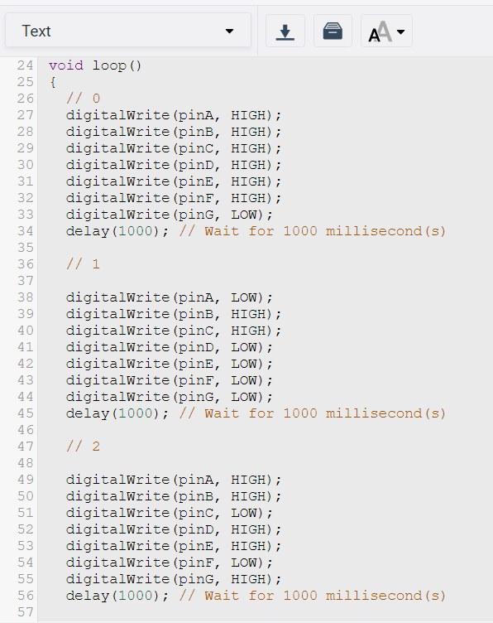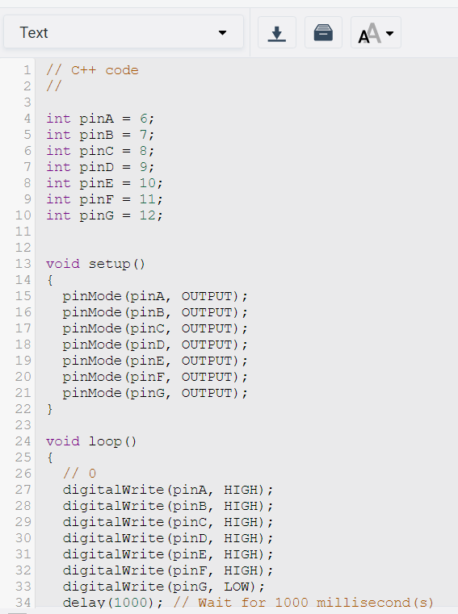

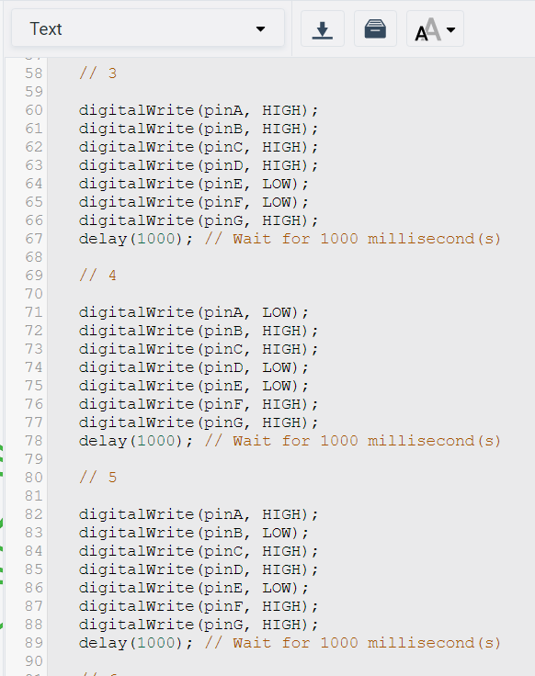

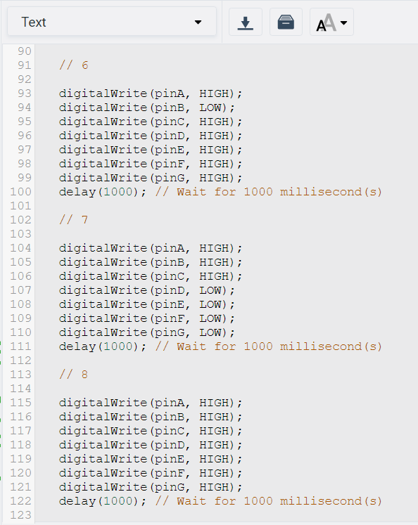

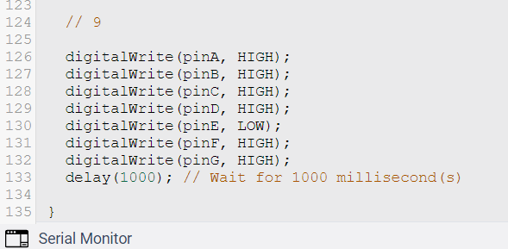

**Embedded C Code:**

// C++ code

//

int pinA = 6;

int pinB = 7;

int pinC = 8;

int pinD = 9;

int pinE = 10;

int pinF = 11;

int pinG = 12;

void setup()

{

pinMode(pinA, OUTPUT);

pinMode(pinB, OUTPUT);

pinMode(pinC, OUTPUT);

pinMode(pinD, OUTPUT);

pinMode(pinE, OUTPUT);

pinMode(pinF, OUTPUT);

pinMode(pinG, OUTPUT);

}

void loop()

{

// 0

digitalWrite(pinA, HIGH);

digitalWrite(pinB, HIGH);

digitalWrite(pinC, HIGH);

digitalWrite(pinD, HIGH);

digitalWrite(pinE, HIGH);

digitalWrite(pinF, HIGH);

digitalWrite(pinG, LOW);

delay(1000); // Wait for 1000 millisecond(s)

// 1

digitalWrite(pinA, LOW);

digitalWrite(pinB, HIGH);

digitalWrite(pinC, HIGH);

digitalWrite(pinD, LOW);

digitalWrite(pinE, LOW);

digitalWrite(pinF, LOW);

digitalWrite(pinG, LOW);

delay(1000); // Wait for 1000 millisecond(s)

// 2

digitalWrite(pinA, HIGH);

digitalWrite(pinB, HIGH);

digitalWrite(pinC, LOW);

digitalWrite(pinD, HIGH);

digitalWrite(pinE, HIGH);

digitalWrite(pinF, LOW);

digitalWrite(pinG, HIGH);

delay(1000); // Wait for 1000 millisecond(s)

// 3

digitalWrite(pinA, HIGH);

digitalWrite(pinB, HIGH);

digitalWrite(pinC, HIGH);

digitalWrite(pinD, HIGH);

digitalWrite(pinE, LOW);

digitalWrite(pinF, LOW);

digitalWrite(pinG, HIGH);

delay(1000); // Wait for 1000 millisecond(s)

// 4

digitalWrite(pinA, LOW);

digitalWrite(pinB, HIGH);

digitalWrite(pinC, HIGH);

digitalWrite(pinD, LOW);

digitalWrite(pinE, LOW);

digitalWrite(pinF, HIGH);

digitalWrite(pinG, HIGH);

delay(1000); // Wait for 1000 millisecond(s)

// 5

digitalWrite(pinA, HIGH);

digitalWrite(pinB, LOW);

digitalWrite(pinC, HIGH);

digitalWrite(pinD, HIGH);

digitalWrite(pinE, LOW);

digitalWrite(pinF, HIGH);

digitalWrite(pinG, HIGH);

delay(1000); // Wait for 1000 millisecond(s)

// 6

digitalWrite(pinA, HIGH);

digitalWrite(pinB, LOW);

digitalWrite(pinC, HIGH);

digitalWrite(pinD, HIGH);

digitalWrite(pinE, HIGH);

digitalWrite(pinF, HIGH);

digitalWrite(pinG, HIGH);

delay(1000); // Wait for 1000 millisecond(s)

// 7

digitalWrite(pinA, HIGH);

digitalWrite(pinB, HIGH);

digitalWrite(pinC, HIGH);

digitalWrite(pinD, LOW);

digitalWrite(pinE, LOW);

digitalWrite(pinF, LOW);

digitalWrite(pinG, LOW);

delay(1000); // Wait for 1000 millisecond(s)

// 8

digitalWrite(pinA, HIGH);

digitalWrite(pinB, HIGH);

digitalWrite(pinC, HIGH);

digitalWrite(pinD, HIGH);

digitalWrite(pinE, HIGH);

digitalWrite(pinF, HIGH);

digitalWrite(pinG, HIGH);

delay(1000); // Wait for 1000 millisecond(s)

// 9

digitalWrite(pinA, HIGH);

digitalWrite(pinB, HIGH);

digitalWrite(pinC, HIGH);

digitalWrite(pinD, HIGH);

digitalWrite(pinE, LOW);

digitalWrite(pinF, HIGH);

digitalWrite(pinG, HIGH);

delay(1000); // Wait for 1000 millisecond(s)

}

**Circuit Designed From TinkerCad:**

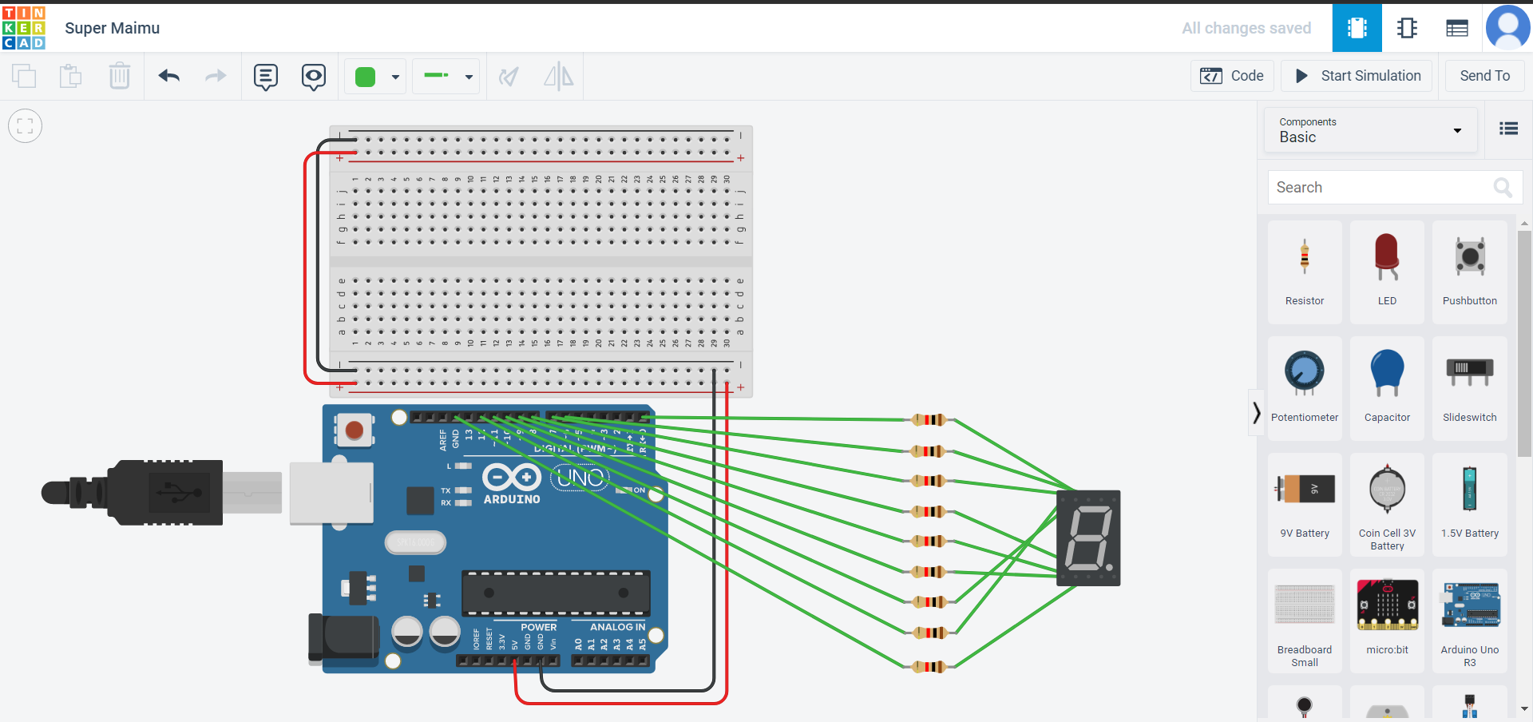

**Simulation of counter progressing as time increases:**

**Time: 2sec, Counter: 2**

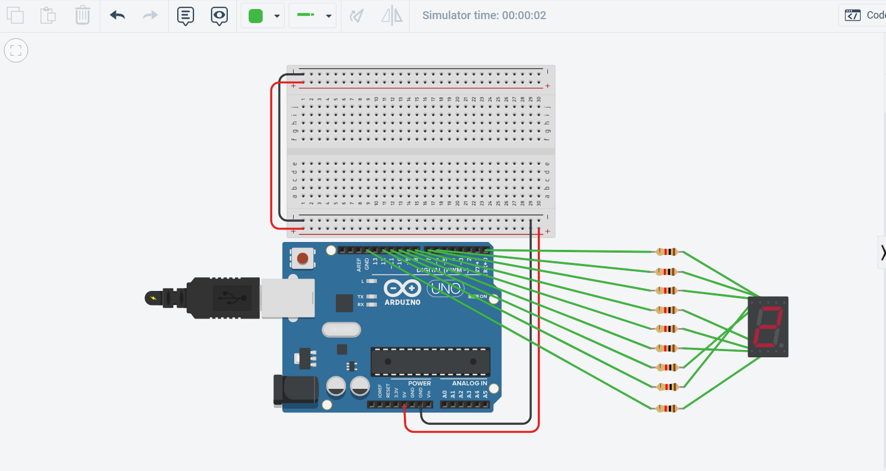

**Time: 5sec, Counter: 5**

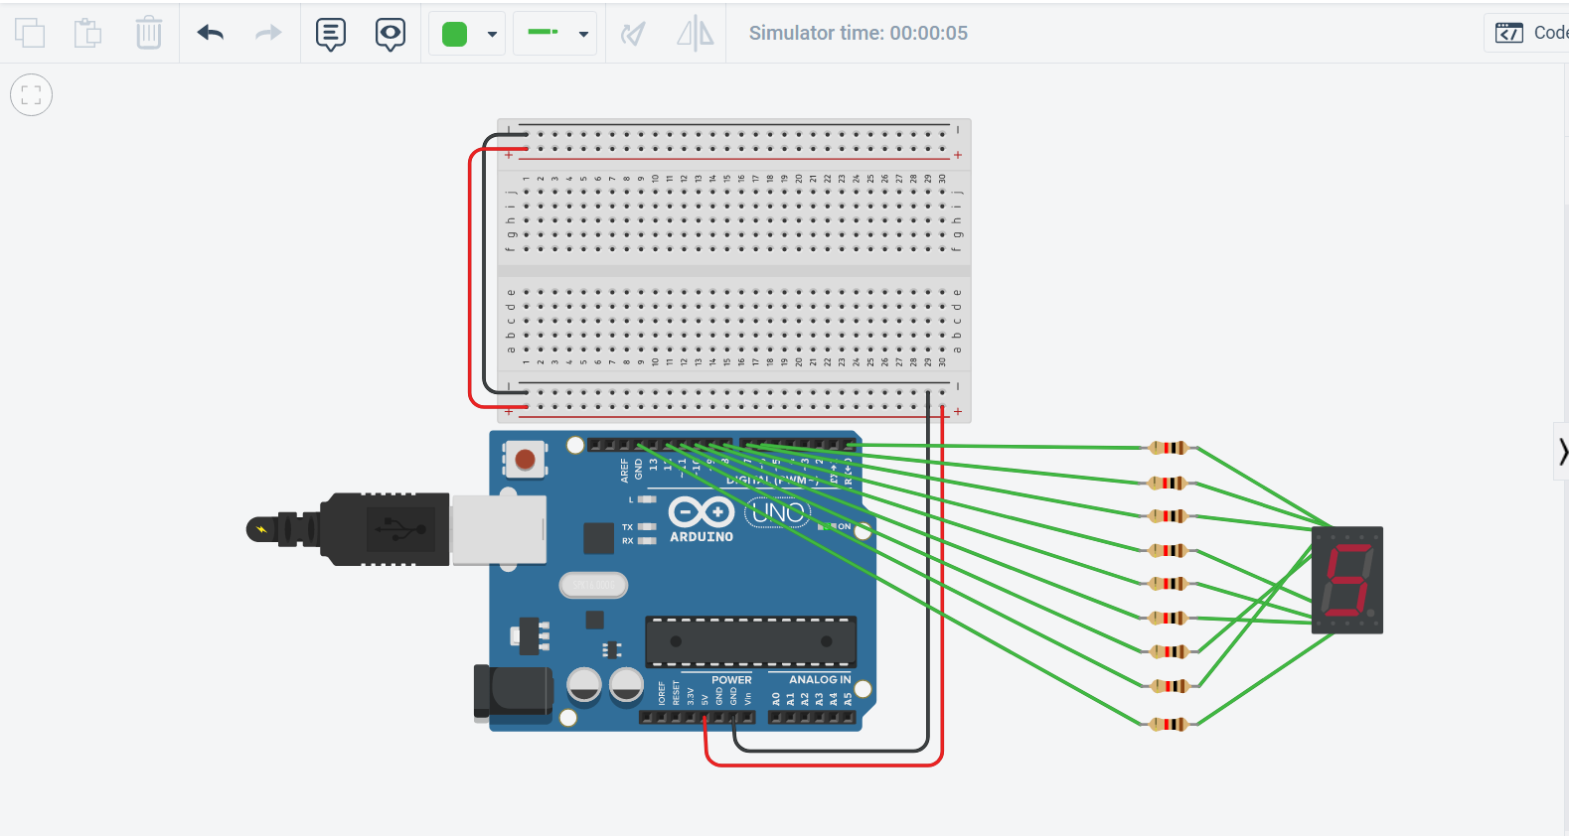

**Time: 9sec, Counter: 9**

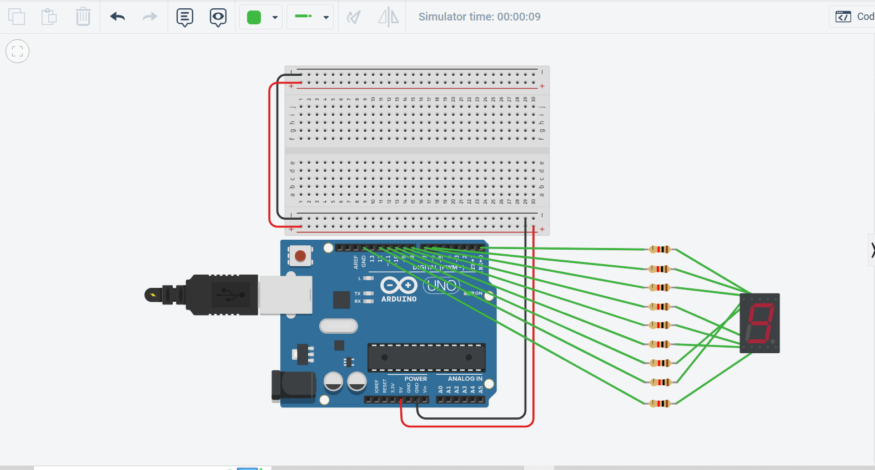

**Time: 1 Min 3sec, Counter: 3**

