

**data pre processing and heirarchical clustering (ASSESSMENT - 5)**

**CSE4020(MACHINE LEARNING)LAB:L49-L50**



**March 9, 2022**

**ANIRUDH VADERA**

**20BCE2940**

**QUESTION:**

1. **Perceptron:**

Construct a perceptron to train AND and OR logic gates.

**Expected Output**

**-----------------------**

1. **Initial Weight**
2. **Actual and Predicted Value of training samples**
3. **Final Weight**
4. **Error**
5. **Multi-Layer Perceptron Network**

Train a MLP using back propagation network to classify cars based on its specification. Perform the result analysis on test samples.

**Expected Output**

**-----------------------**

1. **Initial Weight**
2. **Final Weights**
3. **Actual and Predicted Value of training samples**
4. **Precision, recall, error and Accuracy**

**Description:**

**Perceptron:**

Perceptron is Machine Learning algorithm for supervised learning of various binary classification tasks. Further, **Perceptron is also understood as an Artificial Neuron or neural network unit that helps to detect certain input data computations in business intelligence**.

Perceptron model is also treated as one of the best and simplest types of Artificial Neural networks. However, it is a supervised learning algorithm of binary classifiers. Hence, we can consider it as a single-layer neural network with four main parameters, i.e., **input values, weights and Bias, net sum, and an activation function.**

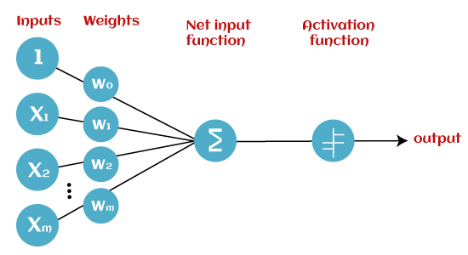

* **Input Nodes or Input Layer:**

This is the primary component of Perceptron which accepts the initial data into the system for further processing. Each input node contains a real numerical value.

* **Wight and Bias:**

Weight parameter represents the strength of the connection between units. This is another most important parameter of Perceptron components. Weight is directly proportional to the strength of the associated input neuron in deciding the output. Further, Bias can be considered as the line of intercept in a linear equation.

* **Activation Function:**

These are the final and important components that help to determine whether the neuron will fire or not. Activation Function can be considered primarily as a step function.

Types of Activation functions:

* Sign function
* Step function, and
* Sigmoid function

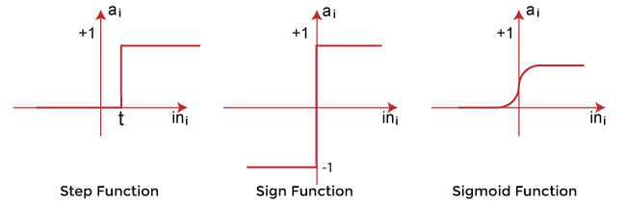

**Types of Perceptron Models**

Based on the layers, Perceptron models are divided into two types. These are as follows:

1. Single-layer Perceptron Model
2. Multi-layer Perceptron model

**Single Layer Perceptron Model:**

This is one of the easiest Artificial neural networks (ANN) types. A single-layered perceptron model consists feed-forward network and also includes a threshold transfer function inside the model. The main objective of the single-layer perceptron model is to analyse the linearly separable objects with binary outcomes.

In a single layer perceptron model, its algorithms do not contain recorded data, so it begins with inconstantly allocated input for weight parameters. Further, it sums up all inputs (weight). After adding all inputs, if the total sum of all inputs is more than a pre-determined value, the model gets activated and shows the output value as +1.

If the outcome is same as pre-determined or threshold value, then the performance of this model is stated as satisfied, and weight demand does not change. However, this model consists of a few discrepancies triggered when multiple weight inputs values are fed into the model. Hence, to find desired output and minimize errors, some changes should be necessary for the weights input.

**Multi-Layered Perceptron Model:**

Like a single-layer perceptron model, a multi-layer perceptron model also has the same model structure but has a greater number of hidden layers.

The multi-layer perceptron model is also known as the Backpropagation algorithm, which executes in two stages as follows:

* **Forward Stage:** Activation functions start from the input layer in the forward stage and terminate on the output layer.
* **Backward Stage:** In the backward stage, weight and bias values are modified as per the model's requirement. In this stage, the error between actual output and demanded originated backward on the output layer and ended on the input layer.

Hence, a multi-layered perceptron model has considered as multiple artificial neural networks having various layers in which activation function does not remain linear, similar to a single layer perceptron model. Instead of linear, activation function can be executed as sigmoid, TanH, ReLU, etc., for deployment.

A multi-layer perceptron model has greater processing power and can process linear and non-linear patterns. Further, it can also implement logic gates such as AND, OR, XOR, NAND, NOT, XNOR, NOR.

**Formula used:**

**Weighted sum:** ∑wi*xi = x1*w1 + x2*w2 +…wn*xn

Add a special term called **bias 'b'** to this weighted sum to improve the model's performance.

**∑wi*xi + b**

An activation function is applied with the above-mentioned weighted sum, which gives us output either in binary form or a continuous value as follows:

**Y = f(∑wi*xi + b)**

**Correcting errors:**

**wi = wi + learning_rate*(outi-output(Error)) * Xij**

**Bias = bias + learning_rate*(output)**

**Question 1:**

**AND GATE:**

**Code:**

import numpy as np

from sklearn.metrics import accuracy_score, precision_score, recall_score,classification_report

x = [ [-1,-1], [-1,1], [1,-1], [1,1]]

x_array = np.asarray(x)

# expected outputs (AND port is the product of each entry

out = np.asarray([-1,-1,-1,1])

m = 2

n = 4

w=[]

for i in range(m):

w.append(0.5)

theta = 0

bias = -1

learning_rate = 1

print("Initial Weights : " , w)

sum = 0

epochs = 10

e = 0

error = [0,0,0,0]

E = 100

pred = []

while E!=0 and e < epochs:

pred = []

E = 0

for i in range(n):

sum = 0

for j in range(m):

sum += x[i][j]*w[j]

sum = sum + bias

if(sum > theta):

output = 1

else:

output = -1

pred.append(output)

error[i] = out[i] - output

for j in range(m):

if(out[i] != output):

w[j] = w[j] + learning_rate*(out[i]-output)*x[i][j]

bias = bias + learning_rate*out[i]

for i in error:

E = E + abs(i)

e = e + 1

print("After " , e , "Epochs : ")

print("Prediction : " , pred)

print("Actual Values : " , out)

print("Error : " , error)

print("The Final Weights are : ", w)

print("The Final Bias is : " , bias)

print("The Final Error is " , "Error Array : ",error,"Error : ",E)]

# Checking the accuracy of our model

print('Accuracy: ',accuracy_score(out,pred))

print('Precision: %.3f' % precision_score(out, pred,average='micro'))

print('Recall: %.3f' % recall_score(out, pred,average='micro'))

# Our Model Report

print('*************** Evaluation on Our Model ***************')

print('Accuracy Score: ', accuracy_score(out,pred))

# Look at classification report to evaluate the model

print(classification_report(out, pred))

print('--------------------------------------------------------')

print("")

**Code Snippets:**

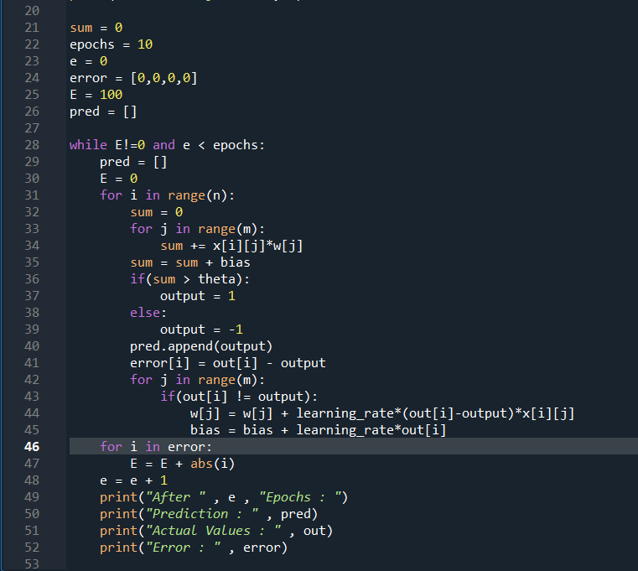

**Output and Results:**

**Required Result:**

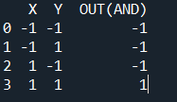

**After several Epochs:**

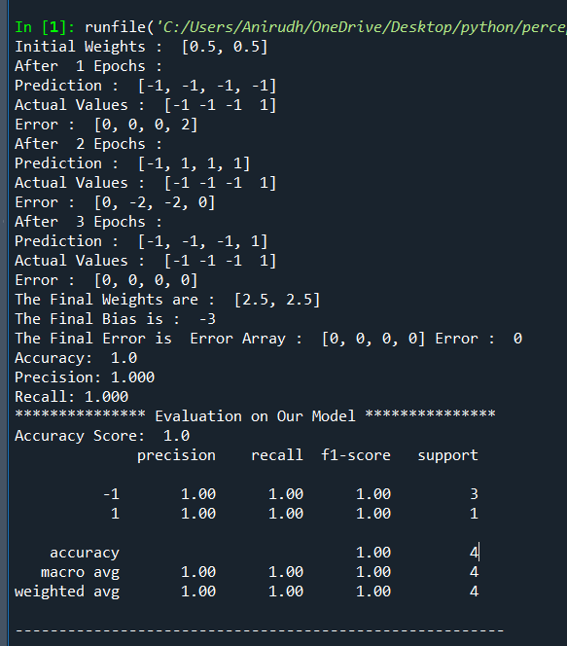

**Initial Weights:**

**C:\Users\Anirudh\OneDrive\Pictures\Screenshots\Screenshot (3268).png**

**Actual and Predicted Values of the Training Samples:**

**After every epochs Predicted and actual values are shown finally they both converge to become same.**

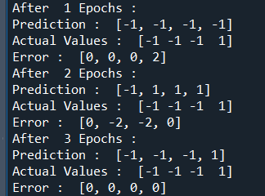

**Final Weights:**

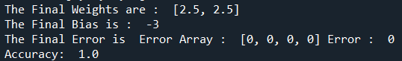

**Accuracy Analysis(Errors):**

**Error after every epoch:**



**Final error:**



**Classification Report(Accuracy,Recall and Precision):**

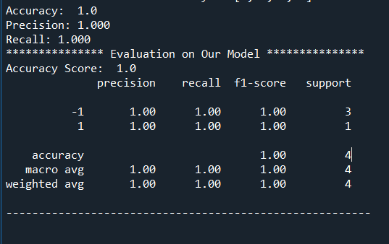

**OR GATE:**

**Code:**

import numpy as np

from sklearn.metrics import accuracy_score, precision_score, recall_score,classification_report

x = [ [-1,-1], [-1,1], [1,-1], [1,1]]

x_array = np.asarray(x)

# expected outputs (AND port is the product of each entry

out = np.asarray([-1,1,1,1])

m = 2

n = 4

w=[]

for i in range(m):

w.append(0.5)

theta = 0

bias = -1

learning_rate = 1

print("Initial Weights : " , w)

sum = 0

epochs = 10

e = 0

error = [0,0,0,0]

E = 100

pred = []

while E!=0 and e < epochs:

pred = []

E = 0

for i in range(n):

sum = 0

for j in range(m):

sum += x[i][j]*w[j]

sum = sum + bias

if(sum > theta):

output = 1

else:

output = -1

pred.append(output)

error[i] = out[i] - output

for j in range(m):

if(out[i] != output):

w[j] = w[j] + learning_rate*(out[i]-output)*x[i][j]

bias = bias + learning_rate*out[i]

for i in error:

E = E + abs(i)

e = e + 1

print("After " , e , "Epochs : ")

print("Prediction : " , pred)

print("Actual Values : " , out)

print("Error : " , error)

print("The Final Weights are : ", w)

print("The Final Bias is : " , bias)

print("The Final Error is : " , "Error Array : ",error,"Error : ",E)

# Checking the accuracy of our model

print('Accuracy: ',accuracy_score(out,pred))

print('Precision: %.3f' % precision_score(out, pred,average='micro'))

print('Recall: %.3f' % recall_score(out, pred,average='micro'))

# Our Model Report

print('*************** Evaluation on Our Model ***************')

print('Accuracy Score: ', accuracy_score(out,pred))

# Look at classification report to evaluate the model

print(classification_report(out, pred))

print('--------------------------------------------------------')

print("")

**Code Snippets:**



**Output and Results:**

**Required Result:**

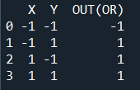

**After several Epochs:**

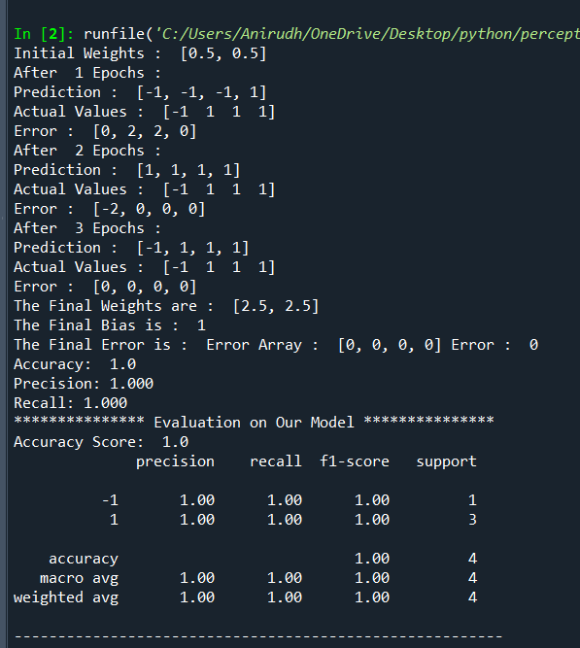

**Initial Weights:**

**C:\Users\Anirudh\OneDrive\Pictures\Screenshots\Screenshot (3268).png**

**Actual and Predicted Values of the Training Samples:**

**After every epochs Predicted and actual values are shown finally they both converge to become same.**

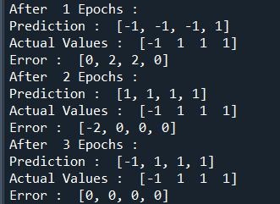

**Final Weights:**

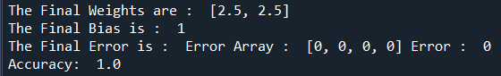

**Accuracy Analysis(Errors):**

**Error after every epoch:**



**Final error:**



**Classification Report(Accuracy,Recall and Precision):**

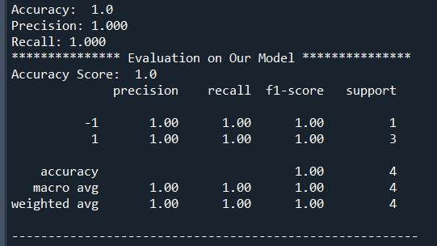

**Inference:**

* **It took 3 epochs for our model to reach the correct results we wanted which means it converged nor too quickly or slowly so the value of learning rate was perfect**
* **After getting the final values of the weights and bias the manual calculations for both AND and OR GATES comes out to be correct with theta as 0.**
* **The accuracy of our model is 100 percent whereas precision is 100 percent and recall is also 100 percent.**

**Question 2:**

**Code:**

import matplotlib.pyplot as plt

import pandas as pd

import numpy as np

from sklearn.model_selection import train_test_split

from sklearn.tree import DecisionTreeClassifier

from sklearn import tree

from sklearn.metrics import plot_confusion_matrix, confusion_matrix, accuracy_score, precision_score, recall_score,classification_report

import seaborn as sns

from sklearn.neural_network import MLPClassifier

# Importing the dfset

df=pd.read_csv("C:/Users/Anirudh/OneDrive/Desktop/car_evaluation.csv")

print(df)

print("\n")

# Check for missing values

print("Checking for missing values :")

print(df.isnull().sum())

print("\n")

# Printing the header of the dfset

print("dfset Header : ")

print(df.head())

print("\n")

# Information regarding the columns

print("Information regarding the columns : ")

print(df.info())

print("\n")

# Information related to the dfset

print("dfset Details : ")

print(df.describe())

print("\n")

# Convert categories into integers for each column.

df.Buying=df.Buying.replace({'low':0, 'med':1, 'high':2, 'vhigh':3})

df.Maint=df.Maint.replace({'low':0, 'med':1, 'high':2, 'vhigh':3})

df.Doors=df.Doors.replace({'2':0, '3':1, '4':2, '5more':3})

df.Persons=df.Persons.replace({'2':0, '4':1, 'more':2})

df.Lug_Boot=df.Lug_Boot.replace({'small':0, 'med':1, 'big':2})

df.Safety=df.Safety.replace({'low':0, 'med':1, 'high':2})

df.Decision=df.Decision.replace({'unacc':0, 'acc':1, 'good':2, 'vgood':3})

# Now let's see the head of our dfframe.

print("After Trimming and correcting the dfset looks like follows : ")

print(df.head())

# Extracting Independent and dependent Variable

X = df[df.columns[:-1]]

Y = df['Decision']

# Splitting the dfset into training and testing set

X_train, X_test, Y_train, Y_test = train_test_split(X, Y, test_size= 0.1, random_state=10)

# Initialize a Multi-layer Perceptron classifier.

mlp = MLPClassifier(solver='lbfgs', alpha=1e-5,random_state=10, max_iter=1000, shuffle=True, verbose=False)

# Train the classifier.

mlp.fit(X_train, Y_train)

# Make predictions.

Y_pred = mlp.predict(X_test)

class_names = ["Unacc","Acc","Good","VGood"]

# Plot confusion matrix for MLP.

mlp_matrix = confusion_matrix(Y_test,Y_pred)

plt.figure(figsize=(8,8))

sns.set(font_scale=1.4)

sns.heatmap(mlp_matrix,annot=True,square=True, cbar=False,linewidth=0.5,fmt="d",cmap="Blues",xticklabels=class_names, yticklabels=class_names)

plt.ylabel('True Label')

plt.xlabel('Predicted Label')

plt.title('Confusion Matrix for Analysis');

# Actual and Predicted Values

print("Actual Values")

print(Y_test)

print("Predicted Values")

print(Y_pred)

print("Prediction of first ten elements : ",list(Y_pred)[0:10])

print("Actual Value of first ten elements: ",list(Y_test)[0:10])

# Checking the accuracy of our model

print('Accuracy: ',accuracy_score(Y_test,Y_pred))

print('Precision: %.3f' % precision_score(Y_test, Y_pred,average='micro'))

print('Recall: %.3f' % recall_score(Y_test, Y_pred,average='micro'))

# Our Model Report

print('*************** Evaluation on Our Model ***************')

print('Accuracy Score: ', accuracy_score(Y_test,Y_pred))

# Look at classification report to evaluate the model

print(classification_report(Y_test, Y_pred))

print('--------------------------------------------------------')

print("")

print('*************** Weights and Bias ***************')

print("weights between input and first hidden layer:")

print(mlp.coefs_[0])

print("\nweights between first hidden and second hidden layer:")

print(mlp.coefs_[1])

print("We can generalize the above to access a neuron in the following way:")

print(mlp.coefs_[0][:,0])

print("w0 = ", mlp.coefs_[0][0][0])

print("w1 = ", mlp.coefs_[0][1][0])

print("w2 = ", mlp.coefs_[0][2][0])

print("w3 = ", mlp.coefs_[0][3][0])

print("w4 = ", mlp.coefs_[0][4][0])

print("w5 = ", mlp.coefs_[0][5][0])

print("Bias values for first hidden layer:")

print(mlp.intercepts_[0])

print("\nBias values for second hidden layer:")

print(mlp.intercepts_[1])

**Code Snippets:**

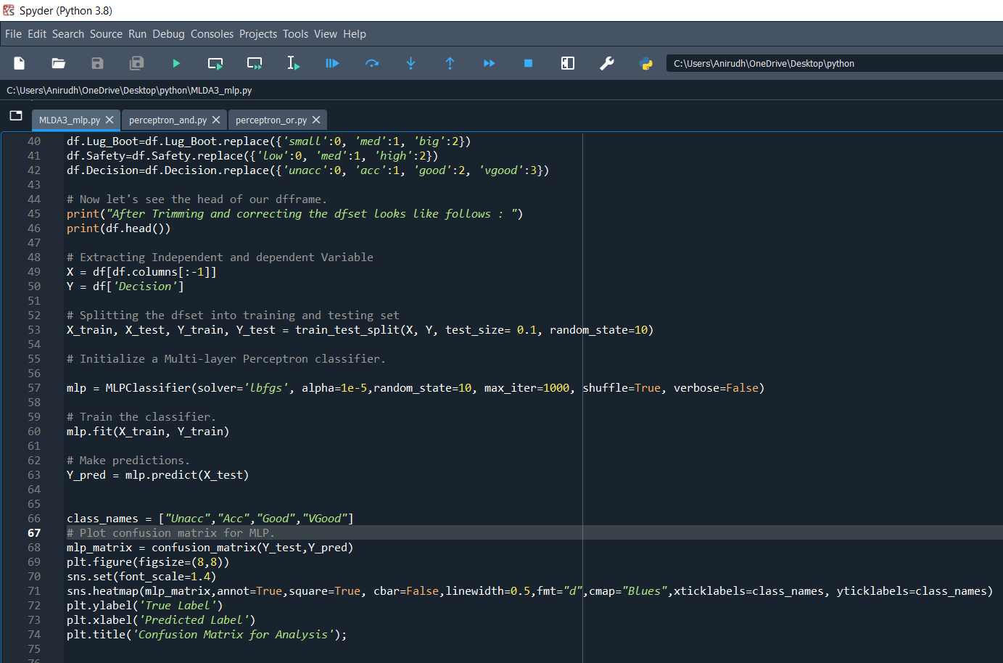

**Output and Results:**

**Dataset Details:**

**Dataset:**

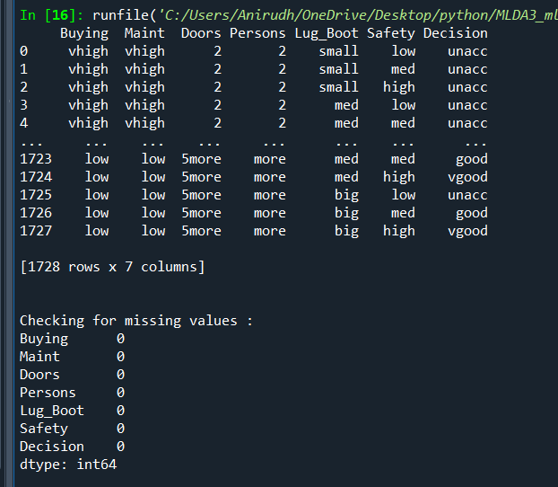

**As the missing values is none we can proceed further:**

**Dataset Details:**

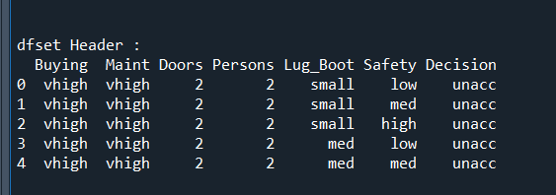

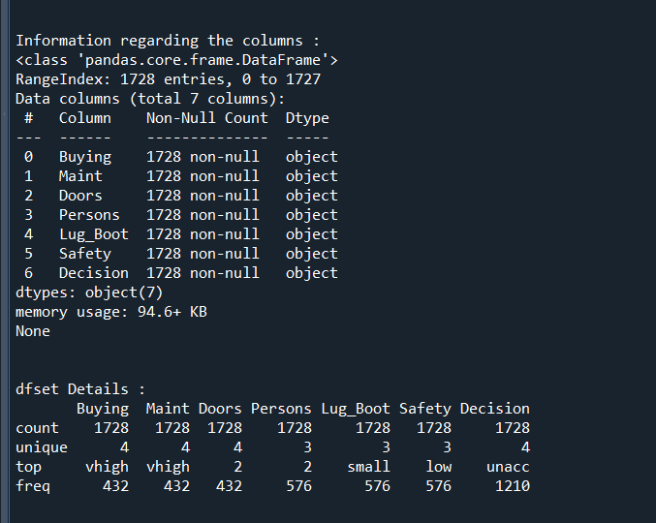

**We convert all the ordinal data into numerical data to perform calculations:**

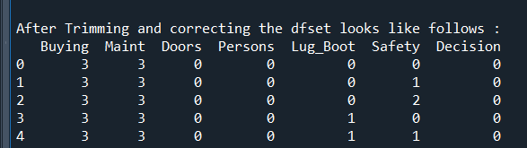

**Weights and Bias:**

**\*\*\*\*\*\*\*\*\*\*\*\*\*\*\* Weights and Bias \*\*\*\*\*\*\*\*\*\*\*\*\*\*\***

**weights between input and first hidden layer:**

[[-5.89006527e+00 -8.61129856e-01 -4.89471304e-01 8.35068418e+00

2.72825035e+00 -3.73319076e-01 -8.84089616e-01 -1.42160270e+00

-2.95354067e+00 -8.58595201e-01 -1.45173328e+00 6.83208485e+00

-1.22462762e+00 -2.90366885e+00 -2.60664498e+00 -5.31222146e-01

-9.32662808e-02 -1.07911801e+00 -1.19994080e+00 -1.22174174e+00

-1.55857552e+00 -3.26966971e+00 -1.14971897e+00 2.60870944e+00

-8.10980153e-01 -1.65791369e+00 1.22767567e+00 3.40736435e+00

2.19969133e+00 -3.09467927e+00 1.17702550e+00 2.69999663e+00

6.61572257e+00 -3.33107663e-01 1.69062724e+00 3.94890963e+00

-1.83709035e+00 -3.93981864e+00 -2.15588687e-01 6.75848382e+00

-4.85867973e-01 2.16596969e+00 -7.03313685e-01 1.49178217e+01

-2.10091881e+00 4.73246344e+00 -2.98778700e-01 -4.86515831e-01

-5.59666378e-01 -3.24067661e-01 1.21802120e+00 -3.24244316e+00

-5.67292801e-01 -1.30565270e-01 -9.96559894e+00 -5.19453135e-01

9.01043636e+00 -3.18694963e+00 4.51513399e+00 -6.89970215e-01

8.07163988e-02 -7.06365644e-02 3.45969453e-01 1.91867691e+00

-1.73178081e+00 -8.40437987e-01 -6.31722605e-02 -2.56769567e+00

1.14630832e+01 -2.40074167e+00 9.18829046e-01 2.56421526e-01

2.98802216e+00 -3.85339653e-01 -1.21542443e+00 -7.77992835e-02

3.20765101e+00 -1.70009988e+00 1.10210625e+00 -3.92495055e-02

-5.40627220e-01 2.65513459e+00 -2.04298859e+00 2.68992657e+00

3.62359494e+00 -1.73403142e+00 -1.47628832e+00 -2.14151149e-01

-1.02277714e+00 -5.38585218e-01 1.79985894e-02 -6.31266838e-01

-2.07331226e-01 5.77079829e+00 -2.88504804e-01 -2.11229018e+00

9.03794468e+00 -1.54942271e-01 -8.64665836e-02 9.41949134e-03]

[ 4.34501512e+00 -7.90194133e-01 -2.07197555e-01 8.76576256e+00

2.15966832e+00 -4.45404052e-01 9.35702635e-01 -3.59729212e-01

-4.48937278e+00 -9.17580819e-01 -3.13060459e-01 8.79853708e-01

-1.78492893e+00 -5.53037256e-01 -1.62047236e+00 -2.89281437e-01

-1.23298517e+00 -1.22232185e+00 1.16366880e+01 -5.64467875e-01

-4.32652530e+00 5.80309384e+00 -1.02599964e+00 2.67777464e+00

-2.56264238e-01 -6.22117845e-01 -2.15787496e+00 3.73975603e+00

1.57463833e+00 -2.12690952e+00 3.41011908e+00 2.49605983e+00

5.09424026e+00 -8.94729240e-01 -1.30346943e+00 -1.11919329e+00

-2.95136158e+00 6.68741112e+00 -2.30831695e-01 7.46967165e+00

-5.46885562e-01 4.52734338e+00 -1.38689622e+00 1.37136385e+01

4.42072594e-01 -5.05495017e-01 -1.87206278e-01 -2.92630778e-01

-8.55061542e-01 -2.40824393e-01 5.85434365e+00 -2.54602702e+00

-2.45953592e-01 -2.15107517e+00 -4.79072840e+00 -2.51953476e-01

7.49807403e+00 -1.64662814e+00 4.72538967e+00 -8.78557305e-01

-9.71098710e-02 -2.39947956e-01 -4.85296592e+00 1.54003788e+00

-3.34077575e+00 -1.12486062e+00 -1.86734096e+00 -3.71192685e+00

8.67179536e+00 -1.60770944e+00 -1.32664642e-01 -8.34752488e-01

2.82482873e+00 -5.27770742e-01 -1.82540740e+00 3.78933889e-01

2.08198395e+00 -6.06832921e-01 1.47206551e+00 -4.83776015e-02

-4.85260435e-01 4.37364617e+00 -3.66340235e-01 2.72479181e+00

9.98527746e+00 4.67101405e+00 -1.19887436e+00 -3.16775779e-01

-2.00393887e-01 -3.07021360e-01 -1.94452421e-01 -1.50089085e+00

-2.01224590e-01 3.16366714e+00 -4.83466269e-01 -1.67600405e+00

5.87043679e+00 2.00708544e+00 -7.07932576e-02 -1.93442824e-01]

[-5.58786554e-02 -6.60908308e-01 -1.83823868e+00 -1.51031988e+00

4.33250987e+00 -5.76530189e-01 2.17728216e+00 -1.49131270e+00

9.71979058e-01 -1.14224976e+00 -3.11768106e-01 -8.96592163e-01

-2.66144116e+00 6.37912219e-01 -3.66731875e+00 -2.59339270e+00

-7.02502842e-01 -1.01260987e+00 3.63826114e-01 -3.39290379e-01

3.25026172e+00 -1.67235213e+00 7.84494454e-01 -5.21714435e-01

5.39920285e-01 5.83279189e-03 -5.03518400e-01 2.02871182e+00

2.00063856e+00 2.51088400e+00 -2.49610439e-01 8.66839837e-01

3.98445897e+00 -1.34378964e+00 -8.87172805e-03 7.77489409e-01

-3.39011255e+00 -1.57498079e+00 5.33312229e-03 -4.52450961e+00

-9.71295886e-02 -4.12063402e+00 -1.81466420e+00 2.15770403e-01

6.21023960e-01 1.37957840e+00 3.73090759e-03 -2.91614640e-01

-1.67843662e+00 -3.62534471e-01 4.55305643e+00 4.84620953e-01

-5.82294813e-01 -7.10289490e-01 -4.52851358e+00 -1.34159225e-01

7.90063042e-01 -9.85566049e-01 5.01205141e+00 5.84862699e-01

-1.12573795e-01 -3.28824623e-01 5.44220781e-01 7.74635985e-01

1.25555061e+00 -1.16621079e+00 -1.24196724e+01 -5.78524485e-02

1.89612793e+00 3.29225586e+00 -1.02841738e+00 -2.63327922e+00

1.05044966e+00 -2.00883391e-01 1.34650919e+00 -1.97686211e+00

1.07571602e+00 -8.74898183e-01 4.02198884e-01 -2.33514718e-01

-2.80576520e-01 -1.77343169e+00 2.24254367e+00 3.34746314e-01

2.70437558e-01 7.26552552e-01 -5.88096110e+00 -2.42612666e-01

-4.85125590e-01 -3.96362563e-01 -1.97232822e-01 -1.38477401e+00

-9.29848412e-02 2.59781597e+00 -1.01906822e+00 -1.79811571e+00

-2.29485360e+00 2.11953876e+00 -2.10958215e-01 -9.63579409e-02]

[-2.44585010e+00 -2.92828700e-01 -1.48896691e+00 3.86274566e-01

3.39025605e+00 3.28024313e-01 -1.30338179e+01 -8.28995161e-01

3.74196101e+00 -1.42343366e+00 -5.11774348e+00 -2.34575822e+00

-1.84236693e+00 -5.05677016e+00 -2.89655522e+00 -2.10450754e+00

-8.02807071e-01 6.13630463e-01 1.42701522e+00 -3.28552164e-01

-6.01519684e-01 1.11115815e+00 -8.80891264e-01 6.79839049e+00

-1.63917573e+01 -6.95846911e+00 -6.37851373e-01 -1.87514981e-01

-7.22829388e+00 2.76457627e+00 5.46892280e+00 -1.65692110e+01

-2.58248848e+00 5.74695788e-01 2.14384929e+00 6.49474561e+00

-3.13051700e+00 -8.56080272e-01 5.49564059e-02 1.44406889e+00

-3.04185461e-01 5.91789159e+00 -8.16221959e-01 9.84688167e-01

-2.35061889e-01 1.35641975e+00 -2.36045955e-01 -2.94848476e-01

-8.39276376e-01 -1.22854176e+00 -3.07792826e-01 -4.08123173e-01

-1.38221156e-01 3.98369598e+00 -7.69510271e+00 -5.51513909e-01

-5.82641494e+00 -1.92571163e+00 3.88480074e+00 -3.81071925e-01

-1.96272586e-01 -7.92980610e-01 -4.86370719e-01 -1.32956422e-01

4.80051942e-01 -4.98573772e+00 7.38462588e+00 -4.64307250e+00

5.06340439e-01 2.42928759e+00 -2.97329797e+00 -3.33223419e+00

2.62584948e+00 -2.93406077e-01 8.66603519e-01 -1.56416761e+00

-7.47011115e+00 -2.99284765e-01 1.58741551e+00 -5.14668786e-02

-1.36752488e-01 -1.29341233e+00 8.32907439e-01 -1.00685098e+00

-1.55332026e+00 -3.49417915e+00 -1.07526483e+01 -2.17467367e-01

-8.69864535e-01 1.83703483e-01 -9.09814550e-02 -4.68055576e-01

-2.28696553e-01 -2.53304007e+00 -3.34416153e-01 -1.27144350e+00

-3.26095063e+00 1.03008087e+00 -4.17578199e-02 -1.17438428e-01]

[-1.08624662e+00 4.80251148e-01 2.24445239e-01 -3.51807119e+00

2.33839288e+00 -1.08656257e-01 9.57661479e-01 -7.18677546e-01

5.77320780e+00 -8.51552862e-01 2.97249330e-01 6.94927548e+00

-8.46368257e-01 -1.59549071e+00 -4.82458648e-01 -9.01835202e-01

-2.22643630e-01 -2.12977660e+00 -8.91462819e-01 -4.29206684e-01

-2.36330496e+00 -6.43711254e+00 -1.79184218e-01 -2.84839650e+00

9.02382389e-01 -8.32481574e-01 6.11763633e-01 2.44046456e+00

3.95297335e+00 6.95212396e+00 -4.38659486e-01 2.72884973e+00

3.05480900e+00 6.15326105e+00 1.93981541e+00 -1.74967773e+00

-1.58730773e+00 -6.34446992e+00 -1.00801247e-01 -7.94442259e-01

-1.88293409e-01 -1.34757959e+00 -4.40980772e-01 -2.11532529e+00

1.40225181e-01 2.65246455e+00 -1.86460252e-01 -2.84403545e-01

-4.28918441e-01 -6.44065649e-01 3.94792232e+00 -8.35720761e-01

-2.38226308e-01 5.44020554e-02 -2.29689069e+00 -6.02566034e-02

-2.88852880e+00 2.97993904e-01 3.84188872e+00 -2.87823346e+00

-1.05110119e-01 6.19368063e-02 -7.50816448e-01 2.59091796e+00

1.09162174e+00 -2.79626447e+00 -5.47912984e+00 5.41805393e+00

-9.62254787e-01 -3.82806023e-01 -3.73039201e-01 -2.35122886e+00

5.89566707e-01 -2.04453983e-01 4.89811038e-01 -1.31923773e+00

2.28523234e+00 -4.81137452e-01 2.75609114e-01 -6.95699400e-02

-1.46148145e-01 -1.33599619e+00 -3.48429924e+00 3.95306930e-01

-2.51082260e+00 2.55969917e+00 2.01569956e+00 -1.69060644e-01

-6.29943769e-01 -3.63028230e-01 -8.85958331e-02 -4.76014836e-01

-2.28513369e-01 3.71742247e+00 -2.93777963e-01 -1.10244611e+00

-8.41190787e+00 5.24510094e+00 4.44181958e-03 -9.73081676e-03]

[-3.73983716e+00 -1.61182678e-01 2.76635194e-01 -8.47468746e+00

2.21184938e+00 -5.34748843e-01 1.27314859e+00 -5.06809994e-02

-1.35764517e+01 1.53768664e+00 1.27974254e+00 -3.06004453e+00

1.10915224e+00 6.89939355e-01 -1.36662336e+00 -2.05093923e+00

-1.65859404e+00 -2.08078723e+00 1.84243613e+00 -4.34212164e-01

-1.96298735e+00 4.36236177e+00 -2.43803909e-01 1.39609251e+00

6.60704130e+00 1.92733546e+00 -5.29137090e-01 2.37910630e+00

3.03332568e+00 -1.36539335e+01 -2.57936300e+00 3.81901683e-01

-7.40618982e+00 6.85441078e+00 -1.58372573e-01 -3.00819136e+00

-4.48230642e+00 -8.42750688e+00 -8.43048476e-02 -4.55661896e+00

-1.45337746e-01 7.19720157e-01 1.03438283e-01 -7.94043496e+00

-1.50664842e+00 -5.46385861e+00 2.63728921e-01 -2.94121099e-01

-3.88683236e-01 -2.16442525e-01 4.43489744e+00 6.82038048e+00

-2.21962895e-01 -3.19482911e+00 4.04722467e+00 -8.04316229e-01

-4.38033148e-01 -6.48300612e-01 -4.40750910e-01 -2.07978865e+00

-1.84015828e-01 -5.49211665e-01 -2.73838706e-01 -1.40515786e+01

3.95168977e-01 9.95802167e+00 -1.50620329e+00 -7.23504069e+00

-1.14474001e+01 -6.23496121e+00 -7.90386647e-01 -3.85226522e+00

8.37332844e-01 -2.39598045e-01 -2.04315377e+00 1.69919679e-01

-3.34685436e+00 -7.66153265e-01 1.47906383e+00 -2.99170570e-02

1.91397192e-01 9.44899846e+00 -1.63406182e+00 3.01810168e+00

-4.80467056e+00 -2.52572298e+00 1.18428331e+00 -4.15051987e-01

3.86622199e-02 -4.00099802e-01 -1.06970046e-01 -3.75086628e-01

-1.71394097e-01 -6.18355840e+00 -4.23291234e-01 -1.93006495e+00

-4.55970816e+00 3.63937137e+00 -7.28936827e-03 6.62987604e-02]]

**weights between first hidden and second hidden layer:**

[[ 4.49453259e+00 -3.18422025e+00 -7.53019330e-01 -4.65013127e-01]

[ 4.10884538e+00 -2.01719477e+00 -9.34572077e-01 -1.23737974e+00]

[ 4.29884457e-01 1.17134055e+00 9.05116475e-01 -2.17040859e+00]

[ 5.23662256e+00 -1.41638639e+00 -2.83146276e-01 -3.55197977e+00]

[-5.10245580e+00 2.12745244e+00 -2.64576250e-01 3.17733695e+00]

[ 5.24229729e-01 -2.32521171e-01 -3.41170376e-01 -2.12368507e-01]

[ 8.27365423e+00 -1.68839752e+00 -2.96167311e+00 -3.54315112e+00]

[ 6.94844622e-01 -4.00548347e-01 -1.10840157e-01 -1.41208666e-01]

[ 9.33451201e+00 -7.53440211e+00 5.93143987e+00 -7.89285879e+00]

[ 1.68702933e+00 -1.44335120e+00 2.32668128e-01 -4.61058756e-01]

[ 3.66388703e+00 -2.08702295e+00 -1.32073181e+00 -2.80527583e-01]

[-1.67915199e+00 6.57279444e+00 -9.10772232e-01 -3.93672287e+00]

[ 2.16211963e+00 -1.12079026e+00 -2.37891086e-01 -6.49533928e-01]

[ 5.73008520e+00 -3.91909826e+00 -1.40877754e+00 -1.16665371e-01]

[-7.07990781e+00 3.03538574e+00 2.17472314e+00 1.50813455e+00]

[ 5.72945598e-01 1.60195733e-01 1.26990275e-01 -3.88540280e-01]

[ 1.61433115e+00 -1.16802409e+00 -5.45032811e-02 -1.30951368e-01]

[ 1.01770561e+00 -8.42436542e-01 -1.09071117e-01 -8.47245775e-02]

[ 6.11902235e+00 -3.40924523e+00 -3.07558021e-01 -2.21003266e+00]

[ 2.25918403e-01 2.80572680e-02 9.94398095e-02 -1.67772625e-01]

[ 4.53310318e+00 8.27066165e-01 -2.01759511e+00 -2.97448446e+00]

[-3.55069762e-01 5.41066175e+00 1.01551155e+00 -5.86668828e+00]

[ 1.01396046e+00 -9.28138089e-01 9.28464699e-01 -1.37946647e+00]

[ 5.62583910e+00 -4.54164739e+00 -1.54457782e+00 6.68143790e-01]

[ 1.48814795e+01 -9.67202605e+00 -2.25333992e+00 -2.58899240e+00]

[ 4.87012626e+00 -2.74375065e+00 -1.05129052e+00 -8.31496236e-01]

[-3.05029729e-01 2.09799156e+00 8.26969044e-02 -1.36032361e+00]

[-4.56916203e+00 1.13826753e-01 1.42472577e+00 2.78636632e+00]

[ 4.72772681e+00 -1.04003115e+00 -3.43843160e+00 -3.53077804e-01]

[ 7.25419317e+00 -1.66066180e+00 4.26736133e+00 -9.36194397e+00]

[ 1.78317563e+00 -3.98488552e-01 4.11224088e-01 -1.45794881e+00]

[ 8.45622499e+00 -5.15589951e+00 -1.36520067e+00 -2.07474470e+00]

[ 8.28214368e+00 -4.31253458e+00 1.24124983e+00 -5.48144116e+00]

[ 3.79058836e+00 -3.32151232e+00 -2.89614128e+00 2.79775482e+00]

[ 3.98565255e-01 3.41829112e+00 -8.22255317e-01 -3.45401881e+00]

[ 4.28406082e+00 1.09449010e+00 -8.98876970e-01 -4.81119174e+00]

[-6.83147970e-01 9.10061985e-02 3.47874569e-01 1.59902274e-01]

[ 8.29083230e+00 2.46851069e+00 -4.00684877e+00 -6.69123629e+00]

[-2.13365635e-01 -2.46069819e-02 1.92539630e-01 1.95642547e-01]

[-7.86641563e+00 6.49356749e+00 -7.53792346e-01 2.23689780e+00]

[-4.18369714e-02 1.86360620e-01 1.79952817e-01 2.15880954e-01]

[ 6.14896272e+00 -5.72780205e+00 -1.24009882e+00 3.25727920e-01]

[ 4.72996672e-01 -1.51835520e-01 -8.39351250e-02 -3.75424822e-02]

[ 1.27987894e+00 1.12118005e+01 -8.05099083e+00 -4.69617356e+00]

[ 2.18488585e+00 -9.86417498e-01 -3.10511383e-01 -1.15938727e+00]

[ 2.49281837e+00 8.97840624e-01 3.22817337e+00 -6.07132812e+00]

[ 2.48088974e-01 4.98965638e-02 3.51355647e-01 -2.52032278e-01]

[ 3.40233280e-01 -3.81082424e-01 -1.15845747e-01 -1.58700173e-01]

[ 2.20251738e+00 -1.29431140e+00 -3.37801678e-01 -4.07657591e-01]

[-2.90927062e-02 7.62909411e-02 8.40346900e-02 -4.21899027e-02]

[-5.30587962e+00 -1.35457019e+00 -1.26183992e+00 7.95755705e+00]

[ 4.56641043e-01 -7.58293790e+00 4.21015730e+00 2.46311689e+00]

[ 1.55213623e-02 4.05688798e-02 1.43447253e-01 1.41892472e-01]

[ 9.49611286e-02 2.76500989e+00 -9.87439822e-01 -1.52189170e+00]

[ 6.39823462e+00 -7.22582143e+00 -3.59153909e-01 1.48115689e+00]

[ 4.51938480e-01 -4.42325439e-01 -3.53862379e-02 1.06583806e-02]

[ 9.36387874e+00 -4.91554539e+00 -4.47285715e+00 -1.27840064e-01]

[-9.35515187e-01 -4.46699223e-01 -2.10213915e-01 1.59979927e+00]

[-1.05477265e+01 2.93489159e+00 3.50011225e+00 4.39095992e+00]

[ 2.46553657e+00 -4.19230990e-01 -8.53181342e-01 -9.75330944e-01]

[ 1.37230531e-01 -6.99543118e-02 -6.35254638e-02 9.56995904e-02]

[ 4.52379758e-01 8.33361496e-01 -1.14402764e-01 -1.15966805e+00]

[ 2.99353893e+00 -6.28959698e-01 -3.32519157e-01 -2.23029000e+00]

[ 7.00596276e+00 -5.25036144e+00 -5.21777011e-01 -1.46400675e+00]

[ 2.70362889e+00 1.30709167e+00 -1.71985059e+00 -2.24363325e+00]

[-5.22305041e+00 6.48491539e+00 6.22708252e+00 -7.80663119e+00]

[ 9.32013647e+00 -1.49554866e-01 -2.92240028e+00 -6.70739604e+00]

[ 5.98054590e+00 -2.53256377e+00 1.60695798e+00 -4.99169181e+00]

[ 5.89651082e+00 -2.13259196e+00 4.31248732e-01 -4.35795512e+00]

[ 4.48373397e+00 -1.85664860e+00 -6.93926483e-01 -2.28330510e+00]

[ 8.77381983e-01 1.31142787e+00 -1.08729459e+00 -1.60822058e+00]

[-8.48136612e-02 1.82187144e+00 -9.68834146e-01 -2.46990713e-01]

[-2.88630471e+00 -2.71112142e-01 8.79318823e-01 1.72898413e+00]

[-2.36725308e-02 -2.77146927e-01 -7.10330121e-02 -2.50949767e-02]

[ 1.83122793e+00 -8.79050085e-01 -1.57132298e-01 -1.19835228e+00]

[ 2.17716819e+00 -5.25435230e+00 1.74845833e+00 1.44547874e+00]

[-3.89740090e+00 5.10413751e+00 -5.71575336e-01 -8.07997754e-01]

[-4.14088137e-01 3.52182990e-01 2.40663307e-01 4.23206755e-03]

[ 4.17039431e-01 -1.27375975e+00 1.50939186e-01 7.73212294e-01]

[-8.33235196e-02 6.96715128e-02 1.55532496e-01 -3.21944965e-02]

[ 2.57217352e-01 -2.42523993e-01 -1.50292345e-01 -2.46406393e-01]

[ 7.25407182e+00 -3.89758139e+00 4.23432890e-01 -3.90015981e+00]

[ 4.48606871e+00 -2.42396143e+00 -1.09530475e-01 -2.28399900e+00]

[-2.23490237e+00 -8.17199600e-01 1.14856663e+00 1.89103863e+00]

[ 5.94559928e-01 6.31125899e+00 -3.92826489e+00 -2.84486272e+00]

[-1.85053552e+00 5.21100690e+00 -1.28448950e+00 -2.21359631e+00]

[ 7.54110888e+00 -2.60560654e+00 -1.58862658e+00 -3.72142524e+00]

[ 1.12186599e-01 1.25788583e-01 9.75183738e-02 1.08715057e-01]

[-3.67980293e-02 5.36760601e-02 -1.80217052e-01 1.52656604e-01]

[ 5.03723404e-01 -5.74762529e-01 -2.44460001e-01 5.64267312e-02]

[ 2.14710169e-01 9.77128087e-02 -1.35314456e-01 -1.34367382e-01]

[ 5.58404275e-01 -2.95607865e-01 1.37401825e-01 -2.99232911e-01]

[ 8.03259455e-03 -6.91541931e-02 1.41567242e-01 1.86105754e-01]

[ 8.54234037e+00 -1.53326009e+00 1.55077983e+00 -8.12500356e+00]

[ 3.15961945e-01 -4.46652826e-01 -3.97361185e-02 -2.27681481e-01]

[-2.04135583e+00 9.15927784e-01 1.21031175e+00 6.04713813e-01]

[-7.89855834e-01 7.97009484e+00 -3.57422136e+00 -3.59507306e+00]

[-2.12968534e+00 2.00929139e+00 -1.52731439e+00 1.40411765e+00]

[-1.78157637e-01 7.96556295e-03 2.33945550e-01 2.36149996e-01]

[-1.64390529e-01 -4.09546354e-02 8.95844405e-02 -6.88735539e-02]]

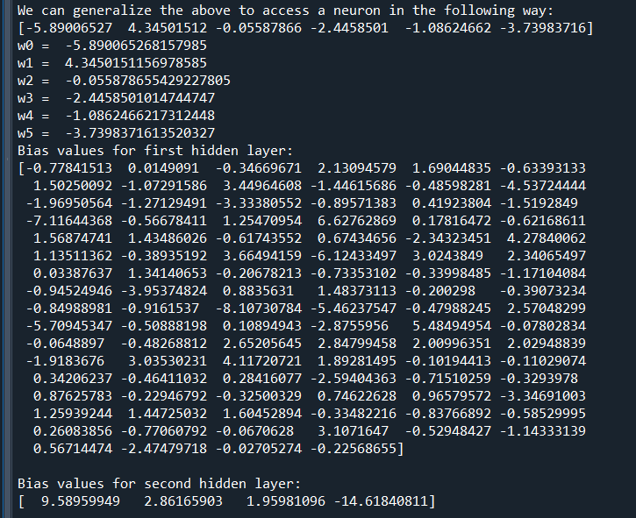

**Initial Weights and Bias:**

**Initial Weights:**

**weights between input and first hidden layer:**

[[-5.89006527e+00 -8.61129856e-01 -4.89471304e-01 8.35068418e+00

2.72825035e+00 -3.73319076e-01 -8.84089616e-01 -1.42160270e+00

-2.95354067e+00 -8.58595201e-01 -1.45173328e+00 6.83208485e+00

-1.22462762e+00 -2.90366885e+00 -2.60664498e+00 -5.31222146e-01

-9.32662808e-02 -1.07911801e+00 -1.19994080e+00 -1.22174174e+00

-1.55857552e+00 -3.26966971e+00 -1.14971897e+00 2.60870944e+00

-8.10980153e-01 -1.65791369e+00 1.22767567e+00 3.40736435e+00

2.19969133e+00 -3.09467927e+00 1.17702550e+00 2.69999663e+00

6.61572257e+00 -3.33107663e-01 1.69062724e+00 3.94890963e+00

-1.83709035e+00 -3.93981864e+00 -2.15588687e-01 6.75848382e+00

-4.85867973e-01 2.16596969e+00 -7.03313685e-01 1.49178217e+01

-2.10091881e+00 4.73246344e+00 -2.98778700e-01 -4.86515831e-01

-5.59666378e-01 -3.24067661e-01 1.21802120e+00 -3.24244316e+00

-5.67292801e-01 -1.30565270e-01 -9.96559894e+00 -5.19453135e-01

9.01043636e+00 -3.18694963e+00 4.51513399e+00 -6.89970215e-01

8.07163988e-02 -7.06365644e-02 3.45969453e-01 1.91867691e+00

-1.73178081e+00 -8.40437987e-01 -6.31722605e-02 -2.56769567e+00

1.14630832e+01 -2.40074167e+00 9.18829046e-01 2.56421526e-01

2.98802216e+00 -3.85339653e-01 -1.21542443e+00 -7.77992835e-02

3.20765101e+00 -1.70009988e+00 1.10210625e+00 -3.92495055e-02

-5.40627220e-01 2.65513459e+00 -2.04298859e+00 2.68992657e+00

3.62359494e+00 -1.73403142e+00 -1.47628832e+00 -2.14151149e-01

-1.02277714e+00 -5.38585218e-01 1.79985894e-02 -6.31266838e-01

-2.07331226e-01 5.77079829e+00 -2.88504804e-01 -2.11229018e+00

9.03794468e+00 -1.54942271e-01 -8.64665836e-02 9.41949134e-03]

[ 4.34501512e+00 -7.90194133e-01 -2.07197555e-01 8.76576256e+00

2.15966832e+00 -4.45404052e-01 9.35702635e-01 -3.59729212e-01

-4.48937278e+00 -9.17580819e-01 -3.13060459e-01 8.79853708e-01

-1.78492893e+00 -5.53037256e-01 -1.62047236e+00 -2.89281437e-01

-1.23298517e+00 -1.22232185e+00 1.16366880e+01 -5.64467875e-01

-4.32652530e+00 5.80309384e+00 -1.02599964e+00 2.67777464e+00

-2.56264238e-01 -6.22117845e-01 -2.15787496e+00 3.73975603e+00

1.57463833e+00 -2.12690952e+00 3.41011908e+00 2.49605983e+00

5.09424026e+00 -8.94729240e-01 -1.30346943e+00 -1.11919329e+00

-2.95136158e+00 6.68741112e+00 -2.30831695e-01 7.46967165e+00

-5.46885562e-01 4.52734338e+00 -1.38689622e+00 1.37136385e+01

4.42072594e-01 -5.05495017e-01 -1.87206278e-01 -2.92630778e-01

-8.55061542e-01 -2.40824393e-01 5.85434365e+00 -2.54602702e+00

-2.45953592e-01 -2.15107517e+00 -4.79072840e+00 -2.51953476e-01

7.49807403e+00 -1.64662814e+00 4.72538967e+00 -8.78557305e-01

-9.71098710e-02 -2.39947956e-01 -4.85296592e+00 1.54003788e+00

-3.34077575e+00 -1.12486062e+00 -1.86734096e+00 -3.71192685e+00

8.67179536e+00 -1.60770944e+00 -1.32664642e-01 -8.34752488e-01

2.82482873e+00 -5.27770742e-01 -1.82540740e+00 3.78933889e-01

2.08198395e+00 -6.06832921e-01 1.47206551e+00 -4.83776015e-02

-4.85260435e-01 4.37364617e+00 -3.66340235e-01 2.72479181e+00

9.98527746e+00 4.67101405e+00 -1.19887436e+00 -3.16775779e-01

-2.00393887e-01 -3.07021360e-01 -1.94452421e-01 -1.50089085e+00

-2.01224590e-01 3.16366714e+00 -4.83466269e-01 -1.67600405e+00

5.87043679e+00 2.00708544e+00 -7.07932576e-02 -1.93442824e-01]

[-5.58786554e-02 -6.60908308e-01 -1.83823868e+00 -1.51031988e+00

4.33250987e+00 -5.76530189e-01 2.17728216e+00 -1.49131270e+00

9.71979058e-01 -1.14224976e+00 -3.11768106e-01 -8.96592163e-01

-2.66144116e+00 6.37912219e-01 -3.66731875e+00 -2.59339270e+00

-7.02502842e-01 -1.01260987e+00 3.63826114e-01 -3.39290379e-01

3.25026172e+00 -1.67235213e+00 7.84494454e-01 -5.21714435e-01

5.39920285e-01 5.83279189e-03 -5.03518400e-01 2.02871182e+00

2.00063856e+00 2.51088400e+00 -2.49610439e-01 8.66839837e-01

3.98445897e+00 -1.34378964e+00 -8.87172805e-03 7.77489409e-01

-3.39011255e+00 -1.57498079e+00 5.33312229e-03 -4.52450961e+00

-9.71295886e-02 -4.12063402e+00 -1.81466420e+00 2.15770403e-01

6.21023960e-01 1.37957840e+00 3.73090759e-03 -2.91614640e-01

-1.67843662e+00 -3.62534471e-01 4.55305643e+00 4.84620953e-01

-5.82294813e-01 -7.10289490e-01 -4.52851358e+00 -1.34159225e-01

7.90063042e-01 -9.85566049e-01 5.01205141e+00 5.84862699e-01

-1.12573795e-01 -3.28824623e-01 5.44220781e-01 7.74635985e-01

1.25555061e+00 -1.16621079e+00 -1.24196724e+01 -5.78524485e-02

1.89612793e+00 3.29225586e+00 -1.02841738e+00 -2.63327922e+00

1.05044966e+00 -2.00883391e-01 1.34650919e+00 -1.97686211e+00

1.07571602e+00 -8.74898183e-01 4.02198884e-01 -2.33514718e-01

-2.80576520e-01 -1.77343169e+00 2.24254367e+00 3.34746314e-01

2.70437558e-01 7.26552552e-01 -5.88096110e+00 -2.42612666e-01

-4.85125590e-01 -3.96362563e-01 -1.97232822e-01 -1.38477401e+00

-9.29848412e-02 2.59781597e+00 -1.01906822e+00 -1.79811571e+00

-2.29485360e+00 2.11953876e+00 -2.10958215e-01 -9.63579409e-02]

[-2.44585010e+00 -2.92828700e-01 -1.48896691e+00 3.86274566e-01

3.39025605e+00 3.28024313e-01 -1.30338179e+01 -8.28995161e-01

3.74196101e+00 -1.42343366e+00 -5.11774348e+00 -2.34575822e+00

-1.84236693e+00 -5.05677016e+00 -2.89655522e+00 -2.10450754e+00

-8.02807071e-01 6.13630463e-01 1.42701522e+00 -3.28552164e-01

-6.01519684e-01 1.11115815e+00 -8.80891264e-01 6.79839049e+00

-1.63917573e+01 -6.95846911e+00 -6.37851373e-01 -1.87514981e-01

-7.22829388e+00 2.76457627e+00 5.46892280e+00 -1.65692110e+01

-2.58248848e+00 5.74695788e-01 2.14384929e+00 6.49474561e+00

-3.13051700e+00 -8.56080272e-01 5.49564059e-02 1.44406889e+00

-3.04185461e-01 5.91789159e+00 -8.16221959e-01 9.84688167e-01

-2.35061889e-01 1.35641975e+00 -2.36045955e-01 -2.94848476e-01

-8.39276376e-01 -1.22854176e+00 -3.07792826e-01 -4.08123173e-01

-1.38221156e-01 3.98369598e+00 -7.69510271e+00 -5.51513909e-01

-5.82641494e+00 -1.92571163e+00 3.88480074e+00 -3.81071925e-01

-1.96272586e-01 -7.92980610e-01 -4.86370719e-01 -1.32956422e-01

4.80051942e-01 -4.98573772e+00 7.38462588e+00 -4.64307250e+00

5.06340439e-01 2.42928759e+00 -2.97329797e+00 -3.33223419e+00

2.62584948e+00 -2.93406077e-01 8.66603519e-01 -1.56416761e+00

-7.47011115e+00 -2.99284765e-01 1.58741551e+00 -5.14668786e-02

-1.36752488e-01 -1.29341233e+00 8.32907439e-01 -1.00685098e+00

-1.55332026e+00 -3.49417915e+00 -1.07526483e+01 -2.17467367e-01

-8.69864535e-01 1.83703483e-01 -9.09814550e-02 -4.68055576e-01

-2.28696553e-01 -2.53304007e+00 -3.34416153e-01 -1.27144350e+00

-3.26095063e+00 1.03008087e+00 -4.17578199e-02 -1.17438428e-01]

[-1.08624662e+00 4.80251148e-01 2.24445239e-01 -3.51807119e+00

2.33839288e+00 -1.08656257e-01 9.57661479e-01 -7.18677546e-01

5.77320780e+00 -8.51552862e-01 2.97249330e-01 6.94927548e+00

-8.46368257e-01 -1.59549071e+00 -4.82458648e-01 -9.01835202e-01

-2.22643630e-01 -2.12977660e+00 -8.91462819e-01 -4.29206684e-01

-2.36330496e+00 -6.43711254e+00 -1.79184218e-01 -2.84839650e+00

9.02382389e-01 -8.32481574e-01 6.11763633e-01 2.44046456e+00

3.95297335e+00 6.95212396e+00 -4.38659486e-01 2.72884973e+00

3.05480900e+00 6.15326105e+00 1.93981541e+00 -1.74967773e+00

-1.58730773e+00 -6.34446992e+00 -1.00801247e-01 -7.94442259e-01

-1.88293409e-01 -1.34757959e+00 -4.40980772e-01 -2.11532529e+00

1.40225181e-01 2.65246455e+00 -1.86460252e-01 -2.84403545e-01

-4.28918441e-01 -6.44065649e-01 3.94792232e+00 -8.35720761e-01

-2.38226308e-01 5.44020554e-02 -2.29689069e+00 -6.02566034e-02

-2.88852880e+00 2.97993904e-01 3.84188872e+00 -2.87823346e+00

-1.05110119e-01 6.19368063e-02 -7.50816448e-01 2.59091796e+00

1.09162174e+00 -2.79626447e+00 -5.47912984e+00 5.41805393e+00

-9.62254787e-01 -3.82806023e-01 -3.73039201e-01 -2.35122886e+00

5.89566707e-01 -2.04453983e-01 4.89811038e-01 -1.31923773e+00

2.28523234e+00 -4.81137452e-01 2.75609114e-01 -6.95699400e-02

-1.46148145e-01 -1.33599619e+00 -3.48429924e+00 3.95306930e-01

-2.51082260e+00 2.55969917e+00 2.01569956e+00 -1.69060644e-01

-6.29943769e-01 -3.63028230e-01 -8.85958331e-02 -4.76014836e-01

-2.28513369e-01 3.71742247e+00 -2.93777963e-01 -1.10244611e+00

-8.41190787e+00 5.24510094e+00 4.44181958e-03 -9.73081676e-03]

[-3.73983716e+00 -1.61182678e-01 2.76635194e-01 -8.47468746e+00

2.21184938e+00 -5.34748843e-01 1.27314859e+00 -5.06809994e-02

-1.35764517e+01 1.53768664e+00 1.27974254e+00 -3.06004453e+00

1.10915224e+00 6.89939355e-01 -1.36662336e+00 -2.05093923e+00

-1.65859404e+00 -2.08078723e+00 1.84243613e+00 -4.34212164e-01

-1.96298735e+00 4.36236177e+00 -2.43803909e-01 1.39609251e+00

6.60704130e+00 1.92733546e+00 -5.29137090e-01 2.37910630e+00

3.03332568e+00 -1.36539335e+01 -2.57936300e+00 3.81901683e-01

-7.40618982e+00 6.85441078e+00 -1.58372573e-01 -3.00819136e+00

-4.48230642e+00 -8.42750688e+00 -8.43048476e-02 -4.55661896e+00

-1.45337746e-01 7.19720157e-01 1.03438283e-01 -7.94043496e+00

-1.50664842e+00 -5.46385861e+00 2.63728921e-01 -2.94121099e-01

-3.88683236e-01 -2.16442525e-01 4.43489744e+00 6.82038048e+00

-2.21962895e-01 -3.19482911e+00 4.04722467e+00 -8.04316229e-01

-4.38033148e-01 -6.48300612e-01 -4.40750910e-01 -2.07978865e+00

-1.84015828e-01 -5.49211665e-01 -2.73838706e-01 -1.40515786e+01

3.95168977e-01 9.95802167e+00 -1.50620329e+00 -7.23504069e+00

-1.14474001e+01 -6.23496121e+00 -7.90386647e-01 -3.85226522e+00

8.37332844e-01 -2.39598045e-01 -2.04315377e+00 1.69919679e-01

-3.34685436e+00 -7.66153265e-01 1.47906383e+00 -2.99170570e-02

1.91397192e-01 9.44899846e+00 -1.63406182e+00 3.01810168e+00

-4.80467056e+00 -2.52572298e+00 1.18428331e+00 -4.15051987e-01

3.86622199e-02 -4.00099802e-01 -1.06970046e-01 -3.75086628e-01

-1.71394097e-01 -6.18355840e+00 -4.23291234e-01 -1.93006495e+00

-4.55970816e+00 3.63937137e+00 -7.28936827e-03 6.62987604e-02]]

**Initial Bias:**

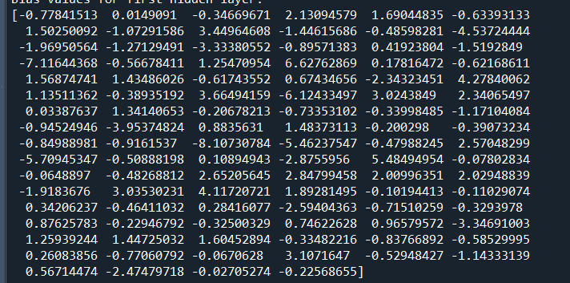

**Final Weights and Bias:**

**Final Weights:**

**Final Bias:**

[[ 4.49453259e+00 -3.18422025e+00 -7.53019330e-01 -4.65013127e-01]

[ 4.10884538e+00 -2.01719477e+00 -9.34572077e-01 -1.23737974e+00]

[ 4.29884457e-01 1.17134055e+00 9.05116475e-01 -2.17040859e+00]

[ 5.23662256e+00 -1.41638639e+00 -2.83146276e-01 -3.55197977e+00]

[-5.10245580e+00 2.12745244e+00 -2.64576250e-01 3.17733695e+00]

[ 5.24229729e-01 -2.32521171e-01 -3.41170376e-01 -2.12368507e-01]

[ 8.27365423e+00 -1.68839752e+00 -2.96167311e+00 -3.54315112e+00]

[ 6.94844622e-01 -4.00548347e-01 -1.10840157e-01 -1.41208666e-01]

[ 9.33451201e+00 -7.53440211e+00 5.93143987e+00 -7.89285879e+00]

[ 1.68702933e+00 -1.44335120e+00 2.32668128e-01 -4.61058756e-01]

[ 3.66388703e+00 -2.08702295e+00 -1.32073181e+00 -2.80527583e-01]

[-1.67915199e+00 6.57279444e+00 -9.10772232e-01 -3.93672287e+00]

[ 2.16211963e+00 -1.12079026e+00 -2.37891086e-01 -6.49533928e-01]

[ 5.73008520e+00 -3.91909826e+00 -1.40877754e+00 -1.16665371e-01]

[-7.07990781e+00 3.03538574e+00 2.17472314e+00 1.50813455e+00]

[ 5.72945598e-01 1.60195733e-01 1.26990275e-01 -3.88540280e-01]

[ 1.61433115e+00 -1.16802409e+00 -5.45032811e-02 -1.30951368e-01]

[ 1.01770561e+00 -8.42436542e-01 -1.09071117e-01 -8.47245775e-02]

[ 6.11902235e+00 -3.40924523e+00 -3.07558021e-01 -2.21003266e+00]

[ 2.25918403e-01 2.80572680e-02 9.94398095e-02 -1.67772625e-01]

[ 4.53310318e+00 8.27066165e-01 -2.01759511e+00 -2.97448446e+00]

[-3.55069762e-01 5.41066175e+00 1.01551155e+00 -5.86668828e+00]

[ 1.01396046e+00 -9.28138089e-01 9.28464699e-01 -1.37946647e+00]

[ 5.62583910e+00 -4.54164739e+00 -1.54457782e+00 6.68143790e-01]

[ 1.48814795e+01 -9.67202605e+00 -2.25333992e+00 -2.58899240e+00]

[ 4.87012626e+00 -2.74375065e+00 -1.05129052e+00 -8.31496236e-01]

[-3.05029729e-01 2.09799156e+00 8.26969044e-02 -1.36032361e+00]

[-4.56916203e+00 1.13826753e-01 1.42472577e+00 2.78636632e+00]

[ 4.72772681e+00 -1.04003115e+00 -3.43843160e+00 -3.53077804e-01]

[ 7.25419317e+00 -1.66066180e+00 4.26736133e+00 -9.36194397e+00]

[ 1.78317563e+00 -3.98488552e-01 4.11224088e-01 -1.45794881e+00]

[ 8.45622499e+00 -5.15589951e+00 -1.36520067e+00 -2.07474470e+00]

[ 8.28214368e+00 -4.31253458e+00 1.24124983e+00 -5.48144116e+00]

[ 3.79058836e+00 -3.32151232e+00 -2.89614128e+00 2.79775482e+00]

[ 3.98565255e-01 3.41829112e+00 -8.22255317e-01 -3.45401881e+00]

[ 4.28406082e+00 1.09449010e+00 -8.98876970e-01 -4.81119174e+00]

[-6.83147970e-01 9.10061985e-02 3.47874569e-01 1.59902274e-01]

[ 8.29083230e+00 2.46851069e+00 -4.00684877e+00 -6.69123629e+00]

[-2.13365635e-01 -2.46069819e-02 1.92539630e-01 1.95642547e-01]

[-7.86641563e+00 6.49356749e+00 -7.53792346e-01 2.23689780e+00]

[-4.18369714e-02 1.86360620e-01 1.79952817e-01 2.15880954e-01]

[ 6.14896272e+00 -5.72780205e+00 -1.24009882e+00 3.25727920e-01]

[ 4.72996672e-01 -1.51835520e-01 -8.39351250e-02 -3.75424822e-02]

[ 1.27987894e+00 1.12118005e+01 -8.05099083e+00 -4.69617356e+00]

[ 2.18488585e+00 -9.86417498e-01 -3.10511383e-01 -1.15938727e+00]

[ 2.49281837e+00 8.97840624e-01 3.22817337e+00 -6.07132812e+00]

[ 2.48088974e-01 4.98965638e-02 3.51355647e-01 -2.52032278e-01]

[ 3.40233280e-01 -3.81082424e-01 -1.15845747e-01 -1.58700173e-01]

[ 2.20251738e+00 -1.29431140e+00 -3.37801678e-01 -4.07657591e-01]

[-2.90927062e-02 7.62909411e-02 8.40346900e-02 -4.21899027e-02]

[-5.30587962e+00 -1.35457019e+00 -1.26183992e+00 7.95755705e+00]

[ 4.56641043e-01 -7.58293790e+00 4.21015730e+00 2.46311689e+00]

[ 1.55213623e-02 4.05688798e-02 1.43447253e-01 1.41892472e-01]

[ 9.49611286e-02 2.76500989e+00 -9.87439822e-01 -1.52189170e+00]

[ 6.39823462e+00 -7.22582143e+00 -3.59153909e-01 1.48115689e+00]

[ 4.51938480e-01 -4.42325439e-01 -3.53862379e-02 1.06583806e-02]

[ 9.36387874e+00 -4.91554539e+00 -4.47285715e+00 -1.27840064e-01]

[-9.35515187e-01 -4.46699223e-01 -2.10213915e-01 1.59979927e+00]

[-1.05477265e+01 2.93489159e+00 3.50011225e+00 4.39095992e+00]

[ 2.46553657e+00 -4.19230990e-01 -8.53181342e-01 -9.75330944e-01]

[ 1.37230531e-01 -6.99543118e-02 -6.35254638e-02 9.56995904e-02]

[ 4.52379758e-01 8.33361496e-01 -1.14402764e-01 -1.15966805e+00]

[ 2.99353893e+00 -6.28959698e-01 -3.32519157e-01 -2.23029000e+00]

[ 7.00596276e+00 -5.25036144e+00 -5.21777011e-01 -1.46400675e+00]

[ 2.70362889e+00 1.30709167e+00 -1.71985059e+00 -2.24363325e+00]

[-5.22305041e+00 6.48491539e+00 6.22708252e+00 -7.80663119e+00]

[ 9.32013647e+00 -1.49554866e-01 -2.92240028e+00 -6.70739604e+00]

[ 5.98054590e+00 -2.53256377e+00 1.60695798e+00 -4.99169181e+00]

[ 5.89651082e+00 -2.13259196e+00 4.31248732e-01 -4.35795512e+00]

[ 4.48373397e+00 -1.85664860e+00 -6.93926483e-01 -2.28330510e+00]

[ 8.77381983e-01 1.31142787e+00 -1.08729459e+00 -1.60822058e+00]

[-8.48136612e-02 1.82187144e+00 -9.68834146e-01 -2.46990713e-01]

[-2.88630471e+00 -2.71112142e-01 8.79318823e-01 1.72898413e+00]

[-2.36725308e-02 -2.77146927e-01 -7.10330121e-02 -2.50949767e-02]

[ 1.83122793e+00 -8.79050085e-01 -1.57132298e-01 -1.19835228e+00]

[ 2.17716819e+00 -5.25435230e+00 1.74845833e+00 1.44547874e+00]

[-3.89740090e+00 5.10413751e+00 -5.71575336e-01 -8.07997754e-01]

[-4.14088137e-01 3.52182990e-01 2.40663307e-01 4.23206755e-03]

[ 4.17039431e-01 -1.27375975e+00 1.50939186e-01 7.73212294e-01]

[-8.33235196e-02 6.96715128e-02 1.55532496e-01 -3.21944965e-02]

[ 2.57217352e-01 -2.42523993e-01 -1.50292345e-01 -2.46406393e-01]

[ 7.25407182e+00 -3.89758139e+00 4.23432890e-01 -3.90015981e+00]

[ 4.48606871e+00 -2.42396143e+00 -1.09530475e-01 -2.28399900e+00]

[-2.23490237e+00 -8.17199600e-01 1.14856663e+00 1.89103863e+00]

[ 5.94559928e-01 6.31125899e+00 -3.92826489e+00 -2.84486272e+00]

[-1.85053552e+00 5.21100690e+00 -1.28448950e+00 -2.21359631e+00]

[ 7.54110888e+00 -2.60560654e+00 -1.58862658e+00 -3.72142524e+00]

[ 1.12186599e-01 1.25788583e-01 9.75183738e-02 1.08715057e-01]

[-3.67980293e-02 5.36760601e-02 -1.80217052e-01 1.52656604e-01]

[ 5.03723404e-01 -5.74762529e-01 -2.44460001e-01 5.64267312e-02]

[ 2.14710169e-01 9.77128087e-02 -1.35314456e-01 -1.34367382e-01]

[ 5.58404275e-01 -2.95607865e-01 1.37401825e-01 -2.99232911e-01]

[ 8.03259455e-03 -6.91541931e-02 1.41567242e-01 1.86105754e-01]

[ 8.54234037e+00 -1.53326009e+00 1.55077983e+00 -8.12500356e+00]

[ 3.15961945e-01 -4.46652826e-01 -3.97361185e-02 -2.27681481e-01]

[-2.04135583e+00 9.15927784e-01 1.21031175e+00 6.04713813e-01]

[-7.89855834e-01 7.97009484e+00 -3.57422136e+00 -3.59507306e+00]

[-2.12968534e+00 2.00929139e+00 -1.52731439e+00 1.40411765e+00]

[-1.78157637e-01 7.96556295e-03 2.33945550e-01 2.36149996e-01]

[-1.64390529e-01 -4.09546354e-02 8.95844405e-02 -6.88735539e-02]]

**Final Weights:**

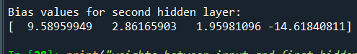

**Actual and Predicted Values of Training Samples:**

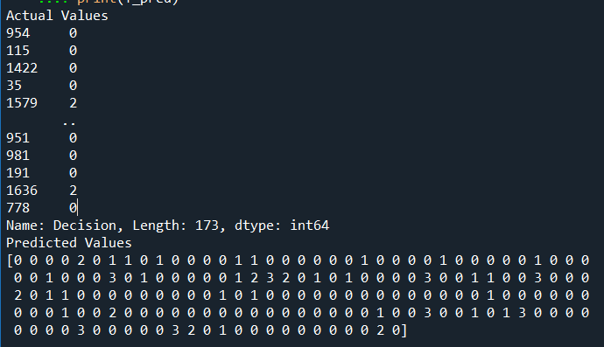

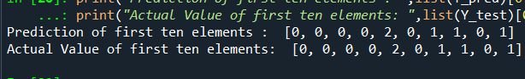

**Confusion Matrix:**

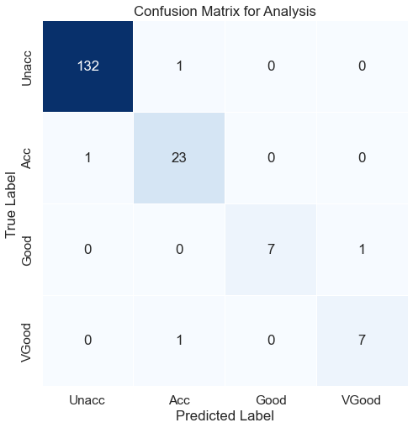

**It shows us 4 were wrong predictions and rest all predictions were correct.**

**1 prediction was stated as Acc while it was Unacc**

**1 prediction was stated as Unacc while it was Acc**

**1 prediction was stated as Vgood while it was Acc**

**1 prediction was stated as Acc while it was VGood**

**Accuracy Analysis (Precision, Accuracy, Recall, Error):**

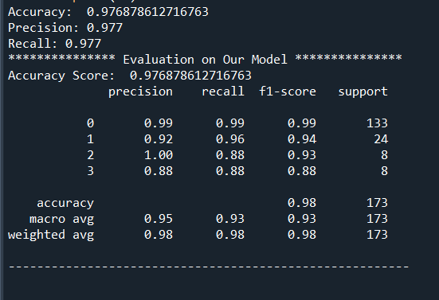

**Inference:**

**The confusion matrix tells us**

* **4 were wrong predictions and rest all predictions were correct.**
* **1 prediction was stated as Acc while it was Unacc**
* **1 prediction was stated as Unacc while it was Acc**
* **1 prediction was stated as Vgood while it was Acc**
* **1 prediction was stated as Acc while it was VGood**
* **The accuracy of our model is 97.68 percent whereas precision is 97.7 percent and recall is also 97.7 percent.**