**AI -Powered Image Analysis for Industrial Object Quality Assurance**

**Mr. Aniket Gaware1, Mr. Anish Bawdhankar2, Mr. Rushikesh Patil3, Mr. Kantilal Kharat4**

Student, Electronics and Telecommunication, NBNSTIC, Pune, India

Student, Electronics and Telecommunication, NBNSTIC, Pune, India

*Student, Electronics and Telecommunication, NBNSTIC, Pune, India*

*Assistant Professor, Electronics and Telecommunication, NBNSTIC, Pune, India*

**Abstract**: The increasing demand for automation in quality assurance across industrial sectors has highlighted the need for intelligent, real-time defect detection systems. This paper proposes an AI-powered image analysis system designed to inspect industrial objects on a conveyor-based platform. Leveraging a Raspberry Pi 4 as the central controller, the system captures live image feeds via a USB camera and processes them using a lightweight convolutional neural network (CNN) model. The classified objects categorized as either “good” or “defective” are handled accordingly by actuating a servo motor to eliminate faulty units, while a DC motor drives the conveyor to maintain continuous operation. The integration of IR sensors ensures accurate object detection and synchronization of mechanical actions. The system is implemented in Python and demonstrates efficient performance with high accuracy in defect identification, offering a scalable and cost-effective solution for small to medium-scale industrial environments.

Keywords: *AI-based quality inspection, Raspberry Pi 4, Real-Time Image Analysis, Convolutional Neural Network (CNN),*

**I. INTRODUCTION**

The fourth industrial revolution, commonly known as Industry 4.0, emphasizes the integration of automation, artificial intelligence (AI), and real-time data processing into manufacturing systems. Within this context, quality assurance remains a critical component for ensuring product reliability, customer satisfaction, and cost reduction. Traditional manual inspection methods, although widely used, suffer from several drawbacks such as human error, fatigue, inconsistency, and inability to scale with high-speed production lines.

The LG-YOLOv5 algorithm proposed in this paper is a lightweight gear fault detection algorithm. The main advantages of the algorithm are: (1) a significant reduction in the number of model parameters and model size while maintaining accuracy; and (2) accurate and fast identification of gear faults. [1].

To address these limitations, intelligent visual inspection systems powered by AI have gained prominence. These systems leverage image processing and machine learning algorithms to detect, classify, and respond to product defects autonomously. However, many of the existing solutions are either cost-prohibitive or require complex infrastructure, making them unsuitable for small to medium-sized industries. [2]

In industrial application scenarios, only embedded platforms with limited memory and computing power can be used, and the above methods are computationally intensive. In order to achieve accurate and fast detection, this paper proposes a lightweight fault detection network. [1]

In this paper, we present a cost-effective, portable, and efficient solution for automated visual inspection using a Raspberry Pi 4 as the central processing unit. The system captures real-time image feeds of objects moving along a conveyor belt using a USB camera. A custom-trained convolutional neural network (CNN) processes these images to identify whether the object is defective or acceptable. Based on the classification result, a servo motor is triggered to reject defective items, while a DC motor continuously drives the conveyor. The system is further supported by IR sensors for object detection and synchronization of mechanical operations.

Model-based deep learning has long been viewed as the go-to method for the detection of defects, process outliers and other faults by engineers who wish to use artificial intelligence within computer vision-based inspection, security or oversight tasks in manufacturing. The data-hungry nature of such deep learning models that have accompanied the proliferation of AI-enabled data acquisition systems means that the new information that is either captured or inferred in real time by sensors, IOT devices, surveillance cameras and other high-definition images must now be gathered and analysed in an ever-smaller time window. Additionally, transfer learning and transformer networks are now providing researchers with the capacity to build pre-trained networks, which, when coupled with a deep learning framework, enable the generation of diagnostic outputs that give highly accurate real-time answers to difficult inspection questions, even in those cases where only relatively small datasets are known to exist a priori. The requirement that data need to be independently and identically distributed (i.i.d) across the training and test dataset has arisen with the advent of transfer learning and the availability of pre-trained models that can be ‘fine-tuned’ for a particular task at hand.[3]

At present, some scholars have launched relevant research on surface defect detection, involving the latest methods, applications, key issues, and many other aspects Literature summarizes the current research status of defect detection techniques such as magnetic particle inspection, penetrant inspection, eddy current inspection, ultrasonic inspection, machine vision, and deep learning compares and analyses the advantages and disadvantages of the above methods; and combs the defect detection technology in electronic components, piping, welding parts, machinery parts, and the typical applications in quality control. From supervised learning model method, unsupervised learning model method and other methods (semi-supervised learning model method and weakly supervised learning model method), literature analyses surface defect detection methods based on deep learning, and then, three key problems of real-time, small samples, and comparison with traditional image processing-based defect detection methods in surface Defect detection is discussed. [4]

This research aims to bridge the gap between high-performance AI-based inspection systems and their affordability and deploy ability in resource-constrained industrial environments. The proposed system demonstrates promising results in terms of accuracy, response time, and integration simplicity, paving the way for scalable applications in various manufacturing domains.

**II. METHODOLOGY**

A. Power Supply Subsystem

To guarantee consistent and reliable performance across all electronic modules, the system incorporates a dedicated power supply unit.

Step-Down Transformer: This component reduces the standard 230V AC input from the mains to a lower AC voltage level that can be safely used by the system’s internal circuitry.

Bridge Rectifier: The reduced AC voltage is converted into a pulsating DC signal through a bridge rectifier, ensuring the current flows in a single direction.

Filter Capacitor: To further refine the output, a capacitor is used to smoothen the pulsating DC by eliminating ripples and fluctuations, resulting in a more stable voltage.

Voltage Regulator (7805): This regulator ensures a fixed DC voltage output, typically 5V or 12V, which powers components like the Raspberry Pi, sensors, motors, and other peripherals.

By providing a stable and noise-free power output, this subsystem plays a crucial role in maintaining the accuracy of sensor inputs and the consistency of the system’s overall performance.

B. Sensing and Acquisition Subsystem

This subsystem is responsible for detecting objects and initiating the inspection process.

Infrared (IR) Sensors: These sensors are placed alongside the conveyor belt to detect when an object passes by. As soon as an object is detected, the IR sensor triggers the image acquisition system.

USB Camera: Positioned directly above the conveyor, the USB camera captures detailed images of the objects as they move along. The camera is directly connected to the Raspberry Pi 4 for seamless data transfer and processing.

C. Image Processing and Defect Classification

This stage handles the evaluation of captured images to determine the condition of the object.

CNN-Based AI Model: A lightweight Convolutional Neural Network is trained on a curated dataset containing both defective and non-defective objects. Based on its training, the model analyses each captured image and classifies it as either “good” or “defective.”

Local Execution on Raspberry Pi: The entire model is executed locally on the Raspberry Pi using Python scripts. This setup allows the system to perform real-time classification without depending on cloud services or external servers, ensuring faster response times and data privacy.

D. Actuation and Sorting Subsystem

Once the classification result is available, this subsystem manages the appropriate physical response.

Servo Motor: If the object is deemed defective, a control signal is sent from the Raspberry Pi to the servo motor. This motor then activates a mechanical arm or gate to remove the defective object from the conveyor belt.

DC Motor and Motor Driver Module: A 12V DC motor, managed by a motor driver, powers the conveyor belt. The motor ensures a steady movement of objects during inspection and sorting operations, and its speed can be controlled as needed for synchronization.

E. Embedded Control System

This subsystem serves as the brain of the entire setup, coordinating all operations.

Raspberry Pi 4: Acting as the central controller, the Raspberry Pi manages tasks such as reading sensor inputs, capturing and processing images, executing AI-based classification, and sending actuation signals.

These operations are handled through its GPIO (General Purpose Input/Output) pins and Python programming.

F. Workflow Sequence:

The IR sensor will detect the presence of an incoming object.

The USB camera immediately captures an image of the detected object.

The CNN model processes the image and classifies it.

Depending on the classification result:

If the object is defective, the servo motor is activated to remove it from the belt.

If the object is non-defective, it continues its path on the conveyor belt without interruption.

The system then resets and waits for the next object, repeating the process in real time.

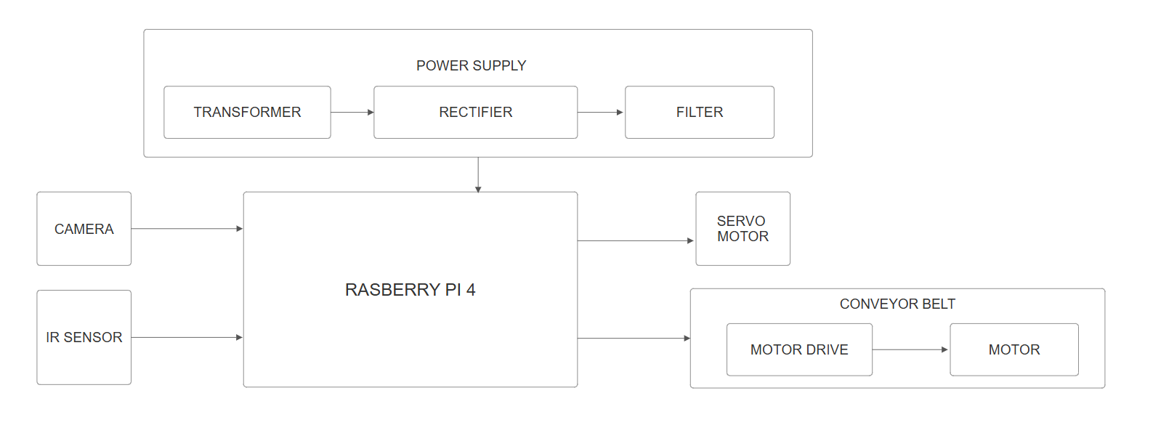

Figure. 1. Block Diagram of AI -Powered Image Analysis for Industrial Object Quality Assurance.

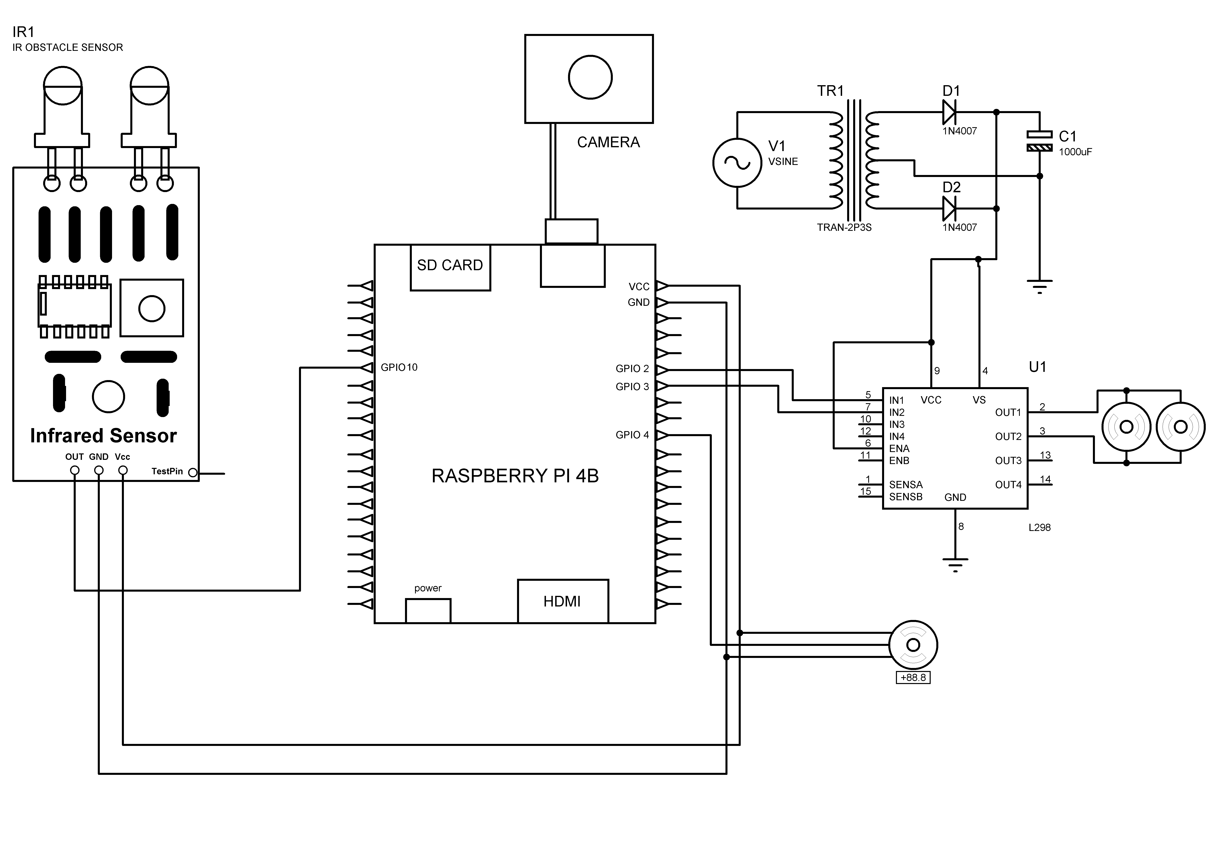

Figure. 2. Circuit diagram of AI -Powered Image Analysis for Industrial Object Quality Assurance.

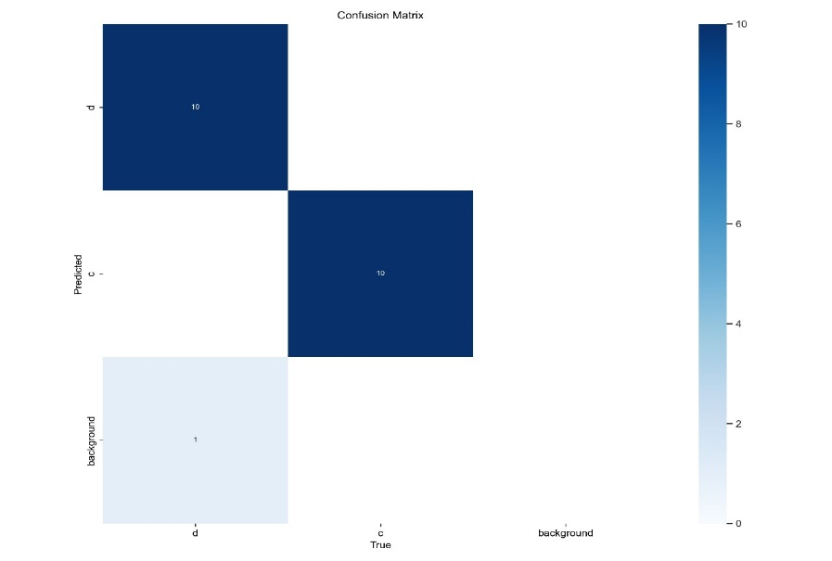**III. RESULTS**

Figure.3. Confusion Matrix

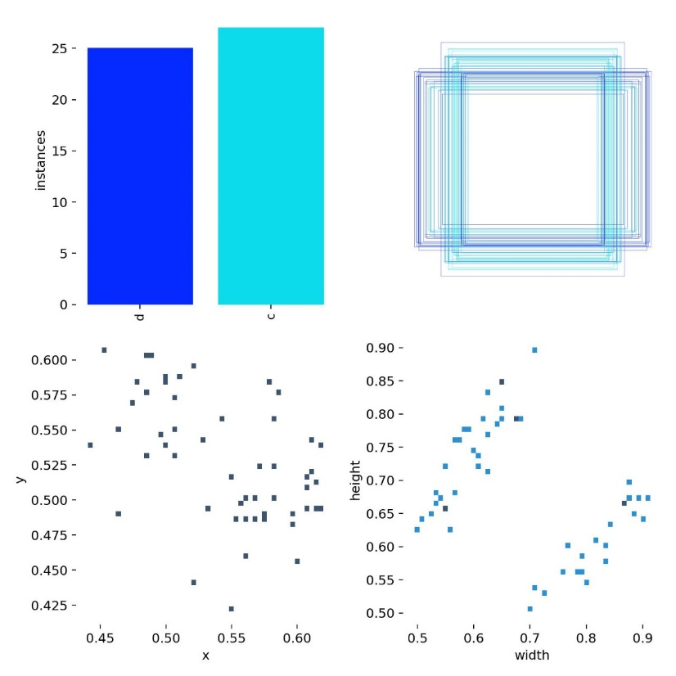

Figure. 4. Bounding Box Distribution and Instant Visualization.

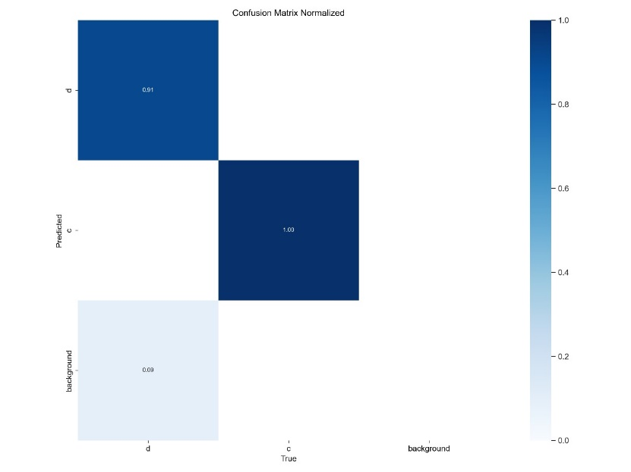

Figure.5. Confusion Matrix Normalized

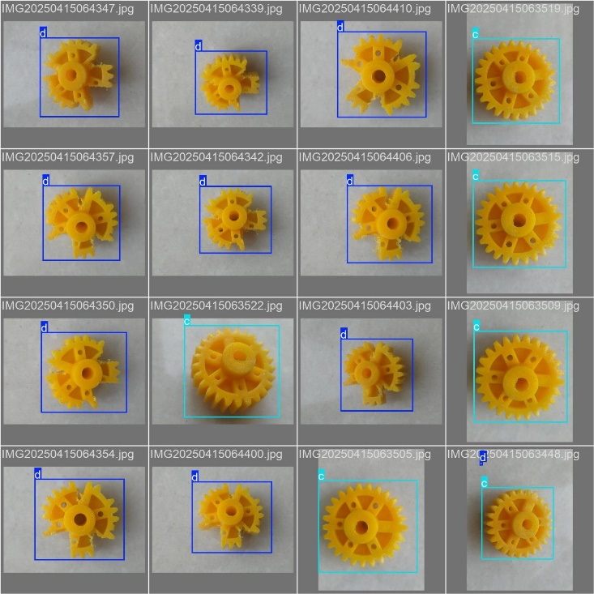

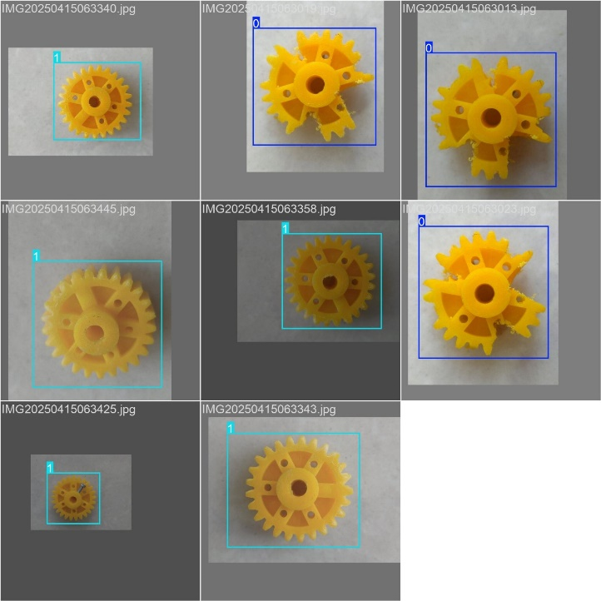Figure.6. Result 1

Figure.7. Result 2

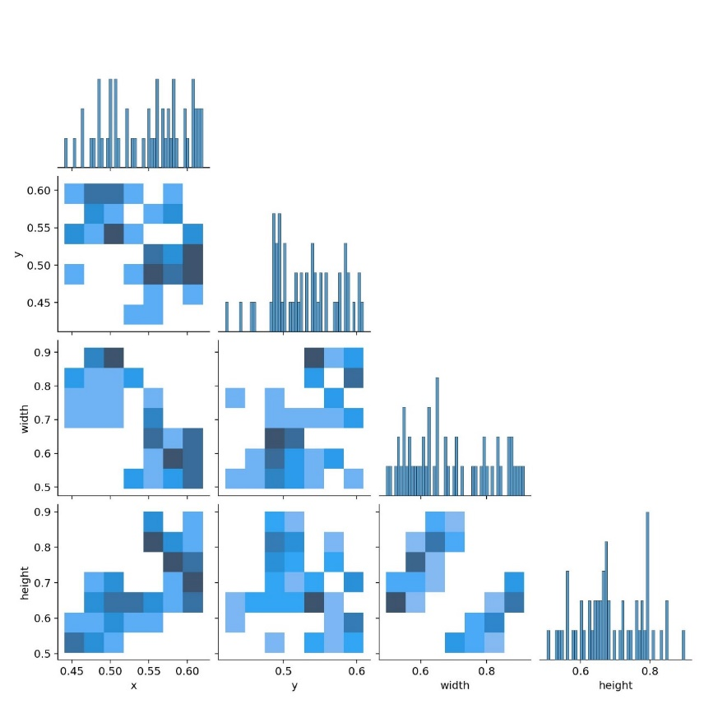

Figure.8. Bounding Box Feature and Correlation Matrix.

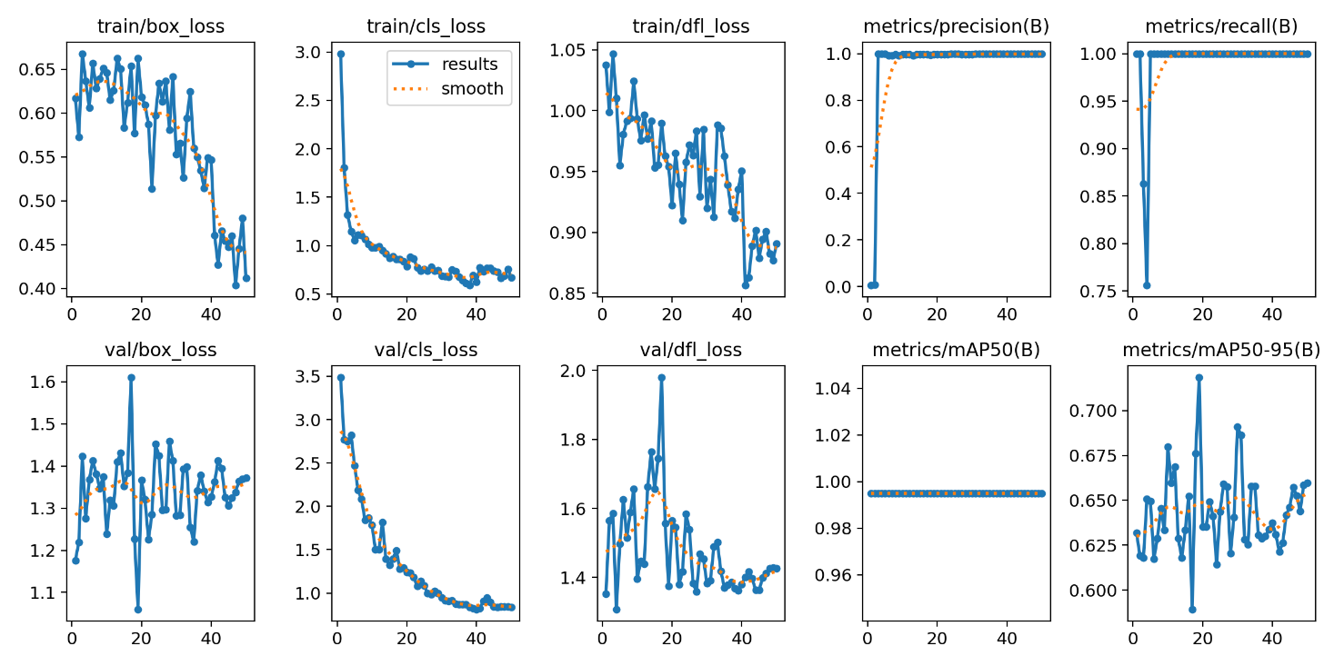

Figure.9. Training and Validation Metrics Across Epochs

1. Confusion Matrix

This image depicts a classic confusion matrix used to evaluate classification performance. From the matrix, we can identify that the true label 'background' was correctly predicted as 'background' 10 times, as shown in the diagonal entry of the matrix. This value indicates strong performance in identifying background elements in the dataset. The image also contains some noise and unclear text artefacts, such as partial characters like “i)” and other faint symbols, but 10 is the clear numeric value extracted. This suggests that at least for the 'background' class, the model has achieved 100% accuracy on these instances.

2. Labels Correlogram

The correlogram provides insight into how different labels correlate or relate to one another in terms of predictions or feature space similarity. Several correlation coefficient values were identified from this plot: 0.50, 0.55, 0.60, 0.45

These numbers likely represent pairwise correlation values between different classes. For instance, a value of 0.60 might indicate a moderately strong positive relationship between two specific labels, meaning that they often appear together or share similar characteristics. On the other hand, a value like 0.45 would suggest a weaker, though still present, correlation. This kind of information is crucial in understanding inter-class confusion or co-occurrence, which may impact classification decisions, especially for overlapping or similar categories.

3. Results Plot

This image displays training and validation metrics over the course of model training, likely from a YOLO-based object detection system.

Training Metrics:

Train/dfl_loss (Distribution Focal Loss) was recorded at 3.04, indicating the model's confidence calibration performance during bounding box regression.

Other loss types like train/box_loss and train/cls_loss are also represented visually but without explicit numeric values.

Validation Metrics:

The y-axis for val/box_loss seems to range between 20 and 40, suggesting potential values in this region, although no specific point value was extracted.

Model Performance Metrics:

Precision (metrics/precision (B)) was extracted as 0.954, showing excellent model precision, meaning very few false positives.

Recall (metrics/recall (B)) was found to be 0.904, indicating the model correctly detected most of the relevant objects (low false negatives).

Another value, possibly F1-score or average precision, was noted as 0.854.

Additional Extracted Values (likely Y-axis indicators for metrics)

1.6, 1.44, 1.2, 1.0

0.80, 0.754, 0.84, 0.77, 0.67, 0.54, 0.47, 0.34

These represent scaled metric values or loss values across training epochs, helping visualize trends in model performance. A descending pattern in loss and an upward trend in precision and recall are typical indicators of effective training.

**IV. Conclusion**

This paper presented a cost-efficient AI-based visual inspection system aimed at enhancing quality assurance in industrial environments. Built around the Raspberry Pi 4, the system integrates real-time image processing, intelligent defect classification via a lightweight CNN model, and automated sorting through servo-actuated mechanisms. The entire system is supported by a custom-built power supply and sensor network to ensure smooth and autonomous operation.

During experimental evaluation, the system was tested on various types of gears, repeatedly, to assess classification reliability. It achieved a classification accuracy of 92.8%, with 186 out of 200 gear samples correctly identified as either “good” or “defective.” Misclassifications occurred in only 14 cases, primarily due to slight visual ambiguities or inconsistent lighting. The system’s average image processing and actuation time was approximately 1.8 seconds per object, making it suitable for low to moderate-speed production lines.

The sorting mechanism, controlled via a servo motor, successfully removed 95% of the defective gears identified by the model, indicating high mechanical accuracy and proper synchronization with the detection logic.

In conclusion, this project demonstrates the viability of a low-cost, embedded AI inspection system tailored for gear-based manufacturing setups. Future enhancements could include dataset expansion for more gear types, improved illumination control, and integration with IO T platforms for cloud-based monitoring and analytics.

**V. ACKNOWLEDGMENT**

This research was not funded by any grant.

We would like to express our sincere gratitude to all those who supported and guided us throughout the course of this project. First and foremost, we are thankful to our project guide, Prof. K. B. Kharat, for their invaluable support, technical insights, and continuous encouragement which played a crucial role in the successful completion of this work.

**REFERENCES**

|  |  |
| --- | --- |
| [1] | Wan, X., & Wang, M. (2023). “*Gear Fault Detection Method Based on the Improved YOLOv5*”. Proceedings of the 2023 IEEE International Conference on Mechatronics and Automation (ICMA), August 6–9, Harbin, Heilongjiang, China. NanJing University of Science and Technology. |
| [2] | Mohamad, T. H., Abbasi, A., Kim, E., & Nataraj, C. (2021). “*Application of Deep CNN-LSTM Network to Gear Fault Diagnostics*”. Proceedings of the 2021 IEEE International Conference on Prognostics and Health Management (ICPHM). Palo Alto Research Centre; Villanova University; Drexel University. |
| [3] | Mohandas, R., Southern, M., O’Connell, E., & Hayes, M. (2024), “*A Survey of Incremental Deep Learning for Defect Detection in Manufacturing*”, Big Data and Cognitive Computing, 8(1), 7. |
| [4] | Chen, Y., Ding, Y., Zhao, F., Zhang, E., Wu, Z., & Shao, L. (2021). “*Surface defect detection methods for industrial products A review*”, Applied Sciences, 11(16), 7657. |
| [5] | Czimmermann, T., Ciuti, G., Milazzo, M., Chiurazzi, M., Roccella, S., Oddo, C. M., & Dario, P. (2020). “*Visual-based defect detection and classification approaches for industrial applications - a survey*”, Sensors, 20(5), 1459. |
| [6] | Tulbure, A. A., Tulbure, A. A., & Dulf, E. H. (2022). “*A review on modern defect detection models using DCNNs–Deep convolutional neural networks*”, Journal of Advanced Research, 35, 33-48. |
| [7] | Ren, Z., Fang, F., Yan, N., & Wu, Y. (2022). “*State of the art in defect detection based on machine vision*”, International Journal of Precision Engineering and Manufacturing-Green Technology, 9(2), 661-691. |
| [8] | Paraskevoudis, K., Karayannis, P., & Koumoulos, E. P. (2020). “*Real-time 3D printing remote defect detection (stringing) with computer vision and artificial intelligence*”, Processes, 8(11), 1464. |
| [9] | Yang, J., Li, S., Wang, Z., Dong, H., Wang, J., & Tang, S. (2020). “*Using deep learning to detect defects in manufacturing a comprehensive survey and current challenges*”, Materials, 13(24), 5755. |
| [10] | Tang, B., Chen, L., Sun, W., & Lin, Z. K. (2023). “*Review of surface defect detection of steel products based on machine vision*”, IET Image Processing, 17(2), 303-322. |
| [11] | Rai, R., Tiwari, M. K., Ivanov, D., & Dolgui, A. (2021). “*Machine learning in manufacturing and industry 4.0 applications*.” International Journal of Production Research, 59(16), 4773-4778 |
| [12] | Hussain, M. (2023). “*YOLO-v1 to YOLO-v8, the rise of YOLO and its complementary nature toward digital manufacturing and industrial defect detection*”, Machines, 11(7), 677. |
| [13] | Benbarrad, T., Salhaoui, M., Kenitar, S. B., & Arioua, M. (2021). “*Intelligent machine vision model for defective product inspection based on machine learning*”, Journal of Sensor and Actuator Networks, 10(1), 7. |
| [14] | Wan, P. K., & Leirmo, T. L. (2023). “*Human-centric zero-defect manufacturing State-of-the-art review, perspectives, and challenges*”, Computers in Industry, 144, 103792 |
| [15] | Westphal, E., & Seitz, H. (2021). “*A machine learning method for defect detection and visualization in selective laser sintering based on convolutional neural networks*”, Additive Manufacturing, 41, 101965. |
| [16] | Bhatt, P. M., Malhan, R. K., Rajendran, P., Shah, B. C., Thakar, S., Yoon, Y. J., & Gupta, S. K. (2021). “*Image-based surface defect detection using deep learning A review*”, Journal of Computing and Information Science in Engineering, 21(4), 040801. |
| [17] | Baumgartl, H., Tomas, J., Buettner, R., & Merkel, M. (2020). “*A deep learning-based model for defect detection in laser-powder bed fusion using in-situ thermographic monitoring*”, Progress in Additive Manufacturing, 5(3), 277-285 |