A

Synopsis

On

**“AI-Powered Image Analysis for Industrial Object Quality Assurance”**

Submitted By

**Mr. Anish Bharat Bawdhankar [XXXXXXXX]**

**Mr. Aniket Narayan Gaware [XXXXXXXX]**

**Mr. Rushikesh Madhusudan Patil [XXXXXXXX]**

Under the Guidance of

**Prof. Kantilal. B. Kharat**



**Sinhgad Technical Education Society’s**

**NBN Sinhgad Technical Institutes Campus, Ambegaon (BK), Pune-41**

**Department of Electronics & Telecommunication Engineering**

**[2024-25]**

**ABSTRACT**

The rapid advancement of artificial intelligence (AI) and image processing technologies has revolutionized various industrial sectors by improving quality control processes. This project, "AI Quality Analysis of Industrial Object by Image Processing," aims to develop a robust system that leverages AI and advanced image processing techniques to analysis the quality of industrial objects in real-time. The system is designed to enhance the efficiency and accuracy of quality inspection, thereby reducing human error and operational costs.

The project involves capturing high-resolution images of industrial objects using cameras strategically placed on the production line. These images are then processed using advanced image processing algorithms to detect defects, anomalies, and deviations from predefined quality standards. Machine learning models, particularly convolutional neural networks (CNNs), are employed to classify and quantify these defects accurately.

This automated quality analysis system offers several advantages over traditional methods, including consistency in inspections, faster processing times, and the ability to operate continuously without fatigue. Additionally, the system can learn and adapt to new defect types over time through continuous training with new data, further enhancing its reliability and effectiveness.

In conclusion, the AI-based quality analysis system represents a significant step forward in industrial quality control, providing a scalable and efficient solution that can be integrated into various manufacturing processes. This project not only highlights the potential of AI and image processing in industrial applications but also paves the way for future innovations in automated quality assurance

***Keywords:*** *MATLAB, AI, Image Processing, DC motor, Gear , Sensors, Camera.*

**INTRODUCTION**

**Overview of Project Work:**

The "AI Quality Analysis of Industrial Object by Image Processing" project is designed to automate the quality inspection process in manufacturing environments. By integrating AI and image processing, the system aims to identify and classify defects in industrial objects efficiently and accurately. This project utilizes high-resolution cameras and state-of-the-art algorithms to ensure that every object produced meets the desired quality standards, thereby reducing waste and increasing overall productivity.

**Problem Statement:**

“Traditional quality inspection methods in manufacturing are often labor-intensive, time-consuming, and prone to human error.”

Gears have a wide variety of use in electrical industries and need to be perfect and flawless with accurate. This problem of seeing and classifying gears are done by humans but have limitations of speed and accuracy. This responsibility of classification of items can be speeded and made more accurate by the use of imaging technology and computers aided by some electrical devices. A gear or more correctly a "gear wheel" is a rotating machine part having cut teeth, or cogs, which mesh with another toothed part in order to transmit torque. In transmissions with multiple gear ratios such as bicycles, motorcycles, and cars the term gear, as in first gear, refers to a gear ratio rather than an actual physical gear. The term describes similar devices, even when the gear ratio is continuous rather than discrete, as in a continuously variable transmission. There are different types of gears and this fact gives us the idea of the complexity of the problem we are attempting to solve with use of imaging and computers. Computer science image processing technology is gradually becoming a part of our daily life as it continues to get excellent results while promoting the technological advancement and development. As the key role of technology that presents gear size and measurement and guides to do research and develop more advanced computer technologies, such as DSP (digital signal processing) technology, and DIP (digital image processing) technology. We will measure the image object features easily by using these technologies.

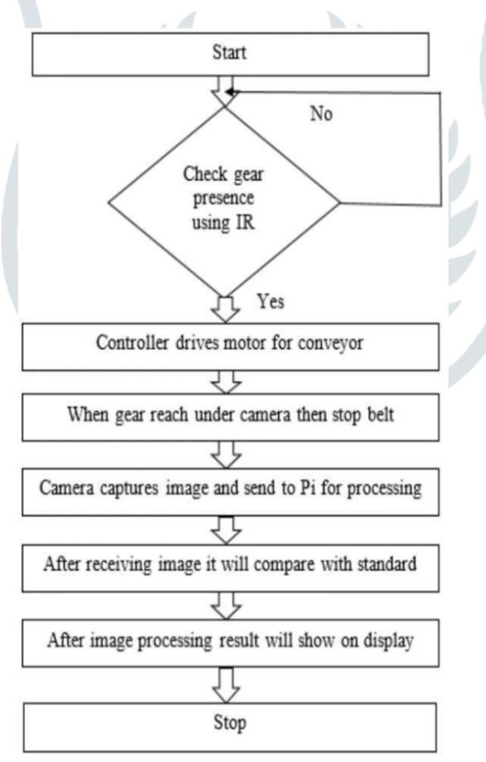**Block Diagram:**

Fig. Block Diagram of “AI Quality Analysis of Industrial Object by Image Processing”

The figure illustrates a system designed to monitor a specific area using a Thermal IR Camera (FLIR). The camera captures thermal images of the area, which are then sent to a Processing Unit. The Processing Unit undergoes three main stages: Pre-processing, Feature extraction, and Classification. If a dangerous animal is detected, the system activates a Warning System. This system uses a Flash light to emit flashes and a Buzzer to produce honks, alerting the surrounding area. Additionally, a Controller Unit sends messages to notify relevant authorities or individuals. If a non-dangerous animal is detected, the system directs it to an Exit without activating the warning mechanisms.

**ADVANTAGES, DISADVANTAGES & APPLICATIONS**

**ADVANTAGES:**

1. Less expensive
2. High reliability
3. Reduces manpower
4. It consumes power but can be balanced by use of superior quality material.
5. Fully automation is possible to reduce more time for inspection

**DISADVANTAGES:**

1. Complex MATLAB program is involved.
2. MATLAB skilled operator is required.

**APPLICATIONS:**

1. Computerized photography.
2. Space image recognition.
3. Remote sensing e.g. Aerial and satellite image interpretations.
4. Medical/Biological image processing e.g. X-ray images, blood/cellular microscope images.

**CONCLUSION:**

The "AI Quality Analysis of Industrial Object by Image Processing" project demonstrates the transformative potential of AI and image processing in industrial quality control. By automating the inspection process, the system ensures higher accuracy, consistency, and efficiency. This project not only reduces operational costs and human error but also sets a new standard for quality assurance in manufacturing. The successful implementation of this system can lead to significant improvements in productivity and product quality, ultimately benefiting manufacturers and consumers alike.

**REFERENCES**

[1] Amandeep Mavi, Mandeep Kaur. “*Identify Defects in Gears Using Digital Image Processing.*” International Journal Of Engineering Research and Development (2012)

[2] Aniket A Jagtap, Shubham D Vaidya, Akash R Samrutwar, Rahul G Kamadi and Nikhil V Bhende. "*Design Of Material Handling Equipment Belt Conveyor System.*” International Journal of Mechanical Engineering and Robotics Research (2015)

[3] Wuyin Jin, Hongru Du, Xia Zhang and Jingping Hu "*Development on Inspection System for Gear’s Dimension Based on Machine Version*." Advanced Materials Research Vols 317-319. (2011)